CITY UNIVERSITY OF HONG KONG
Department of Electrical Engineering
Course code & title | EE6623 Sustainable Energy Systems
Paper | Unit 1 practice paper: Wind Turbine Technologies
Session | Revision paper written in the format of the course examination
Time allowed | Two hours
Instructions | This paper consists of 4 questions. Answer ALL questions.

This is a closed-book practice paper. Show all working. Marks are awarded for the method as well as for the numerical result. Give units.
说明
题目语言和给分方式按照 EE6623-2526A 的试卷：分问、标分、计算与讨论混合、要求画图。范围只包括 Unit 1 和 Tutorial 1–3。数字是新编的，不是教程原题。详细中文解答在另一份 Word 中；请先独立做完再对照。

Question 1 (30 Marks)
A horizontal-axis wind turbine is installed on ground that is 400 m above mean sea level. The ground surface has high crops, hedges and shrubs. An anemometer mounted 10 m above the ground reads 6.5 m/s. The turbine hub height is 70 m and the rotor diameter is 90 m. The air temperature is 10 °C and may be taken as constant with height. For this terrain the friction coefficient is α = 0.20.

1.a
Calculate the wind speed and the specific power in the wind at
- the highest point reached by a blade tip;
- the lowest point reached by a blade tip.
Use the air density appropriate to each altitude. (10 Marks)

1.b
Using the results of part 1.a, determine the ratio of specific powers P_top / P_bottom. Compare this ratio with (H_top / H_bottom)^(3α). Discuss the effect of the air-density variation and the impact of the specific-power variation on the blades. (8 Marks)

1.c
On a representative day the wind speed at the hub rises linearly from zero to the hub-height speed in t1 = 2 h, remains constant for t2 = 10 h, falls linearly back to zero in t1 = 2 h, and is calm for the rest of the day, as shown below. The overall efficiency from the power in the wind to electrical energy is η = 32%. Derive the electrical energy produced in one day and evaluate it in kWh. Use the air density at the hub. (8 Marks)
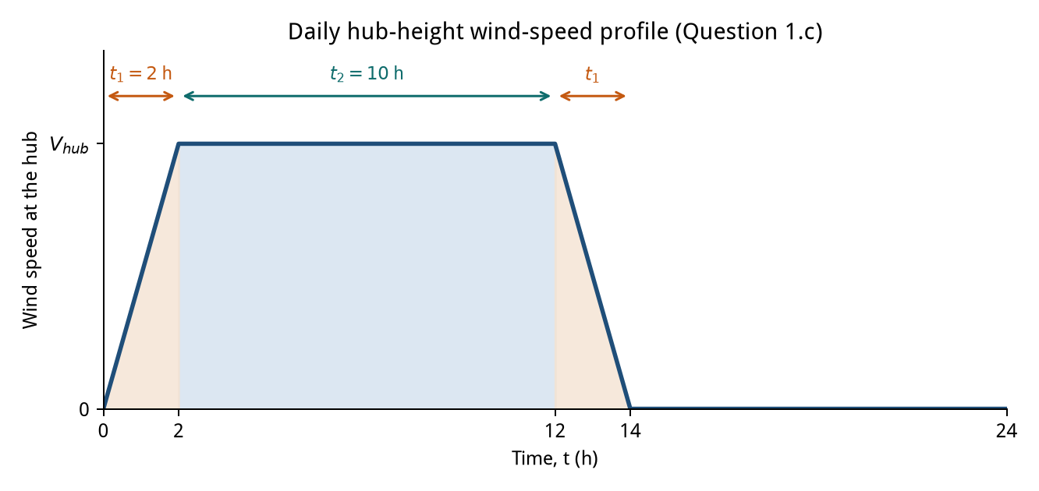
Figure for Question 1.c. V_hub is the hub-height wind speed from part 1.a.

1.d
A thermal power station emits 0.90 kg of CO2 per kWh of electrical energy. Estimate, in tonnes, the mass of CO2 that would not be emitted in one year of 365 days if six turbines identical to the one in part 1.c were used instead. Assume the same daily wind profile on every day of the year. (4 Marks)

Question 2 (30 Marks)

2.a
Briefly describe the function of the following wind-turbine components: blades, pitch system, gearbox, generator, controller, anemometer, yaw drive and tower. State one reason for using a direct-drive generator. (8 Marks)

2.b
(i) Compare an upwind horizontal-axis turbine with a downwind horizontal-axis turbine. (4 Marks)
(ii) Give three advantages and three disadvantages of a vertical-axis turbine relative to a horizontal-axis turbine. (4 Marks)

2.c
Explain why wind turbines with a large number of blades are generally not suitable for electricity generation. Sketch rotor efficiency against tip-speed ratio for an American multiblade rotor and for a three-blade rotor. On the sketch, mark the approximate optimum tip-speed ratio and efficiency of each rotor, and mark the Betz limit. (8 Marks)

2.d
A 60 m diameter, three-bladed wind turbine produces 1.20 MW of electrical power at a wind speed of 13 m/s when the tip-speed ratio is 4.2. The air density is 1.225 kg/m³. Determine
- the blade tip speed;
- the rotor speed in rpm;
- the gear ratio if the generator runs at 1500 rpm;
- the overall efficiency of the plant.
Comment on this efficiency with respect to the Betz limit. (6 Marks)

Question 3 (30 Marks)
A wind turbine feeds power to a three-phase, 11 kV, 50 Hz grid through a wound-rotor induction generator operating with slip-power control. The generator may be treated as ideal. The data are as follows.
Item | Data
Induction machine | Three-phase, 11 kV, 50 Hz, 6 poles, delta-connected
Wind turbine | Horizontal-axis, two blades, diameter 70 m, tower height 85 m, maximum efficiency 45% at a tip-speed ratio of 5.5
Gearbox | Power efficiency 90%, speed ratio 70
Site | Altitude 200 m above mean sea level, average temperature 20 °C, friction coefficient of the terrain 0.15
Wind measurement | 8.0 m/s at a height of 10 m above ground

The slip power of the generator is controlled so that the turbine operates at its optimum efficiency. The power factor at the stator terminals is maintained at unity.

3.a
Find the wind speed at the turbine hub. (4 Marks)

3.b
Find the rotational speed of the turbine, in rpm, when it operates at maximum efficiency at the wind speed of part 3.a. (4 Marks)

3.c
Find the mechanical power available at the shaft of the induction generator, in kW. (6 Marks)

3.d
Find the operating slip. State whether the machine is in sub-synchronous or super-synchronous generation, and state what the sign of the slip implies for the phase sequence of the rotor supply. (6 Marks)

3.e
Calculate the power processed by the power converters and state its direction. Also state the total electrical power delivered to the grid. (4 Marks)

3.f
Sketch a permanent-magnet synchronous generator connected to the grid through a full-rated AC–DC–AC converter, and sketch the doubly-fed induction-generator configuration used in this question. Give one advantage and one drawback of the permanent-magnet configuration compared with the doubly-fed configuration. (6 Marks)

Question 4 (10 Marks)

4.a
In your own words, define Carbon Capture, Clean Energy, CO2 Reduction, Electrical Transportation and Flow Batteries. For each phrase, state whether it is itself a renewable energy resource and how it is relevant to renewable electricity generation. (6 Marks)

4.b
Explain the meaning of cut-in speed, rated wind speed and cut-out (furling) speed. State how the output power of a large pitch-controlled turbine is held at its rated value between rated wind speed and cut-out speed, and why a mechanical brake is still required after the rotor has been furled. (4 Marks)
— END OF PAPER —

