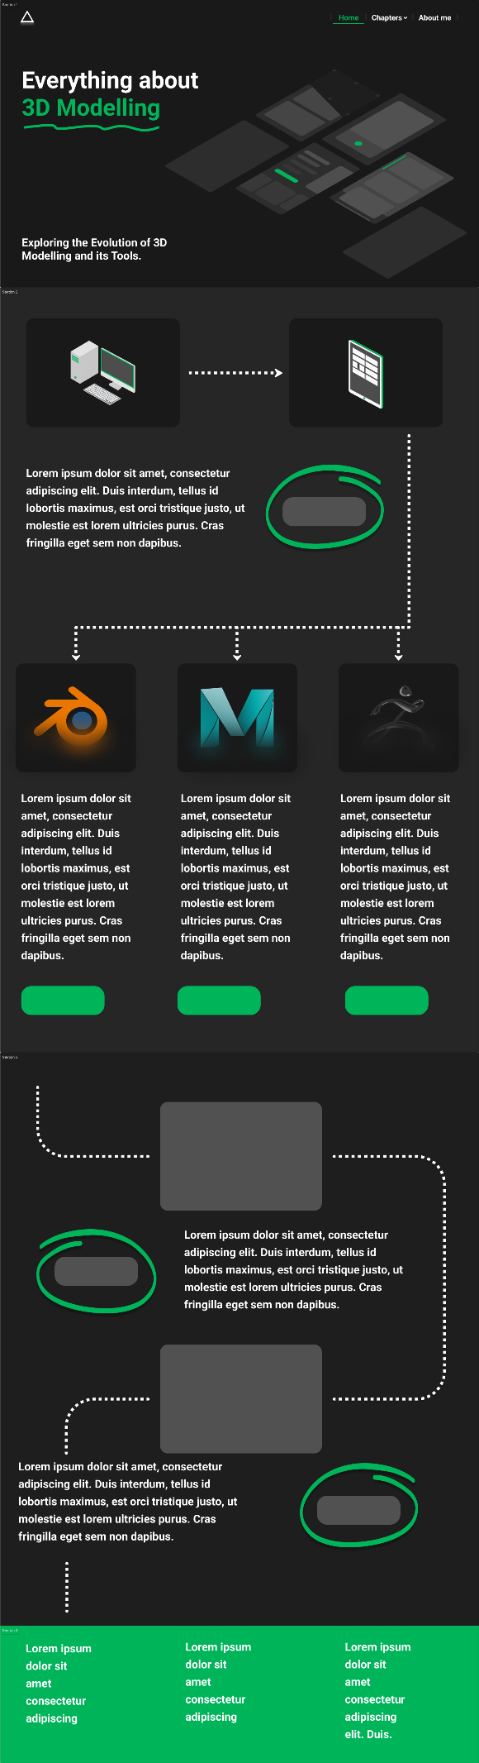**Home Page**  **Content Seiten**

