MINISTERUL EDUCAŢIEI REPUBLICII MOLDOVA

**UNIVERSITATEA TEHNICĂ A MOLDOVEI**

**Facultatea „Calculatoare, Informatică şi Microelectronică”**

FILIERA ANGLOFONĂ

**RAPORT**

**Lucrare de laborator nr. 1**

**la WP**

**A efectuat:**

st. gr. FAF-151 Sezer Aksoy

**A verificat: Irina Cojani**

dr., conf. univ.

  
**2017**

1. Contents

* Win32 API
* GIT
* Window
* Button
* Text Input
* Text

1. **Purpose of the laboratory**

Gain knowledge about basics of event-driven programming, understanding of window’s class and basic possibilities of Win32 API. Also she will try to understand and process OS messages

1. **Laboratory work requirements:**

* for *Basic Level* (grade 5 || 6) you should be able to:
  + Create a Windows application
  + In the middle of the window should be present the following text: "Done with Pride and Prejudice by student name". Replace student name with your name.
  + On windows resize, text should reflow and be in window's middle (vertically and horizontally)
* for *Normal Level* (grade 7 || 8) you should be able to:
  + Realize the tasks from *Basic Level*.
  + Add 2 buttons to window: one with default styles, one with custom styles (size, background, text color, font family/size)
  + Add 2 text elements to window: one with default styles, one with custom styles (size, background, text color, font family/size)
* for *Advanced Level* (grade 9 || 10) you should be able to:
  + Realize the tasks from *Normal Level*.
  + Make elements to interact or change other elements (2 different interactions) *(ex. on button click, change text element color or position)*
  + Change behavior of different window actions (at least 3). For ex.: on clicking close button, move window to a random location on display working space

1. **Description of My Work**

Firstable i created a window on Visual Studio and put 2 text labels ,2 textboxes, 2 buttons. One of them 2 labels is Custom with blue color. The other one has standard still.

One of them 2 textboxes is standard still and the other one has a background color with gray and the text color is White.

One of them 2 buttons is standard still and the other one is custom still with red background color and White text color.

To the first step the custom button can be clickable but standard button can not be clickable. When you click the custom button then the situation will be oppisite.

I added some action with button on my program. For example when we click the custom button which is the red background ,then we will see background of the textboxes color change. And there will be appeare a popup window which is saying “You changed to the custom still” and the custom button will be non clickable.

And when we click the standard button then the popup will appeare again and it shows us a message “You changed to standard still” and custom button will be clickable the standard button will be non clickable.

Also, i changed the background color with custom button.

**Screenshots:**

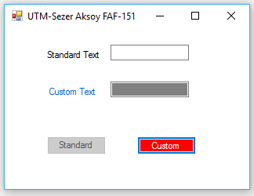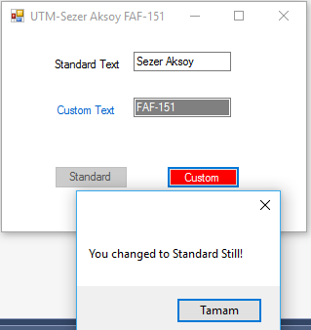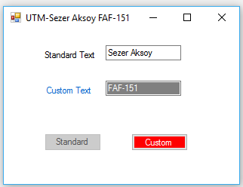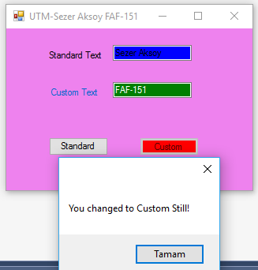

**My github link:**

[**https://github.com/szraksy/WP**](https://github.com/szraksy/WP)