MINISTERUL EDUCAŢIEI REPUBLICII MOLDOVA

**UNIVERSITATEA TEHNICĂ A MOLDOVEI**

**Facultatea „Calculatoare, Informatică şi Microelectronică”**

FILIERA ANGLOFONĂ

**RAPORT**

**Lucrare de laborator nr. 2**

**la WP**

**A efectuat:**

st. gr. FAF-151 Sezer Aksoy

**A verificat: Irina Cojani**

dr., conf. univ.

  
**2017**

## Contents

* The Keyboard
* Child Window Controls
  + Scroll Bar
  + Listbox
* Menus and Other Resources
* Dialog Boxes

## Mandatory Objectives

* Display a dialog box on some event (ex. on clicking some button)
* Add a system menu to your application with at least 3 items (add actions to that items)
* Add a scroll bar that will change any visible parameter of any other element (color of a text)
* Hook keyboard input. Add 2 custom events for 2 different keyboard combinations (ex. change window background on ctrl+space)

## Objectives With Points

* Add a listbox and attach some events when any element is accessed (clicked) **(2 pt)**
* Add 2 scroll bars that will manage main window size or position **(1 pt)**
* Customize your application by adding an icon and using different cursor in application **(1 pt)**
* Use a scroll bar to scroll through application working space. Scroll should appear only when necessary (eg. when window width is smaller than 300px) **(1 pt)**

I made 2 different forms on my Second Labrotary work. First form has custom background image ,listbox which one is represent to the Education year , a button and a message box.

We are chosing the year of the education from the listbox and we are clicking to the button when we clicked to the button then message box appeare and it is saying which year we chosed.

When we click to the Ok on the message box then the second form will be open.

On the second form we have 5 different menu items, announcement area with listbox ,a button, a label ,

on the menu side we have 5 different options which are;

* Changing background color
* changing window size
* changing background color of Button
* Reseting to the default color
* and exit from the program

When we are clicking to the button then we will see more announcements and the listbox’s scrollbar will be visible.

On my program i put custom icon.

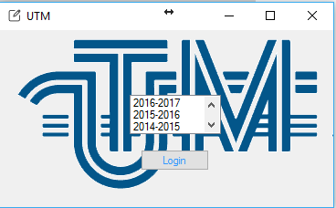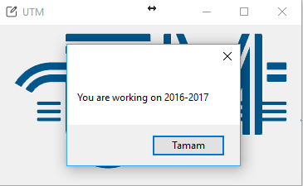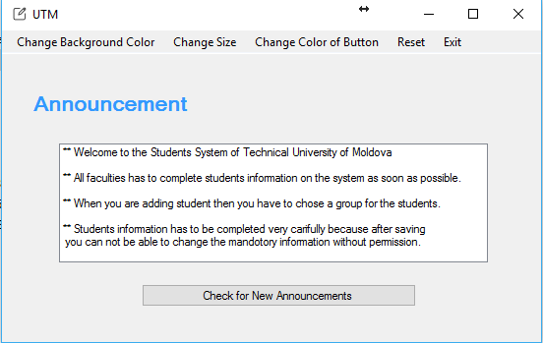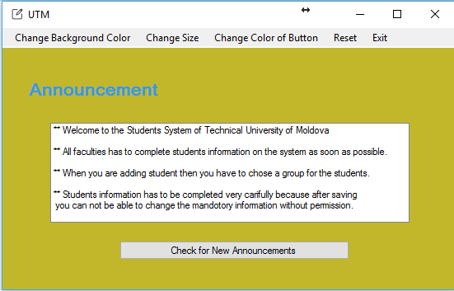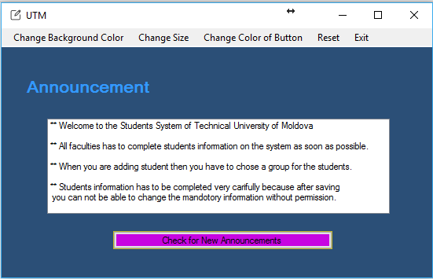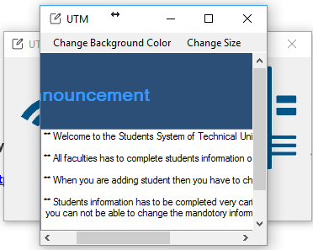

**My github link:**

[**https://github.com/szraksy/WP**](https://github.com/szraksy/WP)