Linear Model – 25 pts

PLEASE READ THIS BEFORE CONTINUING

This assignment will help you practice writing, executing, and interpreting a linear model in R. It will also involve some more practice with GitHub. You may collaborate with a partner to enhance your learning experience. Please ensure the following:

- Submission: Both partners should submit the assignment to Canvas in a Word document, .html, or .pdf file generated through R markdown. Additionally, you should provide a link to your GitHub, where the assignment should be viewable by rendering it as a GitHub-flavored markdown file.
- Setup: It is also assumed you already have a GitHub repository for this class.
- Time: This should take you no longer than the class period to complete.

- 4 pts. Read in the data called “PlantEmergence.csv” using a relative file path and load the following libraries. tidyverse, lme4, emmeans, multcomp, and multcompView. Turn the Treatment , DaysAfterPlanting and Rep into factors using the function as.factor

STAND$Treatment <- as.factor(STAND$Treatment) # example shown here.
- 5 pts. Fit a linear model to predict Emergence using Treatment and DaysAfterPlanting along with the interaction. Provide the summary of the linear model and ANOVA results.

- 5 pts. Based on the results of the linear model in question 2, do you need to fit the interaction term? Provide a simplified linear model without the interaction term but still testing both main effects. Provide the summary and ANOVA results. Then, interpret the intercept and the coefficient for Treatment 2.

- 5 pts. Calculate the least square means for Treatment using the emmeans package and perform a Tukey separation with the compact letter display using the cld function. Interpret the results.

- 4 pts. The provided function lets you dynamically add a linear model plus one factor from that model and plots a bar chart with letters denoting treatment differences. Use this model to generate the plot shown below. Explain the significance of the letters.
plot_cldbars_onefactor <- function(lm_model, factor) {
data <- lm_model$model
variables <- colnames(lm_model$model)
dependent_var <- variables[1]
independent_var <- variables[2:length(variables)]

lsmeans <- emmeans(lm_model, as.formula(paste("~", factor))) # estimate lsmeans
Results_lsmeans <- cld(lsmeans, alpha = 0.05, reversed = TRUE, details = TRUE, Letters = letters) # contrast with Tukey adjustment by default.

# Extracting the letters for the bars
sig.diff.letters <- data.frame(Results_lsmeans$emmeans[,1],
str_trim(Results_lsmeans$emmeans[,7]))
colnames(sig.diff.letters) <- c(factor, "Letters")

# for plotting with letters from significance test
ave_stand2 <- lm_model$model %>%
group_by(!!sym(factor)) %>%
dplyr::summarize(
ave.emerge = mean(.data[[dependent_var]], na.rm = TRUE),
se = sd(.data[[dependent_var]]) / sqrt(n())
) %>%
left_join(sig.diff.letters, by = factor) %>%
mutate(letter_position = ave.emerge + 10 * se)

plot <- ggplot(data, aes(x = !! sym(factor), y = !! sym(dependent_var))) +
stat_summary(fun = mean, geom = "bar") +
stat_summary(fun.data = mean_se, geom = "errorbar", width = 0.5) +
ylab("Number of emerged plants") +
geom_jitter(width = 0.02, alpha = 0.5) +
geom_text(data = ave_stand2, aes(label = Letters, y = letter_position), size = 5) +
xlab(as.character(factor)) +
theme_classic()

return(plot)
}
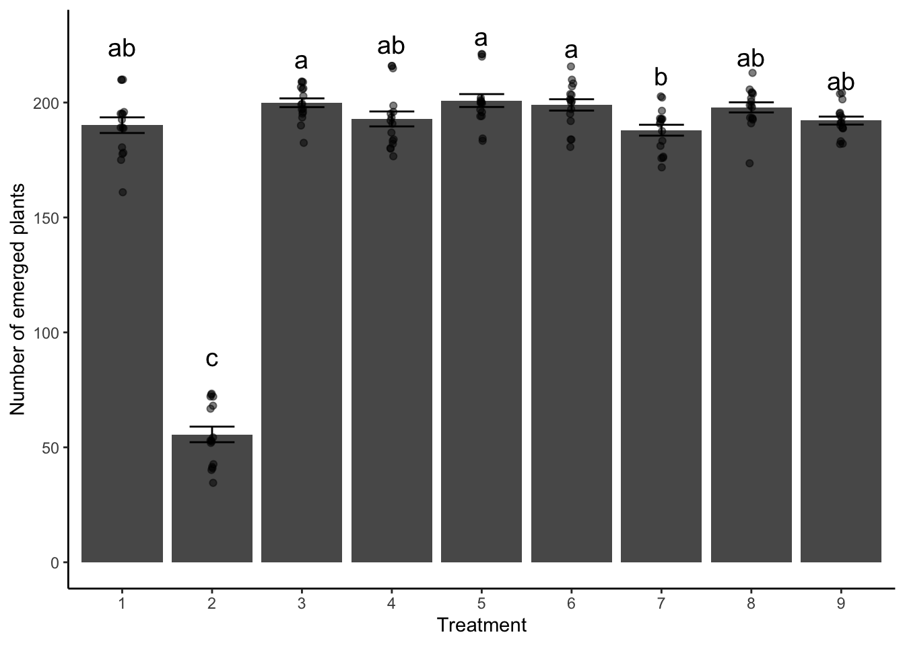

- 2 pts. Generate the gfm .md file along with a .html, .docx, or .pdf. Commit, and push the .md file to github and turn in the .html, .docx, or .pdf to Canvas. Provide me a link here to your github.

