Data wrangling – 25 pts

PLEASE READ THIS BEFORE CONTINUING

This assignment will help you practice integrating some of the tidyverse functions into your R scripts. It will also involve some more practice with GitHub. You may collaborate with a partner to enhance your learning experience. Please ensure the following:

- Collaboration: If you work with a partner, include both names on the final submission by editing the YAML header.
- Submission: Both students should submit the assignment to Canvas in a Word, HTML, or .pdf file generated through R markdown. Additionally, you should provide a link to your GitHub, where the assignment should be viewable by rendering it as a GitHub-flavored markdown file.
- Setup: It is also assumed you already have a GitHub repository for this class.
- Time: This should take you no longer than the class period to complete.

- 3 pts. Download two .csv files from Canvas called DiversityData.csv and Metadata.csv, and read them into R using relative file paths.
- 4 pts. Join the two dataframes together by the common column ‘Code’. Name the resulting dataframe alpha.
- 4 pts. Calculate Pielou’s evenness index: Pielou’s evenness is an ecological parameter calculated by the Shannon diversity index (column Shannon) divided by the log of the richness column.
  - Using mutate, create a new column to calculate Pielou’s evenness index.
  - Name the resulting dataframe alpha_even.
- 4. Pts. Using tidyverse language of functions and the pipe, use the summarise function and tell me the mean and standard error evenness grouped by crop over time.
  - Start with the alpha_even dataframe
  - Group the data: group the data by Crop and Time_Point.
  - Summarize the data: Calculate the mean, count, standard deviation, and standard error for the even variable within each group.
  - Name the resulting dataframe alpha_average
- 4. Pts. Calculate the difference between the soybean column, the soil column, and the difference between the cotton column and the soil column
  - Start with the alpha_average dataframe
  - Select relevant columns: select the columns Time_Point, Crop, and mean.even.
  - Reshape the data: Use the pivot_wider function to transform the data from long to wide format, creating new columns for each Crop with values from mean.even.
  - Calculate differences: Create new columns named diff.cotton.even and diff.soybean.even by calculating the difference between Soil and Cotton, and Soil and Soybean, respectively.
  - Name the resulting dataframe alpha_average2
- 4 pts. Connecting it to plots
  - Start with the alpha_average2 dataframe
  - Select relevant columns: select the columns Time_Point, diff.cotton.even, and diff.soybean.even.
  - Reshape the data: Use the pivot_longer function to transform the data from wide to long format, creating a new column named diff that contains the values from diff.cotton.even and diff.soybean.even.
    - This might be challenging, so I’ll give you a break. The code is below.

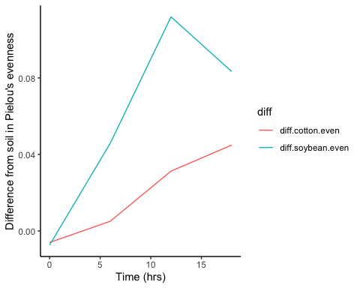
pivot_longer(c(diff.cotton.even, diff.soybean.even), names_to = "diff")

  - Create the plot: Use ggplot and geom_line() with ‘Time_Point’ on the x-axis, the column ‘values’ on the y-axis, and different colors for each ‘diff’ category. The column named ‘values’ come from the pivot_longer. The resulting plot should look like the one to the right.

- 2 pts. Commit and push a gfm .md file to GitHub inside a directory called Coding Challenge 5. Provide me a link to your github written as a clickable link in your .pdf or .docx

