Global performance report

# Introduction

The game included various security requirements testing in different rooms.

Number of rooms: 12

Number of participants: 1

## Section Admin Office

**- Replace simple passwords**

Number and percentage of users who succeeded with no failure: 0 | 0.0%

Number and percentage of users who succeeded after failure: 0 | 0.0%

Number and percentage of users who failed with no success: 0 | 0.0%

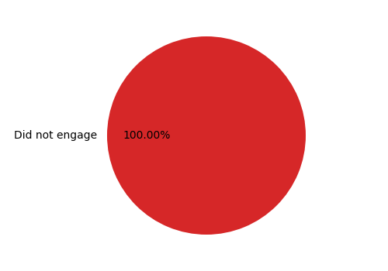

**- Comply with password complexity**

Number and percentage of users who succeeded with no failure: 0 | 0.0%

Number and percentage of users who succeeded after failure: 0 | 0.0%

Number and percentage of users who failed with no success: 0 | 0.0%



## Section Gate

**- Use access badge for entry**

Number and percentage of users who succeeded with no failure: 0 | 0.0%

Number and percentage of users who succeeded after failure: 1 | 100.0%

Number and percentage of users who failed with no success: 0 | 0.0%

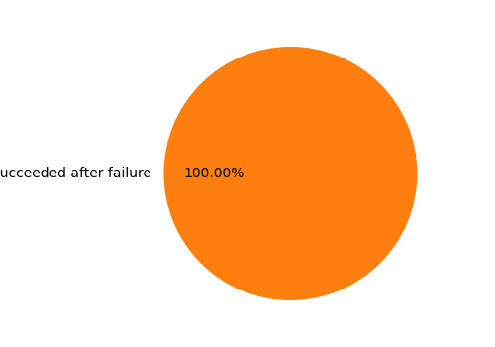

## Section Home

**- Appropriate devices for remote access**

Number and percentage of users who succeeded with no failure: 0 | 0.0%

Number and percentage of users who succeeded after failure: 0 | 0.0%

Number and percentage of users who failed with no success: 0 | 0.0%



## Section News Room

**- Connect to the disaster communication system**

Number and percentage of users who succeeded with no failure: 0 | 0.0%

Number and percentage of users who succeeded after failure: 0 | 0.0%

Number and percentage of users who failed with no success: 0 | 0.0%



## Section Open Office

**- Remove confidential data**

Number and percentage of users who succeeded with no failure: 0 | 0.0%

Number and percentage of users who succeeded after failure: 0 | 0.0%

Number and percentage of users who failed with no success: 0 | 0.0%



## Section New York Train

**- Access confidential data in public**

Number and percentage of users who succeeded with no failure: 0 | 0.0%

Number and percentage of users who succeeded after failure: 0 | 0.0%

Number and percentage of users who failed with no success: 0 | 0.0%



## Section Your Office

**- Respond to phishing email**

Number and percentage of users who succeeded with no failure: 0 | 0.0%

Number and percentage of users who succeeded after failure: 0 | 0.0%

Number and percentage of users who failed with no success: 0 | 0.0%

