CSCI B320

Data Design

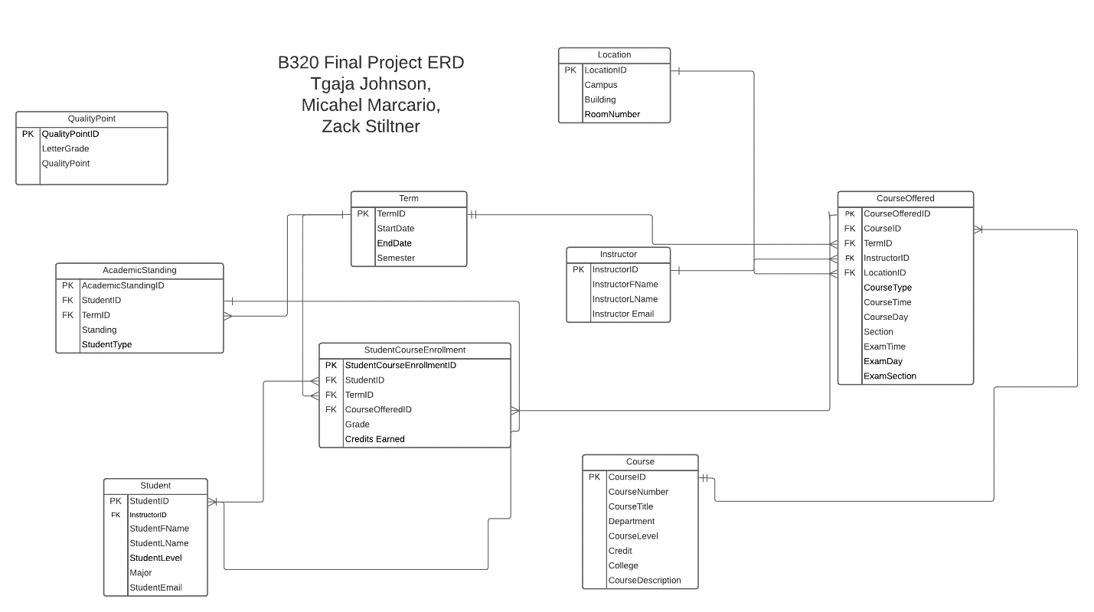

Clarifications/Assumptions

1. Year values are 2018 - 2022.
2. Instructors are able to take classes, but they will receive a StudentID if they do.
3. GPA's will alter with each semester.
4. Course prerequisites will be the same for each student respectively (CSCI & ISAT).
5. Course time, day, and location will alter with each semester.
6. Classes may have different instructors per semester.
7. Each CourseID is only offered once per term.
8. Each student has their own individual range of StudentGradeIDs.
9. No TotalCreditsEarned b/c its calculated.
10. Students can take the same class over different terms.
11. Same courses on different campuses will have same CourseID but different CourseOfferings/OfferedID.
12. Certain classes count towards CSCI & ISAT requirements.
13. Previous Majors are not stored.
14. QualityPoint table is used to translate letter grade into quality points (A is worth 4, B+ is worth 3.5, ect).
15. Grad Students may take Undergraduate courses, but they will count towards MastersGPA.
16. No separate set of StudentIDs for Graduate Students and Undergraduate Students.
17. School only offers full term class.
18. School only offers Fall and Spring classes.
19. All classes are 3 credits
20. NULL values for Course entities = To be determined.
21. CreditHours are the same as LectureHours.
22. Courses with a lab are still 3 credit hours.
23. Courses with a lab are incorporated into the same CourseID and CourseOfferedID.
24. Courses without Buildings and Room numbers in data sets are set to online courses.
25. StudentID has no correlation to what year the student is.
26. All courses offered are lectures.
27. All Transfers entering classes in 8th Term.
28. Incoming students have no registered class or terms
29. All Graduate students are currently in their first term.
30. Graduate students have 0 credit hours upon entering the university.
31. Graduate students prior student information is removed.