Statistical Analysis of The Milwaukee Bucks Shooting Over the Past Decade

Colin Kalsbeek

345 Midterm

4/1/2022

|  |  |  |  |
| --- | --- | --- | --- |
| Field Goal Percentage: | 47 % |  | 45% |
| 3-Point Percentage: | 34% |  | 36% |
| Shooting Percentage: | 44% |  | 43.5% |
| Most shots are spread around evenly. There is a collection of points surrounding the basket. This plot shows no favorability to any specific spot on the court. | |  | Most shots are spread around the court evenly. You can see more shots in the middle of the paint. This most likely came from a re-build, and Milwaukee letting their best shooters go. |

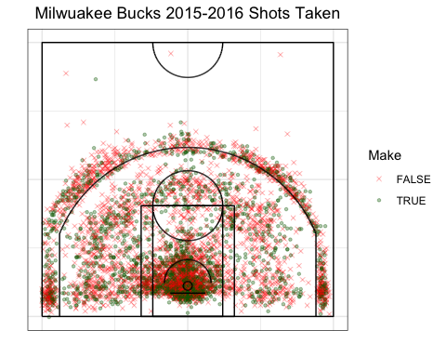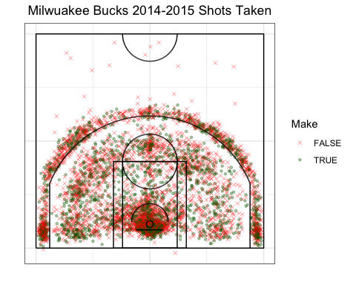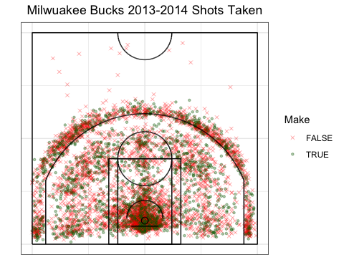

|  |  |  |  |
| --- | --- | --- | --- |
| Field Goal Percentage: | 46% | 48% | 49.5% |
| 3-Point Percentage: | 35% | 36% | 35% |
| Shooting Percentage: | 44% | 46% | 47% |
| This plot shows no favorability to any specific spot on the court. Midrange and three-pointers are evenly spread. | | This shows slightly more midrange shots than the previous year. Along with more corner threes. | You can see the corner threes becoming more densely populated by shots. This also shows 39-footer made by Michael Carter-Williams. |

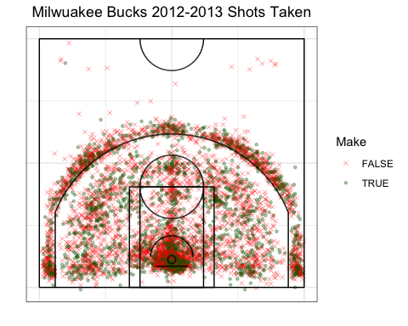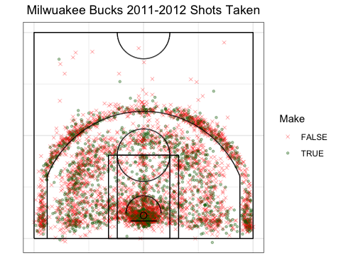

|  |  |  |  |
| --- | --- | --- | --- |
| Field Goal Percentage: | 51% | 53% | 56.5% |
| 3-Point Percentage: | 37% | 35% | 35% |
| Shooting Percentage: | 47% | 48% | 47% |
| This shows many less midrange shots, which have been replaced by three-pointers. | | You can see a semi-circle forming around the three-point line. This most likely can be attributed to the game changing1. | You can see a heavier semi-circle around the three-point line. Immediately inside the three-point line shows practically no shots being taken in that range. |

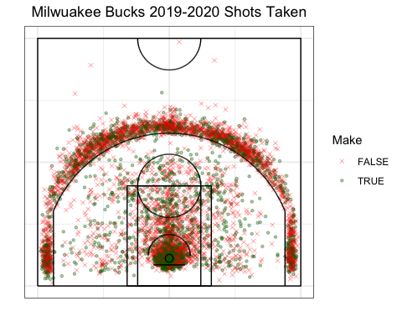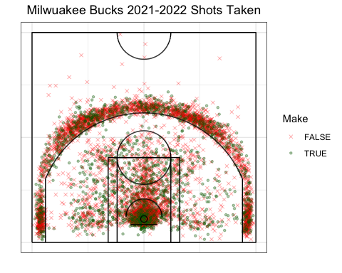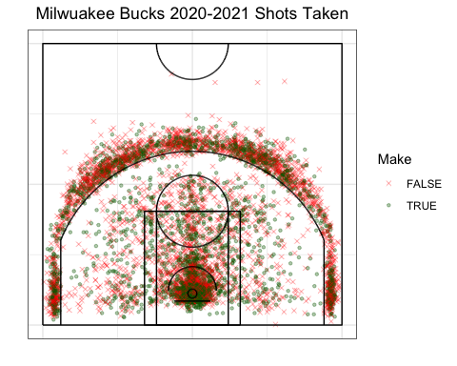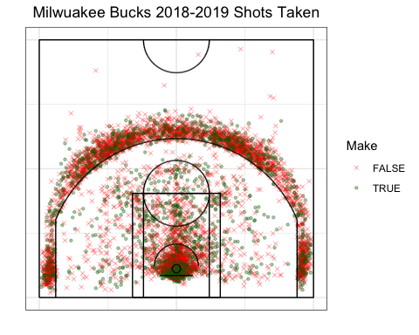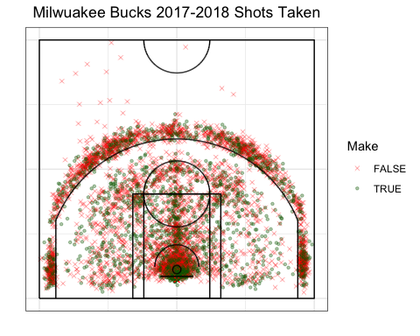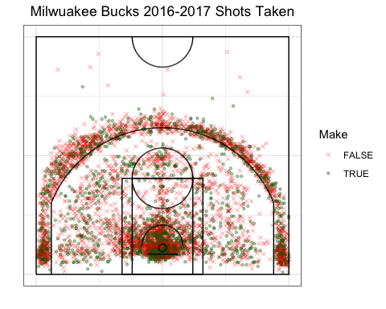

|  |  |  |  |
| --- | --- | --- | --- |
| Field Goal Percentage: | 56% | 55% | 54% |
| 3-Point Percentage: | 35.5% | 39% | 37% |
| Shooting Percentage: | 47% | 49% | 47% |
| There is an obvious focus on three-point shots, and close-range shots. Also, there is a decrease in over 30-foot shots. | | As the Bucks best year in recent history, you can see the distribution of shots becoming less reliant on midrange shots. | You can see a heavy semi-circle surrounding the three-point line. Most field goals are within 16 feet. This creates a sort of dead zone, with minimal shots being between 16 and 24 feet. |

Footnote:

1: In 2016-2017 you can see the transition of the game to be more reliant on threes. Years before 2017, the Milwaukee Bucks averaged 1,440 threes, while the seasons after 2017 averaged 2,705 threes. This change most likely came from the Golden State Warriors era of dominance 2015-2018. Their ability to shoot the three changed the game. This caused the defense to move higher up and spread out more. Therefore, this strategy of basketball not only lets your shooters shoot the ball, but also spreads the court out giving you more high probability shots close to the basket. Resulting in more threes and layups as seen in plots.

Further Analysis:

You can see a slight but consistent increase in the overall shooting percentages. Starting at 43% and slowly making it up to 48%. Three-point percentage roughly stays the same. This could be explained by The Bucks not having many shooter shooting guards. All-Star shooting guard, Khris Middleton, alone cannot make a difference in yearly three-point percentages. Many of Milwaukee’s best shooting guards over the past decade have been facilitators. In 2019, Brook Lopez, the Buck’s center ranked second on their team in three-point percentage. Field goal shooting percentage has increased by a surprising amount. From, 45% in 2013, to 55% in 2021, when they won the NBA Finals. This could be due to the Bucks starting their re-build in 2013. Milwaukee let some of their best players go in order to secure higher draft picks in the future. This re-build was obviously effective as Milwaukee won the NBA Finals in less than 10 years from starting their re-build. This could attribute to a smaller shooting percentage in the beginning of the decade.

The difference from the earliest plot to the latest plot is astounding. In the 2012 season, the shots taken are evenly distributed around the whole court. However, in the 2022 season, the shots taken are almost strictly outside the three-point line, and close to or within the paint. The decrease of half court shots, and increase in three’s and close-ranged shots, shows that players are simply smarter. Players are taking more high probability shots, and when they aren’t, they are cancelling the lower probability of making the longer shot, with scoring more points. The shots being taken in 2022 are much more effective than the shots taken in 2012.

The Milwaukee Bucks shots have changed drastically over the past decade. We now see more threes, and more points in the paint. While there is less midrange shots being attempted. This change is most likely because of the Warrior success. This forced teams to change their strategies if they want to compete. Every shot has a risk reward ratio. The percent chance you miss, and the number of points you will earn in you make it. This new style of basketball maximizes this risk reward ratio by focusing on threes and easy baskets.

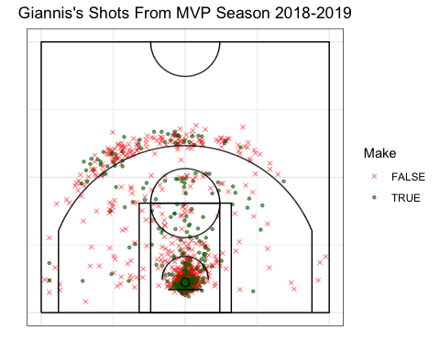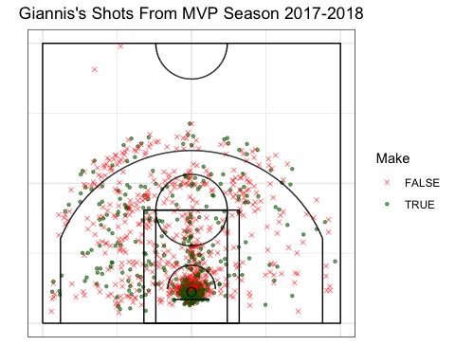

For Fun:

|  |
| --- |
| Giannis Antetokounmpo is a one of one player. He is the first player to win a regular season MVP, a Finals MVP, and an All-Star MVP before 26. Giannis has forced teams to change how they defend The Bucks because of his ability to dominate the game. We are going to analyze how Giannis has had to adapt to specialized defenses who prioritize stopping him over stopping The Bucks.  In 2018, the plot shows how dominate Giannis was, and how nobody had an answer to stop him. He scored from all spots on the court, especially in the paint. Then in 2019, you can see the decrease in midrange shots. This is most likely attributed to defenses playing zone defense. Zone defense allows the defense to collapse on a driving opponent but leaves the threes open for a quick dish out. You could expect Giannis’s assists to go up from 2018. From there we move to the 2020 season. This regular season the Bucks were seeded first in the eastern conference. This plot is similar to the previous year with more threes and mid-range shots. You can also see how Giannis prefers the right corner three versus the left (when perspective is on court). But favors the top of the arch overall. Finally, in 2021 you can see more made threes. Giannis had to practice his three-pointer because most defenses would rather give him space to shoot the three to avoid getting beat to the hoop. Giannis led the NBA in three-point percentage for almost a week in 2021. |

