Automated Breast Lesion Classification in Mammography Using Deep Learning Architectures

Beyza Türkmen Perihan Yıldız Topal Saliha Zülal Demirtaş
bturkmen21@ku.edu.tr ptopal21@ku.edu.tr sdemirtas21@ku.edu.tr
79826 79920 79747

- INTRODUCTION
Breast cancer is one of the most concerning diseases that many women face [1]. Early diagnosis of this disease and accurate breast lesion classification increase the chances of treatment being effective and survival from it. To diagnose this disease mammography is a low dose X-ray imaging modality and it remains the gold standard for breast cancer screening [1]. However, interpreting these mammography images is a complex task and it requires expert radiologists. Despite expert interpretation, it is prone to interobserver variability and diagnostic errors.

Automated systems for breast cancer detection have gained significant attention with development of deep learning medical image analysis techniques. These systems can assist radiologists with providing consistent and reproducible second opinions and make better diagnosis of breast cancer. This project aims to build an automatic classification pipeline that can detect and classify breast lesions using mammography images.

Primary goal is to classify mammographic findings into multiple diagnostic categories which are benign, malignant and benign without callback. This project utilizes a publicly available subset of the CBIS-DDSM dataset [2] and explores various deep learning models. In addition to model training in this project we employ K-Fold cross-validation, statistical hypothesis testing, and visualization techniques to ensure a comprehensive evaluation of model performance. This project not only addresses medical challenges that we encounter but also demonstrates how machine learning methods can be applied responsibly in clinical workflows.

- DATASET
A 10 GB subset of the Curated Breast Imaging Subset of Digital Database for Screening Mammography (CBIS-DDSM) was used in this project. This dataset was originally published by The Cancer Imaging Archive (TCIA) [3], and the smaller version of the dataset was obtained from DatasetNinja [2] for the scale of this project. This dataset was chosen since it contains high-quality images and annotations retrieved from real experts. The dataset includes 3,103 grayscale mammography images, each categorized into one of the three diagnostic labels: benign, malignant, and benign without callback. Each image has a JSON annotation file that includes metadata from expert reports including diagnostic findings and imaging conditions. 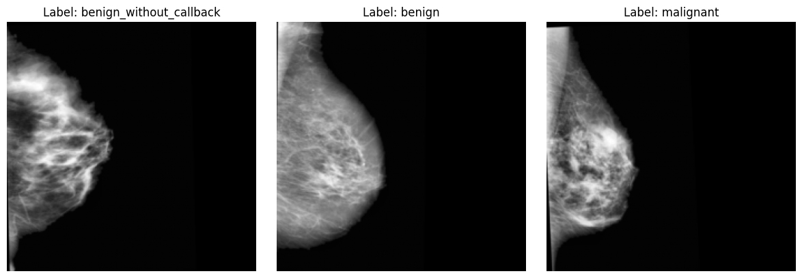
Fig. 1. Sample mammograms from the dataset: benign without callback, benign, and malignant.

- METHODOLOGY
This project analyzes and compares four different deep learning architectures which are Simple-CNN, ResNet50, and Swin-UNet and UNet, for the classification of breast lesions in mammography images.
- Dataset Preparation
Mammography images were loaded in grayscale and normalized to standardize pixel intensity. The dataset was split into training (60%), testing (20%), and validation (20%) subsets using stratified sampling to maintain consistent class distributions. Data augmentation techniques, including random horizontal flips and rotations, were applied to the training set to increase data variability and minimize overfitting. All images were resized to the suitable dimensions for the model.

- Simple-CNN
A custom convolutional neural network was implemented as a baseline model for
classification. The architecture consists of three sequential blocks of convolutional layers with ReLU activation, max-pooling, followed by global average pooling and two fully connected layers. Dropout regularization is applied before the final classification layer to prevent overfitting.The model was trained for 30 epochs using the Adam optimizer with a learning rate of 1e-3, weight decay of 1e-4, and ReduceLROnPlateau scheduler to adaptively reduce the learning rate on validation loss plateau.

- ResNet50
The ResNet50 architecture was adapted for classification by modifying it to accept grayscale mammography images as input. The initial convolutional layer was adjusted from three channels to a single channel by averaging the pretrained weights. Additionally, the classifier head was updated, replacing the original fully connected layer with a dropout layer followed by a linear classification layer. Class imbalance was addressed using class-weighted cross-entropy loss, with weights calculated based on class frequencies.

- SwinNet
SwinNet model applies swin transformer backbone to capture both local and global features using window based self-attention mechanisms. Model has a patch embedding layer with stacked swin transformer blocks and classification head. Input images were converted to three channels to adapt to grayscale images. Data augmentation included random cropping, horizontal flips, rotations and color jitter. Class imbalance is managed by weighted sampler and focal loss. Model was trained for 30 epochs with Adam optimizer and ReduceLROnPlateau scheduler for adjusting learning rate based on validation loss. Early stopping was applied if validation performance did not improve.

- UNet
UNet architecture was adapted for multiclass classification by using its encoder path. It consists of five sequential double convolutional blocks with ReLU activation and max-pooling. Encoded feature maps are aggregated using global average pooling instead of classic decoder. Passed through a fully connected classification head with batch normalization and dropout regularization. Model was trained on grayscale images resized to 224x224 pixels. Data augmentation techniques like random crops, flips, rotations and brightness contrast jitter were applied in the training. Weighted random sampler and focal loss with class based weights were used for addressing class imbalance. The model was trained for 20-30 epochs using Adam optimizer and OneCycleLR scheduler with early stopping based on validation F1 score.

4. EXPERIMENTAL RESULTS
- ResNet50
Four different configurations of the ResNet50 architecture were explored to achieve the highest performance in classifying breast lesions from mammography images.

Configuration 1: The original RGB three-channel was replaced with a single-channel convolution. A linear classification head with dropout regularization was added, and the entire network was fine-tuned. This configuration achieved the highest training and validation performance, with a training F1-score of 0.98 and validation F1-score of 0.55.

Configuration 2: To test whether overfitting originated in the early convolutional layers, the first three ResNet stages were frozen. While training was faster, validation F1 dropped to 0.47, indicating that low-level features still needed adaptation to the mammography domain.

Configuration 3: Squeeze-and-Excitation attention modules were integrated into stages 3 and 4, and the loss function was switched from class-weighted cross-entropy to focal loss to give extra learning weight to the misclassified examples. The model achieved validation F1 of 0.51.

Configuration 4: The final fully connected layer was replaced with a two-layer multilayer perceptron to improve representational learning. This setting produced a smoother loss curve and improved the F1 score to 0.53.

ResNet50 - Best-Performing Model
In the baseline ResNet50 model (Configuration 1), Adam optimizer with learning rate of 1e-4, weight decay of 1e-3, ReduceLROnPlateau scheduler, class-weighted cross-entropy loss was selected after different hyperparameter trials. This method reached the highest train and validation performances, 0.98 and 0.55 respectively, among four trials and served as our reference.
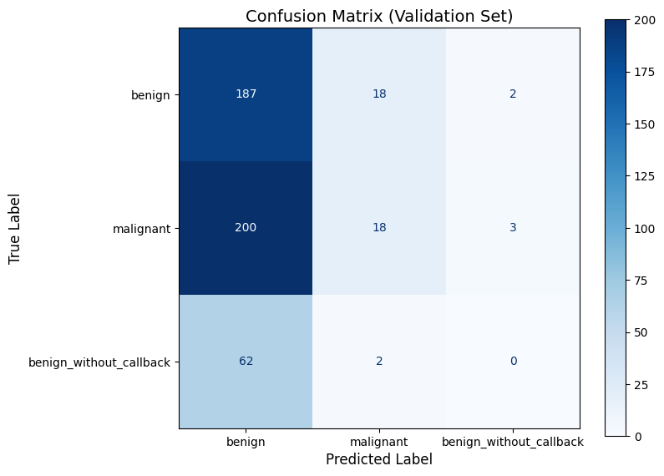
Fig. 2. Confusion matrix of ResNet50 model predictions versus ground truth for benign and malignant mammogram classification.
The model correctly classified most benign samples (187/207), but struggled with malignant and benign_without_callback classes, often misclassifying them as benign. This class confusion suggests that even with class weighting, the representation for minority classes remains weak.
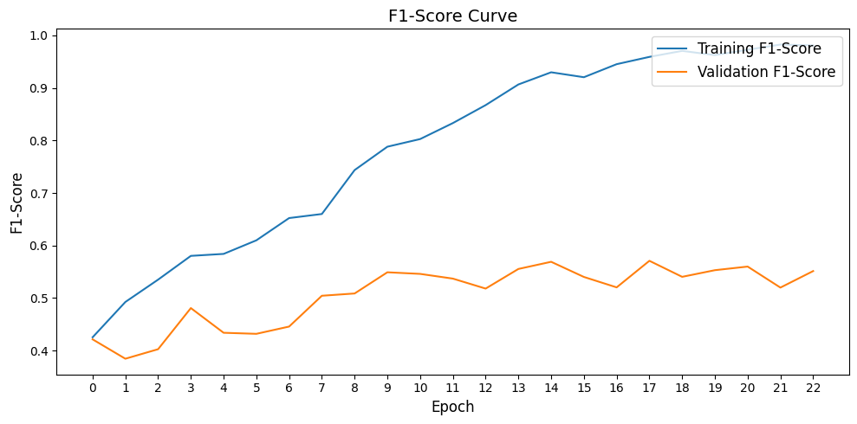
Fig. 3. ResNet50 training and validation F1-score curves over epochs.

Additionally, 5-fold cross-validation was performed on a subset containing 200 samples per class to evaluate the model’s generalization.

TABLE I
Performance Metrics on Training and Validation Sets
 | Train |  |  |  |  | Validation
fold | Loss | F1 | Precision | Recall | Accuracy | Loss | F1 | Precision | Recall | Accuracy
1 | 0.0940 | 0.9855 | 0.9852 | 0.9859 | 0.9854 | 1.3435 | 0.5160 | 0.5149 | 0.5333 | 0.5333
2 | 0.0896 | 0.9727 | 0.9702 | 0.9754 | 0.9715 | 1.3244 | 0.5600 | 0.5565 | 0.5641 | 0.5711
3 | 0.0708 | 0.9826 | 0.9831 | 0.9821 | 0.9827 | 1.3940 | 0.5200 | 0.5265 | 0.5182 | 0.5508
4 | 0.0779 | 0.9809 | 0.9814 | 0.9805 | 0.9781 | 1.4211 | 0.5514 | 0.5508 | 0.5533 | 0.5671
5 | 0.0895 | 0.9711 | 0.9698 | 0.9727 | 0.9708 | 1.3435 | 0.5864 | 0.5855 | 0.5917 | 0.5917

Mean Train F1-Score: 0.94
Mean Validation F1-Score: 0.52

- CNN Model
Two configurations of the SimpleCNN architecture were evaluated. The first configuration served as a baseline model, consisting of three convolutional blocks with batch normalization, dropout, and class-weighted cross-entropy loss. The model was trained for 30 epochs, during which the training F1-score improved to 0.402, while the validation F1-score peaked at 0.373.

To enhance performance, an attention block is integrated for the second configuration. However, the results did not meet expectations. The training early-stopped at epoch 6 due to lack of improvement. The training F1-score plateaued around 0.283, and the validation score remained consistently low at approximately 0.19, indicating poor generalization. This suggests that the addition of attention layers did not benefit the model under the current settings.

- UNet
UNet lacks contextual awareness provided with attention mechanisms while its encoder path effectively captures hierarchical spatial features. Also the model showed signs of overfitting despite regularization strategies and augmentation. It is likely due to the complexity of mammographic patterns that require more expressive representations.

Configuration 1: This has preprocessing where images are read in grayscale and normalized. UNet architecture composed of standard encoder and decoder blocks. It was augmented with a linear classification head. This includes a global average pooling layer, two fully connected layers, dropout regularization, and BatchNorm1d. Model was fine tuned using Adam optimizer with a learning rate scheduler and a WeightedRandomSampler to manage class imbalance during training. An early stopping mechanism was also implemented. This configuration yielded its best performance at Epoch 17 achieving a training F1 score of 0.52 and a validation F1 score of 0.48. Relatively low validation F1 alongside an analysis of learning curves suggests potential overfitting or inherent complexities in dataset

Configuration 2: UNet model was trained using grayscale images. During preprocessing, images were normalized, and augmented with RandomResizedCrop, RandomHorizontalFlip, RandomVerticalFlip, RandomRotation, ColorJitter and RandomErasing for training. Only resizing and normalization were applied for validation. Standard UNet encoder architecture was used with a linear classification head that included a global average pooling layer, two fully connected layers, dropout, and batchNorm1d. For optimization, the model utilized the AdamW optimizer with a OneCycleLR learning rate scheduler. WeightedRandomSampler was implemented and Focal Loss with gamma=0.5 as loss function for managing class imbalance. This configuration achieved a training F1 score of 0.61 and a validation F1 score of 0.41.
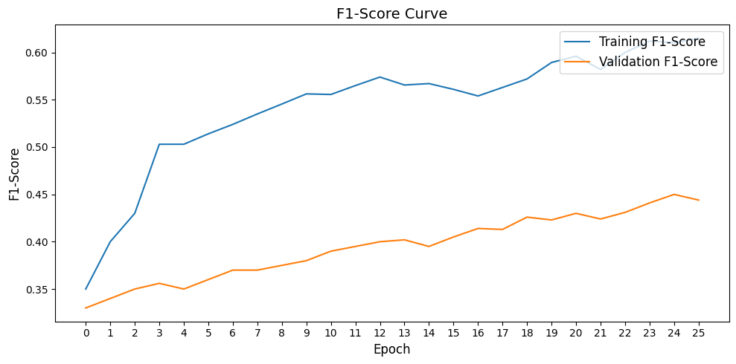
Fig. 4. UNet training and validation F1-score curves over epochs.

- SwinNet
SwinNet highlights the strength of transformer-based architectures in capturing both local and ranged dependencies. Self attention in windowed regions allows models to learn more discriminative features from mammography images. However, the performance gap between training and validation F1 scores shows overfitting. This could be high model capacity of SwinNet in relation to dataset size. But its ability to generalize better than CNN and UNet models makes it a promising choice for further exploration.
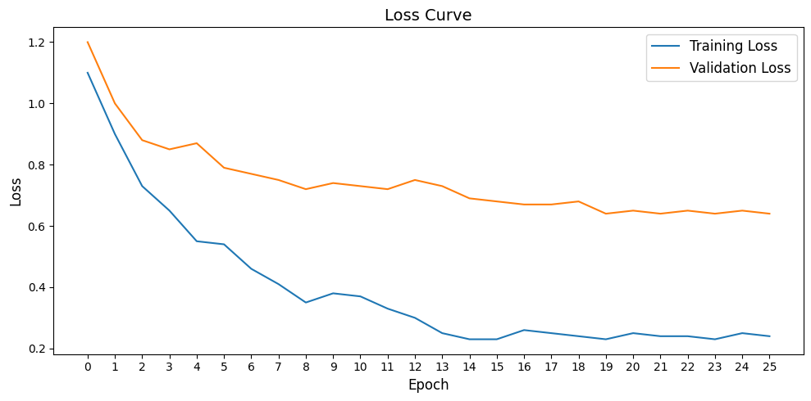
Fig. 5. SwinNet training and validation loss curves over epochs.

For preprocessing, images are converted to RGB format and resized to 224 pixels. Training data is augmented using RandomHorizontalFlip, RandomRotation, RandomResizedCrop, and ColorJitter for improved robustness. Both training and validation images are normalized with 0.5 mean and standard deviation in all three channels. This is a standard swin transformer with a patch size 4, embedding dimension 96, attention block 2, attention heads 4 and a window size 7. Model is optimized using Adam optimizer with learning rate 0.0001 and weight decay 1e-3. ReduceLROnPlateau learning rate scheduler is employed to adjust learning rate based on validation loss and a WeightedRandomSampler is used to address class imbalance in training data. This configuration achieved a training F1 score of 0.68 and a validation F1 score of 0.53.
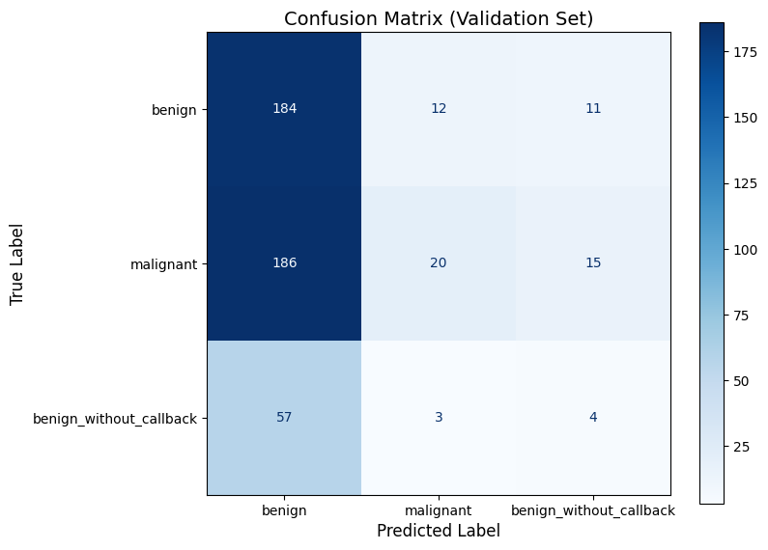
Fig. 7. Confusion matrix of SwinNet model predictions versus ground truth for benign and malignant mammogram classification.

- Statistical Testing
To compare ResNet50 and SwinNet, paired t-test and Wilcoxon test are applied to their 5-fold cross-validation F1 scores. The paired t-test (t = –0.45, p = 0.68) and the Wilcoxon test (W = 6, p = 0.81) both demonstrate no statistically significant difference at α = 0.05. Therefore, since ResNet50 has less complex architecture compared to SwinNet, and still matches with SwinNet’s performance, ResNet50 may be preferable.
5. DISCUSSION
Among the four models tested, SwinNet and ResNet50 delivered better results in terms of validation F1 score, indicating strong generalization abilities on mammography images among the evaluated models. ResNet50 demonstrated the best overall performance, particularly in Configuration 1, where the entire model was fine-tuned and trained with class-weighted cross-entropy loss. Freezing the early layers in Configuration 2 reduced the performance, showing that low-level convolutional filters must adapt to the domain-specific features of mammography. Introducing SE attention and focal loss in Configuration 3 offered improvement, but the model still misclassified many malignant and benign-without-callback cases as benign.

SwinNet, using a transformer-based attention, achieved a validation F1 of 0.53, and showed a better balance between precision and recall than CNN and UNet. However, a large gap between training and validation scores suggest overfitting, possibly due to the model’s high capacity relative to the dataset size.

UNet, despite using deep encoder and class-balancing techniques, underperformed with a validation F1 score peaking at 0.48.

SimpleCNN served as a baseline and achieved the lowest performance, with a validation F1 around 0.37. Attempts to improve the model with attention layers resulted in performance decrease, suggesting that lightweight architectures struggle to learn meaningful patterns from complex mammographic images.

6. CONCLUSION
This project studied application of deep learning models for classification of breast lesions in mammography images. SwinNet and ResNet50 demonstrated the highest scores both in achieving validation F1 scores above 0.5 among other tested architectures. At the same time simpler models like CNN and UNet fell short especially in handling complex patterns and class imbalance in mammography images. One of the limitations in this study is the imbalance of used dataset. It is very likely to impact generalization for underrepresented classes. Additionally, the models were trained and evaluated on a limited number of folds due to computational constraints.
7. REFERENCE
[1] L. Tsochatzidis, L. Costaridou, and I. Pratikakis, “Deep Learning for Breast Cancer Diagnosis from Mammograms—A Comparative Study,” Journal of Imaging, vol. 5, no. 3, p. 37, 2019, doi: 10.3390/jimaging5030037

[2] DatasetNinja, “CBIS-DDSM: Curated Breast Imaging Subset of DDSM,” [Online]. Available: https://datasetninja.com/cbis-ddsm#introduction. [Accessed: Jun. 8, 2025].

[3] The Cancer Imaging Archive, “Curated Breast Imaging Subset of DDSM (CBIS-DDSM),” [Online]. Available:https://www.cancerimagingarchive.net/collection/cbis-ddsm/. [Accessed: Jun. 8, 2025].

