**GeMS: A generalized management strategy evaluation framework for fisheries**

**Main Message:** GeMS is a general simulation framework that can evaluate the performance of fisheries management strategies under a range of underlying population dynamics.

**Abstract**

Generalized Management Strategy Evaluation (GeMS) provides a flexible simulation platform to quantitatively answer questions in fisheries management while incorporating the uncertainty of the management process itself. GeMS uses a two-box, age- and length-structured operating model in which time-variation in all population processes is possible. Time-variation in simulated population processes allows the evaluation of the impact of environmental change, shifts in species distribution, and changes exploitation patterns on management. Time-variation in many population processes can have dramatic impacts on sustainable yields, but this variability is often not incorporated into management. Here, we demonstrate the current capabilities of the GeMS framework using two examples. We conclude by discussing potential uses for GeMS and how it complements the existing tools used for management strategy evaluations.

**Introduction**

One of the main goals of natural resource management is to ensure the sustainable exploitation of a resource, with clearly described trade-offs and acceptable outcomes to all stakeholders. Effectively managing an exploited population requires an understanding of the way a population will respond to changes in exploitation. This can be a difficult task because of the uncertainties inherent in the understanding of an exploited population’s dynamics and implementation of management. In recent years, management strategy evaluation (MSE; (1)) has been proposed as the gold standard for the testing of management strategies under uncertainty (2–4). MSE is a process of creating simulated fisheries (the ‘operating model’) and testing different assessment tools (the ‘estimation model’) and harvest control rules to evaluate their performance in metrics like long term yield, variability in yield, and probability of overfishing (4–6). In doing so, it allows for quantitatively comparing the performance of a suite of management strategies given some assumed underlying dynamics.

MSE has been used for many fisheries around the globe to compare and select management strategies. MSE was pioneered by de la Mare (7) for the International Whaling Commission, and more recently, and has been used for Japanese sardine (*Sardinops melanostictus*; (8)), US west coast flatfish and groundfish (9), and Australian fisheries ((10); see (3) for more examples). The development of “case-specific” procedures is recommended over “generic” ones (11), yet the authors also acknowledged that a major hurdle to conducting MSEs is a general lack of modelling skills and of software packages that can implement “generalized” operating models. In response, an open-source generic MSE framework, Fisheries Library for R (FLR; (12)), was developed to allow scientists to conduct MSEs. FLR is a comprehensive package in which the analyst can specify many details of the operating model to directly match a given assessment, as a result the learning curve can be steep.

MSE starts with an operating model—a simulation of the underlying dynamics of the focus system. Operating models can take on a “hypothesis-oriented approach” (6,13), where alternative operating models incorporating expert beliefs and different assumptions about population drivers are evaluated. For example, ecological processes are known to vary over time due to external factors such as climate change (14), fishing behavior (15), or regime shifts (16,17), and these processes will likely continue to fluctuate in the future. However, parameters in assessment models used in management (such as natural mortality *M* and growth parameters *Κ* and *L∞*) are often either fixed or estimated as time-invariant despite evidence to the contrary (18,19). Furthermore, not considering temporal variation in creating harvest control rules could potentially result in failed management of the stock (8,20). Concurrently, the effects of temporal variation on management vary (see (5,21) for studies on walleye pollock *Theragra chalcogramma*), and a mechanistic understanding of how a population fluctuates over time is often unavailable (22). As such, management strategies robust to fluctuations in the dynamics of the population are desirable (6,23,24). Management strategy evaluation can be used to evaluate the performance of management strategies under changes in ecological processes by using several operating models as hypothetical realities in which strategies can be tested.

Time-variation in population processes is likely to be a wide-spread (and increasingly prevalent; (25)) problem in fisheries management. The true impact of time-varying processes on a population remains unknown, but simulation allows managers to evaluate management alternatives over different projected ‘states of nature’. MSEs conducted on walleye pollock evaluated the performance of management strategies under scenarios of climate change (5,26). These studies found that under changing environmental conditions, keeping the management strategy at status quo had a high probability of resulting in an overfished stock. In the Bering Sea, status quo harvest control rules for snow crab (*Chionoecetes opilio*) were found to result in the stock being potentially falsely declared overfished due to regime shifts in the system dynamics (24). Based on these studies, it is clear that management strategies robust to temporal variation are important for the sustainable management of fisheries. Spatial variation can also play an important role in determining appropriate management strategies. For example, managing three subpopulations as a single unit was likely to result in overexploitation at a local level for small yellow croaker (*Larimichthys polyactis*; (27)). These case-specific evaluations in systems that are often data-rich represent significant investment of time and resources that may not be possible in many fishery systems across the world.

Here we present a Generalized Management Strategy Evaluation framework (GeMS) that allows for the testing of management strategy performance over a range of scenarios with minimal time invested. GeMS allows for time-variation in every population process in the operating model, and also can accommodate movement between two spatially-distinct populations. GeMS only requires inputs of life history parameters to begin an MSE, but time series of historical fishing effort and recruitment from an existing stock assessment can also be incorporated. With these relatively simple inputs, fisheries managers can quickly begin the process of a ‘generalized’ management strategy evaluation. This may help stakeholders to make a decision on whether effort and resources should be invested in a more exhaustive MSE for their system (e.g. using FLR or a custom-built simulation framework). GeMS is written in R (28) and Auto Differential Model Builder (ADMB; (29)), two open-source tools, in the hope of ensuring ease of use, reproducibility, and transparency (12,30).

**Framework**

*General Overview*

MSE is accomplished by simulating populations with characteristics similar to the target population, drawing data with error from the simulated populations required to assess the stock using a given management strategy, applying an assessment method to estimate quantities used in management (e.g. the current biomass and biological reference points), and finally using a specified harvest control rule to determine the allowable catches in a given year (Fig. 1). The calculated allowable catches are removed from the simulated population and process is repeated into the ‘future’ to mimic the feedback that occurs in the management of an actual fishery (3–5). GeMS uses this general framework, broken into three components:

1. Operating model: The operating model for GeMS is a two-area, age- and length-structured population dynamics model with capacity for time-varying parameters in all population and management processes.
2. Estimation model: Currently, two estimation models exist: a Schaeffer model, and an age- and length-structured model with the capacity to allow growth, natural mortality, and selectivity to vary over time.
3. Harvest control rule (HCR): Currently, available HCRs are a fixed exploitation rate, a fixed catch, and a sloped control rule based on proxies of target biomasses and fishing mortalities.

A full description of the equations defining each component can be found in the appendix.

*Basic steps to GeMS*

The package can be installed from Github at <https://github.com/szuwalski/GeMS>. After it is downloaded, all that is needed to begin an MSE is a control file. The control file dictates the entire MSE process and includes parameters of the operating model, the properties of the estimation model, and the type of HCR that should be applied. GeMS comes with a master control file (Master_CTL.csv) to serve as a template, as well as several examples based on a cod-like stock (31). A full description of all parameters in the control file can be found on the Wiki for the Github repository containing GeMS. A function call run_GeMS() initiates the MSE, and produces basic diagnostics and output, which can then be analyzed by the user according to their needs.

*Example 1: Performance of a production model*

The surplus production model (32) is one of the simplest models of fish population dynamics, only considering changes in exploitable biomass of the fishable stock (33). Written in the Schaefer form (34), this model is computationally simple, and requires few data sources (only catch and an index of relative abundance) to compute management reference points (BMSY and FMSY). However, the model also makes assumptions that may over-simplify population characteristics, such as assuming all individuals are identical within a population, which might result in inappropriate management advice.

An example MSE that examines the management performance of a surplus production model for a population with cod-like characteristics with three different levels of productivity (as seen through the ‘steepness’ parameter of the stock-recruit relationship) is included in the folder ‘inst/extdata/Cod_1_Production’ of the GeMS Github repository. A production model was selected in the control file for each scenario (i.e. in “Cod_Base_CTL.csv”, “Cod_HighProd_CTL.csv”, and “Cod_LowProd_CTL.csv”) as the desired assessment method and the MSE was executed by running code similar to this R code:

library(GeMS)

CurrentDirectory<-“C:/GeMS/MyDir”

OMNames <-c(“Cod_Base_CTL”, “Cod_HighProd_CTL”, “Cod_LowProd_CTL”)

run_GeMS(MSEdir=CurrentDirectory,CTLNameList=OMNames)

In this example, production models underestimate the fishing mortality that would produce maximum sustainable yield (Fig 2). Consequently, the stock is underexploited (Fig. 3). The extent to which the optimal catches are underestimated declines as the productivity of the stock decreases. Figures 2 and 3 were produced from the output of the function “ProductionModelOutput()”, which writes figures in .PNG format to a folder named ‘Plots’ in the working directory. A figure that displays the life history of a given control file is also written to ‘Plots’ (e.g. Fig. 4). A walkthrough of how to manipulate steepness to explore changes in management performance can be found in the Wiki. This simple example illustrates how to evaluate the impact of an estimation model on management performance by changing one parameter at a time in the underlying population dynamics and comparing results. With this information, an investigator will have a better understanding of the circumstances under which a particular estimation model would provide appropriate estimates of management-related quantities and can focus research priorities and data collection endeavors. Production models did not provide unbiased management advice for these scenarios, but age-structured models may provide better estimates.

*Example 2: Retrospective patterns in age-structured models*

Age-structured integrated assessment models, the general form of which (35) includes variables such has natural mortality rates, vulnerability to fishing, and stock-recruitment relationships (36). Integrated analysis models combine a variety of data sources into a single analysis (37,38), and provide advice on stock status and management quantities (39). These assessment models often estimate management quantities better than other types of models (40–42).

However, time-variation in population processes can hamper the ability of assessments to estimate quantities important in management without bias (20,43,44). Retrospective patterns are defined as systematic biases in estimates of derived quantities from a model, given increasing years of data (45). When retrospective patterns are strong, perhaps due to a misspecified stock assessment model, the model could be rendered unsuitable for management purposes (31). For example, a Pacific halibut (*Hippoglossus stenolepis*) stock assessment was found to have consistently overestimated biomass and underestimated harvest rates (46,47). This resulted in inappropriate harvest strategies being set for managing the stock (47). One of the ways in which this could be mitigated is by allowing a process (such as growth, natural mortality, or selectivity) to vary over the time, even if the “true” time-varying process is unknown (44). However, reducing retrospective patterns does not necessarily translate to unbiased management reference points, and GeMS can be used to investigate such a question.

GeMS can simulate circumstances that give rise to retrospective biases by allowing time-variation in population processes like growth, natural mortality, and selectivity in the operating model. Using the cod-like population again as an example, we present an example MSE with three scenarios. The first scenario applied the age-structured assessment method to data drawn from an operating model in which the assumptions of the assessment matched the operating model’s dynamics. The second and third scenarios were run with control files in which the parameter governing natural mortality in the operating model (“NatMn”) was input as a vector, with a sudden change of the parameter value in the middle of the time series. The performance of an assessment method in which natural mortality varied was then compared to an assessment in which natural mortality was static. The 10 replicates of the MSE was conducted for each scenario, and each replicate was projected 20 years, beginning with 50 years of historical data for assessment. GeMS can be ran in parallel for larger jobs by changing a few optional switches in ‘run_GeMS’ (see code below. The example files can be found in the folder ‘inst/extdata/Cod_5_AgeStructure’ of the Github repository.

run_GeMS(CurDir = CurrentDirectory, # directory in which the control files reside

CreateFolderNameList = OMNames, # list of control files

runparallel = T, # this tells GeMS to use parallel processing

cores = 2, # this tells GeMS to use 2 cores in parallel

GeMSops = list(silent=T, # this tells GeMS to not output progress

ADoptions = “-gbs 2000000000” # memory management))

First and foremost, the scenario in which the assumptions in the assessment matched the operating model dynamics returned unbiased estimates of quantities used in management (Fig. 5). This sets an important benchmark and verifies that the structure of the assessment method is correct. However, when applying the same assessment method to data drawn from the operating model in which natural mortality varied over time, retrospective patterns and biased management quantities resulted (as expected, Fig. 5). Retrospective patterns and biases (to some extent) were corrected in the assessment in which natural mortality was allowed to vary (Fig. 5). The way in which the time-invariant assessment methods ‘accommodate’ time-variation can be seen by the plots of estimated population process (Fig. 6). In this case, the assessment method in which natural mortality was fixed ‘accommodated’ variation in natural mortality by negative biases in recruitment before the change in M, positive biases in estimated F, and negative biases in fishery selectivity (44).

**Discussion**

GeMS provides a simple method to quickly and quantitatively evaluate the performance of management strategies under different states of nature. It allows for variation in all processes in the operating model and providing the option of spatial dynamics, both of which will likely be important considerations under a changing climate. GeMS is not meant as a replacement for stock assessment and will not be able to capture all the idiosyncrasies of existing assessments. Therefore, GeMS is meant as a starting point for stakeholders to assess their needs for a more comprehensive MSE using other software such as FLR (12) or writing their own framework. It can also be used to ask more fundamental questions about stock assessment performance over a range of life histories, estimation models, and harvest control rules. In addition to the questions described above, GeMS could help to answer questions including (but not limited to) the following:

* What is the value of improved assessment methods or data for assessment?
* How would implementing an MPA or changing gear types impact maximum sustainable yield?
* How does the performance of a management strategy using a production model change (in terms of long term yield) under scenarios in which climate change influences somatic growth?
* How does movement between two populations impact the performance of age-structured assessment methods?
* How would changes in species interactions (via range shifts, for example) influence the potential yield of a given species?

The code for GeMS is open source and published on Github so that users can provide feedback continuously, and an open dialogue between the developers and the users can be established. We hope that GeMS can efficiently evolve to meet additional needs and improve its capabilities through a transparent development and feedback process. Additional examples and information can be found in the GeMS Github repository and associated Wiki.

**Acknowledgements**

We would like to thank the Packard Foundation (Grant #2016-64741) and researchers in the Sustainable Fisheries Group at the University of California, Santa Barbara for help in beta testing.

**References**

1. Smith ADM. Management strategy evaluation – the light on the hill. In: Hancock DA, editor. Population dynamics for fisheries management: Australian Society for Fish Biology Workshop proceedings, Perth, 24-25 August 1993. Perth, Western Australia: Australian Society for Fish Biology; 1994. p. 249–53.

2. Punt AE. Refocusing Stock Assessment in Support of Policy Evaluation. In: Tsukamoto K, Kawamura T, Takeuchi T, Beard Jr TD, Kaiser MJ, editors. Fisheries for Global Welfare and Environment: Memorial Book of the 5th World Fisheries Congress 2008 [Internet]. 2008 [cited 2017 May 14]. p. 139–52. Available from: https://www.terrapub.co.jp/onlineproceedings/fs/wfc2008/pdf/wfcbk_139.pdf

3. Punt AE, Butterworth DS, de Moor CL, De Oliveira JAA, Haddon M. Management strategy evaluation: best practices. Fish Fish. 2016 Jun 1;17(2):303–34.

4. Rademeyer RA, Plagányi ÉE, Butterworth DS. Tips and tricks in designing management procedures. ICES J Mar Sci. 2007 May 1;64(4):618–25.

5. A’mar ZT, Punt AE, Dorn MW. The evaluation of two management strategies for the Gulf of Alaska walleye pollock fishery under climate change. ICES J Mar Sci J Cons. 2009 Aug 1;66(7):1614–32.

6. Punt AE, A’mar T, Bond NA, Butterworth DS, de Moor CL, De Oliveira JAA, et al. Fisheries management under climate and environmental uncertainty: control rules and performance simulation. ICES J Mar Sci J Cons. 2014 Oct 1;71(8):2208–20.

7. de la Mare WK. Simulation Studies on Management Procedures. Rep Int Whal Comm. 1986;36:429–50.

8. Hurtado-Ferro F, Hiramatsu K, Shirakihara K. Allowing for environmental effects in a management strategy evaluation for Japanese sardine. ICES J Mar Sci. 2010 Dec 1;67(9):2012–7.

9. Wetzel CR, Punt AE. Model performance for the determination of appropriate harvest levels in the case of data-poor stocks. Fish Res. 2011 Jul 1;110(2):342–55.

10. Smith ADM, Smith DC, Haddon M, Knuckey IA, Sainsbury KJ, Sloan SR. Implementing harvest strategies in Australia: 5 years on. ICES J Mar Sci. 2014 Jan 1;71(2):195–203.

11. Butterworth DS, Punt AE. Experiences in the evaluation and implementation of management procedures. ICES J Mar Sci. 1999 Dec 1;56(6):985–98.

12. Kell LT, Mosqueira I, Grosjean P, Fromentin J-M, Garcia D, Hillary R, et al. FLR: an open-source framework for the evaluation and development of management strategies. ICES J Mar Sci. 2007 May 1;64(4):640–6.

13. Kell LT, De Oliveira JAA, Punt AE, McAllister MK, Kuikka S. Operational management procedures: an introduction to the use of management strategy evaluation frameworks. In: The Knowledge Base for Fisheries Management. 1st ed. Amsterdam: Elsevier; 2006. p. 379–407. (Developments in Aquaculture and FIsheries Science; vol. 36).

14. Hollowed AB, Barange M, Beamish RJ, Brander K, Cochrane K, Drinkwater K, et al. Projected impacts of climate change on marine fish and fisheries. ICES J Mar Sci. 2013 Sep 1;70(5):1023–37.

15. Szuwalski CS, Burgess MG, Costello C, Gaines SD. High fishery catches through trophic cascades in China. Proc Natl Acad Sci. 2017 Jan 24;114(4):717–21.

16. Conners ME, Hollowed AB, Brown E. Retrospective analysis of Bering Sea bottom trawl surveys: regime shift and ecosystem reorganization. Prog Oceanogr. 2002 Oct 1;55(1):209–22.

17. Szuwalski CS, Punt AE. Regime shifts and recruitment dynamics of snow crab, Chionoecetes opilio, in the eastern Bering Sea. Fish Oceanogr. 2013 Sep 1;22(5):345–54.

18. Thorson JT, Hicks AC, Methot RD. Random effect estimation of time-varying factors in Stock Synthesis. ICES J Mar Sci J Cons. 2015 Jan 1;72(1):178–85.

19. Webber DN, Thorson JT. Variation in growth among individuals and over time: A case study and simulation experiment involving tagged Antarctic toothfish. Fish Res. 2016 Aug;180:67–76.

20. Lee Q, Thorson JT, Gertseva VV, Punt AE. The benefits and risks of incorporating climate-driven growth variation into stock assessment models, with application to Splitnose Rockfish (Sebastes diploproa). ICES J Mar Sci [Internet]. 2017 Aug 22 [cited 2017 Oct 4]; Available from: https://academic.oup.com/icesjms/article/doi/10.1093/icesjms/fsx147/4091482/The-benefits-and-risks-of-incorporating-climate

21. Mueter FJ, Bond NA, Ianelli JN, Hollowed AB. Expected declines in recruitment of walleye pollock (Theragra chalcogramma) in the eastern Bering Sea under future climate change. ICES J Mar Sci. 2011 Jul 1;68(6):1284–96.

22. Thorson JT. Spatio-temporal variation in fish condition is not consistently explained by density, temperature, or season for California Current groundfishes. Mar Ecol Prog Ser. 2015;526:101–112.

23. Holt CA, Punt AE. Incorporating climate information into rebuilding plans for overfished groundfish species of the U.S. west coast. Fish Res. 2009 Sep;100(1):57–67.

24. Szuwalski CS, Punt AE. Fisheries management for regime-based ecosystems: a management strategy evaluation for the snow crab fishery in the eastern Bering Sea. ICES J Mar Sci. 2013 Sep 1;70(5):955–67.

25. Szuwalski CS, Hollowed AB. Climate change and non-stationary population processes in fisheries management. ICES J Mar Sci. 2016 May 1;73(5):1297–305.

26. Ianelli JN, Hollowed AB, Haynie AC, Mueter FJ, Bond NA. Evaluating management strategies for eastern Bering Sea walleye pollock (Theragra chalcogramma) in a changing environment. ICES J Mar Sci J Cons. 2011 Jul 1;68(6):1297–304.

27. Ying Y, Chen Y, Lin L, Gao T. Risks of ignoring fish population spatial structure in fisheries management. Can J Fish Aquat Sci. 2011 Nov 25;68(12):2101–20.

28. R Core Team. R: A language and environment for statistical computing. [Internet]. Vienna, Austria: R Foundation for Statistical Computing; 2017. Available from: https://www.R-project.org/

29. Fournier DA, Skaug HJ, Ancheta J, Ianelli J, Magnusson A, Maunder MN, et al. AD Model Builder: using automatic differentiation for statistical inference of highly parameterized complex nonlinear models. Optim Methods Softw. 2012 Apr 1;27(2):233–49.

30. Anderson SC, Monnahan CC, Johnson KF, Ono K, Valero JL. ss3sim: An R Package for Fisheries Stock Assessment Simulation with Stock Synthesis. PLOS ONE. 2014 Apr 3;9(4):e92725.

31. Hurtado-Ferro F, Szuwalski CS, Valero JL, Anderson SC, Cunningham CJ, Johnson KF, et al. Looking in the rear-view mirror: bias and retrospective patterns in integrated, age-structured stock assessment models. ICES J Mar Sci. 2015 Jan 1;72(1):99–110.

32. Ricker WE. Computation and Interpretation of Biological Statistics of Fish Populations. Bull Fish Res Board Can. 1975;191:382.

33. Polacheck T, Hilborn R, Punt AE. Fitting Surplus Production Models: Comparing Methods and Measuring Uncertainty. Can J Fish Aquat Sci. 1993 Dec 1;50(12):2597–607.

34. Schaefer MB. Some aspects of the dynamics of populations important to the management of the commercial marine fisheries. Inter-Am Trop Tuna Comm Bull. 1954;1(2):23–56.

35. Walters CJ. A Generalized Computer Simulation Model for Fish Population Studies. Trans Am Fish Soc. 1969 Jul 1;98(3):505–12.

36. Lawson TA, Hilborn R. Equilibrium Yields and Yield Isopleths from a General Age-Structured Model of Harvested Populations. Can J Fish Aquat Sci. 1985 Nov 1;42(11):1766–71.

37. Fournier D, Archibald CP. A General Theory for Analyzing Catch at Age Data. Can J Fish Aquat Sci. 1982 Aug 1;39(8):1195–207.

38. Maunder MN, Punt AE. A review of integrated analysis in fisheries stock assessment. Fish Res. 2013 May;142:61–74.

39. ICES. Report on the Classification of Stock Assessment methods developed by SISAM. 2012 p. 1–15. (ICES CM 2012/ACOM/SCICOM:01).

40. Butterworth DS, Rademeyer RA. Statistical catch-at-age analysis vs. ADAPT-VPA: the case of Gulf of Maine cod. ICES J Mar Sci. 2008 Dec 1;65(9):1717–32.

41. Punt AE, Smith ADM, Cui G. Evaluation of management tools for Australia’s South East Fishery.2. How well can management quantities be estimated? Mar Freshw Res. 2002;53(3):631–44.

42. Radomski P, Bence JR, Quinn II TJ. Comparison of virtual population analysis and statistical kill-at-age analysis for a recreational, kill-dominated fishery. Can J Fish Aquat Sci. 2005 Feb 1;62(2):436–52.

43. Johnson KF, Monnahan CC, McGilliard CR, Vert-pre KA, Anderson SC, Cunningham CJ, et al. Time-varying natural mortality in fisheries stock assessment models: identifying a default approach. ICES J Mar Sci J Cons. 2014 Apr 9;fsu055.

44. Szuwalski CS, Ianelli JN, Punt AE. Reducing retrospective patterns in stock assessment and impacts on management performance. ICES J Mar Sci [Internet]. 2017 Sep 6 [cited 2017 Sep 12]; Available from: https://academic.oup.com/icesjms/article/doi/10.1093/icesjms/fsx159/4106929/Reducing-retrospective-patterns-in-stock

45. Mohn R. The retrospective problem in sequential population analysis: An investigation using cod fishery and simulated data. ICES J Mar Sci. 1999 Aug 1;56(4):473–88.

46. Clark WG, Hare SR. Assessment of the Pacific halibut stock at the end of 2007. Int Pac Halibut Comm Rep Assess Res Act. 2008;2007:117–203.

47. Valero JL. Harvest policy considerations on retrospective bias and biomass projections. Int Pac Halibut Comm Rep Assess Res Act 2011. 2012;311–329.

**Appendix**

*Operating model*

Population dynamics model

The population dynamics model is a single-sex, age-structured model that tracked the number of individuals in an age class by year, *N*a,y, and allowed natural mortality, *M*y to vary over time.

|  |  |  |
| --- | --- | --- |
|  |  | 1 |
|  |  | 2 |
|  |  | 3 |

Mean recruitment followed a Beverton-Holt stock-recruit relationship parameterized in terms of steepness (*h*; the expected proportion of virgin recruitment entering the population when spawning biomass is 20% of virgin levels), *R*0 (virgin recruitment) and *SB*0 (virgin spawning biomass). Recruitment variation was log-normally distributed with mean 0 and standard deviation σr. Spawning biomass at year *y* (*SBy*) is a function of numbers-at-age (*Na,y*), maturity-at-age (*Mata,y*), and weight-at-age (*Wa,y*).

|  |  |  |
| --- | --- | --- |
|  |  | 4 |
|  |  | 5 |

Annual fishing mortality, *F*y, was comprised of a separable annual selectivity at length curve (logistic):

|  |  |  |
| --- | --- | --- |
|  |  |  |
|  |  | 6 |

where and determine the length *l* at which the probabilities of capture are respectively 50% and 95% in year l. Selectivity parameters were specified in the operating model in terms of length (equation 6) and converted to age conditional upon the length-at-age curve by rearranging equation 8 (which is conditional upon growth). Time variation in selectivity parameters in the operating model was specified by a vector input by the user. Maturity, *Mat*a,y, is also a logistic function of age and two estimated parameters (*P50,y* and *P95,y*, which were the year-specific ages at which the probability of maturing is 50% and 95%, respectively) and assumed constant over time:

|  |  |  |
| --- | --- | --- |
|  |  | 7 |

Length-at-age followed a growth increment von Bertalanffy form:

|  |  |  |
| --- | --- | --- |
|  |  | 8 |
|  |  | 8a |
|  |  | 8b |

where is the maximum length during year *y*, was the growth rate in year *y* and *t0* was the age corresponding to a predicted length of 0. Changes in and were specified as a vector in the operating model. Weight was a function of length:

|  |  |  |
| --- | --- | --- |
|  |  | 9 |

Conditional length-at-age for both the catch and survey were calculated from the numbers at age matrix by specifying a single standard deviation σlen and the expected length-at-age determined using equation 9. The array, *LAa,z,y* with *a* rows representing the number of age classes and *z* columns representing the number of length bins during year *y* contained the probability of an individual of age *a* being length *z* (i.e. the proportion of each age class in each length bin). Length bins were pre-specified by the user.

|  |  |  |
| --- | --- | --- |
|  |  | 10 |
|  |  | 11 |

where Binz was a vector of the midpoints of the specified length bins. Numbers at length were calculated from this matrix of (normalized) probabilities of length-at-age by multiplying each row by the number of individuals at age and then summing over rows (i.e. age).

|  |  |  |
| --- | --- | --- |
|  |  | 12 |

The weight of the catch during year *y* was calculated as:

|  |  |  |
| --- | --- | --- |
|  |  | 13 |

The survey-selected biomass at the time of the survey was calculated as:

|  |  |  |
| --- | --- | --- |
|  |  | 14 |

where was the survey selectivity defined as:

|  |  |  |
| --- | --- | --- |
|  |  | 15 |

As with fishery selectivity, the parameters associated with survey selectivity (and , the length at which the probability of being selected in the fishery is 50% and 95%, respectively) were specified according to length and then transformed to age within the operating model conditional upon growth.

*Data simulation*

Catch biomass, catch length frequencies, fishery-independent survey indices of abundance and survey length frequencies were generated using the operating model with error to be used in the estimation models for each year in the simulation. Observed catch biomass and survey biomass were modeled as:

|  |  |  |
| --- | --- | --- |
|  |  | 17 |
|  |  | 18 |

where εyis a normally distributed random variable with a mean of 0 and a user-specified standard deviation σε. Observed length frequencies for both the catch and the survey are generated by sampling the true numbers at length calculated above using the ‘sample’ function in R a specified number of times.

*Estimation model*

The equations governing the population dynamics within the estimation model matched those of the operating model, with a several of exceptions. Table 1 lists the estimable parameters of the assessment method. The estimation model only has the capacity to allow the parameters related to the population processes of growth, fisheries selectivity, or natural mortality to vary over time. When one of these processes was allowed to vary over time in the estimation model, annual deviations from the mean were modeled as fixed-effects parameters with specified penalties similar to the way in which recruitment and fishing mortality are modeled (see ‘likelihood components’ below). For example, average recruitment (μR) within the assessment method was estimated with annual deviations (Rdev,y); eq. 19).

|  |  |  |
| --- | --- | --- |
|  |  | 19 |

In a similar manner, fishery selectivity at age can be estimated within the assessment as deviations around a mean.

|  |  |
| --- | --- |
|  | 20 |

*Likelihood components*

The assessment method was fit to the data generated from the operating model based on four likelihood components. The log-likelihoods (ignoring constants) for catch and the survey index of abundance were log-normal:

|  |  |  |
| --- | --- | --- |
|  |  | 20 |
|  |  | 21 |

Catch and survey length frequencies were fit under the assumption of multinomial sampling:

|  |  |  |
| --- | --- | --- |
|  |  | 22 |
|  |  | 23 |

where was the observed proportion at length of the catch in year *y*, was the predicted proportion at length in year *y* of the catch, was the observed proportion at length of the survey biomass in year *y*, and was the predicted proportion at length of the survey biomass in year *y*. The data were weighted with the same CVs and sample sizes with which they were generated (Table 1). Small penalties were added to the objective function to ensure the smoothness of estimated recruitment, fishing mortality, time-varying natural mortality, time-varying selectivity, and time-varying growth in the form of:

|  |  |  |
| --- | --- | --- |
|  |  | 24 |

where is the vector of the deviations associated with recruitment, fishing mortality, natural mortality, selectivity and/or growth and γx is the weight applied to each likelihood component (specified as a CV of ~0.41 for all quantities because it produced estimates that were not overly variable, but still contributed little to the objective function).

*Harvest control rules*

Management targets are needed to parameterized harvest control rules to determine catches in the projections. Fitting stock recruit curves automatically can be difficult because some tuning is often required. Consequently, proxies for reference points were used instead where the biomass at which maximum sustainable yield occurs (*B*MSY) and the fishing mortality that produces that biomass at equilibrium (*F*MSY) were based on spawning-biomass-per-recruit methods (e.g. Clark, 1991; NPFMC, 2007). *F*35%, or the fishing mortality that reduces spawning biomass per recruit (SBPR) to 35% of virgin levels is used as a target fishing mortality for Alaskan fisheries (NPFMC, 2007). *B*35% was calculated as the SBPR corresponding to *F*35% multiplied by an average recruitment calculated from the entire time series of estimated recruitments. Calculated values of *F*35% and *B*35% were used in conjunction with a control rule to adjust the proportion of *F*35% that was applied to the population based on the status of the population relative to *B*35%. The fishing mortality derived from equation 24 was deemed the fishing mortality corresponding to the TAC (which coincides with the OFL), the *F*OFL, and was applied to the population to find the TAC using equation 14.

|  |  |  |  |
| --- | --- | --- | --- |
|  |  | | 25 |
| Where, | |  | |
|  | | The currently estimated mature biomass in the projected year for TAC determination | |
|  | | Mature biomass resulting from fishing at | |
|  | | Fishing mortality that reduces the mature biomass per recruit to 35% of the unfished level | |
|  | | Determines the slope of the descending limb of the control rule (specified as 0.25 here) | |
|  | | Fraction of *B*35% below which fishing mortality is zero (specified as 0.05 here) | |

Other simple harvest control rules are available, including a constant catch, a constant fishing mortality, and applying the ‘true’ FMSY, which is calculated by a grid search over fishing mortalities within the operating model.

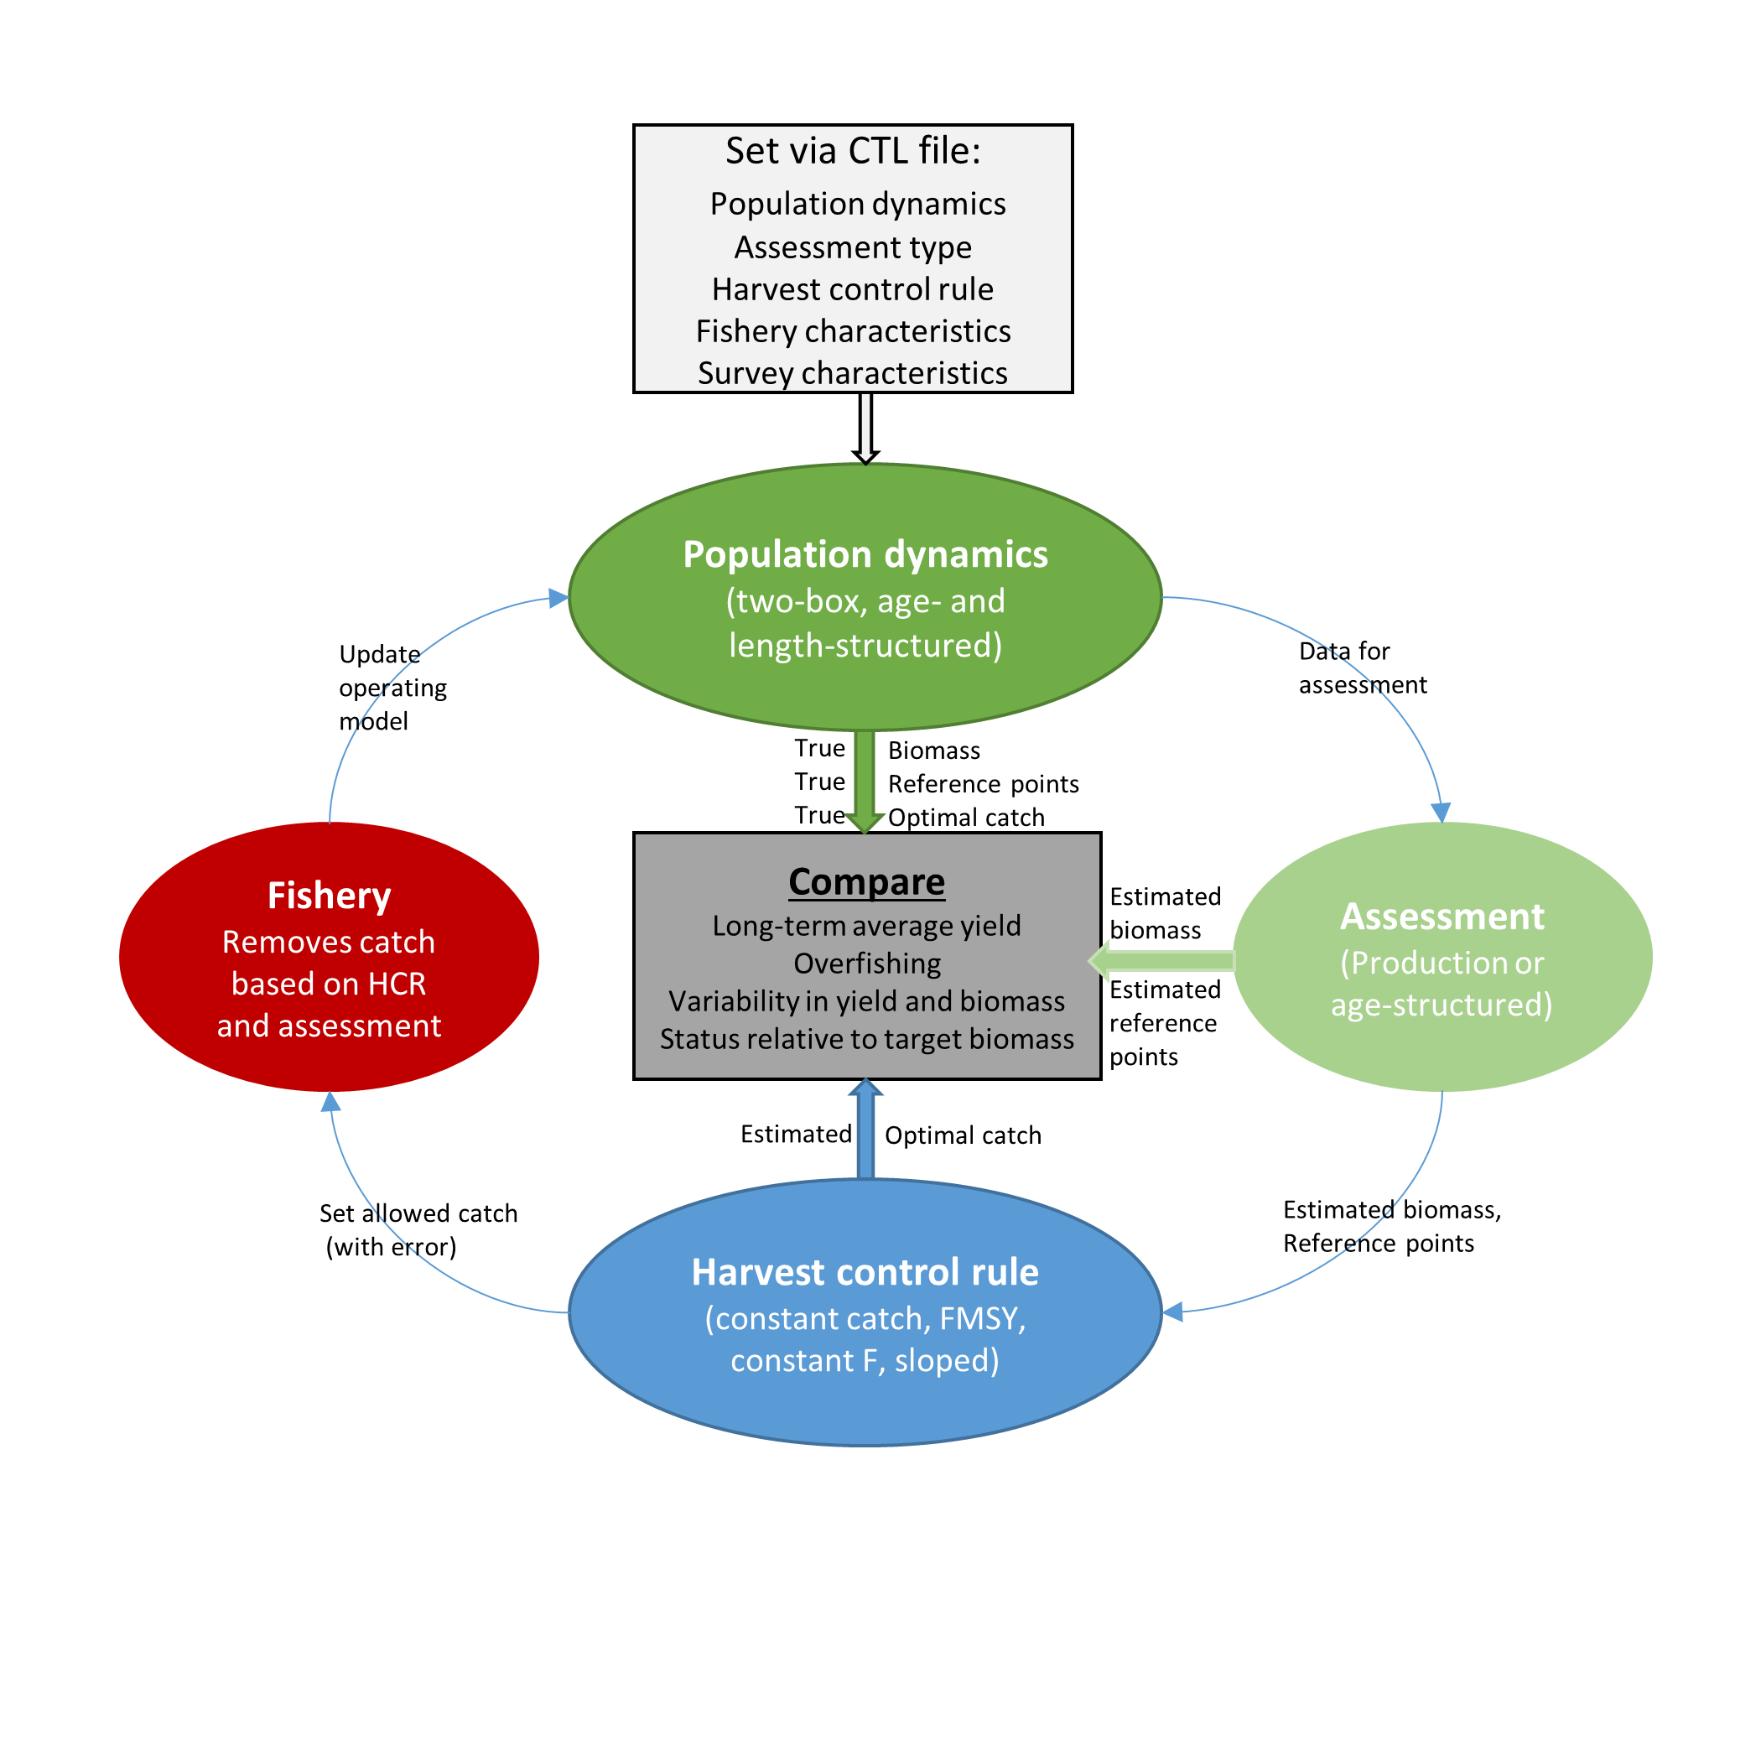

Figure 1. Flow chart representing the flow of information through a management strategy evaluation in GeMS.

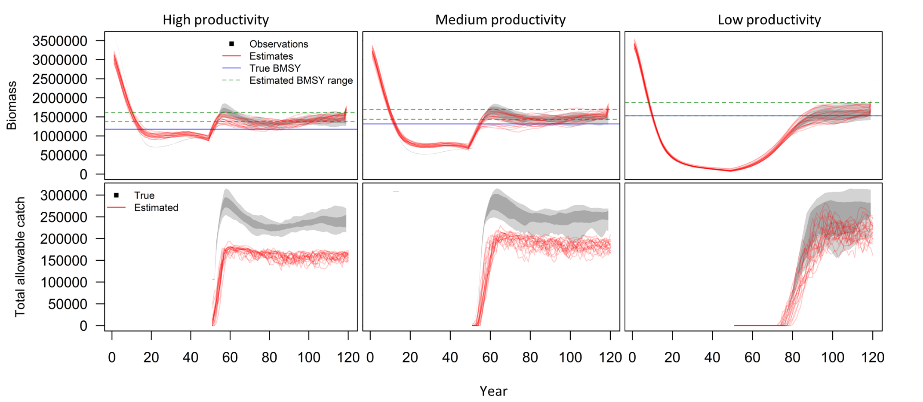

Figure 2. A comparison of the fits to biomass and estimated catch recommendations from a production model applied to simulated populations with high, medium, and low productivity (i.e. steepness equals 0.8, 0.65, 0.4 in the stock recruit relationship).

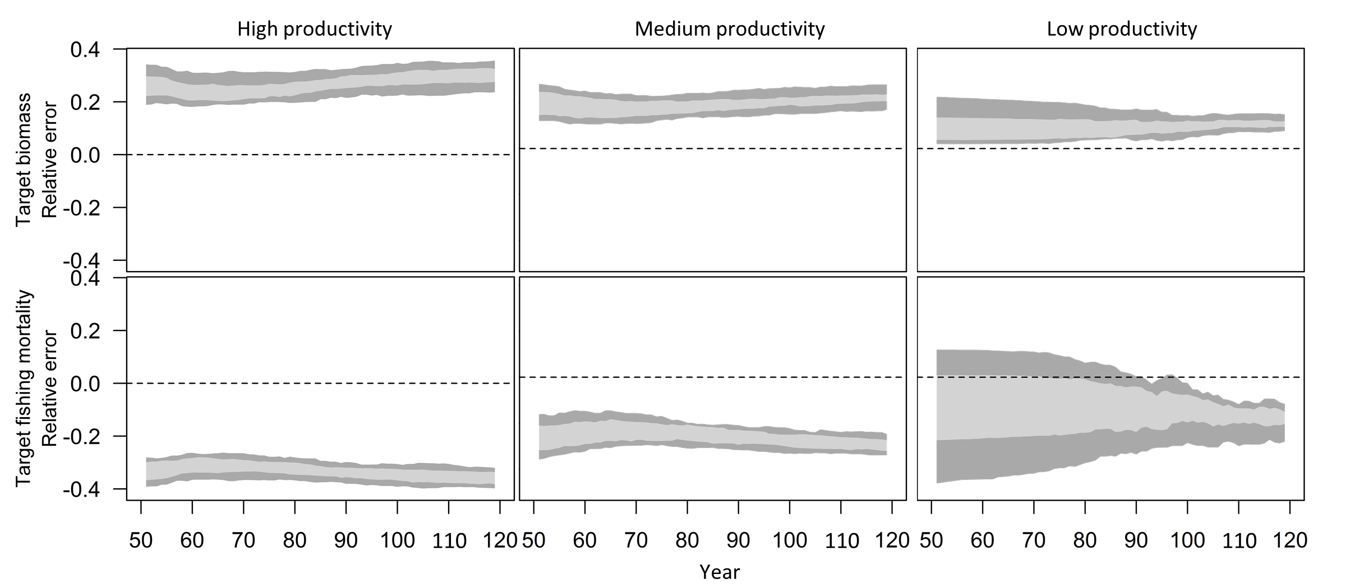

Figure 3. Relative error in estimated target biomasses and target fishing mortalities in each year of the projection period from a production model applied to simulated populations with high, medium, and low productivity (i.e. steepness equals 0.8, 0.65, 0.4 in the stock recruit relationship).



Figure 4. Standard output describing the life history processes in the operating model. In this case, only natural mortality varies over time, but all processes have the capacity to change.

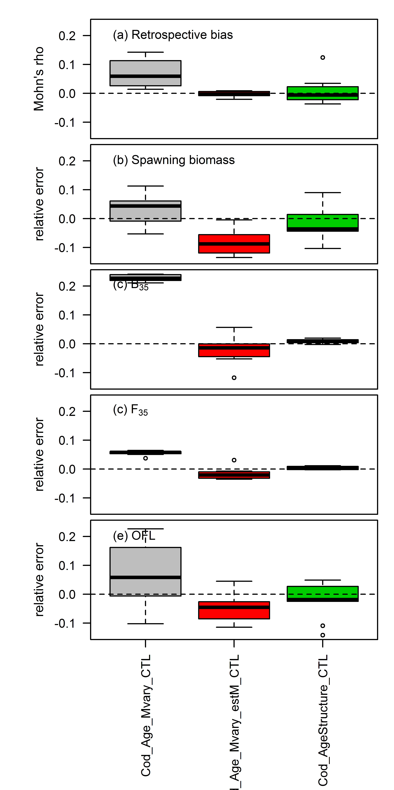

Figure 5. A comparison of the estimated management quantities from age-structured assessment methods. “Cod_Age_Mvary_CTL” is an assessment method that fixes natural mortality at a single value applied to an operating model in which natural mortality varies over time. “Cod_Age_Mvary_estM_CTL” is an assessment method that estimates a time-varying natural mortality applied to an operating model in which natural mortality varies over time. “Cod_AgeStructure_CTL” is an assessment method that fixes natural mortality at a single value applied to an operating model in which natural mortality is constant over time.



Figure 6. A comparison of the estimated population processes from 2 age-structured assessment methods applied to an operating model in which natural mortality varies over time. “Cod_Age_Mvary_CTL” is an assessment method that fixes natural mortality at a single value; “Cod_Age_Mvary_estM_CTL” is an assessment method that estimates a time-varying natural mortality.