**Spatio-Temporal Models of Intermediate Complexity for Ecosystem Assessments: a new tool for spatial fisheries management**

James T. Thorson1*, Grant Adams2, Kirstin Holsman3

1 Habitat and Ecosystem Process Research program, Alaska Fisheries Science Center, NMFS, NOAA, Seattle, WA, USA

2 School of Aquatic and Fisheries Sciences, University of Washington, Seattle, WA, USA

3 Resource Ecology and Fisheries Management program, Alaska Fisheries Science Center, NMFS, NOAA, Seattle, WA, USA

* Corresponding author

[James.Thorson@noaa.gov](mailto:James.Thorson@noaa.gov)

Target journal: Fish and Fisheries

Keywords: spatio-temporal model; VAST; ecosystem model; models of intermediate complexity for ecosystem assessments; MICE; essential fish habitat

**Table of contents**:

1. Introduction
2. Methods
   1. Model development
   2. Parameter estimation
   3. Case study application
   4. Simulation experiment
3. Results
4. Discussion
   1. Projecting climate impacts
   2. Optimizing survey designs
   3. Designation of essential fish habitat
   4. Multi-model inference regarding status and productivity
   5. Future research
5. Acknowledgements

**Abstract**

Multispecies models are widely used to evaluate and interpret trade-offs in fisheries management arising from species interactions, and are increasingly being developed to provide scientific advice to inform annual management changes. However, identifying climate impacts and sensitive habitats requires integrating spatial heterogeneity and localized environmental impacts into multispecies models. We therefore develop a spatio-temporal model of intermediate complexity for ecosystem assessments (called a “MICE-in-space”), which is fitted to samples from a bottom trawl survey and a time-series of fishing mortality records for multiple species using maximum likelihood techniques. The model is implemented using new extensions to an existing R package *VAST*, and its complexity can scale from purely descriptive (an index standardization model with no temporal dynamics) through stacked single-species models (independent dynamics for each species) to a multi-species model (one or more ratio-dependent interactions among species). We demonstrate this model using data for four commercially important groundfishes in the Gulf of Alaska using data 1982-2015. Model selection shows that species interactions are more parsimonious than a descriptive or single-species models. The selected model identifies core habitat for each species, estimates a statistically significant, negative impact of walleye pollock (*Gadus chalcogrammus*) on productivity of other species, and suggests that fishing mortality for Pacific cod (*G. microcephalus*) is above the biological reference point (BRP) expected to result in 40% of unfished biomass. A simulation experiment conditioned on estimated parameters shows that fitting a model with fewer species at a coarse spatial resolution degrades estimation performance somewhat, but that the sign and relative strength of interactions and biological reference points can still be estimated accurately. We conclude that MICE-in-space models can estimate fishing impacts, species-tradeoffs, biological reference points, and habitat quality, and are therefore suitable for a wide range of spatial fisheries management applications. We recommend ongoing research to use spatio-temporal models to attribute changes in productivity and distribution to multiple mechanisms, and to develop probabilistic forecasts of short- (1-5 year) and long-term (10-100 year) climate impacts on marine ecosystems.

**1. Introduction**

Fisheries managers use a mix of different management instruments to regulate fishing and other marine impacts. These typically include: limits on fishery landings and incidental catch for individual species; spatial regulation of activities occurring near sensitive habitats or species; ecosystem-based limits on total landings and fishing gears; and allocation of species quotas to different ports or fleets based on forecasted changes in species distribution or productivity. These four regulations are informed, respectively, by stock, habitat, ecosystem, and climate-impact assessments, and fisheries science is developing tools to implement these four types of assessments rapidly, transparently, and at low cost. Fisheries managers have benefited from tools that accomplish more than one assessment-type, e.g., by using “models of intermediate complexity for ecosystem assessments” (MICE models; Éva E. Plagányi, Punt, Hillary, Morello, Thébaud, Hutton, Pillans, Thorson, Fulton, & Smith, 2014) to simultaneously regulate single-species landings (stock assessment) and multispecies tradeoffs (ecosystem assessment).

The dynamics of marine species is regulated by biological interactions such as predation and competition, and also impacted by technical interactions arising from shared impacts of fishing activities (S. K. Gaichas, Aydin, & Francis, 2010; Pikitch et al., 2014; Spencer et al., 2016a). As a result, harvesting can impact target species directly, and also impact interdependent species indirectly through changes in natural mortality and resource availability. The indirect impact of harvesting on non-target species may be counterintuitive, and fisheries management requires information regarding these impacts both to mitigate fishing impacts on unproductive species as well as to identify management strategies that are expected to perform well for a variety of stakeholders.

Fisheries managers therefore use ecosystem models to identify potential trade-offs of management decisions that arise from biological and technical interactions (Hollowed, 2000; Éva E. Plagányi, Punt, Hillary, Morello, Thébaud, Hutton, Pillans, Thorson, Fulton, Smith, et al., 2014). Ecosystem models can vary in complexity from models of intermediate complexity for ecosystem assessment (MICE), which estimate population parameters for a subset of key interacting species from time-series of data, to end-to-end whole ecosystem models that simulate the interactions of multiple oceanographic, ecological, and anthropogenic processes (Collie et al., 2016; Ortiz et al., 2016; Éva E. Plagányi, Punt, Hillary, Morello, Thébaud, Hutton, Pillans, Thorson, Fulton, Smith, et al., 2014). However, a key aspect of ecosystem models is that they incorporate processes such as predation, competition, and fishing (de Mutsert et al., 2016; Ortiz et al., 2016; Éva E. Plagányi & Butterworth, 2012). These models are typically used to forecast changes in population density, productivity, and fishery catch under alternative management procedures and environmental conditions, and forecasts will likely be improved via explicit inclusion of biological and technical interactions.

Global climate change is causing rapid shifts in the spatial distribution of physical habitat, nutrients, forage species, and predators. These shifts can cause rapid changes in structure and productivity for the ecosystem managed by a given jurisdiction. Models that fail to account for ecosystem changes resulting from spatial shifts are less likely to accurately forecast performance of alternative management procedures, and in some cases will have degraded performance when informing fisheries management (Fu et al., 2017; Kempf, Huse, Dingsør, Floeter, & Temming, 2010; Spencer et al., 2016a). One avenue to account for ecosystem changes resulting from spatial distribution shifts is to develop ecosystem models that estimate variation in species density and/or productivity at fine-spatial scales while also accounting for species interactions.

Spatially-explicit ecosystem models could potentially inform spatial planning, identify tradeoffs for alternative management strategies, and provide annual advice regarding limits on fishery harvest. Ideally, these models would have good statistical properties (e.g., statistical consistency and well-defined forecast intervals; (Arni Magnusson, Punt, & Hilborn, 2013)), would assimilate available data (e.g., resource surveys) through probabilistic estimation methods, and could provide biological reference points for harvest recommendations. There is a growing literature developing multispecies spatio-temporal models using Bayesian or likelihood techniques to estimate variation in density at fine spatial scales (Ovaskainen et al., 2017; Thorson, Munch, & Swain, 2017; Schliep et al., 2018). However, these previous approaches have not explicitly included fishing mortality, and therefore have not been capable of estimating biological reference points for regulating fishery catches.

We therefore develop a spatio-temporal multispecies model including species interactions, fishing mortality, and estimating fishing mortality and biomass relative to biological reference points that are commonly used in stock assessment. This spatio-temporal model has structural complexity intermediate between single-species and end-to-end ecosystem models while accounting for spatial variation, so we call it a “Spatial model of intermediate complexity for Ecosystem assessments” (MICE-in-space). To do so, we extend an existing vector-autoregressive spatio-temporal modelling framework, implemented using package *VAST* (Thorson & Barnett, 2017), which has been used previously for stock assessments (e.g., Winker, Thorson, Fairweather, Leslie, & Durholtz, 2017), ecosystem status reports (e.g., Yasumiishi, Cieciel, Andrews, & Siddon, 2017), and journal articles in many regions worldwide (see Thorson In press for more examples). We then demonstrate this MICE in space model by application to survey data for four species in the Gulf of Alaska, and use a simulation experiment conditioned on this case study to explore the statistical properties of the model. Through development of generic software, we envision that MICE-in-space models will help further align stock, ecosystem, and habitat assessments, and improve future ecosystem-based management advice.

**2. Methods**

We seek to develop an approach that combines features of three existing types of models used in marine ecosystems:

1. Spatially explicit models can be broadly categorized as “spatially stratified” or “spatio-temporal” models (Berger et al., 2017). Spatially stratified models have a long history in population and ecosystem modelling (Beverton and Holt 1957; Goethel *et al.* 2011), but typically cannot be fitted to data representing dynamics occurring at fine spatial scales because the amount of data per stratum decreases as the number of spatial strata is increased. By contrast, we develop a spatio-temporal model that incorporates a spatial correlation function to approximate dynamics occurring continuously across space (Cressie & Wikle, 2011; Kristensen, Thygesen, Andersen, & Beyer, 2014), such that the spatial resolution of the model can be manipulated with relatively small changes in model performance. Although there have been previous “spatio-temporal multispecies models” (e.g., Walters and Bonfil 1999), they typically have not been fitted statistically using techniques that estimate uncertainty.
2. Models of Intermediate Complexity (MICE), which represent dynamics for 2-10 species; explicitly consider environmental, ecological, anthropogenic, and management trade-offs; and fit to available data in a probabilistic framework that allows for model validation similar to conventional single-species models (É E. Plagányi, 2007). Specifically, our MICE in space model can fit a similar number of species while estimating parameters and generating probabilistic forecasts of spatio-temporal dynamics.
3. Joint dynamic species distribution models (JDSDM), which estimate population density including the degree of spatial autocorrelation; account for covariation in density and productivity among multiple species; and incorporate changes in spatial distribution for multiple species over time (Thorson et al., 2016). Specifically, the MICE in space model identifies the predicted mix of species encountered at any given location, thereby providing an estimate of likely technical interactions (e.g., Dolder *et al.* 2018).

Finally, we seek to combine these elements in a manner that allows ecologists to develop a model that scales in complexity from descriptive (i.e., without explicit models for species dynamics and interactions) through stacked single-species models (i.e., independent dynamics for each species) to multi-species models (i.e., explicitly considering species interactions). To accomplish these goals, we develop a model as follows.

**2.1 Model development**

We start by modelling population density $d(s,c,t)$ for each of multiple species $c$, locations $s$, and years $t$, while fitting to the samples of biomass $b(i)$ that are common in marine systems. To do so, we adapt an existing Poisson-link delta model that accounts for numbers-density $n(s,c,t)$ and biomass-per-individual $w(s,c,t)$, where :

|  |  |
| --- | --- |
|  | (1) |

where encounter probability $p_{i}=\exp\left(-a_{i}×n\left(s_{i}, c_{i}, t_{i}\right)\right)$ follows a Poisson process given numbers density, positive catch rates $r_{i}=\frac{a_{i}×n(s_{i}, c_{i}, t_{i})×w(s_{i}, c_{i}, t_{i})}{p(i)}$ is affected by both numbers density and biomass-per-individual (Thorson 2017), and $g\left(B | r\left(i\right),σ^{2}\left(c\right)\right)$ is a probability density function for unexplained variation in positive catch rates. This Poisson-link delta model is numerically efficient approximation to the compound Poisson-gamma distribution (Foster & Bravington, 2013), while still stipulating that model features have a log-linear effect on population density.

Each component of the delta-model then has a separate intercept for each species and year ( $β_{n}(c,t)$ and $β_{w}(c,t)$) and includes “spatial variation,” which is constant over time ( $ω_{n}(s,c)$ and $ω_{w}(s,c)$), as well as “spatio-temporal variation,” which varies over time ( $ε_{n}(s,c,t)$ and $ε_{w}(s,c,t)$):

|  |  |
| --- | --- |
| $$\log\left(n\left(s,c,t\right)\right)=β_{n}\left(c,t\right)+ω_{n}\left(s,c\right)+ε_{n}(s,c,t)$$ $$\log\left(w\left(s,c,t\right)\right)=β_{w}\left(c,t\right)+ω_{w}\left(s,c\right)+ε_{w}(s,c,t)$$ | (2) |

where spatial variation is estimated while specifying a spatial hyperdistribution:

|  |  |
| --- | --- |
| $$Ω_{n}\sim MVN(0,R(κ_{n})⊗L_{ωn}L_{ωn}^{T})$$ | (3) |

where $Ω_{n}$ is the matrix of spatial variation $ω_{n}(s,c)$, $R(κ_{n})$ is a matrix of spatial correlations among locations $s$ given estimated decorrelation rate $κ_{n}$ and a transformation matrix $H$ representing geometric anisotropy, $L_{ωn}$ is a triangular matrix representing species associations with one or more “spatial factors” representing covariance $L_{ωn}L_{ωn}^{T}$ in spatial distribution, and we define an identical distribution for $Ω_{w}$, except involving a separate estimate of $κ_{w}$ and $L_{ωw}$. Similarly, spatio-temporal variation is independent in each year:

|  |  |
| --- | --- |
| $$Ε_{n}\left(t\right)\sim MVN(0,R(κ_{n})⊗L_{εn}L_{εn}^{T})$$ | (4) |

where $Ε_{n}\left(t\right)$ is the matrix of spatio-temporal variation $ε_{n}(s,c,t)$ in a given year $t$, and $L_{εn}L_{εn}^{T}$ represents the covariance in spatio-temporal variation in numbers density, and we again define an identical distribution for $Ε_{w}\left(t\right)$, involving a separate estimate of $L_{εw}$. This spatio-temporal index standardization is useful for generating an index of abundance for each species that has little estimation covariance among years (Thorson & Barnett, 2017; Thorson & Haltuch, 2018). However, it does not define a probability distribution for a year with no available data (due to no information for intercepts in that year).

We next extend this model by defining a probability distribution for population density in year $t$ given previous estimates. To do so, we approximate nonlinear dynamics for species interactions via a first-order Taylor series expansion around its equilibrium, which results in a first-order vector autoregressive model (Ives, Dennis, Cottingham, & Carpenter, 2003; Thorson et al., 2017; Certain, Barraquand, & Gårdmark, In press):

|  |  |
| --- | --- |
| $$\log\left(d\left(s,t\right)\right)=α(s)+B\log\left(d\left(s,t-1\right)\right)+…$$ | (5) |

where $α(s)$ is a spatially varying and time-invariant intercept that represents spatial variation in carrying capacity and $B$ is the species interactions matrix where $b_{c,c^{*}}$ indicates that a 1% change in density for species $c^{*}$ causes a change of $b_{c,c^{*}}$ in per-capita productivity for species $c$. We parameterize the species-interactions matrix as:

|  |  |
| --- | --- |
| $$B=Ρ+χψ^{T}$$ | (6) |

where $Ρ$ is a diagonal matrix where diagonal element $ρ\left(c,c\right)-1$ represents intra-specific density dependence (the degree that population density for species $c$ decreases per-capita productivity for that species), and $χψ^{T}$ represents inter-species density dependence. $χ$ and $ψ$ are both $C$ by $R$ matrices (where suitable restrictions are applied for parameter identifiability), and this parameterization is common in cointegration models used in econometrics (Engle & Granger, 1987; Thorson et al., 2017). Importantly, $χψ^{T}$ has rank $0≤R≤C$, where the rank represents the number of ratio-dependent axes of community regulation arising from species interactions, and where $χψ^{T}$ can be defined to have either complex or real eigenvalues (representing dynamics with or without population cycles) depending upon the quality of available data (Thorson et al., 2017).

In addition to approximation species interactions via an autoregressive model, we again include spatial and spatio-temporal variation and also incorporate the impact of an instantaneous fishing mortality rate $f(t)$ on population density:

|  |  |
| --- | --- |
| $$\log\left(d\left(s,t\right)\right)=α+ω\left(s\right)+B\log\left(d\left(s,t-1\right)\right)+ε\left(s,t\right)-f(t)$$ | (7) |

Solving for $\log\left(d\left(s,t\right)\right)$ and re-writing as a delta-model then yields:

|  |  |
| --- | --- |
| $$\log\left(n\left(s,t\right)\right)=β_{n}+ω_{n}\left(s\right)+\sum_{Δ=0}^{t}{B^{Δ}ε_{n}(s,t)}-ξ\sum_{Δ=0}^{t}{B^{Δ}f(t)}$$ $$\log\left(w\left(s,t\right)\right)=β_{w}+ω_{w}\left(s\right)+\sum_{Δ=0}^{t}{B^{Δ}ε_{w}(s,t)}-(1-ξ)\sum_{Δ=0}^{t}{B^{Δ}f(t)}$$ | (8) |

where species interactions $B$ are identical between the two components of the delta model, and where $ξ$ determines the degree to which fishing mortality decreases numbers density or biomass-per-individual (we assume $ξ=1$ in the following, but future research could explore the topic further). $f(t)$ must be specified as data for every species, although future research could extend the model to estimate this as a parameter by fitting to fishery catches. We do not include density covariates[1] but also recommend future research to incorporate these, e.g., so that dynamics could be driven by downscaled climate projections (Hollowed *et al.* 2013).

Finally, we calculate biological reference points (BRP) for population abundance and fishing intensity. As BRP for population abundance, we calculate average unfished biomass $b_{0}(c)$ for each species $c$ and envision a scenario in which fisheries managers seek to maintain a population biomass near a proxy for maximum sustainable yield, $b(c)≈0.4b_{0}\left(c\right)$, corresponding to 40% of unfished biomass (while future applications could use 35% of other values). Average unfished biomass is calculated by setting $f\left(c,t_{0}\right)=0$ for all species simultaneously (Holsman *et al.* 2016; Moffitt *et al.* 2016) and summing expected population density across locations:

|  |  |
| --- | --- |
| $$b_{0}=E\left(\sum_{s=1}^{n_{s}}{a_{s}\exp\left\{β_{n}+ω_{n}\left(s\right)+B^{*}ε_{n}\left(s,t_{0}\right)\right\}\exp\left\{β_{w}+ω_{w}\left(s\right)+B^{*}ε_{w}\left(s,t_{0}\right)\right\}}\right)$$ | (9) |

where $E$ is the expected value given a nonlinear (exponential) transformation of random effects ($ω_{n}\left(s\right)$, $ε_{n}(s,t_{0})$, $ω_{w}\left(s\right)$, and $ε_{w}(s,t_{0})$), which we approximate using the epsilon bias-correction estimator (Thorson & Kristensen, 2016). $B^{*}$ is defined as a matrix power series $B^{*}=\sum_{Δ=0}^{t}{B^{Δ}}$, and we stipulate that the community has an equilibrium biomass such that is $B^{*}$ can be calculated as $vec\left(B^{*}\right)={\left(I-B⊗B\right)}^{-1}vec(I)$ (Ives et al., 2003 Eq 17). As BRP for fishing intensity, we calculate the fishing mortality rate $f_{0.4}(c)$ that would result in $b\left(c\right)=0.4b_{0}\left(c\right)$ if $f_{0.4}(c)$ were continued indefinitely (sensu K. K. Holsman, Ianelli, Aydin, Punt, & Moffitt, n.d.). Fishing intensity BRP $f_{0.4}(c)$ was calculated as:

|  |  |
| --- | --- |
| $${ f_{0.4}=-\left(I-B\right)}^{-1}b_{targ}$$ | (10) |

where $b_{targ}=log⁡(0.4)$ for each species, and future users could calculate $f_{X}(c)$ for any value of $0<X<1$. Given these BRPs, we then calculate stock status as the ratio of fishing mortality or expected biomass in a given year with the associated BRP:

|  |  |
| --- | --- |
| $$f_{ratio}\left(c,t\right)=f(c,t)/ f_{0.4}(c)$$ $$b_{ratio}\left(c,t\right)=E\left(\frac{\sum_{s=1}^{n_{s}}{a_{s}n\left(s,c,t\right)w\left(s,c,t\right)\exp\left(\sum_{Δ=0}^{t}{B^{Δ}f\left(t\right)}\right)}}{\sum_{s=1}^{n_{s}}{a_{s}\exp\left(β_{n}+ω_{n}\left(s\right)+B^{*}ε_{n}(s,t_{0})\right)\exp\left(β_{w}+ω_{w}\left(s\right)+B^{*}ε_{w}(s,t_{0})\right)}}\right)$$ | (11) |

where we again apply the epsilon bias-correction estimator when calculating $b_{ratio}\left(c,t\right)$.

**2.2 Parameter estimation**

We fit this model using a publicly available package VAST (Thorson & Barnett, 2017), release number 1.8.0 (<https://github.com/James-Thorson/VAST>) within the statistical environment (R Core Team, 2017). This R package has features for single-species index standardization (Thorson, Shelton, Ward, & Skaug, 2015), multi-species rank-reduction techniques (Thorson et al., 2016), and probabilistic forecasting of future distribution (Thorson, 2019a), and has been used in a variety of different stock and ecosystem assessment reports in several marine regions worldwide (Thorson, 2019b). However, it has not previously included features for estimating species interactions $B$, the impact of fishing mortality $f\left(t\right)$, or biological reference points. Species interactions had previously been explored in several recent spatio-temporal models (Ovaskainen et al., 2017; Thorson et al., 2017; Schliep et al., 2018), but this study is the first to our knowledge to incorporate both species interactions and fishing mortality in a multispecies spatio-temporal model. We argue that this combination of features represents the minimum necessary for a MICE-in-space model.

VAST estimates parameters by identifying the values that maximize a log-likelihood function. It estimates several fixed effects as defined previously: species interactions matrix $B$, spatial correlations $L_{ωn}$, spatio-temporal correlations $L_{εn}$, spatial decorrelation rate $κ_{n}$, geometric anisotropy $H$, and residual sampling variation $σ^{2}(c)$, numbers-density intercepts $β_{n}(c)$ and average-weight $β_{w}(c)$ for each species $c$. To calculate the marginal log-likelihood, it approximates the integral across all random effects using the Laplace approximation (Skaug & Fournier, 2006), and specifically integrates across random effects representing spatial variation $ω\left(s\right)$ and spatio-temporal variation $ε\left(s,t\right)$ for all species, locations, and times. The Laplace approximation is implemented using package TMB (Kristensen, 2014), which uses automatic differentiation to efficiently calculate the matrix of second derivatives (used in the Laplace approximation) and the gradient of the Laplace approximation (used when maximizing fixed effects). TMB predicts all random effects by maximizing the joint likelihood function given maximum likelihood estimates of fixed effects, and we use the epsilon bias-correction estimator to correct for “retransformation bias” when predicting any derived quantity (e.g., biomass biological reference point $b_{ratio}\left(c,t\right)$) that involves a nonlinear transformation of predicted random effects (Thorson & Kristensen, 2016). TMB also applies a generalization of the delta-method to calculate standard errors for all fixed and random effects, as well as all derived quantities (Kass & Steffey, 1989).

We note that this MICE in space model involves the assumption that the expected survey catches are proportional to local abundance and sample the entire stock. These assumptions are analogous to assuming that the catchability coefficient $q=1$, and this assumption (or variants involving a tight prior) are common in stock assessments in the Gulf of Alaska. Future developments of the MICE-in-space model may involve estimating a catchability coefficient, presumably by treating the fishery history as a depletion experiment as this is the primary source of information in biomass-dynamic models (A. Magnusson & Hilborn, 2007). We leave this as a topic of future development and exploration, but note that our assumptions about catchability result in precise estimates of population scale relative to other model assumptions.

* 1. **Case study application**

We demonstrate this model via application to data for four commercially important species in the US Gulf of Alaska: *Gadus chalcogrammus* (Alaska pollock), *G. microcephalus* (Pacific cod), *Hippoglossus stenolepis* (Pacific halibut), *Atheresthes stomias* (arrowtooth flounder). We fit the model to biomass-sampling data obtained from a bottom trawl survey data from 1982-2015, conducted every 3rd year from 1982-1999 and every 2nd year from 1999 to present data. For fishing mortality, we extract the ratio of fishery catches and stock assessment estimates of total biomass, and define $f\left(c,t\right)=-\log\left(1-\frac{c\left(c,t\right)}{b\left(c,t\right)}\right)$. We compare model performance for four alternative models:

1. *Index standardization model*: As a benchmark model, we fit a standard “index standardization model” where intercepts are treated as fixed effects and spatio-temporal terms are independent for each year (Eq. 2). We include this model to determine whether including species interactions and fishing mortality provides a more parsimonious description of community dynamics than a purely descriptive spatio-temporal model.
2. *No interactions and identical species*: We include the simplest model with density dependence but no interactions (i.e., $b\left(c,c^{*}\right)=ρ$ if $c=c^{*}$ and $b\left(c,c^{*}\right)=0$ otherwise) while including fishing mortality.
3. *No interactions with heterogenous species*: We also include a more complex version of model #2, where density-dependence varies among species (i.e., $b\left(c,c\right)=ρ(c)$ for each species $c$) while including fishing mortality. This model allows for species-specific autocorrelation but includes no interactions among species.
4. *Species interactions*: Finally, we include a model with community-level regulation ($B=Ρ+χψ^{T}$, where $rank\left(χ\right)=1$ and $b\left(c,c\right)=ρ$) and fishing mortality. This model is useful to show whether species interactions improves model fit relative to ignoring interactions among species.

To visualize results, we show log-biomass density at each modeled location and each species:

|  |  |
| --- | --- |
| $$\log\left(\hat{d}\left(s,t\right)\right)=\left\{β_{n}+ω_{n}\left(s\right)+ε_{n}\left(s,t\right)\right\}+\left\{β_{w}+ω_{w}\left(s\right)+ε_{w}\left(s,t\right)\right\}-\left\{\sum_{Δ=0}^{t}{B^{Δ}f\left(t\right)}\right\}$$ | (12) |

and where we calculate unfished biomass density $\hat{d}\left(s,t_{0}\right)$ by fixing $f\left(c,t_{0}\right)=0$. We recommend future research incorporating dynamic habitat variables (e.g., bottom temperature) as physical drivers of changing productivity, as well as skill-testing for models with and without covariates (Thorson, 2019a; Desiree Tommasi et al., 2017) but do not address the topic further here.

**2.4 Simulation experiment**

We also explore model performance using a simulation experiment conditioned upon the most parsimonious model fitted to data for these four species in the Gulf of Alaska. To do so, we (1) generate 100 simulated data sets using a “bootstrap simulator” available within the VAST R package, (2) fit a modified model to each simulated data set, and compare estimates from step #2 with known values from step #1. The bootstrap simulator uses the specified model structure and estimated values for all fixed effects, but generates new values for all random effects ($ω_{n}\left(s\right)$, $ε_{n}\left(s,t\right)$, $ω_{w}\left(s\right)$, and $ε_{w}\left(s,t\right)$) and then generates new values for biomass-sampling data ($b$) given those simulated values for random effects. In doing so, in generates new data from the same locations, with the same samples sizes and timing as the original data set, and therefore conditions upon both the estimated parameters (fixed effects) and true sample sizes (timing and frequency of sampling) that is available in the real world.

For each simulation replicate, we fit a reduced model comprised of data for only two species (*A. stomias* and *G. chalcogrammus*) and operating at a coarse spatial resolution (50 knots) relative to the resolution used in the bootstrap simulator (100 knots). We do this for two reasons. First, analyses in the real-world will always involve fewer interacting species than the “true” number of interacting species operating in nature, and will also involve a reduced spatial resolution relative to the spatial scale operating in nature. Therefore, reducing the number of species and spatial resolution in the estimation model relative to the operating model ensures that both of these potential sources of bias are present in our simulation experiment. Second, reducing the spatial resolution and number of species increases the speed of parameter estimation, thereby allowing for an efficient simulation experiment. We choose *A. stomias and G. chalcogrammus* because diet analysis has demonstrated strong predation of *A. stomias* upon juvenile *G. chalcogrammus* (Gaichas *et al.* 2015; Livingston *et al.* 2017; Spies *et al.* 2017). We then evaluate model fit by comparing estimated and true values for the species interaction matrix $B$ as well as estimates of the fishing mortality biological reference point $f_{0.4}$. Based on previous research, we expect that the sign of species interactions should be correctly estimated in the majority of simulation replicates (Certain et al., In press; Thorson et al., 2017).

**3. Results**

Fitting a spatio-temporal index standardization model and three “MICE in space” models to data for four commercial species in the Gulf of Alaska shows that these four models estimate similar patterns of biomass (Fig. 1). Specifically, pollock has its highest biomass in 1989 before declining to low biomass in 2001/2007 when fishing mortality rates are relatively high, and Pacific cod similarly reaches its lowest biomass in 2001 before recovering somewhat despite elevated fishing mortality rates. By contrast, arrowtooth flounder attains high biomass in 1989-1992 and again in 2003-2005 before declining in recent years. The index standardization model only provides estimates of biomass in years with available data, while the MICE-in-space models interpolate biomass between years with sampling data, although uncertainty intervals are wider for years without sampling data (e.g., see the width of uncertainty intervals for arrowtooth flounder in unsampled years 1990/1991 relative to sampled years 1980/1992). MICE-in-space models also estimate average unfished biomass $b_{0}$ and arrowtooth flounder spends nearly half of the modeled years above this biomass due to process errors and a close-to-zero fishing mortality rate.

Despite estimating similar patterns in population biomass, the three MICE-in-space models provide different estimates of the fishing mortality rate expected to attain 40% of unfished biomass ($f_{0.4}$, left column in Fig. 2). The model assuming identical density dependence among species estimates the same $f_{0.4}$ for all species, while the species with interactions estimates a relatively high $f_{0.4}$ for pollock and lower $f_{0.4}$ for other species. The model with interactions also estimates relatively large standard errors for $f_{0.4}$ (broad distributions in left column Fig. 2). Differences in $b_{target}$ estimates for each species are much smaller among models (right column of Fig. 2).

Model selection using the Akaike Information Criterion (AIC) suggests that the model with species interactions is the most parsimonious model (Table 1), although the model without interactions but different density-dependence among models also has strong support ($∆AIC=1.0$). The AIC-selected model includes four interactions among species that are significant based on a two-sided Wald test at $p<0.05$, representing a negative impact of pollock on per-capita productivity of all other species as well as a positive impact of Pacific halibut on productivity of arrowtooth flounder. Inspecting estimates of population density from the AIC-selected model with species interactions (Fig. 3), we see, e.g., that arrowtooth flounder has increased in density primarily inshore from Kodiak Island. Similarly, biomass of pollock in 1984 and 1995 is concentrated offshore from Kodiak Island, and the low biomass in 2005 is due in part to decreased density southwest of Kodiak in that period. Calculating stock status using the AIC-selected model shows that fishing mortality is above the estimate of $f_{0.4}$ for Pacific cod from 2011-2015, and that biomass was below 40% of $b_{0}$ in 2001 and was approaching that level again by 2015 (Fig. 4). However, stock status is not perfectly correlated between fishing mortality and biomass reference points due to process errors, interactions, and other effects that can, e.g., allow biomass to remain above 40% of $b_{0}$ despite fishing above $f_{0.4}$.

Last, we include results from a simulation experiment exploring the ability of a MICE-in-space model to correctly estimate species interactions given plausible forms of model mis-specification, i.e., (1) ignoring species that have non-negligible interactions with modeled species, and (2) modeling dynamics at a coarser spatial resolution than the resolution of biological interactions. To visualize this simulation design, we compare true and estimated population density for a single replicates of the simulation experiment (Fig. 5). This shows that the model can accurately capture spatial variation in unfished population density (i.e., comparing 1st and 2nd rows of Fig. 5), as well as density in the final year (3rd and 4th rows of Fig. 5), despite only fitting biomass for two of the four simulated species and fitting density at a coarser spatial scale than is used when simulating data. When summarizing across all simulation replicates, the MICE-in-space model is able to estimate a negative impact of pollock on arrowtooth productivity in nearly all simulation replicates although estimates of this interaction appear to be biased towards more negative numbers (Fig. 6A, top-right panel). Similarly, the majority of simulation replicates estimate a negative impact of arrowtooth on pollock productivity (Fig. 6A, bottom-left panel), and density-dependence (Fig. 6A diagonal panels) are approximately unbiased. The bias in interactions translates to some bias in estimates of fishing mortality reference point for arrowtooth flounder (Fig. 6B top panel), where the MICE-in-space model exhibits a positive bias in $f_{0.4}$ for arrowtooth flounder. However, the majority of simulation replicates correctly identify that arrowtooth has a lower $f_{0.4}$ than pollock. We therefore conclude that, given the quantity and frequency of available data and the estimated biological and sampling variability, the MICE-in-space model is able to estimate broad qualitative differences in productivity among species as well as the likely sign of species interactions. However, caution should be exercised when interpreting the exact value for fishing mortality targets based on this multispecies model.

**4. Discussion**

In this paper, we have developed the first multispecies spatio-temporal model that includes species interactions, fishing mortality, and statistical estimates of species-specific biological reference points commonly used for fisheries management. We have showed that a MICE-in-space can function as an operating model within a simulation study, and this simulation experiment suggests that the model can accurately estimate species interactions even in the presence of common forms of model mis-specification (i.e., missing fine-scale dynamics and modeling only a subset of interacting species). Finally, a case-study demonstration involving four species in the Gulf of Alaska has showed that incorporating species interactions is more parsimonious than assuming independent dynamics among species. Various configurations of the model estimated similar trends in biomass and biomass reference points but differed more in estimated fishing mortality reference points, and this is in-line with other previous multi-species model comparisons (Kinzey and Punt 2009; Uchiyama *et al.* 2016).

The species interactions estimated from MICE-in-space contrast with previous analyses of trophic relationships based on diet analyses in the Gulf of Alaska. Models that include diet data suggest that arrowtooth flounder, cod, and halibut account for the majority of predation upon pollock (Gaichas, Aydin, & Francis, 2015) and therefore predict that these stocks have a negative impact on pollock productivity (A’mar, Punt, & Dorn, 2010; Van Kirk, Quinn, & Collie, 2010). However, the MICE-in-space developed here estimated no significant impact of either arrowtooth flounder, cod, or halibut on pollock productivity. Previous ecosystem models have also suggested that increased pollock production would lead to increased halibut production, in contrast with the negative impact of pollock on halibut estimated here (Gaichas et al., 2015).

Diet data represent the integrated outcome of behavioral and spatial processes that underlie variation in consumption across habitats, years, species, and individuals. Diet studies therefore provide valuable information regarding trophic interactions that structure marine ecosystems (e.g., Livingston et al. 2017). However, estimates of predation impacts on species productivity will typically depend upon structural modelling assumptions, such that models may differ about the magnitude or sign of species interactions even when fitting to diet data (Kaplan et al., 2018; Reum, Blanchard, Holsman, Aydin, & Punt, In press). Finally, non-consumptive processes may cause diet analyses to misrepresent the cumulative impact of changing biomass for one species on per-capita productivity for other species. For example, behavioral plasticity can reduce foraging rates in many species (e.g., Heithaus et al., 2007), resulting in a decrease in productivity (due to decreased weight-at-age) that exceeds that predicted due to a direct change in natural mortality measured by predator stomach contents. Comparing results from multiple ecosystem models can help to evaluate the sensitivity of estimated ecosystem properties to structural assumptions and multiple data sources. We therefore support ongoing comparative research using multiple ecological models when evaluating climate or human-mediated changes on marine ecosystems (Kaplan et al., 2018; Olsen et al., 2016; Tittensor et al., 2018), and note that the MICE-in-space model could fill a useful niche in these model portfolios.

Given the differences in estimated interactions between the MICE-in-space model and previous ecosystem models using diet-data, we do not recommend using the MICE-in-space model for analyzing harvest trade-offs between species in the Gulf of Alaska (Moffitt et al., 2016; e.g., Walters, Christensen, Martell, & Kitchell, 2005) until these differences have been explained and addressed . However, we note that the MICE-in-space model is the first in the Gulf of Alaska to estimate fine-scaled variation in multispecies density, and is also the first to discriminate species interactions from the covariance caused by different responses to shared but unmeasured environmental drivers. We therefore believe that the MICE-in-space model is ready for use for several real-world fisheries management activities including projection of localized climate impacts, optimization of survey designs, designation of essential fish habitat, and multi-model inference regarding fishery status and productivity. We discuss each of these in detail below.

**4.1 Projecting climate impacts**

Globally, marine heatwaves of anomalously warm conditions are increasing in frequency and strength (Alistair J. Hobday, Alexander, et al., 2016). Attendant climate-driven changes to the survival and distribution of species are progressively documented in response to such events (Alabia et al., 2018; Morley et al., 2018; Pinsky, Worm, Fogarty, Sarmiento, & Levin, 2013). Rapid reorganization of food webs, novel interactions, and shifting spatial distributions confound traditional assessment methods that do not consider unidirectional change or non-stationarity in environmental drivers of mortality, selectivity, and growth (Skern-Mauritzen *et al.* 2015; Pinsky *et al.* 2018). As such, future short-term forecasts and long-term projections of many fish stocks will likely require models that include climate-driven changes to spatial distributions and species interactions (Deyle, May, Munch, & Sugihara, 2016; Alistair J. Hobday, Cochrane, et al., 2016; Alistair J. Hobday et al., 2018; Désirée Tommasi et al., 2017; Desiree Tommasi et al., 2016). Spatially-explicit MICE models such as the one presented here represent a potential tool for managing fisheries under changing conditions, as they can be used to derive biological reference points (BRPs) that account for climate-driven changes and provide estimates of uncertainty around such BRPs.

**4.2 Optimizing survey designs**

In addition to potential conflict between governments (Pinsky *et al.* 2018), changing spatial distributions due to climate change complicates fisheries management because historical survey operations and methods may no longer cover the range of important fish populations. For example, walleye pollock and Pacific cod in the Bering Sea are enormously productive and valuable fisheries, and both shifted northward out of the historically surveyed area between 2010 and 2017. Fisheries science and management agencies therefore face a difficult task of funding existing resource surveys versus developing new surveys in response to changes in resource distribution and productivity. Existing fishery-independent surveys are often very expensive (e.g., approximately $1 million US for the 130 bottom trawl stations in the northern Bering Sea in 2017) and agencies face trade-offs between decreased survey sample sizes or frequency in existing surveys vs. extending surveys to new areas. The trade-off between maintaining existing surveys and developing new ones would ideally be informed by scientific methods that condition upon available data and incorporate known forms of spatial, temporal, and sampling variation (e.g., Reich, Pacifici, & Stallings, 2018). We therefore recommend future research using a MICE-in-space model for survey optimization, whereby a MICE in space operating model is fitted to available historical data for interacting species (given their historical fishing mortality rates) to generate simulated sampling data under alternative potential sampling designs. Each simulated data set could then be fitted by each sampling design, and the average performance (e.g., standard error when estimating an index of abundance, or the strength of species interactions) could be calculated across all simulation replicates. This method would represent an objective process to evaluate alternative configurations of limited sampling effort, and could presumably result in more efficient use of limited agency sampling.

**4.3 Designation of essential fish habitat**

Finally, fisheries managers use a wide array of spatial management tools in addition to regulations on fishery catch, effort, timing, and gear. In the US, fisheries management councils are required to designate essential fish habitat (EFH) and habitat areas of particular concern (HAPC) every five years. These designations are typically done using species distribution models, SDMs (Rooper et al., 2016), and the MICE-in-space is a generalization of these models that additionally includes fishery harvest, species co-occurrence, and biological interactions. We note that the US national EFH program defines four levels of EFH model (NMFS 2010; Lederhouse *et al.* 2017), ranging from low (Levels 1-2: population distribution and density) to high (Levels 3-4: spatial variation in demographic rates and overall productivity). Within this classification, a MICE-in-space reconstructs spatial variation in productivity from survey biomass and fishery removals, and therefore represents the highest-level basis for designating EFH. Unlike previous EFH models, however, the MICE-in-space estimates temporal variability in species distribution, density, and productivity, driven by both species interactions, fishing, and residual spatio-temporal variation. Temporal variability has not been extensively addressed in EFH models or processes in the US, although we note that EFH-designations are already updated every 5 years and could be designated using five-year forecasts of productivity given forecasted environmental conditions. However, whether this time-varying designation of EFH and HAPC is acceptable to stakeholders and fisheries managers will of course depend upon many local and non-technical considerations including: available human resources; management priorities; and previous regional approaches to EFH designation (Copps et al., 2007).

**4.4 Multi-model inference regarding status and productivity**

Non-spatial climate-enhanced multispecies models (K. K. Holsman et al., n.d.), and climate-enhanced single-species models (e.g., Barbeaux et al., 2017) are increasingly evaluated for Alaskan stocks impacted by anomalously warm conditions in the North Pacific through the North Pacific Marine Fisheries Council assessment process. Balancing model complexity and mechanistic detail with computational demand, data compilation, and ease of interpretation of results is an ongoing challenge, especially for models that require multiple data sources and types (Holsman et al. 2017). Stepwise hierarchical selection approaches for narrowing the focal components for forecasting risk can help balance demands and costs in computing, and identify key attributes to be evaluated in MICE models, which are intermediate in complexity but represent highly quantitative approaches (A. J. Hobday et al., 2011; K. Holsman et al., 2017). Shifting spatial distributions and changing mortality rates (e.g., through predation or starvation) are often confounded in ecosystem models, and simultaneously addressing these two issues is a key goal in current ecosystem models in regions including the Bering Sea (e.g., Spencer et al., 2016a). Underlying model structure and implicit versus explicit treatment of environmental or trophic changes to a population becomes extremely important when projecting models for management advice, especially on longer timescales (Ianelli *et al.* 2016). Forecasting distribution and productivity using a wide range of models with different structural assumptions (a.k.a. multi-model inference) can be used to identify sensitivities in model specification and propagation of error (Spence *et al.* In press; Kaplan *et al.* 2018). Examples of this multi-model approach to forecasting climate impacts include FISH-MIP (Alistair J. Hobday, Cochrane, et al., 2016) and the Alaska Climate Change Integrated Modeling project (ACLIM; Hollowed et al. in prep). We recommend further research regarding MICE-in-space models when used within an ensemble of other models that have less spatial resolution but more detailed submodels for population demography (e.g., age or size structure).

**4.5 Future research**

We recommend several avenues for future research regarding MICE-in-space, including: (1) incorporating prior information regarding species interactions; (2) fitting to fishery catches; (3) incorporating density covariates; and (4) comparison with alternative ecosystem models.

1. *Prior information regarding species interactions*: In this paper, we have freely estimated species interactions given information in survey data. However, analysts could seek to incorporate prior information (e.g., from diet data or assumptions about bioenergetics), and we envision two ways to do so. First, analysts could “hardwire” the interaction matrix, either eliminating some interactions a priori (e.g., Hall et al., 2006) or such that it matches specified values for single-species intrinsic growth rates and per-capita consumption rates. Alternatively, analysts might specify a Bayesian prior on these values while using available data its value. The latter would require additional statistical research, but would allow analysts to integrate diet analyses while retaining the computational flexibility of the current study.
2. *Fitting to fishery catches*: In this paper, we have pre-specified a fishing mortality rate for each species that varies among years but is constant across space, and this has driven interannual variation in status relative to estimated biological reference points. We again see two ways to relax this assumption. First, analysts could specify spatial variation in fishing mortality, such that forecasts incorporate historical data regarding the spatial distribution of fishing effort. Alternatively, analysts could specify spatial variation in fishery catch or landings (obtained from fishery observers or other reporting). Specifying fishery catch for each species, knot, and year would require estimating fishing mortality rates as a model parameter, but this specification would still be “separable” and would likely have little impact on computational requirements. Neither of these options are currently available in the R package VAST used here, but both could be added during future developments.
3. *Incorporating density covariates*: Forecasting climate impacts is a growing concern for identifying suitable management strategies (Holsman *et al.* 2016; Ianelli *et al.* 2016). Although density covariates will not always improve predictive skill for short-term forecasts (Thorson, 2019a), we encourage future research to explore the potential benefits of incorporating multi-species interactions, density covariates, and species associations for forecasting distribution shifts over short (<3 year) or longer time-horizons.
4. *Comparison with alternative ecosystem models*: Perhaps most importantly, we recommend detailed, side-by-side comparison of MICE-in-space and other ecosystem models. These comparisons are vital to identify the relative computational and human-resource costs of these different models, as well as identify when models provide different advice (Kaplan et al., 2018; Spencer et al., 2016b). However, this topic would require substantial additional effort and is an obvious topic for future research.

The MICE-in-space is publicly available in the R package *VAST*, which is already used for stock assessment and ecosystem status reports in the North Pacific (Thorson, 2019b). We anticipate that public access and ongoing documentation for this implementation of a “MICE in space” will facilitate future model comparisons. We hope that it will facilitate the use of multispecies models for spatial management including climate forecasts, survey optimization, and EFH designation.

**Acknowledgements**

We thank K. Aydin for discussions while developing ideas in this project, and I. Kaplan and K. Aydin for comments on a previous draft. We also thank K. Kristensen and the developers of Template Model Builder, the many people who have contributed to the development and testing of package *VAST*, and acknowledge support from a grant #15-027 from the Habitat Assessment Improvement Plan to develop and document the earlier package *SpatialDeltaGLMM*. Finally, we thank the many scientists who have contributed to the Gulf of Alaska Bottom Trawl Survey, which is an invaluable resource for studying that region.

**References**

Alabia, I. D., García Molinos, J., Saitoh, S.-I., Hirawake, T., Hirata, T., & Mueter, F. J. (2018). Distribution shifts of marine taxa in the Pacific Arctic under contemporary climate changes. *Diversity and Distributions*, (May), 1–15. https://doi.org/10.1111/ddi.12788

A’mar, Z. T., Punt, A. E., & Dorn, M. W. (2010). Incorporating ecosystem forcing through predation into a management strategy evaluation for the Gulf of Alaska walleye pollock (Theragra chalcogramma) fishery. *Fisheries Research*, *102*(1), 98–114. https://doi.org/10.1016/j.fishres.2009.10.014

Barbeaux, S., Aydin, K., Fissel, B., Holsman, K. K., Palsson, W., Shotwell, K., … Zador, S. G. (2017). Assessment of the Pacific cod stock in the Gulf of Alaska. *NPFMC Gulf of Alaska SAFE*, 183–326.

Berger, A. M., Goethel, D. R., Lynch, P. D., Quinn, T., Mormede, S., McKenzie, J., & Dunn, A. (2017). Space oddity: The mission for spatial integration. *Canadian Journal of Fisheries and Aquatic Sciences*, *74*(11), 1698–1716. https://doi.org/10.1139/cjfas-2017-0150

Burnham, K. P., & Anderson, D. (2002). *Model Selection and Multi-Model Inference* (2nd ed.). New York: Springer.

Certain, G., Barraquand, F., & Gårdmark, A. (In press). How do MAR(1) models cope with hidden nonlinearities in ecological dynamics? *Methods in Ecology and Evolution*. https://doi.org/10.1111/2041-210X.13021

Collie, J. S., Botsford, L. W., Hastings, A., Kaplan, I. C., Largier, J. L., Livingston, P. A., … Werner, F. E. (2016). Ecosystem models for fisheries management: Finding the sweet spot. *Fish and Fisheries*, *17*(1), 101–125. https://doi.org/10.1111/faf.12093

Copps, S. L., Yoklavich, M. M., Parkes, G. B., Wakefield, W. W., Bailey, A., Greene, H. G., … Burns, R. W. (2007). Applying marine habitat data to fishery management on the US West Coast: Initiating a policy-science feedback loop. *Mapping the Seafloor for Habitat Characterization. Geol. Assoc. Can. Spec. Pap*, *47*, 451–462.

Cressie, N., & Wikle, C. K. (2011). *Statistics for spatio-temporal data*. Hoboken, New Jersey: John Wiley & Sons.

de Mutsert, K., Steenbeek, J., Lewis, K., Buszowski, J., Cowan, J. H., & Christensen, V. (2016). Exploring effects of hypoxia on fish and fisheries in the northern Gulf of Mexico using a dynamic spatially explicit ecosystem model. *Ecological Modelling*, *331*, 142–150. https://doi.org/10.1016/j.ecolmodel.2015.10.013

Deyle, E. R., May, R. M., Munch, S. B., & Sugihara, G. (2016). Tracking and forecasting ecosystem interactions in real time. *Proceedings of the Royal Society B: Biological Sciences*, *283*(1822). https://doi.org/10.1098/rspb.2015.2258

Engle, R. F., & Granger, C. W. (1987). Co-integration and error correction: representation, estimation, and testing. *Econometrica: Journal of the Econometric Society*, 251–276.

Foster, S. D., & Bravington, M. V. (2013). A Poisson–Gamma model for analysis of ecological non-negative continuous data. *Environmental and Ecological Statistics*, *20*(4), 533–552. https://doi.org/10.1007/s10651-012-0233-0

Fu, C., Olsen, N., Taylor, N., Grüss, A., Batten, S., Liu, H., … Shin, Y. J. (2017). Spatial and temporal dynamics of predator-prey species interactions off western Canada. *ICES Journal of Marine Science*, *74*(8), 2107–2119. https://doi.org/10.1093/icesjms/fsx056

Gaichas, Aydin, K., & Francis, R. C. (2015). Wasp waist or beer belly? Modeling food web structure and energetic control in Alaskan marine ecosystems, with implications for fishing and environmental forcing. *Progress in Oceanography*, *138*, 1–17. https://doi.org/10.1016/j.pocean.2015.09.010

Gaichas, S. K., Aydin, K. Y., & Francis, R. C. (2010). Using food web model results to inform stock assessment estimates of mortality and production for ecosystem-based fisheries management. *Canadian Journal of Fisheries and Aquatic Sciences*, *67*(9), 1490–1506. https://doi.org/10.1139/F10-071

Hall, S. J., Collie, J. S., Duplisea, D. E., Jennings, S., Bravington, M., & Link, J. (2006). A length-based multispecies model for evaluating community responses to fishing. *Canadian Journal of Fisheries and Aquatic Sciences*, *63*(6), 1344–1359. https://doi.org/10.1139/f06-039

Heithaus, M. R., Frid, A., Wirsing, A. J., Dill, L. M., Fourqurean, J. W., Burkholder, D., … Bejder, L. (2007). State-dependent risk-taking by green sea turtles mediates top-down effects of tiger shark intimidation in a marine ecosystem. *Journal of Animal Ecology*, *76*(5), 837–844. https://doi.org/10.1111/j.1365-2656.2007.01260.x

Hobday, A. J., Smith, A. D. M., Stobutzki, I. C., Bulman, C., Daley, R., Dambacher, J. M., … Zhou, S. (2011). Ecological risk assessment for the effects of fishing. *Fisheries Research*, *108*(2–3), 372–384. https://doi.org/10.1016/j.fishres.2011.01.013

Hobday, Alistair J., Alexander, L. V., Perkins, S. E., Smale, D. A., Straub, S. C., Oliver, E. C. J., … Wernberg, T. (2016). A hierarchical approach to defining marine heatwaves. *Progress in Oceanography*, *141*, 227–238. https://doi.org/10.1016/j.pocean.2015.12.014

Hobday, Alistair J., Cochrane, K., Downey-Breedt, N., Howard, J., Aswani, S., Byfield, V., … van Putten, E. I. (2016). Planning adaptation to climate change in fast-warming marine regions with seafood-dependent coastal communities. *Reviews in Fish Biology and Fisheries*, *26*(2), 249–264. https://doi.org/10.1007/s11160-016-9419-0

Hobday, Alistair J., Spillman, C. M., Eveson, J. P., Hartog, J. R., Zhang, X., & Brodie, S. (2018). A Framework for Combining Seasonal Forecasts and Climate Projections to Aid Risk Management for Fisheries and Aquaculture. *Frontiers in Marine Science*, *5*(April), 1–9. https://doi.org/10.3389/fmars.2018.00137

Hollowed, A. (2000). Are multispecies models an improvement on single-species models for measuring fishing impacts on marine ecosystems? *ICES Journal of Marine Science*, *57*(3), 707–719. https://doi.org/10.1006/jmsc.2000.0734

Holsman, K. K., Ianelli, J., Aydin, K., Punt, A. E., & Moffitt, E. A. (n.d.). A comparison of fisheries biological reference points estimated from temperature-specific multi-species and single-species climate-enhanced stock assessment models. *Deep Sea Research Part II: Topical Studies in Oceanography*. https://doi.org/10.1016/j.dsr2.2015.08.001

Holsman, K., Samhouri, J., Cook, G., Hazen, E., Olsen, E., Dillard, M., … Andrews, K. (2017). An ecosystem-based approach to marine risk assessment. *Ecosystem Health and Sustainability*, *3*(1), e01256. https://doi.org/10.1002/ehs2.1256

Ives, A. R., Dennis, B., Cottingham, K. L., & Carpenter, S. R. (2003). Estimating community stability and ecological interactions from time-series data. *Ecological Monographs*, *73*(2), 301–330.

Kaplan, I. C., Francis, T. B., Punt, A. E., Koehn, L. E., Curchitser, E., Hurtado-Ferro, F., … Essington, T. E. (2018). A multi-model approach to understanding the role of Pacific sardine in the California Current food web. *Marine Ecology Progress Series*.

Kass, R. E., & Steffey, D. (1989). Approximate bayesian inference in conditionally independent hierarchical models (parametric empirical bayes models). *Journal of the American Statistical Association*, *84*(407), 717–726. https://doi.org/10.2307/2289653

Kempf, A., Huse, G., Dingsør, G., Floeter, J., & Temming, A. (2010). The importance of overlap – predicting North Sea cod recovery with a multi species fisheries assessment model. *ICES Journal of Marine Science*, *67*(April), 1989–1997.

Kristensen, K. (2014). *TMB: General random effect model builder tool inspired by ADMB.* Retrieved from https://github.com/kaskr/adcomp

Kristensen, K., Thygesen, U. H., Andersen, K. H., & Beyer, J. E. (2014). Estimating spatio-temporal dynamics of size-structured populations. *Canadian Journal of Fisheries and Aquatic Sciences*, *71*(2), 326–336. https://doi.org/10.1139/cjfas-2013-0151

Magnusson, A., & Hilborn, R. (2007). What makes fisheries data informative? *Fish and Fisheries*, *8*(4), 337–358.

Magnusson, Arni, Punt, A. E., & Hilborn, R. (2013). Measuring uncertainty in fisheries stock assessment: the delta method, bootstrap, and MCMC. *Fish and Fisheries*, *14*(3), 325–342.

Moffitt, E. A., Punt, A. E., Holsman, K., Aydin, K. Y., Ianelli, J. N., & Ortiz, I. (2016). Moving towards ecosystem-based fisheries management: Options for parameterizing multi-species biological reference points. *Deep Sea Research Part II: Topical Studies in Oceanography*, *134*, 350–359. https://doi.org/10.1016/j.dsr2.2015.08.002

Morley, J. W., Selden, R. L., Latour, R. J., Frölicher, T. L., Seagraves, R. J., & Pinsky, M. L. (2018). Projecting shifts in thermal habitat for 686 species on the North American continental shelf. *PLoS ONE*, *13*(5), 1–28. https://doi.org/10.1371/journal.pone.0196127

Olsen, E., Fay, G., Gaichas, S., Gamble, R., Lucey, S., & Link, J. S. (2016). Ecosystem Model Skill Assessment. Yes We Can! *PLOS ONE*, *11*(1), e0146467. https://doi.org/10.1371/journal.pone.0146467

Ortiz, I., Aydin, K., Hermann, A. J., Gibson, G. A., Punt, A. E., Wiese, F. K., … Boyd, C. (2016). Climate to fish: Synthesizing field work, data and models in a 39-year retrospective analysis of seasonal processes on the eastern Bering Sea shelf and slope. *Deep-Sea Research Part II: Topical Studies in Oceanography*, *134*, 390–412. https://doi.org/10.1016/j.dsr2.2016.07.009

Ovaskainen, O., Tikhonov, G., Dunson, D., Grøtan, V., Engen, S., Sæther, B.-E., & Abrego, N. (2017). How are species interactions structured in species-rich communities? A new method for analysing time-series data. *Proc. R. Soc. B*, *284*(1855), 20170768. https://doi.org/10.1098/rspb.2017.0768

Pikitch, E. K., Rountos, K. J., Essington, T. E., Santora, C., Pauly, D., Watson, R., … Munch, S. B. (2014). The global contribution of forage fish to marine fisheries and ecosystems. *Fish and Fisheries*, *15*(1), 43–64. https://doi.org/10.1111/faf.12004

Pinsky, M. L., Worm, B., Fogarty, M. J., Sarmiento, J. L., & Levin, S. A. (2013). Marine taxa track local climate velocities. *Science*, *341*(6151), 1239–1242. https://doi.org/10.1126/science.1239352

Plagányi, É E. (2007). *Models for an ecosystem approach to fisheries*. Food & Agriculture Org. Retrieved from http://books.google.com/books?hl=en&lr=&id=MJI3aZApEQkC&oi=fnd&pg=PP9&dq=models+for+an+ecoystem+approach+to+fisheries&ots=HggvLmdgLv&sig=vCbRBUVqZlUCKnWkv8I2OVbbmRY

Plagányi, Éva E., & Butterworth, D. S. (2012). The Scotia Sea krill fishery and its possible impacts on dependent predators: Modeling localized depletion of prey. *Ecological Applications*, *22*(3), 748–761. https://doi.org/10.1890/11-0441.1

Plagányi, Éva E., Punt, A. E., Hillary, R., Morello, E. B., Thébaud, O., Hutton, T., … Rothlisberg, P. C. (2014). Multispecies fisheries management and conservation: Tactical applications using models of intermediate complexity. *Fish and Fisheries*, *15*(1), 1–22. https://doi.org/10.1111/j.1467-2979.2012.00488.x

Plagányi, Éva E., Punt, A. E., Hillary, R., Morello, E. B., Thébaud, O., Hutton, T., … Smith, A. D. (2014). Multispecies fisheries management and conservation: tactical applications using models of intermediate complexity. *Fish and Fisheries*, *15*(1), 1–22.

R Core Team. (2017). *R: A Language and Environment for Statistical Computing*. Vienna, Austria: R Foundation for Statistical Computing. Retrieved from https://www.R-project.org/

Reich, B. J., Pacifici, K., & Stallings, J. W. (2018). Integrating auxiliary data in optimal spatial design for species distribution modelling. *Methods in Ecology and Evolution*, *9*(6), 1626–1637. https://doi.org/10.1111/2041-210X.13002

Reum, J., Blanchard, J., Holsman, K., Aydin, K., & Punt, A. E. (In press). Species-specific ontogenetic diet shifts attenuate trophic cascades and lengthen food chains in exploited ecosystems. *Oikos*.

Rooper, C. N., Sigler, M. F., Goddard, P., Malecha, P., Towler, R., Williams, K., … Zimmermann, M. (2016). Validation and improvement of species distribution models for structure-forming invertebrates in the eastern Bering Sea with an independent survey. *Marine Ecology Progress Series*, *551*, 117–130. https://doi.org/10.3354/meps11703

Schliep, E. M., Lany, N. K., Zarnetske, P. L., Schaeffer, R. N., Orians, C. M., Orwig, D. A., & Preisser, E. L. (2018). Joint species distribution modelling for spatio-temporal occurrence and ordinal abundance data. *Global Ecology and Biogeography*, *27*(1), 142–155. https://doi.org/10.1111/geb.12666

Skaug, H., & Fournier, D. (2006). Automatic approximation of the marginal likelihood in non-Gaussian hierarchical models. *Computational Statistics & Data Analysis*, *51*(2), 699–709.

Spencer, P. D., Holsman, K. K., Zador, S., Bond, N. A., Mueter, F. J., Hollowed, A. B., & Ianelli, J. N. (2016a). Modelling spatially dependent predation mortality of eastern Bering Sea walleye pollock, and its implications for stock dynamics under future climate scenarios. *ICES Journal of Marine Science: Journal Du Conseil*, *73*(5), 1330–1342. https://doi.org/10.1093/icesjms/fsw040

Spencer, P. D., Holsman, K. K., Zador, S., Bond, N. A., Mueter, F. J., Hollowed, A. B., & Ianelli, J. N. (2016b). Modelling spatially dependent predation mortality of eastern Bering Sea walleye pollock, and its implications for stock dynamics under future climate scenarios. *ICES Journal of Marine Science*, *73*(5), 1330–1342. https://doi.org/10.1093/icesjms/fsw040

Thorson, J. T. (2019a). Forecast skill for predicting distribution shifts: A retrospective experiment for marine fishes in the Eastern Bering Sea. *Fish and Fisheries*, *20*(1), 159–173. https://doi.org/10.1111/faf.12330

Thorson, J. T. (2019b). Guidance for decisions using the Vector Autoregressive Spatio-Temporal (VAST) package in stock, ecosystem, habitat and climate assessments. *Fisheries Research*, *210*, 143–161. https://doi.org/10.1016/j.fishres.2018.10.013

Thorson, J. T., & Barnett, L. A. K. (2017). Comparing estimates of abundance trends and distribution shifts using single- and multispecies models of fishes and biogenic habitat. *ICES Journal of Marine Science*, *74*(5), 1311–1321. https://doi.org/10.1093/icesjms/fsw193

Thorson, J. T., & Haltuch, M. A. (2018). Spatiotemporal analysis of compositional data: increased precision and improved workflow using model-based inputs to stock assessment. *Canadian Journal of Fisheries and Aquatic Sciences*, 1–14. https://doi.org/10.1139/cjfas-2018-0015

Thorson, J. T., Ianelli, J. N., Larsen, E. A., Ries, L., Scheuerell, M. D., Szuwalski, C., & Zipkin, E. F. (2016). Joint dynamic species distribution models: a tool for community ordination and spatio-temporal monitoring. *Global Ecology and Biogeography*, *25*(9), 1144–1158. https://doi.org/10.1111/geb.12464

Thorson, J. T., & Kristensen, K. (2016). Implementing a generic method for bias correction in statistical models using random effects, with spatial and population dynamics examples. *Fisheries Research*, *175*, 66–74. https://doi.org/10.1016/j.fishres.2015.11.016

Thorson, J. T., Munch, S. B., & Swain, D. P. (2017). Estimating partial regulation in spatiotemporal models of community dynamics. *Ecology*, *98*(5), 1277–1289. https://doi.org/10.1002/ecy.1760

Thorson, J. T., Shelton, A. O., Ward, E. J., & Skaug, H. J. (2015). Geostatistical delta-generalized linear mixed models improve precision for estimated abundance indices for West Coast groundfishes. *ICES Journal of Marine Science: Journal Du Conseil*, *72*(5), 1297–1310. https://doi.org/10.1093/icesjms/fsu243

Tittensor, D. P., Eddy, T. D., Lotze, H. K., Galbraith, E. D., Cheung, W., Barange, M., … Walker, N. D. (2018). A protocol for the intercomparison of marine fishery and ecosystem models: Fish-MIP v1.0. *Geoscientific Model Development*, *11*(4), 1421–1442. https://doi.org/10.5194/gmd-11-1421-2018

Tommasi, Desiree, Stock, C. A., Hobday, A. J., Methot, R., Kaplan, I. C., Eveson, J. P., … Werner, F. E. (2017). Managing living marine resources in a dynamic environment: The role of seasonal to decadal climate forecasts. *Progress in Oceanography*, *152*, 15–49. https://doi.org/10.1016/j.pocean.2016.12.011

Tommasi, Désirée, Stock, C. A., Pegion, K., Vecchi, G. A., Methot, R. D., Alexander, M. A., & Checkley, D. M. (2017). Improved management of small pelagic fisheries through seasonal climate prediction: *Ecological Applications*, *27*(2), 378–388. https://doi.org/10.1002/eap.1458

Tommasi, Desiree, Stock, C., Hobday, A., Methot, R., Kaplan, I., Eveson, P., … Werner, C. (2016). Managing living marine resources in a dynamic environment: the role of seasonal to decadal climate forecasts. *Progress in Oceanography*, *152*(February), 15–49. https://doi.org/10.1016/j.pocean.2016.12.011

Van Kirk, K. F., Quinn, T. J., & Collie, J. S. (2010). A multispecies age-structured assessment model for the Gulf of Alaska. *Canadian Journal of Fisheries and Aquatic Sciences*, *67*(7), 1135–1148. https://doi.org/10.1139/F10-053

Walters, C. J., Christensen, V., Martell, S. J., & Kitchell, J. F. (2005). Possible ecosystem impacts of applying MSY policies from single-species assessment. *ICES Journal of Marine Science*, *62*(3), 558–568. https://doi.org/10.1016/j.icesjms.2004.12.005

Winker, H., Thorson, J. T., Fairweather, T. P., Leslie, R. W., & Durholtz, D. (2017). *Towards improving precision in South African demersal trawl survey indices using geostatistical GLMMs* (No. MARAM/IWS/2017/Hake/BG8) (pp. 1–18). Cape Town, South Africa.

Yasumiishi, E., Cieciel, K., Andrews, A., & Siddon, E. (2017). *Spatial and temporal trends in the abundance and distribution of groundfish in pelagic waters of the eastern Bering Sea during late summer, 2002-2016* (2017 Ecosystem status report). Juneau AK: Alaska Fisheries Science Center, National Marine Fisheries Service.

Table 1 – Model selection among candidate models, showing the model name (see Section 2.3 in main text for details), the marginal log-likelihood of the maximum likelihood estimate, the number of fixed effects, and the Akaike Information Criterion score for each model (where the most parsimonious model has $∆AIC=0$ and models with $∆AIC<3$ have some statistical support (Burnham & Anderson, 2002)

|  |  |  |  |
| --- | --- | --- | --- |
| Model | Log-likelihood | Number of parameters | $$∆AIC$$ |
| Index standardization | 142867.2 | 160 | 6.6 |
| No interactions and identical species | 142971.6 | 57 | 9.3 |
| No interactions and heterogenous species | 142964.4 | 60 | 1 |
| Species interactions | 142959.9 | 64 | 0 |

Table 2 – Estimated interactions from the model including species interactions. For example, a 1% increase in density for *A. stomias* is estimated to cause a -0.07 decrease in per-capita productivity for *G. chalcogrammus*.

|  |  |  |  |  |  |
| --- | --- | --- | --- | --- | --- |
|  |  | **Impact of a 1% increase in density of …** | | | |
|  |  | *Atheresthes stomias* | *Gadus chalcogrammus* | *G. microcephalus* | *Hippoglossus stenolepis* |
| **… on per-capita productivity of …** | *Atheresthes stomias* | 0.72 (0.06) | -0.05 (0.02) | -0.04 (0.03) | 0.12 (0.06) |
| *Gadus chalcogrammus* | -0.07 (0.06) | 0.68 (0.04) | 0.03 (0.02) | -0.10 (0.07) |
| *G. microcephalus* | 0.07 (0.04) | -0.05 (0.02) | 0.60 (0.04) | 0.10 (0.06) |
| *Hippoglossus stenolepis* | 0.06 (0.04) | -0.04 (0.02) | -0.03 (0.02) | 0.72 (0.07) |

Fig. 1 – Total biomass for each species in each of four alternative models (see legend in bottom right panel for color codes), as well as fishing mortality rate (black dashed line with scale on right-hand y-axis) for each species. Note that the spatio-temporal index standardization model predicts biomass only in years with available data and is shown as a line with whiskers (+/- one standard error), while other models predict biomass in years without sampling and are shown as a shaded interval (+/- one standard error)

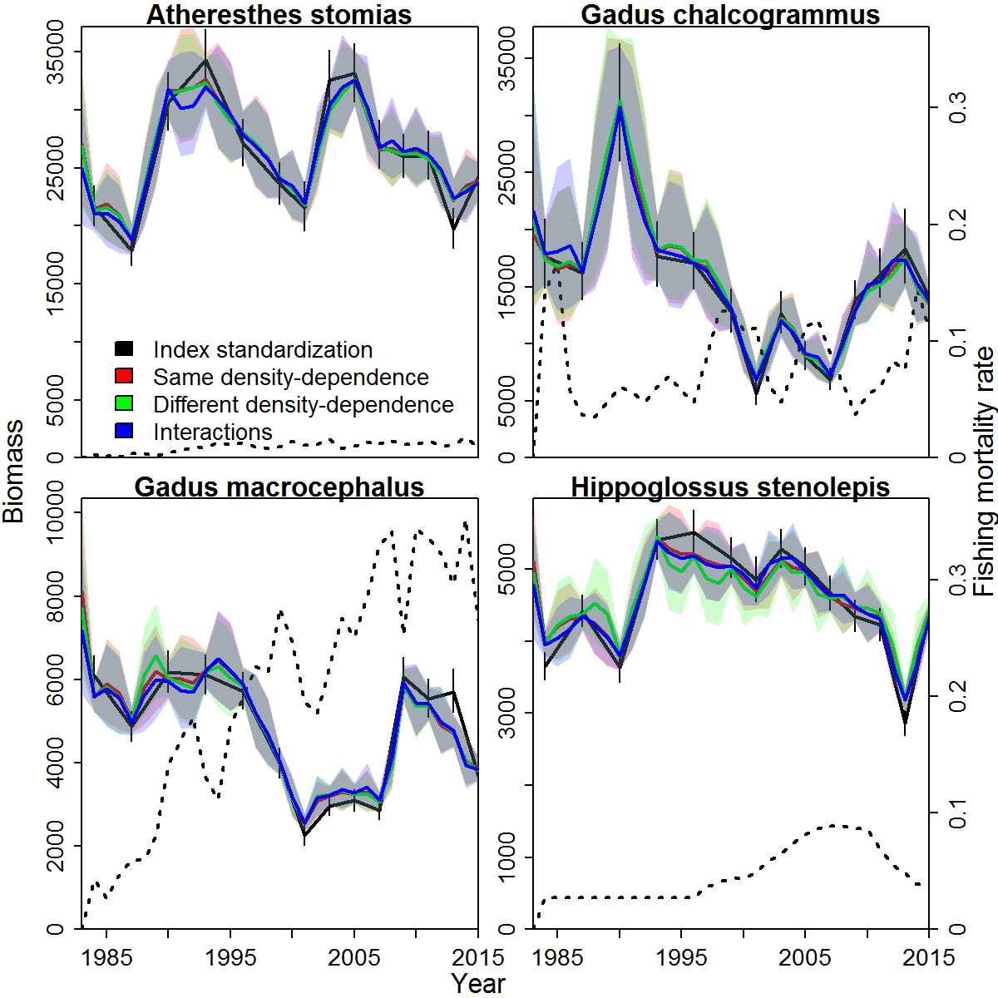

Fig. 2 – Biological reference points estimated by each model, where $b_{targ}$ is 40% of estimated biomass in the absence of fishing, and $f_{targ}$ is the fishing mortality estimated to result in biomass equal to $b_{targ}$ on average.

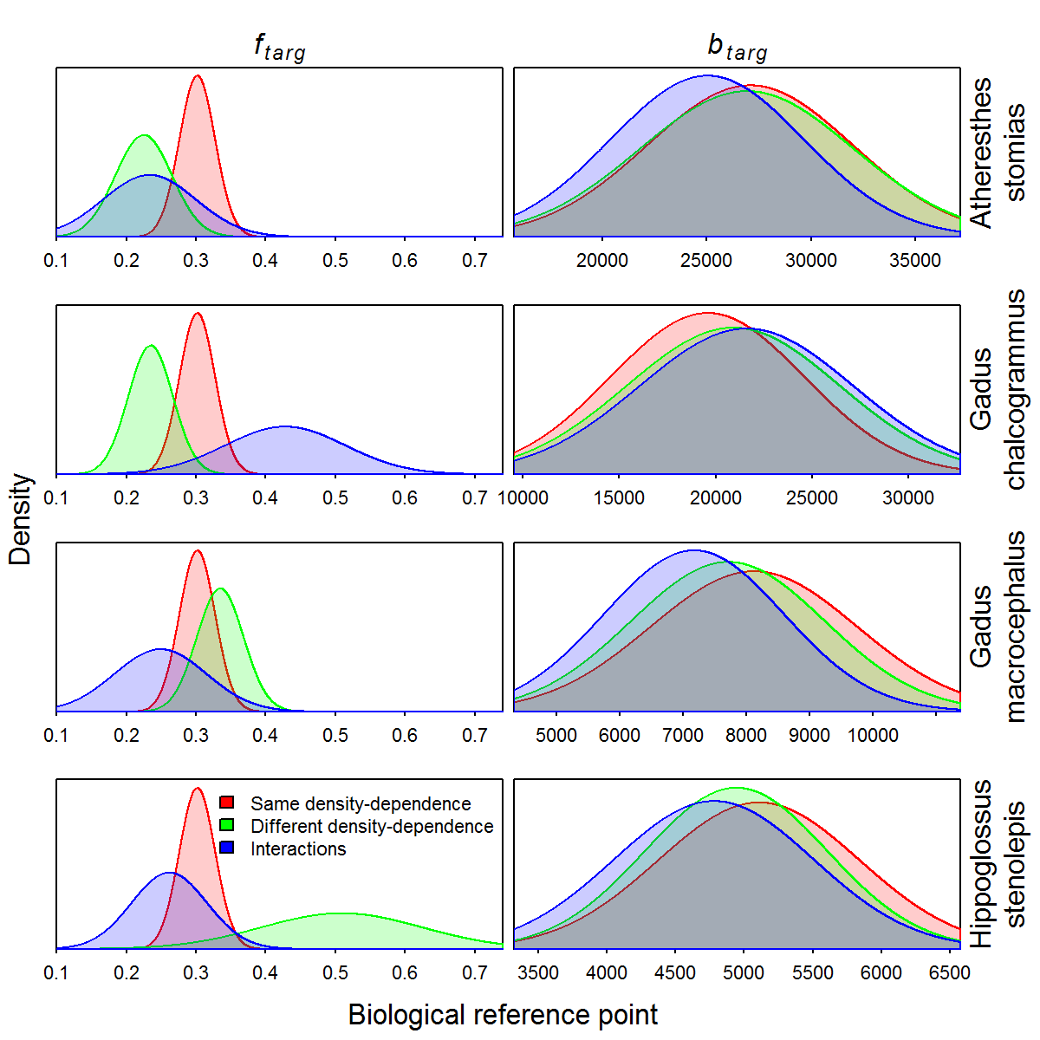

Fig. 3 – Maps showing natural logarithm of biomass density (red: high density; blue: low density) for each species (columns) in several years (rows), where the first year (top row) shows the estimate of unfished biomass. Years are chosen for illustration to be approximately even spaced but only using years with available survey data (note that density legend is identical among species and years)

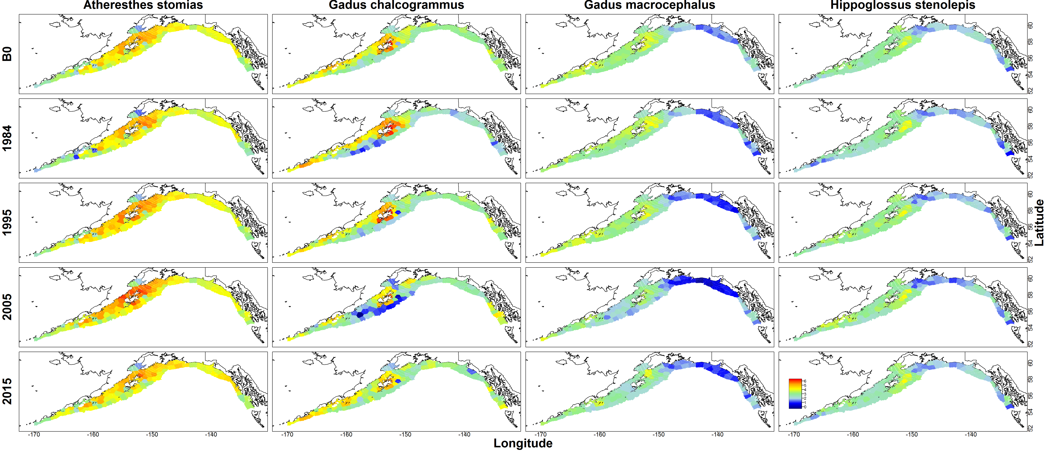

Fig. 4 – Stock status plot (y-axis: fishing mortality ratio, $f_{ratio}\left(c,t\right)$, x-axis, biomass ratio, $b_{ratio}\left(c,t\right)$, see Eq. 11) for each species estimated using the model with species interactions (see legend in bottom-right panel for color codes)

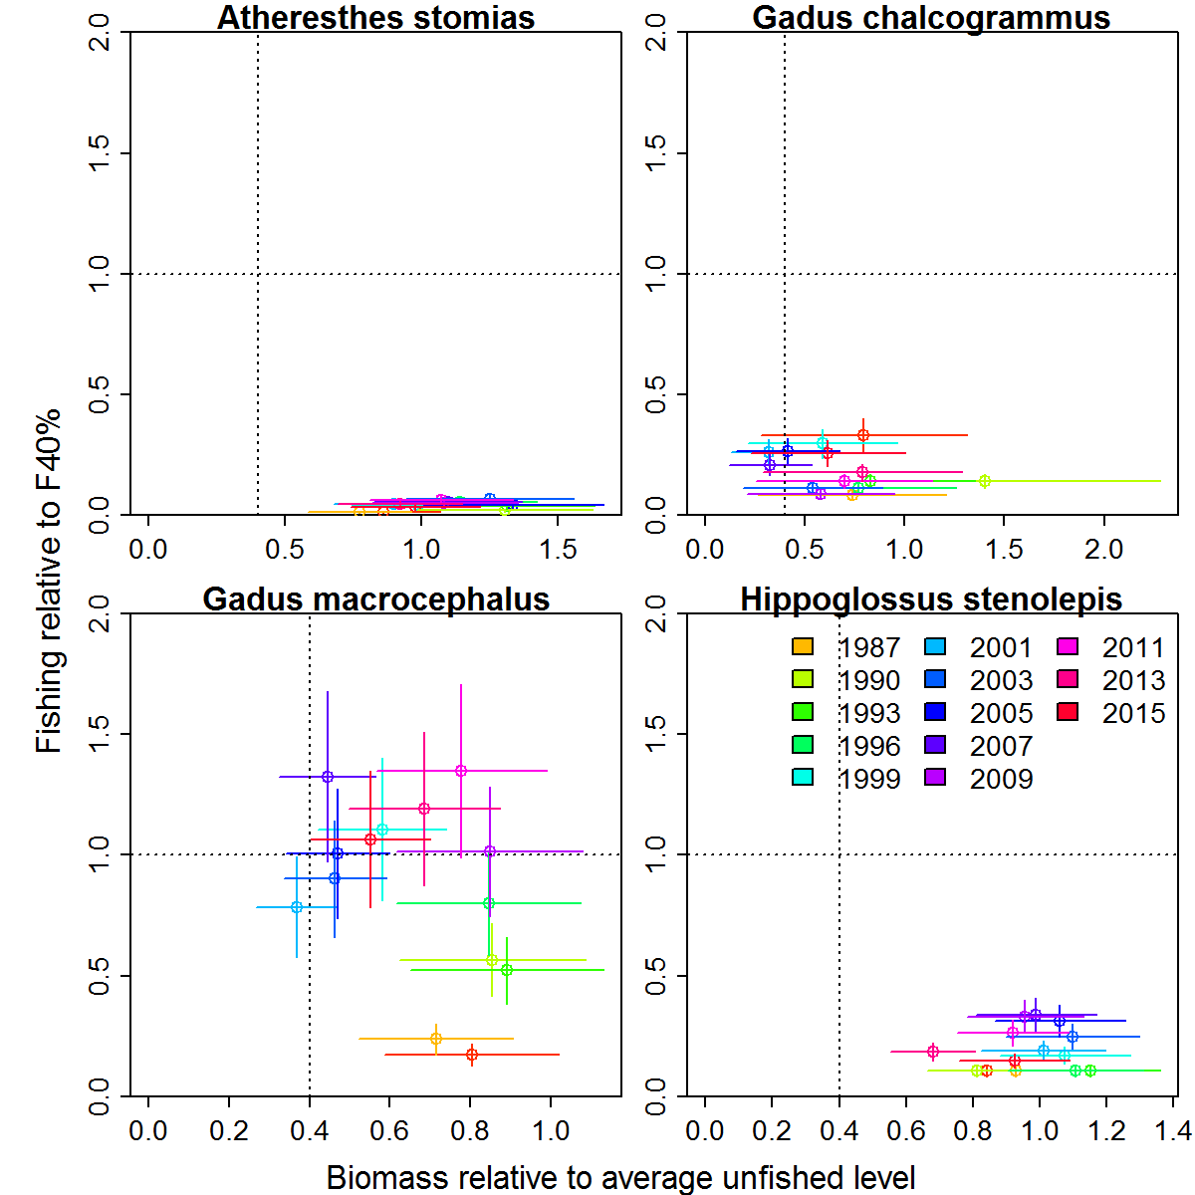

Fig. 5 – Illustration of simulation experiment, showing unfished density (1st and 2nd rows) and population density in 2015 (3rd and 4th rows where red is high density and blue is low density) for four species (columns), allowing comparison of true simulated density (1st and 3rd rows) vs. estimated density (2nd and 4th rows) when simulating a new data set conditional on fixed effects estimated from real-world data. Note that the simulation model simulates density for four species at a fine spatial scale (100 knots), while the estimation model estimates density for only two species at a coarse spatial scale (50 knots).

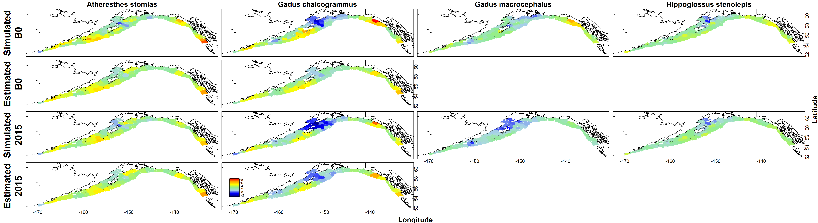

Fig. 6 – Estimates of interaction matrix $B$ (Fig. 6A) or biological reference points including fishing mortality resulting in 40% of average unfished biomass, $f_{0.4}$ (Fig. 6B left column) or the relative error in estimates of unfished biomass, $b_{targ}$ (Fig. 6B, right column) from a simulation experiment generating data based on the most parsimonious fitted model, and then restricting data to two species (*Atheresthes stomias* and *Gadus chalcogrammus*) and fitting at a coarse spatial resolution (50 knots). Each panel in the visualization of the interaction matrix (Fig. 6A) shows a histogram of estimates from each simulation replicate, where the true value is indicated by a vertical dashed line and the average estimated value is listed in the top-left of each panel. The visualization of biological reference points (Fig. 6B) similarly shows a histogram of estimates and the true value, and lists the bias (first number) and root-mean-squared error (second number) in the top-right of each panel.

Fig. 6A:

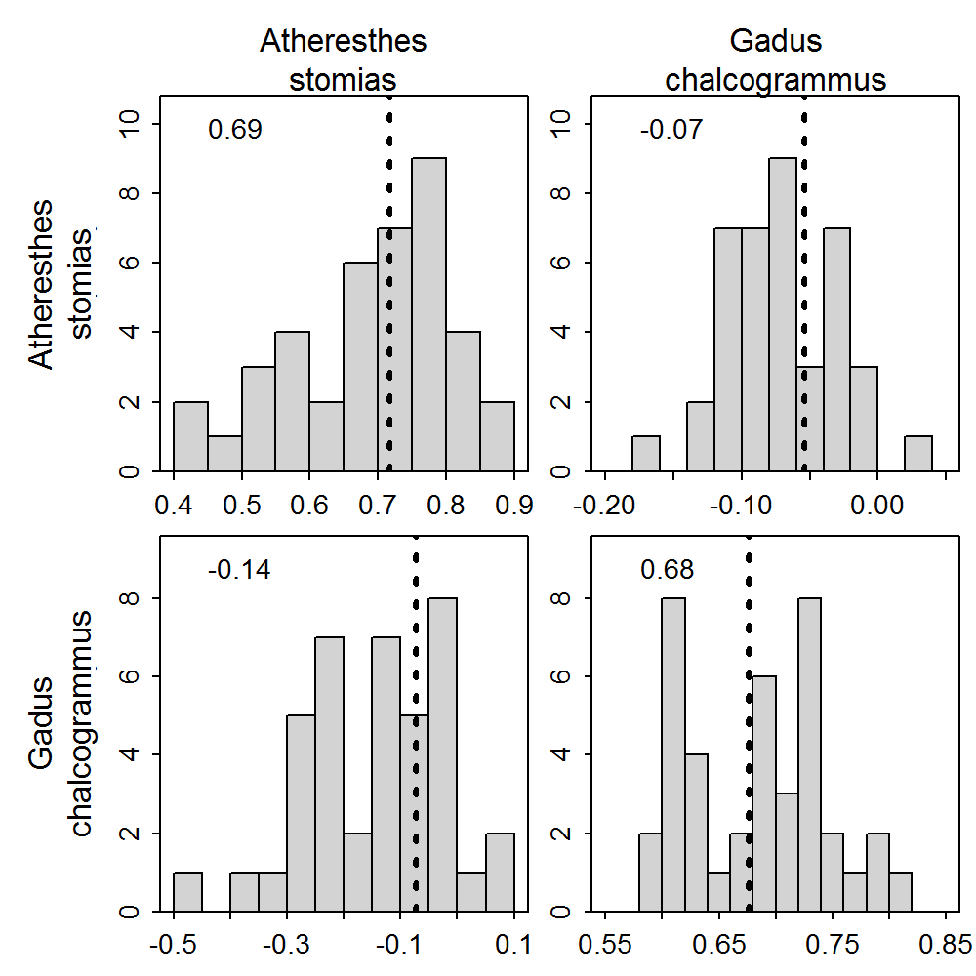

Fig. 6B

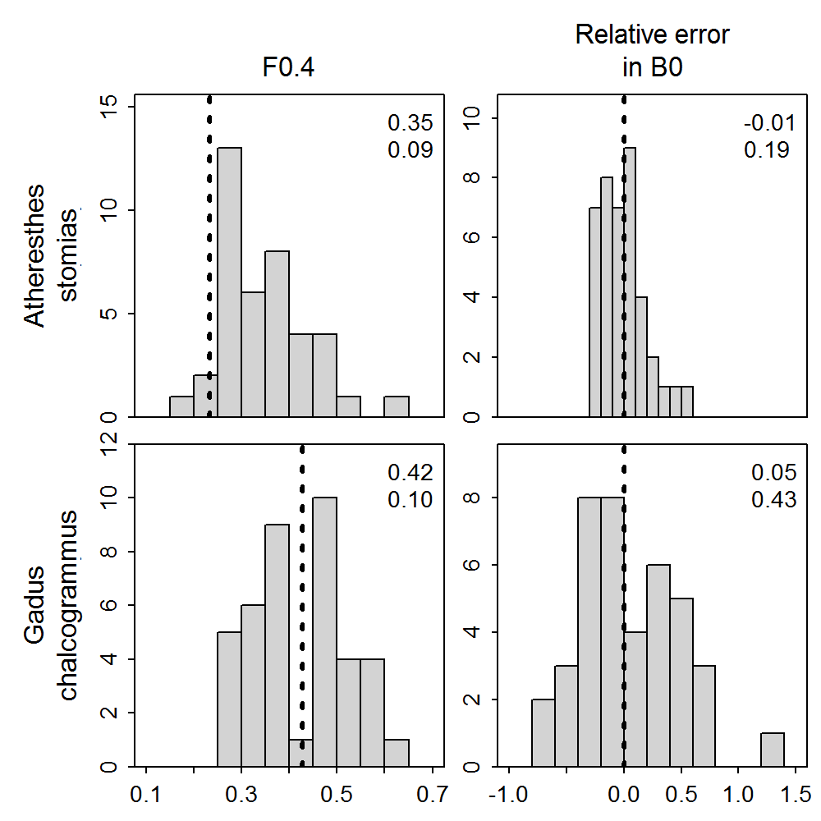

1. See Thorson (In press) for a description of the catchability covariates, density covariates, and vessel effects that can be incorporated into VAST. Options for catchability covariates and vessel effects are available when fitting species interactions as described here, although we do not explore these features here. Density covariates currently are not implemented to work in conjunction with estimates of species interactions.