Mortality events drive Bering Sea crab populations
Cody Szuwalski^{1,2} other authors to come
¹National Oceanic and Atmospheric Administration, Alaska Fisheries Science Center, Seattle, W
²University of Washington, School of Aquatic and Fishery Sciences, Seattle, WA

Abstract
Crab are some of the most abundant species in the Bering Sea and support fisheries historically valued at over $300 million ex-vessel per year. Boom and bust dynamics are common, and we use population dynamics models to identify drivers of change for six crab populations in the Bering Sea. Most large population declines appear unrelated to crab fisheries; episodic mortality and recruitment variability are the key drivers. Density dependent effects, temperature, and size explain a significant portion of the variability in mortality for all populations in our study. Correlated population processes among lightly fished and heavily fished populations suggest environmental change is an important driver of dynamics. Incorporating episodic mortality events into management projections lowers expected yields and biomasses. Our results underscore the need to model historical and future mortality events in fisheries management particularly when there are positive links to temperature or density, in spite of the complications to traditional management strategies it can present.

Body
Crab are some of the most abundant species in the Bering Sea ecosystem and historically have supported some of the most valuable fisheries in the Bering Sea (with salmon and pollock). In particular, snow crab and Bristol Bay red king crab support large and valuable fisheries, but several other more lightly fished populations also exist in the Bering Sea (Figure 1). The trajectories for most of these populations are volatile: booms and busts are common. Most recently, the snow crab population collapsed to unprecedented levels after a marine heatwave in 2018-2019 (Szuwalski et al., 2023) and the fishery was closed for the first time ever. This coincided with a closure of Bristol Bay red king crab, which put communities dependent upon crab fisheries under considerable financial strain and precipitated a half billion dollar disaster relief effort (REF). Large variability in crab abundance occurs in spite of intense management and some of the best data in the world (Hilborn et al., 2021). Population surveys for Bering Sea crab exist stretching back to 1975 (Zacher et al., 2024), catch data from the fisheries are carefully collected both on the docks and at sea (REF), and laboratory experiments are routinely conducted to understand population processes like growth and maturity (REF).
Management for Bering Sea crab is similar to most other closely managed fisheries with extensive data. Each year acceptable biological catches are set based on three outputs from a stock assessment: current biomass, target biomass, and a target fishing mortality. Colloquially, these pieces represent ‘where we are, where we want to be, and how we get there’ (respectively). Targets for biomass are based on equilibrium projections that assume stationarity in recruitment (i.e. young crab entering the population) and a constant natural mortality. However, periods of elevated natural mortality have been required to fit the survey data for crab in the assessments used in management, suggesting natural mortality is not constant. Furthermore, there is a possibility of unobserved mortality in groundfish fisheries of unknown magnitude as a result of trawl gear fatally impacting, but not capturing crab on the sea floor (Rose).
Given the observed boom and bust dynamics and a potential violation of assumptions made in management, we ask the following questions: 1) how frequent are large declines in Bering Sea crab populations, 2) what drives these declines and are there common linkages, 3) if population collapse is a common phenomenon, how can this information be used in management, and 4) if collapses are linked to temperature, how can management respond under a changing climate?
To answer these questions, we fit population dynamics models to the available data for six crab populations in the eastern Bering Sea with a key difference from the stock assessment models used in management: the estimation of an annually varying ‘other mortality’ that accounts for processes like predation, unobserved mortality in non-directed fisheries, cannibalism, disease, and starvation. We then used generalized additive models (GAMs; Wood, 2011) to explain estimated variability in our estimates of other mortality using population abundance, temperature occupied, and average size as covariates. We also identified periods during which a population declined more than 40% and used our model estimates to identify drivers for each of these population declines. Finally, we explored the impacts of incorporating the expectation of mortality events into management. Based on these analyses, we end with suggestions for Bering Sea crab fisheries and the larger natural resource management community.
The six populations we modeled are: snow crab, Bristol Bay red king crab (BBRKC), Tanner crab, Pribilof Islands red king crab (PIRKC), Pribilof Islands blue king crab (PIBKC), and Saint Matthews blue king crab (SMBKC). The models fit the available data well with acceptable diagnostics for all populations (see supplementary materials). Large correlations existed among estimated population processes among populations, which suggest shared drivers of dynamics. For example, Tanner crab, immature snow crab, and PIRKC all had significantly correlated estimates of other mortality, as did the two populations around the Pribilof Islands (Figures SX). Other mortality for mature snow crab and BBRKC, the two most valuable commercial populations, were also significantly positively correlated. Abundance trajectories were positively correlated for the blue king crab stocks and BBRKC, reflecting the large declines seen in these populations.
GAMs incorporating abundance, average size, and temperature occupied explained the variability in estimates of other mortality significantly better than not including the variables for 7 out of 8 population/maturity combinations (Figure 2). Higher abundances were associated with higher mortality for all populations except Tanner crab and SMBKC (Figure 2). Larger average size was associated with higher mortality for all populations except Tanner crab and BBRKC, which had U-shaped relationships. Higher temperatures were associated with higher estimated mortality for all populations and the effect was most dramatic for immature snow crab and BBRKC.
The combined contributions of changes in recruitment, fishing mortality, and other mortality resulted in volatile total abundance trajectories for Bering Sea crab (figure 3). Abundance declines of 40% or greater happened 19 times across all populations, but only 4 of these were associated with fishing mortalities that were higher than the median estimated rates. This suggests crab fishing is rarely a large driver of decline for populations other than blue king crab. Caution must be taken when using above average fishing mortality as an indicator of fishery-driven decline, though. For example, the decline in snow crab abundance after the 2018-2019 heatwave was primarily driven by declines in the proportion of the population not vulnerable to the fishery, so, even though estimated fishing mortality was high, it was clearly not the driver of the collapse. The remaining large drops in abundance were related to increased mortality, low recruitment, or a combination of the two. Clusters of population declines occurred during three periods: 1980-1984, 1996-1999, and 2015-2020. These all marked periods of ecosystem change and were relatively warm (REF).
The output of our models allows us to begin developing descriptive histories of the volatility for each population (figure SX). Snow crab has gone through two periods of boom and bust. The population abundances occurred during 1990s, but the population decline sharply in 1999. Neither fishing mortality nor other mortality were above average during this period: the declines were driven by a sustained collapse in recruitment. The management response was strong, the population was declared ‘overfished’ (which, in spite of referencing ‘fishing’ is a term used to describe a stock that is at low relative abundance regardless of cause; REF), and the stock slowly rebuilt. In the mid-2010s, the largest recruitment event observed in the population occurred and the population was projected increase to abundances not seen since the 1990s. However, the population collapsed again before those projections could come to fruition and this collapse was a result of a mortality event, not a recruitment failure. A model similar to those used within this manuscript was developed for snow crab to try to understand what drove the mortality behind the collapse. Predation, cannibalism, starvation, disease, non-directed fishery bycatch, and THIS were considered as potential drivers. Ultimately, the model output suggested that the 2018-2019 marine heatwave increased the metabolic requirements for snow crab and that starvation likely contributed to the collapse (Szuwalski et al., 2023).
The other large commercial fishery, BBRKC, declined precipitously during the early 1980s as a result of a confluence of unfortunate events: recruitment collapsed in 1979, fishing mortality spiked in 1980, and a period of elevated ‘other mortality’ occurred from 1980-1984. BBRKC experienced relatively high temperatures during this period of other mortality, but there have also been questions about bycatch in non-crab fisheries during this period of time (REF). The management response to the collapse was strong and fishing mortality was reduced, which resulted in a slow rebuilding to another peak in abundance during the mid-2000s. Poor recruitment occurred throughout this time period, but ‘other mortality’ was also low, which allowed the rebuilding. Unfortunately, estimated other mortality increased again in the 2010s, which, coupled with poor recruitment and increasing fishing mortality lead to the lowest estimates of abundance on record in the 2020s. Analyses have been published for BBRKC that link declines in recruitment to ocean acidification (REFS), but more widespread consideration of hypotheses and processes that drive dynamics (e.g. ‘other mortality’ and drivers like predation, bycatch, disease, cannibalism, or starvation) could be useful in directing management effort for BBRKC and the other crab stocks in the Bering Sea. Developing appropriate indices to represent those drivers is time- and resource-intensive and will depend on continued funding for surveys and laboratory studies.
The descriptive histories above are only possible when using models that estimate a time-varying ‘other mortality’ and we argue that this sort of history-building will be crucial to management, so that population changes for which management has a ‘lever’ to enact change (e.g. directed fishing) can be distinguished from those management does not (e.g. climate change). However, dangers also exist in building ‘just-so-stories’ around ecological models like this (REF). Determining causality from observational data can be difficult, particularly in complex systems for which relatively short time series are available (REF). Nonetheless, there are considerable risks in not attempting to understand the population changes in a broader context than just fishery-driven dynamics. For example, assuming that population dynamics are driven by fishing when they are actually driven by climate or disease (for example) can result in misdirected (and ultimately wasted) management resources. Experiments, surveys, and analyses aimed at identifying causal drivers of ecosystem change are likely the best hope for designing effective management strategies as climate change reorganizes ecosystems.
Regardless of the true underlying drivers of population change for Bering Sea crab are, Bering Sea crab populations are in crisis. The median estimate of commercial abundance during 2023 across all populations was less than 5% of the maximum observed, with the two most economically important populations (BBRKC and snow crab) estimated at 1.7% and 7.2% of maximum, respectively (figure 4). Given the currently poor status of Bering Sea crab populations, it is natural to ask if incorporating the expectation of episodic mortality events into biomass and fishing mortality targets could improve management outcomes for Bering Sea crab. To explore this question, we parameterized a model based on BBRKC in two ways and then calculated equilibrium management targets and expected yields. In the first model, natural mortality was assumed to be constant. In the second model, we sampled yearly other mortality from historical estimates and simulated 1000 populations to develop a distribution for the expected yield and biomass for a given fishing mortality under the possibility of episodic mortality events.
Expected yield and biomass were nearly halved when allowing for the possibility of mortality events and variability in yield and biomass was high (figure 4). Depending on the timing and magnitude of mortality events and their relationship to the timing of recruitment events, biomasses could range from 5-200% of the equilibrium value. Even though there were large differences in expected yields and biomass, the fishing mortality that produced the maximum long-term yield did not change. The key change to the harvest control rule affected by incorporating expected mortality events would lowering the target biomass. This would allow fishing to occur at much lower abundances than is currently allowed. Unintended consequences of incorporating environmentally driven stochasticity into management targets (i.e. increasing the fishing pressure on populations undergoing ‘stress’) happens for other population processes as well. For example, incorporating climate change effects into recruitment for snow crab results in lowering biomass targets as ice recedes, allowing higher exploitation rates to occur as the population is undergoing climate stress (Szuwalski et al., 2021).
The current management goals for Bering Sea crab are to provide ‘optimal yield’ based on the equilibrium concepts of maximum sustainable yield (Crab FMP). Firmly negative population trends culminating in all-time lows of commercial biomass for many populations in the last decade suggest that management may not be achieving those goals, in spite of what appear to be relatively conservative harvests. Multiple violated assumptions of the underlying theory behind status quo management strategies suggest that working backwards from what has occurred rather than what ‘ought’ to have occurred based on theory might yield more positive results. In practice, this could mean taking a more experimental approach to exploitation rates to identify management actions that might improve stock trajectories (e.g Walters). Experimental management would likely need to be coupled with institutional change to provide fishers and communities dependent on crab fisheries more flexibility to support their livelihoods from the Bering Sea ecosystem.
Our observations and modeling for Bering Sea crab may have important implications for other managed living resources. Mortality events can occur for a range species for a range of reasons (REFs) and management response might change for each. Broadly, resource management operates at two levels: strategic (i.e. goal setting) and tactical (i.e. actions to accomplish goals).
From a strategic perspective, protecting populations from (and after) collapse and supporting resource-dependent communities are often central goals and should guide the type of management actions considered. Protecting populations from/after collapse can be challenging in the current equilibrium management paradigm if adverse drivers are built into the calculation of expectations of the population under no fishing, as shown above. The challenge arises from the downward shift of targets from incorporating expected collapses into the projection, which would allow for harder fishing at lower abundances compared to status quo rules. It is possible that alternate forms of harvest control rules could provide better management outcomes when populations are prone to mortality events. The shape of these rules would likely depend on the drivers of mortality events. INSERT ECON LIT HERE. Based on our analyses, consideration of population abundance, size composition, and temperature may be useful covariates to consider.
The problem of boom-bust dynamics is not new: forage fish are the classic example in fisheries. Anchovy and sardine off southern California have gone through boom-bust cycles over the last 500 years (much of which was in the absence of fishing) according to scales collected in the sediment around the Channel Islands (McClatchie et al., 2017). Crustacean populations can also vary considerably and withstand high fishing mortalities. For example, Dungeness crab populations in the Pacific Northwest have persisted in spite of very high exploitation rates (>90% in some areas) on the large males (Richerson et al., 2016). These examples suggest that fishing fishing is not a dominant driver of population change for some species and might suggest a higher tolerance for low abundances when specifying allowable harvests.
However, a key difference between forage fish, Dungeness crab, and the Bering Sea crab in our study is life span. Anchovies live XX years and mature at XX years old (REF), sardines live XX years and mature at XX years old (REF), and Dungeness crab live XX years and mature at XX years old (REF). In contrast, snow crab live XX years and mature at XX years old (REF), red king crab lives XX year and mature at XX years old (REF), and blue king crab live XX years and mature at XX years old (REF). These differences in life history can be important for how responsive a population can be to favorable environmental conditions. These differences also might be related to why PIBKC has not come back in spite of not being fished for a quarter of a century and why the king crab populations in the Gulf of Alaska collapsed and did not return (REF). SUM IT UP.
From a tactical perspective, models with time-varying other mortality are not often used in fisheries science, and for what seem like good reasons in stationary systems where fishing is a primary driver of dynamics. First, change in other processes alias for change in mortality—a change in growth or catchability can look very similar to a change in mortality (‘hide or die’ REFs; Szuwalski et al., 2019). Furthermore, the data to which population dynamics models are fit are also subject to observation error, so there is some risk that estimates of mortality are reflecting noise in the data rather than a signal from the population (REF). In addition to difficulties reliably estimating variable mortality, small changes in the mortality used to calculate reference points can result in large changes to management advice (e.g. Thorson et al., 2015). Because of these points, the prevailing advice for population dynamics models is to estimate a time-invariant natural mortality (Johnson et al., 2014), often informed by a prior that considers the longevity of the modeled species (Hamel, 2014).

Our modeling choices are a departure from current ‘best practices’ in stock assessment, but we argue that modeling ‘other mortality’ and attributing that mortality to some source(s) (or at least attempting to) will likely be an increasingly important issue as climate change progresses and when fishing is one of many drivers of dynamics. We also recommend that scientists and managers build models that have alternate assumptions about the drivers of dynamics (including time-varying mortality), simulation test all population dynamics models, methods of attribution and management strategies, and check for historical biases and retrospective patterns.
Collapses of harvested natural resources will continue to happen; knowing when and/or why is a hard scientific problem, but one that needs to be undertaken. If the causes of collapse can be identified, developing appropriate management strategies can be relatively straightforward. For example, if predation is a key driver of a harvested population, incentivizing fishing for the predator in areas where there is the most overlap between predator and prey may reduce pressure on the prey population (REF). Regardless of whether we understand the causes, management systems should be developed that have the flexibility to promptly address sudden collapses, which may be more frequent as climate changes (Litzow et al., 2024). These systems should be built on the principles that collapses should be met with decisive management action (i.e. closures) and implementing social institutions that soften the economic blow to those dependent upon the resource (e.g. providing diverse fishing opportunities). If we can understand why something occurred, decisive action can be taken. If we cannot understand why something happened, action still must be taken, so modeling exercises should be undertaken to ensure decisions are made sensibly.

Acknowledgements to come
Github.com/szuwalski/ebs_crab
References to come

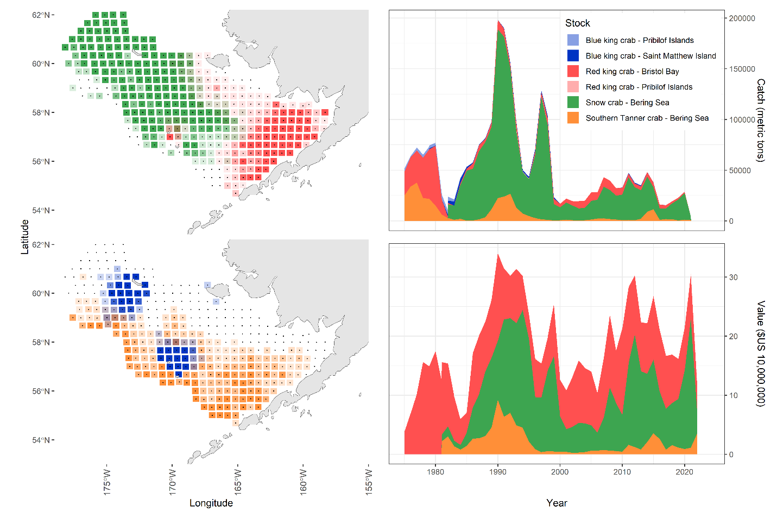
Figure 1. Location of crab populations in the Bering Sea (left) and the catch and ex-vessel value of that catch for crab populations (right).

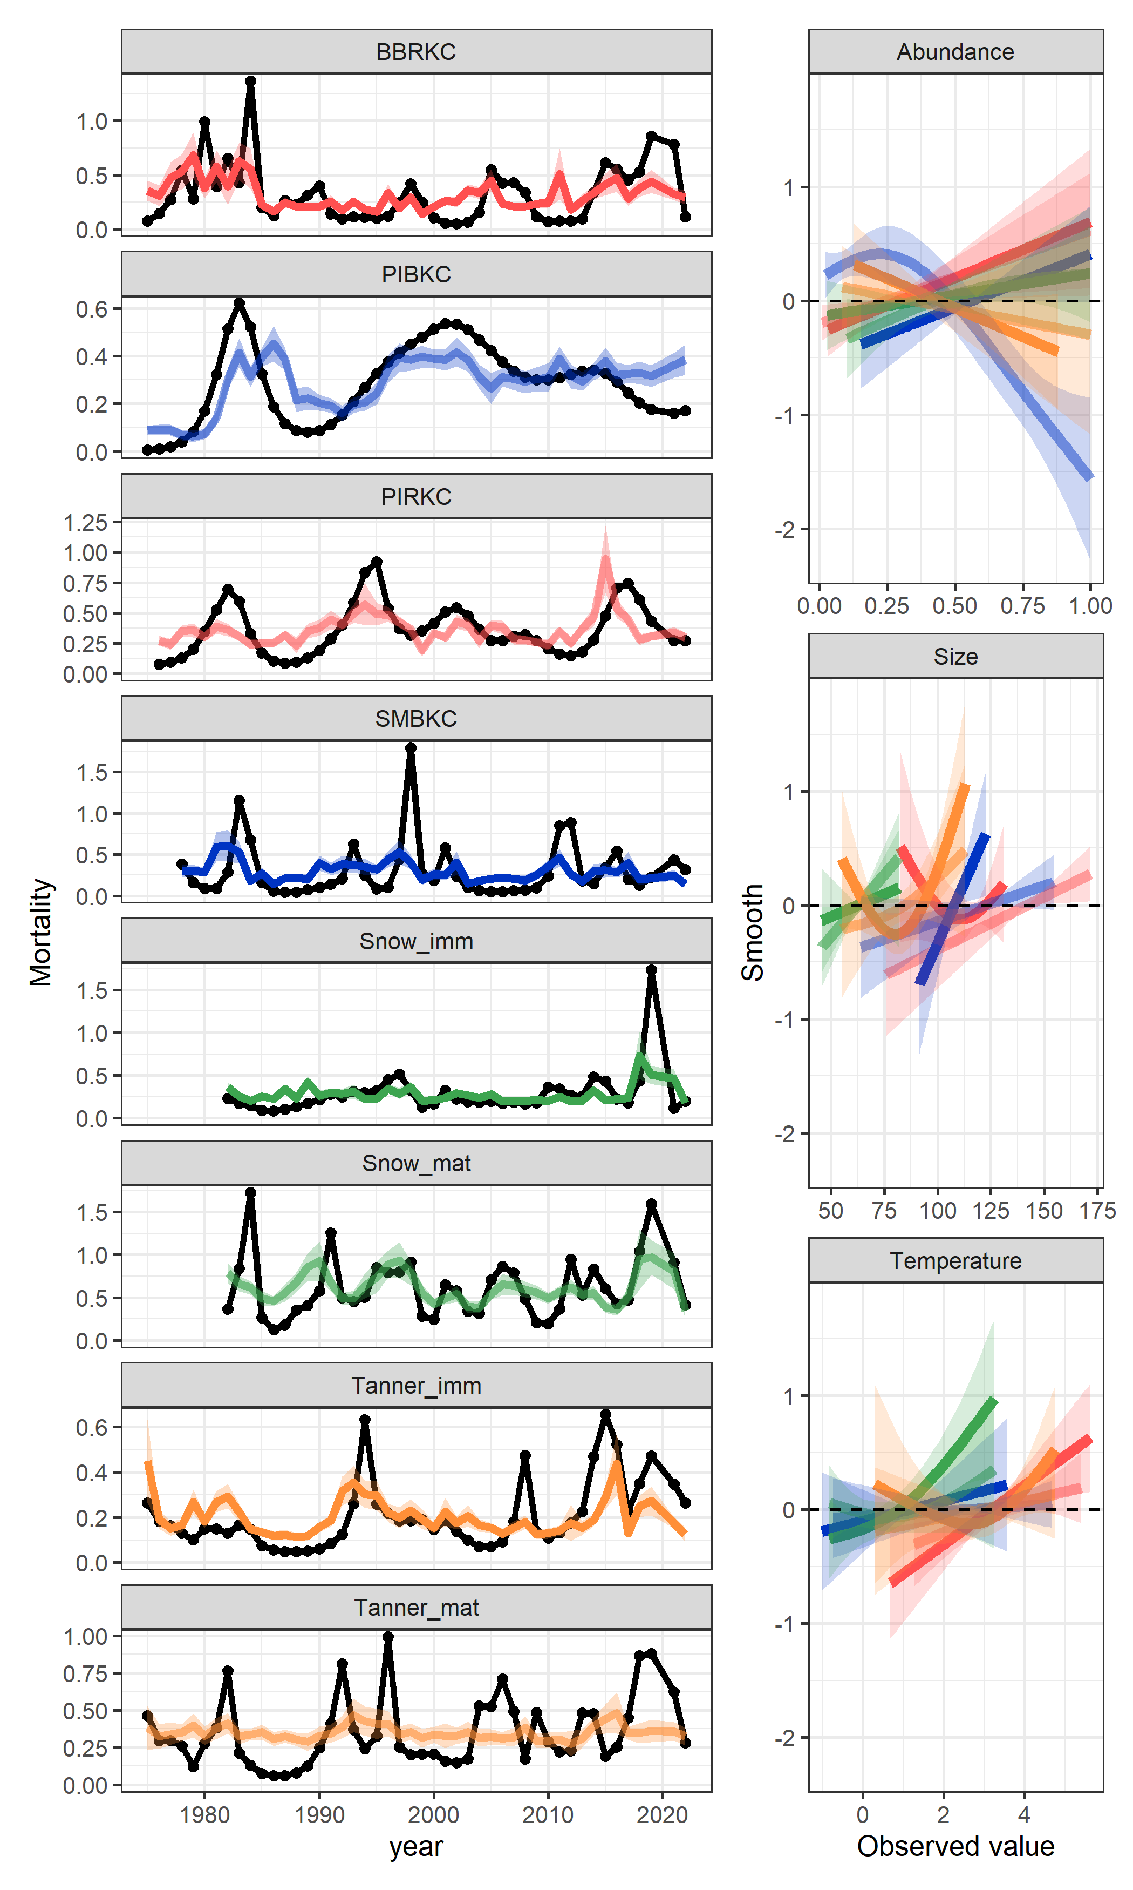
Figure 2. Estimated mortality from population dynamics models (left; black lines) with GAM estimates of those time series (colored lines). Smooth relationships estimated within the GAMs for three covariates. Colors represent a population and are consistent among figures.

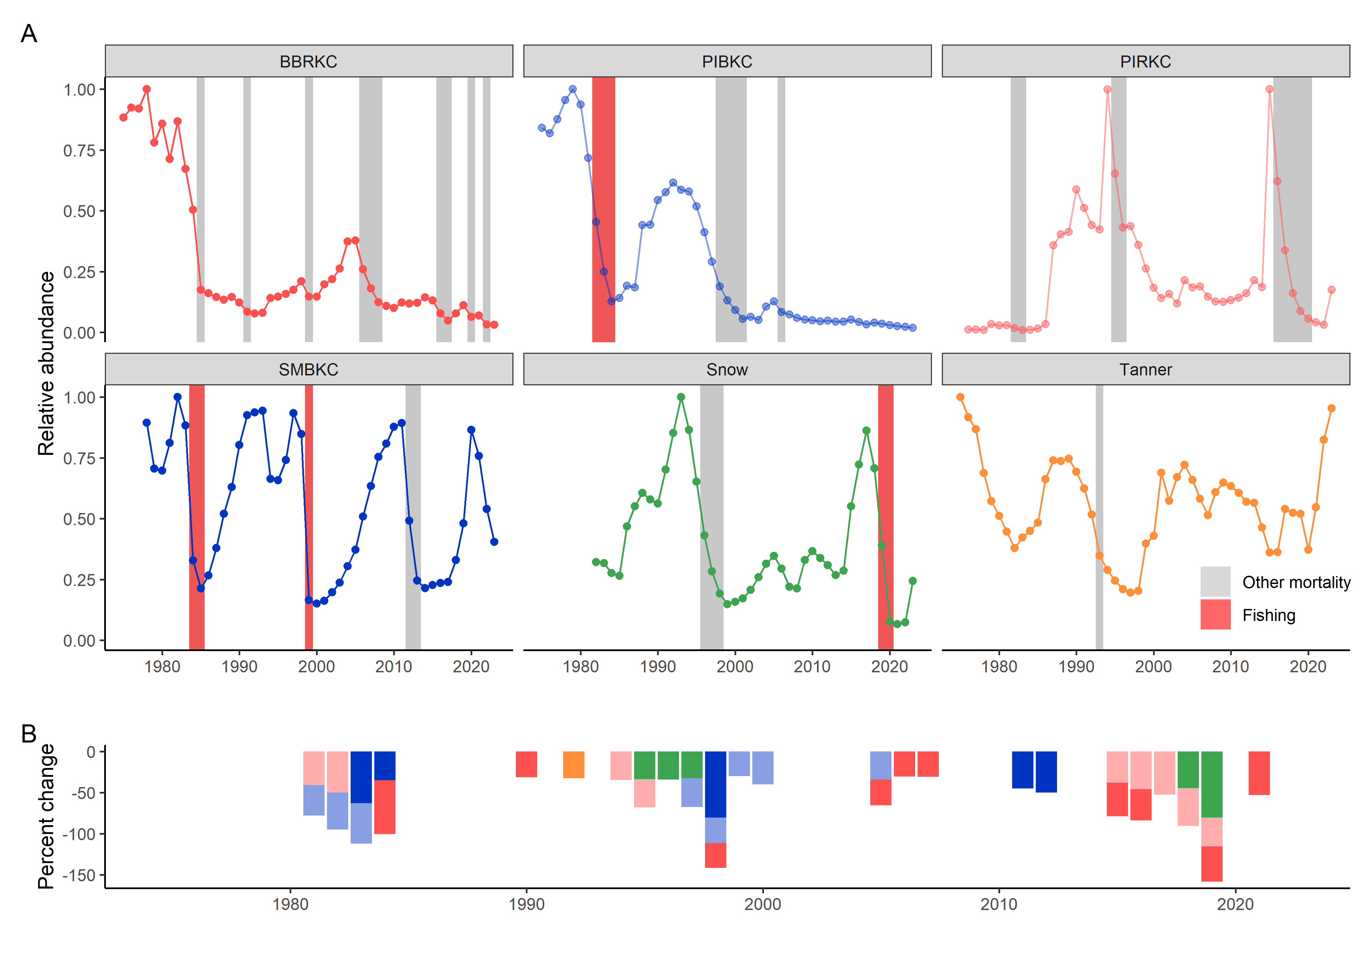
Figure 3. Estimated relative total abundance (add uncertainty) by crab population (A) with periods during which the abundance declined by at least 40% (vertical rectangles). Red rectangles correspond to periods of decline during which estimated fishing mortality was greater than the median; grey bars indicate periods when fishing mortality was below the median. Panel B collates the declines by year and magnitude.

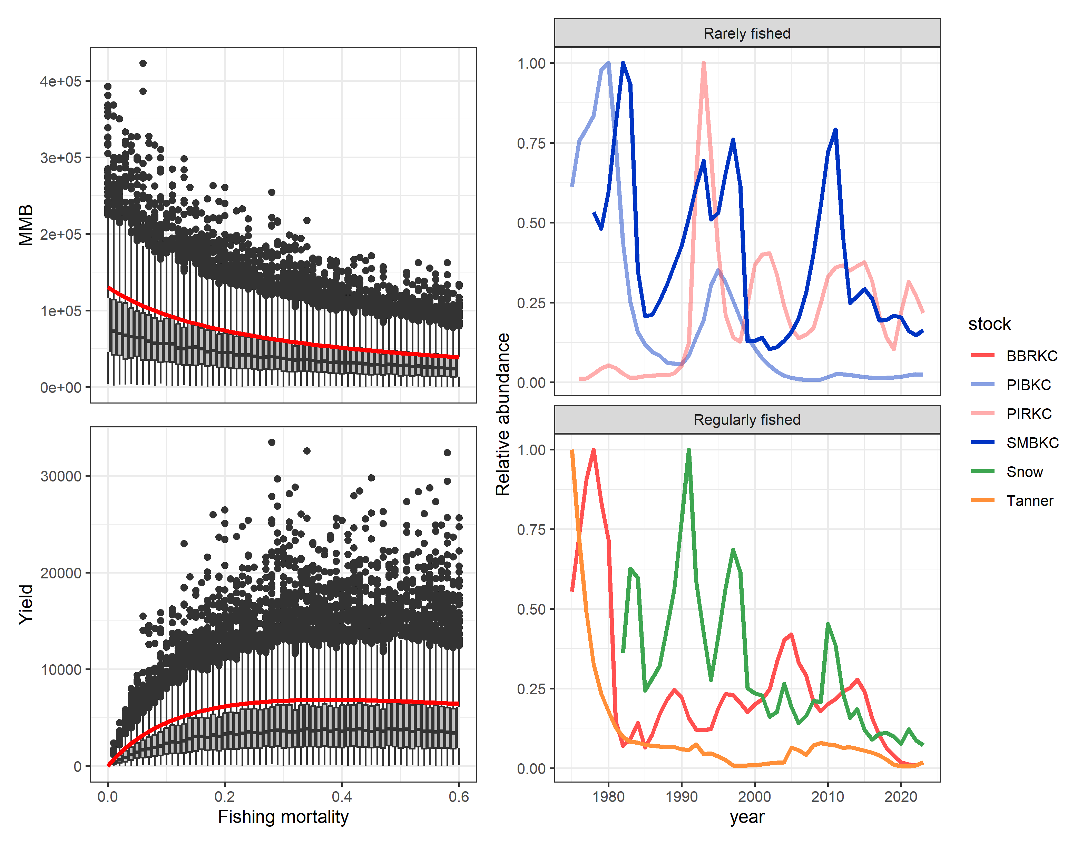
Figure 4. Equilibrium mature biomass (top left) and yields (bottom left) for a given fishing mortality when natural mortality is constant (red line) and when mortality events are considered via stochastic simulations (box plots). Trajectories of the abundance of industry preferred sizes of crab from rarely fished populations (top right) and regularly fished populations (bottom right)[add uncertainty].

Supplementary materials for “Episodic mortality drives Bering Sea crab populations”

METHODS
Data
The eastern Bering Sea trawl survey has been conducted annually since the mid-1970s although no survey was conducted during 2020 due to the COVID-19 pandemic (Zacher et al. 2023). During the first decade of the survey there was a gradual expansion of the survey area leading to variability in both the number of stations sampled, and survey extent, primarily in the northwest of the survey grid (i.e. in the vicinity of St. Matthew Island). The survey extent was standardized in 1988, and 376 stations have been consistently sampled since. A 0.5-hr tow is made near the center of each 20 x 20 nmi (37 x 37 km) square on a sampling grid. Since 1982, the standardized sampling gear has been the 83-112 eastern otter trawl (Zacher et al. 2023). Prior to 2006 all carapace width and chela height measurements (used to assess male maturity) were measured to 1 mm. During the period 2006-2015 the majority were measured were measured to 1 mm, and a subsample specifically for chela height measurements were measured to 0.1 mm using Vernier calipers. Beginning in 2016 all crab have been measured to 0.1 mm using digital calipers. Individual crab are measured to the nearest 2 g using a digital scale. In cases where subsampling is required due to catch size, crab are divided into kept and discarded categories and weighed to the nearest 10 g. The ratio of kept/discarded is then used to calculate a sampling factor by which the sampled catch may later be expanded.

Male crab maturity was determined using the procedure outlined in Richar and Foy (2022). Briefly, paired, log-transformed, carapace width and chela height data are divided into a series of intervals along the log-carapace width (x) axis, within the log-carapace width range over which two overlapping data clouds occur. Data from each interval are used to calculate a distribution, and the minima of the region separating the 2 dominant peaks is obtained. The set of midpoints for each log-carapace width interval is then combined with the set of extracted minimas to create an (x,y) data set. A linear model is then run using these points as inputs, and the calculated regression line is the final maturity cutline.

Temperature occupied for each stock was calculated from the measured bottom temperature from each tow, weighted by the CPUE for a given species at that tow (figure SX). Average size was calculated as a weighted mean of the vector of size, with weights given as the abundance of crab in a given size bin estimated from the fitted population dynamics models (figure SX).

Directed fishery data

Fisheries catches are reported by Alaska Department of Fish and Game (ADFG) statistical area in logbooks and were aggregated by year to be used as input in this analysis. The fishery generally starts at the end of October and closes at the beginning of May, and most of the catches occur during a short period in winter. Catch of retained crab from the directed snow crab pot fishery from survey year 1982 to the 2021 were used in this analysis and are based on dockside landings. The fishery was closed in 2022 and 2023 due to low abundances. Information on discarded crab are collected via on-board observers who measure, count, and weigh samples of crab brought aboard fishing vessels. More information on the fisheries data collection process can be seen in the individual stock assessments (Szuwalski, 2023; Palof et al., 2023; Sterns, et al., 2023; Stockhausen 2023).

Population dynamics model
The population dynamics models used here are based closely on those used in the stock assessments for Bering Sea (see references). The model tracks numbers of male crab at size s by maturity state m over time t ($N_{t,s,m}$) with 5 mm size bins over different ranges of sizes for each population (Table S1). For king crab species, only one maturity state is modeled (i.e. instead of a numbers at size matrix for both immature and mature animals, there is a single numbers at size matrix) and maturity is calculated post hoc as a function of size. All models are divided into two ‘periods’: before fishery and after fishery. The timing of the fishery is different for each population and is denoted by the month in which it occurs (q below). Mortality is the only population process that occurs in the first seven months of a given year (the crab year starts in July when the US National Marine Fisheries Service (NMFS) bottom trawl survey takes place):

$$\begin{aligned}n_{t=y+\frac{q}{12},s,m}=N_{t=y,s,m} e^{-\frac{q}{12}M_{m}} \#1\end{aligned}$$

Fishing is assumed to occur as a pulse fishery in which the crab captured and brought on deck of fishing vessels, $C_{cap}$, are a function of capture selectivity, $S_{cap}$, the number of crab in the Bering Sea at the time of fishing, and the fishing mortality applied, $F_{t}$. A retention ogive, $S_{ret}$, is applied to the captured crab to determine what fraction of crab at a given size are retained, $C_{ret,y}$, and what fraction are discarded back into the ocean. A discard mortality proportion, $d_{mort}$, of 0.3 is applied to the crab returned to the ocean.

$$\begin{aligned}C_{cap,y}=n_{t=y+\frac{q}{12},s,m}\left(1-e^{-F_{t}*S_{cap,s}}\right)\#2\end{aligned}$$

$$\begin{aligned}C_{ret,y}=C_{cap,y}S_{ret,s} \#3\end{aligned}$$

$n_{t=y+\frac{q}{12},s,m}=n_{t=y+\frac{q}{12},s,m}e^{-F_{t}S_{cap,s}}+{(1-d}_{mort})C_{cap,y}{(1-S}_{ret,s})$ 4

Growth occurs after the fishery and is represented in the model by multiplying the vector of molting crab at size by a size-transition matrix, $X_{s,s'}$, that specifies the size to which crab grow given an initial size (Figure 3). This process results in two temporary vectors of numbers at size for Chionoecetes species where immature crab are denoted by the subscript m=1; mature crab are denoted by the subscript m=2:

$$\begin{aligned}n_{t=y+\frac{q}{12},s,m=1}=z\left(1-ρ_{s}\right)X_{s,s^{'}}n_{t=y+\frac{q}{12},s,m=1}\#5\end{aligned}$$

$$\begin{aligned}n_{t=y+\frac{q}{12}s,m=2}={zρ}_{s}X_{s,s^{'}}n_{t=y+\frac{q}{12},s,m=1}+n_{t=y+\frac{q}{12},s,m=2} \#6\end{aligned}$$

A single equation can describe king crab species given the lack of terminal molt:

$$\begin{aligned}n_{t=y+\frac{q}{12},s}=\left(1-z_{s}\right)X_{s,s^{'}}n_{t=y+\frac{q}{12},s}+z_{s}X_{s,s^{'}}n_{t=y+\frac{q}{12},s}\#7\end{aligned}$$

The size transition matrices $X_{s,s'}$ used here are borrowed from the stock assessments for each species, which are based on growth increment data (see assessments for detail).

The probability of maturing (ρ) and molting probability (z) are handled differently for king crab vs. Chionoecetes species. Chionoecetes species have a terminal molt to maturity, after which they do not grow again (Tamone et al. 1995). The probability of maturing is based on the observed ogives of the proportion of mature new shell males by size calculated from chelae height measured in the NMFS survey data, $ρ_{s}$; Richar and Foy, 2022; figure 3). These observed probabilities of having undergone terminal molt are input as data in the model. All immature individuals of Chionoecetes species are assumed to molt (i.e. z = 1). King crab do not have a molt to maturity, but the probability of molting varies with size. Here, a declining logistic function was estimated for each king crab species within the model:
$$\begin{aligned}z_{s}=1-\frac{1}{1+e^{(-m_{s}\left(s-m_{50}\right))}}\#8\end{aligned}$$
Where the size at 50% molting is m₅₀ and the slope of the logistic function is m_{s.} Recruitment is a freely estimated vector composes of a mean and deviations around that mean. Recruitment enters the model in the first three size bins with relative proportions allocated to a given size bin ($θ_{1,2,3})$derived from stock assessment estimates:
$$\begin{aligned}n_{t=y+\frac{q}{12},s=1,2,3,m=1}=n_{t=y+\frac{q}{12},s=1,2,3,m=1}+ r_{y}θ_{1,2,3} \#9\end{aligned}$$
Finally, the remaining portion of the year’s natural mortality is applied to the population after growth, molting, recruitment, and fishing occurs. Note that this allows a crab to experience two different levels of mortality within a given year as it undergoes terminal molt.
$$\begin{aligned}N_{t=y+1,s,m}=n_{t=y+\frac{q}{12},s,m} e^{-\frac{12-q}{12}M_{t,s,m}} \#10\end{aligned}$$
Likelihoods

The objective function for the population dynamics models consists of likelihood components (representing the fit of the model to the data) and penalty components (which incorporate constraints in the fitting based on prior information) that are summed and minimized in log space to estimate parameters within the model. Several data sources were fit to using the following likelihoods. Observed size composition data for crab caught in the survey and retained and discarded crab in the fishery were fit using multinomial likelihoods and were implemented in the form:

$$L_{x}=λ_{x}\sum_{y}{N_{x,y}\sum_{l}{p_{x,y,l}^{obs}ln⁡(\frac{p_{x,y,l}^{pred}}{p_{x,y,l}^{obs}}}})$$

$L_{x}$ was the likelihood associated with data component x, where $λ_{x}$ represented an optional additional weighting factor for the likelihood, $N_{x,y}$ was the sample sizes for the likelihood, $p_{x,y,l}^{obs}$ was the observed proportion in size bin l during year y for data component x, and $p_{x,y,l}^{pred}$ was the predicted proportion in size bin l during year y for data component x. Sample sizes were input as 50.

Observed indices of abundance in the survey and retained and discarded catches in numbers in the fishery were fit with log normal likelihoods implemented in the form:

$$L_{x}=λ_{x}\sum_{y}{\frac{{(\ln\left({\hat{I}}_{l,x,y}\right)-\ln\left(I_{l,x,y}\right))}^{2}}{2σ_{x,y}^{2}}}$$

$L_{x}$ was the contribution to the objective function of data component x, $λ_{x}$was any additional weighting applied to the component, ${\hat{I}}_{l,x,y}$ was the predicted value of quantity l from data component x during year y, $I_{l,x,y}$ was the observed value of quantity I from data component x during year y and $σ_{x,y}^{2}$ was the observed or specified variance for data component x during year y.

Smoothing penalties were placed on estimated vectors of deviations for other mortality using normal likelihoods on the second differences of the vectors. Normal priors were also placed on the mean value of natural mortality and the deviation of the estimated mortality from that mean. The normal priors were of the form:

$$P_{x}=λ_{x}\sum_{y}{\frac{{(\ln\left({\hat{I}}_{l,x,y}\right)-\ln\left(I_{l,x,y}\right))}^{2}}{2σ_{x,y}^{2}}}$$

$P_{x}$ was the contribution to the objective function of the penalty associated with model estimate x, $λ_{x}$ was any additional weighting applied to the component, ${\hat{I}}_{l,x,y}$ was the predicted value of population process I relevant to penalty x during year y, $I_{l,x,y}$was the prior value of process I relevant to penalty x during year y and $σ_{x,y}^{2}$ was the observed or specified variance for data component x during year y.

Diagnostics (to come)
Snow crab

Bristol Bay red king crab

Tanner crab

Pribilof Islands red king crab

Pribilof Islands blue king crab

Saint Matthews blue king crab

Discussion (to come)

Why be optimistic we can estimate mortality?
Why be skeptical?

Table S1. Characteristics of modeled populations.
Stock | Sizes | Prior on  ‘other mortality’ | Maturity | Year range | Fishery timing
Snow crab | 30-135 | 0.27 | Chela-based | 1982-2023 | February
Tanner crab | 25-185 | 0.27 | Chela-based | 1975-2023 | February
BBRKC | 45-170 | 0.18 | >120 mm | 1975-2023 | September
PIRKC | 45-220 | 0.18 | > 120 mm | 1976-2023 | September
SMBKC | 45-170 | 0.18 | >105 mm | 1978-2023 | September
PIBKC | 45-200 | 0.18 | >120 mm | 1975-2023 | September

Table S2. AICs for GAMs relating estimated mortality to covariates. (to come)

Figure S1. Correlations between estimated population processes.

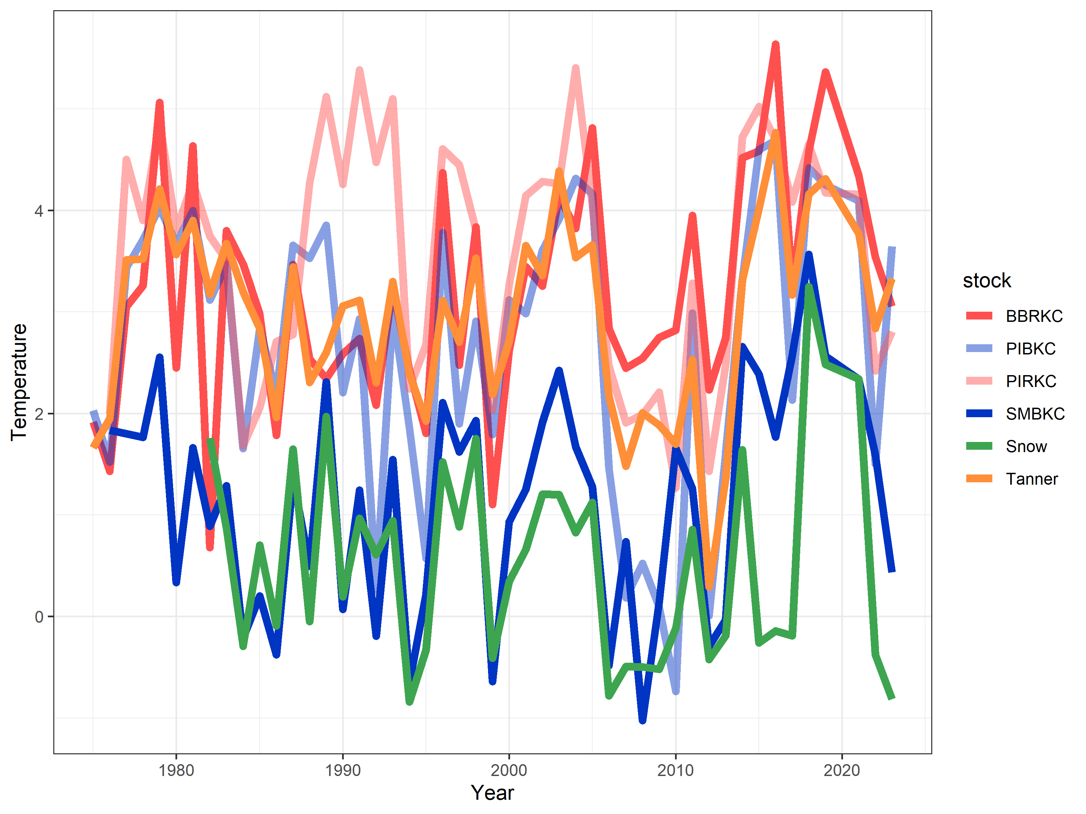

Figure S1. Temperature occupied by population.

Figure S2. Average size by population.
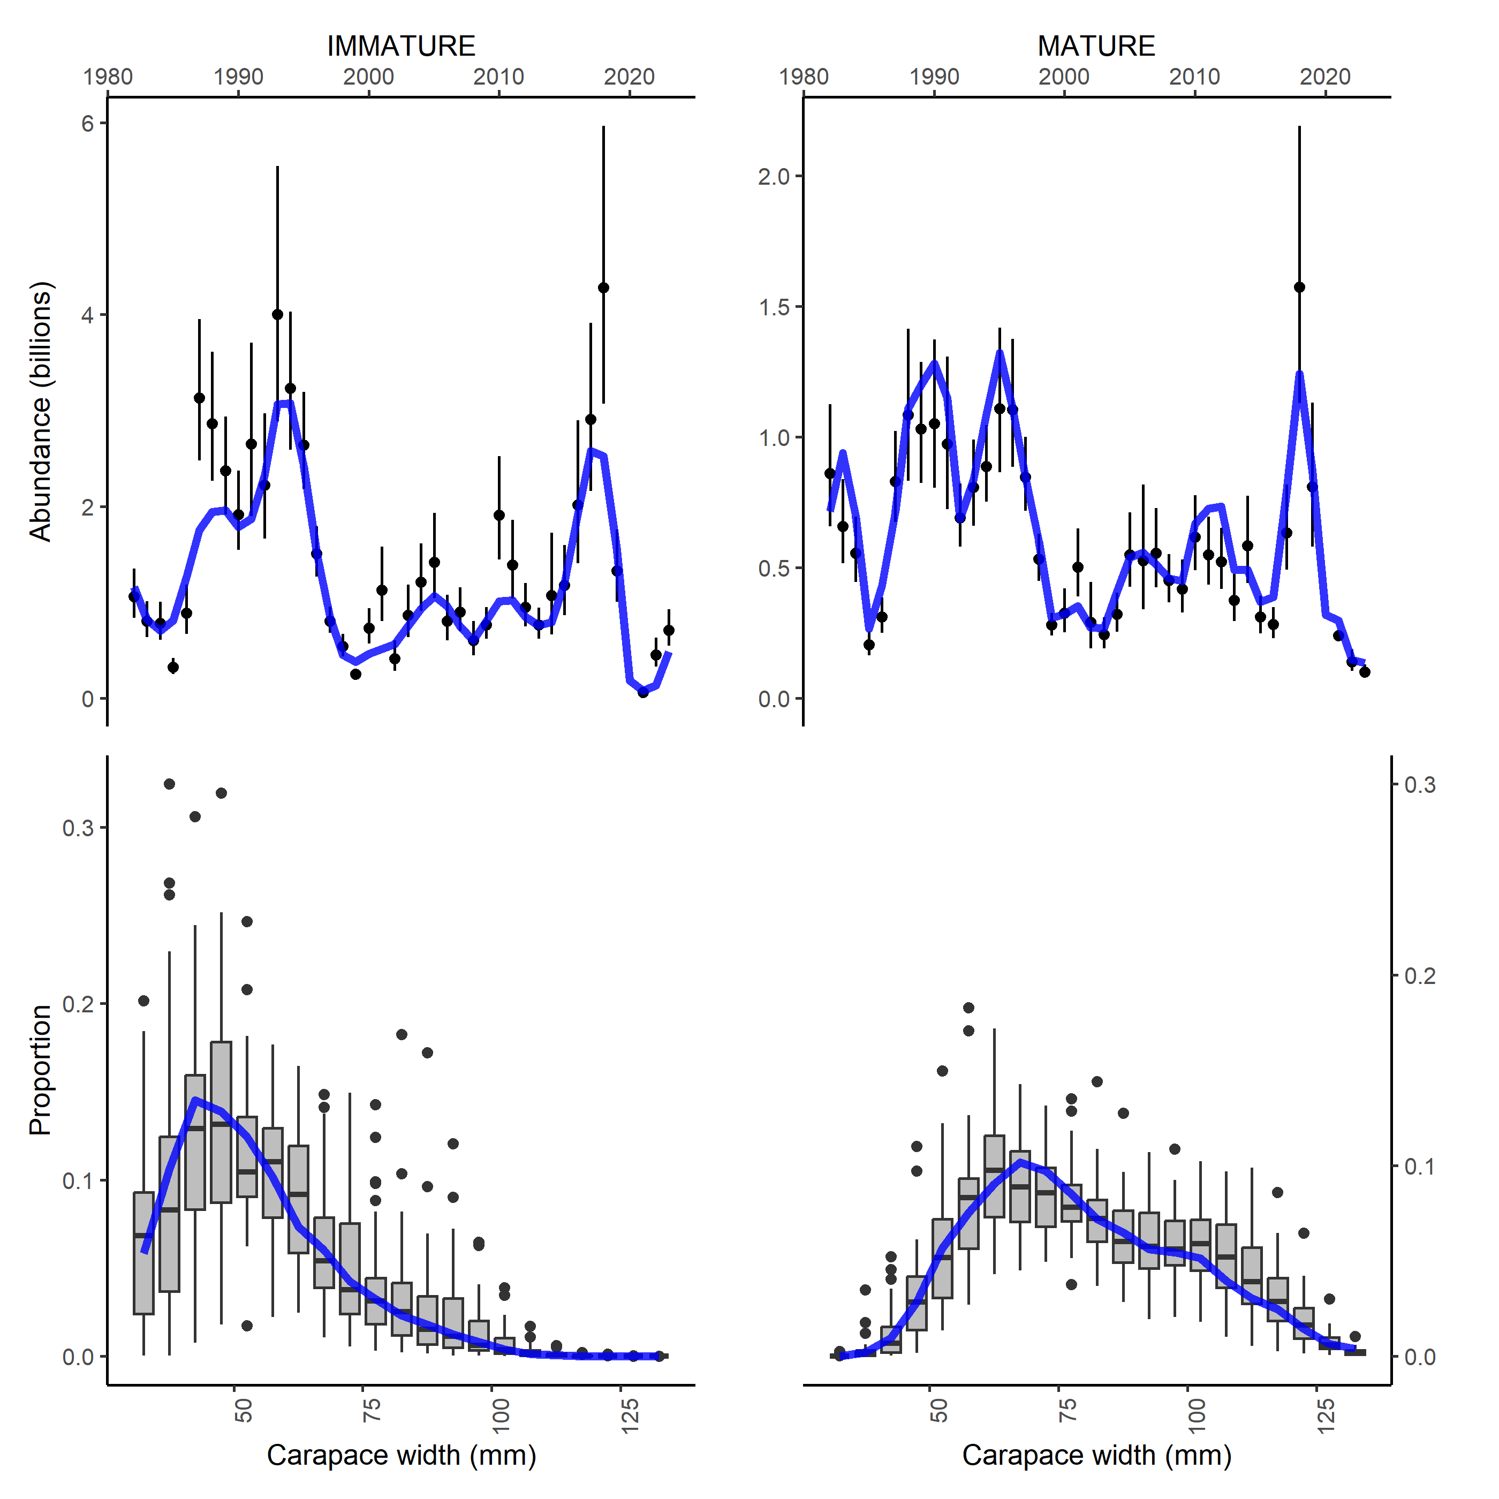
Figure S3. Fits to survey indices for snow crab.
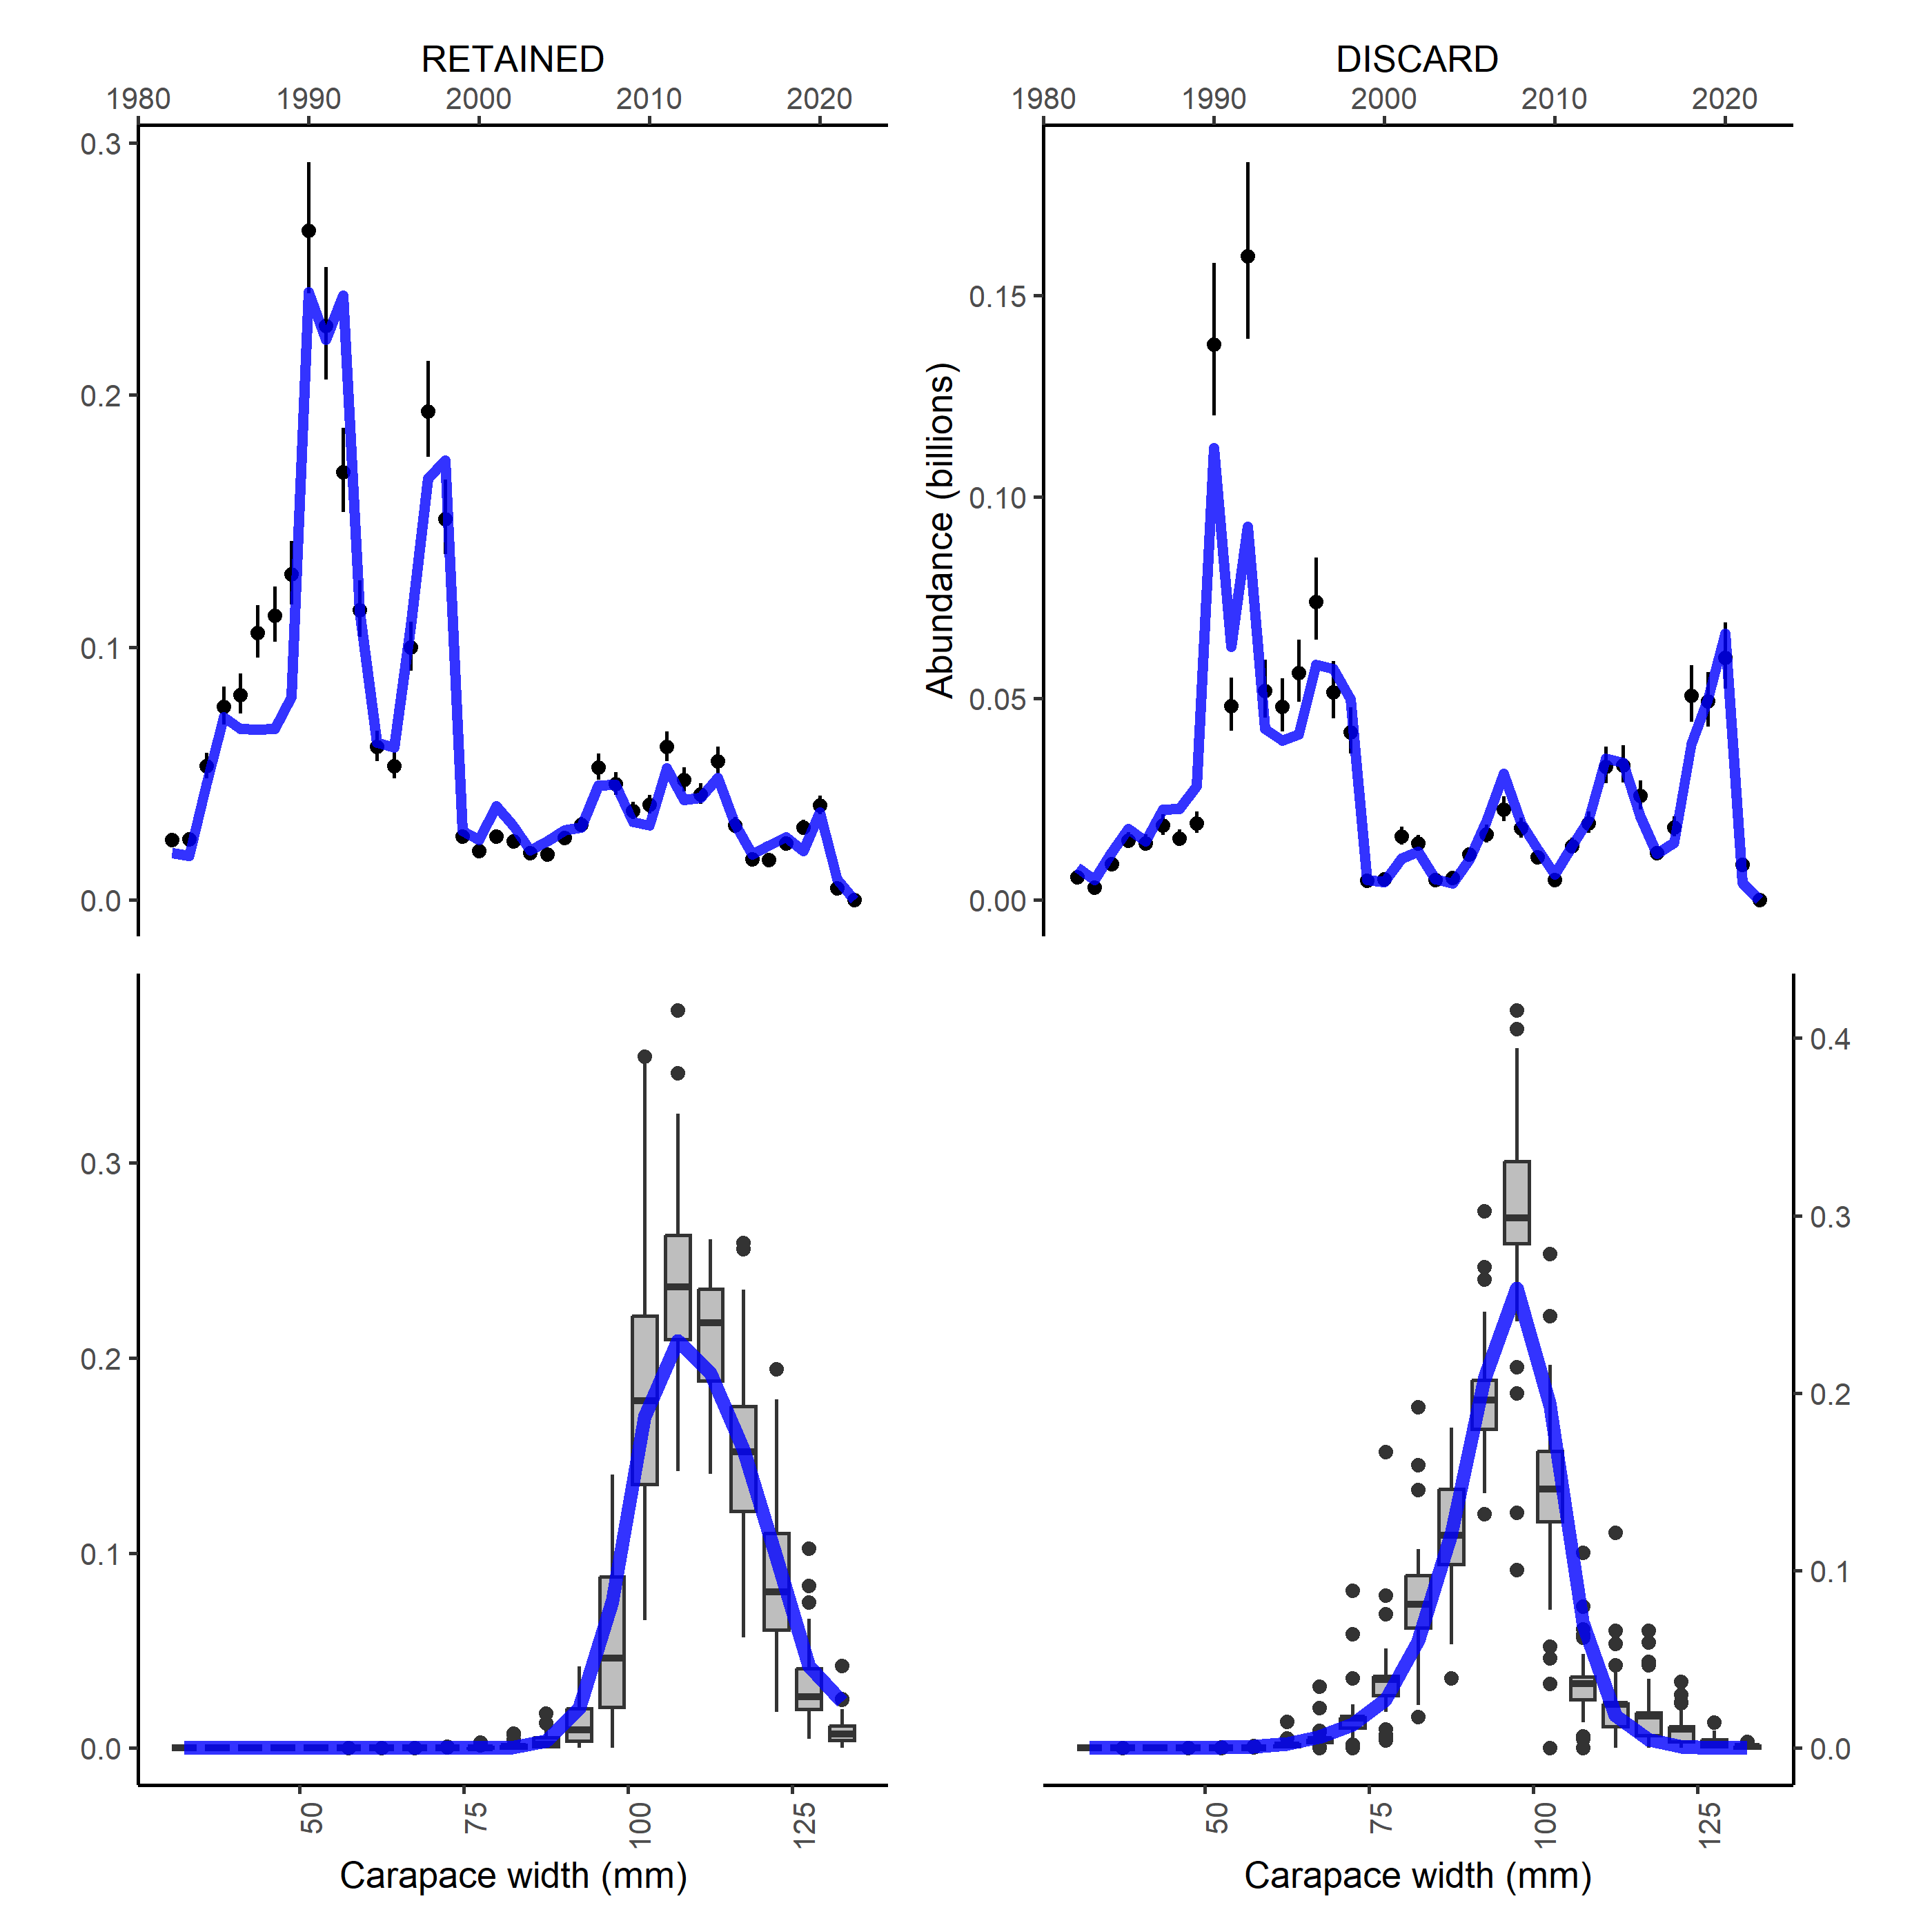
Figure S4. Fits to catch data for snow crab.
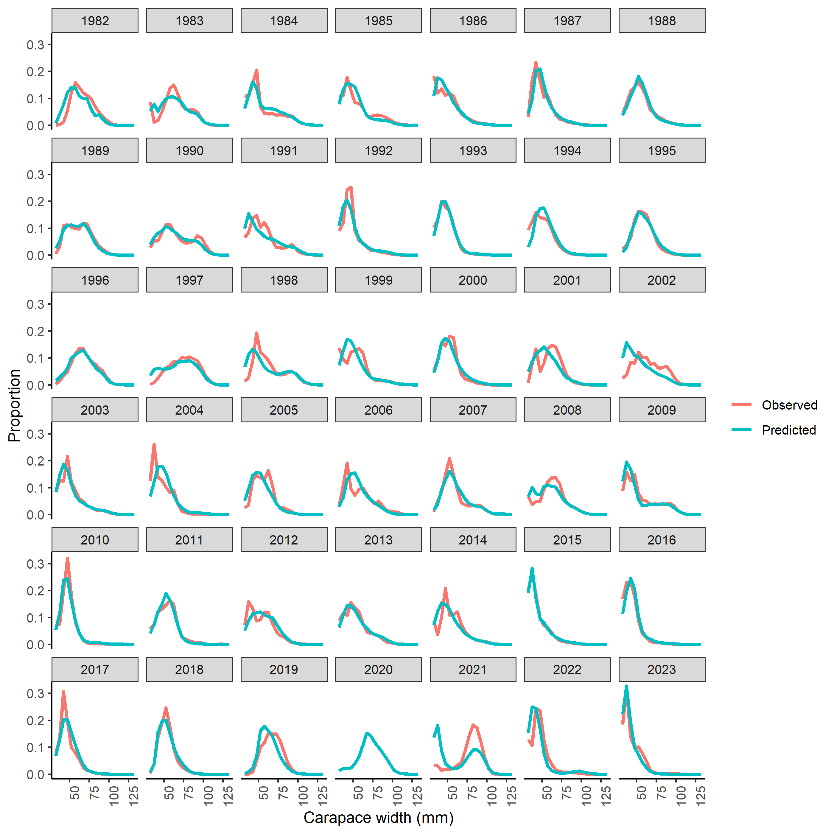
Figure S5. Fits to immature snow crab size composition data.

Figure S6. Fits to mature snow crab size composition data.

Figure S7. Fits to retained catch size composition data for snow crab.

Figure S8. Fits to discarded catch size composition data for snow crab.

Figure S9. Estimated and specified population processes for snow crab. Growth transition matrix (top), survey selectivity (bottom left), fishery selectivity (bottom middle), and probability of undergoing terminal molt (bottom right).
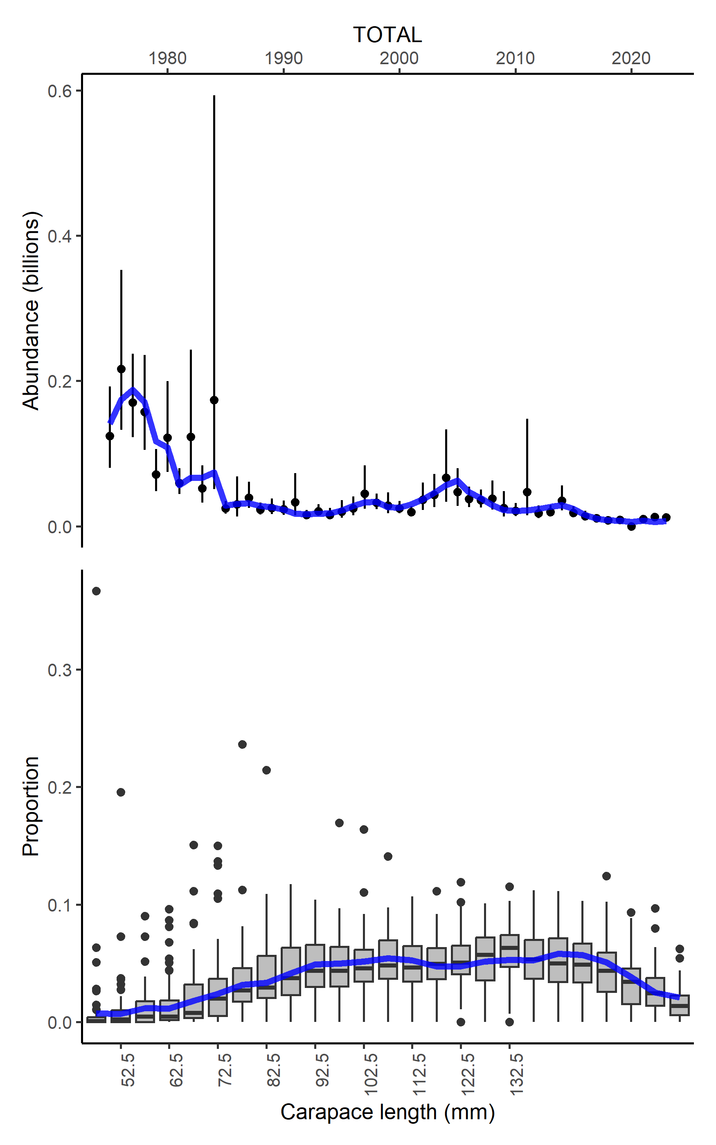
Figure S10. Fits to survey index of abundance for BBRKC.

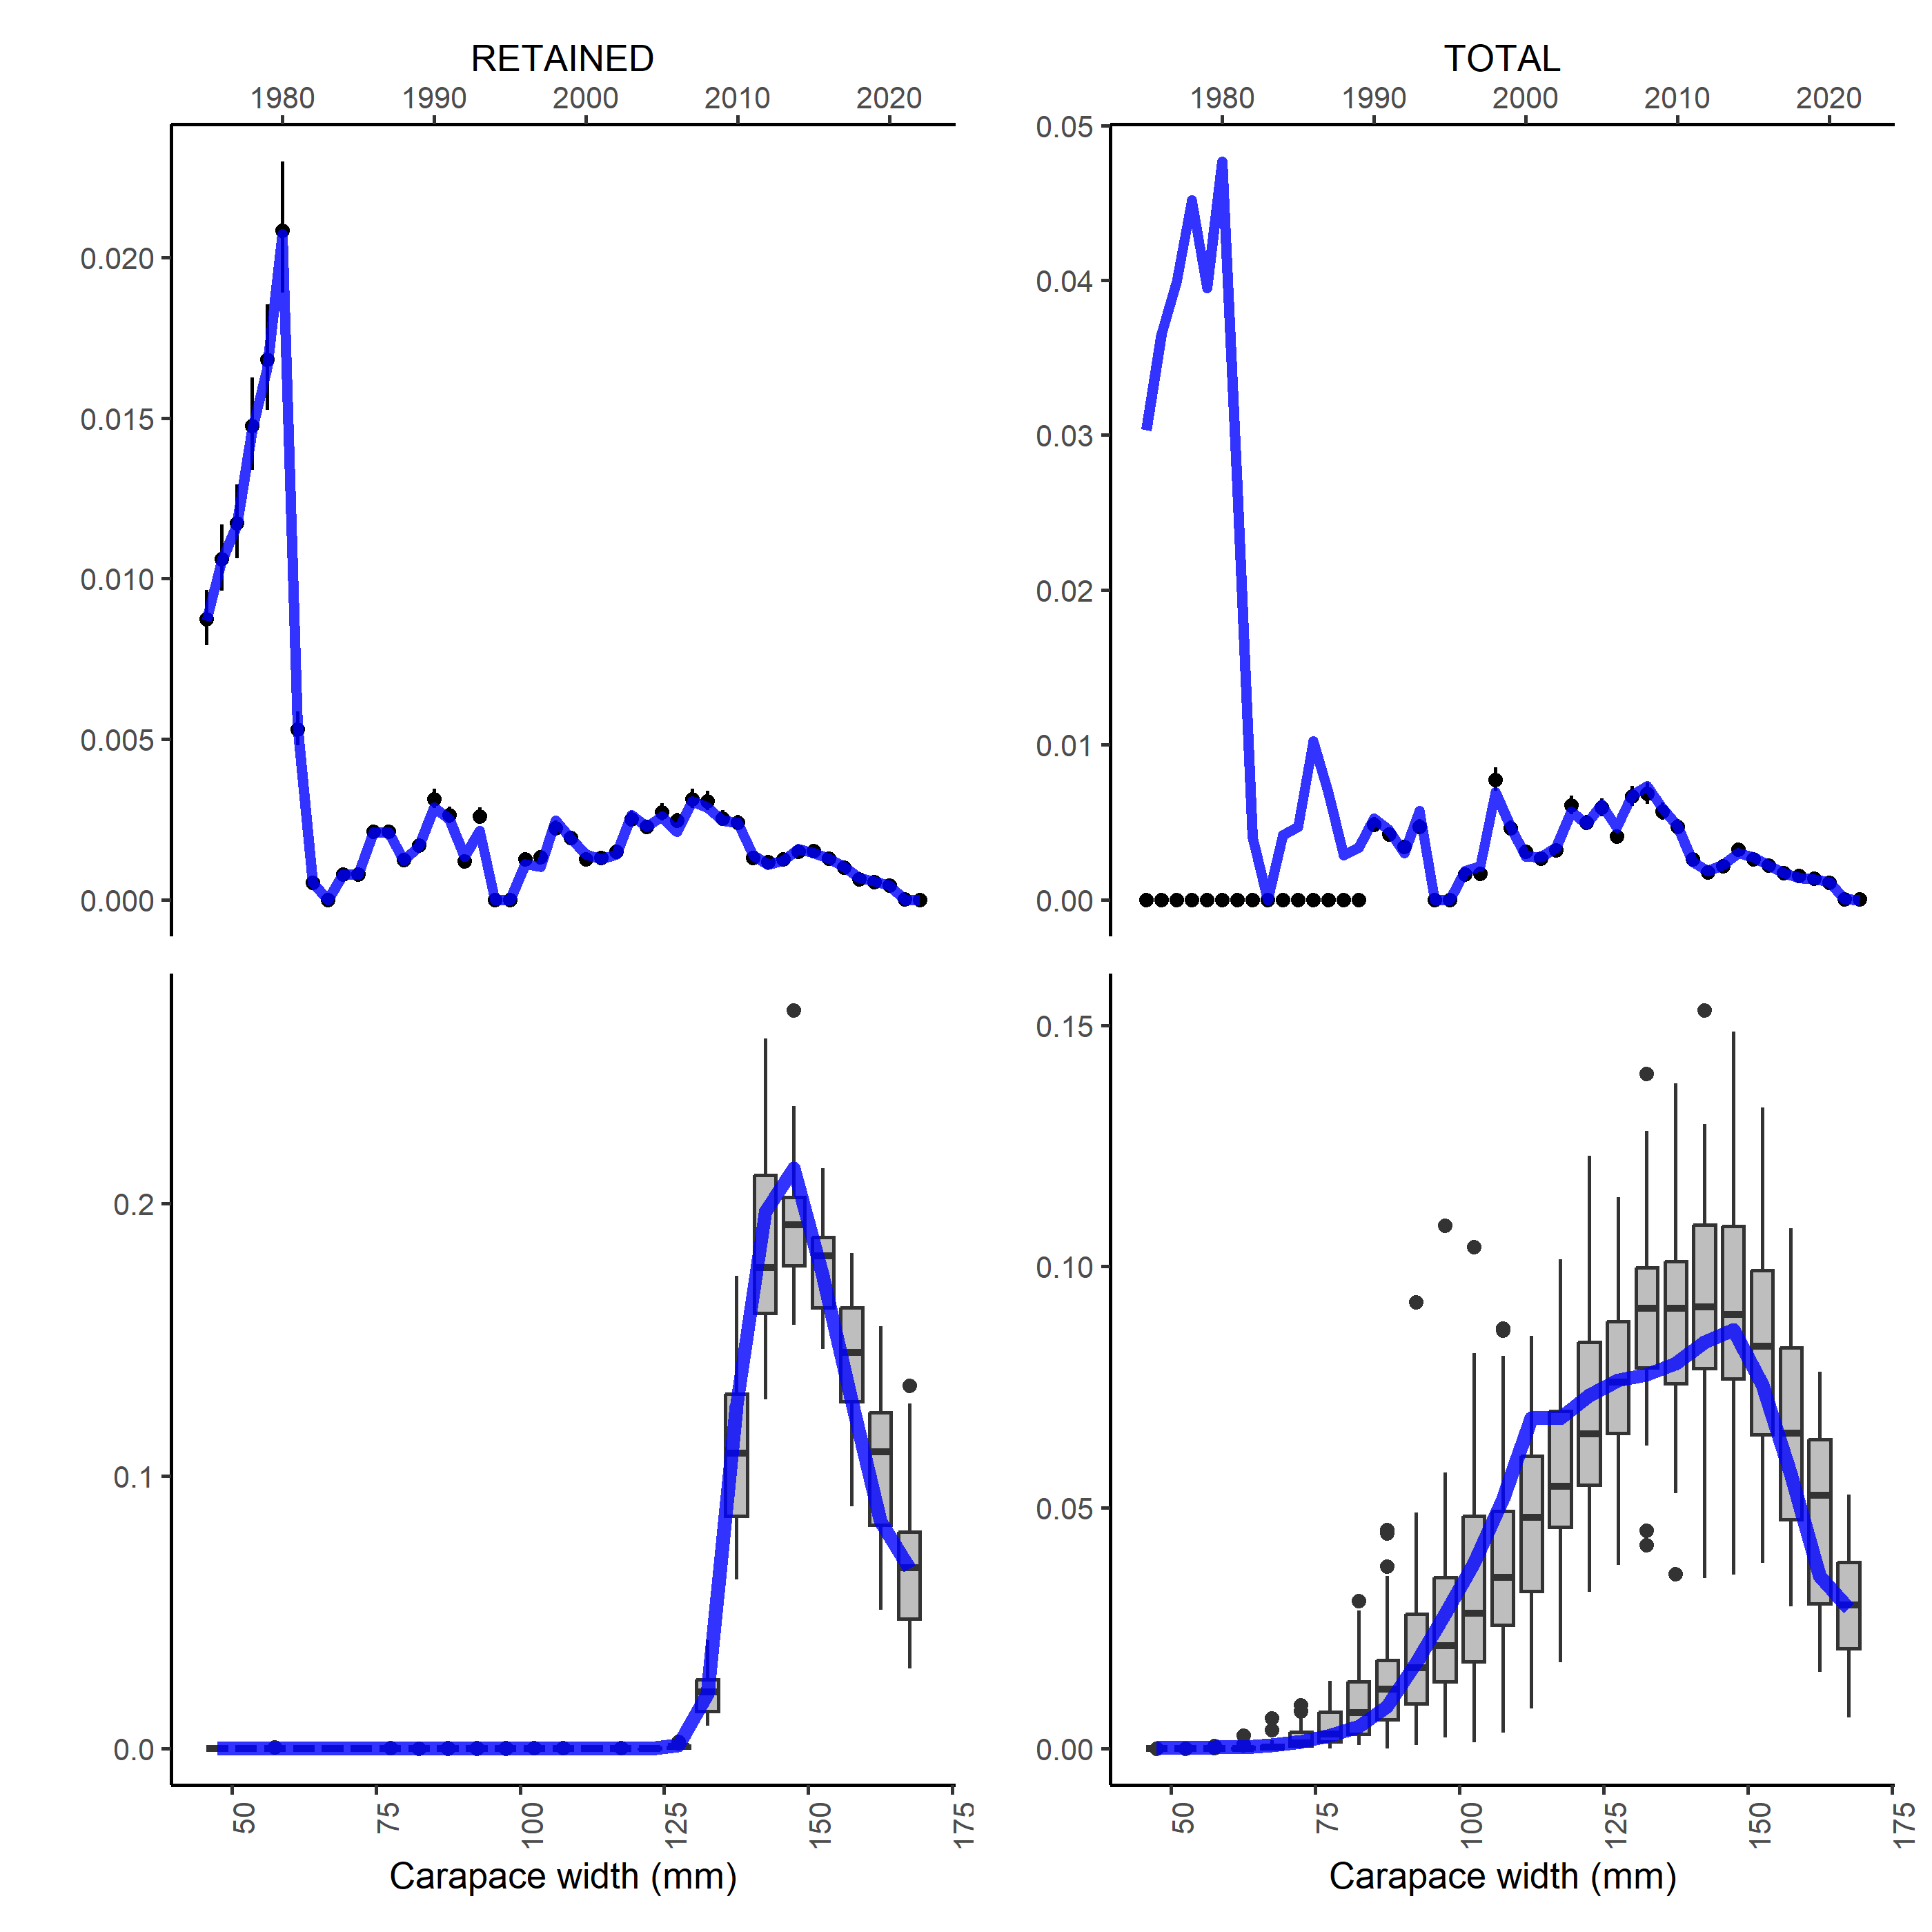
Figure S11. Fits to retained and total catch for BBRKC.

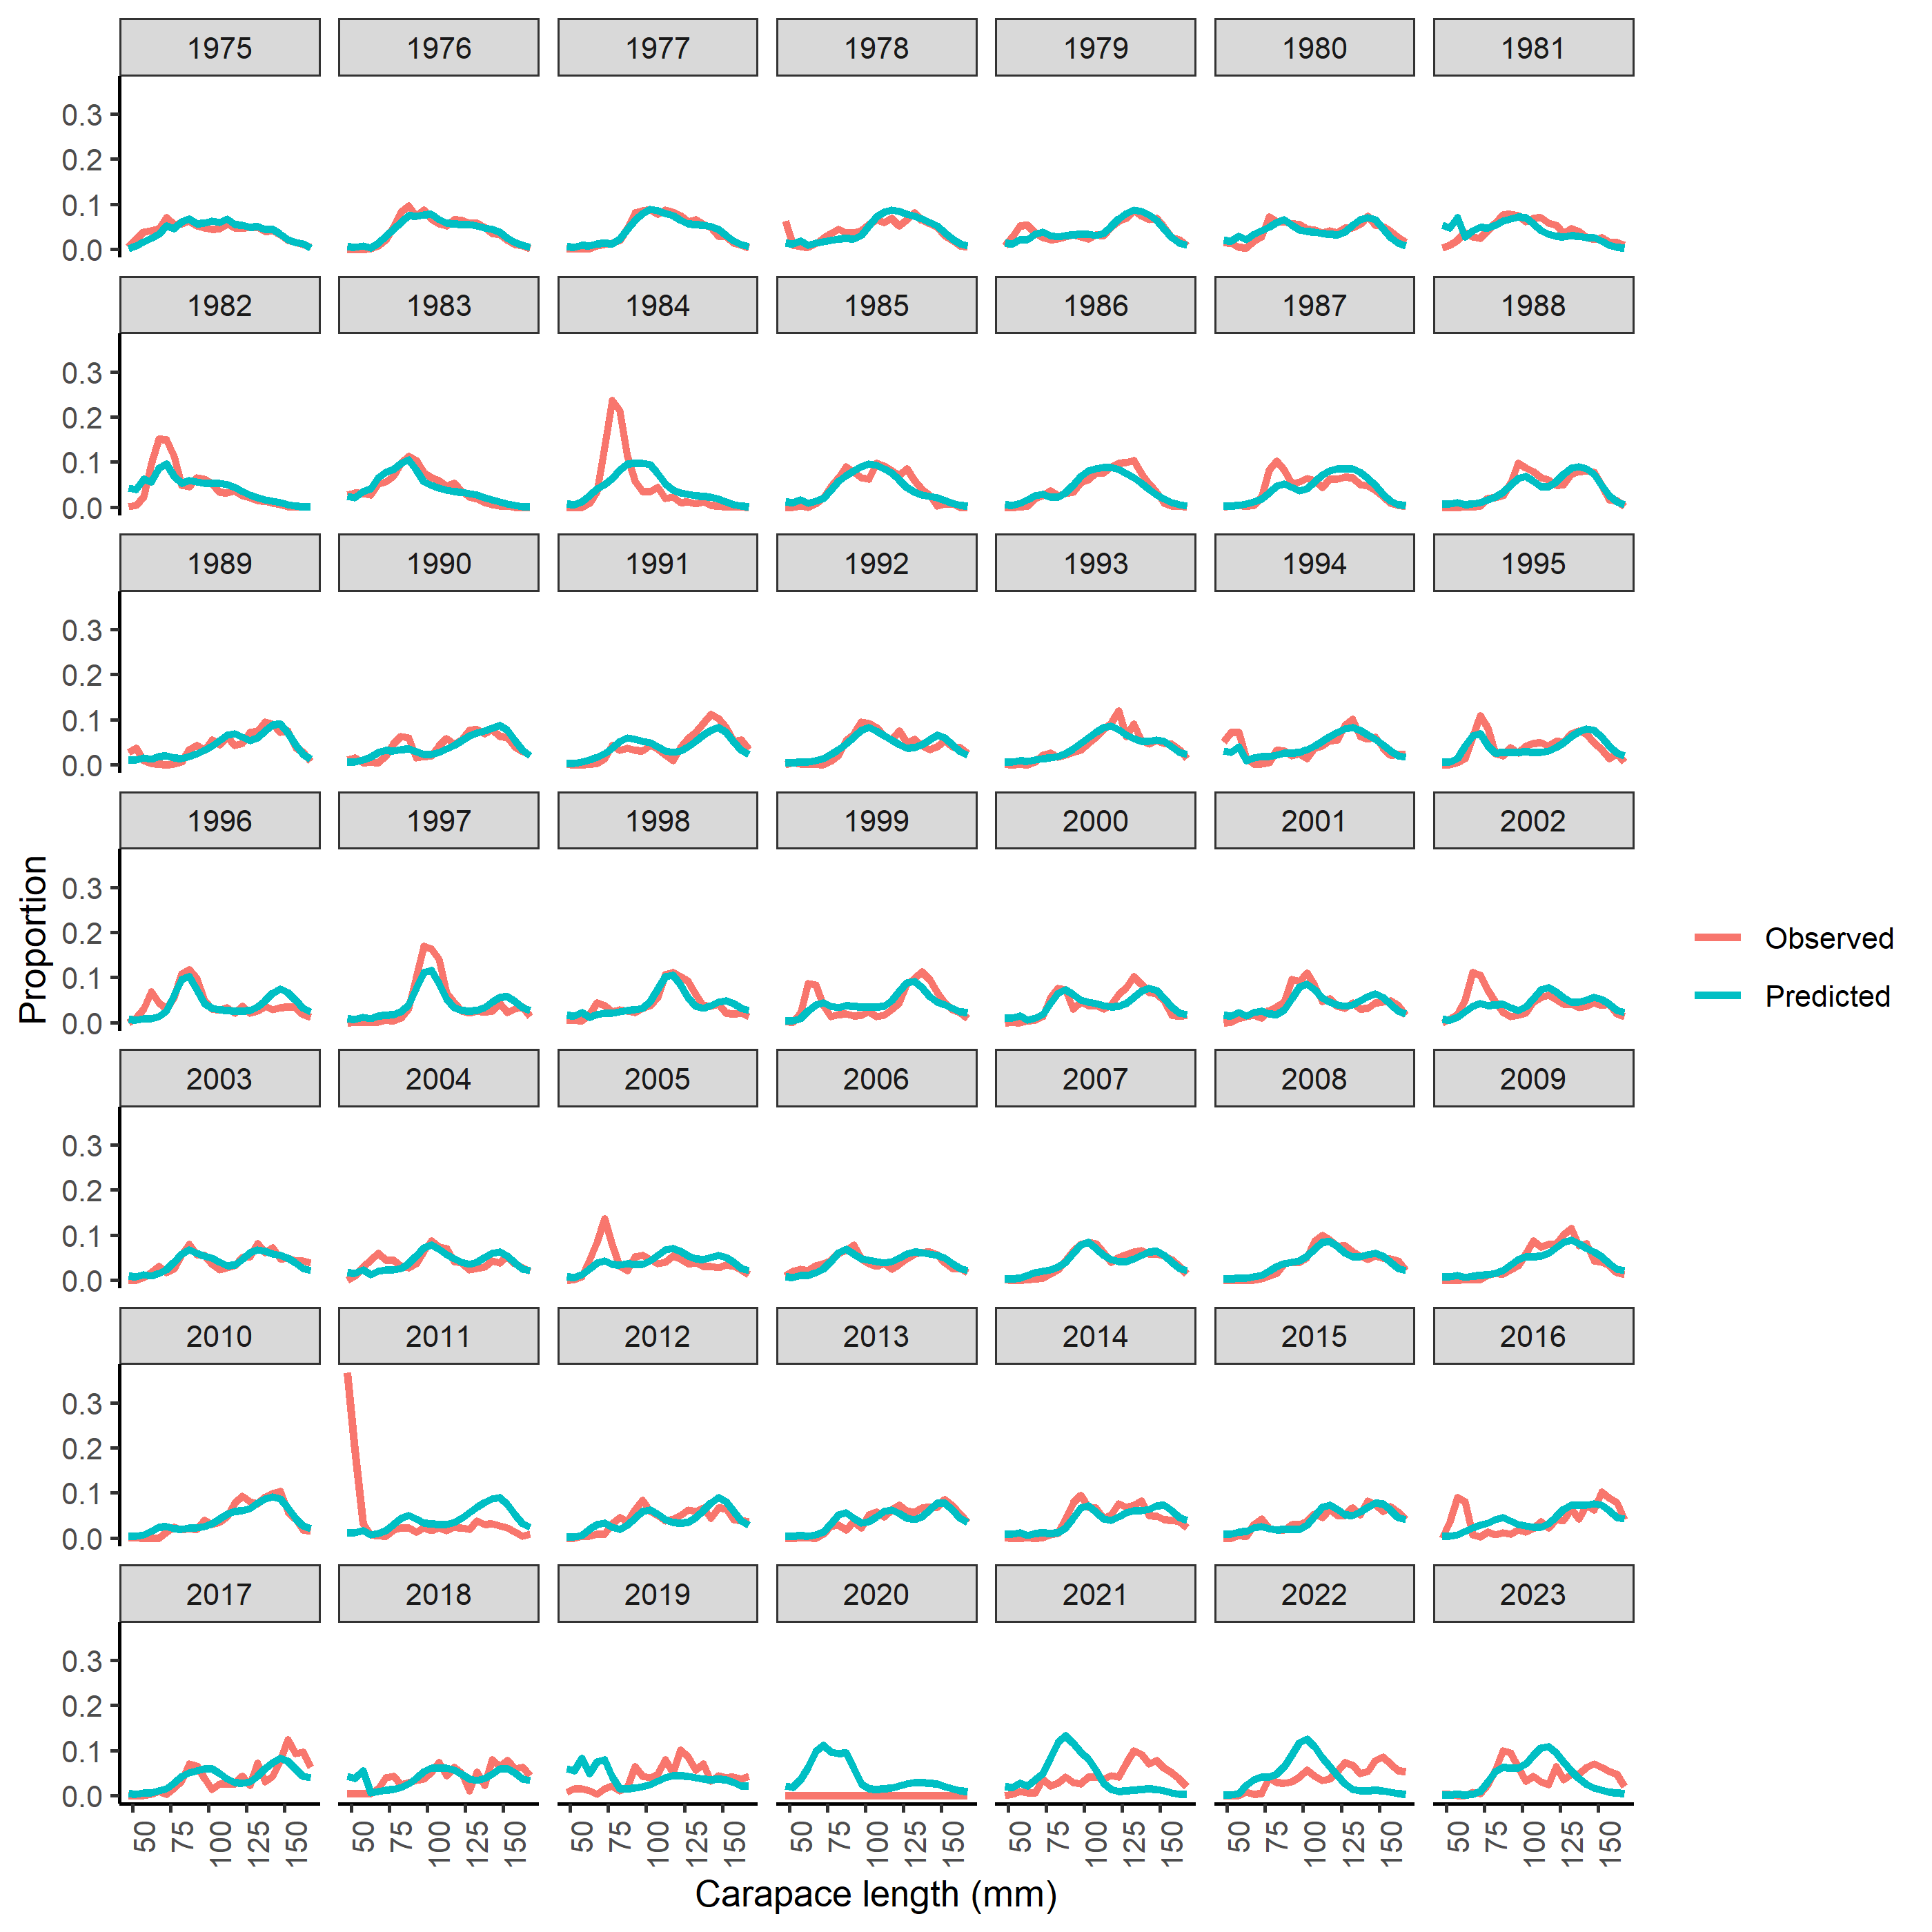
Figure S12. Fits to survey size composition data for BBRKC.

Figure S13. Fits to retained size composition data for BBRKC.
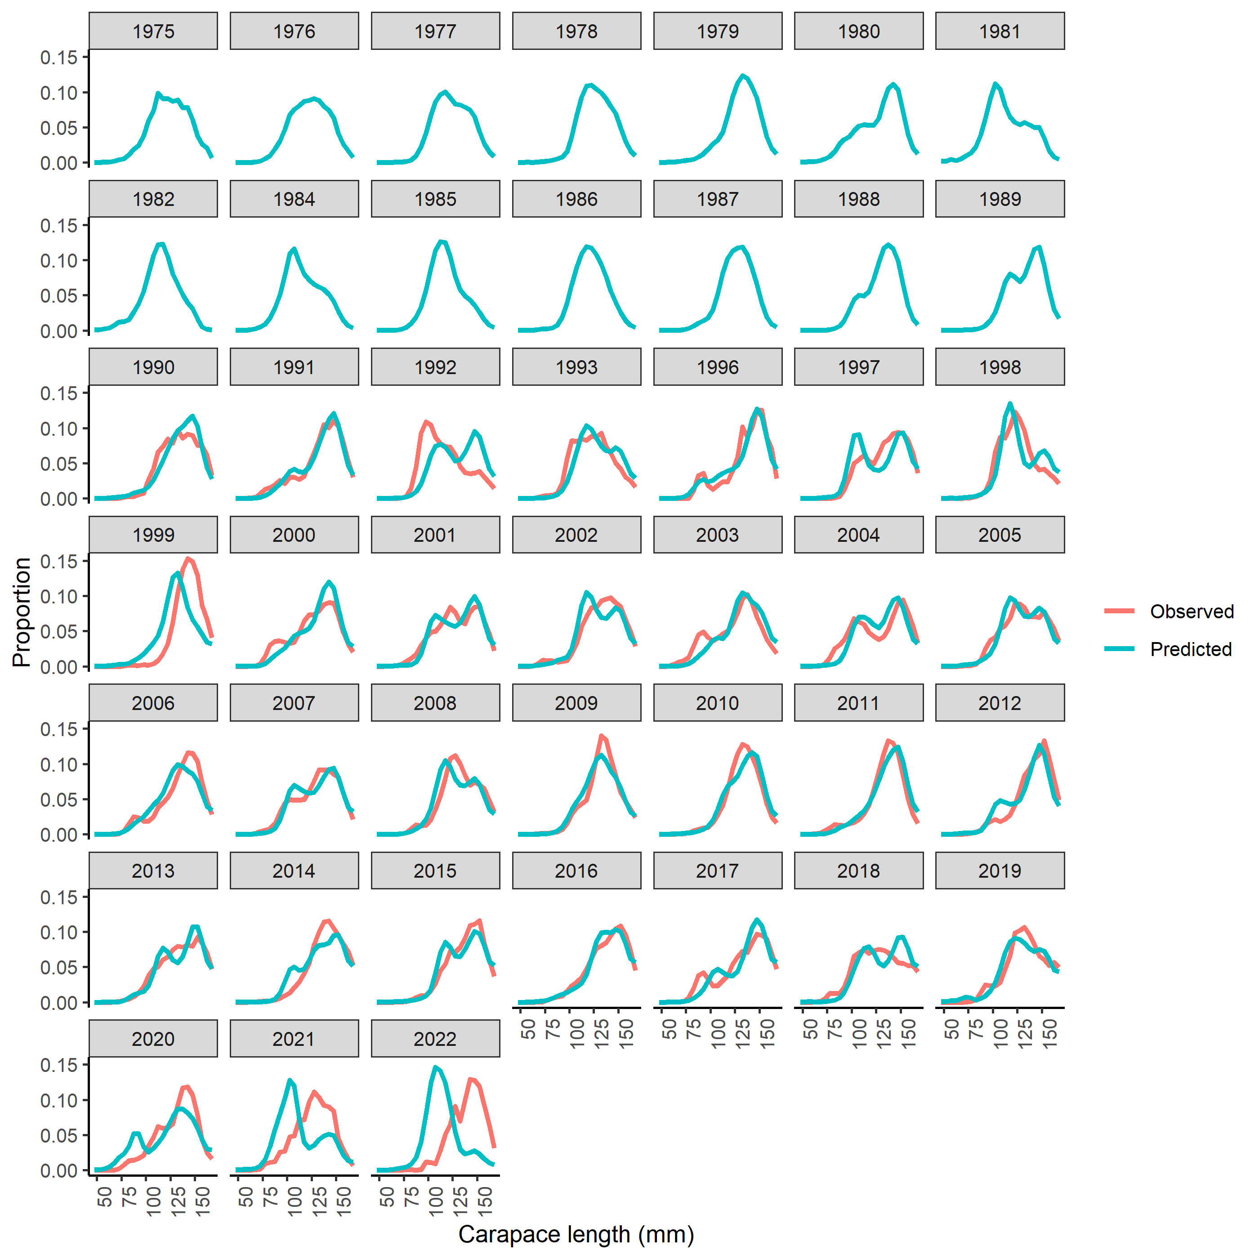
Figure S14. Fits to total size composition data for BBRKC.
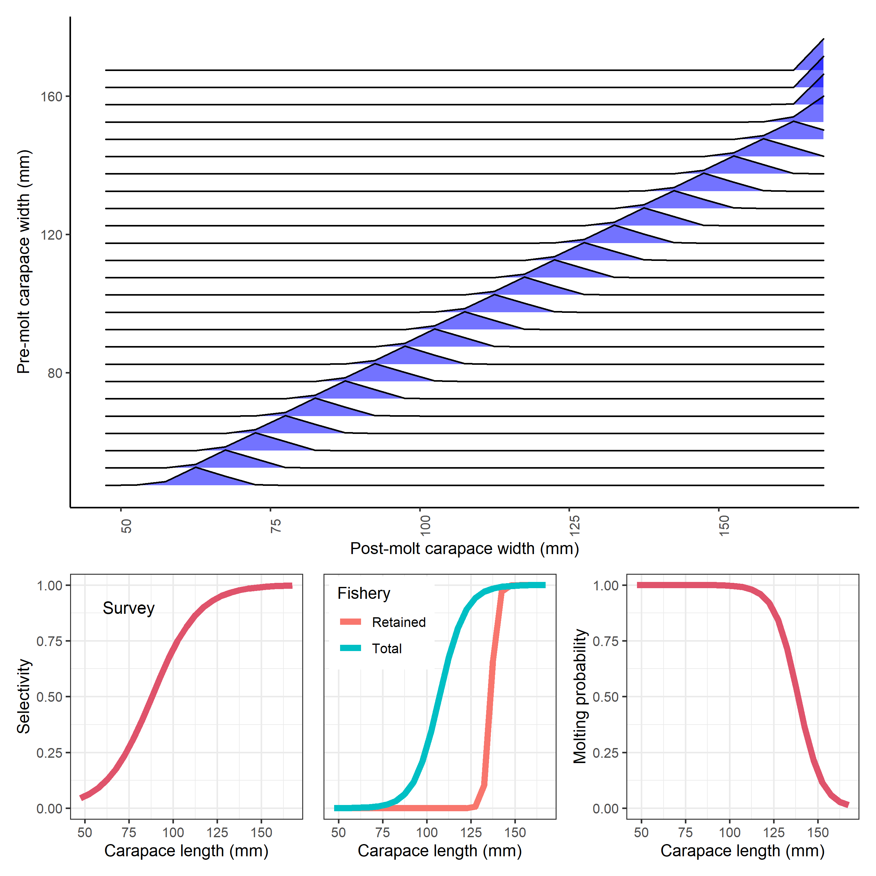
Figure S15. Estimated and specified population processes for BBRKC. Growth transition matrix (top), survey selectivity (bottom left), fishery selectivity (bottom middle), and probability of undergoing terminal molt (bottom right).
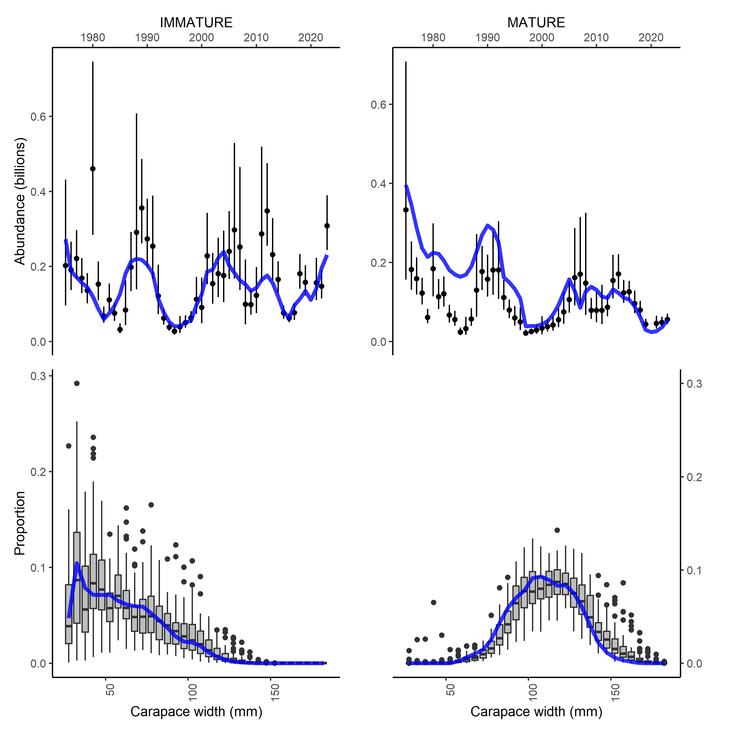
Figure S16. Fits to survey indices for Tanner crab.
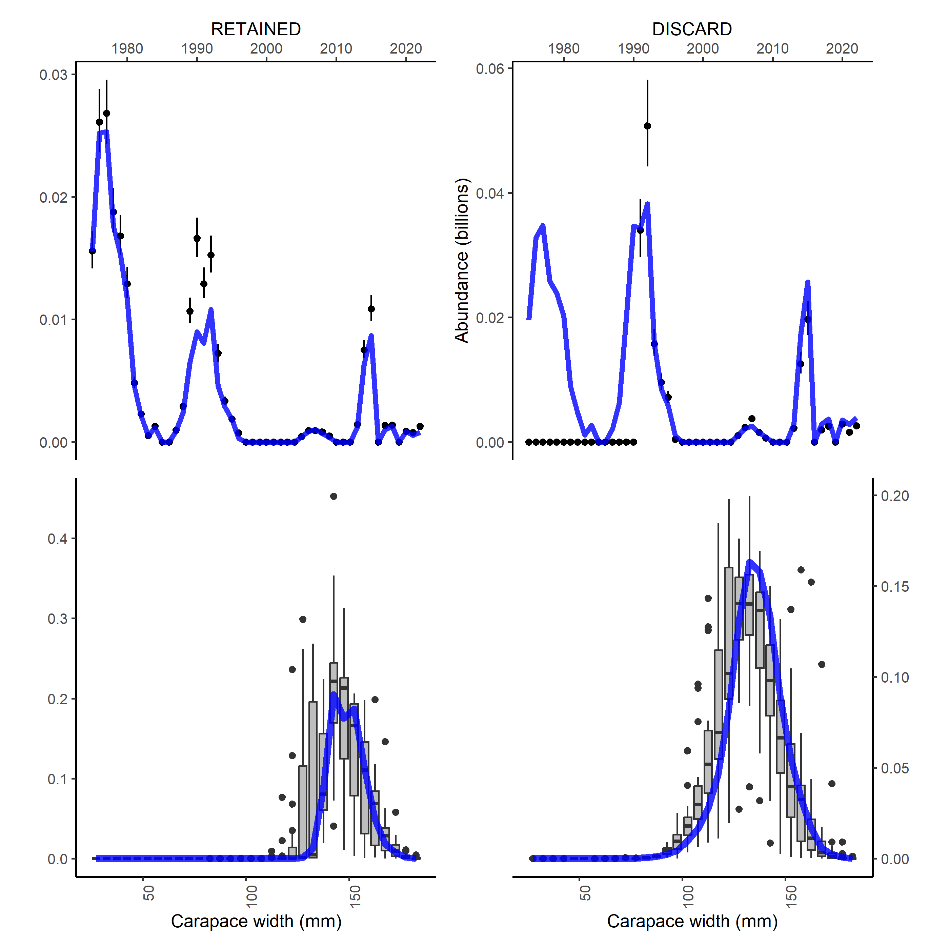
Figure S17. Fits to catch data for Tanner crab.
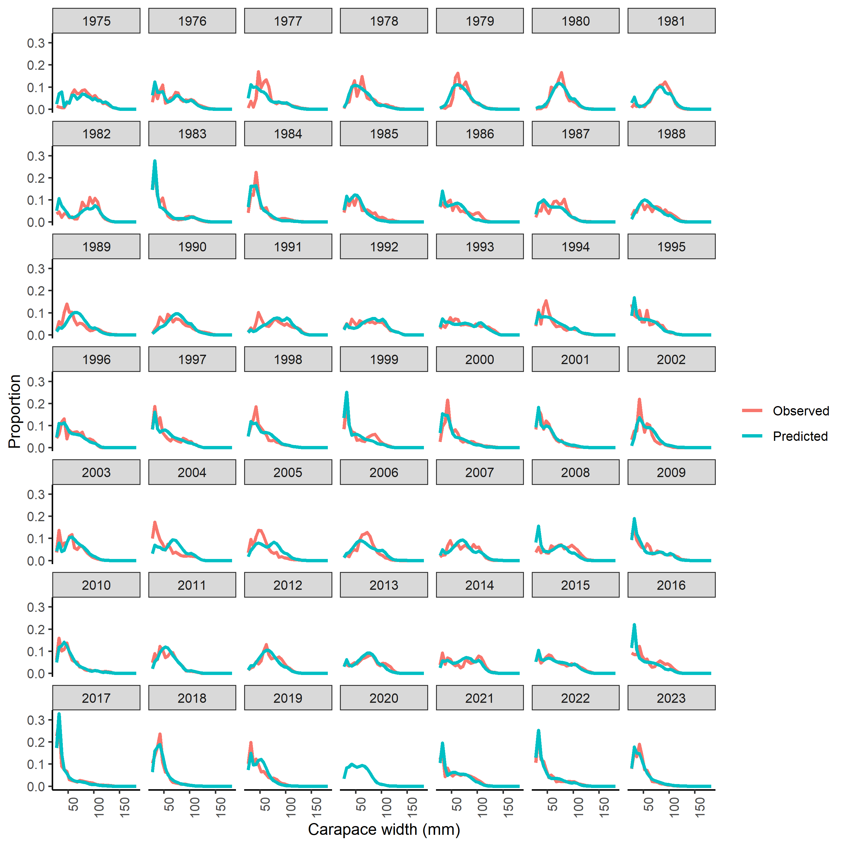
Figure S18. Fits to immature Tanner crab size composition data.

Figure S19. Fits to mature Tanner crab size composition data.
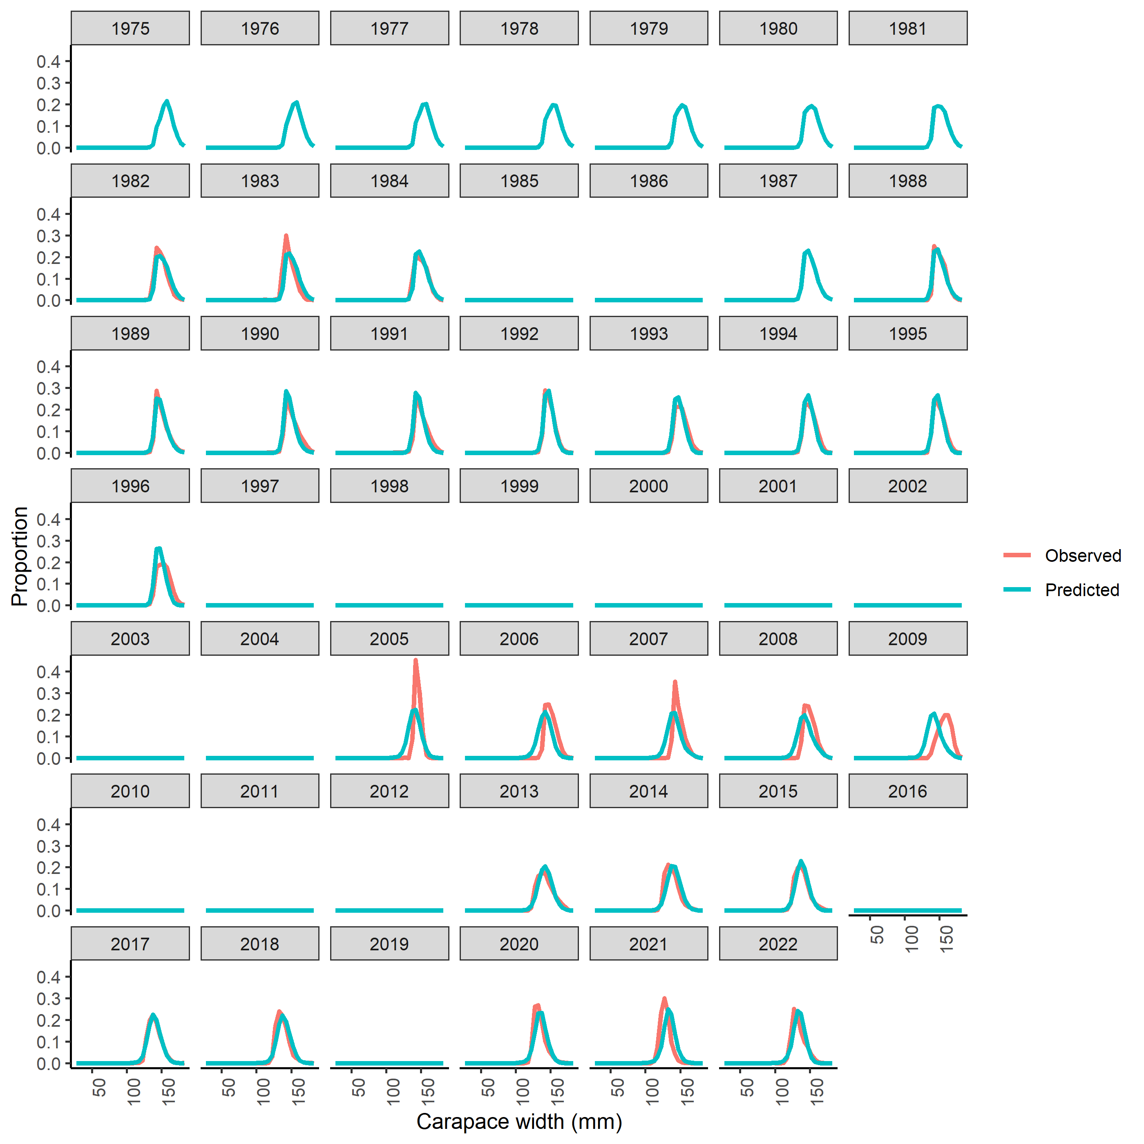
Figure S20. Fits to retained catch size composition data for Tanner crab.

Figure S21. Fits to discarded catch size composition data for Tanner crab.

Figure S22. Estimated and specified population processes for Tanner crab. Growth transition matrix (top), survey selectivity (bottom left), fishery selectivity (bottom middle), and probability of undergoing terminal molt (bottom right).
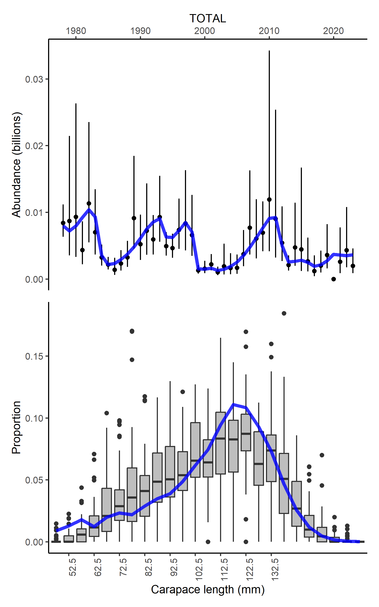
Figure S23. Fits to survey index of abundance for SMBKC.
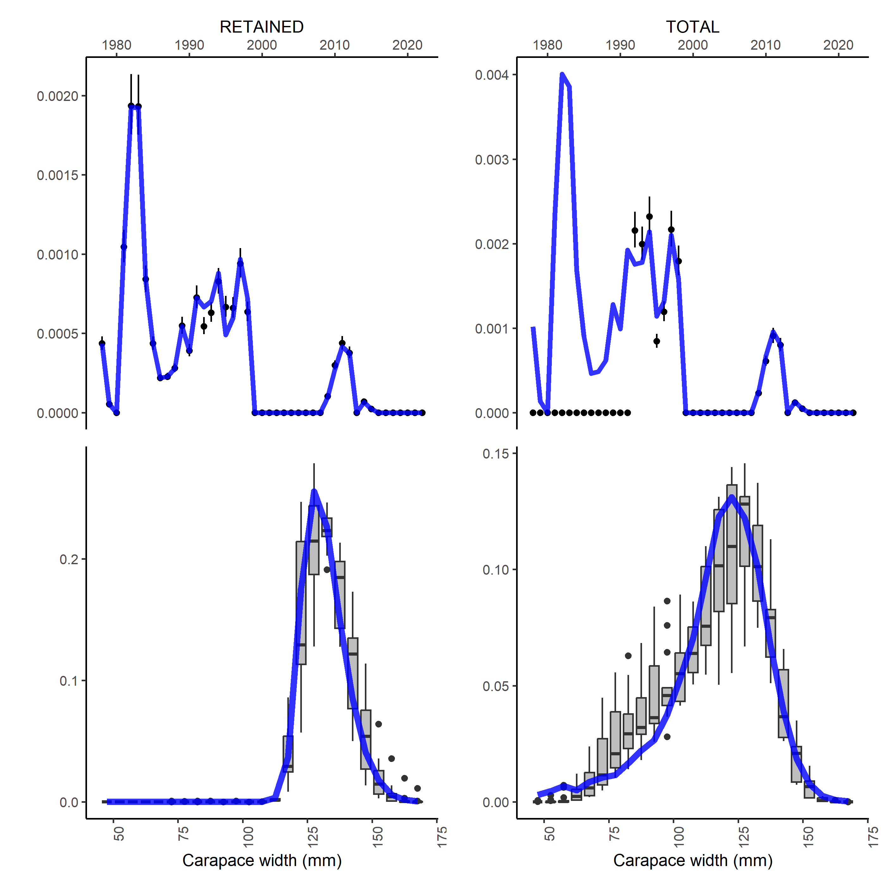
Figure S24. Fits to retained and total catch for SMBKC.

Figure S25. Fits to survey size composition data for SMBKC.
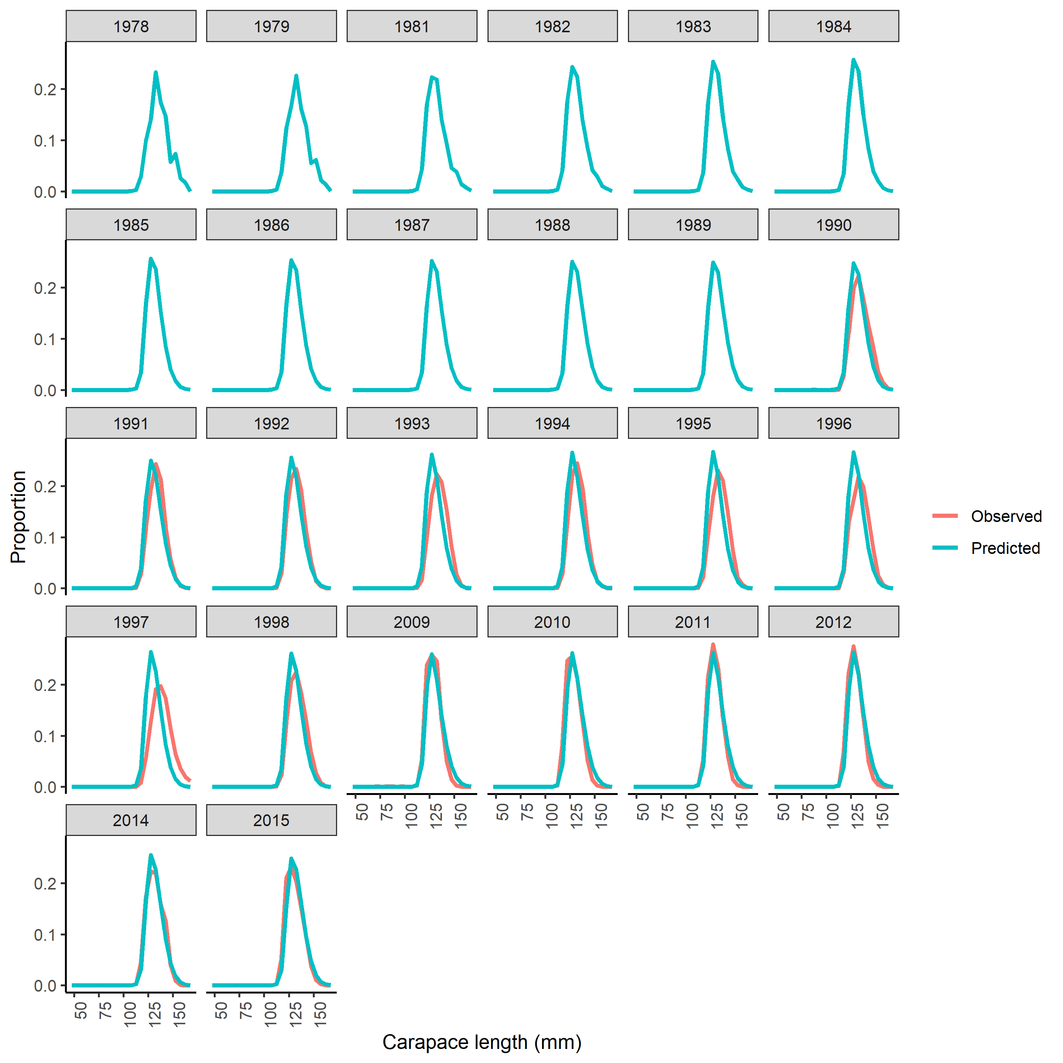
Figure S26. Fits to retained size composition data for SMBKC.
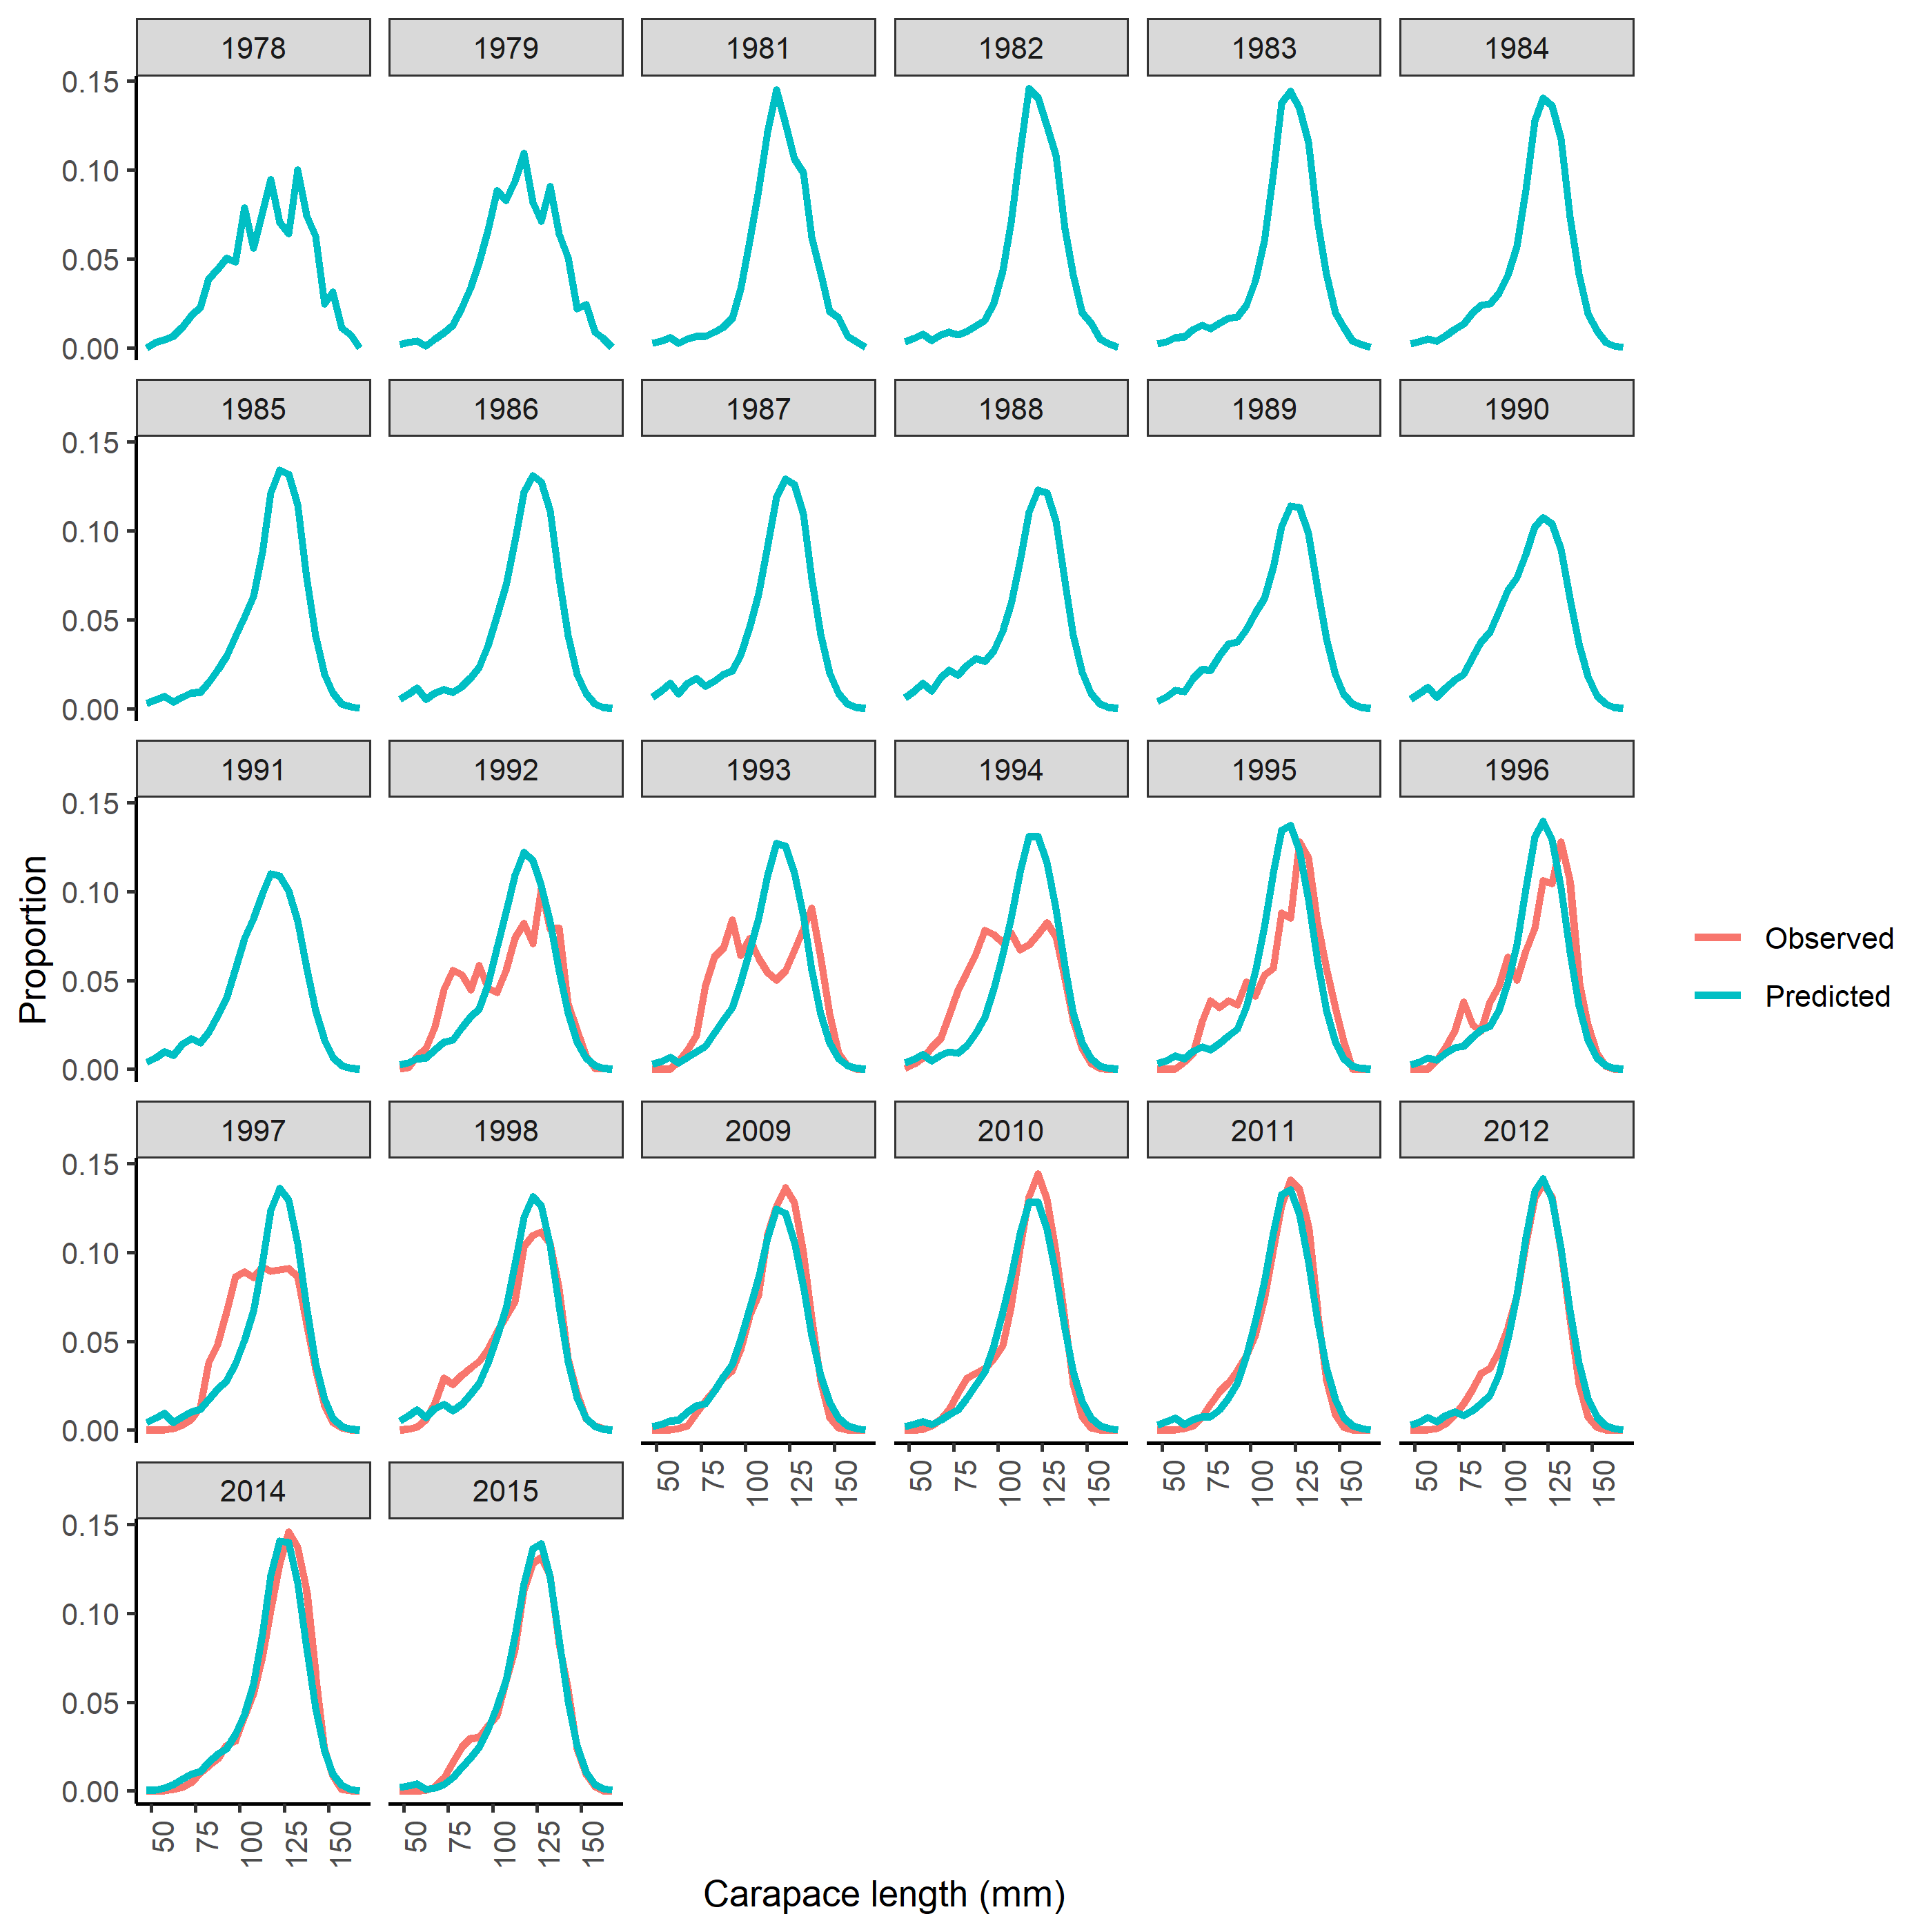 Figure S27. Fits to total size composition data for SMBKC.
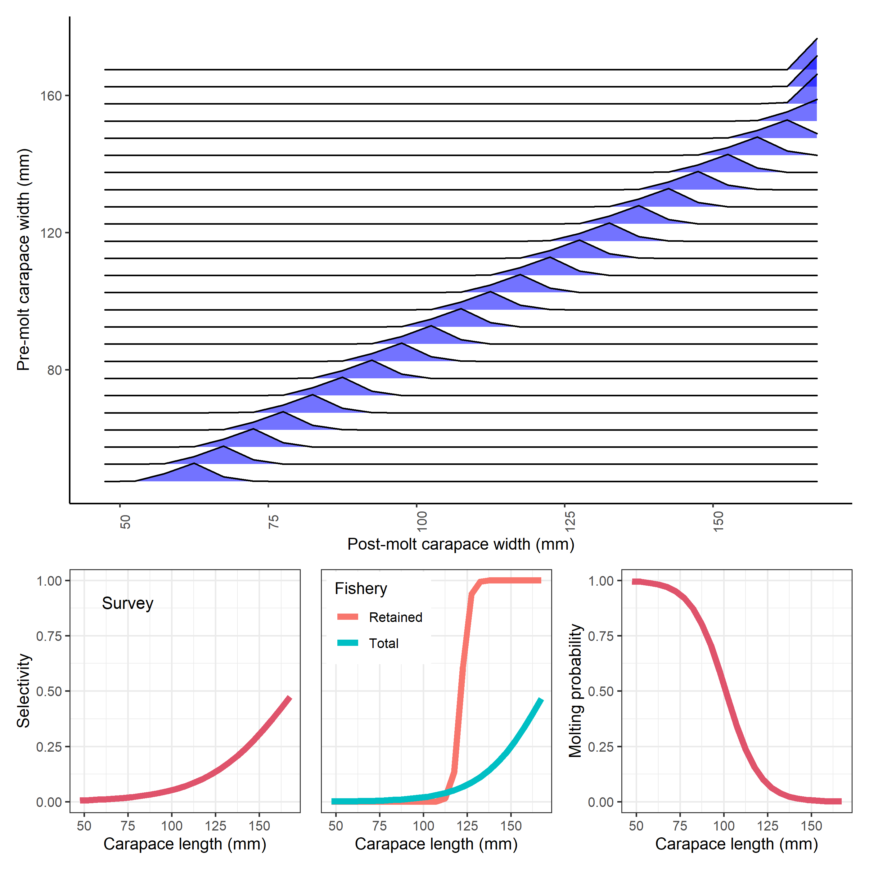 Figure S28. Estimated and specified population processes for SMBKC. Growth transition matrix (top), survey selectivity (bottom left), fishery selectivity (bottom middle), and probability of undergoing terminal molt (bottom right).
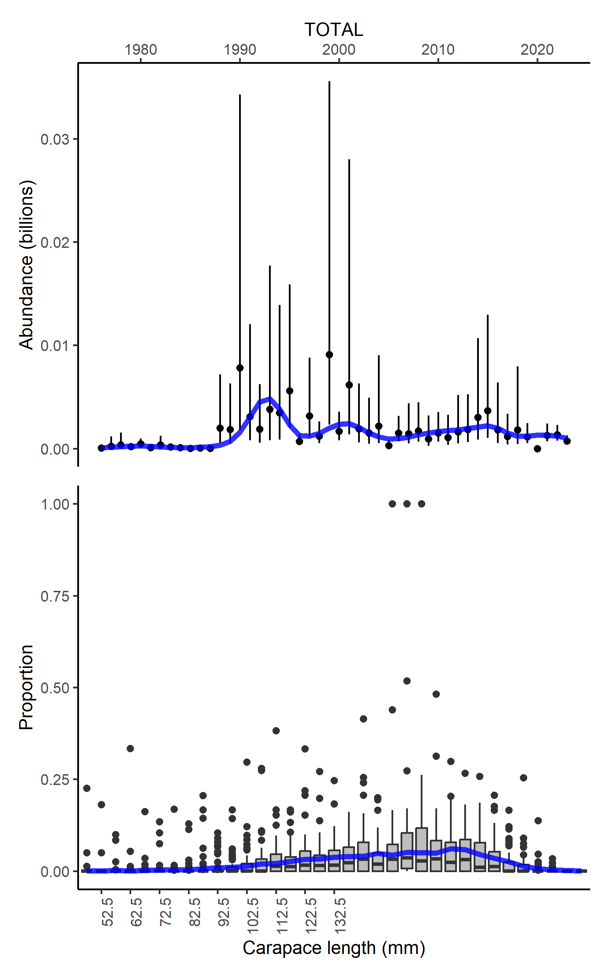
Figure S29. Fits to survey index of abundance for PIRKC.
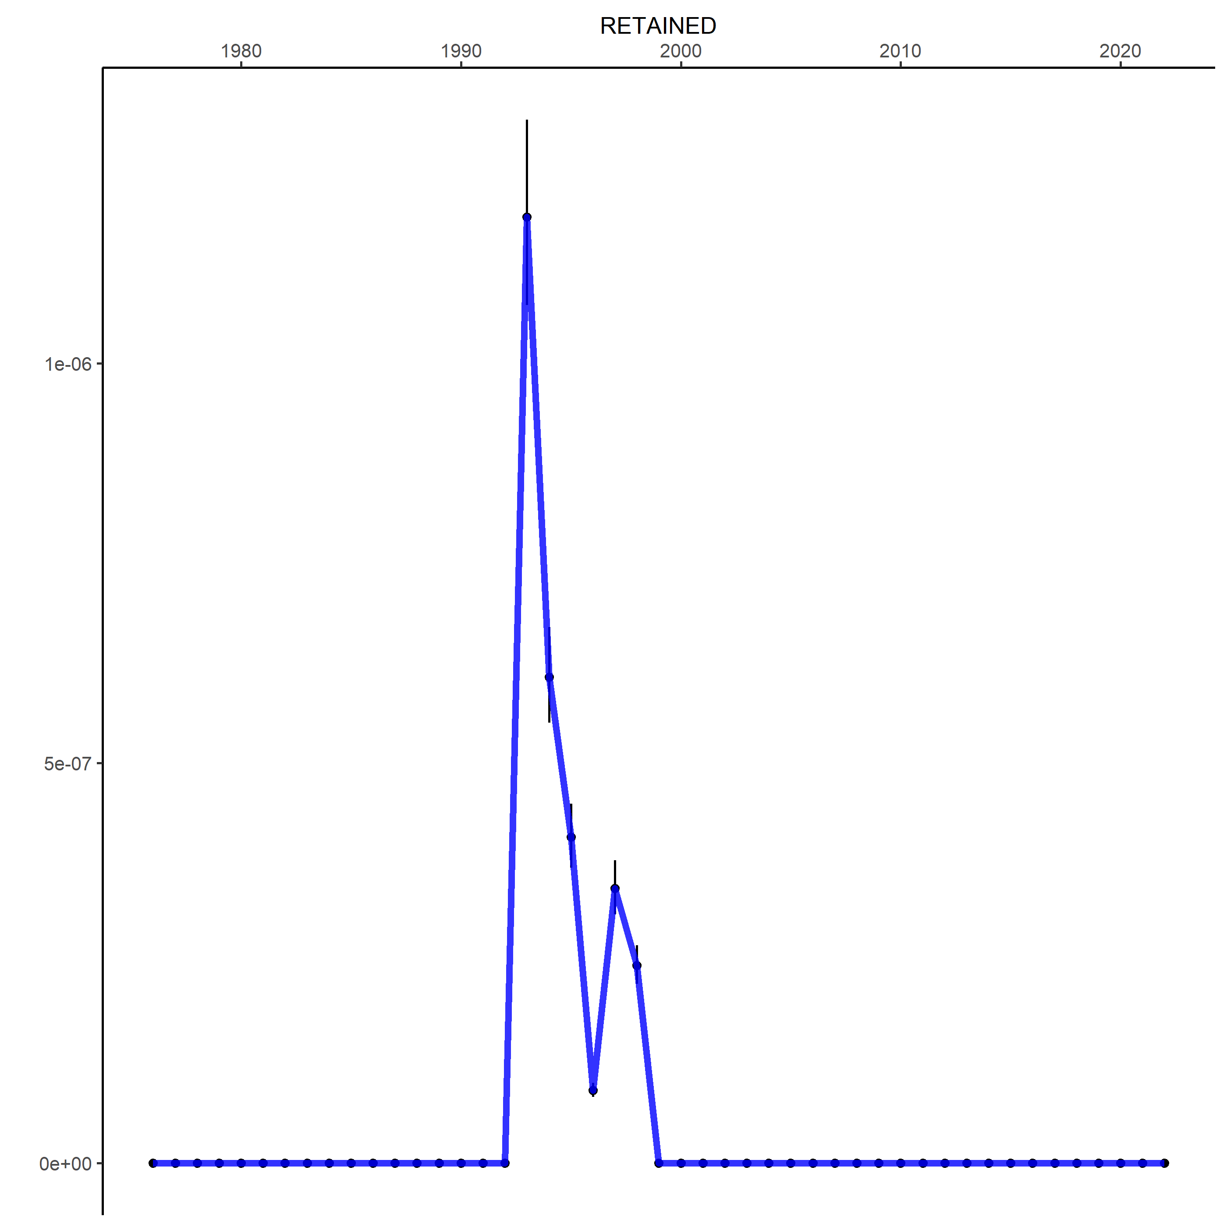
Figure S30. Fits to retained catch for PIRKC.
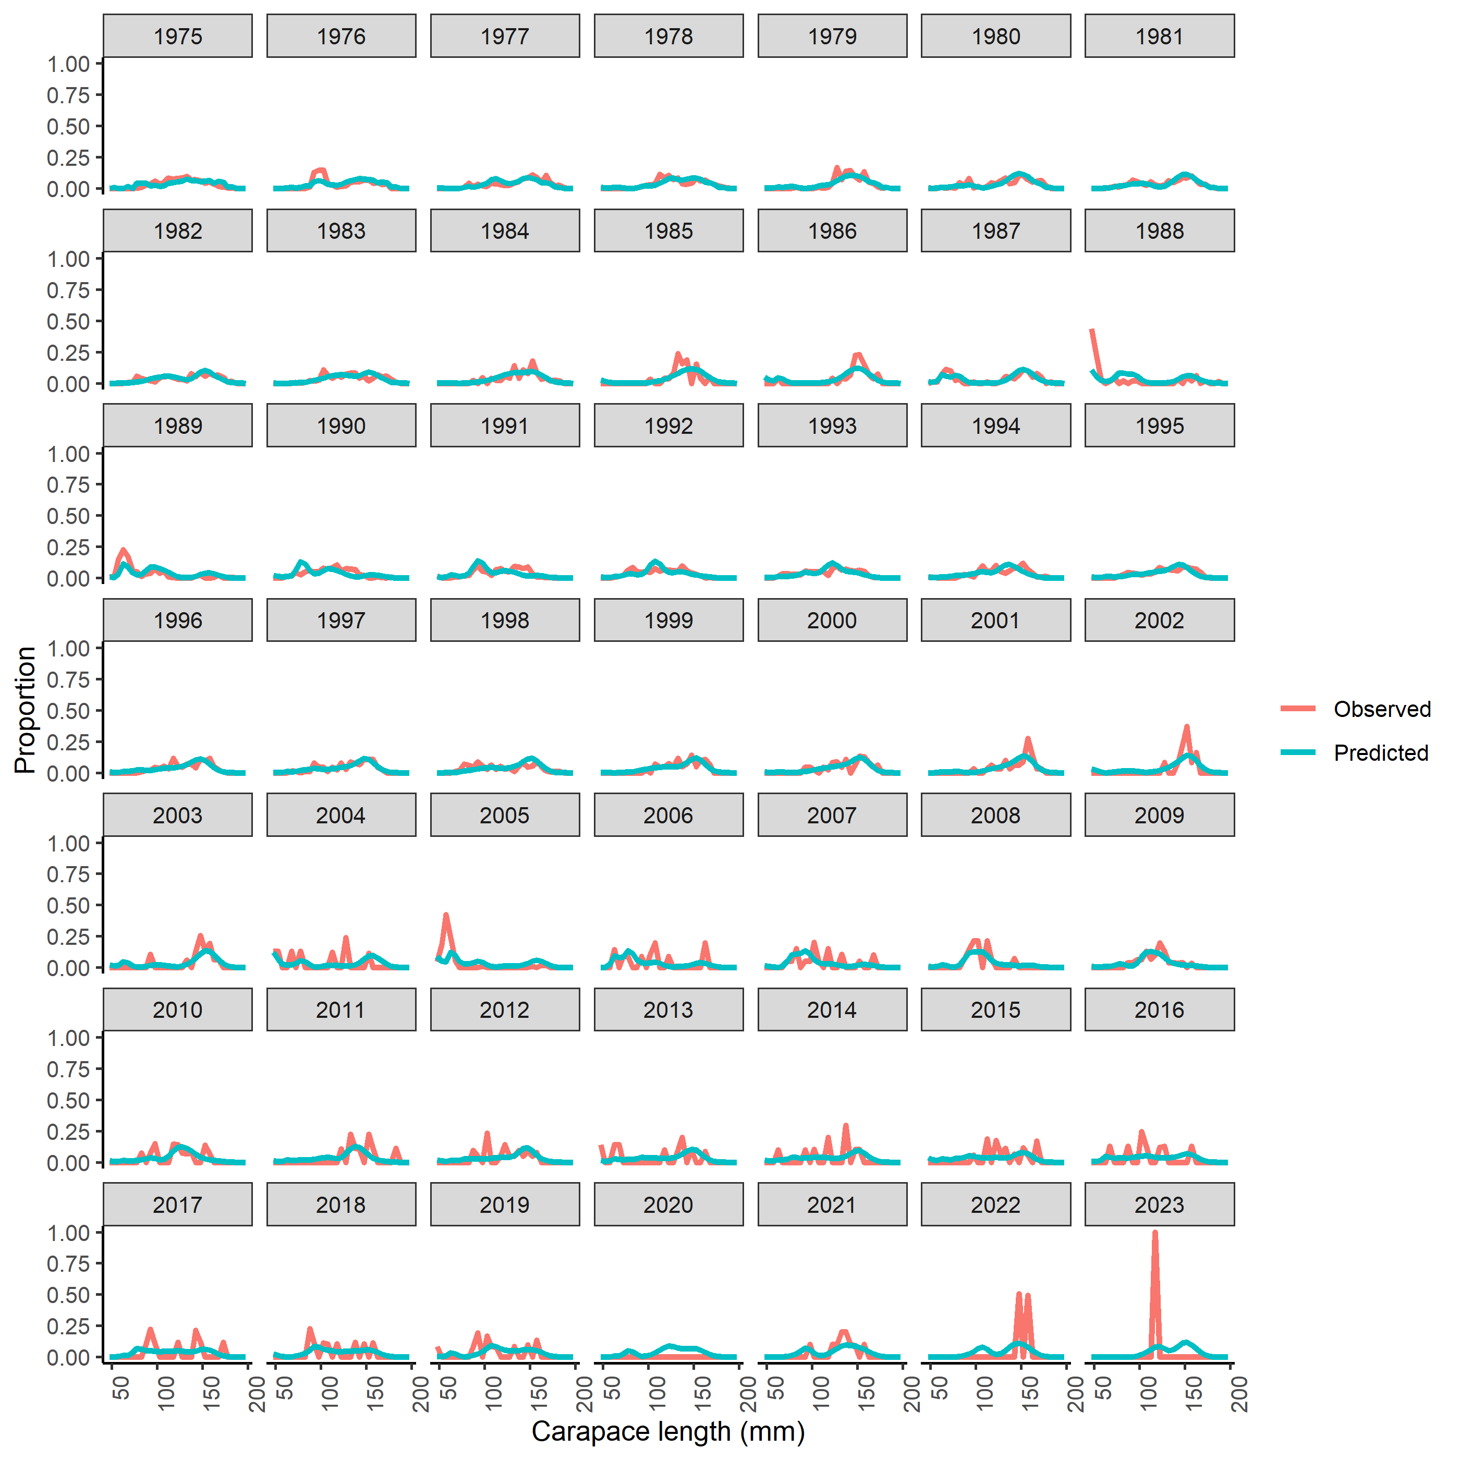
Figure S31. Fits to survey size composition data for PIRKC.
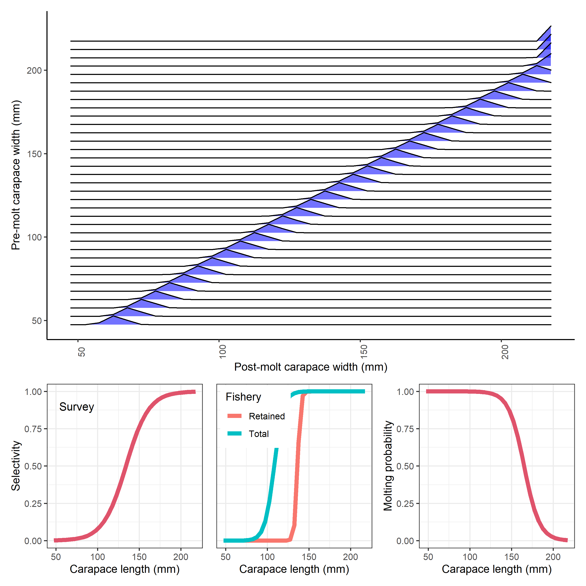
Figure S32. Estimated and specified population processes for PIRKC. Growth transition matrix (top), survey selectivity (bottom left), fishery selectivity (bottom middle), and probability of undergoing terminal molt (bottom right).
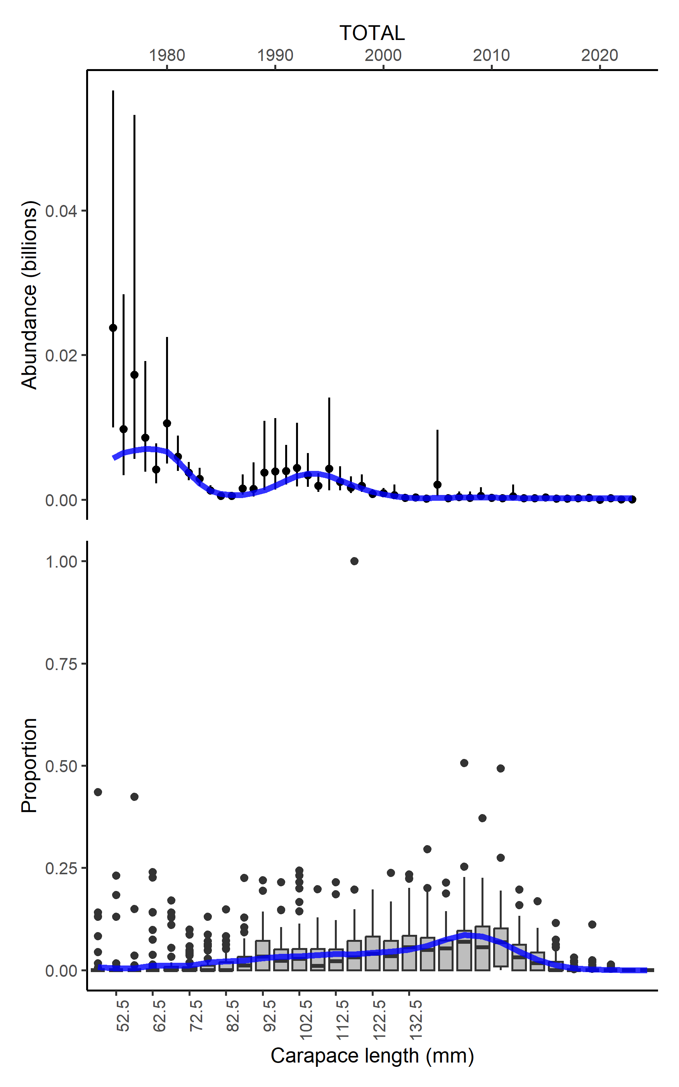
Figure S33. Fits to survey index of abundance for PIBKC.
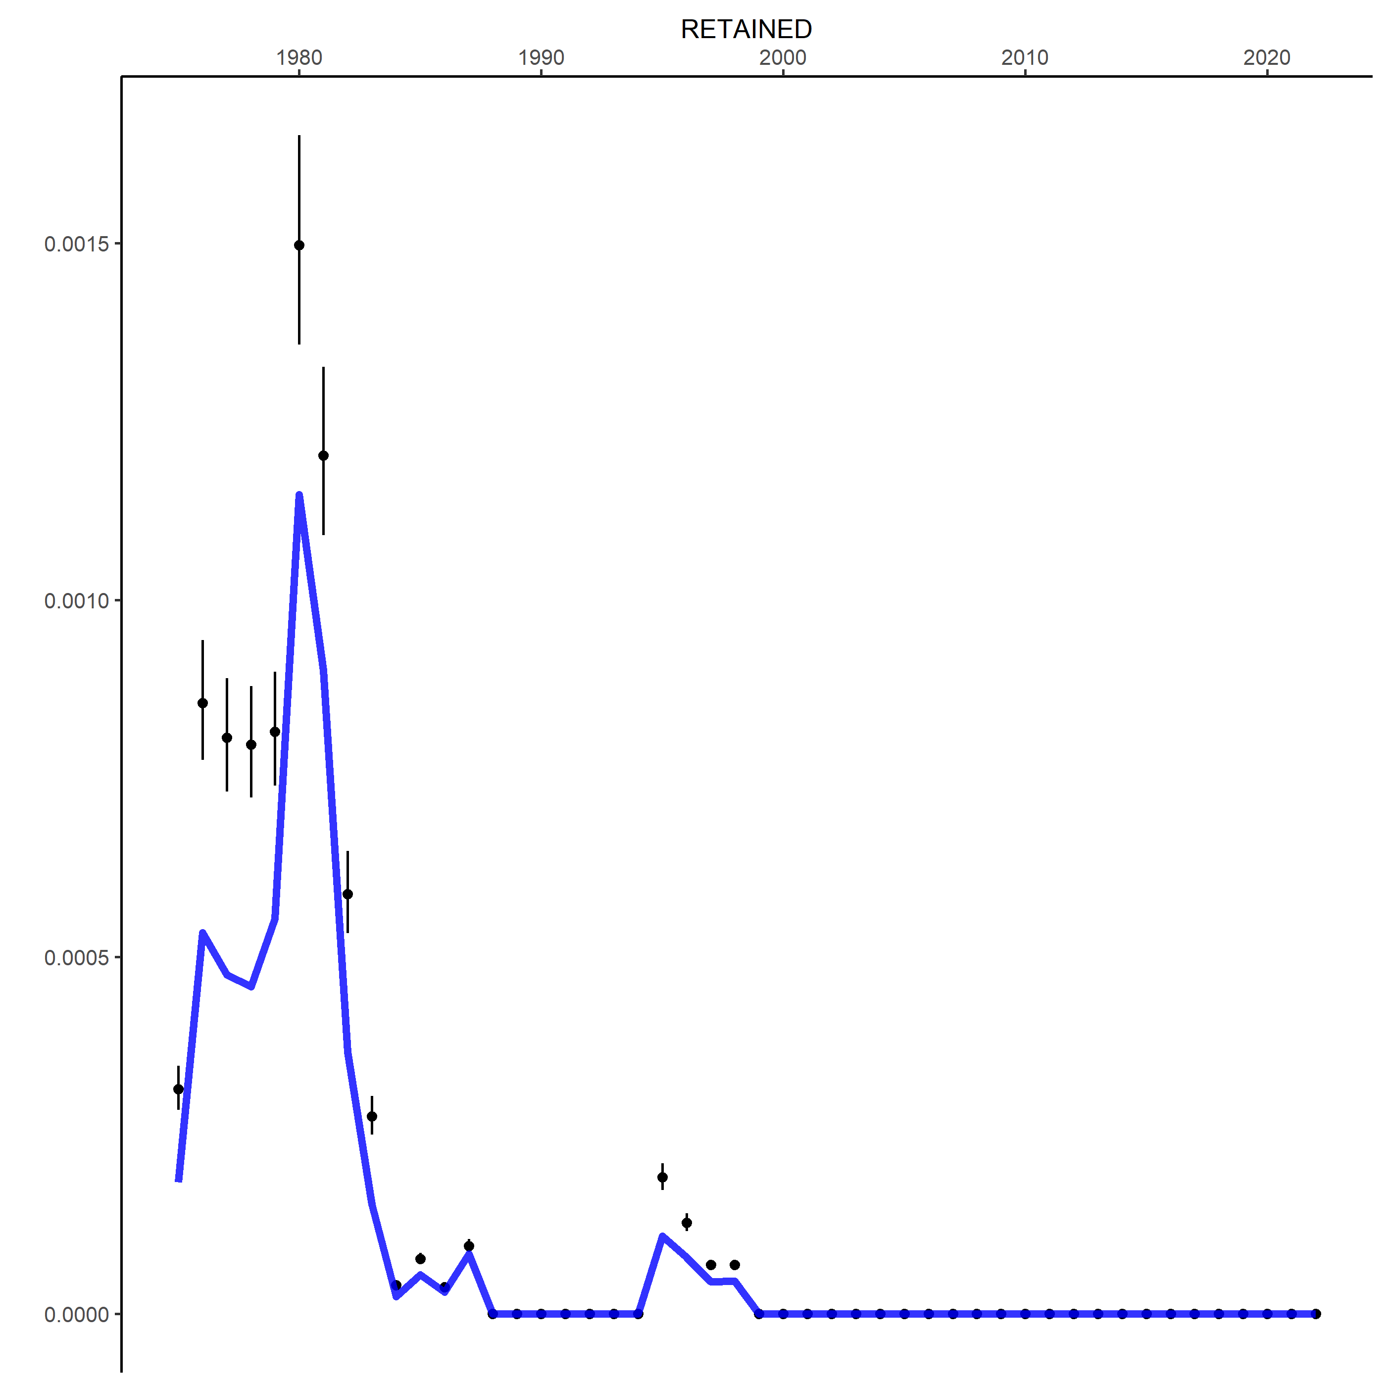
Figure S34. Fits to retained catch for PIBKC.
 Figure S35. Fits to survey size composition data for PIBKC.
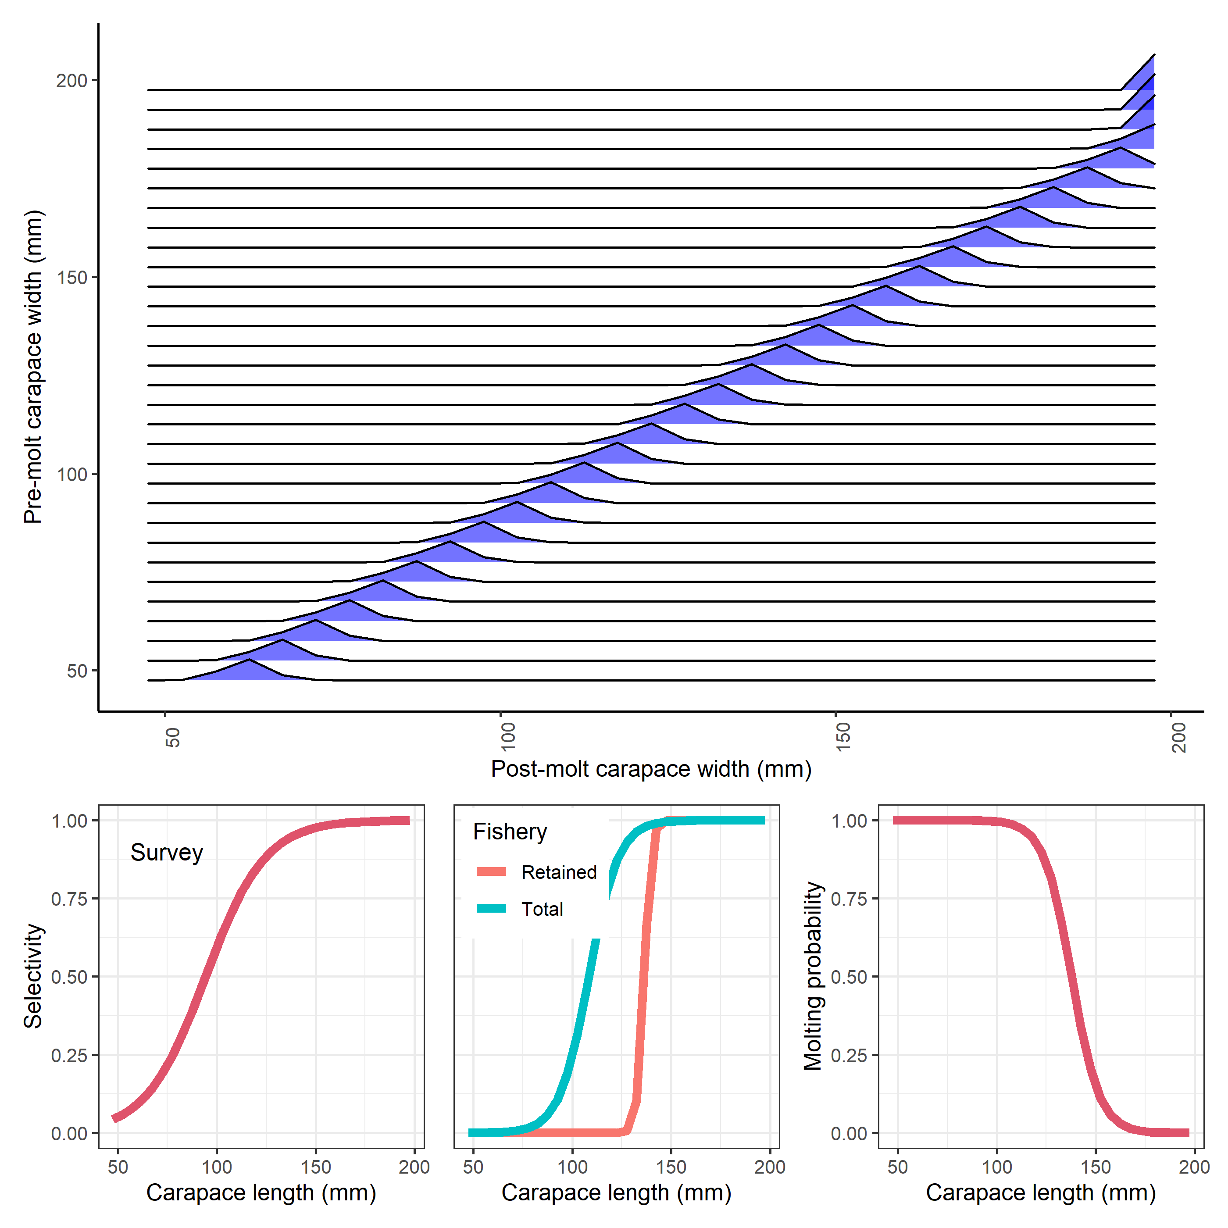 Figure S36. Estimated and specified population processes for PIBKC. Growth transition matrix (top), survey selectivity (bottom left), fishery selectivity (bottom middle), and probability of undergoing terminal molt (bottom right).

