**Episodic events drive Bering Sea crab populations**

Cody Szuwalski and interested crab stock assessment authors and plan team members

**Goals:**

Describe the dynamics of Bering Sea crab in the context of changing climate and management

Discern between changes in abundance for which management has levers and those that it did not

Discuss as a microcosm in the larger context of fisheries management

**Abstract:**

Crab are some of the most abundant species in the Bering Sea and support fisheries valued over $XX million ex-vessel a year. Boom and bust dynamics are common and we link abrupt population changes to

**Background**

* Abundances of crab populations in the Bering Sea have been historically volatile with periods of boom and bust.
* The dominant population dynamics modeling paradigm is to estimate a time-invariant ‘natural’ mortality based on longevity and directly account for directed and non-directed fishery mortality in the assessment.
* Assessments for crab in the Bering Sea have a history of needing to incorporate periods of elevated mortality to fit the survey data.
* Further, the validity of non-directed fishery data has been questioned given the potential for unobserved mortality related to gear strikes during which crab are not captured and brought on board to be recorded.
* To explore these two issues, we modeled Bering Sea crab stocks with the necessary data (n=6) with a model that allows for an annually varying ‘other’ mortality source that accounts for ‘natural’ (e.g. predation, senescence, starvation) and non-directed fishery mortality (e.g. observed bycatch in flatfish fisheries or unobserved mortality by gear strikes).
* (explain why this is a useful exercise alongside a traditional assessment)
* Some stocks fished hard, some stocks basically unexploited.

**Key questions**

* What accounts for the historical volatility for each stock: fishing, other mortality, or recruitment?
* Are there relationships between the population processes within/among species? (e.g. stock/recruit, mortality/abundance, fishing/other mortality…)
* Are population processes correlated with environmental variables?
* Can we summarize the main drivers for each stock? What generalizations can be made based on estimated population processes?
* Identify years in which a stock increased or decreased by XX%. Was the change associated with fishing, other mortality, or recruitment?
* Is there a correlation between estimated other mortality and average size in the population? (this might suggest a size-dependency in other mortality)
* Do estimates of recruitment and fishing mortality change with the implementation of time-varying ‘other mortality’?

**Population dynamics models**

* Each stock is modeled with 5 mm size bins over the range of sizes observed in the survey (show ridges plots by color)
* Only males are modeled, given sexual dimorphism and male-only fisheries
* Loose priors for average ‘other mortality’ are based on assumed longevities; sigma for interannual deviations large.
* For king crab, size transition matrices are input; molting probabilities are estimated.
* For snow crab, size transition matrices and molting probabilities are input.
* Add table with sizes modeled, data available, priors used, parameters estimates, likelihood components.

**Preliminary observations**

* BBRKC and PIBKC abundances would be hard to tell apart with no label
* Estimated other mortality seems to be related to density for several stocks (PIRKC, snow, Tanner)
* Pulsed recruitments are common with no SR relationship
* BBRKC was on the way up again until mid-2000s…then whomp...period of increased mortality + recruitment failure
* Fishing mortality and other mortality area correlated for SMBKC, BBRKC, and snow (only stocks with consistent and intense fishing). Is this a feature or a bug of these sorts of models?
* Blue king crab stock abundances very correlated
* *Eventually will put some of these into models that can consider lags and/or non-linearity, so don’t read too hard into this*
* Do increases in F come after drops in biomass? That is, did the stock collapse and we didn’t control the F well enough?
* What are the relative timings of changes in biomass, recruitment, F, and M? Look at ccf().

BBRKC

**Discussion**

* Retrospective patterns associated with assuming constant other mortality. If there are mortality events, we will overharvest at the worst time (snow crab 2020)
* What is the relative risk of missing a mortality event vs. chasing noise? How do we strike that balance?
* When should we believe estimates of ‘other mortality’? How does the data quality/quantity influence this? Spectrum of believability with stocks on it?
* What do these generalizations mean for the management of the stocks? Discuss current and potential management levers. What can we actually do?
* When do we give up (PIBKC)?
* Is there any use in thinking about stock enhancement?
* How does this methodology fit in the bigger picture of modeling paradigms? Explicitly incorporating a bunch of drivers vs. modeling ‘buckets’ of dynamics drivers, then looking for correlations between outside covariates and the buckets? What are the pros and cons of each approach?
* What does this all mean for reference points? They’re historically useful, but non-stationary drivers and no stock recruit relationship means maximum sustainable yield is a questionable concept moving forward. Can risk-based management provide a way forward? We traditionally talk about maximizing yield, perhaps we should be talking about managing risk.
* Why are crab a good candidate for modeling time-varying mortality?

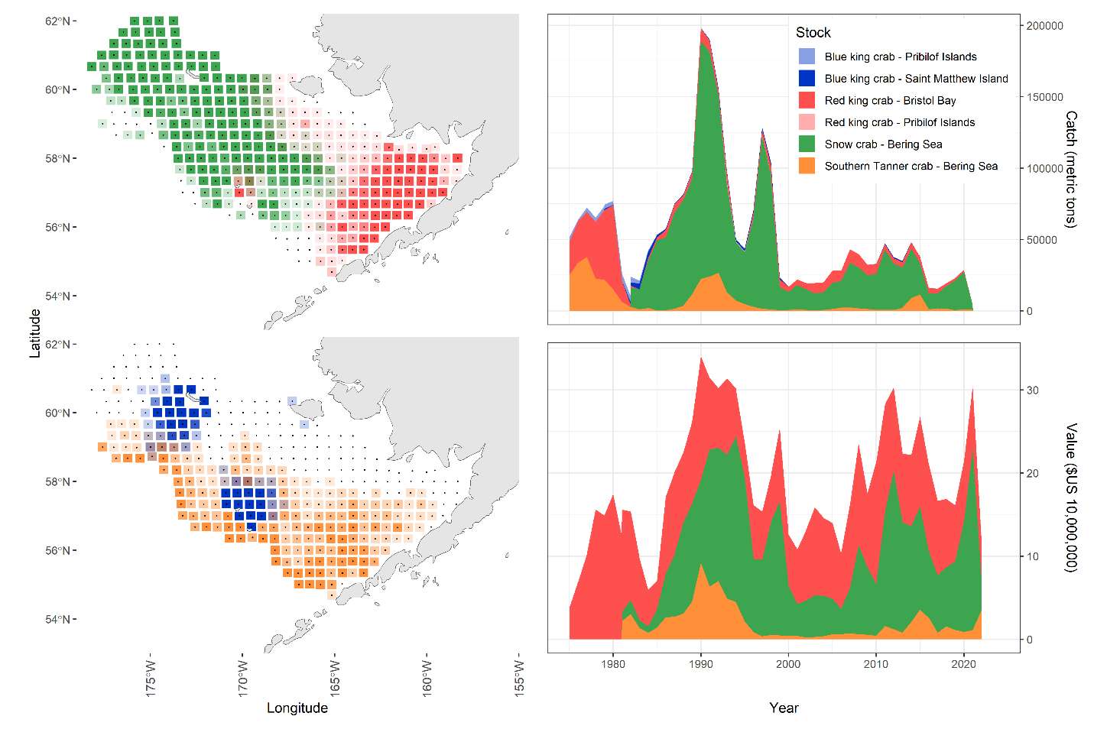

Figure 1. Map with different stock distribution by color + catches + value

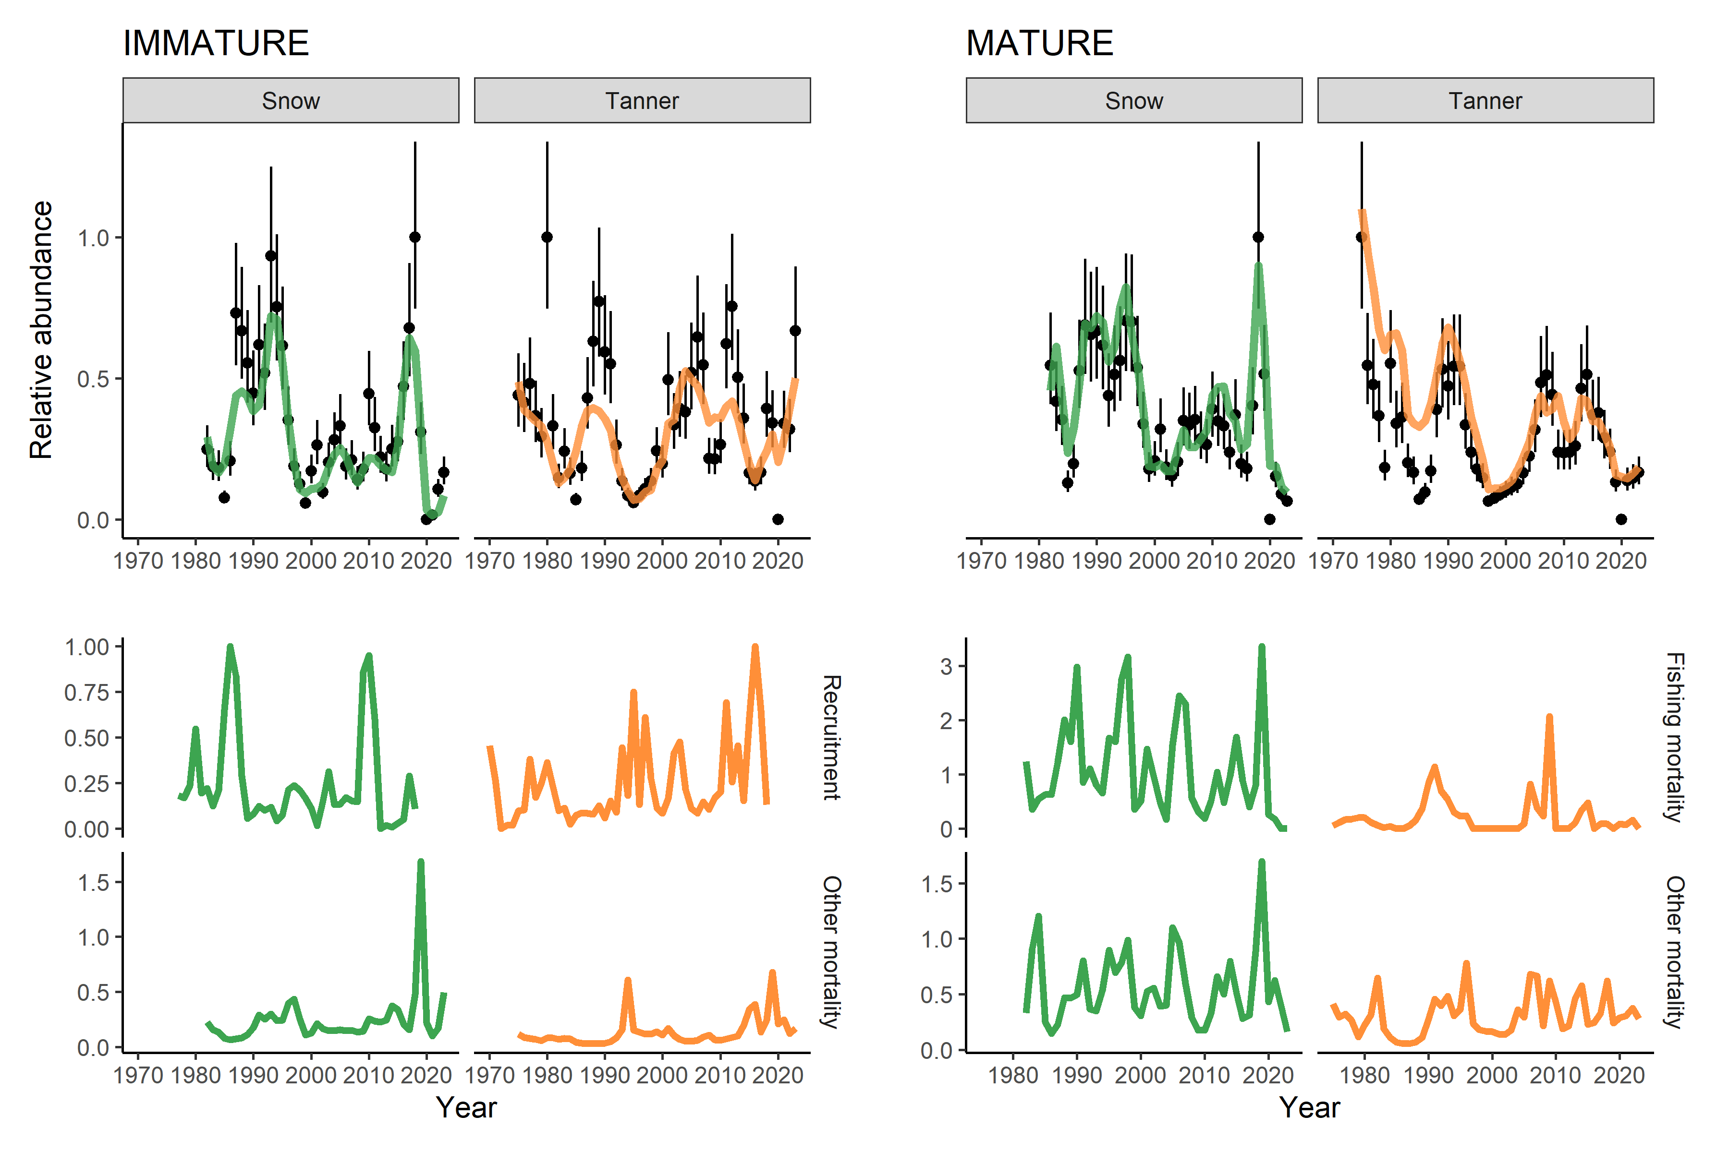

Figure 2. Snow + tanner time series of abundance with key points in the stock’s history linked to the time series of estimated population processes. Label important points with “R, F, M” to indicate recruitment, fishing, or mortality. Add shading for uncertainty in estimates.

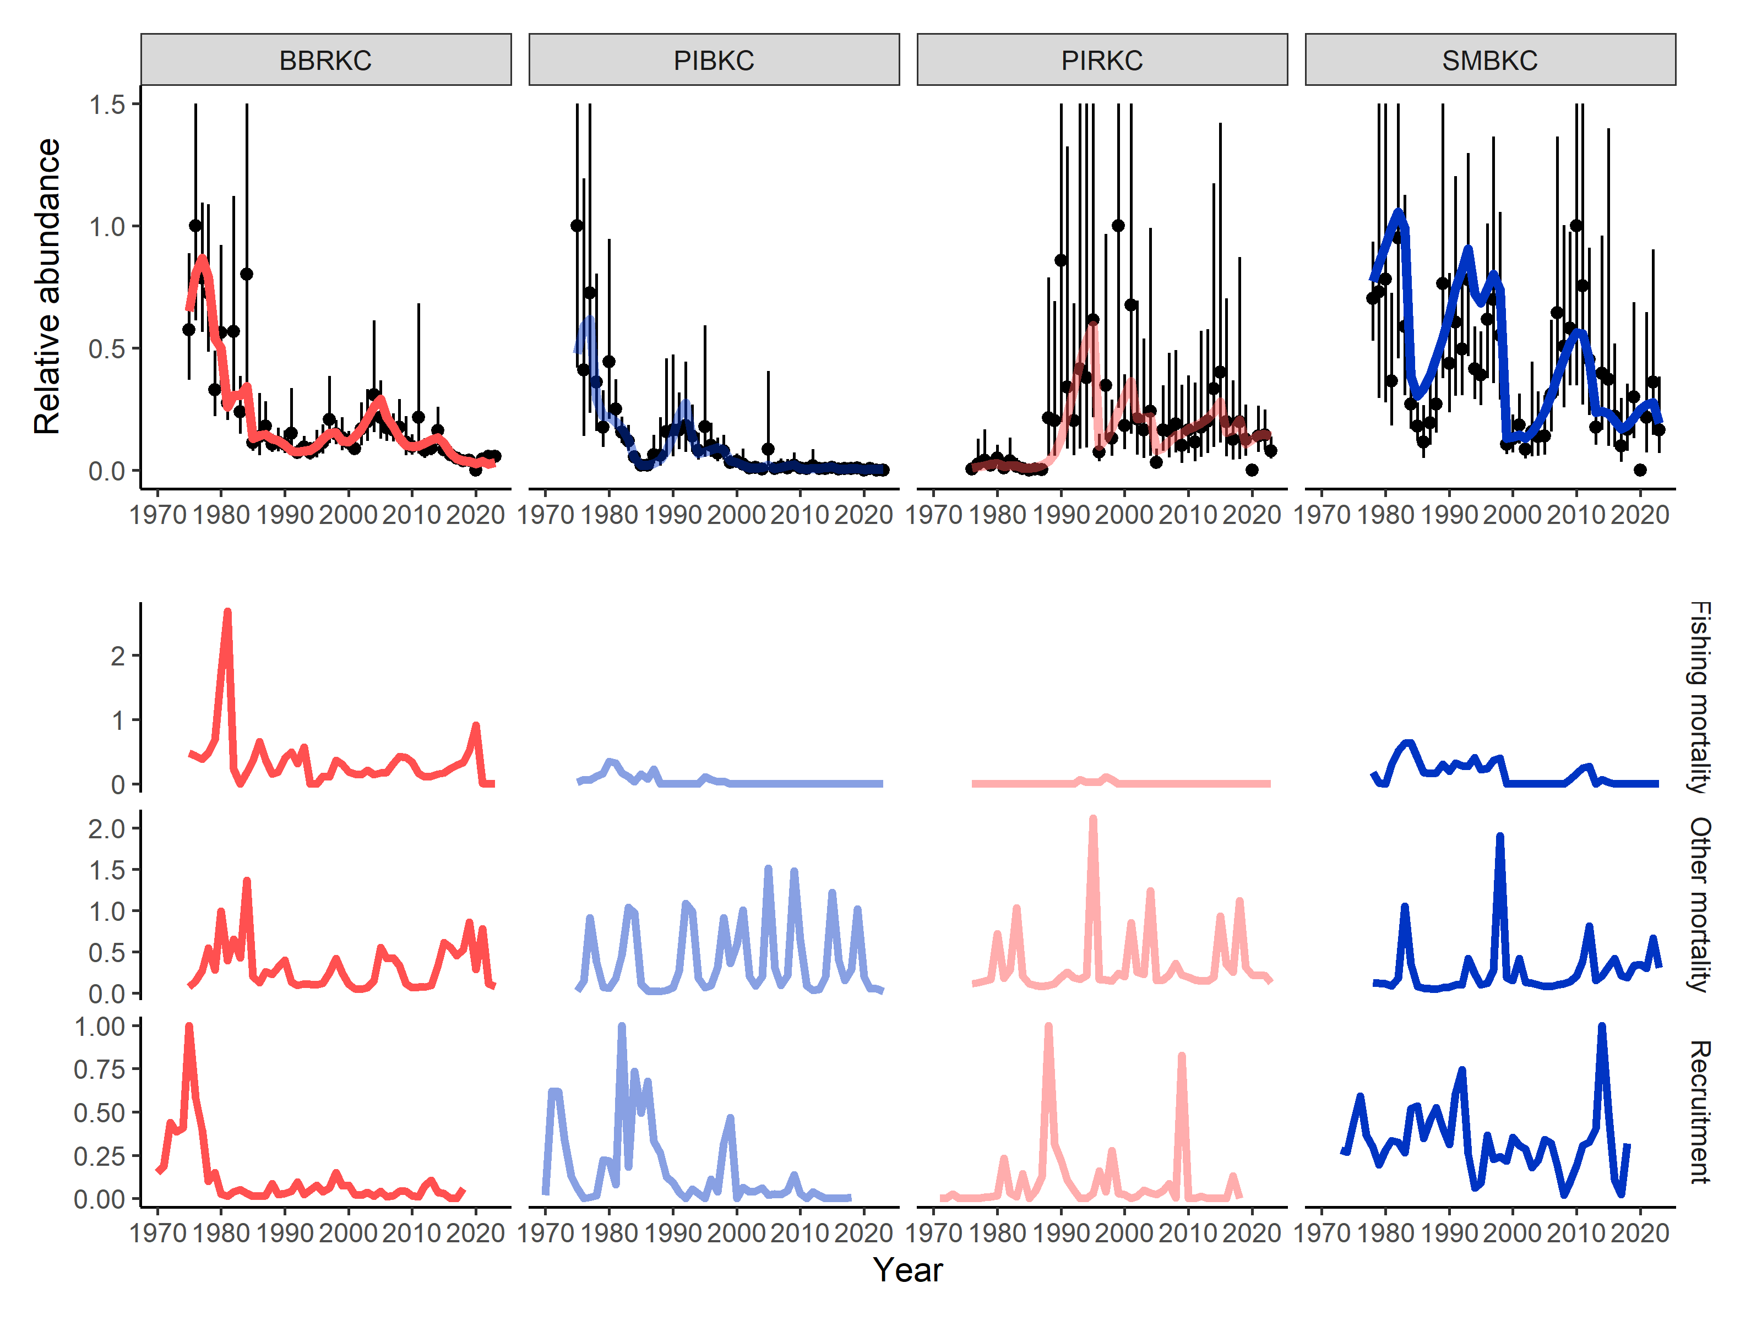

Figure 3. King crab time series of abundance with key points in the stock’s history linked to the time series of estimated population processes. Label important points with “R, F, M” to indicate recruitment, fishing, or mortality. Add shading for uncertainty in estimates.

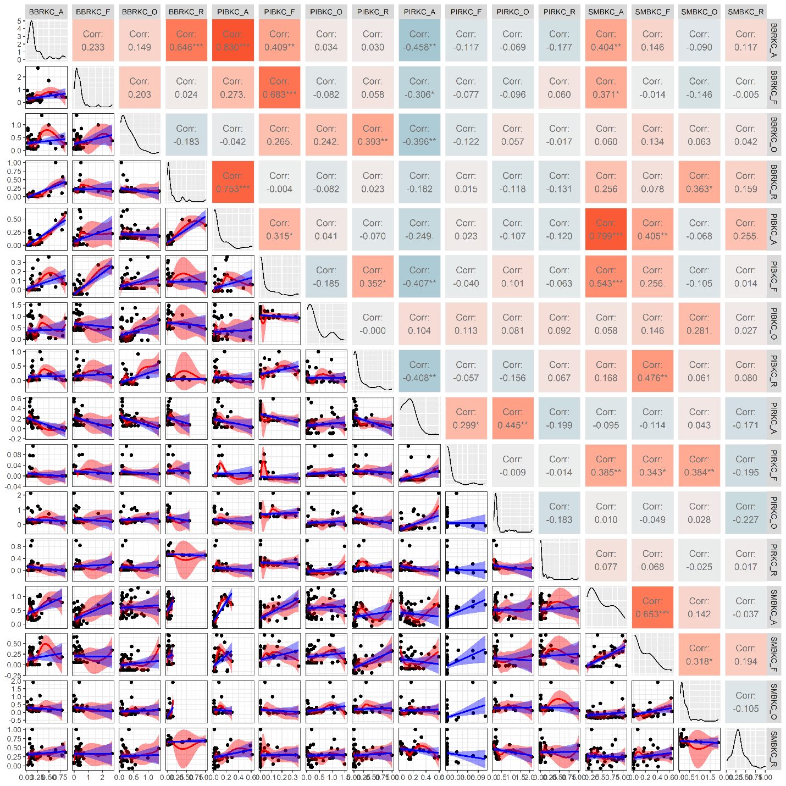

Figure 4. Among stock correlations between population processes for King crab. (these correlation plots are just for exploration and something else will be in the manuscript)

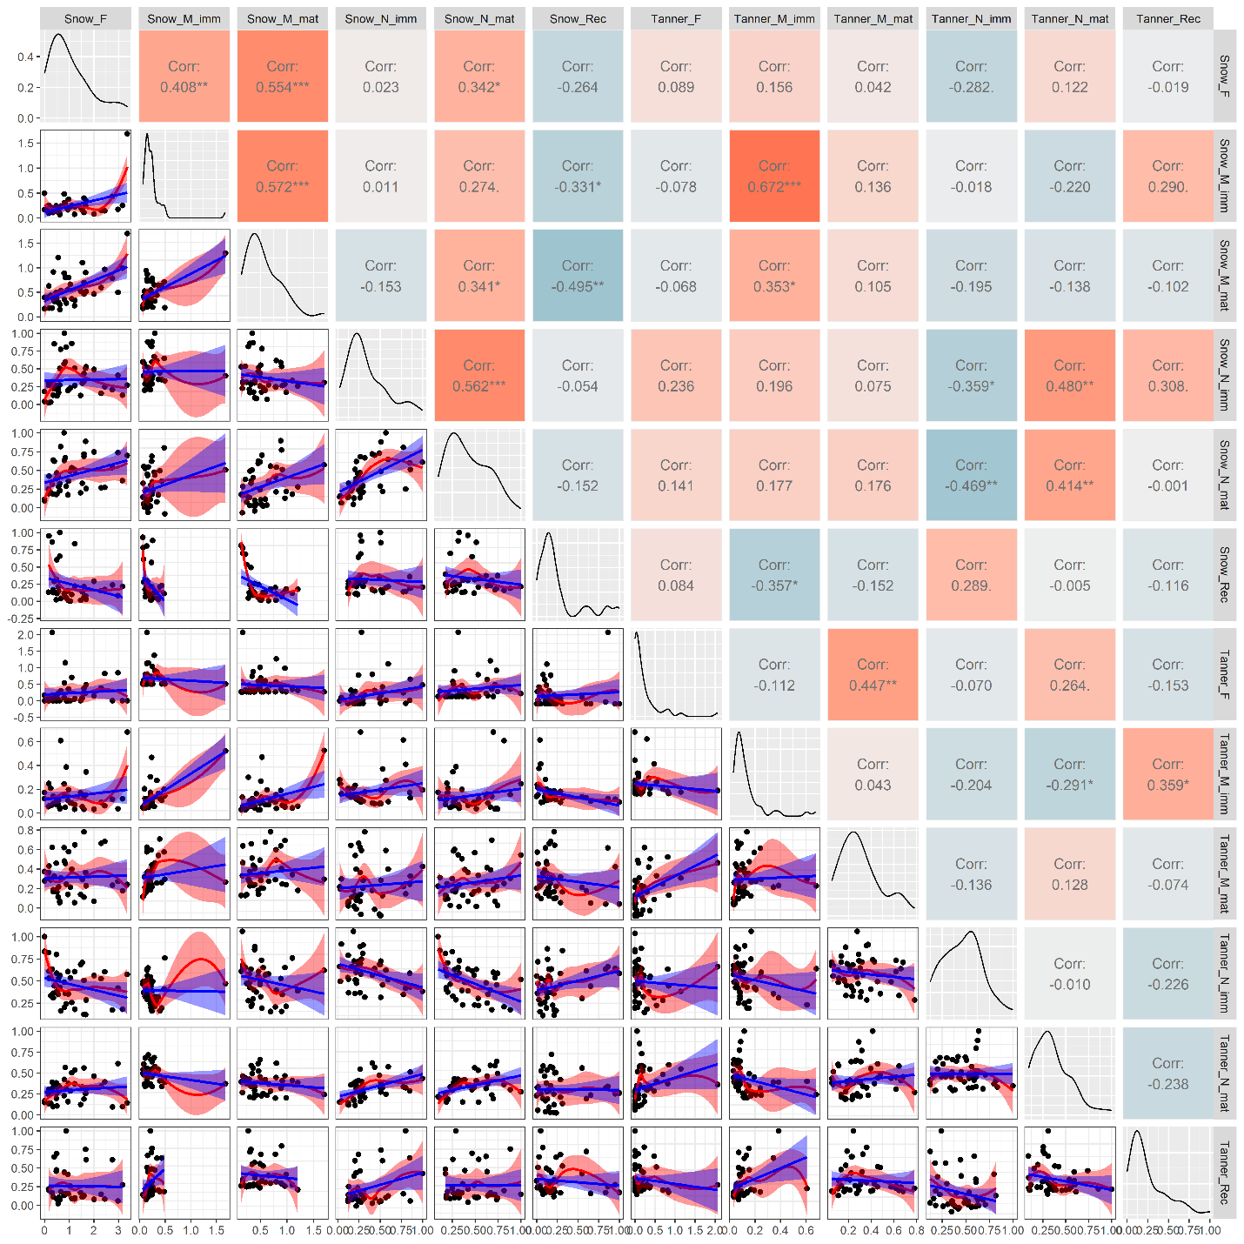

Figure 5. correlations between estimated time series for Chionoecetes crab, delineated by maturity state.

Table S1. Characteristics of modeled populations.

|  |  |  |  |  |
| --- | --- | --- | --- | --- |
| **Stock** | **Sizes** | **Prior on ‘other mortality’** | **Maturity** | **Year range** |
| Snow crab | 30-135 | 0.27 | Chela-based | 1982-2023 |
| Tanner crab | 25-185 | 0.27 | Chela-based | 1975-2023 |
| BBRKC | 45-170 | 0.18 | >120 mm | 1975-2023 |
| PIRKC | 45-220 | 0.18 | > 120 mm | 1976-2023 |
| SMBKC | 45-170 | 0.18 | >105 mm | 1978-2023 |
| PIBKC | 45-200 | 0.18 | >120 mm | 1975-2023 |

Fig s1. Show a figure of the number of crab used to make the estimates + stations observed

Fig sXX. Diagnostics figures for each stock (would be great to have a single diagnostic figure for each stock).

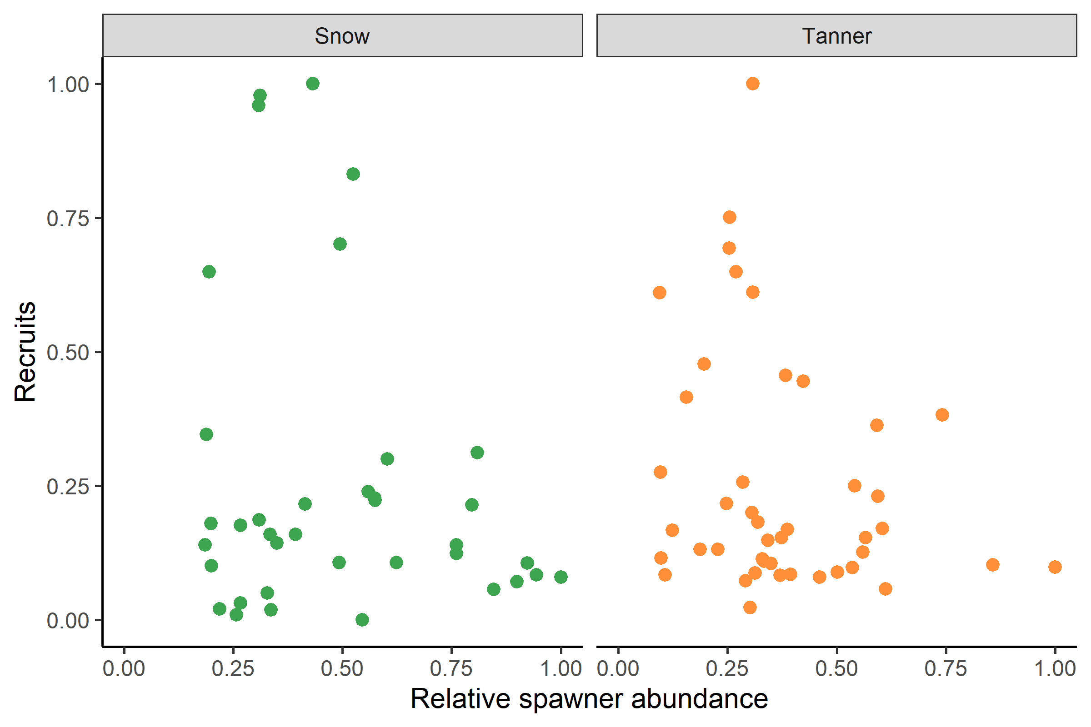

Fig s2. Stock recruit relationships for Chionocetes spp. (plot curves, test for significance)

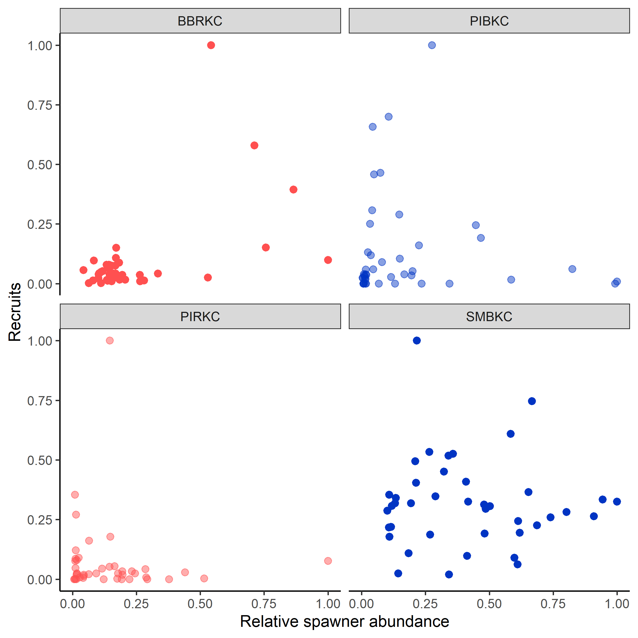

Fig sx. Stock recruit relationship for Paralithodes spp. (plot curves, test for significance)

Fig s3. Figure with survey selectivity for all stocks on one panel fishery selectivity in the other

Fig s4. Relationship between density, recruitment, and mortality within stock.

Fig s5. Relationship between recruitment among stocks.

Fig s6. Relationship between mortality among stocks.

Fig s7. Relationship between bottom temperature, SST, etc. and mortality, recruitment.

Fig s8. Relationship between mortality and average size by stock.