Impacts of warming waters on global snow crab populations
(Will summarize once results available something like: “Warming waters increase mortality in global snow crab populations”)
Cody Szuwalski^{1,2}, Darrell Mullowney³, Tobie Surette⁴, other authors to come
¹Alaska Fishery Science Center
²University of Washington
³DFO, Newfoundland
⁴DFO, Moncton

ABSTRACT TO COME

Snow crab (Chionoecetes opilio) are an economically and ecologically important species in higher latitudes of the northern hemisphere. Over the last decade, the average global annual harvest has measured approximately 200,000 metric tons, which was worth US$XX billion ex-vessel (Figure 1). There are seven key fishing nations, with ten major populations among them. Snow crab occur in areas that have relatively cold bottom water temperatures (REF), which can be achieved either by intermittent ice cover (e.g. Bering Sea and Barents Sea) or currents that bring cold water to lower latitudes (e.g. Canada, Korea, and Japan). The fisheries generally use pots to capture only the largest males in the populations; females are generally discarded (REF).
Recently, Bering Sea snow crab collapsed from record highs in 2018 to record lows in 2021 after a marine heatwave (Szuwalski et al., 2023). Movement, predation, disease, cannibalism, fishery effects, density dependence, and temperature effects were all considered in models to explain the decline; temperature and density dependence were the most important variables in the model. Given a reduced spatial footprint and increased caloric needs, starvation was proposed as a primary driver of the collapse (Szuwalski et al., 2023). Subsequent lab and field studies corroborated this assessment by noting that energetic condition of snow crab in the field during 2019 were beneath the mortality threshold identified in starvation experiments (Fedewa et al., 2025).
The collapse of snow crab precipitated fisheries closures and disaster declarations in the eastern Bering Sea. However, other populations around the globe are steady or increasing. EXAMPLES.
Given the economic and ecological importance of snow crab and the different trajectories experienced by populations, we ask the following questions: 1) do populations share similar responses to changes in environment and population demography, 2) if so, why did the Bering Sea population collapse while others have not, 3) are there warning signs that could forecast imminent collapses in the future, and 4) what can we learn from the diversity of approaches used to manage snow crab globally to confront climate change in fisheries management?
To answer these questions, we collated data for XX of the YY currently fished populations. Then we fit population dynamics models to each population’s data to estimate recruitment (crab coming into the population), fishing mortality (crab removed through fishing), and ‘other’ mortality (mortality from all other sources, like predation, starvation, and disease). We then attempted to explain variability in estimated recruitment, other mortality, and the observed probability of maturing using generalized additive models (GAMs; Wood, 2011). Large-scale indices of environmental variation (e.g. the Arctic Oscillation), small scale environmental variables (e.g. ice cover), and population characteristics (i.e. average size and abundance) were included as covariates in our GAMs.
Results
Population dynamics model fits and discussion (mostly SI…which are already very long)
- Goodness of fit, convergence, simulation, uncertainty
- Importance of each process in dynamics (recruits=beginning, mortality=removals, maturity=growth stops)
Mortality estimates:
- trends, variability, comparison across region
- deviance explained, relationships to covariates, strongest relationship, consistency across regions
Maturity estimates:
- trends, variability, comparison across region
- deviance explained, relationships to covariates, strongest relationship, consistency across regions
Recruitment estimates:
- trends, variability, comparison across region
- deviance explained, relationships to covariates, strongest relationship, consistency across regions
Discussion
Was variability in some processes easier to explain with environment/population than others?
Why might this be?
Which estimated process has the biggest impact on the population? Fishery performance?
Are internal drivers (density) or external drivers (ice) more important for dynamics?
Why did Alaska collapse and not other populations? Have other populations experienced as warm of temperatures (or as extreme of temperatures relative to an average) as Alaska? Final figure candidate is a map with temperatures occupied by region and the direction of currents in each area. Include projected temperatures. Maybe also a forecast of mortality for each population based on historical relationships and projections for each area?
Can we forecast collapses? Are there thresholds that we should be concerned with for snow crab management?
What can we learn from snow crab that could be applicable to other species?

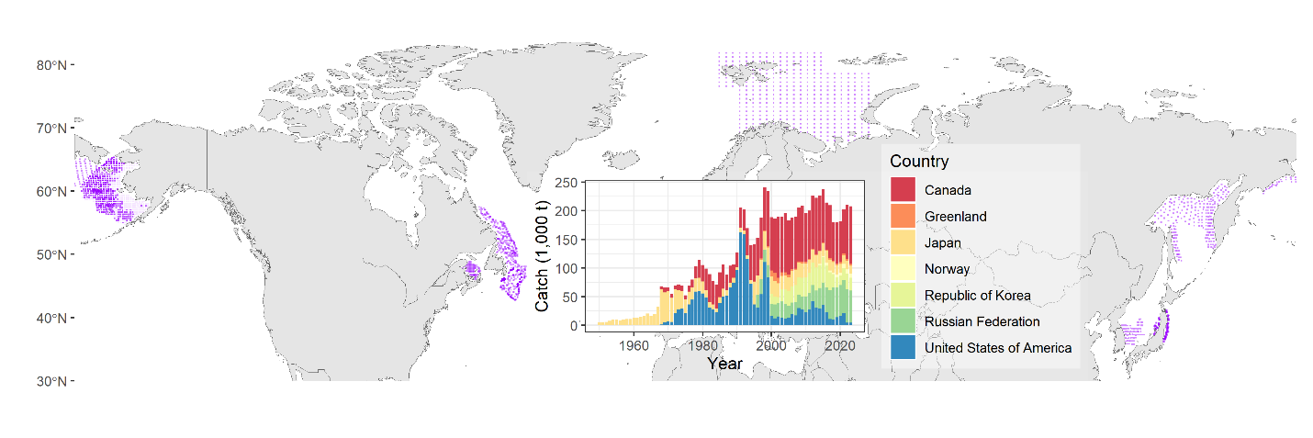
Figure 1. Global capture of snow crab (inlaid) and spatial distribution of fishery or survey in each location (purple dots). (Match colors to inlaid figure once better spatial data are available from countries)
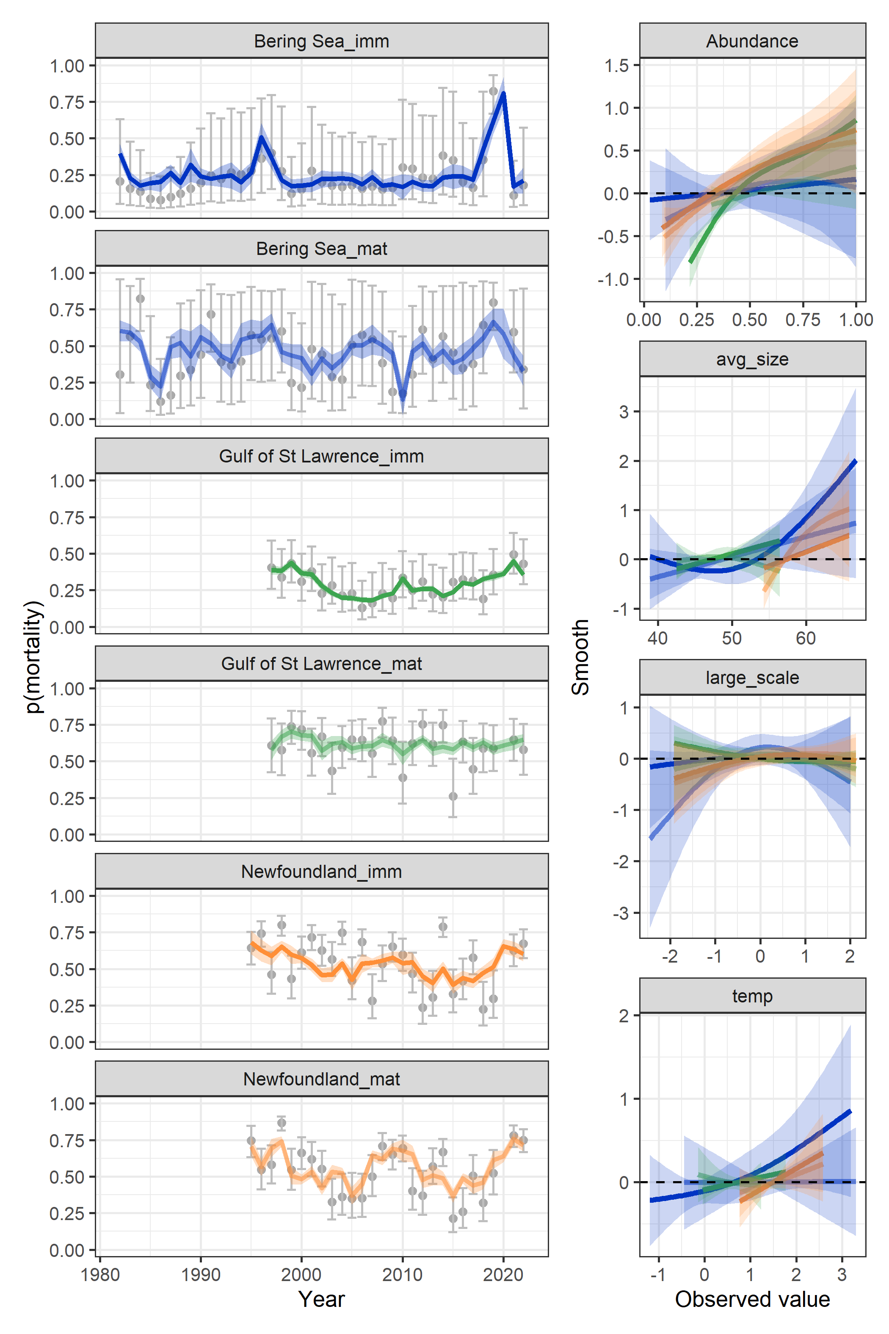
Figure 2. Estimated mortality by population and maturity state (left) and relationships between mortality and environmental variables by population and maturity state (right). (will expand as country data becomes available)

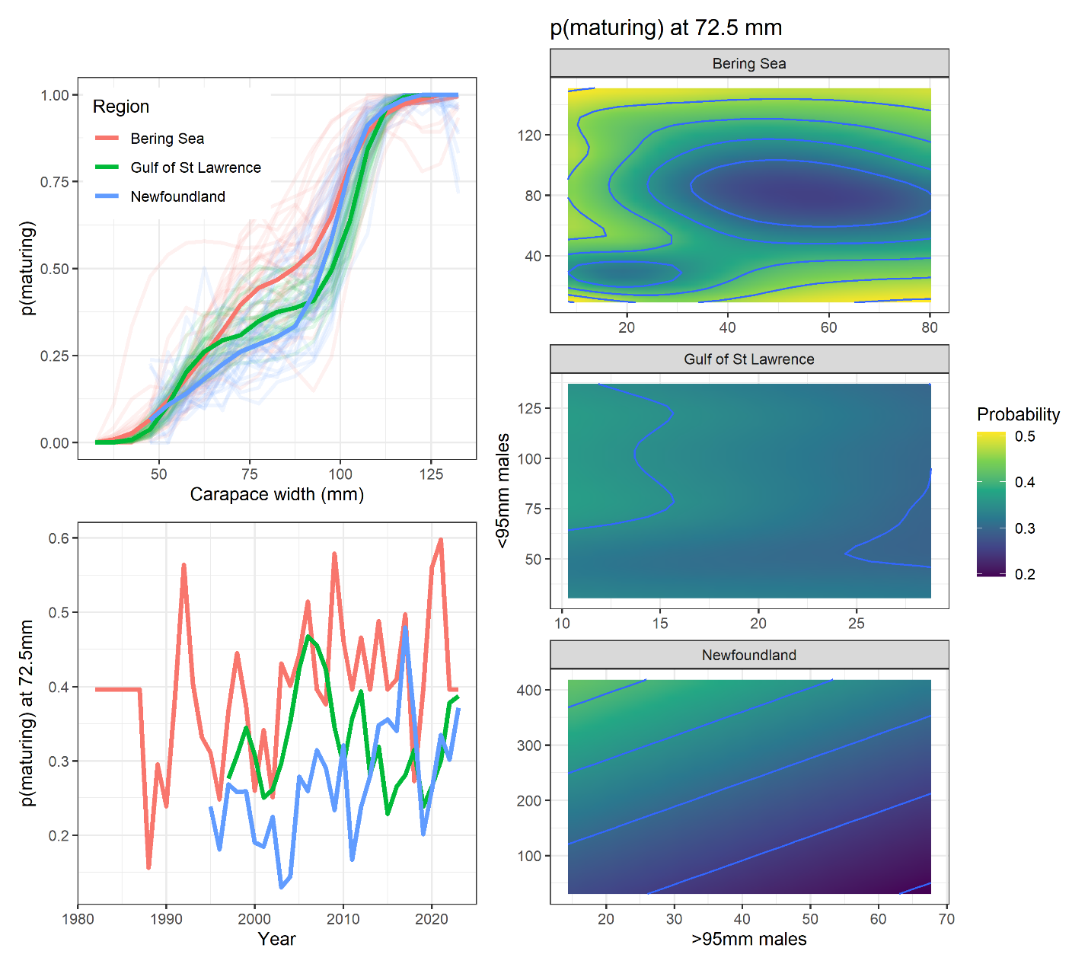
Figure 3. Observed probability of maturing over size (top left), observed probability of maturing over time at 72.5 mm carapace width (bottom left), estimated relationship between probability of maturing at 72.5 mm carapace width and the density of small (<95mm) and large (>=95 mm) males. (will expand as country data becomes available)

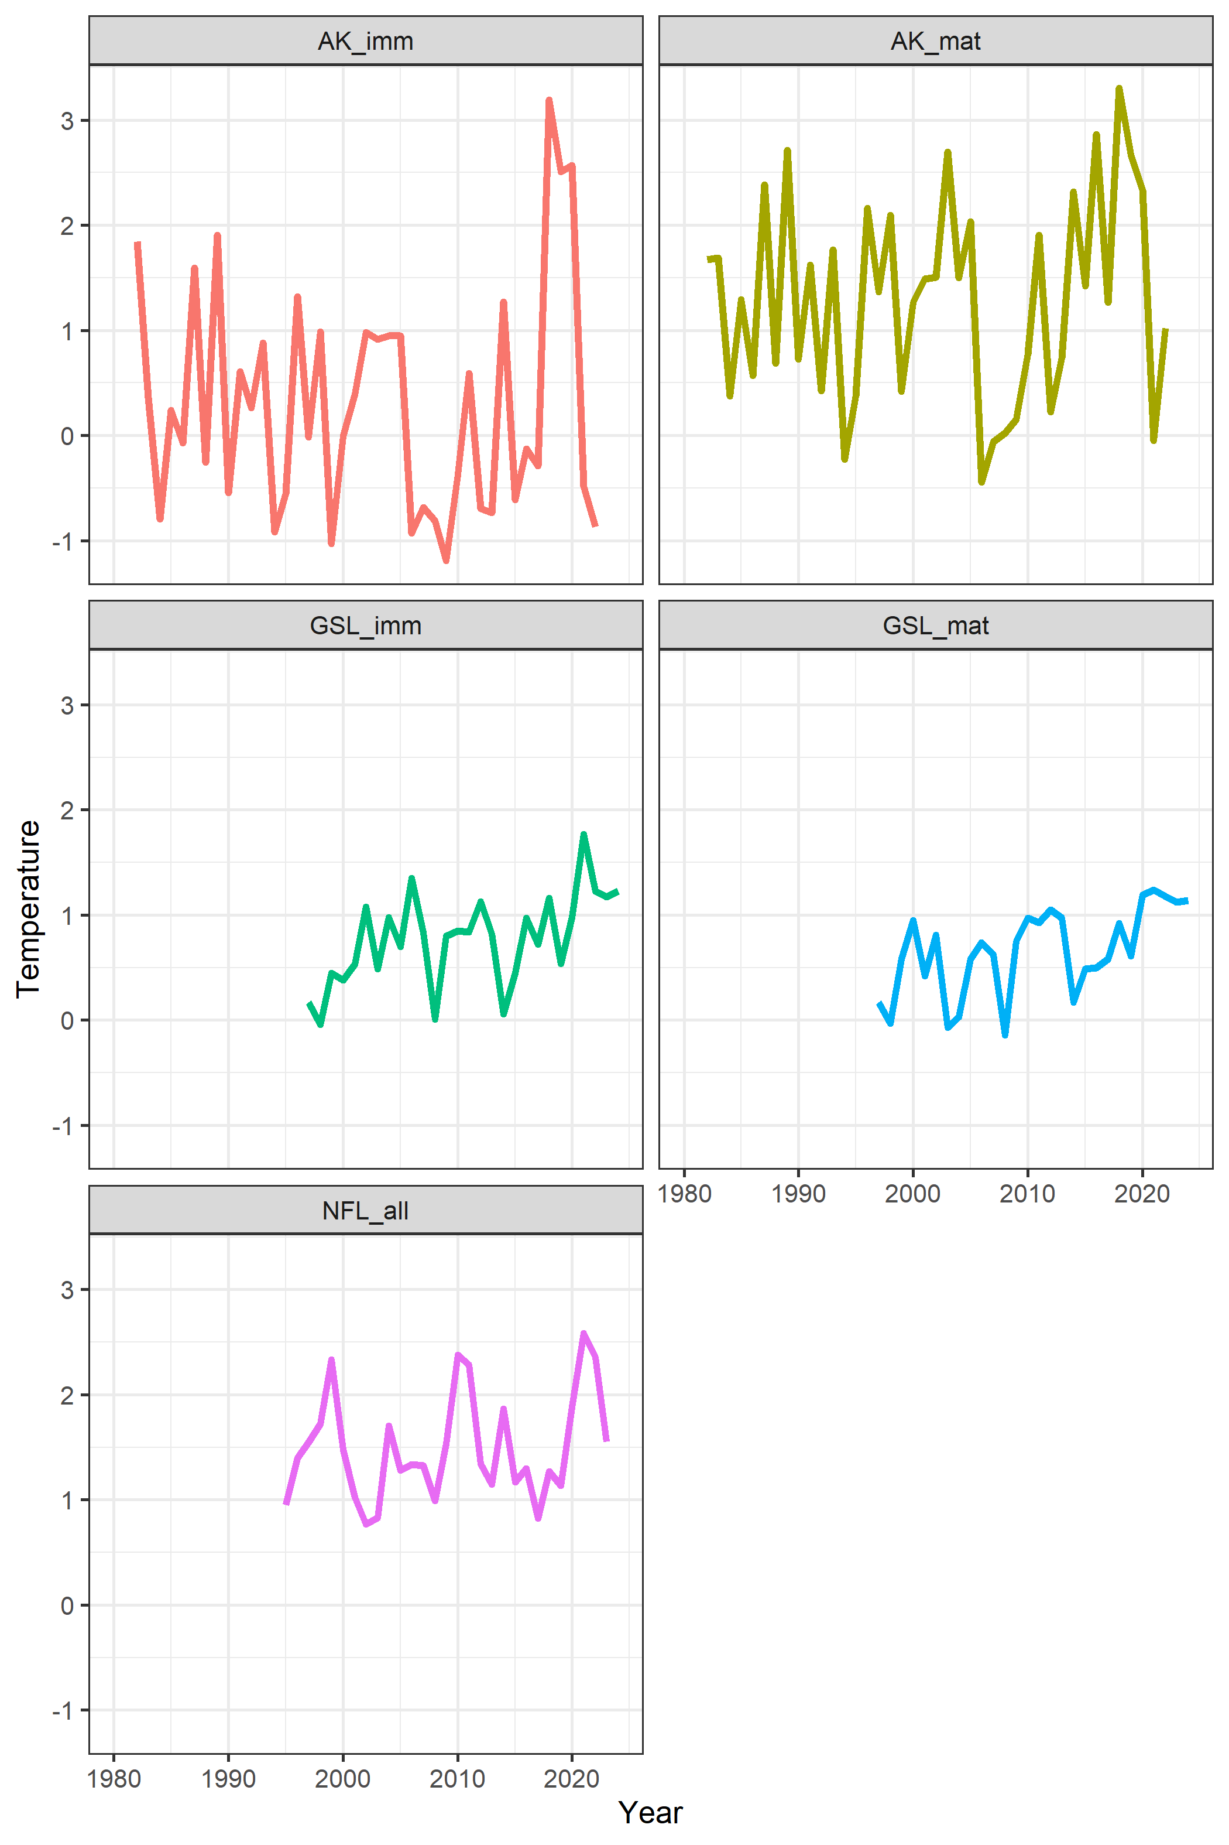
Figure 4. Temperatures occupied by population and maturity state. (will turn this into figure to answer: Why did Alaska collapse and not other populations? map with temperatures occupied by region and the direction of currents in each area. Include projected temperatures and mortality forecasts.)

