***Marine heatwave induced predatory release spurred record Tanner crab recruitment***

**Background**

Snow crab and Tanner crab are members of the *Chionoecetes* genus with similar life history, but occupy distinct areas of the Bering Sea (figure 1). Pacific cod are the largest predator of snow crab and Tanner crab in the Bering Sea. A marine heatwave in the Bering Sea precipitated the collapse of snow crab starting in 2018, but the most recent bottom trawl surveys indicate the largest Tanner crab pseudocohort ever observed in the Bering Sea also established during the heatwave (figure 1 & 2; 2018 was the approximate time of settlement of the crab observed in 2023 survey). Pacific cod also undertook a massive migration in 2018 and 2019 into the northern Bering Sea.

**Key question**

Why was there such a big recruitment for Tanner crab?

**Hypotheses**

H1: A competitive relationship exists between large snow crab and Tanner crab. The collapse of snow crab was precipitated by the 2018 and 2019 heatwave; this released Tanner crab from the competitive pressure and a large Tanner crab pseudocohort resulted.

H2: Pacific cod present a downward pressure on small Tanner crab dynamics through direct predation.

H3: Both H1 and H2 are important in the dynamics of small Tanner crab.

H4: Neither H1 or H2 are important in the dynamics of small Tanner crab.

**Methods**

* Examine crosscorrelations in time series to understand leading and lagging dynamics.
* Examine the spatiotemporal dynamics of small Tanner crab (45-55 mm carapace width) using large snow crab abundance, cod abundance, depth, and temperature as covariates. A first cut using GAMs is presented here. Binomial models for presence/absence are used and abundance is modeled in lognormal space. The same models are also presented for snow crab for context.

$$d_{y,s}^{Tan}\sim s\left(d_{y,s}^{cod}\right)+s\left(d_{y,s}^{snow}\right)+s\left(depth\right)+s\left(temp\right)+as.factor(Year)$$

$$p_{y,s}^{Tan}\sim s\left(d_{y,s}^{cod}\right)+s\left(d_{y,s}^{snow}\right)+s\left(depth\right)+s\left(temp\right)+as.factor(Year)$$

Where $d_{y,s}^{Tan}$ is the density of small Tanner crab in year y at station s and $p_{y,s}^{Tan}$ is the presence of small Tanner crab in year y at station s.

**Preliminary results**

There were no strong lagging or leading dynamics among the time series. Small positive correlations were observed between small snow crab and large snow crab at ~3 year lag (figure 3). A small positive correlation was observed between large snow crab and cod at a 3 year lag (figure 3). A small negative correlation at one year lag was observed between small Tanner crab and cod abundance.

All covariates were significant in the GAMs, but effect sizes varied (significance unsurprising given amount of data; figure 4) and the % variance explained were low (also unsurprising given the variability within and across years). Higher probabilities of presence of small Tanner crab were associated with higher bottom temps, fewer cod, deeper waters, and fewer large snow crab (except at high snow crab density; figure 4). Higher densities at locations where small Tanner crab were observed were associated with higher bottom temperatures, lower densities of cod, and deeper water (figure 4). The effect size of large snow crab of the relationship between small Tanner crab density and large snow crab density was difficult to distinguish from zero (figure 4).

**Discussion**

H2 seems most likely for Tanner crab given these observation, with important environmental relationships.

Cod density had small positive relationships with small snow crab density.

The difference in direction of relationships between cod density and small Tanner crab vs. small snow crab seems to be a function of relative magnitudes of abundance. There are generally an order of magnitude more small snow crab in the Bering Sea than Tanner crab. So the impact of cod predation can be seen in Tanner, but not snow crab. This also suggests predation indices from stomach contents of Pacific cod for Chionoecetes crab in the Bering Sea may have different interpretations. For snow crab the index may better represent recruitment; for Tanner crab the index may better represent juvenile mortality.

Add shortcomings and needs for improvement.

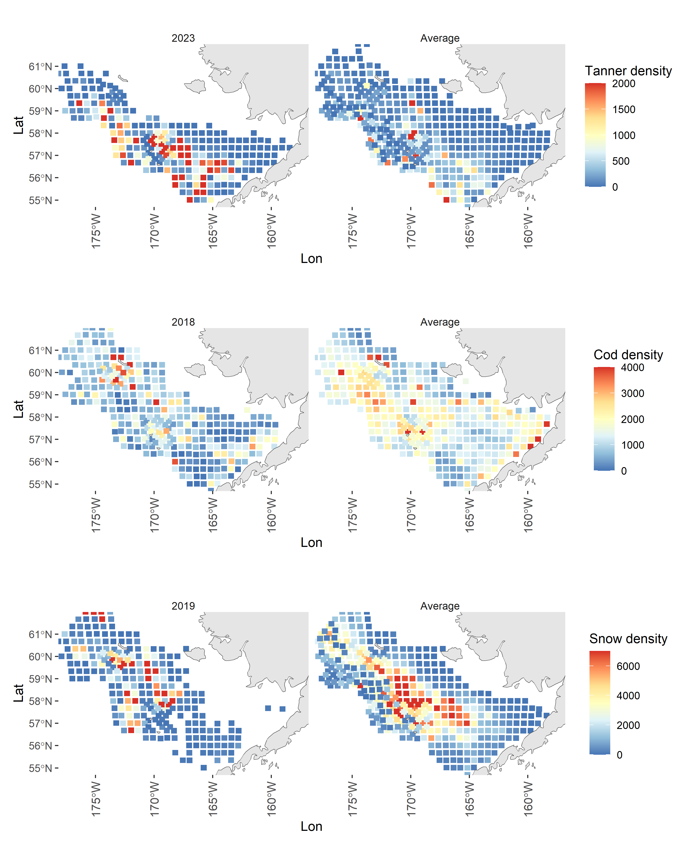

Figure 1. Maps of observed densities of Tanner crab, Pacific cod, and large snow crab (top to bottom) derived from a year of survey data relevant to the largest estimated recruitment event for Tanner crab (left column) and the average density over all years of data (right column).

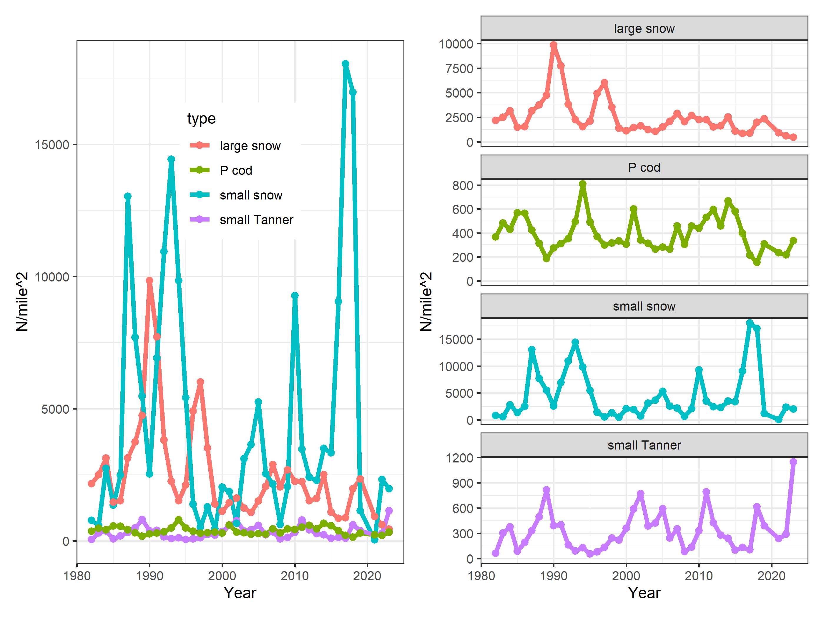

Figure 2. Time series of large snow crab, Pacific cod, small snow crab, and small Tanner crab. Left plot is for ease of comparing scale; right panel is for ease of comparing pattern.

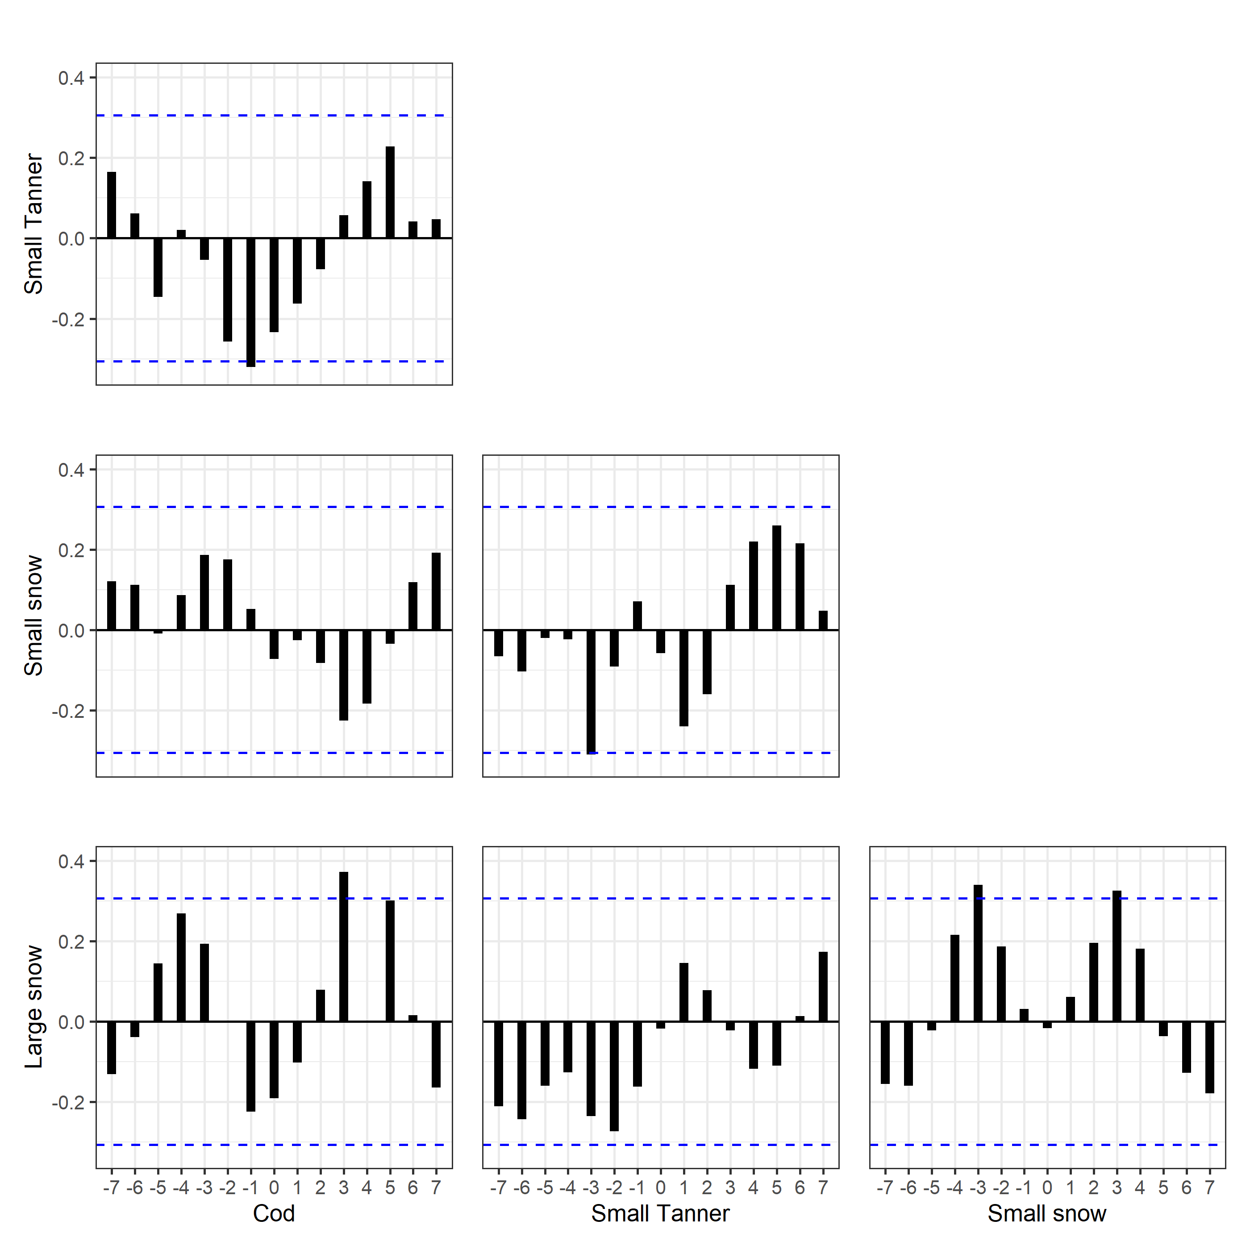

Figure 3. Crosscorrelation between time series in figure 2. X-axis is the lag used for correlating the time series.

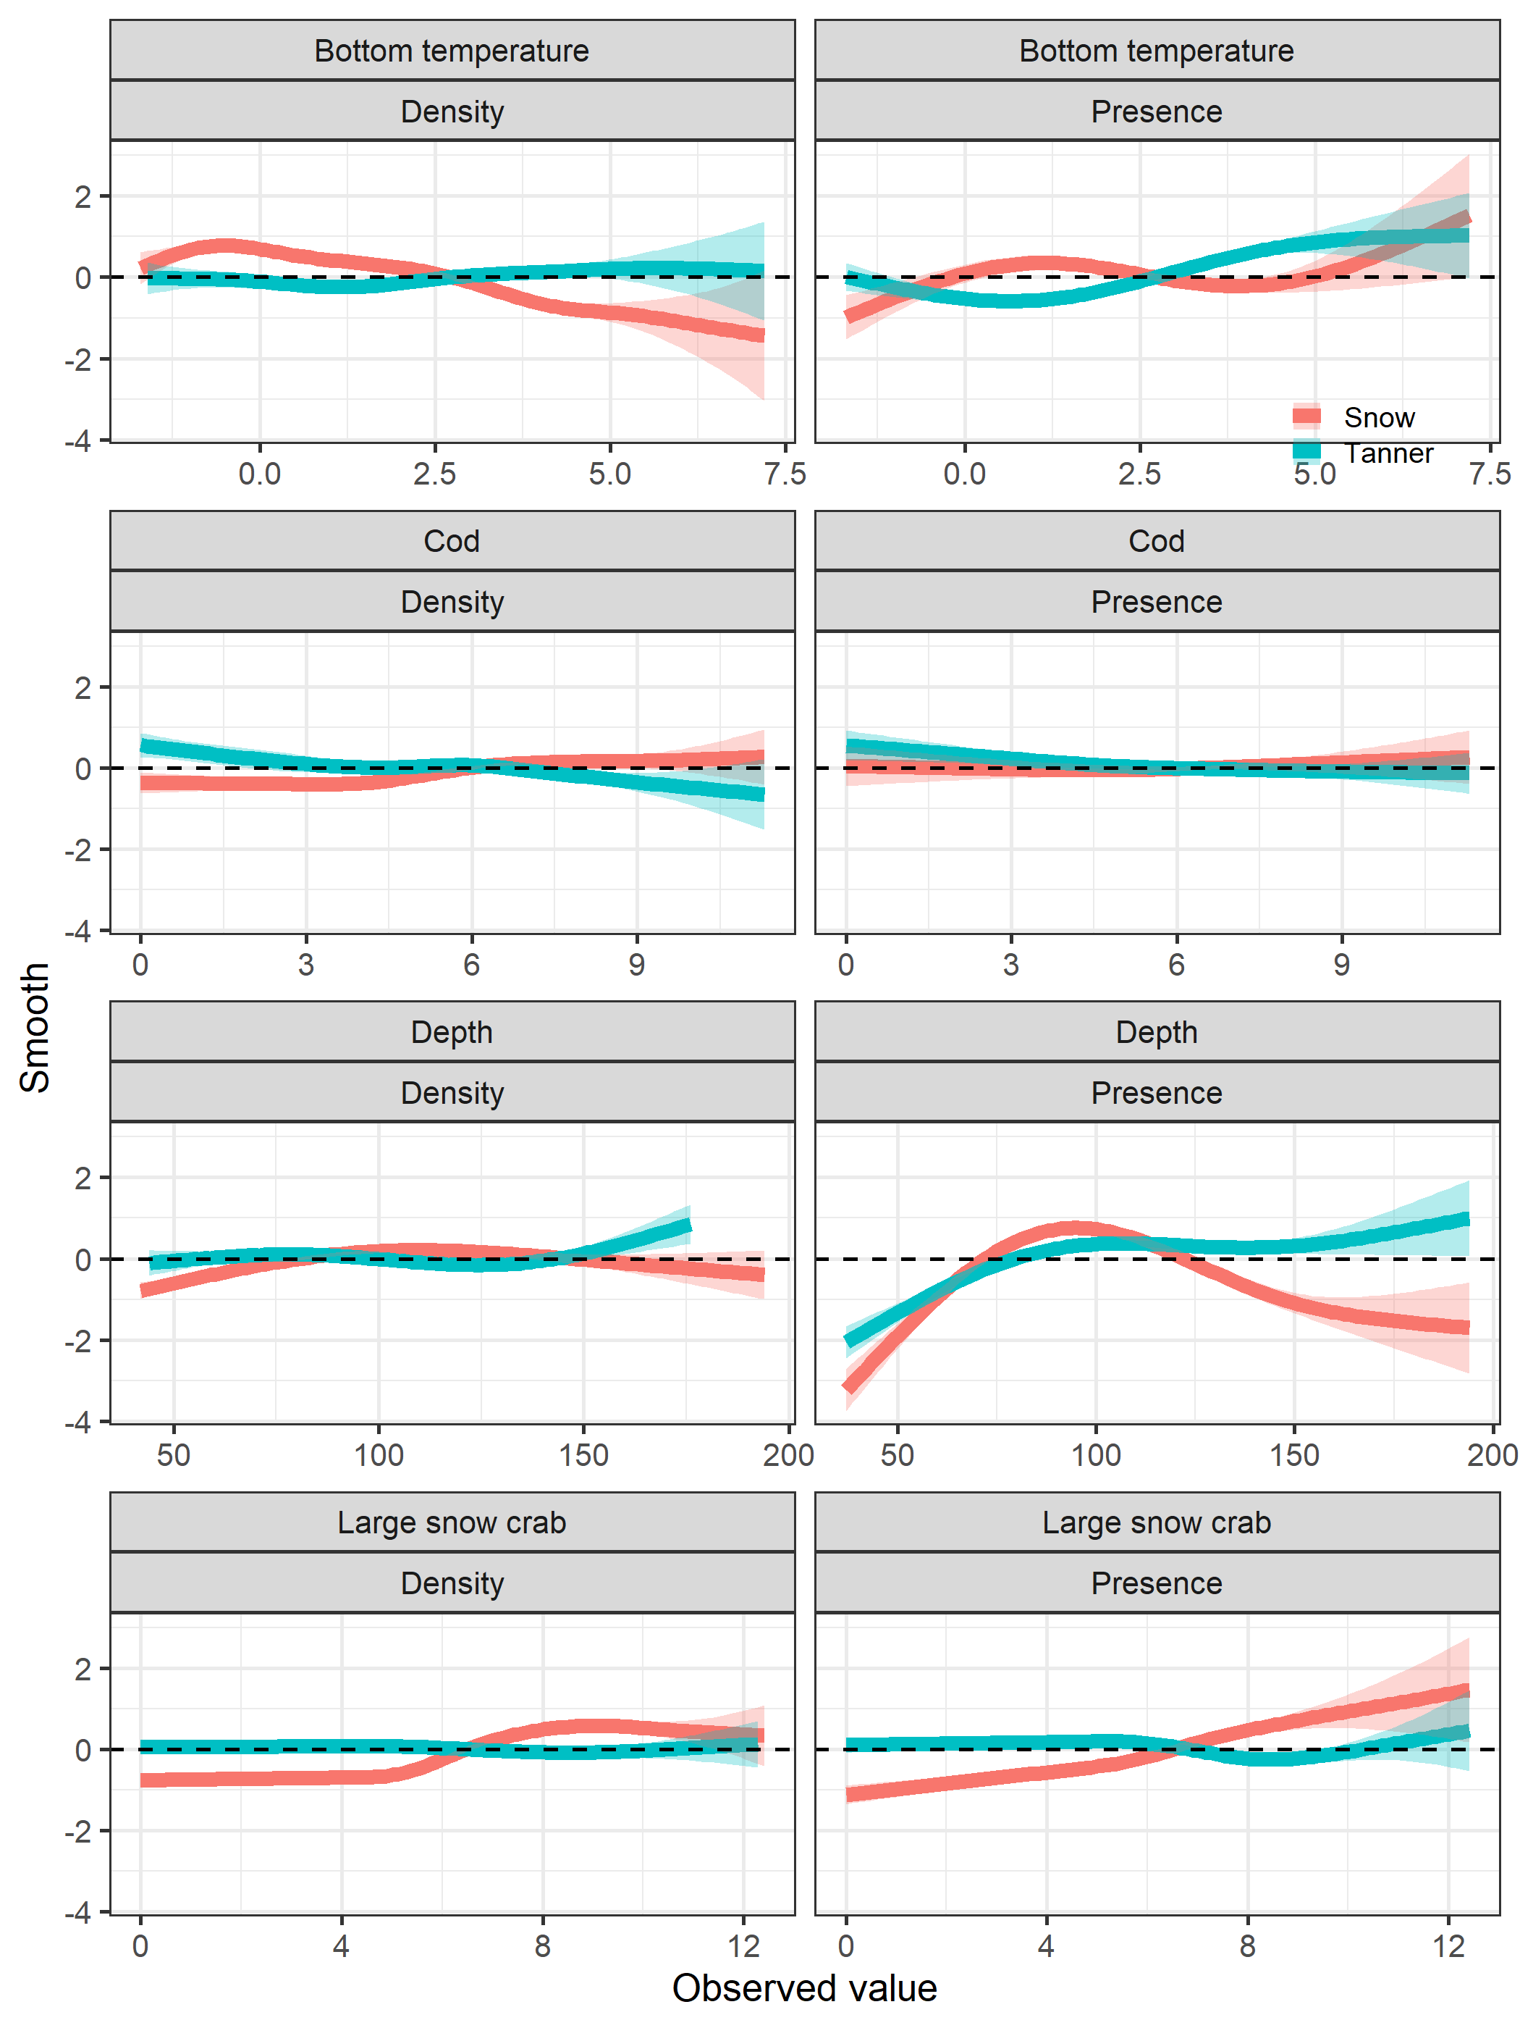

Figure 4. Shapes of estimated smooths from GAMs relating the presence (right column) and density (left column) of Tanner crab (blue) and snow crab (red) to different covariates.