# Exercise 1

Goal of this exercise is reading the files containing the image which is done with the use of the Pillow library.

# Exercise 2

Goal of the second exercise is converting the image yoda.jpg to black and white using thresholding.  
It is done by getting a RGB values of a point, summing and dividing them by 3 and then, if calculated sum is greater than a threshold (in my program it is 120), it returns white pixel, otherwise it returns black.

Created image:

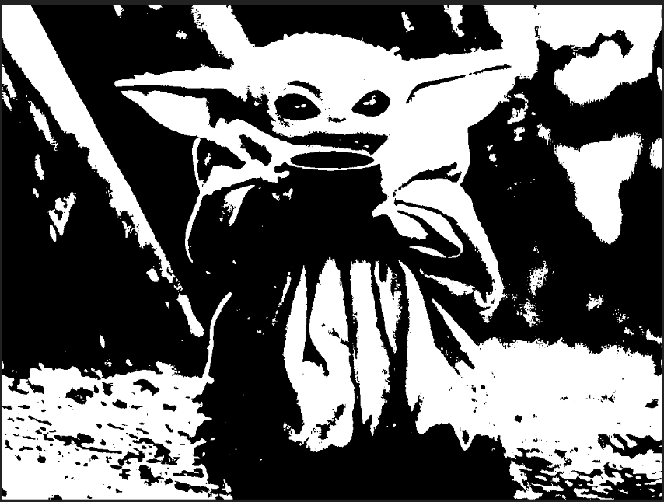

# Exercise 3

Goal of the third exercise is using histogram equalization on the image yoda.jpg.  
Similarly as in the second exercise, RGB value for each pixel is divided by 3 and are counted in dictionary counter. Then a CDF distribution is created in the same dictionary. Normalization is then done by calculating a new color value for each grayscale color with a formula

$$h\left(v\right)= round\left(\frac{cdf\left(v\right)-{cdf}_{min}}{\left(height*width\right)-{cdf}_{min}}\right)$$

Created image:

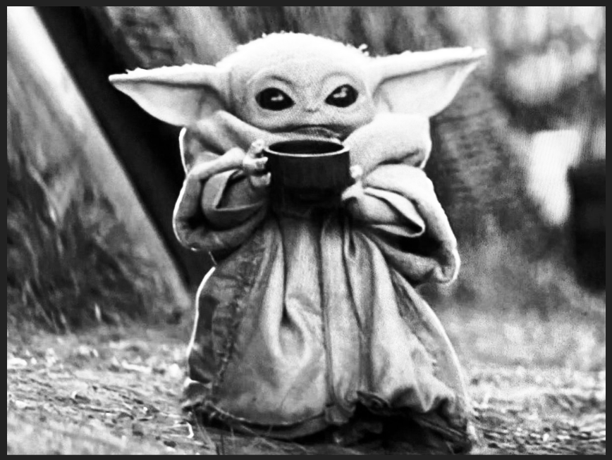

# Exercise 4

Goal of this exercise is using mean filter on the image road.jpg and utilizing a summed area table for that purpose. Summed area table is a table that in each cell contains sum of all values that are above and/or to the left to it.   
To make use of a summed area table, a gray border of half of a mask is created around the image.  
Then for each pixel, new value is created by dividing sum of all RGB values in a mask sized square around it by a mask squared.

Created image:

