# CO2509 Mobile Computing Report

# Szymon Janusz

## First Design

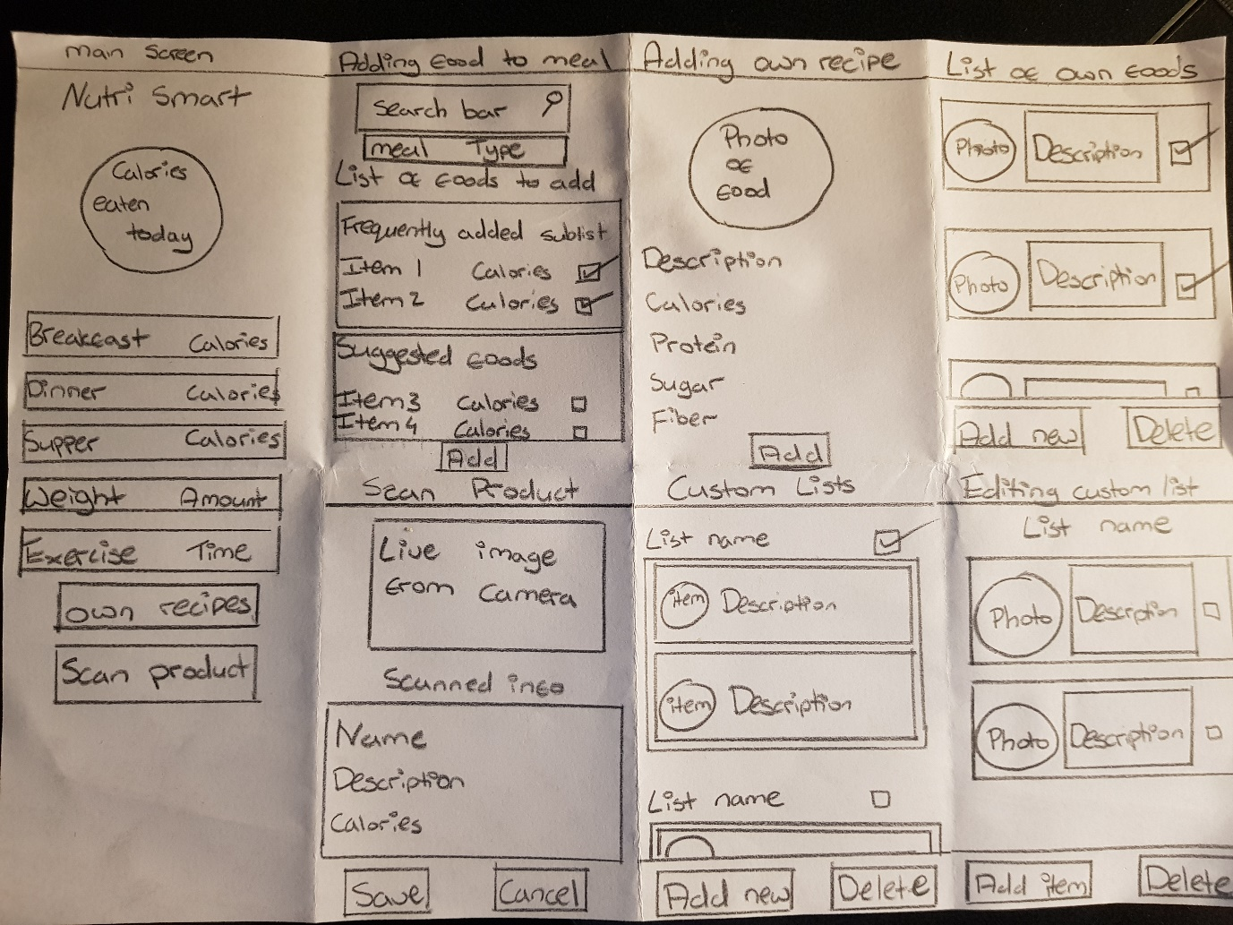

The first design includes additional features, which were beyond the initial assignment brief. This design included exercise, calories and weight tracking. The UI is would be intuitive to use and is based off Samsung Health and its material design. The user would be able to add custom-made foods and store them locally as an item, which can then be added to their daily routine to breakfast, dinner or supper. The calorie counter would refresh every day, at 00.00 hours and provide the user with an overview of their calorie intake. Additional internet functionality would be present through the ability to scan product barcodes and fill in or change missing information if needed. A page to view favourite and all items added would be created which would let the user toggle the favourite status of any item and could allow the user to delete an item from local storage.

## Second Design

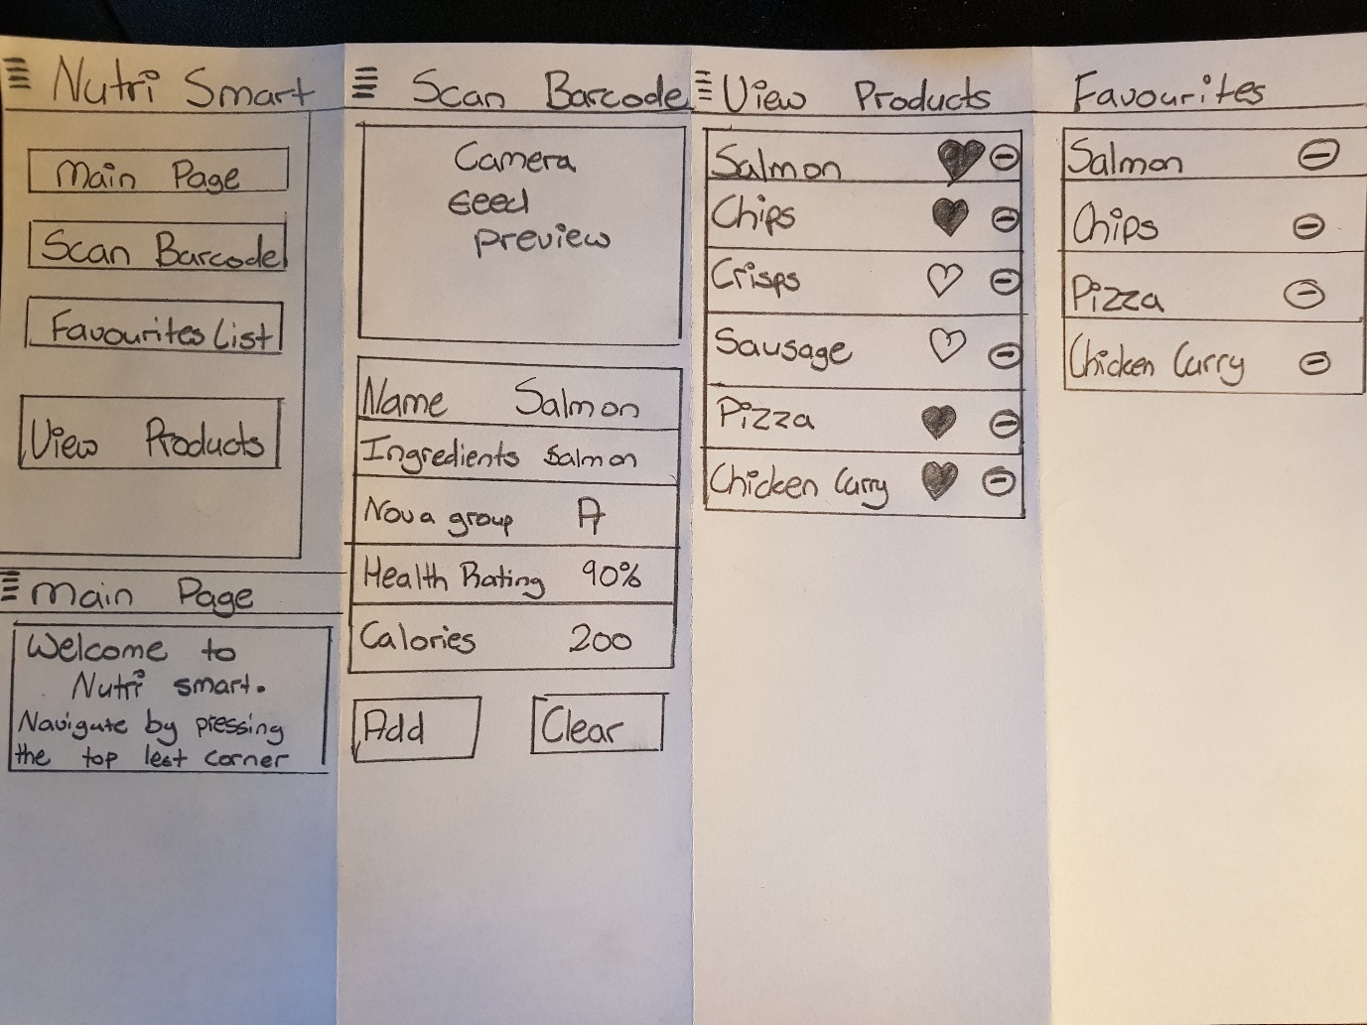

The burger menu that would be consistent throughout the design would allow the user for quick navigation between pages. This design would not include additional features such as weight, exercise or calorie tracker, that could possibly make it more intuitive and less overwhelming for users to use successfully. One of the screens would allow the user to scan a product barcode, and add it to local storage with the ability to edit the data fields before they are stored. A page to select and favourite items and products would allow the user to more quickly select items they would like to add to a meal.

## Third Design

The next design is like the first, but with reduced features. The initial menu screen remains similar, with reduced content available. The weight and exercise tracker would be removed as they were not hard requirements, leaving a streamlined application in place. A calorie counter would remain available and allow the user to track their energy intake. The streamlined design with big buttons would make the application usable for everyone; even those with vision impairments. The white and black contrast would aid with vision. Products can be added to meals, and the total calorie intake would be displayed on the home screen. Overall, this design follows a “Visually soothing interface” (Debasmita Saha, 2015), where the sections are clearly separated, allowing the user to see that the buttons would perform different functions.

## Fourth Design

The last design (home screen divided into squares) could be more appealing than. The home screen would feature 4 equally spaced squares that the user can click on. Each would have a label, eg. “Meal”, “Scan Product”, which describe functionality and that take the user to the appropriate page upon clicking. Product barcodes can be scanned and saved for offline use. A list of favourite items can be changed by the user upon clicking a button, which would render the item separately, on top of the list containing all other unfavourited items. This design along with others would allow for minimal attentional and cognitive load (Dillon, 2006) as “all necessary information [is] in the interface for the user to exploit as needed”. This results in an application that is easy to use.

# References

Debasmita Saha, A. M., 2015. User Interface Design Issues for Easy and Efficient Human Computer Interaction: An Explanatory. *National Conference on Computational Technologies,* 3(1), p. 132.

Dillon, A., 2006. User Interface Design. *Encyclopedia of Cognitive Science,* p. 456.