Abstract Classes

# Before Class

1. Familiarise yourself with the concept of abstract classes.
   1. <https://www.javatpoint.com/abstract-class-in-java>
   2. <https://docs.oracle.com/javase/tutorial/java/IandI/abstract.html>
2. **How an abstract class is implemented in a programming language.** - Klasa abstrakcyjna jest implementowana w języku programowania poprzez oznaczenie jej jako "abstract" i przez zawieranie co najmniej jednej metody abstrakcyjnej, czyli takiej, która nie ma implementacji, a jej nazwa i sygnatura są określone, ale nie ma ciała. Klasa abstrakcyjna nie może być utworzona jako instancja, ale może być rozszerzana przez inne klasy, które implementują jej metody abstrakcyjne.
3. **What an abstract class can contain.** - Klasa abstrakcyjna może zawierać pola, metody oraz konstruktory, takie jak inne klasy. Może również zawierać metody abstrakcyjne, które są to metody, które nie mają implementacji, a ich nazwa i sygnatura są określone, ale nie ma ciała. Metody te są oznaczone jako "abstract" i muszą być zaimplementowane przez klasy pochodne.
4. **How an abstract class is represented in a UML class diagram.-** kursywa  
     
   Inne : kursywa

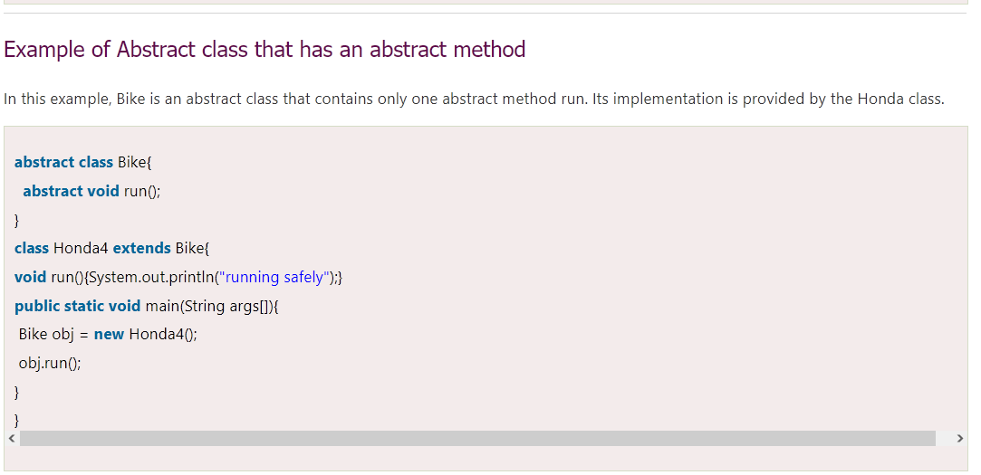

# During Class

1. An abstract Shape class describes abstract geometric figures. The class contains an abstract area() that returns the area of a geometric figure. Define an abstract class along with an abstract method.
2. Define the Rectangle, Triangle, and Circle classes that derive from the Shape class. Then write a program in which you create one object for each of the ageometric figures and calculate and display the area of these figures.
3. Complete the Shape class with an abstract perimeter() method that returns the perimeter of a geometric figure. Then write a program in which you create one object for each of the geometric figures, and calculate and display both the area and perimeter of these figures.
4. An abstract Message class describes an abstract message. The class contains the text attribute with the message text and accessor and mutator methods for this attribute. The parameterless constructor allows you to create a new, empty message, while the overloaded constructor with one parameter allows you to create a new message with the given content. The class also includes a charNumber() method that returns the number of characters in the message. Moreover, the abstract class includes an abstract send() method for sending a message (displays message along with its details). Define an abstract class and its attributes and methods.
5. Using inheritance, define an SMS class that derives from the Message class and describes text messages sent from a mobile phone. The class contains the phone number attribute to which the text message is sent. The class constructor allows you to initialize a phone number. The class also includes accessor and mutator methods to modify value of the attribute. Then create and send two mobile messages.
6. Using inheritance, define an Email class that derives from the Message class and describes messages sent using email. The class includes the following attributes: message subject and recipient's address. The class also includes accessor and mutator methods for class attributes. Add a constructor that allows you to create an email with the given subject and content that is sent to the given email address. Then create and send two emails.

# After Class

1. Create a User class with the following attributes: first name, last name, email, phone number. Then modify the SMS and Email classes. Use User class objects instead of the phone number and email attributes.
2. Create a UML class diagram that includes the Message, SMS, Email, and User class definitions. Pay attention to the relationships between the classes.
3. Create a project that describes the different types of vehicles. Define an abstract class Vehicle. Consider what attributes and methods (including abstract ones) an abstract class should contain. Add a constructor in the class to create a vehicle. Then, using inheritance, define Car, Bus, Truck classes representing specific types of vehicles. Consider what attributes and methods should these classes contain. Finally, create one car, bus and truck and display details on them.