纯铜降温数据
t(min) | V(mv) | △V+(mv) | △V-(mv) | △V(mv) | T(k) | △T(k)
0 | -2.8497 | 0.2548 | -0.2545 | 0.2546 | 196.37 | 8.180
3 | -2.4489 | 0.2062 | -0.1992 | 0.2027 | 183.26 | 6.772
6 | -2.1102 | 0.1625 | -0.1622 | 0.1623 | 171.68 | 5.693
9 | -1.8251 | 0.1414 | -0.1537 | 0.1475 | 161.43 | 5.441
12 | -1.5810 | 0.1214 | -0.1159 | 0.1186 | 152.21 | 4.594
15 | -1.3735 | 0.1042 | -0.0996 | 0.1019 | 143.99 | 4.127
18 | -1.1850 | 0.0930 | -0.0882 | 0.0906 | 136.19 | 3.832
21 | -1.0332 | 0.0800 | -0.0752 | 0.0776 | 129.65 | 3.403
24 | -0.8975 | 0.0701 | -0.0656 | 0.0678 | 123.60 | 3.076
27 | -0.7829 | 0.0616 | -0.0575 | 0.0595 | 118.33 | 2.778
30 | -0.6865 | 0.0541 | -0.0499 | 0.0520 | 113.78 | 2.486
33 | -0.6022 | 0.0487 | -0.0445 | 0.0466 | 109.70 | 2.277
36 | -0.5318 | 0.0438 | -0.0396 | 0.0417 | 106.23 | 2.075
39 | -0.4709 | 0.0398 | -0.0355 | 0.0376 | 103.17 | 1.903
42 | -0.4179 | 0.0362 | -0.0324 | 0.0343 | 100.48 | 1.758
45 | -0.3714 | 0.0340 | -0.0304 | 0.0322 | 98.08 | 1.671
48 | -0.3311 | 0.0316 | -0.0281 | 0.0298 | 95.97 | 1.565
51 | -0.2953 | 0.0289 | -0.0263 | 0.0276 | 94.09 | 1.461
54 | -0.2643 | 0.0275 | -0.0244 | 0.0259 | 92.44 | 1.385
57 | -0.2370 | 0.0264 | -0.0233 | 0.0248 | 90.98 | 1.336
60 | -0.2134 | 0.0249 | -0.0220 | 0.0234 | 89.70 | 1.269
63 | -0.1922 | 0.0234 | -0.0212 | 0.0223 | 88.55 | 1.213
66 | -0.1741 | 0.0228 | -0.0204 | 0.0216 | 87.56 | 1.181
69 | -0.1588 | 0.0220 | -0.0196 | 0.0208 | 86.73 | 1.142
72 | -0.1445 | 0.0215 | -0.0190 | 0.0202 | 85.94 | 1.116
75 | -0.1323 | 0.0203 | -0.0183 | 0.0193 | 85.26 | 1.067
78 | -0.1218 | 0.0201 | -0.0177 | 0.0189 | 84.68 | 1.048
81 | -0.1130 | 0.0199 | -0.0172 | 0.0185 | 84.19 | 1.031
84 | -0.1052 | 0.0195 | -0.0169 | 0.0182 | 83.76 | 1.013
87 | -0.0981 | 0.0190 | -0.0169 | 0.0179 | 83.36 | 1.002
90 | -0.0923 | 0.0187 | -0.0163 | 0.0175 | 83.04 | 0.978
96 | -0.0834 | 0.0184 | -0.0161 | 0.0172 | 82.54 | 0.966
102 | -0.0759 | 0.0178 | -0.0159 | 0.0168 | 82.12 | 0.946
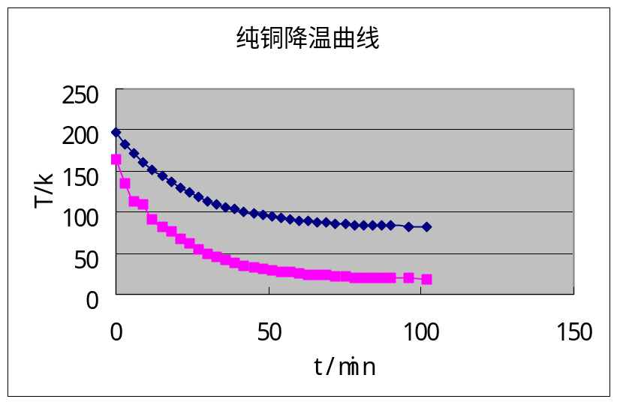

在降温过程中，电压U_{h1}=3.009v, 电流I₁=30mA, △T=0.946k
因此，λ= U_{h1}•I₁•l/(△T•A)=5.04W/k•cm

纯铜升温数据

t(min) | U(mv) | △V+(mv) | △V-(mv) | △V(mv) | T(k) | △T(k)
0 | -0.1611 | -0.0091 | 0.0110 | -0.0100 | 86.856 | -0.551
3 | -0.2885 | -0.0021 | 0.0042 | -0.0031 | 93.731 | -0.167
6 | -0.3453 | 0.0043 | -0.0026 | 0.0034 | 96.721 | 0.180
9 | -0.4036 | 0.0078 | -0.0060 | 0.0069 | 99.745 | 0.355
12 | -0.4502 | 0.0100 | -0.0081 | 0.0090 | 102.12 | 0.460
15 | -0.4946 | 0.0120 | -0.0102 | 0.0111 | 104.37 | 0.557
18 | -0.5313 | 0.0129 | -0.0114 | 0.0121 | 106.20 | 0.604
21 | -0.5598 | 0.0143 | -0.0130 | 0.0136 | 107.62 | 0.674
24 | -0.5885 | 0.0162 | -0.0145 | 0.0153 | 109.03 | 0.752
27 | -0.6136 | 0.0164 | -0.0147 | 0.0155 | 110.26 | 0.757
30 | -0.6380 | 0.0172 | -0.0157 | 0.0164 | 111.44 | 0.796
33 | -0.6580 | 0.0184 | -0.0167 | 0.0175 | 112.41 | 0.845
36 | -0.6755 | 0.0191 | -0.0175 | 0.0183 | 113.25 | 0.877
39 | -0.6928 | 0.0200 | -0.0181 | 0.0190 | 114.08 | 0.909
42 | -0.7063 | 0.0204 | -0.0190 | 0.0197 | 114.72 | 0.937
45 | -0.7188 | 0.0208 | -0.0194 | 0.0201 | 115.31 | 0.953
48 | -0.7300 | 0.0211 | -0.0197 | 0.0204 | 115.84 | 0.964
51 | -0.7409 | 0.0228 | -0.0203 | 0.0215 | 116.36 | 1.016
54 | -0.7494 | 0.0229 | -0.0210 | 0.0219 | 116.76 | 1.032
57 | -0.7563 | 0.0232 | -0.0214 | 0.0223 | 117.08 | 1.047
60 | -0.7621 | 0.0234 | -0.0215 | 0.0224 | 117.36 | 1.053
63 | -0.7678 | 0.0238 | -0.0220 | 0.0229 | 117.62 | 1.072
66 | -0.7732 | 0.0240 | -0.0224 | 0.0232 | 117.88 | 1.085
69 | -0.7780 | 0.0240 | -0.0227 | 0.0233 | 118.10 | 1.090
72 | -0.7826 | 0.0241 | -0.0228 | 0.0234 | 118.32 | 1.094
75 | -0.7859 | 0.0244 | -0.0231 | 0.0237 | 118.47 | 1.107
78 | -0.7898 | 0.0246 | -0.0233 | 0.0239 | 118.65 | 1.115
81 | -0.7927 | 0.0248 | -0.0235 | 0.0241 | 118.79 | 1.124
84 | -0.7947 | 0.0249 | -0.0235 | 0.0242 | 118.88 | 1.125
87 | -0.7970 | 0.0250 | -0.0237 | 0.0243 | 118.99 | 1.132
90 | -0.7990 | 0.0251 | -0.0239 | 0.0245 | 119.08 | 1.138

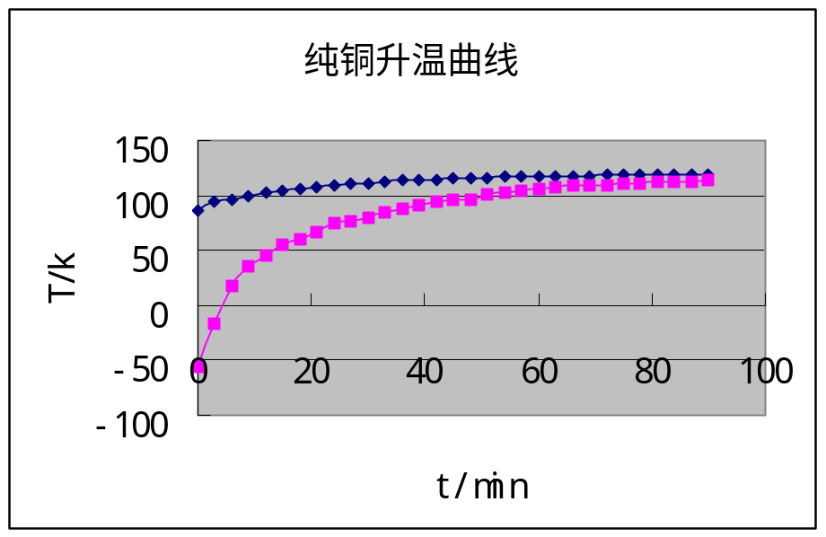
在升温过程中，H3的电流I_{h3}=200mA, H1电压U_{h1}=3.015v, 电流I₁=29.8mA, △T=1.138k
因此，λ= U_{h1}•I₁•l/(△T•A)=4.13W/k•cm

