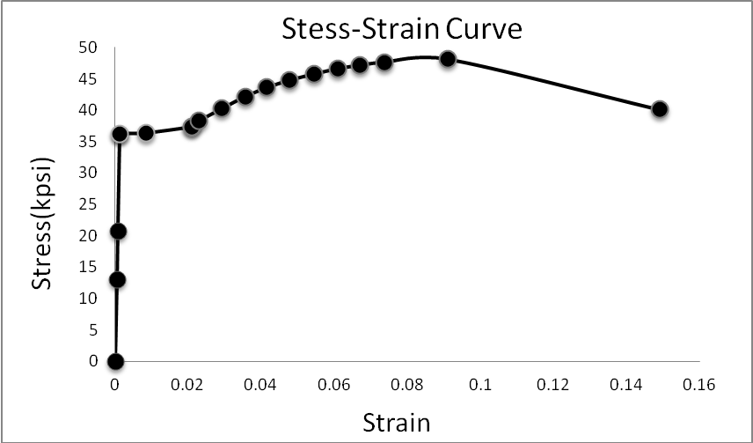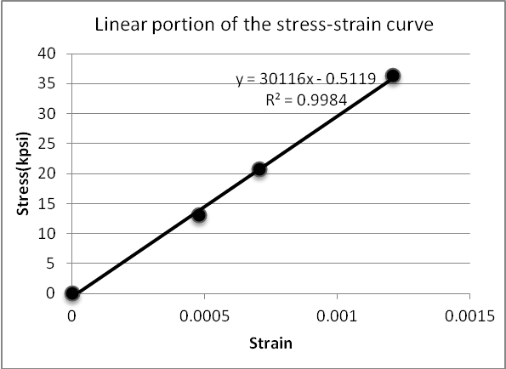
Stress(kpsi) | Strain
0 | 0
13.088903 | 0.00048
20.72834 | 0.000705
36.261862 | 0.00121
36.363721 | 0.008455
37.382313 | 0.02098
38.349975 | 0.022995
40.285299 | 0.029235
42.169694 | 0.035585
43.595722 | 0.041505
44.767102 | 0.047785
45.734764 | 0.05439
46.600567 | 0.061035
47.109863 | 0.06686
47.619159 | 0.073705
48.077525 | 0.090995
40.081581 | 0.14907

