Final Exam Problems for
Fundamentals of Engineering Materials
(Fall Semester, 2002)
Student Name: Student ID Number: Class Number:

1. Complete the sentences by filling appropriate words in the blanks. (50 points)
- With regard to the types of interatomic bonding, metals involve __________ bonding; ceramics and glasses involve mixed ________- _________bonding; polymers typically involve strong __________bonds along polymeric chains but have weaker _____________bonding between adjacent chains; semiconductors such as Si are predominantly _________ in nature, but some semiconducting compounds such as CdS exhibit mixed _________ - __________ character.
(2) The most closely packed planes in FCC, BCC, and HCP crystal structures are { }, { }, and { }, respectively. The most closely packed directions in FCC, BCC, and HCP crystal structures are < >, < >, and < >, respectively.
- The directionality of properties for single crystals is termed ________________, while the non-directionality of properties for polycrystalline materials is termed _______________.
- The polymorphic forms of pure iron are ____________(~912ºC), ____________(912ºC -1394ºC), and _____________(>1394ºC).
- Crystalline silica (SiO₂) is formed when __________tetrahedrons are arrayed into a regular 3D network.
- Among the linear, branched, crosslinked, and network molecular structures of polymers, the ___________ structure is most likely to crystallize.
- A rapid cooling process helps in forming ______________(crystalline, or noncrystalline) structures.
- According to geometry and size, the structural imperfections in crystalline solids can be categorized into three types: ______________(examples: ________, _________, _____________), ________________(examples: _________, _____________, _____________), and ______________(examples: ______________, ______________)
- Interstitial solids solutions have only a limited solubility of solute atoms, whereas the solubility of solute atoms in substitutional solid solutions is appreciable and even complete, depending on the following four features: __________________, ____________________, __________________, and ____________________.
(10) Atoms diffuse in crystalline solids by two mechanisms: __________mechanism and ______________mechanism.
(11) The dependence of diffusivity (diffusion coefficient) on temperature and activation energy can be described with an Arrhenius-type expression: ___________________________.

(12) Compared with volume (lattice) diffusion, “short-circuit” diffusion requires less activation energy and thus produces rapid diffusion rate. The “short-circuit” diffusion paths include _____________, ________________, and _________________, etc.
(13) During the rapid solidification of many alloys, compositional gradients are created and cored structures are produced. A cored structure can be eliminated by a heat-treating process that is named ____________________.
(14) Among the three typical transformations (pearlitic, bainitic, and martensitic) of austenite in steels, _____________transformation is diffusional, ____________ transformation is semi-diffusional, and ______________transformation is diffusionless.
(15) In order to refine the grain size of metals during solidification, such methods as _________________, _____________________, and __________________can usually be employed.
(16) Plastic deformation of crystalline metals takes place by two fundamental mechanisms: _______________and _____________. A large amount of plastic deformation can only be achieved by ______________ mechanism
(17) The ductility of Zn (HCP), α-Fe (BCC), and Cu (FCC) can be arranged in a descending order: ________, __________, and ______________.
(18) Ceramics usually exhibit lack of plasticity and brittle fracture at room temperature, partially because_________________________________________.
(19) The plastic deformation of lead (Pb) and tin (Sn) at room temperature belongs to _______________(cold working, or hot working).
(20) Based on the relation between dislocation slip motion and plastic deformation, metals can be strengthened by the following four mechanisms: ____________________________, _____________________________, __________________________, and _____________________________.
2. Sketch the following planes and directions within cubic unit cells. (12 points)
  - (111), [111];
  - (011), [011];
  - (112), [112]
3. A 0.20 wt%C hypoeutectoid steel is slowly cooled from about 950ºC to room temperature. (15 points)
- Calculate the mass fractions of phases in the resulting microstructure;
- Calculate the mass fractions of microconstituents in the resulting microstructure;
- Schematically sketch and label the resulting microstructure.

4. The relationship between crystal strength and dislocation density is schematically described in the figure below. Briefly explain why the crystal strength varies in this manner with increasing dislocation density. (8 points)

Theoretical strength for perfect crystal

Strength of whiskers (nearly perfect crystal)
Strength

Strain hardening by cold-working

Annealed crystal

Dislocation density

5. The titanium-copper phase diagram is shown below. (15 points)
- Label the phases in the phase regions that have not been labeled;
- Specify all temperature-composition points at which eutectics, eutectoids, peritectics, and congruent phase transformations occur;
(c ) For each of the above transformations, write the reaction upon cooling.

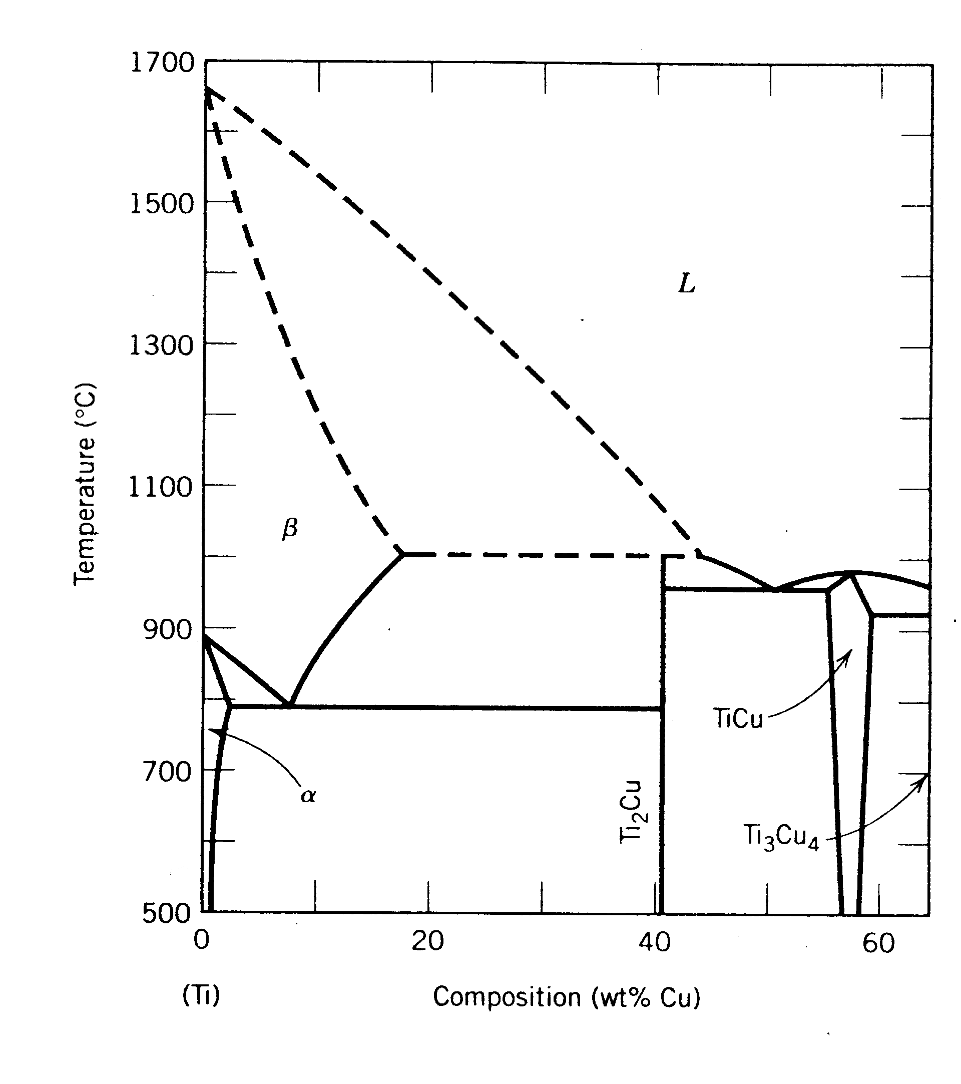

A rapid solidification process helps to form () structures.
* The critical cooling rate for an alloy steel to obtain martensitic structure is ()
that for a plain carbon steel having the same carbon content.
* Strengthening by grain size reduction is not valid at () temperatures.
* The plastic deformation of lead and tin at room temperature belongs to ().
* At the same temperature, carbon atoms diffuse faster in () than in ().
* Forming of cottrel atmospheres () the mobility of dislocations.
* For aging of Al-Cu alloys, the maximum strengthening effect is achieved when
the precipitate phase has a () interface with the matrix.
* Lath martensite forms in () steels, contributiing to (); plate martensite forms in
() steels, yielding ().
* The mechanical properties of steels vary largely with microstructure. For the
same carbon content, the strength and hardness of the following microstructure
may be marked as (), and the ductility may be ranked as ().
* For an edge dislocation, the Burger vector b () the dislocation line;for screw ... () /
mixed ... ().

