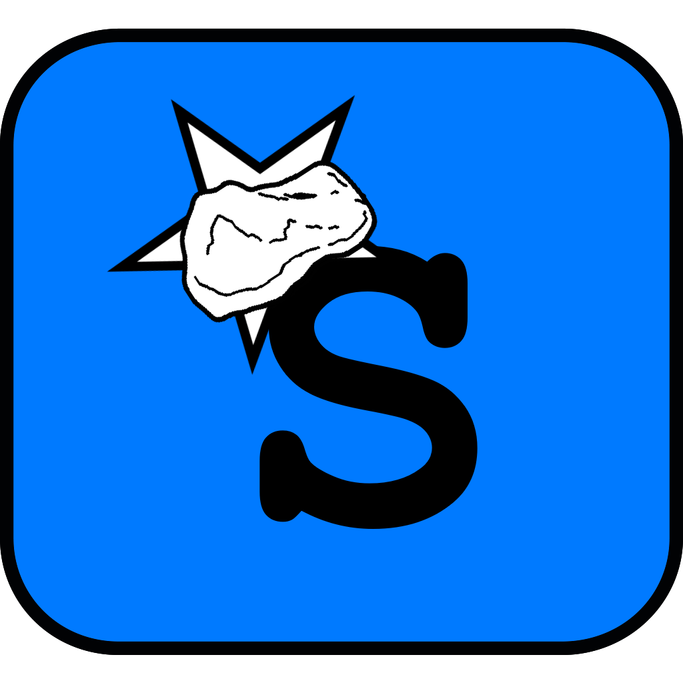
Universe Rampage

Post Mortem
© Starrock

Julian Heinen, Dominik Richter

Inhaltsverzeichnis
1Game Design 3
2Tasks of the team members 3
2.1Julian Heinen 3
2.2Dominik Richter 3
2.3Both 3
3Used tools 4
3.1Engines 4
3.2Version Control 4
3.3Communication 4
3.4Resources 4
4What worked well 5
4.1Teamwork 5
4.2Distribution of work 5
4.3Progress 5
5What worked not so well 5
6Summary 6

Game Design
Our goal was to create a 2D asteroidesque survival spaceshooter, that focuses on a challenging gameplay with features, that encourage to get better and play again. The player controls a spaceship and tries to survive as long as possible while avoiding asteroids, destroying enemies and scavenging wreckages to get points. To make the game more challenging and applying more of a survival structure, the player also has to manage four resources: structure, shield, energy and fuel. The gameplay is not continous but portioned in so called “Sessions”, which can be seen as individual rounds. After a session, the results will be stored in an online leaderboard, so that players can compete with each other.

Tasks of the team members
Because of our different experiences with the used engines, each team member had different tasks up to a point where the experience gap got smaller.

Julian Heinen
As project lead, Julian was responsible for the documentation of the project and managing user resources. Since he had experience with C#, Farseer and Monogame, he was in charge of implementing the main engine, scene management, entity management and the used entities, artificial intelligence (AI), player management, sounds and input.

Dominik Richter
Since Dominik had no experience with C# and the used engines, he had to learn the basics of the language and Monogame. But since C# is pretty similar to Java, which is taught at the HTW, he managed to get into the language very fast. From this point onwards, Dominik was responsible for the implementing the templates, the user interface and tweaking farseer attributes for entities. He also implemented the physics handlers such as collision response.

Both
Most of the listed tasks were not done completely by one person, but were implemented with team work, by coding suggestions, new ideas and bugfixing. This way both of us were partly involved in about 70% of the others code and work.

Used tools
In the process of development, we used various free or open source engines and tools.

Engines
We decided on using the language C# for developing the game. Hence there were possibilities such as Unity, XNA, or Monogame as a game engine. The choice fell on Monogame, since Unity would have been an overkill for the game concept, because most of the features provided by unity would not have been used.

For physics, we decided to use the Farseer Engine, a 2D physics engine developed for XNA and Monogame. The engine provides easy to use and realistic physics and collision handling, so that we didn't have to focus much on this aspect.

Version Control
For handling versions and simultanious programming, we used Bitbucket, a Git provider. With a repository, we could work on the code simultanously, create our own branches and switch between versions and commits. Since Git is also used in big companies, this was the best choice to make.

Communication
For communication, we mainly used telegram, an instant messanger for smartphone and desktop, or met up in university to talk about ideas and progress. This way we had very short communication paths, what minized decisions.

Resources
All of the graphics used for the game are self made with Paint.net. The audios were taken from free audio websites such as http://opengameart.org/ . The only exception is the Metal Gear sound „Alert“, which has been directly recorded out of the game, because it was fitting for the used situation and kind of funny.

What worked well

Teamwork
Our team had a very good synergy, since we have worked together in previous projects and knew each other, our weaknesses and strengths as well as how the other works. This is why we knew who could do what at that the project will go well, so we were motivated the whole time.

Distribution of work
Since we used Git for version control and had our concept ready, we could easily divide the various features into little packages and distribute these packages among us. This way we had almost all the time work to do and our results could be seen in the game with each new commit.

Progress
Our concept constisted of many features that we wanted to include in our game. Because we had time pressure, we had to start early with implementation. We constantly worked on the game with high spirits, so we made progress every week. Each major progress at the end of a week had a huge impact on the project, what could have been seen when debugging our code.

What worked not so well
In our opinion there haven't been anything that didn't went well. For our second prototype we had some features not implemented yet or even marked as failed, but these could as well be implemented in the future. So we can't think of anything that would fit in this section.

Summary
We had very much fun thinking of game ideas and concepts, putting every thought into an environment of other toughts. After our concept was finished (pseudo finished because concepts never are finished), we had to think about how to implement various things and learned that we could use many things learned while studying, for example design patterns taught by Professor Folz.
It was a challenge to use another programming language and new engines especially managing so many classes and files, but we think that we have achieved our goal.

The lecture „Game Design and Development“ was very interesing gave us a slight insight in the process of creating a video game. We can only recommend participating in the lecture to take on a challenge different from other lectures at the HTW.

