第一步：WebSite拷贝出来，修改为WebSiteBJ

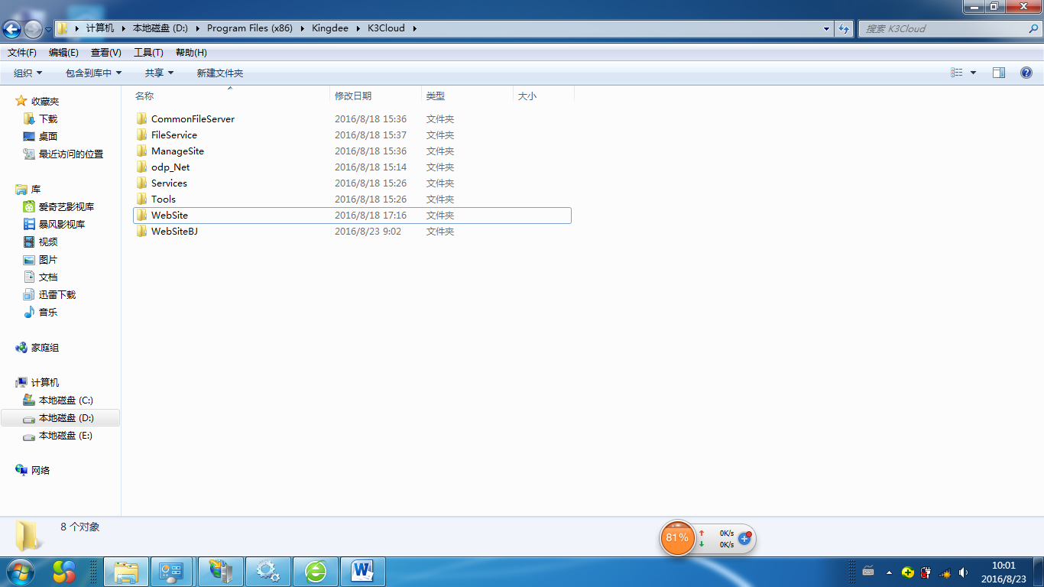

第二步：IIS新建手工新建站点和应用程序池，包括K3CloudBJ和K3CloudAppBJ

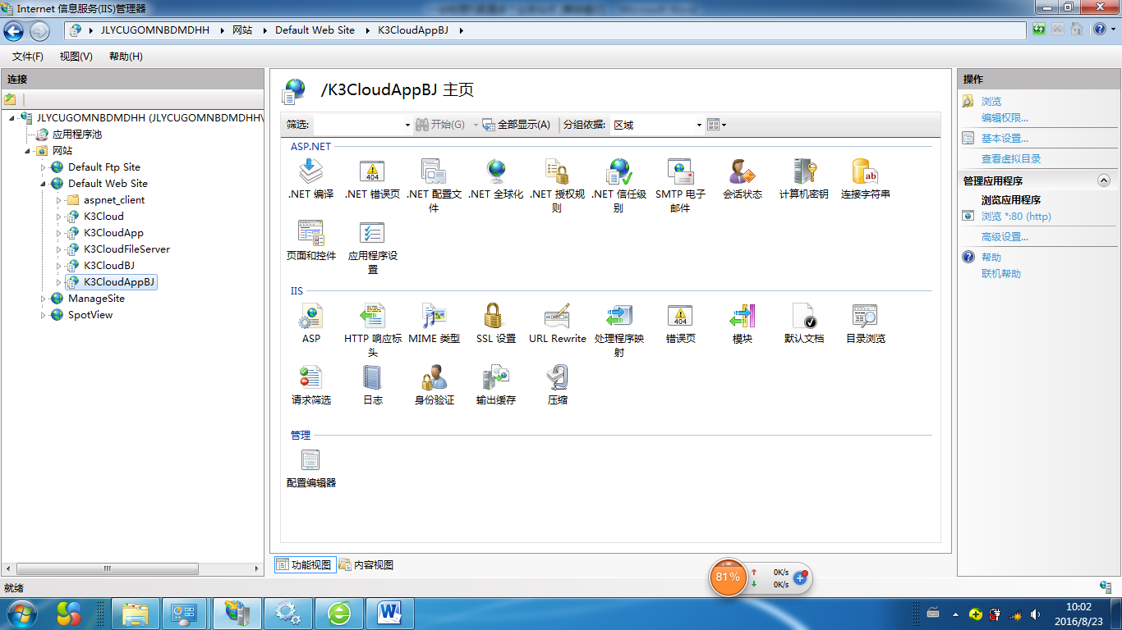

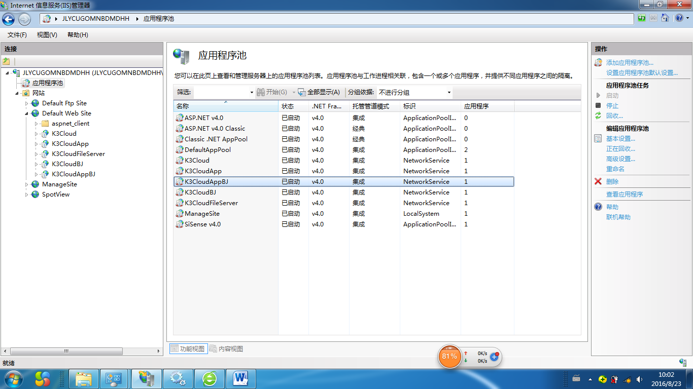

注意：应用程序池的运行标识修改为NetworkService

第三步：

1）修改\Kingdee\K3Cloud\WebSiteBJ\App_Data下的common配置文件，相关K3Cloud站点配置修改为K3CloudBJ站点配置，例如：

<add key="kdsReportUrl" value="k3cloud://localhost/K3CloudBJ/Clientbin/K3cloudclient/kdsReport.manifest" />

<add key="DesignerUrl" value="k3cloud://localhost/K3CloudBJ/Clientbin/K3cloudclient/boside.manifest" />

<add key="CloudClientUrl" value="k3cloud://localhost/K3CloudBJ/Clientbin/K3cloudclient/K3cloudclient.manifest" />

<add key="ReportIDEDesignerUrl" value="k3cloud://localhost/K3CloudBJ/Clientbin/K3cloudclient/ReportIDE.manifest" />

<add key="LoginUrl" value="http://localhost/K3CloudBJ/" />

<add key="ComputeSiteUrl" value="http://LOCALHOST/K3CloudAppBJ/" />

<add key="FinReportUrl" value="k3cloud://localhost/K3CloudBJ/Clientbin/K3cloudclient/FINReport.manifest" />

<add key="KDServiceSite" value="http://localhost/K3CloudBJ/" />

2）修改\Kingdee\K3Cloud\WebSiteBJ\App_Data下的SiteInfo配置文件，ID字段从K3Cloud修改为K3CloudBJ，例如：

<Id>K3CloudBJ</Id>

VDName字段从K3Cloud修改为K3CloudBJ，例如：

<DeploySite>

<HostName>localhost</HostName>

<DefautPort>80</DefautPort>

<Protocol>http</Protocol>

<SiteName>Default Web Site</SiteName>

<VDName>K3CloudBJ</VDName>

<AppPoolIdentityType>NetworkService</AppPoolIdentityType>

<PhysicalPath>d:\Program Files (x86)\Kingdee\K3Cloud\WebSiteBJ</PhysicalPath>

</DeploySite>

<ComputingService>

<HostName>localhost</HostName>

<DefautPort>80</DefautPort>

<Protocol>http</Protocol>

<SiteName>Default Web Site</SiteName>

<VDName>K3CloudAppBJ</VDName>

<AppPoolIdentityType>NetworkService</AppPoolIdentityType>

<PhysicalPath>d:\Program Files (x86)\Kingdee\K3Cloud\WebSiteBJ</PhysicalPath>

</ComputingService>

3）修改\Kingdee\K3Cloud\Services\ManagementService\App_Data中的SiteEngine配置文件，添加红色字体部分配置，指向WebSiteBJ目录中的SiteInfoBJ.xml（原来目录中的SiteInfo需要修改为SiteInfoBJ），例如：

<?xml version="1.0" encoding="utf-8"?>

<SiteEngine xmlns:xsd="http://www.w3.org/2001/XMLSchema" xmlns:xsi="http://www.w3.org/2001/XMLSchema-instance">

<SiteIndexes>

<SiteInforItem>

<SiteInforFile>%InstallPath%\ManageSite\App_Data\SiteInfo.xml</SiteInforFile>

</SiteInforItem>

<SiteInforItem>

<SiteInforFile>%InstallPath%\WebSite\App_Data\SiteInfo.xml</SiteInforFile>

</SiteInforItem>

<SiteInforItem>

<SiteInforFile>%InstallPath%\WebSiteBJ\App_Data\SiteInfoBJ.xml</SiteInforFile>

</SiteInforItem>

<SiteInforItem>

<SiteInforFile>%InstallPath%\FileService\App_Data\SiteInfo.xml</SiteInforFile>

</SiteInforItem>

</SiteIndexes>

</SiteEngine>

4）修改\Kingdee\K3Cloud\WebSiteBJ\Bin中的Kingdee.BOS.ScheduleService.exe配置config文件，修改为K3CloudAppBJ站点，例如：

<add key="ComputeSiteUrl" value="http://LOCALHOST/K3CloudAppBJ/" />

第四步：重启K3CloudJobProcess和K3CloudManager服务，重启IIS

之后，登陆Cloud管理中心，就可以看到2个站点

