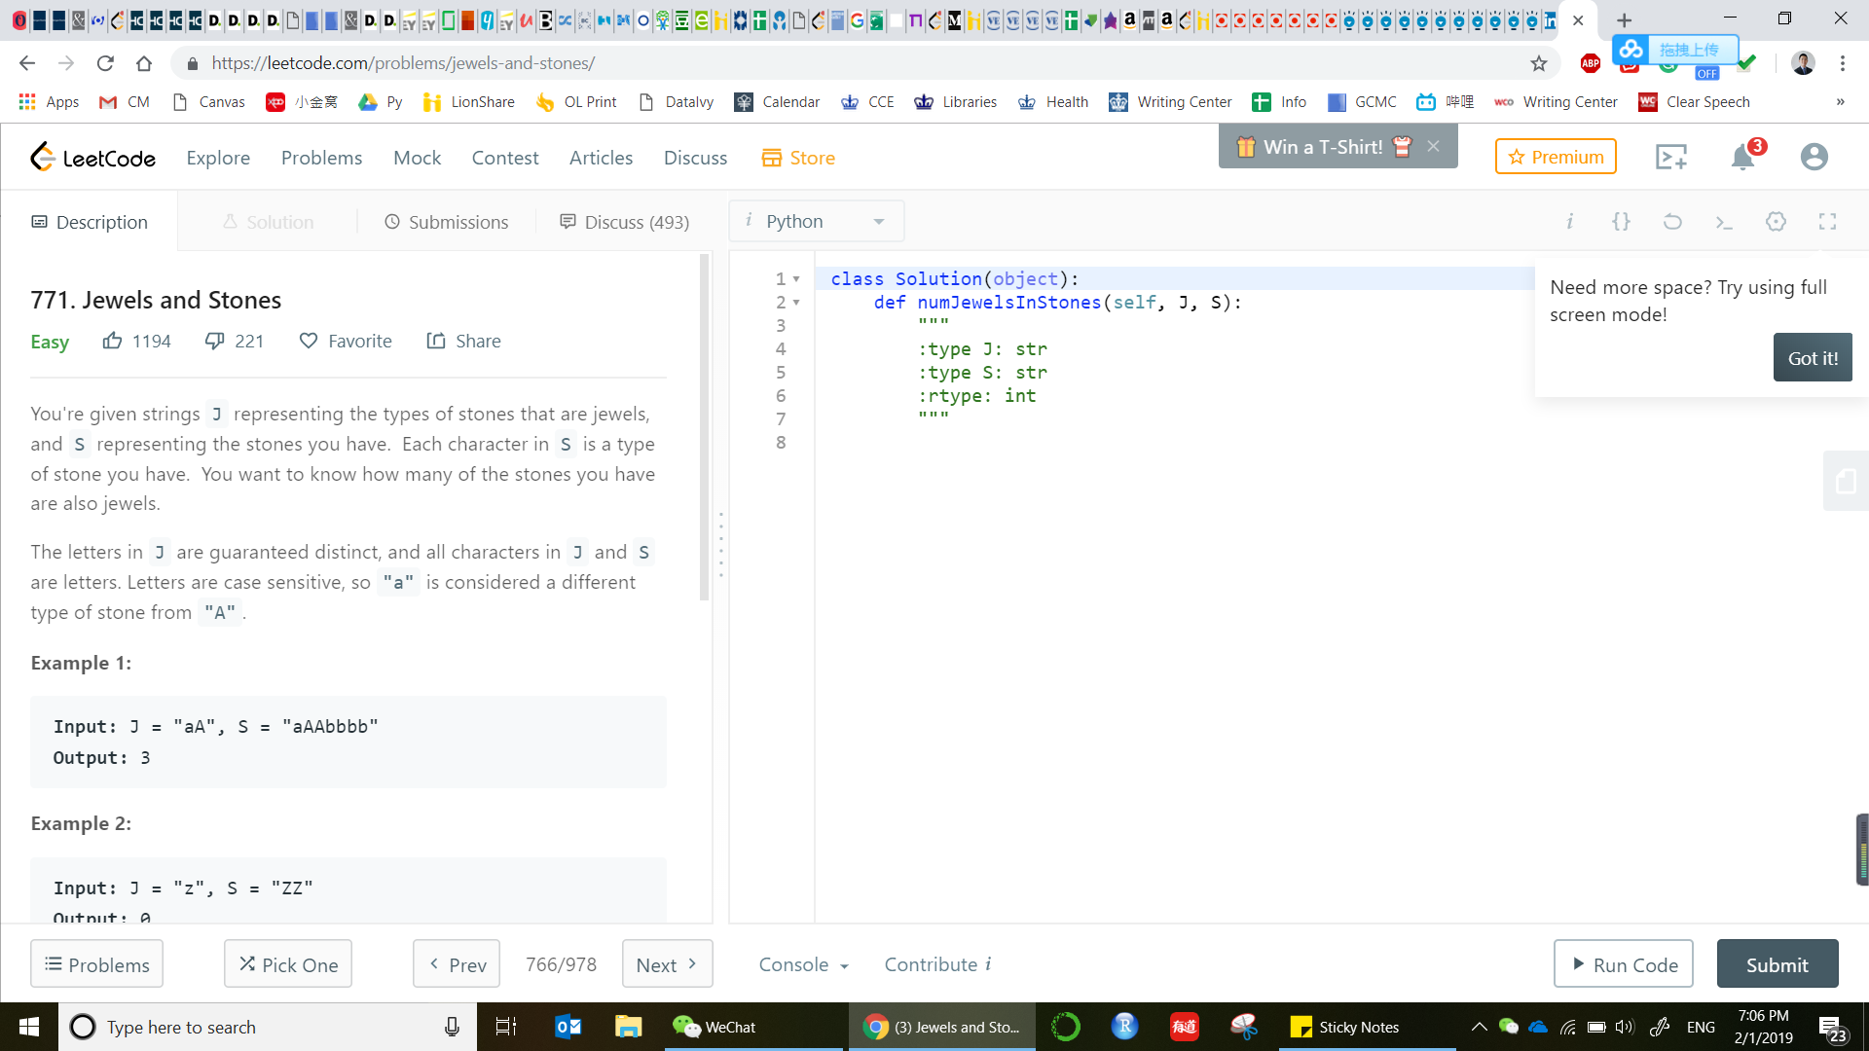

**771. Jewels and Stones**

Easy

1194221FavoriteShare

You're given strings J representing the types of stones that are jewels, and S representing the stones you have.  Each character in S is a type of stone you have.  You want to know how many of the stones you have are also jewels.

The letters in J are guaranteed distinct, and all characters in J and Sare letters. Letters are case sensitive, so "a" is considered a different type of stone from "A".

**Example 1:**

**Input:** J = "aA", S = "aAAbbbb"

**Output:** 3

**Example 2:**

**Input:** J = "z", S = "ZZ"

**Output:** 0

**Note:**

* S and J will consist of letters and have length at most 50.
* The characters in J are distinct.

Accepted

177,031

Submissions

214,436

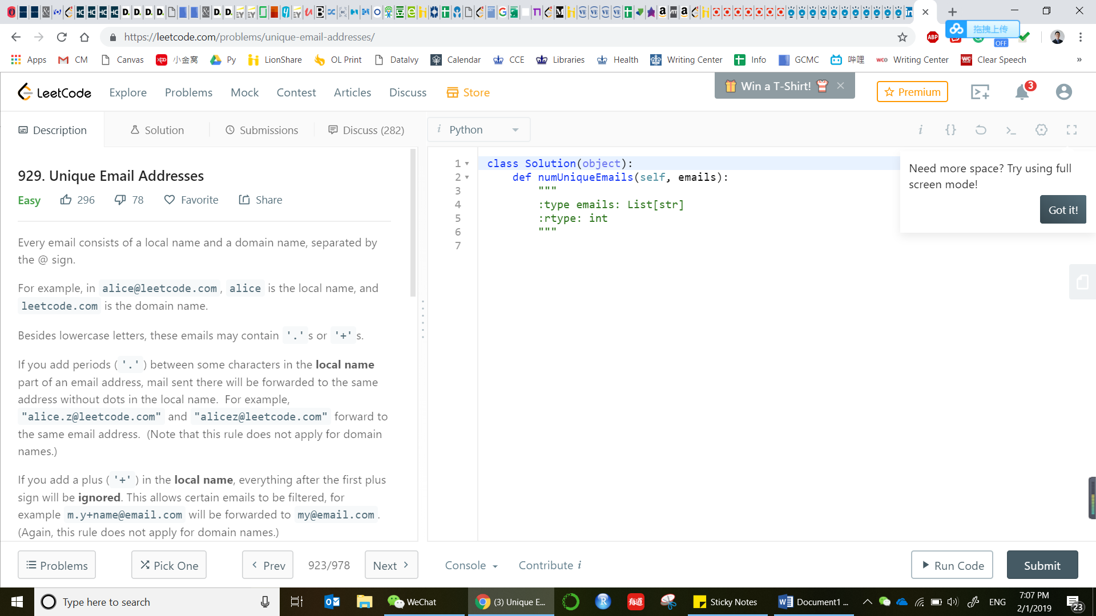

**929. Unique Email Addresses**

Easy

29678FavoriteShare

Every email consists of a local name and a domain name, separated by the @ sign.

For example, in alice@leetcode.com, alice is the local name, and leetcode.com is the domain name.

Besides lowercase letters, these emails may contain '.'s or '+'s.

If you add periods ('.') between some characters in the **local name**part of an email address, mail sent there will be forwarded to the same address without dots in the local name.  For example, "alice.z@leetcode.com" and "alicez@leetcode.com" forward to the same email address.  (Note that this rule does not apply for domain names.)

If you add a plus ('+') in the **local name**, everything after the first plus sign will be **ignored**. This allows certain emails to be filtered, for example m.y+name@email.com will be forwarded to my@email.com.  (Again, this rule does not apply for domain names.)

It is possible to use both of these rules at the same time.

Given a list of emails, we send one email to each address in the list.  How many different addresses actually receive mails?

**Example 1:**

**Input:** ["test.email+alex@leetcode.com","test.e.mail+bob.cathy@leetcode.com","testemail+david@lee.tcode.com"]

**Output:** 2

**Explanation:** "testemail@leetcode.com" and "testemail@lee.tcode.com" actually receive mails

**Note:**

* 1 <= emails[i].length <= 100
* 1 <= emails.length <= 100
* Each emails[i] contains exactly one '@' character.

Accepted

63,669

Submissions

79,987

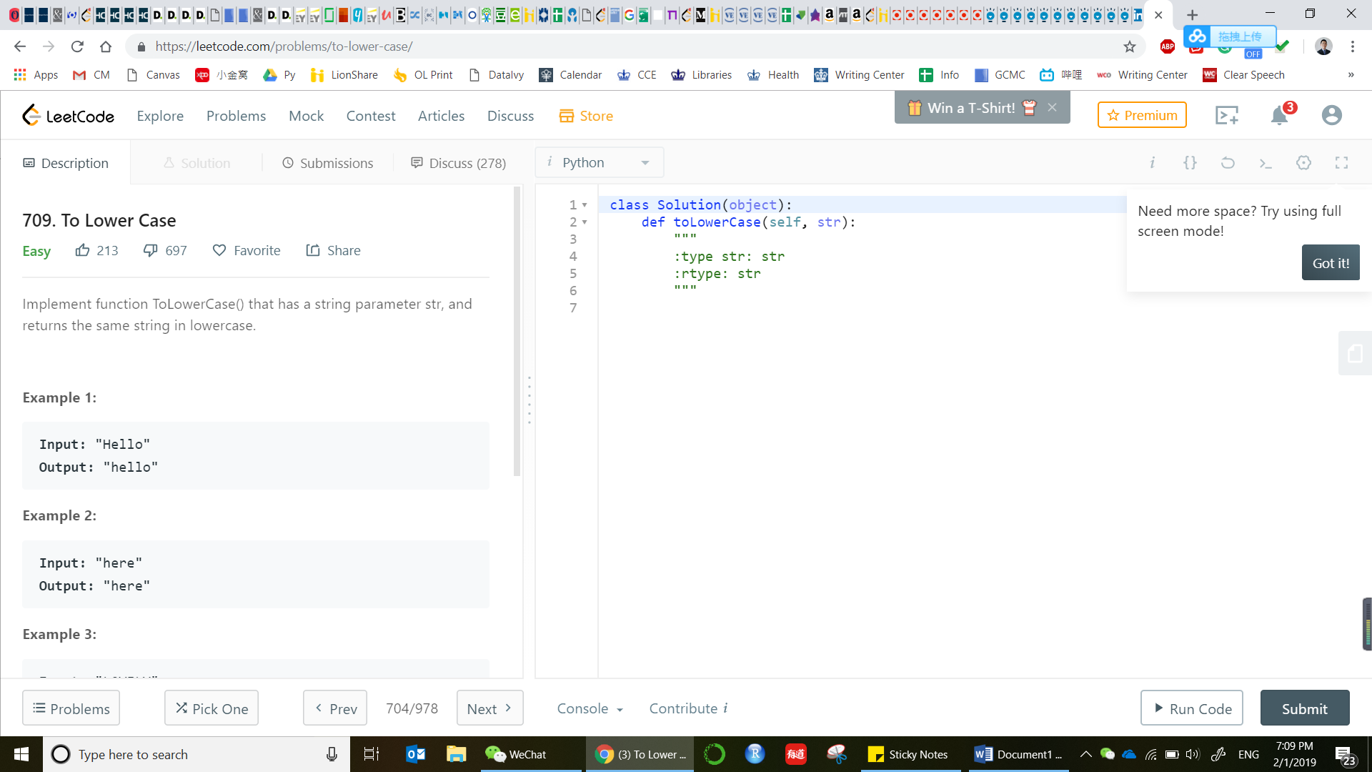

**709. To Lower Case**

Easy

213697FavoriteShare

Implement function ToLowerCase() that has a string parameter str, and returns the same string in lowercase.

**Example 1:**

**Input:** "Hello"

**Output:** "hello"

**Example 2:**

**Input:** "here"

**Output:** "here"

**Example 3:**

**Input:** "LOVELY"

**Output:** "lovely"

Accepted

66,079

Submissions

87,155

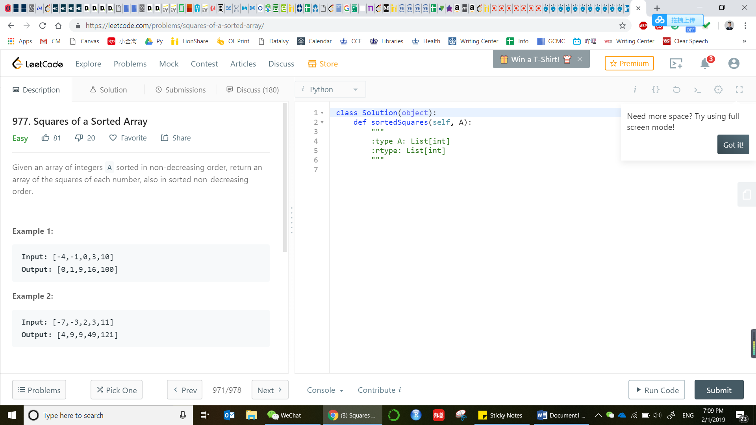

**977. Squares of a Sorted Array**

Easy

8120FavoriteShare

Given an array of integers A sorted in non-decreasing order, return an array of the squares of each number, also in sorted non-decreasing order.

**Example 1:**

**Input:** [-4,-1,0,3,10]

**Output:** [0,1,9,16,100]

**Example 2:**

**Input:** [-7,-3,2,3,11]

**Output:** [4,9,9,49,121]

**Note:**

1. 1 <= A.length <= 10000
2. -10000 <= A[i] <= 10000
3. A is sorted in non-decreasing order.

Accepted

17,186

Submissions

23,085

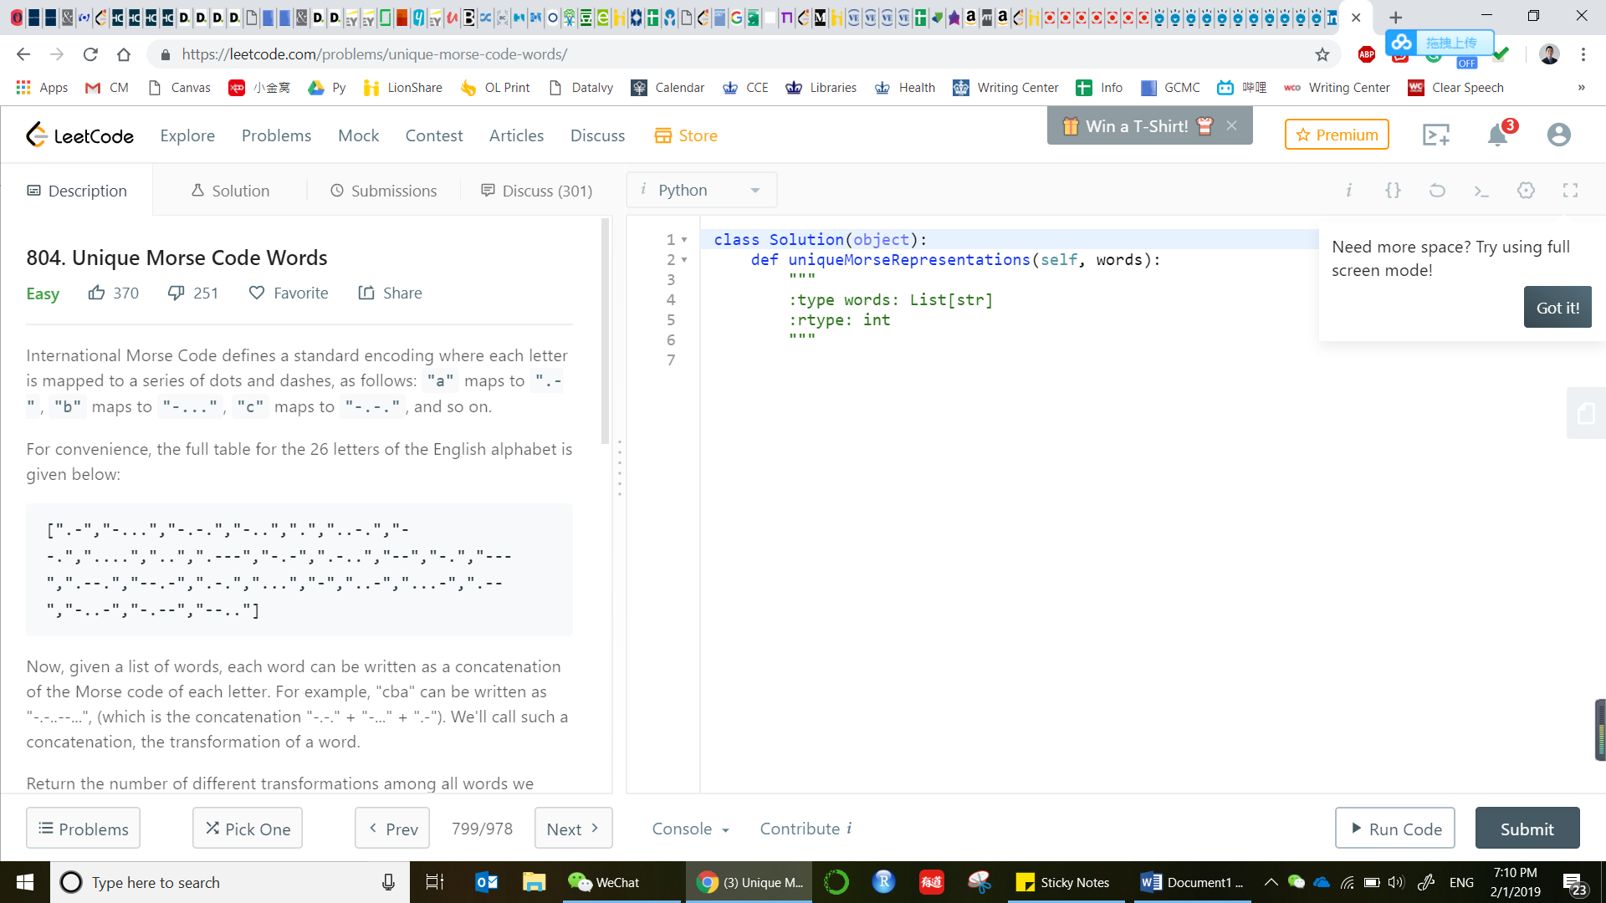

**804. Unique Morse Code Words**

Easy

370251FavoriteShare

International Morse Code defines a standard encoding where each letter is mapped to a series of dots and dashes, as follows: "a" maps to ".-", "b" maps to "-...", "c" maps to "-.-.", and so on.

For convenience, the full table for the 26 letters of the English alphabet is given below:

[".-","-...","-.-.","-..",".","..-.","--.","....","..",".---","-.-",".-..","--","-.","---",".--.","--.-",".-.","...","-","..-","...-",".--","-..-","-.--","--.."]

Now, given a list of words, each word can be written as a concatenation of the Morse code of each letter. For example, "cba" can be written as "-.-..--...", (which is the concatenation "-.-." + "-..." + ".-"). We'll call such a concatenation, the transformation of a word.

Return the number of different transformations among all words we have.

**Example:**

**Input:** words = ["gin", "zen", "gig", "msg"]

**Output:** 2

**Explanation:**

The transformation of each word is:

"gin" -> "--...-."

"zen" -> "--...-."

"gig" -> "--...--."

"msg" -> "--...--."

There are 2 different transformations, "--...-." and "--...--.".

**Note:**

* The length of words will be at most 100.
* Each words[i] will have length in range [1, 12].
* words[i] will only consist of lowercase letters.

Accepted

64,491

Submissions

87,756

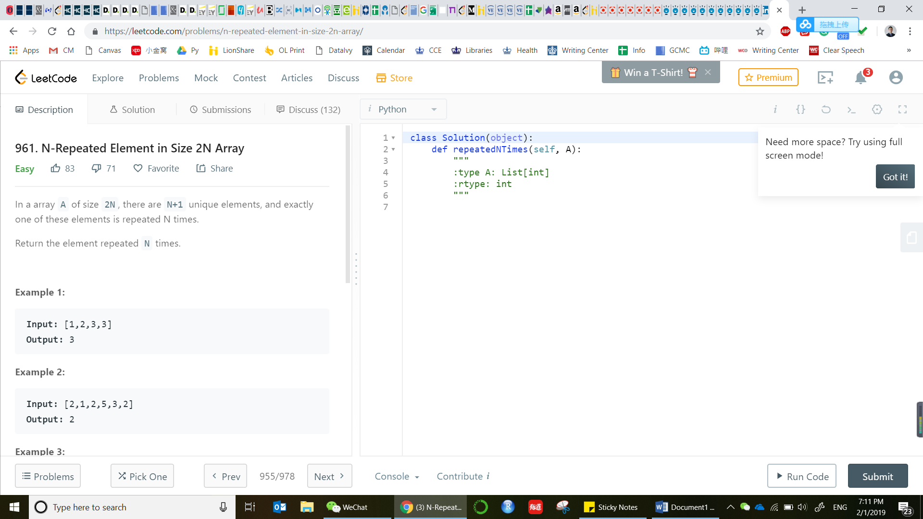

**961. N-Repeated Element in Size 2N Array**

Easy

8371FavoriteShare

In a array A of size 2N, there are N+1 unique elements, and exactly one of these elements is repeated N times.

Return the element repeated N times.

**Example 1:**

**Input:** [1,2,3,3]

**Output:** 3

**Example 2:**

**Input:** [2,1,2,5,3,2]

**Output:** 2

**Example 3:**

**Input:** [5,1,5,2,5,3,5,4]

**Output:** 5

**Note:**

1. 4 <= A.length <= 10000
2. 0 <= A[i] < 10000
3. A.length is even

Accepted

23,168

Submissions

31,596

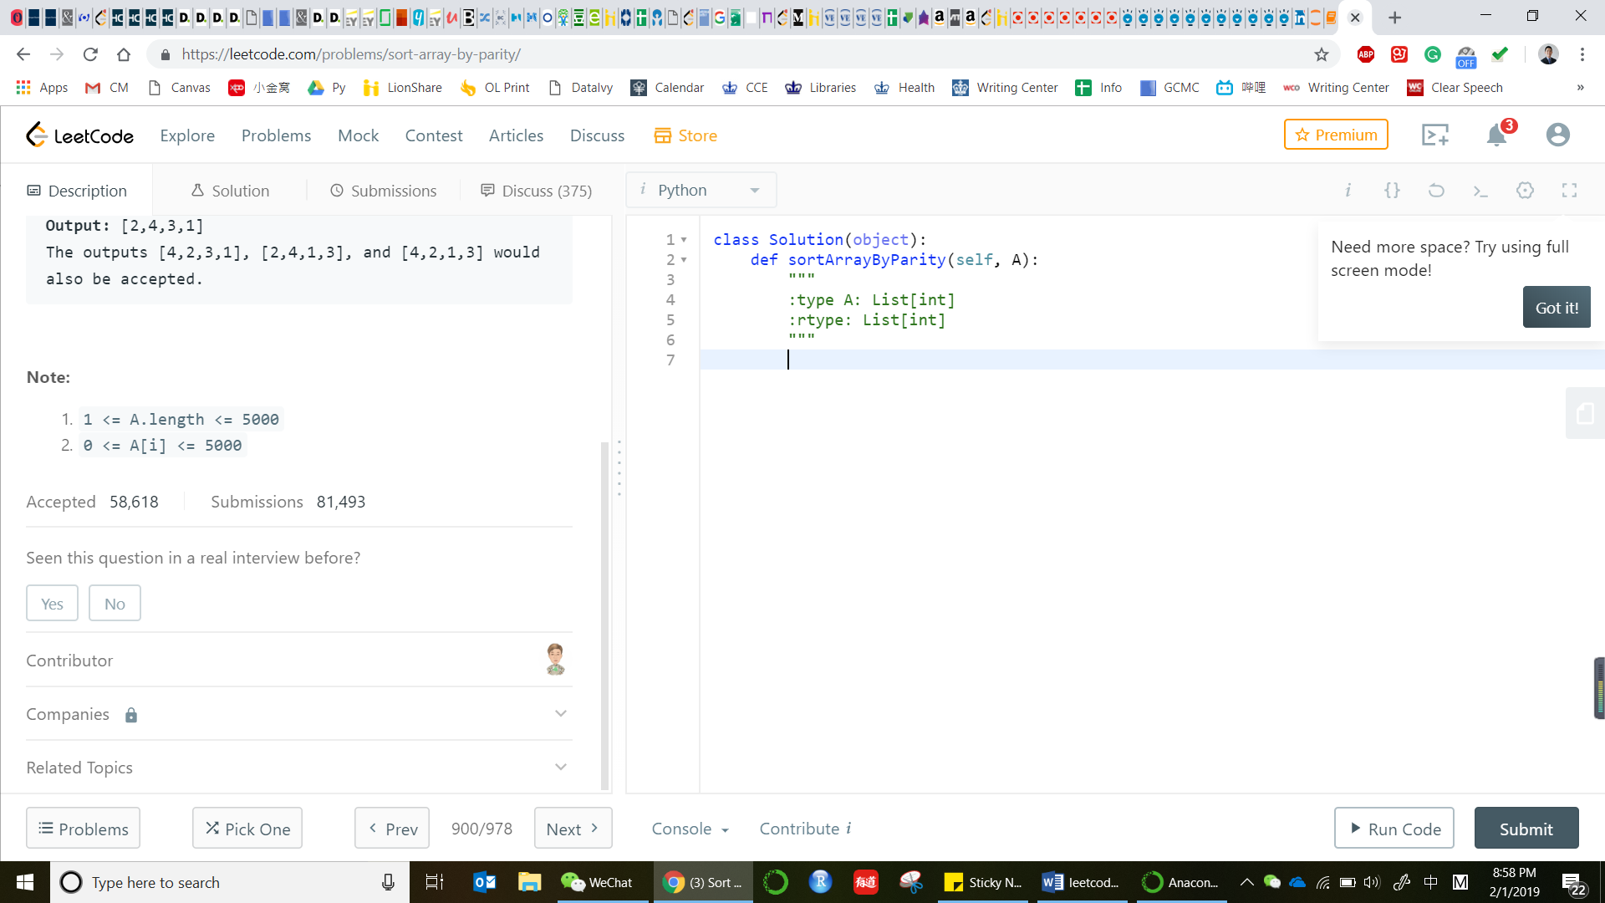

**905. Sort Array By Parity**

Easy

32343FavoriteShare

Given an array A of non-negative integers, return an array consisting of all the even elements of A, followed by all the odd elements of A.

You may return any answer array that satisfies this condition.

**Example 1:**

**Input:** [3,1,2,4]

**Output:** [2,4,3,1]

The outputs [4,2,3,1], [2,4,1,3], and [4,2,1,3] would also be accepted.

**Note:**

1. 1 <= A.length <= 5000
2. 0 <= A[i] <= 5000

Accepted

58,618

Submissions

81,493