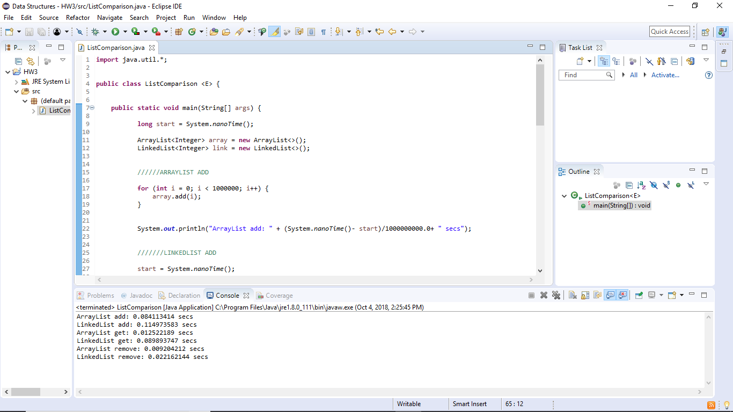Taylor Herb   
INFSCI2500 HW3

I expected add and remove to be faster with LinkedList than ArrayList since it should be easier to add/remove using LinkedList (LinkedList should have O(1) and ArrayList has O(n)). However, my output shows that it was faster to add and remove in ArrayList.   
The output for get is what I expected since it’s easier to access using ArrayList. I did have to reduce the size of my iterator for the get method while using the LinkedList because looping through 1 million entries made the program time out. So this output shows how long it takes for the LinkedList to access 9000 entries vs the ArrayList accessing 1 million entries.