Low Level Design (add HOTELS module)

Project Code | Team 4
Project Name | Hotel Bookings Management System

Prepared/Modified by | Role | Date of Preparation
Farheen Sadriwala | Software Engineer | 3/12/2016
Reviewed by | Role | Date of Review
Umang Garg | Software Engineer | 3/12/2016
Approved by | Role | Date of Approval
Vaishali Shrivastava | Training Manager
Circulation List | farheen.sadriwala@capgemini.com  tanmay.a.sharma@capgemini.com  umang.garg@capgemini.com  urvashi.rathore@capgemini.com  mohit.sarraf@capgemini.com  chirag.kochar@capgemini.com  ibrahim.saiyed@capgemini.com | Version Number of the template:1.0
Version Number | 1.3

Table of Contents

1. Description Of The Unit 3
2. References 4
3. Dependencies / Assumptions 5
4. Class Diagrams 6
5. Sequence Diagrams 10
6. Design Components 11
6.1 List Of UI Components 11
6.2 List Of Design Classes 12
7. Re-Usable Routines/Components 13
8. Messages 14
9. Configuration Files 15
10. Crud Matrix Table 16
11. Data Mapping Matrix 17
12. Action Flow Matrix 19
13. Stored Procedures 20
14. Program Specification / Pseudo Code 21

Description Of The Unit

The add hotels module allows the admin of the application to add new hotels into the database. This module can be used only by the admin of the application.

On clicking on the add hotels link in the admin panel, the admin is redirected to a add page. The admin enters all the details of the hotel like hotel name, hotel description, city, address, average rate per night, rating etc. If the entered hotel details are invalid, appropriate error messages are displayed.

After entering all the hotel details, the details are inserted into the database on clicking the add button.

References

Reference | Description
Repository reference
Class Diagram
SRS
UTP
DB Design

Dependencies / Assumptions

Dependencies:
The admin should be logged in.

Assumptions:
The admin details are stored in the database.

Class Diagrams

Class Diagram

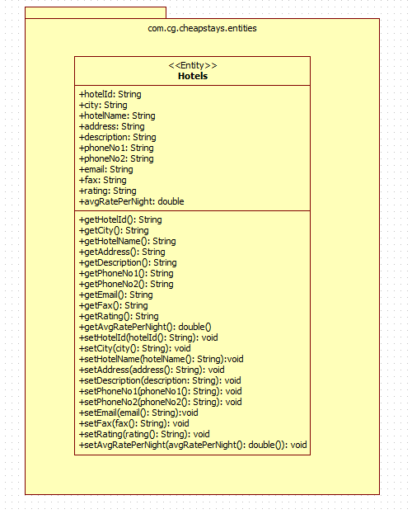

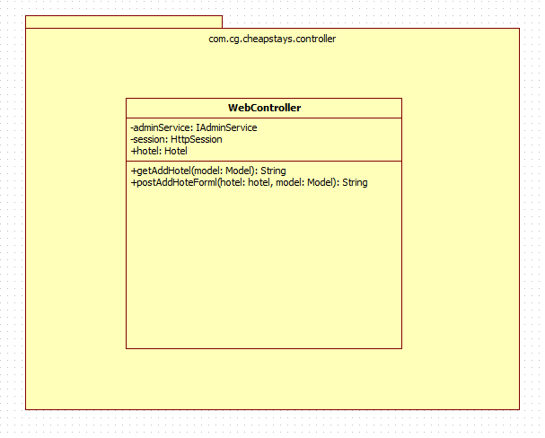

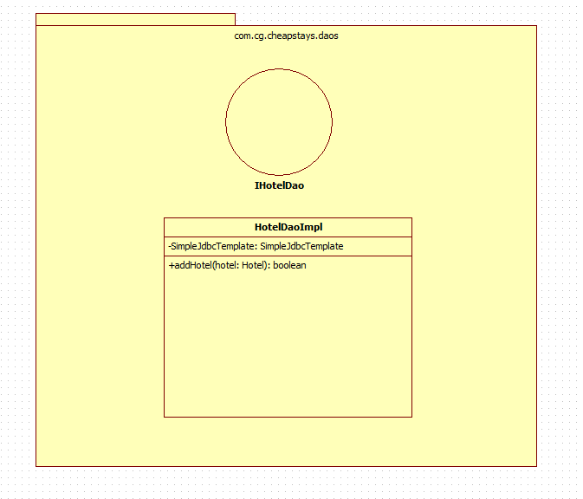

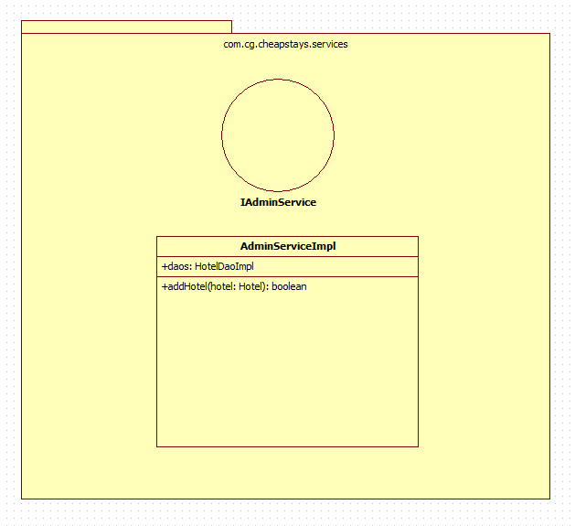

Sequence Diagrams

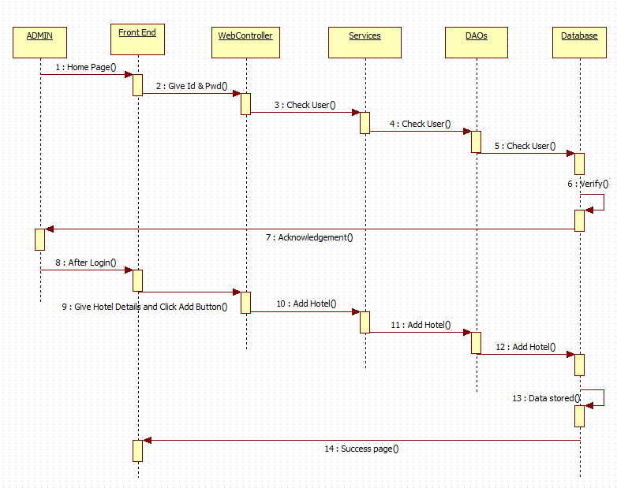

Design Components

List Of UI Components
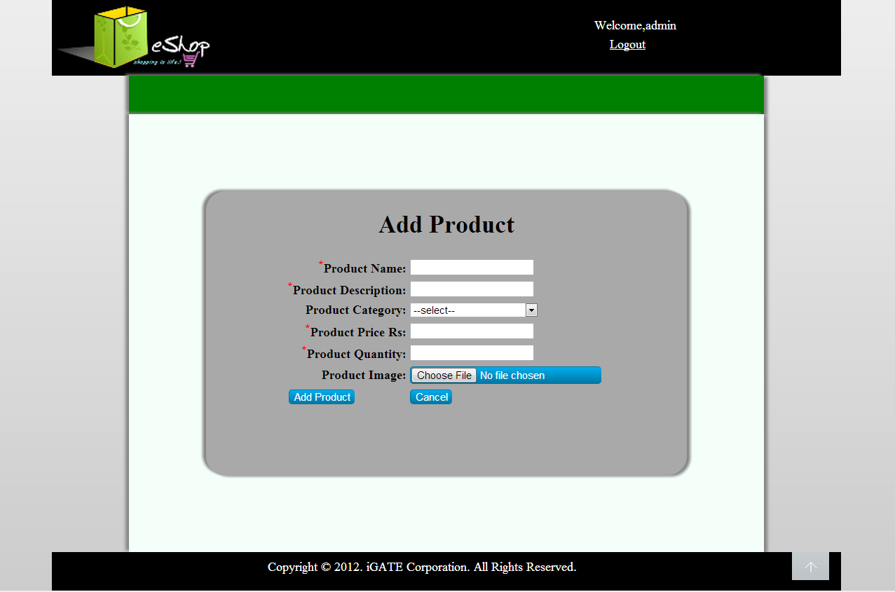

List Of Design Classes
Sr. No. | LLD Name | Class Name | Method Name | Method Description
1 | Add Hotels  Module | Hotel | Appropriate getters and setters methods | Getters retrieve the property values and setters set the property values
2 | Add Hotels Module | WebController | getAddHotelForm(Model model):String  postAddHotelForm(@ModelAttribute Hotel hotel, Model model):String | Sets the model attribute.  Calls addHotel() of AdminServiceImpl class. If it returns object then it redirects to indexHotelManagement page else it redirects to addHotelForm page with appropriate error message.
3 | Add Hotels Module | AdminServiceImpl | addHotel(Hotel hotel):boolean | Calls addHotel() of HotelDaoImpl class and returns the result to controller.
4 | Add Hotels Module | HotelDaoImpl | addHotel(Hotel hotel):boolean | Inserts the hotel details into the database and returns the result to AdminServiceImpl.

Re-Usable Routines/Components

Re-Usable Routines/Components

- CSS files
- Database properties files
- Logger properties files

Messages

#. | Type | Message Text
M1 | Error | Please Enter Only Digits
M2 | Error | City field is mandatory
M3 | Error | Hotel Name is mandatory
M4 | Error | Address is mandatory
M5 | Error | Description is mandatory
M6 | Error | Enter only digits
M7 | Error | Enter a valid phone number (Only 10 digits)
M8 | Error | Enter a valid phone number (Only 10 digits)
M9 | Error | Select an option from the given list
M10 | Error | Format: characters@characters.domain
M11 | Error | Format: xxx(1-9)-xxx(0-9)-xxxx(0-9)

Configuration Files

File Name | Path | Description
servletContext.xml | /Development/Source | To configure datasources.
springConfig.xml | /Development/Source | To configure controller.
Web.xml | /Development/Source | To configure the bean properties.

Crud Matrix Table

# | Table Name | Create | Read | Update | Delete
1. | Hotels | Y | N | N | N

Data Mapping Matrix

Sr. No. | Screen Label | Field Source | Field Type | Data Type | Max Length | Data Flow | Mandatory
1 | Hotel Id | NA | Label | NA | NA | UI | NA
2 | hotelId | Hotel. hotelId | TextBox | Number | NA | UI→D | Yes
3 | City | NA | Label | NA | NA | UI | NA
4 | city | Hotel. city | TextBox | Varchar | 10 | UI→D | Yes
5 | Hotel Name | NA | Label | NA | NA | UI | NA
6 | hotelName | Hotel. hotelName | Dropdown | Varchar | 30 | UI→D | Yes
7 | Address | NA | Label | NA | NA | UI | NA
8 | address | Hotel. address | TextArea | Varchar | 35 | UI→D | Yes
9 | Description | NA | Label | NA | NA | UI | NA
10 | description | Hotel. description | TextBox | Varchar | 50 | UI→D | Yes
11 | Average Rate Per Night | NA | Label | NA | NA | UI | NA
12 | avgRatePerNight | Hotel. avgRatePerNight | TextBox | Varchar | (7,2) | UI→D | Yes
13 | Phone No1 | NA | Label | NA | NA | UI | NA
14 | phoneNo1 | Hotel. phoneNo1 | TextBox | Varchar | 10 | UI→D | Yes
15 | Phone No2 | NA | Label | NA | NA | UI | NA
16 | phoneNo2 | Hotel. phoneNo2 | TextBox | Varchar | 10 | UI→D | Yes
17 | Rating | NA | Label | NA | NA | UI | NA
18 | rating | Hotel. rating | Dropdown | Varchar | 4 | UI→D | Yes
19 | Email | NA | Label | NA | NA | UI | NA
20 | email | Hotel. email | TextBox | Varchar | 30 | UI→D | Yes
21 | Fax | NA | Label | NA | NA | UI | NA
22 | fax | Hotel. fax | TextBox | Varchar | 15 | UI→D | Yes
23 | Add Hotel | NA | Button | NA | NA | UI | NA

Legend
UI → D (User Interface to Database)
UI (User Interface Only)

Action Flow Matrix

Sr. No. | Action | Description | Process
1 | On click of Add Hotels link in the Admin panel | Redirected to the Add page | The admin clicks on the add hotels link in the admin panel and gets redirected to the add page.
2 | On click of Add button in add page | The hotel details are inserted into the database. | Data is entered in the fields by the admin which gets inserted into the database when add button is pressed.

Stored Procedures

# | Stored Procedure Name  (with Description) | Input/Out Parameters | Type | Size
1. | NA | NA | NA | NA

Program Specification / Pseudo Code

<ACTION :ADD_HOTELS_CLICK >

Pseudo Code:
- Client Side Scripting:
None

- Server Side Scripting:
BEGIN
Call getAddHotelForm(Model model) in Controller class
Navigate to add page
END

14. 2 <ACTION: ADD_CLICK>

Pseudo Code:

- Client Side Scripting:
IF invalid HotelId
Print Error Message M1
IF City isEmpty
Print Error Message M2
IF HotelName isEmpty
Print Error Message M3
IF Address isEmpty
Print Error Message M4
IF Description isEmpty
Print Error Message M5
IF invalid AverageRatePerNight
Print Error Message M6
IF invalid PhoneNo1
Print Error Message M7
IF invalid PhoneNo2
Print Error Message M8
IF Rating isEmpty
Print Error Message M9
IF invalid Email
Print Error Message M10
IF invalid Fax
Print Error Message M11

- Server Side Scripting:
BEGIN
Call postAddHotelForm(@ModelAttribute Hotel hotel, Model model) in Controller class in Presentation Layer
BEGIN
Call addHotel(Hotel hotel) in AdminServiceImpl class in Service Layer
BEGIN
Call addHotel(Hotel hotel) in HotelDaoImpl class in Data Access Layer
BEGIN
Create query for insert records into Hotels
Return Boolean value
END
Return Boolean value to Service Layer
END
Return Boolean value to Presentation Layer
END
IF successful navigate to indexHotelManagement page
Else navigate to addHotelForm page and show error.
END
REVISION HISTORY OF THE WORK PRODUCT

# | Date | Version # | Section Changed | Details of changes made | Approved By
1 | 26/11/2016 | 1.0 | LLD prepared | N/A | Vaishali Shrivastava
2 | 1/12/2016 | 1.1 | Reusable components,  Pseudo code | Reusable components added.  The pseudo code is modified as per the specified flow. | Vaishali Shrivastava
3 | 1/12/2016 | 1.2 | Reusable components,  References,  Data Mapping Matrix. | Reusable Components added.  File name with relative path is added in the references section.  The name of text boxes(screen label is changed). | Vaishali Shrivastava
4 | 3/12/2016 | 1.3 | Configuration files,UI Components | Paths of the configuration files is updated and UI components(Screen Shots) added. | Vaishali Shrivastava

