Low Level Design (add roomS module)

Project Code | Team 4
Project Name | Hotel Bookings Management System

Prepared/Modified by | Role | Date of Preparation
Farheen Sadriwala | Software Engineer | 3/12/2016
Reviewed by | Role | Date of Review
Umang Garg | Software Engineer | 3/12/2016
Approved by | Role | Date of Approval
Vaishali Shrivastava | Training Manager
Circulation List | farheen.sadriwala@capgemini.com  tanmay.a.sharma@capgemini.com  umang.garg@capgemini.com  urvashi.rathore@capgemini.com  mohit.sarraf@capgemini.com  chirag.kochar@capgemini.com  ibrahim.saiyed@capgemini.com | Version Number of the template:1.3
Version Number | 1.3

Table of Contents

1. Description Of The Unit 3
2. References 4
3. Dependencies / Assumptions 5
4. Class Diagrams 6
5. Sequence Diagrams 10
6. Design Components 11
6.1 List Of UI Components 11
6.2 List Of Design Classes 12
7. Re-Usable Routines/Components 13
8. Messages 14
9. Configuration Files 15
10. Crud Matrix Table 16
11. Data Mapping Matrix 17
12. Action Flow Matrix 18
13. Stored Procedures 19
14. Program Specification / Pseudo Code 20

Description Of The Unit

The add rooms module allows the admin of the application to add new rooms for the hotels into the database. This module can be used only by the admin of the application.

On clicking on the add rooms link in the admin panel, the admin is redirected to a add page. The admin enters all the details of the room like id of the hotel to which the room belongs, room number, room type and per night rate. If the entered room details are invalid, appropriate error messages are displayed.
After entering all the room details, the details are inserted into the database on clicking the add button.

References

Reference | Description
Repository reference
Class Diagram
SRS
UTP
DB Design

Dependencies / Assumptions

Dependencies:
The hotel management panel should be designed.

Assumptions:
The hotel details to which the room belongs are stored in the database.

Class Diagrams

Class Diagram

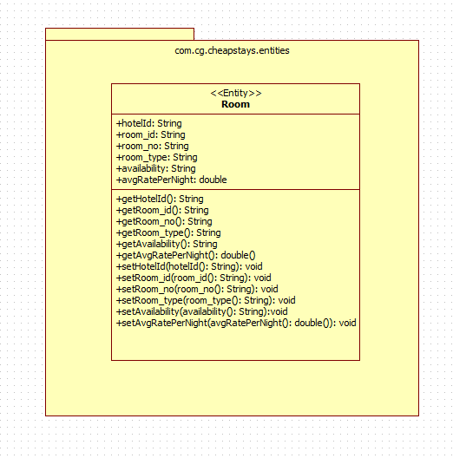

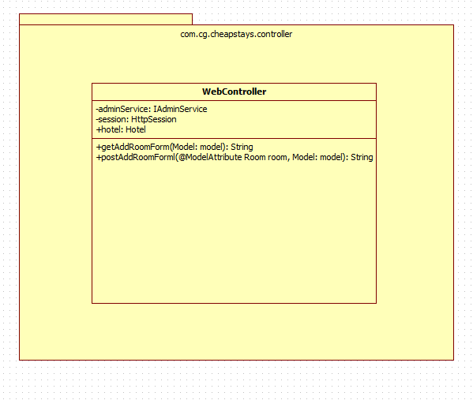

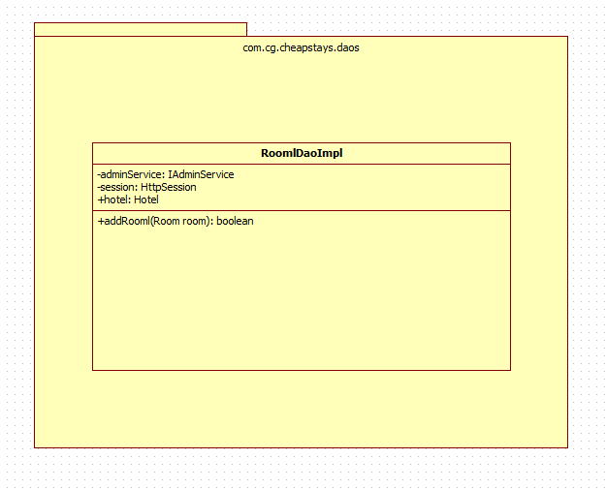

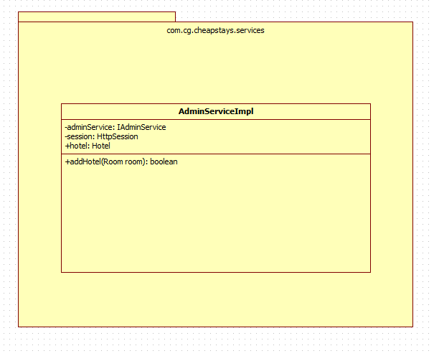

Sequence Diagrams

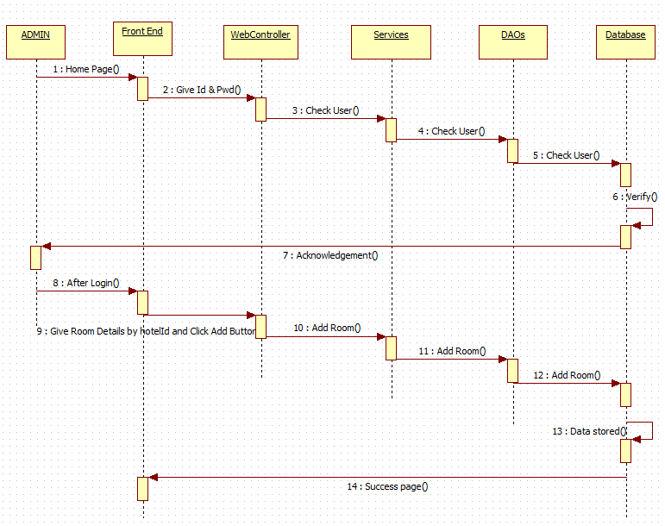

Design Components

List Of UI Components
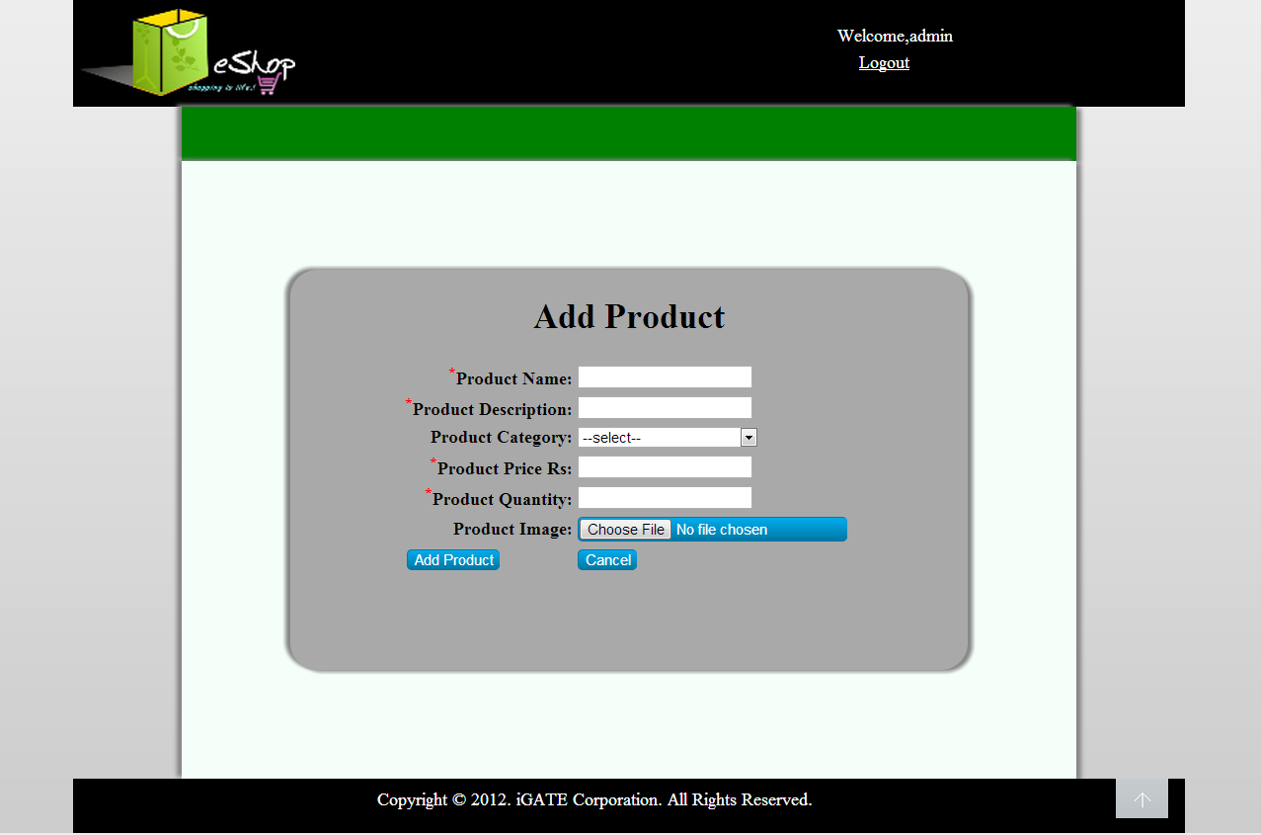

List Of Design Classes
Sr. No. | LLD Name | Class Name | Method Name | Method Description
1 | Add Rooms  Module | Room | Appropriate getters and setters methods | Getters retrieve the property values and setters set the property values
2 | Add Rooms Module | WebController | getAddRoomForm(Model model):String  postAddRoomForm(@ModelAttribute Room room, Model model):String | Sets the model attribute.  Calls addRoom() of AdminServiceImpl class. If it returns object then it redirects to indexRoomManagement page else it redirects to addRoomForm page with appropriate error message.
3 | Add Rooms Module | AdminServiceImpl | addRoom(Room room):boolean | Calls addRoom() of RoomDaoImpl class and returns the result to controller.
4 | Add Rooms Module | RoomDaoImpl | addRoom(Room room):boolean | Inserts the room details into the database and returns the result to AdminServiceImpl.

Re-Usable Routines/Components

Re-Usable Routines/Components

- CSS file
- Database properties files
- Logger properties files

Messages

#. | Type | Message Text
M1 | Error | Please Enter Only Digits
M2 | Error | Please Enter Only Digits
M3 | Error | This field cannot be empty
M4 | Error | Enter only digits

Configuration Files

File Name | Path | Description
servletContext.xml | /Development/Source | To configure datasources.
springConfig.xml | /Development/Source | To configure controller.
Web.xml | /Development/Source | To configure the bean properties.

Crud Matrix Table

# | Table Name | Create | Read | Update | Delete
1. | room_details | Y | N | N | N

Data Mapping Matrix

Sr. No. | Screen Label | Field Source | Field Type | Data Type | Max Length | Data Flow | Mandatory
1 | Hotel Id | NA | Label | NA | NA | UI | NA
2 | hotelId | Room. Hotel | TextBox | Number | NA | UI→D | Yes
3 | Room No | NA | Label | NA | NA | UI | NA
4 | roomNo | Room.roomNo | TextBox | Varchar | 3 | UI→D | Yes
5 | Room Type | NA | Label | NA | NA | UI | NA
6 | roomType | Room.roomType | Dropdown | Varchar | 30 | UI→D | Yes
7 | per Night Rate | NA | Label | NA | NA | UI | NA
8 | perNightRate | Room. perNightRate | TextBox | Number | (8,2) | UI→D | Yes
9 | availability | Room.availability | Hidden | Char | 1 | UI | NA
10 | Add Room | NA | Button | NA | NA | UI | NA

Legend
UI → D (User Interface to Database)
UI (User Interface Only)

Action Flow Matrix

Sr. No. | Action | Description | Process
1 | On click of Add Rooms link in the Admin panel | Redirected to the Add page | The admin clicks on the add rooms link in the admin panel and gets redirected to the add page.
2 | On click of Add button in add page | The room details are inserted into the database. | Data is entered in the fields by the admin which gets inserted into the database when add button is pressed.

Stored Procedures

# | Stored Procedure Name  (with Description) | Input/Out Parameters | Type | Size
1. | NA | NA | NA | NA

Program Specification / Pseudo Code

<ACTION :ADD_ROOMS_CLICK >

Pseudo Code:
- Client Side Scripting:
None

- Server Side Scripting:
BEGIN
Call getAddRoomForm(Model model) in Controller class
Navigate to add page
END

14. 2 <ACTION: ADD_CLICK>

Pseudo Code:

- Client Side Scripting:

IF invalid HotelId
Print Error Message M1
IF invalid RoomNo
Print Error Message M2
IF RoomType isEmpty
Print Error Message M3
IF invalid perNightRate
Print Error Message M4

- Server Side Scripting:
BEGIN
Call postAddRoomForm(@ModelAttribute Room room, Model model) in Controller class in Presentation Layer

BEGIN
Call addRoom(Room room) in AdminServiceImpl class in Service Layer
BEGIN
Call addRoom(Room room) in RoomDaoImpl class in Data Access Layer
BEGIN
Create query for insert records into room_details
Return Boolean value.
END
Return Boolean value to Service Layer
END
Return Boolean value to Presentation Layer

END
IF successful navigate to indexRoomManagement page
Else navigate to addRoomForm page and show error.
END

REVISION HISTORY OF THE WORK PRODUCT

# | Date | Version # | Section Changed | Details of changes made | Approved By
1 | 26/11/2016 | 1.0 | LLD prepared | N/A | Vaishali Shrivastava
2 | 1/12/2016 | 1.1 | Reusable components,  Pseudo code | Reusable components added.  The pseudo code is modified as per the specified flow. | Vaishali Shrivastava
3 | 1/12/2016 | 1.2 | Reusable components,  References,  Data Mapping Matrix. | Reusable Components added.  File name with relative path is added in the references section.  The name of text boxes(screen label is changed). | Vaishali Shrivastava
4 | 3/12/2016 | 1.3 | Configuration files,UI Components | Paths of the configuration files is updated and UI components(Screen Shots) added. | Vaishali Shrivastava

