Low Level Design (delete HOTELS module)

Project Code | Team 4
Project Name | Hotel Bookings Management System

Prepared/Modified by | Role | Date of Preparation
Farheen Sadriwala | Software Engineer | 3/12/2016
Reviewed by | Role | Date of Review
Umang Garg | Software Engineer | 3/12/2016
Approved by | Role | Date of Approval
Vaishali Shrivastava | Training Manager
Circulation List | farheen.sadriwala@capgemini.com  tanmay.a.sharma@capgemini.com  umang.garg@capgemini.com  urvashi.rathore@capgemini.com  mohit.sarraf@capgemini.com  chirag.kochar@capgemini.com  ibrahim.saiyed@capgemini.com | Version Number of the template:1.3
Version Number | 1.3

Table of Contents
1. Description Of The Unit 3
2. References 4
3. Dependencies / Assumptions 5
4. Class Diagrams 6
5. Sequence Diagrams 10
6. Design Components 11
6.1 List Of UI Components 11
6.2 List Of Design Classes 12
7. Re-Usable Routines/Components 13
8. Configuration Files 14
9. Crud Matrix Table 15
10. Action Flow Matrix 16
11. Stored Procedures 17
12. Program Specification / Pseudo Code 18

Description Of The Unit

The delete hotels module allows the admin of the application to delete the hotel details stored in the database. This module can be used only by the admin of the application.

On clicking on the delete hotels link in the admin panel, the admin is redirected to a delete page. The admin deletes all the details of the hotel like hotel name, hotel description, city, address, average rate per night, rating etc.

After deleting the hotel details, the changes are reflected into the database on clicking the delete button.

References

Reference | Description
Repository reference
Class Diagram
SRS
UTP
DB Design

Dependencies / Assumptions

Dependencies:
The Add Hotels module should be designed.

Assumptions:
The hotel details are inserted in the database.

Class Diagrams

Class Diagram

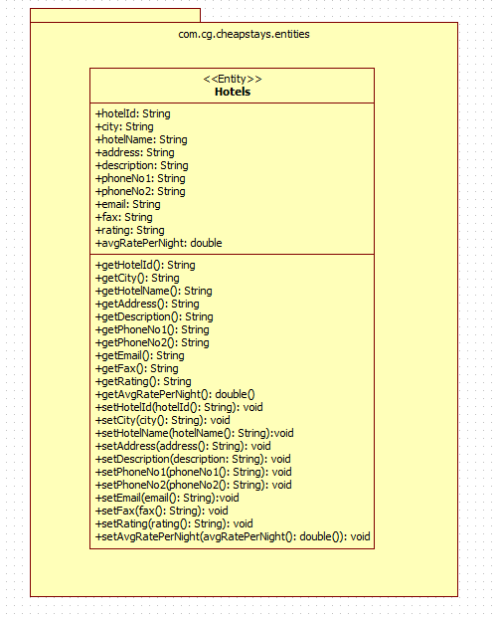

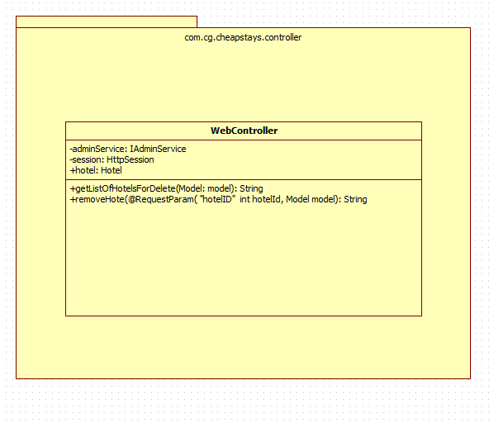

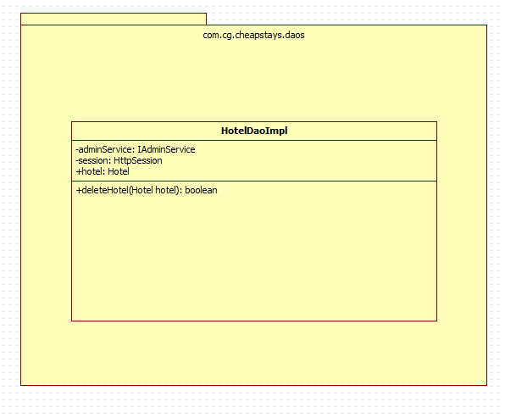

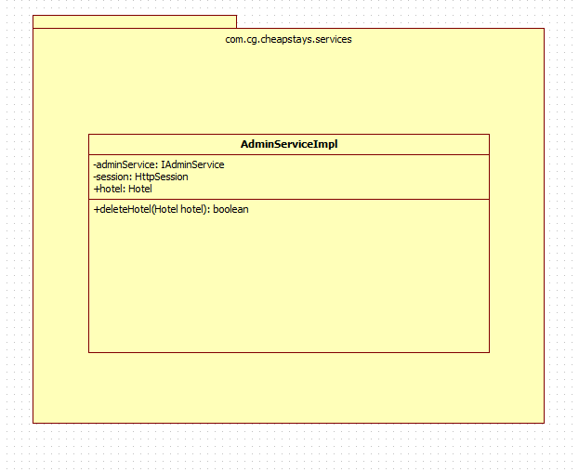

Sequence Diagrams

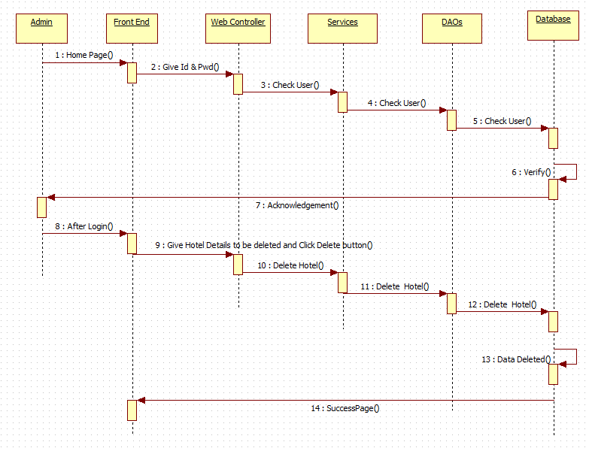

Design Components

List Of UI Components
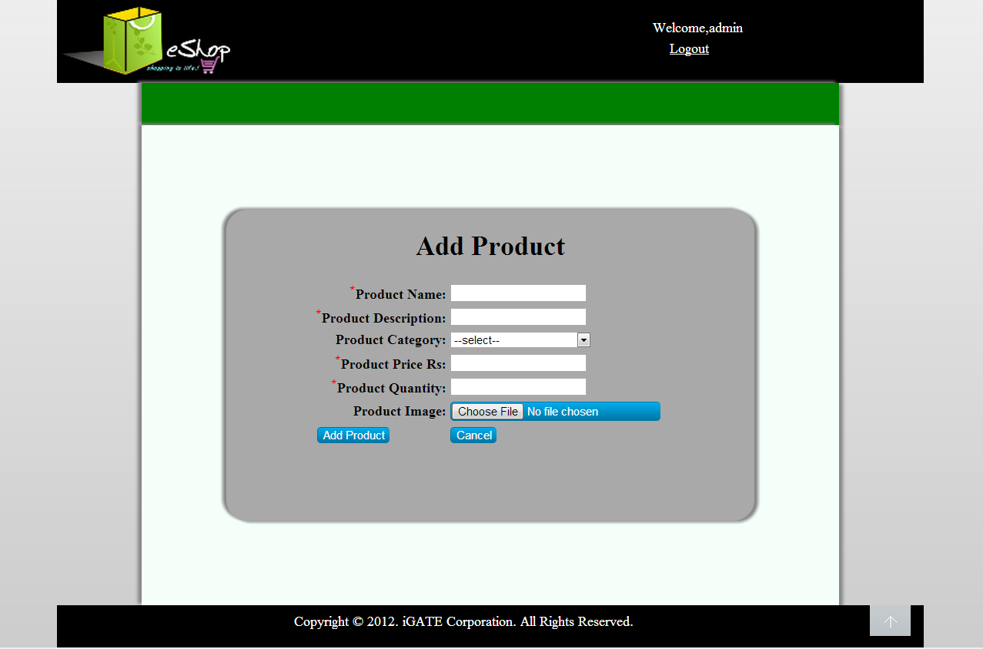

List Of Design Classes
Sr. No. | LLD Name | Class Name | Method Name | Method Description
1 | Delete Hotels  Module | Hotel | Appropriate getters and setters methods | Getters retrieve the property values and setters set the property values
2 | Delete Hotels Module | WebController | getListOfHotelsForDelete(Model model) :String  removeHotel(@RequestParam(“hotelId”) int hotelId, Model model):String | Sets the model attribute.  Calls deleteHotel() of AdminServiceImpl class. If deletion is successful then it redirects to deleteSuccess page else it redirects to listOfHotelForDelete page with appropriate error message.
3 | Delete Hotels Module | AdminServiceImpl | deleteHotel(Hotel hotel):boolean | Calls deleteHotel() of HotelDaoImpl class and returns the result to controller.
4 | Delete Hotels Module | HotelDaoImpl | deleteHotel(Hotel hotel):boolean | Deletes the hotel details from the database and returns the result to AdminServiceImpl.

Re-Usable Routines/Components

Re-Usable Routines/Components

- CSS files
- Database properties files
- Logger properties files

Configuration Files

File Name | Path | Description
servletContext.xml | /Development/Source | To configure datasources.
springConfig.xml | /Development/Source | To configure controller.
Web.xml | /Development/Source | To configure the bean properties.

Crud Matrix Table

# | Table Name | Create | Read | Update | Delete
1. | Hotels | N | N | N | Y

Action Flow Matrix

Sr. No. | Action | Description | Process
1 | On click of Delete Hotels link in the Admin panel | Redirected to the Delete page | The admin clicks on the delete hotels link in the admin panel and gets redirected to the delete page.
2 | On click of Delete button in delete page | The hotel details are deleted from the database. | Data is deleted by the admin which gets reflected into the database when delete button is pressed.

Stored Procedures

# | Stored Procedure Name  (with Description) | Input/Out Parameters | Type | Size
1. | NA | NA | NA | NA

Program Specification / Pseudo Code

<ACTION :delete_hotels_CLICK >

Pseudo Code:
- Client Side Scripting:
None

- Server Side Scripting:
BEGIN
Call getListOfHotelsForDelete(Model model) in Controller class
Navigate to delete page
END

14. 2 <ACTION: DELETE_CLICK>

Pseudo Code:

- Client Side Scripting:
None

- Server Side Scripting:
BEGIN
Call removeHotel(@RequestParam(“hotelId”) int hotelId, Model model) in Controller class in Presentation Layer
BEGIN
Call deleteHotel(Hotel hotel) in AdminServiceImpl class in Service Layer
BEGIN
Call deleteHotel(Hotel hotel) in HotelDaoImpl class in Data Access Layer
BEGIN
Create query for deleting records from Hotels
Return Boolean value
END
Return Boolean value to Service Layer
END
Return Boolean value to Presentation Layer
END
IF successful navigate to deleteSuccess page
Else navigate to listOfHotelForDelete page and show error.
END

REVISION HISTORY OF THE WORK PRODUCT

# | Date | Version # | Section Changed | Details of changes made | Approved By
1 | 26/11/2016 | 1.0 | LLD prepared | N/A | Vaishali Shrivastava
2 | 1/12/2016 | 1.1 | Reusable components,  Pseudo code | Reusable components added.  The pseudo code is modified as per the specified flow. | Vaishali Shrivastava
3 | 1/12/2016 | 1.2 | Reusable components,  References,  Data Mapping Matrix. | Reusable Components added.  File name with relative path is added in the references section.  The name of text boxes(screen label is changed). | Vaishali Shrivastava
4 | 3/12/2016 | 1.3 | Configuration files,UI Components | Paths of the configuration files is updated and UI components(Screen Shots) added. | Vaishali Shrivastava

