Low Level Design (UPDATE HOTELS module)

Project Code | Team 4
Project Name | Hotel Bookings Management System

Prepared/Modified by | Role | Date of Preparation
Farheen Sadriwala | Software Engineer | 3/12/2016
Reviewed by | Role | Date of Review
Umang Garg | Software Engineer | 3/12/2016
Approved by | Role | Date of Approval
Vaishali Shrivastava | Training Manager
Circulation List | farheen.sadriwala@capgemini.com  tanmay.a.sharma@capgemini.com  umang.garg@capgemini.com  urvashi.rathore@capgemini.com  mohit.sarraf@capgemini.com  chirag.kochar@capgemini.com  ibrahim.saiyed@capgemini.com | Version Number of the template:1.3
Version Number | 1.3

Table of Contents
1. Description Of The Unit 3
2. References 4
3. Dependencies / Assumptions 5
4. Class Diagrams 6
5. Sequence Diagrams 10
6. Design Components 11
6.1 List Of UI Components 11
6.2 List Of Design Classes 12
7. Re-Usable Routines/Components 13
8. Messages 14
9. Configuration Files 15
10. Crud Matrix Table 16
11. Data Mapping Matrix 17
12. Action Flow Matrix 19
13. Stored Procedures 20
14. Program Specification / Pseudo Code 21

Description Of The Unit

The update hotels module allows the admin of the application to update the hotel details stored in the database. This module can be used only by the admin of the application.

On clicking on the update hotels link in the admin panel, the admin is redirected to an update page. The admin evaluates all the details of the hotel like hotel name, hotel description, city, address, average rate per night, rating etc and makes necessary changes in the details. If the entered hotel details are invalid, appropriate error messages are displayed.

After updating the hotel details, the changes are reflected into the database on clicking the update button.

References

Reference | Description
Repository reference
Class Diagram
SRS
UTP
DB Design

Dependencies / Assumptions

Dependencies:
The Add Hotels module should be designed.

Assumptions:
The hotel details are inserted in the database.

Class Diagrams

Class Diagram

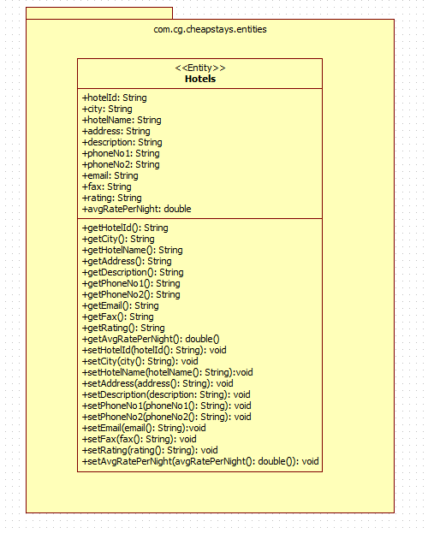

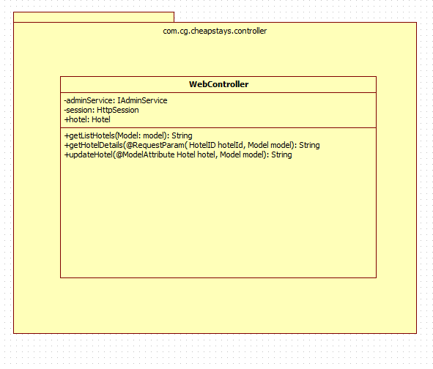

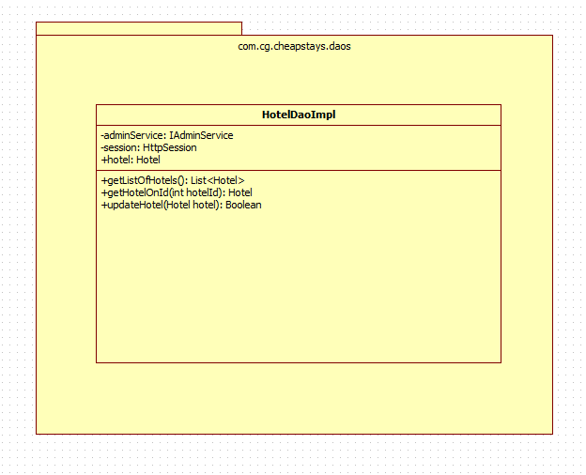

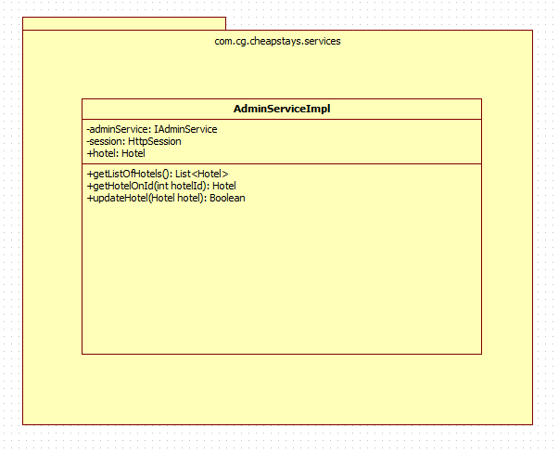

Sequence Diagrams

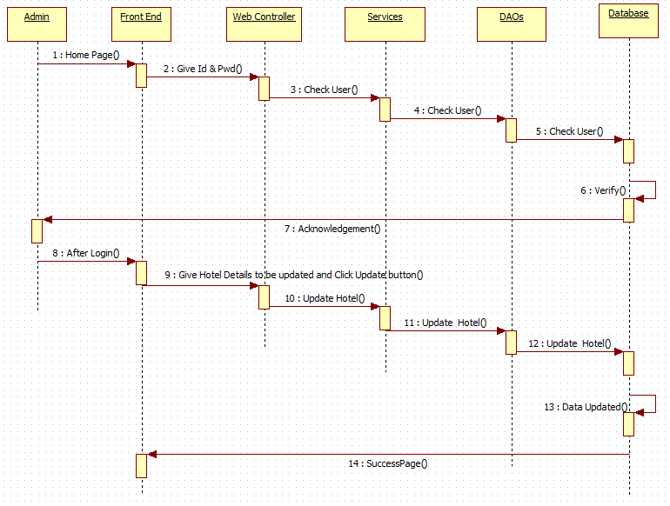

Design Components

List Of UI Components
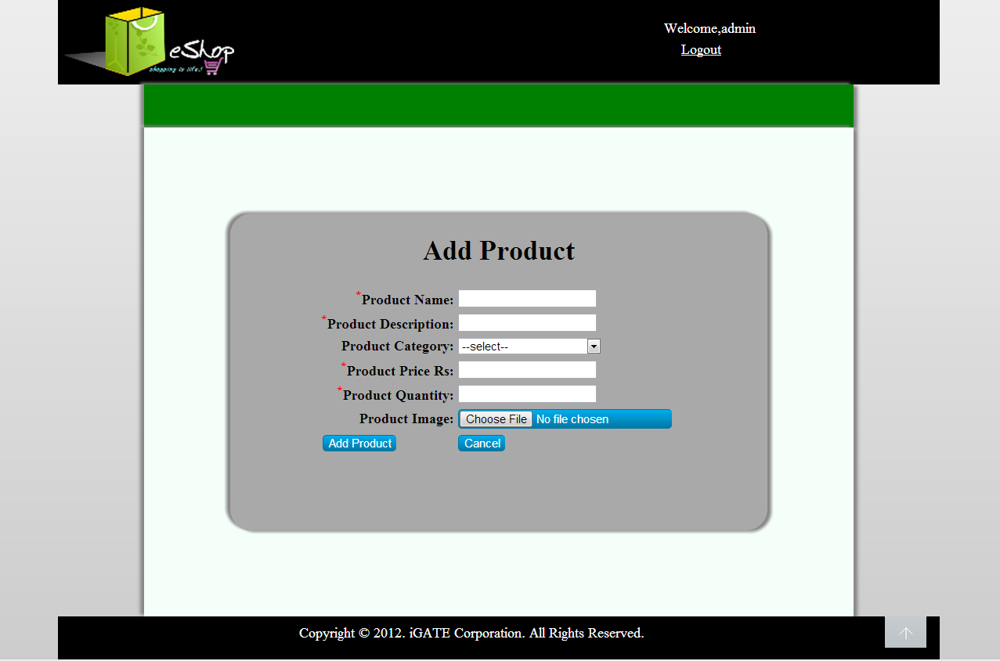

List Of Design Classes
Sr. No. | LLD Name | Class Name | Method Name | Method Description
1 | Update Hotels  Module | Hotel | Appropriate getters and setters methods | Getters retrieve the property values and setters set the property values
2 | Update Hotels Module | WebController | getListOfHotels(Model model):String  getHotelDetails(@RequestParam(“hotelId”) int hotelId, Model model):String  updateHotel(@ModelAttribute Hotel hotel, Model model):String | Sets the model attribute.  Calls getHotelOnId() of AdminServiceImpl class. It retrieves hotel details based on its id.  Calls updateHotel() of AdminServiceImpl class. If it returns object then it redirects to indexHotelManagement page else it redirects to updateHotel page with appropriate error message.
3 | Update Hotels Module | AdminServiceImpl | getListOfHotels():List<Hotel>  getHotelOnId(int hotelId):Hotel  updateHotel(Hotel hotel):boolean | Return the list of hotels to the controller.  Returns the hotel details based on id to the controller.  Returns the updated hotel details to the controller.
4 | Update Hotels Module | HotelDaoImpl | getListOfHotels():List<Hotel>  getHotelOnId(int hotelId):Hotel  updateHotel(Hotel hotel):boolean | Inserts the list of hotels into the database and returns the result to AdminServiceImpl.  Inserts the hotel details based on id into the database and returns the result to AdminServiceImpl.  Updates the hotel details into the database and returns the result to AdminServiceImpl

Re-Usable Routines/Components

Re-Usable Routines/Components

- CSS files
- Database properties files
- Logger properties files

Messages

#. | Type | Message Text
M1 | Error | Please Enter Only Digits
M2 | Error | City field is mandatory
M3 | Error | Hotel Name is mandatory
M4 | Error | Address is mandatory
M5 | Error | Description is mandatory
M6 | Error | Enter only digits
M7 | Error | Enter a valid phone number (Only 10 digits)
M8 | Error | Enter a valid phone number (Only 10 digits)
M9 | Error | Select an option from the given list
M10 | Error | Format: characters@characters.domain
M11 | Error | Format: xxx(1-9)-xxx(0-9)-xxxx(0-9)

Configuration Files

File Name | Path | Description
servletContext.xml | /Development/Source | To configure datasources.
springConfig.xml | /Development/Source | To configure controller.
Web.xml | /Development/Source | To configure the bean properties.

Crud Matrix Table

# | Table Name | Create | Read | Update | Delete
1. | Hotels | N | N | Y | N

Data Mapping Matrix

Sr. No. | Screen Label | Field Source | Field Type | Data Type | Max Length | Data Flow | Mandatory
1 | Hotel Id | NA | Label | NA | NA | UI | NA
2 | hotelId | Hotel. hotelId | TextBox | Number | NA | UI→D | NA
3 | City | NA | Label | NA | NA | UI | NA
4 | city | Hotel. city | TextBox | Varchar | 10 | UI→D | Yes
5 | Hotel Name | NA | Label | NA | NA | UI | NA
6 | hotelName | Hotel. hotelName | Dropdown | Varchar | 30 | UI→D | Yes
7 | Address | NA | Label | NA | NA | UI | NA
8 | address | Hotel. address | TextArea | Varchar | 35 | UI→D | Yes
9 | Description | NA | Label | NA | NA | UI | NA
10 | description | Hotel. description | TextBox | Varchar | 50 | UI→D | Yes
11 | Average Rate Per Night | NA | Label | NA | NA | UI | NA
12 | avgRatePerNight | Hotel. avgRatePerNight | TextBox | Varchar | (7,2) | UI→D | Yes
13 | Phone No1 | NA | Label | NA | NA | UI | NA
14 | phoneNo1 | Hotel. phoneNo1 | TextBox | Varchar | 10 | UI→D | Yes
15 | Phone No2 | NA | Label | NA | NA | UI | NA
16 | phoneNo2 | Hotel. phoneNo2 | TextBox | Varchar | 10 | UI→D | Yes
17 | Rating | NA | Label | NA | NA | UI | NA
18 | rating | Hotel. rating | Dropdown | Varchar | 4 | UI→D | Yes
19 | Email | NA | Label | NA | NA | UI | NA
20 | email | Hotel. email | TextBox | Varchar | 30 | UI→D | Yes
21 | Fax | NA | Label | NA | NA | UI | NA
22 | fax | Hotel. fax | TextBox | Varchar | 15 | UI→D | Yes
23 | Add Hotel | NA | Button | NA | NA | UI | NA

Legend
UI → D (User Interface to Database)
UI (User Interface Only)

Action Flow Matrix

Sr. No. | Action | Description | Process
1 | On click of Update Hotels link in the Admin panel | Redirected to the Update page | The admin clicks on the update hotels link in the admin panel and gets redirected to the update page.
2 | On click of Update button in update page | The hotel details are updated into the database. | Data is altered in the fields by the admin which gets updated into the database when update button is pressed.

Stored Procedures

# | Stored Procedure Name  (with Description) | Input/Out Parameters | Type | Size
1. | NA | NA | NA | NA

Program Specification / Pseudo Code

<ACTION :UPDATE_HOTELS_CLICK >

Pseudo Code:
- Client Side Scripting:
None

- Server Side Scripting:
BEGIN
Call getListOfHotels(Model model) in Controller class
Navigate to update page
END

14. 2 <ACTION: UPDATE_CLICK>

Pseudo Code:

- Client Side Scripting:
IF invalid HotelId
Print Error Message M1
IF City isEmpty
Print Error Message M2
IF HotelName isEmpty
Print Error Message M3
IF Address isEmpty
Print Error Message M4
IF Description isEmpty
Print Error Message M5
IF invalid AverageRatePerNight
Print Error Message M6
IF invalid PhoneNo1
Print Error Message M7
IF invalid PhoneNo2
Print Error Message M8
IF Rating isEmpty
Print Error Message M9
IF invalid Email
Print Error Message M10
IF invalid Fax
Print Error Message M11

- Server Side Scripting:
BEGIN
Call getHotelDetails(@RequestParam(“hotelId”) int hotelId, Model model) in Controller class in Presentation Layer
Call updateHotel(@ModelAttribute Hotel hotel, Model model) in Controller class in Presentation Layer

BEGIN

Call getListOfHotels():List<Hotel>in AdminServiceImpl class in Service Layer
Call getHotelOnId(int hotelId) in AdminServiceImpl class in Service Layer
Call updateHotel(Hotel hotel) in AdminServiceImpl class in Service Layer
BEGIN
Call getListOfHotels():List<Hotel> in HotelDaoImpl class in Data Access Layer
Call getHotelOnId(int hotelId) in HotelDaoImpl class in Data Access Layer
Call updateHotel(Hotel hotel) in HotelDaoImpl class in Data Access Layer

BEGIN
Create query for updating records into Hotels
Return Boolean value
END
Return Boolean value to Service Layer
END
Return Boolean value to Presentation Layer
END
IF successful navigate to indexHotelManagement page
Else navigate to updateHotel page and show error.
END
REVISION HISTORY OF THE WORK PRODUCT

# | Date | Version # | Section Changed | Details of changes made | Approved By
1 | 26/11/2016 | 1.0 | LLD prepared | N/A | Vaishali Shrivastava
2 | 1/12/2016 | 1.1 | Reusable components,  Pseudo code | Reusable components added.  The pseudo code is modified as per the specified flow. | Vaishali Shrivastava
3 | 1/12/2016 | 1.2 | Reusable components,  References,  Data Mapping Matrix. | Reusable Components added.  File name with relative path is added in the references section.  The name of text boxes(screen label is changed). | Vaishali Shrivastava
4 | 3/12/2016 | 1.3 | Configuration files,UI Components | Paths of the configuration files is updated and UI components(Screen Shots) added. | Vaishali Shrivastava

