Low Level Design (update rooms module)

Project Code | Team 4
Project Name | Hotel Bookings Management System

Prepared/Modified by | Role | Date of Preparation
Farheen Sadriwala | Software Engineer | 3/12/2016
Reviewed by | Role | Date of Review
Umang Garg | Software Engineer | 3/12/2016
Approved by | Role | Date of Approval
Vaishali Shrivastava | Training Manager
Circulation List | farheen.sadriwala@capgemini.com  tanmay.a.sharma@capgemini.com  umang.garg@capgemini.com  urvashi.rathore@capgemini.com  mohit.sarraf@capgemini.com  chirag.kochar@capgemini.com  ibrahim.saiyed@capgemini.com | Version Number of the template:1.3
Version Number | 1.3

Table of Contents
1. Description Of The Unit 3
2. References 4
3. Dependencies / Assumptions 5
4. Class Diagrams 6
5. Sequence Diagrams 10
6. Design Components 11
6.1 List Of UI Components 11
6.2 List Of Design Classes 12
7. Re-Usable Routines/Components 13
8. Messages 14
9. Configuration Files 15
10. Crud Matrix Table 16
11. Data Mapping Matrix 17
12. Action Flow Matrix 18
13. Stored Procedures 19
14. Program Specification / Pseudo Code 20

Description Of The Unit

The update rooms module allows the admin of the application to update the room details stored in the database. This module can be used only by the admin of the application.

On clicking on the update rooms link in the admin panel, the admin is redirected to an update page. The admin evaluates all the details of the room like id of the hotel to which the room belongs, room number, room type and per night rate. If the entered room details are invalid, appropriate error messages are displayed.

After updating the room details, the changes are reflected into the database on clicking the update button.

References

Reference | Description
Repository reference
Class Diagram
SRS
UTP
DB Design

Dependencies / Assumptions

Dependencies:
The Add Rooms module should be designed.

Assumptions:
The room details are inserted in the database.

Class Diagrams

Class Diagram

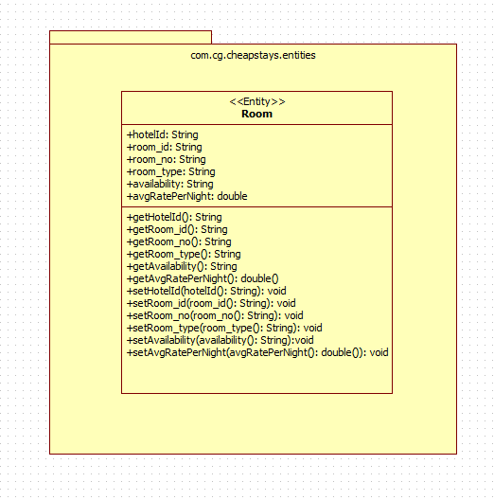

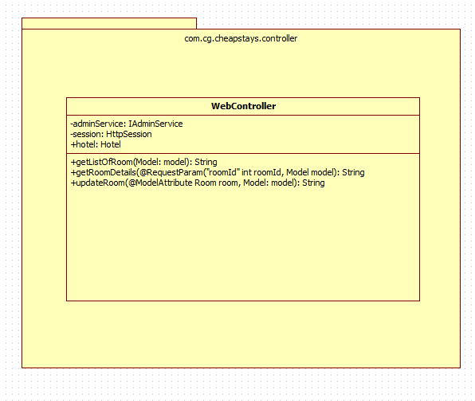

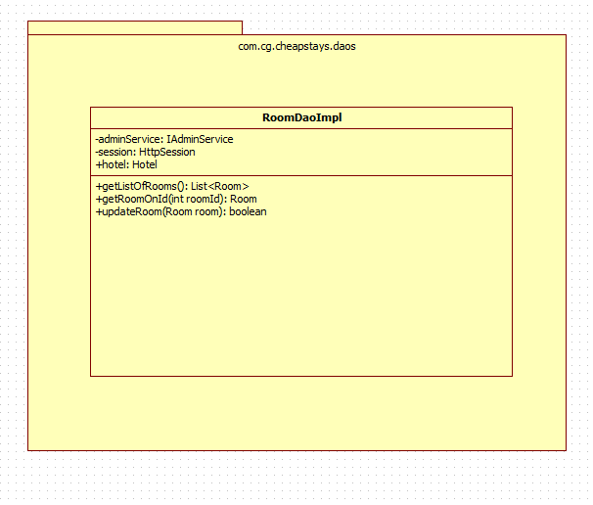

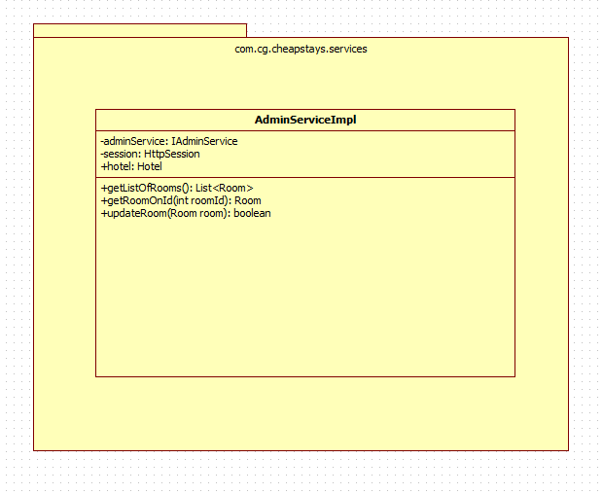

Sequence Diagrams

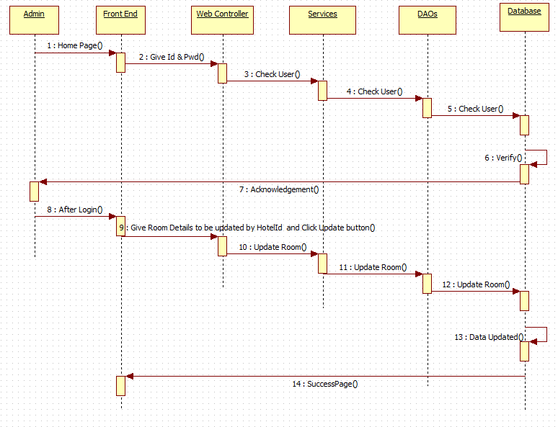

Design Components

List Of UI Components
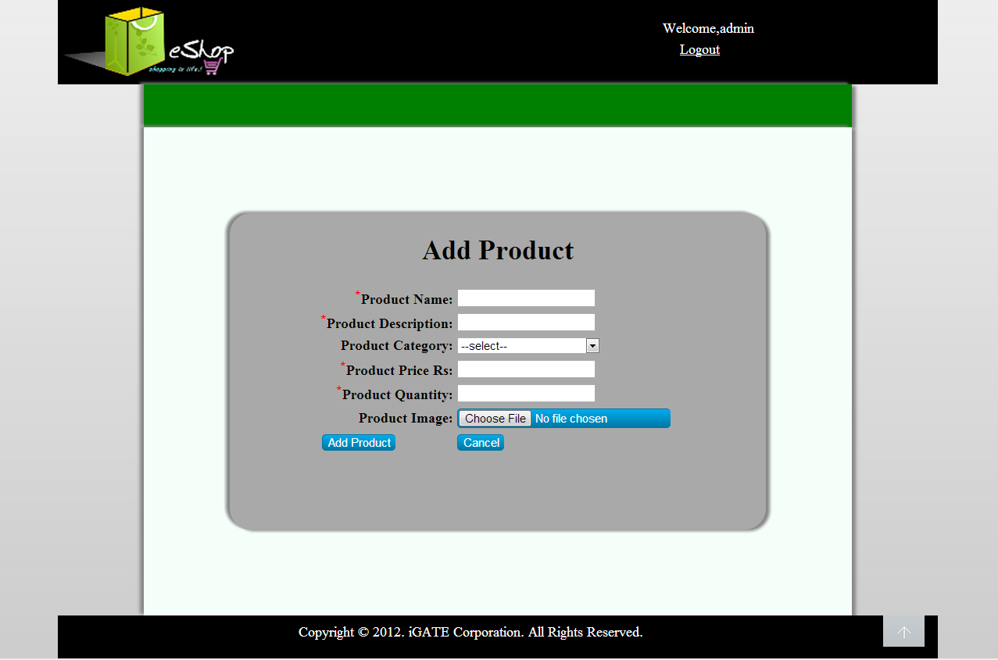

List Of Design Classes
Sr. No. | LLD Name | Class Name | Method Name | Method Description
1 | Update Rooms  Module | Room | Appropriate getters and setters methods | Getters retrieve the property values and setters set the property values
2 | Update Rooms Module | WebController | getListOfRooms(Model model):String  getRoomDetails(@RequestParam(“roomId”) int roomId, Model model):String  updateRoom(@ModelAttribute Room room, Model model):String | Sets the model attribute.  Calls getRoomOnId() of AdminServiceImpl class. It retrieves room details based on its id.  Calls updateRoom() of AdminServiceImpl class. If it returns object then it redirects to indexRoomManagement page else it redirects to updateRoom page with appropriate error message.
3 | Update Rooms Module | AdminServiceImpl | getListOfRooms():List<Room>  getRoomOnId(int roomId):Room  updateRoom(Room room):boolean | Returns the list of rooms to the controller.  Returns the room details based on id to the controller.  Returns the updated room details to the controller.
4 | Update Rooms Module | RoomDaoImpl | getListOfRooms():List<Room>  getRoomOnId(int roomId):Room  updateRoom(Room room):boolean | Inserts the list of rooms into the database and returns the result to AdminServiceImpl.  Inserts the room details based on id into the database and returns the result to AdminServiceImpl.  Updates the room details into the database and returns the result to AdminServiceImpl

Re-Usable Routines/Components

Re-Usable Routines/Components

- CSS files
- Database properties files
- Logger properties files

Messages

#. | Type | Message Text
M1 | Error | Please Enter Only Digits
M2 | Error | Please Enter Only Digits
M3 | Error | This field cannot be empty
M4 | Error | Enter only digits

Configuration Files

File Name | Path | Description
servletContext.xml | /Development/Source | To configure datasources.
springConfig.xml | /Development/Source | To configure controller.
Web.xml | /Development/Source | To configure the bean properties.

Crud Matrix Table

# | Table Name | Create | Read | Update | Delete
1. | Room_details | N | N | Y | N

Data Mapping Matrix

Sr. No. | Screen Label | Field Source | Field Type | Data Type | Max Length | Data Flow | Mandatory
1 | Hotel Id | NA | Label | NA | NA | UI | NA
2 | hotelId | Room. Hotel | TextBox | Number | NA | UI→D | NA
3 | Room No | NA | Label | NA | NA | UI | NA
4 | roomNo | Room.roomNo | TextBox | Varchar | 3 | UI→D | Yes
5 | Room Type | NA | Label | NA | NA | UI | NA
6 | roomType | Room.roomType | Dropdown | Varchar | 30 | UI→D | Yes
7 | per Night Rate | NA | Label | NA | NA | UI | NA
8 | perNightRate | Room. perNightRate | TextBox | Number | (8,2) | UI→D | Yes
9 | availability | Room.availability | Hidden | Char | 1 | UI | NA
10 | Add Room | NA | Button | NA | NA | UI | NA

Legend
UI → D (User Interface to Database)
UI (User Interface Only)

Action Flow Matrix

Sr. No. | Action | Description | Process
1 | On click of Update Rooms link in the Admin panel | Redirected to the Update page | The admin clicks on the update rooms link in the admin panel and gets redirected to the update page.
2 | On click of Update button in update page | The room details are updated into the database. | Data is altered in the fields by the admin which gets updated into the database when update button is pressed.

Stored Procedures

# | Stored Procedure Name  (with Description) | Input/Out Parameters | Type | Size
1. | NA | NA | NA | NA

Program Specification / Pseudo Code

<ACTION :update_rooms_CLICK >

Pseudo Code:
- Client Side Scripting:
None

- Server Side Scripting:
BEGIN
Call getListOfRooms(Model model) in Controller class
Navigate to update page
END

14. 2 <ACTION: UPDATE_CLICK>

Pseudo Code:

- Client Side Scripting:
IF invalid HotelId
Print Error Message M1
IF invalid RoomNo
Print Error Message M2
IF RoomType isEmpty
Print Error Message M3
IF invalid perNightRate
Print Error Message M4

- Server Side Scripting:
BEGIN
Call getRoomDetails(@RequestParam(“roomId”) int roomId, Model model) in Controller class in Presentation Layer
Call updateRoom(@ModelAttribute Room room, Model model) in Controller class in Presentation Layer

BEGIN

Call getListOfRooms():List<Room>in AdminServiceImpl class in Service Layer
Call getRoomOnId(int roomId) in AdminServiceImpl class in Service Layer
Call updateRoom(Room room) in AdminServiceImpl class in Service Layer
BEGIN
Call getListOfRooms():List<Room> in RoomDaoImpl class in Data Access Layer
Call getRoomOnId(int roomId) in RoomDaoImpl class in Data Access Layer
Call updateRoom(Room room) in RoomDaoImpl class in Data Access Layer

BEGIN
Create query for updating records into room_details
Return Boolean value
END
Return Boolean value to Service Layer
END
Return Boolean value to Presentation Layer
END
IF successful navigate to indexRoomManagement page
Else navigate to updateRoom page and show error.
END

REVISION HISTORY OF THE WORK PRODUCT

# | Date | Version # | Section Changed | Details of changes made | Approved By
1 | 26/11/2016 | 1.0 | LLD prepared | N/A | Vaishali Shrivastava
2 | 1/12/2016 | 1.1 | Reusable components,  Pseudo code | Reusable components added.  The pseudo code is modified as per the specified flow. | Vaishali Shrivastava
3 | 1/12/2016 | 1.2 | Reusable components,  References,  Data Mapping Matrix. | Reusable Components added.  File name with relative path is added in the references section.  The name of text boxes(screen label is changed). | Vaishali Shrivastava
4 | 3/12/2016 | 1.3 | Configuration files,UI Components | Paths of the configuration files is updated and UI components(Screen Shots) added. | Vaishali Shrivastava

