Student Enrollments BI Solutions Admin Manual

Certificate in Business Intelligence and Database Development

**Description:** This manual outlines the components of the Student Enrollments business intelligence solution.

**Change Log:** (When, Who, What)

20241211,TCoutermarsh,Created first draft of document

# Overview

This BI solution is for a **small private school with** **less than thirty employees.** The solution consists of the following components:

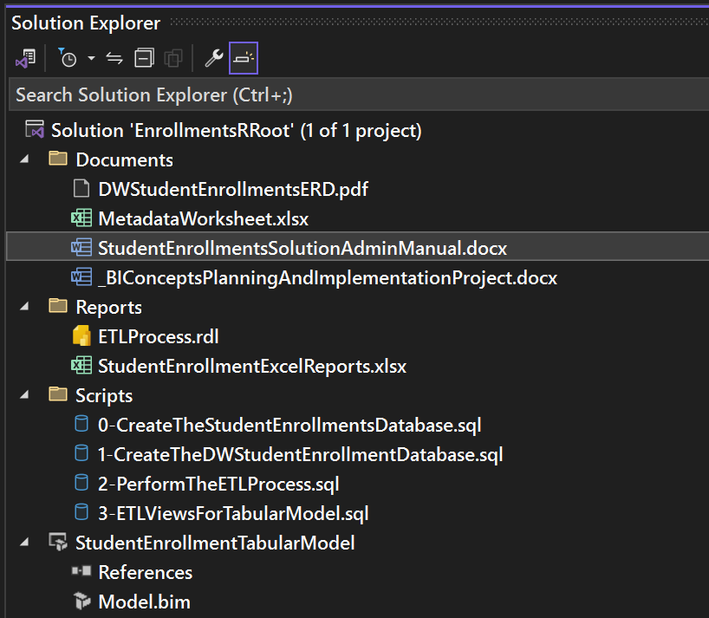

* The Visual Studio solution
* The data warehouse ERD
* The data warehouse metadata worksheet
* This admin manual document
* The solution instructions document
* The sample Excel report
* The ETL processing report
* The source database creation script
* The data warehouse creation script
* The data warehouse ETL script
* The Tabular module ETL script
* The Student Enrollments Tabular Model

Figure: The components of the Student Enrollments BI Solution

# The Visual Studio Solution

This component is used to store and organize all the other components of this BI Solution. Visual Studio is also able to connect to SQL Server and run the SQL Scripts if needed within the application if chosen. The tabular model has also been created through Visual Studio by connecting to SQL Server and the Datawarehouse that was created from the SQL Scripts. Within the physical folder of this BI Solution, Visual Studio mirrors all components and subfolders organization, and the Visual Studio solution is within the zipped physical folder.

Figure:

# The Source Database Review Script

This component is used to create the OLTP Datawarehouse that contains the original data before converting to the OLAP star schema Datawarehouse. This Datawarehouse is structured by the following individual tables: Departments, Classrooms, Classes, Students and Enrollments.

Code sample:

# The Data Warehouse Metadata worksheet

This component is used to plan the conversion of the source data script component in the OLTP structure to the OLAP of the new Datawarehouse. Key transformations made are making the Enrollments table a fact table and the rest of the tables as a dimension table. Classrooms and Departments are no longer their own tables and instead have been combined into the Class dimension table while still having DepartmentID and ClassroomID. A Dates dimension table has been created as well.

Figure:

# The Data Warehouse ERD

This component is used to show a visual of the relationships between the dimension and fact table in the new OLAP Datawarehouse. FactEnrollments has a many to 1 relationship with DimClasses and DimStudents. Along with a 1 to 1 relationship with DimDates.

# The Data Warehouse Creation Script

This component is used to create the tables that have been mapped out in the Metadata Worksheet component.

Code sample:

Figure:

# The Data Warehouse ETL script

This component is used to extract the data from the original data source script component, transform the data as planned into a view and then insert the newly transformed data into the new tables created in the new Datawarehouse from the Datawarehouse Creation script component. An ETL log view is also created to track the progress on whether the new data was loaded successfully.

Code sample:

Figure:

# The Tabular module ETL script

This component is used to create views off the newly created and loaded OLAP Datawarehouse which will be connected to the tabular model. Minor transformations are made, the Datekey is converted to a character datatype.

Code sample:

Figure:

# The Student Enrollments Tabular Model

This component is used to create measures and data transformations such as adding hierarchies to the tables and converting datatypes as needed. The tabular model will be used to connect to for reporting purposes.

Figure:

# The Sample Excel reports

This component is used to create a report that displays the number of enrollments in each class by connecting to the tabular model with Excel.

Figure:

