ETL Processing Final
In this final project, you will create a complex ETL process. This activity will take you about 20 to 30 hours, so plan accordingly!

The Final consists of four Milestones:

Milestone 1: File Imports
Restore the Patients database and automate ETL from CSV files to the Patients database.

Milestone 2: Data Warehouse ETL
Automate ETL from Patients and DoctorSchedules databases to the DWClinicReportsData database.

Milestone 3: Non-SQL ETL
Upload ETL report data from DWClinicReportData to an Excel Spreadsheet.

Milestone 4: Automation, Reports, and Documentation
Automate, Report, and Document your ETL process, then write a "Lessons Learned" paper.

Important: You must upload your current milestone version of the final each week to the same assignment in Canvas.

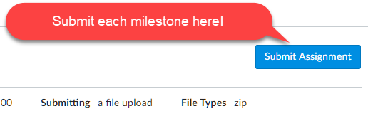
Figure 1. Summitting the assignment.

Note: Name your zip file as ETLFinal_YourNameHere.zip each time you upload the file to Canvas. The instruction team will see all the previous versions, so there is no need to be more specific.

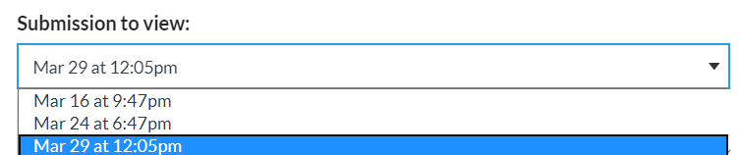
Figure 2. What the instructor sees when multiple files are submitted for assignments.

Be aware that, although you must upload your current milestone file each week, the assignment will only be graded once, at the end of the course!

Important: The structure of your files and folder will affect your grade, just as it would on a real-life project.

Overview
In this final you play the role of a consultant hired to an ETL solution for a small medical clinic. It is similar to a contract I worked on and acts as a practical measure of your knowledge.

Currently, the business has individual clinics send data to a corporate office by uploading CSV files each day. Those files are then added to one of the two databases. The current ETL process is entirely manual.

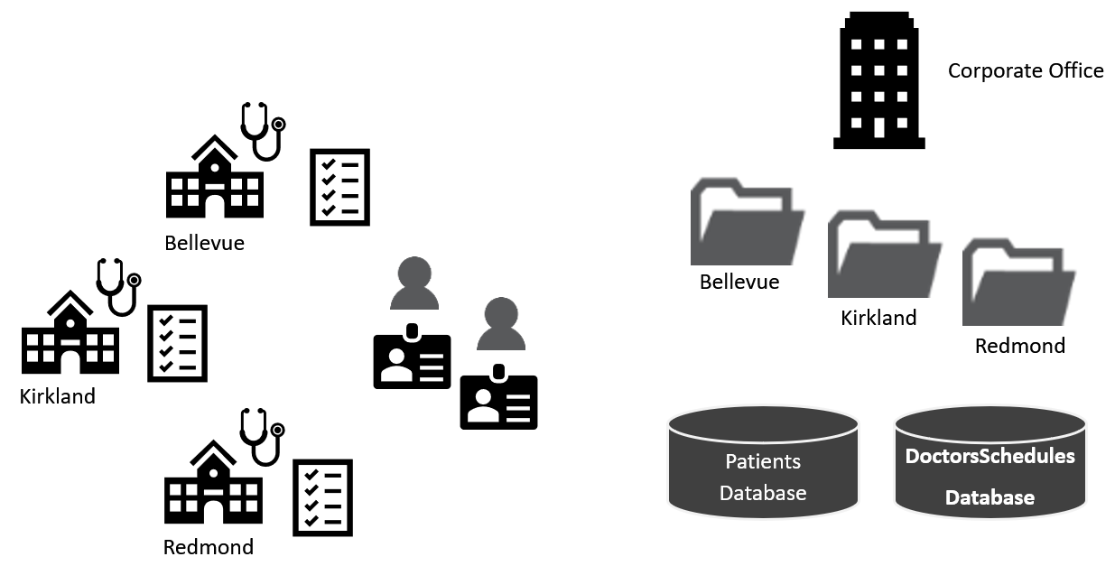
Figure 3. Topology of the current design.

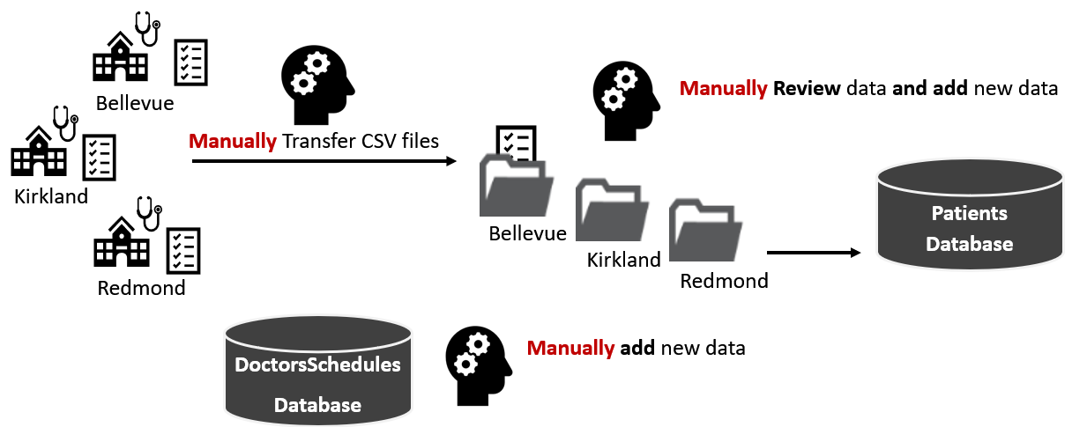
Figure 4. Visualization of the manual ETL file process

The new ETL process will include some automation. If all goes well, they may fully automate in the future.
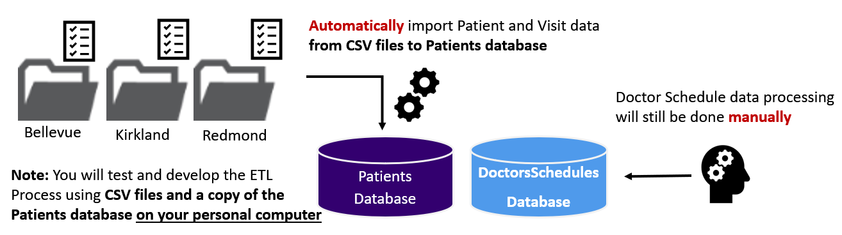
Figure 5. Visualization of the manual ETL file process

Milestone 1: File-Based ETL
The goal of milestone 1 is to automate the import of data from the CSV files into the "Patients" database. There are two sets of files in each folder, with new patient data and new visits data. Perform the listed steps to complete Milestone 1.

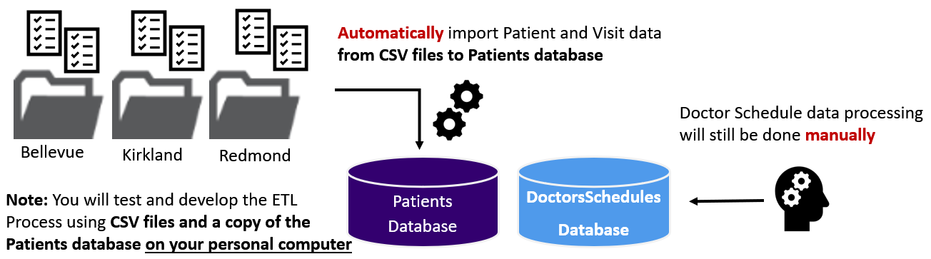
Figure 6. Visualization of the file import process

Important: You need to review and look for common issues (bad data, nulls, data types, column order, etc.) to make your ETL process work.

Step 1 - Review the Data
There are two sets of CSV files to process. These files represent data added daily to the source databases.

Copy the ClinicDailyData folder (with its subfolders and files) to your "C:\_BISolutions\" folder. Then review each file, looking for any issues in their design and data!

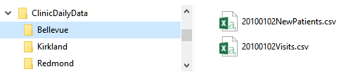
Figure 7. Examples of the daily data CSV files

Note: There are several typical issues to watch for:
- Column Names
- Column Order
- Bad Data
- Concatenations
- Dates and times

Step 2 - Create a Blank Visual Studio Solution
You must organize these files into a single VS solution as we have throughout the course.
Make sure to:

- Make matching virtual folders in Visual Studio.
- Place your files in the correct physical folders and add them in Visual Studio.
- Start organized and stay organized as you work, or you will lose points!

Your physical folders and files must be organized as shown in figure 8.
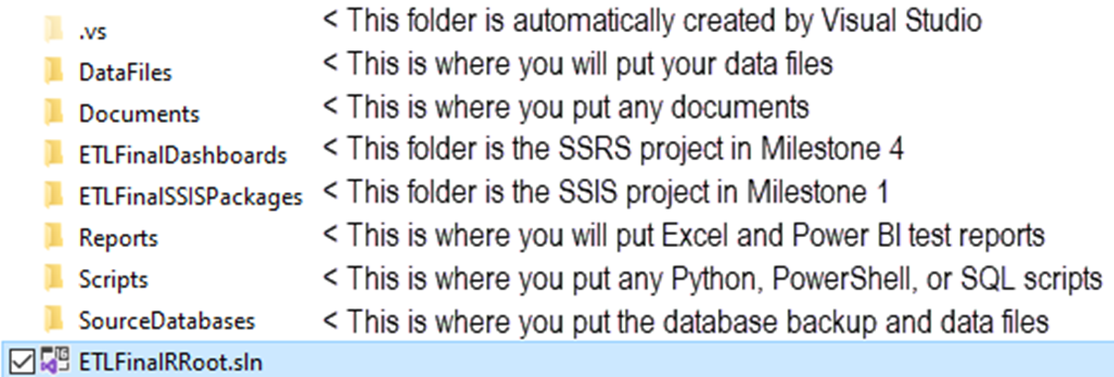
Figure 8. File and folder organization of the solution

Step 3 - Create a Dev copy of the OLTP Databases
You need to restore the two source databases called DoctorsSchedules and Patients on your personal computer. These will be your developer copies of the databases. The .BAK files for each database are included with Finals Zip file and should be placed in the _BISolutions\Databases folder. The following code restores those databases (Note the Path!)

ALTER DATABASE [Patients] SET SINGLE_USER WITH ROLLBACK IMMEDIATE;
RESTORE DATABASE [Patients]
FROM DISK = N'C:/_BISolutions/Databases/Patients.bak'
WITH RECOVERY, REPLACE;
ALTER DATABASE [Patients] SET MULTI_USER;
Go

ALTER DATABASE [DoctorsSchedules] SET SINGLE_USER WITH ROLLBACK IMMEDIATE;
RESTORE DATABASE [DoctorsSchedules]
FROM DISK = N'C:/_BISolutions/Databases/DoctorsSchedules.bak'
WITH RECOVERY, REPLACE;
ALTER DATABASE [Patients] SET MULTI_USER;

Note: In real life you would not work on the Production server when you are testing your file import automation. Instead, you would use a "Dev" server to create and test your process. Consider that you are working on your own "developer" server to simulate this.

Step 4 - Document the tables and transformations
Now review the local dev copies of the source databases and note any issues you find in their designs. Look for things like inconsistent or ambiguous names and data types. Document your source, destination, and transformations in the ETL Transformation metadata worksheet (.\Document\BISolutionWorksheets.xlsx). Make sure to update both tabs as needed.

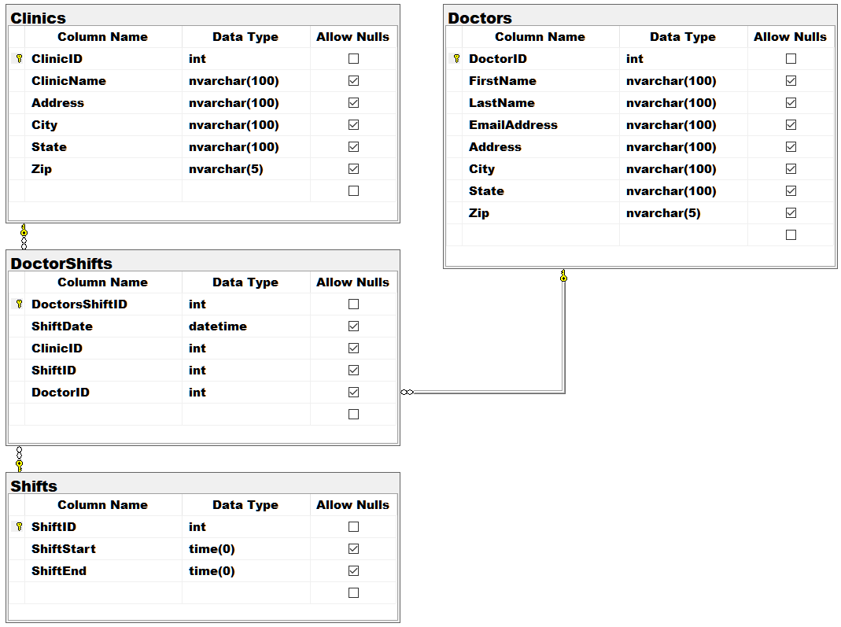
Figure 9. The DoctorsSchedules Database

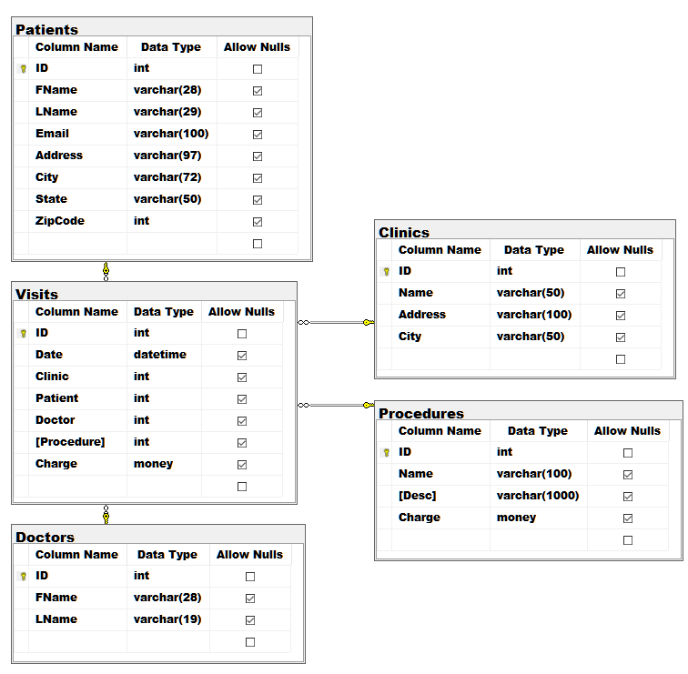
Figure 10. The Patients Database

Hint: Pay attention to column orders, emails addresses, and datetime issues.

Step 5 - Create an SSIS Package
Add an SSIS project ETLFinalSSISPackages to your Visual Studio. Create a package called ETLFilesToDatabases that imports data from the files into your local dev version of the "Patients" database.

Step 4. Update your ETL process design in Excel metadata spreadsheet
Update the metadata spreadsheet with the source, destination, and transformation metadata as needed to describe your ETL process (See figure 11). Make sure to update both tabs as needed.

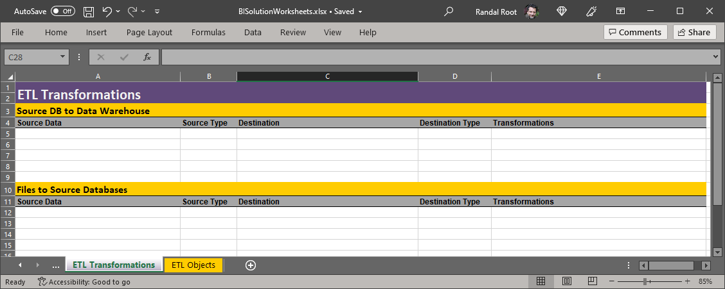
Figure 11. The Metadata Worksheet

Notes:
- You may use Python, SQL, or SSIS tasks to perform this ETL process.
- Any Python or SQL code must be added to a script file and included in the solution, even if it is already in a SISS Script task.
- Incrementally load the source databases with CSV data (This is supposed to happen daily).
- Convert schedule time data to a 24-hour format.
- Use Views and Stored Procedures when working with SQL code.

Important:
- Please create and save your Visual Studio solution as C:\_BISolutions\UWETLFinalYourName
- Please set the Python interpreter path to Visual Studio's 3.9 (so we can grade it without having to change paths!).

Submit a BI Solution to the Canvas Site
Note: You must upload the new versions of the final each week to the same assignment in Canvas. Although you must upload your current milestone file each week, the assignment will only be graded once, at the end of the course! (See Figures 1 and 2 for clarification!)

Milestone 02: Data Warehouse ETL
The goal of Milestone 02 is to create an ETL process from the "DoctorsSchedules" and "Patients" OLTP databases and to "DWClinicReportData" OLAP database.

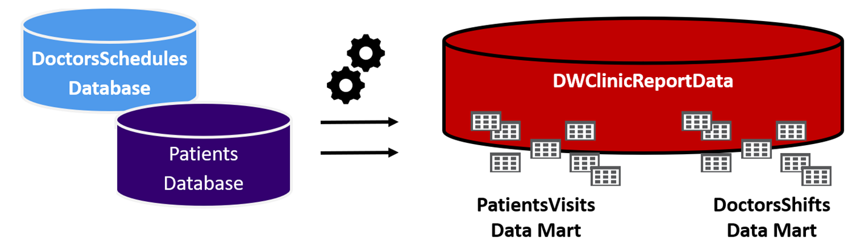
Figure 12. The databases used in the Milestone 2

Step 1. Create a Data Warehouse
Use the data warehouse database script (\Scripts\CreateDWClinicReportData.sql) to create your data warehouse destination database.

Step 2. Review the database design
There are two data marts (A and B) in this data warehouse. Note that DimPatients is a Type-2 SCD design, but all other tables are a Type-1 SCD design.

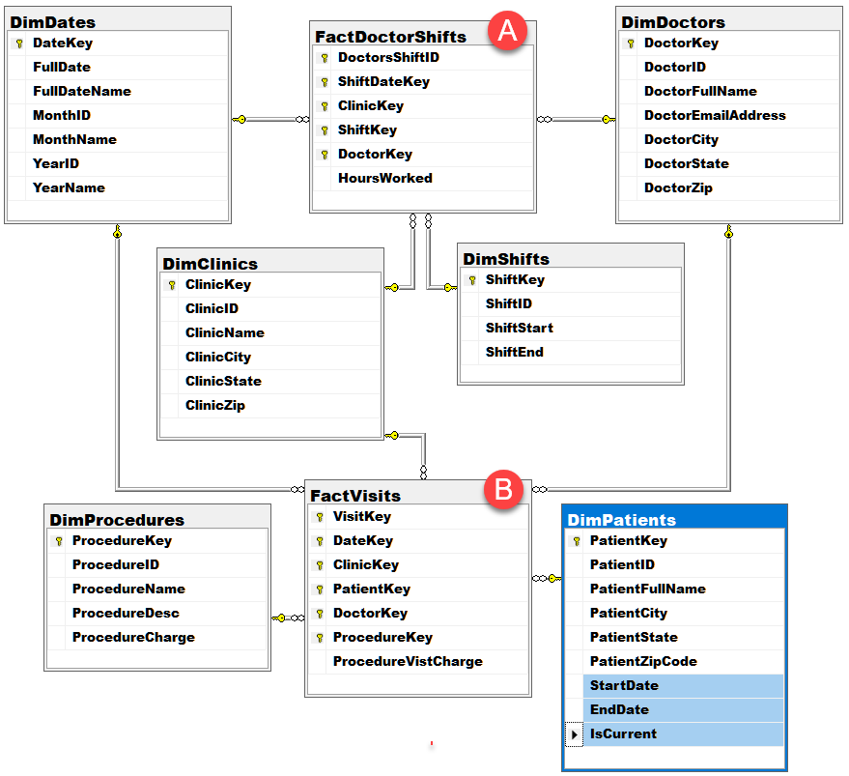
Figure 13. The CreateDWClinicReportData database tables

Step 3. Create a SQL ETL process and SSIS Package
Create an ETL processing scripts using SQL views and stored procedures. Then create an SSIS ETL package called "DWClinicReportDataETL.dtsx" to run the stored procedures.

Step 4. Update your ETL process design in Excel metadata spreadsheet
Update the metadata spreadsheet with the source, destination, and transformation metadata as needed to describe your ETL process (See figure 11). Make sure to update both tabs as needed.

Notes:
- Transformations can be done using SQL or Python (but I recommend using SQL and staging tables).
- Incrementally load all tables (except DimDates and DimShifts.)
- All script code must be placed in script files and included in the solution. Make sure to organize your files and folders, as shown in figure 8.

Important:
- Please create and save your Visual Studio solution as C:\_BISolutions\UWETLFinalYourName
- Please set the Python interpreter path to Visual Studio's 3.9 (so we can grade it without having to change paths!).

Submit a BI Solution to the Canvas Site
Note: You must upload the new versions of the final each week to the same assignment in Canvas. Although you must upload your current milestone file each week, the assignment will only be graded once, at the end of the course! (See Figures 1 and 2 for clarification!)

Milestone 03: Non-SQL ETL
The goal of Milestone 03 is to create an ETL process between the "DWClinicReportData" database and Excel spreadsheet for use by data analysts.

Step 1. Create Views
Create two views in the data warehouse to shape export data to be used in the ETL process like the one in figure 14. Have one view pull data about doctor shifts and the other data about patient visits. Use your best judgment about what should be included in each view in order to create useful reports.

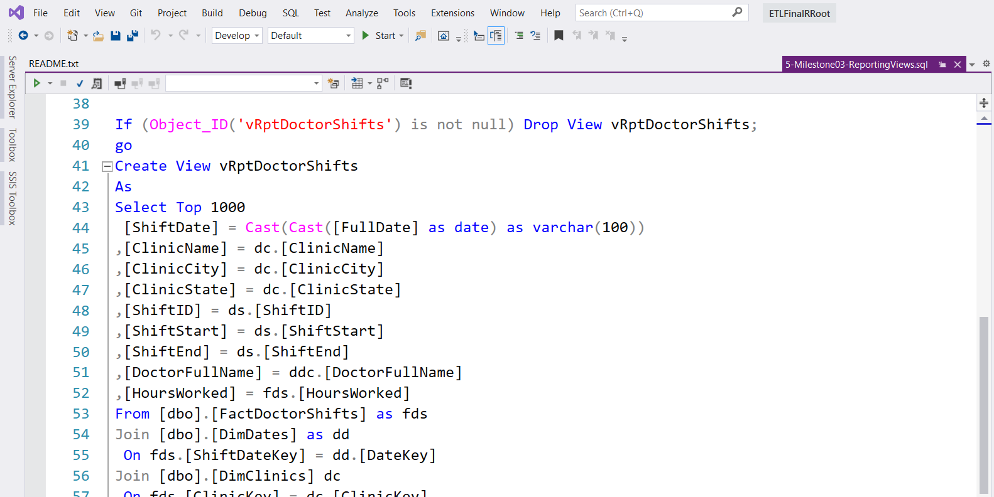
Figure 14. An example view for shaping export data

Step 2. Extract, Transform, and Load data
Create a Python script to Extract, Transform, and Load data from DWClinicReportData into an Excel spreadsheet. The Python script will first create a new Excel spreadsheet called ClinicReportsData_<Current Date>.xlsx in your Solution's Reports folder (figure 15). Then import the report data from your SQL views into two worksheets (one for each view you created in step 1.)

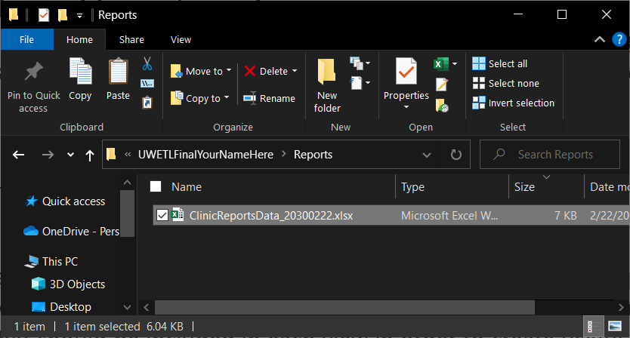
Figure 15. The ClinicReportsData.xlsx in your Solution's Reports folder

Step 4. Create an SSIS Package
Create an SSIS package called ETLClincReportsDocumentData.dtsx, that executes your Python script.

Step 5. Update your ETL process design in Excel metadata spreadsheet
Update the metadata spreadsheet with the source, destination, and transformation metadata as needed to describe your ETL process (See figure 11). Make sure to update both tabs as needed.

Notes:
- All script code must be placed in script files and included in the solution. Make sure to organize your files and folders, as shown in figure 8.

Important:
- Please create and save your Visual Studio solution as C:\_BISolutions\UWETLFinalYourName
- Please set the Python interpreter path to Visual Studio's 3.9 (so we can grade it without having to change paths!).

Submit a BI Solution to the Canvas Site
Note: You must upload the new versions of the final each week to the same assignment in Canvas. Although you must upload your current milestone file each week, the assignment will only be graded once, at the end of the course! (See Figures 1 and 2 for clarification!)

Milestone 04: Automation, Reporting, and Documentation
The goal of Milestone 04 is to complete the BI solution by adding automation, reporting, and documenting your solution. Perform the following steps to complete Milestone 04.

Step 1. Create a new SQL Agent Job to automate your ETL process.
- Create a SQL Agent Job called ETLDWClinicReportData to run your SSIS packages.
- Set the Job Owner as SA and configure it to run each night at 1 AM.
- Generate a SQL Script for the Job and add structured error handling to the script.
- Add the script file to your Visual Studio Solution.
Step 2. Create SQL Reporting Views
- Create ETL report views that pull data ETL log and the MSDB jobs tables.
Step 3. Create ETL Dashboard Reports with SSRS.
- Add an SSRS project called ETLDashboardReports to your Visual Studio solution.
- Create ETL report that shows the contents of the ETL log and MSDB jobs table.
Note:
- Be sure to name your SSRS DataSources and DataSets to identify what database or objects they are using.
- Make sure to update your Excel development document to record the objects in your BI solution accurately. The reason for this is that things tend to change as you go through the creation of any BI Solution, and you need to make sure your final documentation reflects what was built.

2. Create a Technical Manual
Next, you need to create a technical manual that describes the ETL processes you've created. Any reader should read your documents and understand the solution's components, why they are used, and how they are used. Please save your document as a PDF.

Submit a BI Solution to the Canvas Site
Each week you configure and test your solution, ZIP the entire BI solution folder, and upload it to the Canvas website. Remember that you will have placed all the ETL scripts, SSIS, Excel ETL, and Word docs into one solution folder. Zip everything up into one Zip file and submit it to Canvas.

Note: You must upload the new versions of the final each week to the same assignment in Canvas. Although you must upload your current milestone file each week, the assignment will only be graded once, at the end of the course! (See Figures 1 and 2 for clarification!)

Bonus Points: Write a Lessons Learned Paper
Write a paper that outlines what you have learned in this class. The review helps both you and me to understand your progress in this class. You may be surprised to see that this process solidifies what you have learned (or at least other students have told me it does!) There is no need to make this an exhaustive coverage of what you did, but write least a few well-written text paragraphs.

Final Grading
- Milestone 1: File Imports (100 pts)
- Milestone 2: Data Warehouse ETL (100 pts)
- Milestone 3: Non-SQL ETL to Excel(100 pts)
- Milestone 4: Automation, Reports, and Documentation (100 pts)
- "Lessons Learned" paper (50 Bonus points)

