Inhaltsverzeichnis
PART 1 - INTRODUCTION 3
Introduction 3
Developing 4
Requirements 6
Installing the tools 6
PART 2 - PREPARING THE WORK ENVIRONMENT 10
How will you compile our compiler? 10
Work folder 11
Creating the project in Lazarus 11
Configuring the MASM32 13
PART 3 - INVENTING A LANGUAGE 18
The language 18
THE SOURCE CODE 19
WORDS RESERVED 19
COMMENTS 20
NUMBERS 20
IDENTIFIER 20
STRUCTURE OF A PROGRAM 20
OPERATORS 21
EXPRESSIONS 21
TYPE OF DATA 21
VARIABLES 21
ARRANGEMENTS 22
STRUCTURES 22
FUNCTIONS 22
SYSTEM FUNCTIONS 22
PART 4 - CREATING A LEXICAL ANALYZER 24
Parts of a compiler 24
How we will write our compiler 25
Our Lexical Analyzer 26
Back with Lazarus 26
PART 5 - COMPLETING THE LEXICAL ANALYZER 33
PART 6 - SYNTACTIC ANALYSIS 47
Lexer and Parser 47
Support for errors 48
Some more routines 49
Variable support 50
PART 7 - STARTING TO GENERATE CODE 53
Code Generation 53
Assembler Variables 54
Generating assembler 55
PART 8 - VARIABLE DECLARATION 60
A simple code 60
Improving the code 63
PART 9 - ANALYZING EXPRESSIONS 67
The expressions 67
Notation of expressions 67
Operators 68
Operator Precedence 68
Evaluation of expressions in Titan 68
Summary 77
PART 10 - THE FIRST INSTRUCTIONS 78
Operator Storage 78
Compiling an expression 79
Titan assignments 80
PART 11 - TESTING THE EXPRESSION EVALUATOR 87
Expression Processing 87
Part 12 - System functions 96
A stop along the way 96
Creating our "print" function 97

PART 1 - INTRODUCTION
January 5, 2019 Tito Hinostroza Leave a comment
Yes. Just as it sounds. In this series of articles I will explain (try) in a simple way (at least it is the expectation), the design and implementation of a compiler, practically from scratch. Although elementary, this compiler can generate binary code, with the help of an assembler, for Intel's x86 architecture.

Introduction
This project stems from the need to want to answer a constant and recurring question, when I present a project related to compilers: How is a compiler made?
It is not easy to explain how a project of this nature develops, and as often happens in many areas of knowledge, there is no single way to develop it; So the question is perhaps wrong. Ask: How a compiler is made, can implicitly imply the erroneous claim that there is only one way to do it. Nothing is further from reality. There are as many ways to make a compiler as there are ways to make any software project. The field of computer science, and more specifically that of software development, is plagued with development methodologies (probably more than in any other area of ​​knowledge), each claiming to be the best.
It is true that compilers are very special projects, and the most difficult ones that exist, especially when they are self-contained, but that is why they are no longer software projects and as such should be handled as any other program of great complexity is handled.
The first compilers, like the first computers, were made by small teams or even by one person. The first Fortran compiler required man-years of work and was written by a team of outstanding IBM professionals; while the Free Pascal compiler was started by only one person, although it currently has a team of programmers.
The fact that a complete compiler is a complex software engineering project does not mean that we cannot do it ourselves. It is totally feasible to make a small compiler in a short time and without advanced knowledge, just to satisfy, a little, curiosity.
This is possible today, because we have much more advanced development tools and software than those we had 30 or 40 years ago. Today, modern IDE and RAD tools allow us complex developments in a short time. It is not necessary anymore, handle complicated command lines, know the hardware in depth and be an expert in assembler and binary code.
In these times, it is entirely feasible to make, with little effort, a simple compiler like those handled in compiler courses.
In this project, I am not going to talk about complex development techniques, modern methodologies, design patterns or context-free grammars.
Even because of the nature of this program, I will not use object-oriented programming or new paradigms. I will simply use structured and imperative programming of the lowest level. This on the one hand, will allow to make the code more readable for those who start in the world of programming, and on the other hand it will help fulfill the objective of making a self-contained compiler.
A self-contained compiler is one that can compile itself, using its own compiler. This, although it sounds like the chicken and egg problem, is totally feasible and has been used in several modern compilers such as C, C ++, Pascal. For this it is necessary to start by making a compiler in any other language, and then, when the compiler is complete enough, to be able to migrate and translate the compiler using its own language.
Creating a program with a compiler is like using a plant or factory to create equipment or parts. Creating a compiler with another compiler is like using a factory to create another factory. But creating a self-contained compiler is like using a factory to create a factory that manufactures its own parts. At one point, the “manufactured” factory will no longer depend on the factory that created it and will be independent. That will imply that a self-contained compiler must be written in their own language and when so, it will be a creature that will live by feeding itself. Without help. He will be alone in the world. There will be no software, warranty, support, forums, or online help. A self-contained compiler will depend only on itself.
This is the magnitude of the project that I intend to carry out. To date, who writes, has created some compilers and interpreters, for various languages ​​and architectures. One of my latest creations is a compiler in Pascal for the 6502 microcontroller: https://github.com/t-edson/P65Pas . Despite this, I do not consider myself an expert on the subject, but someone with some experience. However, this will be the first self-contained compiler (if I succeed) that I will be creating.
Do not expect to become an expert in compilers, just by being able to create one, following a tutorial. Compiler development is a very extensive and complex issue; and should be thoroughly studied for those who have an interest. These articles will only show how a simple one is created and for didactic purposes.

Developing
This compiler, which I have not yet baptized with a name, will be built from scratch, with the help of another compiler, and an assembler. We will not use any modern LEX or YACC or LLVM type tools, because it would complicate the project and because the goal of making it self-contained would not be met, since these tools are independent developments.
We will start the code from the simplest part that would become the lexical analyzer routines and end with the more complex code generator routines. We will not use complicated designs in the software (many features will be sacrificed), so the code should be easy to follow.
I have structured the development in the following parts:
- Introduction
- Preparing the work environment (tools).
- Inventing a language .
- Creating a lexical analyzer .
- Completing the lexical analyzer .
- Parsing .
- Starting to generate code .
- Declaration of variables.
- Analyzing expressions
- The first instructions .
- Testing the expression evaluator
- System functions
- Conditional implementation.
- Implementation of loops.
- Fix handling.
- Function management
- File management. Command line.
- Autocompilation
These are the topics that have been defined, at least for now. since the project is only in its initial phase.
How to make a complete compiler, it is a titanic task (assuming that the Titans wrote compilers), and it can take years of work, for this project we will reduce our expectations / objectives, considerably:
- As a source language (the one we are going to compile), we will use a simple imperative language, typed and with very few instructions.
- The code will be compiled to assembly code, which will then be converted to binary code, with the help of an assembler and linker.
- Complex types will not be included, only a numerical type and a type for strings.
- We will write minimalist code with little modularity and no dependencies.
The last objective is oriented to be able to achieve the most ambitious objective which is to be able to make the compiler self-contained.
The purpose of the compilation is to create binaries for Intel's x86 architecture in 32 bits, on Windows. Initially I thought about compiling for Intel 16-bit (which is where I have more experience), but considering that the 16-bit code is, these days, obsolete common PCs, I decided to compile for 32 bits. I chose the Windows operating system, because it has the most information about its APIs, and there is a lot of development in this regard.
To start creating the source code of the compiler, we will use the Pascal language, which is easy to handle and adapts well to the objectives and restrictions of the project.

Requirements
Making a compiler is a task that involves diverse knowledge. For our case, and given the simplicity of our project, we will only require knowledge of:
- Assembler for the 32-bit Intelx86 architecture, because this will be the architecture for which we will generate code.
- Basic knowledge of Pascal, at least in its Turbo Pascal mode, since advanced language features will not be used.
- Basic knowledge of compiler theory, at least in terms of understanding the parts it contains and the function of each of these parts.
Needless to say, but the Windows Operating system is supposed to be handled well, in terms of file handling and the CMD command line.
If any of these issues is not well known, it is advisable to review them first to better understand how this compiler is doing. Otherwise, we will be working "mechanically" without being clear about the fundamentals.

Installing the tools
For this ambitious project we are going to use some tools / programs that we will need to install on Windows. These are:
- The Lazarus development environment (https://www.lazarus-ide.org/)
- The MASM32 assembler (http://www.masm32.com/download.htm)
- A text editor, such as the notepad ++ (https://notepad-plus-plus.org/download/v7.6.2.html)
I take it for granted that the interested reader can install these tools without problems (there is also ample information on the network), since if he is not able to do so, much less will he be able to create a compiler, like the one intended in this project.
As a development tool, we will use the free Lazarus environment to develop the first version of the compiler. In other words, we will use the Pascal language, to create the compiler. But no advanced objects or features of the language will be used to later facilitate the migration of the source code to the new compiler language. Pascal is chosen, among other benefits, because the language we are going to use will resemble the standard Pascal. However, you can use another language / IDE if you wish, but in these articles we will use Pascal and Lazarus.
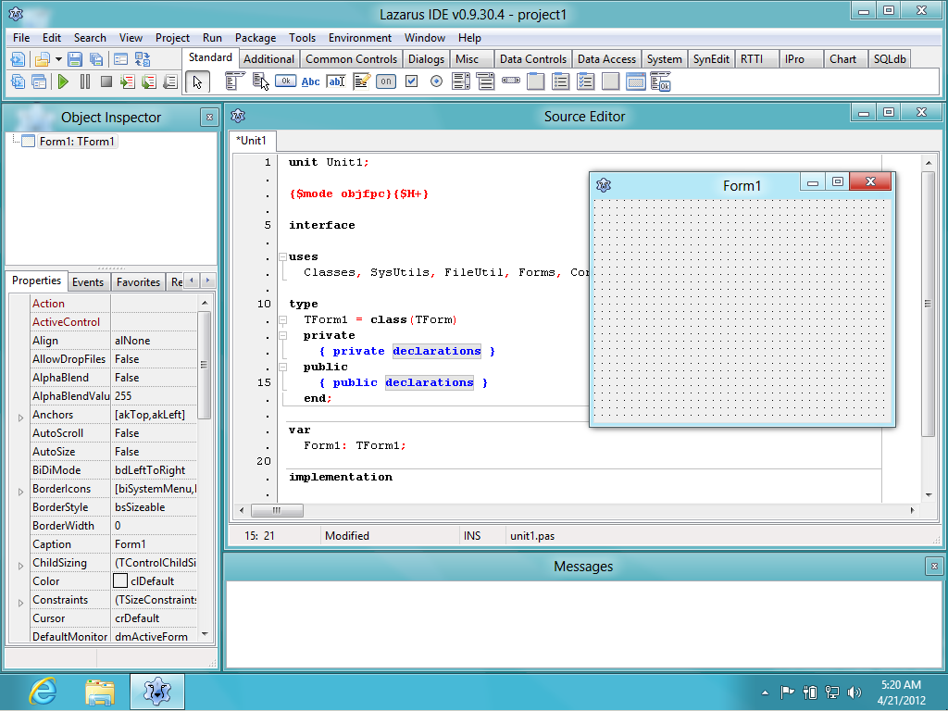
We will not need to install any other additional package and from Lazarus we will only use a basic console type project.
As an assembler, we are going to use the MASM32 because in addition to being free, it is already prepared with all the development kit (assembler and linker), making the installation easier and it is already prepared to work with 32 bits which is the architecture that we are going to Use in this project. In the same way, some other assembler can be used if desired. I am not a computer dictator.
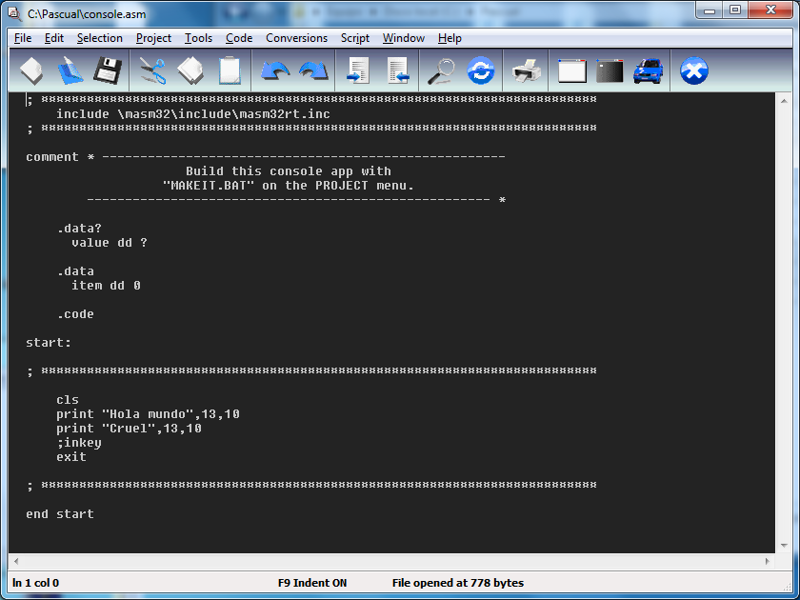
In our case, we will use very little the IDE that comes with the package and we will only use the assembler and linker to obtain the binaries, from the assembly program that we will generate.
The text editor that I am going to use is the Notepad ++, but as always, there is freedom to choose someone else. In this regard, there are considerable options available. Various text editors swarm the web, many of surprising quality and free. This is more a matter of taste. If desired, you can also use the simple Windows notepad. No problem. There are people who still compile using command line editors.
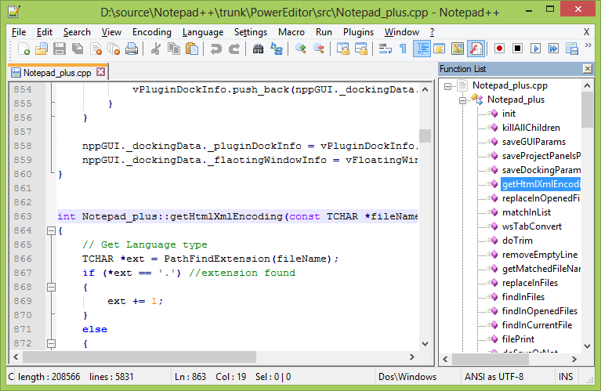
It may be convenient to use the NppExec plug-in, which at least in my case, has been very useful for me when testing assembly code.
For reference only, the version of Lazarus that I am using is version 1.8.0 of 64 bits, version 11, and Notepad ++ version 7.2.2

PART 2 - PREPARING THE WORK ENVIRONMENT
6 January, 2019 Tito Hinostroza Leave a comment
In the previous article we made an introduction about this project and its scope. We also saw the tools that we are going to use. Now we are going to configure these tools and prepare the work environment to start the development, in a comfortable way. But first we will clarify what is the work scheme we want to achieve.

How will you compile our compiler?
The compiler we are creating will work in the common way that most compilers that compile to native code work (such as C, C ++, Pascal, or Go, not like Java or C #), except perhaps because of the need for an additional step .
The idea of ​​compilers is to generate an executable from a source code. In the case of a C program, the process would be something like this:
<test.c>
|
Compiler
|
<test.obj>
|
Linker
|
<test.exe>
Where you can see that compilation is only the first step. Then it is necessary to use a linker to finally generate the executable file. The compiler generates a * .obj file (object code) that is already machine code, but without structure.
The linker does the job of building an executable by analyzing the calls to the subroutines and modules that are made in the program. One of the functions of the linker is, for example, to remove subroutines that are not used.
In this project we will create a compiler, not a linker and we will not generate a * .obj file directly, but we will generate a file in assembler * .asm.
Most of the work we will do, in this project, will be to obtain an executable that will be our compiler and will be called “titan.exe”.
Then we could use this program to compile a source code, which could be "test.tit" and the final result should be "test.exe":
We can schematize this flow:
<test.tit>
|
Our "titan" Compiler
|
<test.asm>
|
Assembler "MASM32"
|
<test.obj>
|
"Polink" linker
|
<test.exe>
As you can see, the compilation flow goes through different stages, creating intermediate files at each stage. The "Polink" linker comes with MASM32, so if we have installed the MASM32 we already have it.
Except for the use of the assembler, our compiler will work the same as most native code compilers. But this is not uncommon, because there are many compilers that also use an assembler to generate object code.

Work folder
As we said in the previous article, this compiler will compile over Windows, and also for Windows, so it is clear that we will need a Windows operating system. Although our compiler will generate binary code for 32 bits, we can work on Windows 32 or 64 bits.
First, we must choose a folder on our disk, where we will be creating the necessary files. For convenience it is convenient to create the folder in the same unit where we have the MAS32 installed. In my case I have installed it in “C: \ masm32 \” so I will create my work folder in C: and call it “c: \ Titan”, because this is the name of the project, as well as the programming language that We will create (See the following article).
This will be the only working folder, and here we will be placing all the files that make up the project.
It is important to ensure that the user has access and privileges to read, write, delete and modify this folder so as not to hinder the development process.

Creating the project in Lazarus
As a first step we will create the project in Lazarus that we will use to create our compiler.
As I mentioned, I am going to use Lazarus because it is a free and quite comfortable IDE to work on, I also hope that the language to be used is similar to Pascal's syntax and some Basic, since I do not plan to create old-style C languages, because of those there are already many (C ++, Java, PHP, awk, ...) and I personally do not support that style of syntax.
However, at this level, the reader can choose his favorite environment (and language) for development. The goal here is just to start from a tool that allows me to create an initial version of the compiler with a simple syntax. You can even use an interpreter (like Python) and not necessarily a compiler, because the idea is that this project is a functional compiler, but finally the code will be rewritten in the language of the compiler itself.
To create the project, we open the Lazarus IDE and create a new project of the “Simple Program” type:
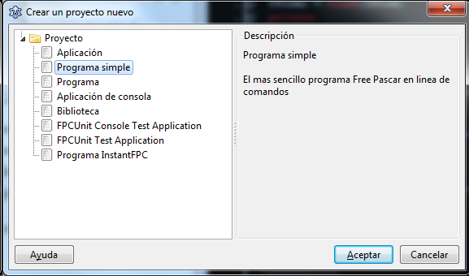
This will create a console application (without GUI), and with the minimum code:
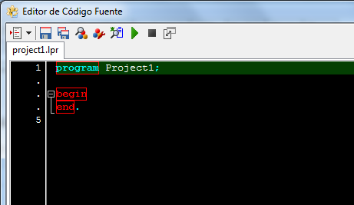
In my case, I have configured my Lazarus editor with a black background using the menu options:> Tools> Options> Editor> Colors.
It is necessary to create a console application because we do not forget that this code will be rewritten later in the language of the same compiler, and it must also be a console application for its simplicity.
Now we must save the project in the new folder we have created (C: \ Titan \). For this we use the menu:> Project> Save Project as ... and we give it the name "titan":
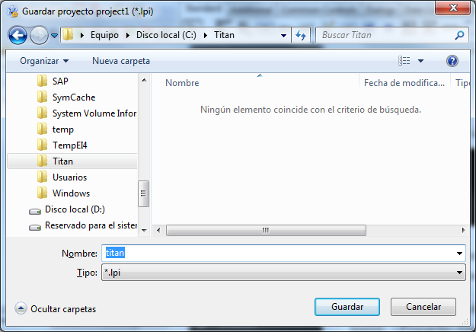
After this, we will have our project created and ready to start developing it. But we won't write anything yet.
In the “C: \ Titan” folder, 3 files (titan.lpi, titan.lpr, and titan.lps) must be created that correspond to the 3 files in this project.

Configuring the MASM32
The next step is to configure the assembly and linking of an assembly file, using the MASM32.
This task is important because in the development of the compiler we will need to carry out many sessions of “Compilation-> Assembled-> Linked”.
It is recommended that the user first become familiar with the use of MASM32 to have a better understanding of this step. There is enough information on the network.
The objective of this step is to achieve the assembly and linking of an assembly file to generate an executable.
The first thing we are going to do is create, in the “C: \ Titan \” folder, a file with the name “input.asm” which is a file where we will place the source code in assembler. We can do it with any text editor. Within this file we can place the following code:
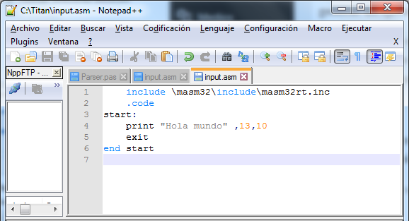
This will be our “Hello world” program in assembler that we will process with the MASM32. The only job this code does is write "Hello world" on the console. It is not the subject of these articles, teach programming in assembler. The reader would do well to review information about it such as the one shown at: http://www.cs.virginia.edu/~evans/cs216/guides/x86.html or http://win32assembly.programminghorizon.com/tutorials .html .
To assemble this code, we can open the CMD and run the MASM32 assembler:
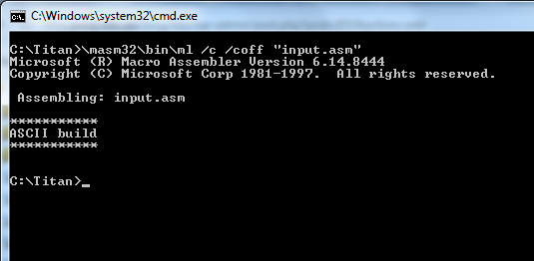
We call the program "ml", because this is the name of the MASM32 assembler, and we use the "/ c" parameter to only perform the assembly because "ml" can also perform the binding. The / coff parameter is to define the format of the object file.
If all goes well, this should generate the file "input.obj":
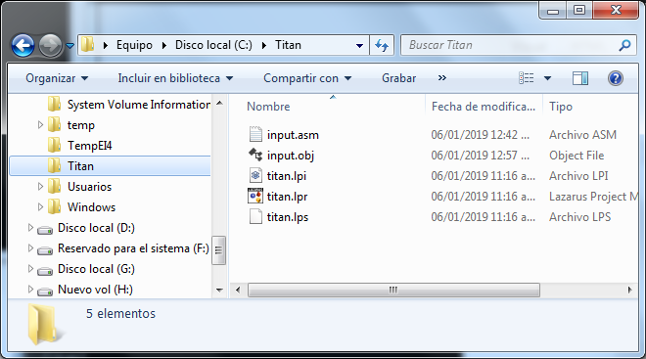
But the “input.obj” file is not yet the executable, so the next step is to link this object code, using a linker:
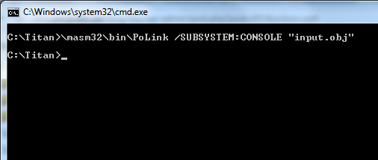
This linker is a silent program and will not display messages as long as there are no errors. The / SUBSYSTEM parameter is to indicate what type of application we want to generate.
If everything went well, we will have our executable file, and we can execute it, obtaining the following output.
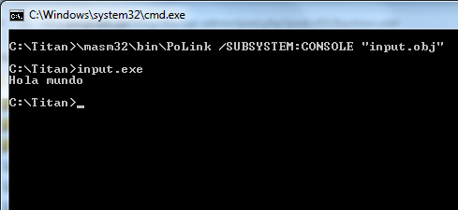
What we have seen here is a complete Writing, Assembly and Linked session, and it is what used to be done before when programming in pure assembler.
As we do not want to be constantly executing the same commands, it is convenient to write a * .bat file, which automates the assembly, linking and, in passing, the execution. To do this we will create the file: “test.bat” with the following content:
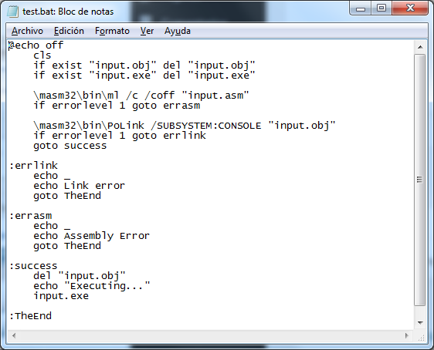
In addition, the assembly and linking code, what this code does is to verify the possible errors, to run the program only if there have been no errors.
Then, every time the assembly program is modified, we can launch this “bat” to assemble / link / execute easily.
If you do not know what a “bat” file is or have had difficulties in understanding any of the steps indicated here, it is advisable to read a little, and investigate, on difficult issues, before proceeding.
Assuming that we have been able to achieve these steps successfully, we are ready to start the development of the compiler, but first we will define a programming language, in the following article.

PART 3 - INVENTING A LANGUAGE
January 9, 2019 Tito Hinostroza Leave a comment

The language
The next step in creating our compiler will be the creation of language. For this we can propose 2 options:
- Use an existing language, such as C or Pascal.
- Create a new language from scratch.
Implementing an existing language is a huge task, even if we choose a simple language like Basic or C, because the complexity of its syntax and the amount of instructions it handles, goes against our goal of simplicity. Needless to say, languages ​​like C ++ or Object Pascal.
Creating a new language gives us the advantage of being able to define a basic syntax and according to our requirements. Therefore, we will go for that option.
Now, for simplicity, we will define the following requirements for our language:
- Imperative. None of complex functional characteristics.
- Typed. This facilitates the analysis of expressions and error detection.
- With only two types of data. What is necessary to be self-contained.
- Reduced amount of instructions. Not to complicate the implementation.
- File management support.
However, the language must have enough power to be able to write a simple compiler.
These two objectives are opposed; On the one hand, the minimally complex language must be made, but on the other hand, it must have the capacity to develop a compiler in this language, which implies a considerable level of power.
As we want the language to compile a source code, the most logical thing is that this code is in a file, so the language must have functions to read files, even if it is text.
Another of the functionalities that the language should have, given that it must be able to implement a lexical analyzer, will be that it must have functions and operators for string manipulation, and of course it must have the type of string data.
Now, it is possible that the language does not implement the string type (which would be a relief), and handle everything as character arrays, in the same style as C, but this would imply making the compiler even more complex, because surely you should implement pointers and their respective arithmetic.
The language support for numbers is minimal and we only need to handle 1 type of whole numerical data, which can serve us as a character (similar to the “char” type of C) or as a Boolean value, if we restrict its value at 0 or 1.
Another of the characteristics that language must have is to be able to support the use of functions or procedures, because it is the minimum that can be requested to make a program something modular. At the moment there is no plan to implement external libraries or some kind of modular structure, so as not to complicate the project.
Despite the restrictions for simplicity of language, this part is the most fun of the project, because here we can let go of our creativity considerably.
The language that I propose here, and which I will call "Titan", is one born from my experience and creativity, but you can define your own structures or reserved words.

THE SOURCE CODE
For simplicity, our language will be case sensitive, that is, it will be case sensitive. Making language case-sensitive is simple, but it involves additional work (such as implementing the transformation functions), and considering that our initial goal is to simplify the language, as much as possible, we will dispense with this characteristic.
Another additional detail, to simplify our compiler, is that we will only handle one type of string data, and to simplify its implementations, we will define them of a fixed size, of 255 characters, in the same Pascal style, in its first versions.
Due to this limitation, lines of more than 255 characters may not be available in the source code, because there would be no way to save them easily.
The syntax that I am going to define has the following objectives:
- Allow a quick and simple implementation of the lexical analyzer.
- Be a high level language. So it won't look much like C.
- Facilitate writing to the programmer, avoiding the use of many symbols.
To meet the last objective, the use of the semicolon as an instruction delimiter is being dispensed with (although it may be implemented later) and the use of parentheses is avoided whenever possible. It will try to use the end of line as a delimiter, as is done in Visual Basic.
However, this syntax is experimental, so we may make subsequent changes.
An additional detail is that we will not include error verification routines in some instructions. In this way we will simplify the code, but we must make it clear that a good design always implies handling error protection routines.
The language I define here uses words from the English alphabet, for convenience, but you can use Spanish or any other language.

WORDS RESERVED
Words that cannot be used as identifiers or some other element of language are defined here.
For now, we will only handle the following reserved words:
"Var", "number", "string", "if", "then", "end", "while", "do", "proc", "func" and "exit".
As can be deduced, we will try to keep this list as small as possible (for simplicity of the compiler), but it is possible that we will expand this list as we develop the language, however, this is a good starting point.

COMMENTS
Comments will be defined with the characters "//" in the same way as in the C language.
Comments will be from a single line. For now we will not implement multi-line comments, but we expect to use the characters / *… * / as in C / C ++.

NUMBERS
Only integers of up to 32 bits will be recognized, such as: 123, -10000, or 001.
There is no support for floating point numbers, for now.

IDENTIFIER
Identifiers are the names that will be used for the variables. For our case, the following rules will be used:
- The first character must always be a letter, either uppercase or lowercase or the hyphen character under "_".
- The following characters, if any, can be any letter, number or the hyphen character under "_".
For letters only letters of the English alphabet will be recognized.
Consider that identifiers are case sensitive and that identifiers equal to reserved words cannot be used.
Another detail to keep in mind is that the identifier length cannot exceed 255 characters, nor contain characters outside the ASCII alphabet.

STRUCTURE OF A PROGRAM
Programs may have a free structure, but it is recommended:
<function declarations>
<variable declarations>
<main program>
The “Hello world” program will be in our case.
print "Hello world"
Another example could be:
var x: number;
var cad: string
cad = "hello"
print cad
Note that the semicolon, in the end, is not used.

OPERATORS
In our case, we will only implement:
“=” Operator of variable assignment and number comparison.
"<>" Number comparison operator.
“+” Sum of numbers or concatenation of strings.
“-” subtraction of numbers.
">" Comparison of numbers.
"<" Comparison of numbers.
The concatenation of strings will be done with the same “+” operator that is used for arithmetic addition. Concatenation is important in order to perform chain manipulation.

EXPRESSIONS
The expressions will be simple. Maximum of two operands, apart from the allocation, if it exists.
Thus, the following expressions will be valid:
x = 1;
x = x + y
x> 0
But the following expressions are invalid:
x = x + y + 1 // More than 2 operands after assignment
x> y + 1 // More than 2 operands
Since the expressions are simple, there are no problems in defining the precedence of operators and we will only assume that the assignment has the highest precedence.

TYPE OF DATA
We will only handle two types of data.
Numerical type -> Signed numbers, up to 32 bits in length. Examples: 1000, -50 Only integer values ​​are allowed.
Chain type -> Chains of any length, terminated in NULL character. Example: "Hello." Strings will have a maximum length of 255 characters.
Within the code, strings can only occupy one line.
Numerical types may also be used as Boolean values, assuming that any non-zero value is considered TRUE.

VARIABLES
Variables are declared with the reserved word "var":
var x: number
var s: string
Only one statement is allowed for each word "var."
Declarations can be made anywhere in the code.
Constants will not be handled, for now.

ARRANGEMENTS
You can create data arrays of the number and string types:
var x [10]: integer
var cad [5]: string
This definition indicates that an array of 10 elements is being created: From x [0] to x [9].
The chains can also be treated as arrangements:
var cad: string
cad [1] = 65 // first character 'A'

STRUCTURES
Only one conditional statement and one loop will be recognized.
The conditional sentence will have the form:
if <expression> then <body> end
The loop to be implemented will be the "while", and will have the form:
while <expression> do <body> end

FUNCTIONS
The language will include predefined functions for some useful tasks, but you can also define user functions:
func <name>
<body>
end
Functions can also use local parameters or variables. All parameters will be passed by value. At least at this stage.
Functions can return values ​​using the "exit" instruction.
double func (x: integer)
exit x + x
end

SYSTEM FUNCTIONS
Some internal functions will be implemented, that is, they do not need to be declared. These are:
print <expression>
Print one value per console.
println <expression>
It allows you to print a value per console, adding a line break at the end.
exit <expression>
Exits a function, returning a value.
length (<expression>)
Returns the length of a string, as a number.
StrToInt (<expression>)
Returns a string converted to number.
IntToStr (<expression>)
Convert a number to a string.

PART 4 - CREATING A LEXICAL ANALYZER
January 13, 2019 Tito Hinostroza Leave a comment

Parts of a compiler
At this point in the project, and before starting the development of the compiler source code, we should be clear, what are the parts of which a compiler is composed.
Compilers can be made in as many ways as chocolate cakes can be made. That is the good and the bad of making compilers. There is no “International Regulatory Committee on the ways in which Compilers are made” or anything similar.
So, please stop asking. How are compilers made? A better question would be, could you explain some way in which compilers are made?
Luckily, most compilers have more or less defined modules. Some of them are:
Lexical analyzer.- Also known as “lexer”. It is he who identifies and extracts the so-called "tokens", which are the minimum elements of characters with coherent meaning for a programming language.
Syntactic analyzer.- Also known as "parser". It is who processes the tokens according to the grammar rules of the programming language (such as where an identifier is allowed). Usually its result ends in what is called "Syntax Tree"
Semantic analyzer.- Although less known and identified, this analyzer performs a higher level check to the source code, such as if a type of data is valid in the position where it is located.
Syntax tree.- There may be one or more. It is a branched structure that represents the source code in terms of structure. The nodes of the tree can represent functions or declarations. It is used to perform semantic analysis and for code generation.
Intermediate code generator.- Many compilers include this module, whose main objective is to perform at the first stage in the code generation. An intermediate code is usually used to simplify code generation and to facilitate the creation of new code generators.
Code generator.- It is the module that creates the destination code Ideally, the destination code is binary or executable, but most compilers only create object code or, even, only assembly code (as we are going to do).
Code Optimizer.- The code optimization can be performed at various levels, such as in the stage prior to the code generation or in the generated object file. The idea is to obtain a simplified, optimal and / or fast code. For them there are various applicable rules and techniques.
Each of these modules can become very complex and there are researchers who are constantly doing research and contributions. The techniques for creating compilers are not written in a holy book.
In this article we will begin with the creation of a simple lexical analyzer whose main objective is only token extraction.

How we will write our compiler
In this article, we will start writing code, and as we have already mentioned, we will consider some basic rules when writing the compiler routines. These are:
- We will use the Pascal language in its basic capabilities. Object Pascal capabilities will not be used.
- We will only use Pascal as imperative and typed language.
- We will only use two types of data: Integer and String.
- We will only use simple conditional IF .. THEN… ELSE.
- We will only use WHILE loops. We will not use REPEAT or FOR.
- Nested procedures will not be used within another procedure. No functions
- No third party libraries will be used. The entire compiler will be implemented from scratch with the native functions of the string and number handling language.
- No pointers will be used.
- The type “string” of Pascal that we will use, will be restricted (by convention) to a maximum size of 255 characters.
- The file management functions must also be the native ones that the language implements.
- Functions and procedures can receive parameters but only by value, not by reference.
- Since there are no Boolean types, integer values ​​will be used to emulate them, taking into account that the value 0 represents FALSE.
- Not having "char" types will use integer values.
- Simple expressions of two or three operands will be used.
It can be noted that there are strong restrictions as to what we can (and what we cannot) use language. This is an additional challenge when writing the compiler, but it will help us to:
- In the future, being able to translate the Pascal compiler into the compiler's own language.
- Facilitate the explanation of the compiler, by having a simple code and not having to explain advanced language concepts.
Having made clear the restrictions at the time of writing the code, we then go to the first module of the compiler.

Our Lexical Analyzer
Compared to professional compilers, our lexical analyzer will seem like a child's play, but it won't stop being functional.
To better understand the lexical analyzers, I suggest reading my article http://blog.pucp.edu.pe/blog/tito/2016/12/19/jugando-con-palabras-analizadoresctualicos/
Our “lexer” will simply be a set of procedures and functions that will allow us to recognize the different types of tokens with which we will work in our programming language.
For simplicity we will only define the following types of tokens:
- Spaces
- Line breaks.
- Identifiers
- String literals
- Numeric literals
- Unknown tokens
With these tokens it is enough to represent all the elements of our language.
The spaces are those that correspond to character # 32 (of the ASCII code), but could also be included in the tabs.
Line breaks are line delimiters, and in Windows they are represented by two characters: # 10 and # 13.
The identifiers were defined in the previous article, when we created the language.
String literals are characters delimited by double quotes, such as "Hello" or "this is a string."
Numerical literals are numerical characters such as: 123 or 002. At the moment we will not consider numbers with decimals or floating point.
All other tokens will be considered as unknown, but they will also have a type. In this group the symbols like “+”, “-” or “:” will fall.

Back with Lazarus
In the second article we had left Lazarus's environment ready to start working. Now we will continue to create a file that will be our first program in our Titan language.
Let's create a file called "input.tit", which must be a text file and put the following content:
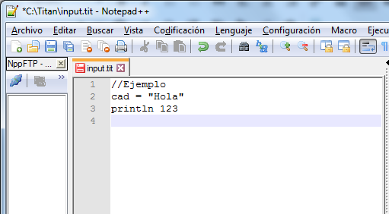
This file is not a coherent code, but simply a good sample to test our lexical analyzer, because it contains all the syntactic elements.
We must put this file in the same folder where we have our Lazarus project, so that in our working folder we already have several files:
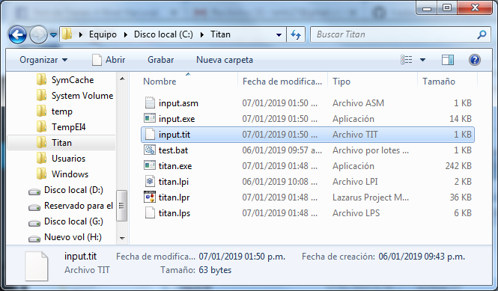

As our intention is to read the tokens from a source file, we will start with the routine to read lines from a text file. We open the titan.lpi project and write the following code:
{Project of a compiler with minimal implementation.}
program titan;
var
inFile: Text; // Input file
srcLine: string [255]; // Line currently read
begin
AssignFile (inFile, 'input.tit');
Reset (inFile);
while not eof (inFile) do begin
readln (inFile, srcLine);
writeln (srcLine);
end;
Close (inFile);
ReadLn;
end.
This is the typical scheme of a program for reading files in Pascal. If we execute it, we will see the contents of the “input.tit” file in the console.
But this is far from being a lexical analyzer, because it only extracts lines and the lines are not considered tokens in our definition. However, this code will be the basis of our lexical analyzer, which will also work by reading lines from the source file.
Our lexer will feed on the text lines of a file, so to gain speed, and for simplicity (since we cannot use advanced language features) we will use a variable string to store each line that we read from the file. We will call this variable “srcLine”:
srcLine: string [255]; // Line currently read
Now this line must be explored character by character, so we will need to access it as an arrangement and we will also need an index, or pointer, to read each character of the “srcLine”. We will call that index “idxLine”:
idxLine: integer;
We will also need two more variables to handle the input file (source code) and the output file (assembler file) that our compiler will generate:
Now having these variables, we can implement some basic functions of what will be our "lexer":
function EndOfLine: integer;
begin
if idxLine> length (srcLine) then exit (1) else exit (0);
end;

function EndOfFile: integer;
{Returns TRUE if there are no longer characters or lines to read.}
begin
if eof (inFile) then begin
if EndOfLine <> 0 then exit (1) else exit (0);
end else begin
exit (0);
end;
end;

procedure NextLine;
// Go to the next line of the input file
begin
if eof (inFile) then exit;
readln (inFile, srcLine); // Read new line
idxLine: = 1; // Point to first character
end;
These functions handle scrolling through the input file (NextLine), and verification of the file limits (EndOfLine and EndOfFile).
This is important because as we do the scan, it may be the case that we have reached the end of the file, in which case it is no longer meaningful to continue exploring. End-of-line verification (EndOfLine) is used to know when we should read the next line, although this is only seen at low levels of the “lexer” (more basic functions) because at higher levels, changing the line is something that It is done transparently.
Note that the EndOfLine and EndOfFile functions should return Boolean values, but here they are returning numbers, to comply with the language restrictions we can use. One of them is precisely that we can only use data of type "integer" and "string", although we can also use unsigned integers or smaller capacity, without losing the essence of the restriction.
The logic of these functions is simple, so I don't think the reader has problems with interpretation. Pay attention to the way you pass a new line, resetting the index "idxLine" to 1, to start exploring from the first character.
An improvement we could make for this code is to include a counter of processed lines in order to know on which line an error occurs. For this we must add a variable, which we will call “srcRow” and our NextLine procedure would be:
procedure NextLine;
// Go to the next line of the input file
begin
if eof (inFile) then exit;
readln (inFile, srcLine); // Read new line
inc (srcRow);
idxLine: = 1; // Point to first character
end;
But even with these routines, we still don't have the ability to identify and extract tokens. We still have to write higher level routines (which are created using other simpler routines).
There are a couple of routines that are present in almost all lexical analyzers, and are those that are responsible for exploring the entry character by character. Here we will define them like this:
procedure ReadChar;
{Read the current character and update "srcChar".}
begin
srcChar: = ord (srcLine [idxLine]);
end;

procedure NextChar;
{Increase "idxLine". Go to the next character.}
begin
idxLine: = idxLine + 1; // Go to the next character
end;
To read the current character (to which “idxLine” points) we will use the ReadChar () procedure. Note that the current character is returned in the global variable "srcChar", which is numeric. You could also return as a result of the function, without problems, but here you are trying to use the simplest way of working. But change is trivial.
The NextChar () routine only increases the index to point to the next character, but it follows that for security, you must always be comparing if you reach the end of the line. Trying to explore further will generate a runtime error.
With these routines we could already create a loop to go exploring characters of a line and it would have the form:
while EndOfLine = 0 do begin
ReadChar; // Read on "scrChar"
// Do something with "scrChar"
NextChar; // Take character
end;
Note how the booelano (integer) value returned by EndOfLine () is compared.
This loop would only work well for one line and could be used to extract its tokens, but what we are looking for is something more general that allows us to extract tokens from several lines in a comfortable and somewhat transparent way.
If we now put together all the routines shown, we would have something like this:
{A compiler project with minimal implementation to be self-contained.}
program titan;
var
// Source code management
inFile: Text; // Input file
outFile: Text; // Output file
idxLine: integer;
srcLine: string [255]; // Line currently read
srcRow: integer; // Current line number
srcChar: byte; // Character currently read

function EndOfLine: integer;
begin
if idxLine> length (srcLine) then exit (1) else exit (0);
end;
function EndOfFile: integer;
{Returns TRUE if there are no longer characters or lines to read.}
begin
if eof (inFile) then begin
if EndOfLine <> 0 then exit (1) else exit (0);
end else begin
exit (0);
end;
end;
procedure NextLine;
// Go to the next line of the input file
begin
if eof (inFile) then exit;
readln (inFile, srcLine); // Read new line
inc (srcRow);
idxLine: = 1; // Point to first character
end;
procedure ReadChar;
{Read the current character and update "srcChar".}
begin
srcChar: = ord (srcLine [idxLine]);
end;
procedure NextChar;
{Increase "idxLine". Go to the next character.}
begin
idxLine: = idxLine + 1; // Go to the next character
end;
begin
// Open input file
AssignFile (inFile, 'input.tit');
Reset (inFile);
NextLine; // Read first line in "srcLine" s
while EndOfLine = 0 do begin
ReadChar; // Read on "scrChar"
write (chr (srcChar)); // Do something with "scrChar"
NextChar; // Take character
end;
Close (inFile);
ReadLn;
end.
This code will only show us character by character, the content of the first line of the input file. Although it is not a “lexer” because it does not extract tokens but characters, it is convenient to study it (and execute it) to move forward with the development with good understanding.
In the following article we will finish implementing the lexical analyzer and test it with the file we are preparing.

PART 5 - COMPLETING THE LEXICAL ANALYZER
January 19, 2019 Tito Hinostroza Leave a comment
In the previous article we saw how the compilers are structured, identifying the modules that compose them.
As an aid, to complement our understanding, the following diagram (obtained thanks to Wikipedia) shows how these different parts are linked:
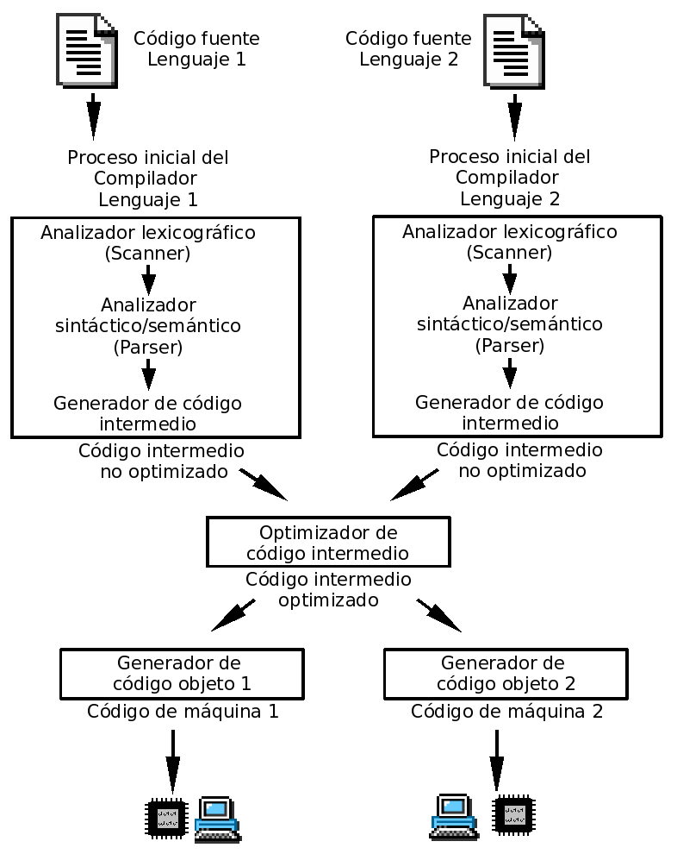

Although it is not common to have a compiler that compiles two source languages, it is possible to have two compilers that generate the same intermediate language (such as the "bytecode", generated by Java and several other compilers).
What is usually used is to start from the same intermediate code to generate several machine codes or simply interpret that intermediate code.
Now, returning to our Titan compiler, we will continue with our lexical analyzer.
In the previous article, we had already implemented a simple code for the extraction of characters, from a text file but we still could not identify tokens, because for this we need more advanced extraction functions that handle strings.
First we will need some character identification routines:
function IsAlphaUp: integer;
{Indicates if the character in "srcChar" is uppercase alphabetic.}
begin
if chr (srcChar)> = 'A' then begin
if chr (srcChar) <= 'Z' then begin
exit (1);
end else begin
exit (0);
end;
end else begin
exit (0);
end;
end;
function IsAlphaDown: integer;
{Indicates if the character in "srcChar" is alphabetic nimuscle.}
begin
if chr (srcChar)> = 'a' then begin
if chr (srcChar) <= 'z' then begin
exit (1);
end else begin
exit (0);
end;
end else begin
exit (0);
end;
end;
function IsNumeric: integer;
{Indicates if the character in "srcChar" is alphabetic nimuscle.}
begin
if chr (srcChar)> = '0' then begin
if chr (srcChar) <= '9' then begin
exit (1);
end else begin
exit (0);
end;
end else begin
exit (0);
end;
end;
Note that, due to restrictions, we are using a numerical variable (srcChar) instead of a “char” type, which would facilitate the code.
Note also that these routines would not be necessary if we could use sets (a useful feature in the Pascal language) in our code, but since we are restricting the functionalities of the language, we have no choice but to implement character recognition in a “manual” way.
But these functions are far below the task of extracting tokens (which is what lexers do), they only identify characters, so we must create other higher level functions that bring us closer to the tokens.
But before entering these routines we will need two additional variables: srcToken and srcToktyp, declared as follows:
srcToken: string; // Current Token
srcToktyp: integer; // Token Type
The variable “srcToken” will be used to save the current token, the last one we have identified. We keep it in a variable to make quick comparisons.
The variable "srcToktyp" is a number that will serve as an identifier of the type of token we have in "srcToken", and will have the following interpretation:
// 0-> End of line
// 1-> Space
// 2-> Identifier: “var1”, “VARIABLE”
// 3-> Numeric literal: 123, -1
// 4-> Literal string: “Hello ”,“ Hey ”
// 5-> Comment
// 9-> Unknown.
This classification is due to what we had proposed for our language. That is, we will identify the token using the value of a numerical variable. This is common in most lexical analyzers although it is preferred to use enumerated types, rather than simple numbers, but we already know that we have imposed restrictions on language here.
Now to move forward in the identification and extraction of tokens, we need special routines. The approach I propose here is to use a routine for each type of token to be processed, instead of using a single routine to identify all types of tokens. This simplifies the identification code.
The following functions use the routines seen in the previous article and the identification routines that we have shown here to explore lines and extract characters (increasing the index “idxLine”) according to the type of element they handle:
procedure ExtractIdentifier;
var
IsToken: integer; // Temporary variable
begin
srcToken: = '';
srcToktyp: = 2;
IsToken: = 1;
while IsToken = 1 do begin
srcToken: = srcToken + chr (srcChar); // Accumulate
NextChar; // Go to the next
if EndOfLine = 1 then begin // No more characters
exit;
end;
ReadChar; // Read follow. in "srcChar"
IsToken: = IsAlphaUp or IsAlphaDown;
IsToken: = IsToken or IsNumeric;
end;
end;
procedure ExtractSpace;
var
IsToken: integer; // Temporary variable
begin
srcToken: = '';
srcToktyp: = 1;
IsToken: = 1;
while IsToken = 1 do begin
srcToken: = srcToken + chr (srcChar); // Accumulate
NextChar; // Go to the next
if EndOfLine = 1 then begin // No more characters
exit;
end;
ReadChar; // Read follow. in "srcChar"
IsToken: = ord (srcChar = ord (''));
end;
end;
procedure ExtractNumber;
var
IsToken: integer; // Temporary variable
begin
srcToken: = '';
srcToktyp: = 3;
IsToken: = 1;
while IsToken = 1 do begin
srcToken: = srcToken + chr (srcChar); // Accumulate
NextChar; // Go to the next
if EndOfLine = 1 then begin // No more characters
exit;
end;
ReadChar; // Read follow. in "srcChar"
IsToken: = IsNumeric;
end;
end;
procedure ExtractString;
var
IsToken: integer; // Temporary variable
begin
srcToken: = '';
srcToktyp: = 4;
IsToken: = 1;
while IsToken = 1 do begin
srcToken: = srcToken + chr (srcChar); // Accumulate
NextChar; // Go to the next
if EndOfLine = 1 then begin // No more characters
exit;
end;
ReadChar; // Read follow. in "srcChar"
IsToken: = ord (srcChar <> ord ('"'));
end;
NextChar; // Take the final quote
srcToken: = srcToken + '"'; // Accumulate
end;
procedure ExtractComment;
begin
srcToken: = '';
srcToktyp: = 5;
while EndOfLine = 0 do begin
srcToken: = srcToken + chr (srcChar); // Accumulate
NextChar; // Take character
end;
end;
Note that character scanning routines resemble the same scheme we saw in the previous article, but now we have added additional conditions to filter the corresponding characters.
Some parts of the code look strange because expressions are being simplified to meet the limitation of using simple expressions.
Although these routines have been defined in a way that suits our language, the reader may well make the modifications he deems necessary to adapt them to his language, if he has substantial differences (and not just different identifiers) than the one I have proposed.
All routines comply with leaving the result in “srcToken” and update “srcToktyp”. But these routines do not identify the token itself, but require that a previous identification be made to review the following characters and discriminate whether or not they belong to the type of token they handle. You could say that these functions process the "next characters".
What we would lack is a routine, which can make the first identification, based on the first character (or first two), what kind of token is presented to us. This identification is simple, because for example, a numerical character will indicate that the token that follows is of type 3 (numeric literal), and we must pass the treatment to the corresponding routine.
The following routine does precisely this job:
procedure NextToken;
// Read a token and return the text in "srcToken" and type in "srcToktyp".
// Move the read position to the next token.
begin
srcToktyp: = 9; // Unknown by default
if EndOfFile = 1 then begin
srcToken: = '';
srcToktyp: = 0; // End of line
exit;
end;
if EndOfLine = 1 then begin
srcToken: = '';
srcToktyp: = 0; // End of line
NextLine;
end else begin
// There are characters to read on the line
ReadChar; // Read in "srcChar"
if IsAlphaUp = 1then begin
ExtractIdentifier;
exit;
end;
if IsAlphaDown = 1 then begin
ExtractIdentifier;
exit;
end;
if srcChar = ord ('_') then begin
ExtractIdentifier;
exit;
end;
if IsNumeric = 1 then begin
ExtractNumber;
exit;
end;
if srcChar = ord ('') then begin
ExtractSpace;
exit;
end;
if srcChar = ord ('"') then begin
ExtractString;
exit;
end;
if srcChar = ord ('/') then begin
if NextCharIsSlash = 1 then begin
ExtractComment;
exit;
end;
end;
srcToken: = chr (srcChar); // Accumulate
srcToktyp: = 9;
NextChar; // Go to the next
end;
end;
This procedure allows, now, to read the source file and determine what type of token the current character belongs to and then extract the characters that correspond to that token, returning the token in “srcToken” and the type in “srcToktyp”.
With each call made to NextToken (), you will have a new token in “srcToken”, until the end of the file is reached.
The identification of comments has an additional level of complication because it requires two characters "//" for reliable identification and not to be confused with the division operator. To do this, the NextCharIsSlash () function has been implemented that allows you to “take a look” at the next character, because if you read ReadChar () twice and you will find that you do not have the symbol “//” there would be no way to return back, to continue with a normal scan.
Logically there are many ways to deal with this problem, but what I propose here is only a practical solution based on my experience as a developer.
The following code integrates all the routines seen previously and now we can say that we already have our complete lexical analyzer including the NextCharIsSlash () function:
{A compiler project with minimal implementation to be self-contained.}
program titan;
var
// Source code management
inFile: Text; // Input file
outFile: Text; // Output file
idxLine: integer;
srcLine: string [255]; // Line currently read
srcRow: integer; // Current line number
srcChar: byte; // Character currently read

srcToken: string;
srcToktyp: integer; // Token Type:
// 0-> End of line
// 1-> Space
// 2-> Identifier: "var1", "VARIABLE"
// 3-> Numeric literal: 123, -1
// 4-> Literal string: "Hello", "hey"
// 5-> Comment
// 9-> Unknown.
function EndOfLine: integer;
begin
if idxLine> length (srcLine) then exit (1) else exit (0);
end;
function EndOfFile: integer;
{Returns TRUE if there are no longer characters or lines to read.}
begin
if eof (inFile) then begin
if EndOfLine <> 0 then exit (1) else exit (0);
end else begin
exit (0);
end;
end;
procedure NextLine;
// Go to the next line of the input file
begin
if eof (inFile) then exit;
readln (inFile, srcLine); // Read new line
inc (srcRow);
idxLine: = 1; // Point to first character
end;
procedure ReadChar;
{Read the current character and update "srcChar".}
begin
srcChar: = ord (srcLine [idxLine]);
end;
procedure NextChar;
{Increase "idxLine". Go to the next character.}
begin
idxLine: = idxLine + 1; // Go to the next character
end;
function NextCharIsSlash: integer;
{Increase "idxLine". Go to the next character.}
begin
if idxLine> length (srcLine) -1 then exit (0);
if srcLine [idxLine + 1] = '/' then exit (1);
exit (0);
end;
function IsAlphaUp: integer;
{Indicates if the character in "srcChar" is uppercase alphabetic.}
begin
if chr (srcChar)> = 'A' then begin
if chr (srcChar) <= 'Z' then begin
exit (1);
end else begin
exit (0);
end;
end else begin
exit (0);
end;
end;
function IsAlphaDown: integer;
{Indicates if the character in "srcChar" is alphabetic nimuscle.}
begin
if chr (srcChar)> = 'a' then begin
if chr (srcChar) <= 'z' then begin
exit (1);
end else begin
exit (0);
end;
end else begin
exit (0);
end;
end;
function IsNumeric: integer;
{Indicates if the character in "srcChar" is alphabetic nimuscle.}
begin
if chr (srcChar)> = '0' then begin
if chr (srcChar) <= '9' then begin
exit (1);
end else begin
exit (0);
end;
end else begin
exit (0);
end;
end;
procedure ExtractIdentifier;
var
IsToken: integer; // Temporary variable
begin
srcToken: = '';
srcToktyp: = 2;
IsToken: = 1;
while IsToken = 1 do begin
srcToken: = srcToken + chr (srcChar); // Accumulate
NextChar; // Go to the next
if EndOfLine = 1 then begin // No more characters
exit;
end;
ReadChar; // Read follow. in "srcChar"
IsToken: = IsAlphaUp or IsAlphaDown;
IsToken: = IsToken or IsNumeric;
end;
end;
procedure ExtractSpace;
var
IsToken: integer; // Temporary variable
begin
srcToken: = '';
srcToktyp: = 1;
IsToken: = 1;
while IsToken = 1 do begin
srcToken: = srcToken + chr (srcChar); // Accumulate
NextChar; // Go to the next
if EndOfLine = 1 then begin // No more characters
exit;
end;
ReadChar; // Read follow. in "srcChar"
IsToken: = ord (srcChar = ord (''));
end;
end;
procedure ExtractNumber;
var
IsToken: integer; // Temporary variable
begin
srcToken: = '';
srcToktyp: = 3;
IsToken: = 1;
while IsToken = 1 do begin
srcToken: = srcToken + chr (srcChar); // Accumulate
NextChar; // Go to the next
if EndOfLine = 1 then begin // No more characters
exit;
end;
ReadChar; // Read follow. in "srcChar"
IsToken: = IsNumeric;
end;
end;
procedure ExtractString;
var
IsToken: integer; // Temporary variable
begin
srcToken: = '';
srcToktyp: = 4;
IsToken: = 1;
while IsToken = 1 do begin
srcToken: = srcToken + chr (srcChar); // Accumulate
NextChar; // Go to the next
if EndOfLine = 1 then begin // No more characters
exit;
end;
ReadChar; // Read follow. in "srcChar"
IsToken: = ord (srcChar <> ord ('"'));
end;
NextChar; // Take the final quote
srcToken: = srcToken + '"'; // Accumulate
end;
procedure ExtractComment;
begin
srcToken: = '';
srcToktyp: = 5;
while EndOfLine = 0 do begin
srcToken: = srcToken + chr (srcChar); // Accumulate
NextChar; // Take character
end;
end;
procedure NextToken;
// Read a token and return the text in "srcToken" and type in "srcToktyp".
// Move the read position to the next token.
begin
srcToktyp: = 9; // Unknown by default
if EndOfFile = 1 then begin
srcToken: = '';
srcToktyp: = 0; // End of line
exit;
end;
if EndOfLine = 1 then begin
srcToken: = '';
srcToktyp: = 0; // End of line
NextLine;
end else begin
// There are characters to read on the line
ReadChar; // Read in "srcChar"
if IsAlphaUp = 1then begin
ExtractIdentifier;
exit;
end;
if IsAlphaDown = 1 then begin
ExtractIdentifier;
exit;
end;
if srcChar = ord ('_') then begin
ExtractIdentifier;
exit;
end;
if IsNumeric = 1 then begin
ExtractNumber;
exit;
end;
if srcChar = ord ('') then begin
ExtractSpace;
exit;
end;
if srcChar = ord ('"') then begin
ExtractString;
exit;
end;
if srcChar = ord ('/') then begin
if NextCharIsSlash = 1 then begin
ExtractComment;
exit;
end;
end;
srcToken: = chr (srcChar); // Accumulate
srcToktyp: = 9;
NextChar; // Go to the next
end;
end;
begin
// Open input file
AssignFile (inFile, 'input.tit');
Reset (inFile);
NextLine; // To do the first reading.
while EndOfFile <> 1 do begin
NextToken;
writeln (srcToken);
end;
Close (inFile);
ReadLn;
end.
This code of more than 200 lines will be our lexical analyzer. There are still routines that we will be completing and maybe some slight modifications, but in any case, they will be minor changes.
If the input file contains the text shown:
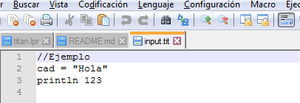
When executing our program, we will see that it shows us on the screen all the tokens that we have in our source file:
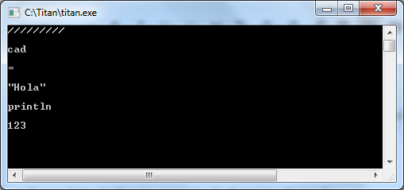
Each line of the exit represents a token and is the expected exit. A notable detail is that the token that represents the comment, the first one, is not accurate as to the content of the comment. This behavior does not affect us because comments are not expected to be processed. These are only useful for the writer, not for the compiler, so they will be discarded.
Note that line breaks are also considered as tokens, although without representation. The same goes for spaces. These do contain space characters but logically they are not visible in the terminal.
The other tokens are naturally extracted and have the expected appearance.
In the next part of this series we will see some complementary routines of the “lexer” and how we can use them to do a syntactic analysis and we will even start generating simple code.

PART 6 - SYNTACTIC ANALYSIS
February 9, 2019 Tito Hinostroza 2 comments
In the previous article we saw how to build a lexical analyzer (lexer) using simple Pascal instructions. In this part we will begin to implement the parser routines. But as always, a little theory before starting.

Lexer and Parser
As we have already seen, lexical analyzers allow us to extract tokens. A parser, however, extracts syntactic elements, from the source code.
What are syntactic elements?
You could say that they are the same tokens, but with a different interpretation. Consider an example. The word "my_variable" is considered by the "lexer" as a simple identifier (variable, constant, type, ...). For the "parser" however, it may be the name of a variable. That implies that the "parser" have a higher level of knowledge of the source code.
What do parsers do?
Lexical analyzers only generate tokens, and these tokens are used by the syntax analyzer to perform its work, which usually consists of filling one (or more than one) structure called “The syntax tree”, which is then used for code generation.
A parser can also use what is called "The table is symbols". This structure serves to facilitate the recognition of certain syntactic elements, of the source code. A C compiler, for example, necessarily requires a table of symbols. A Pascal compiler, however, can work without one.
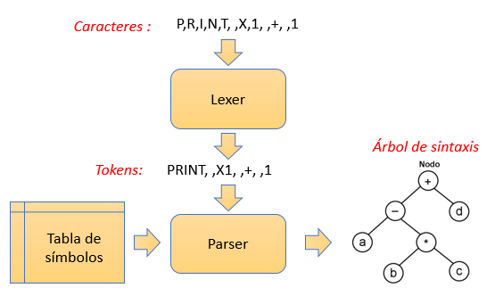
The parser is managed based on rules of a grammar known as "context-free grammar", unlike lexical analyzers that are handled in the field of regular grammars, using terminology of the hierarchy of Chomsky
There is extensive literature on the subject of grammars that should be read a little, before continuing with the issue of compilers.
Are the "lexers" of the "parsers" really different?
The lexical and syntactic analyzer are two different modules of a compiler with different functions, but many times these differences are not well separated.
There may be quite simple token languages, so that they do not require a parser.
There is a whole theory (actually, more than one) behind this issue, but there are always diverse and even contradictory opinions.
As we are not specialists in the subject, we just have to assume that they are different modules. Experience will then tell us what the differences are.
However, one of the methods that help us to detect the difference between a lexical analyzer and a syntactic analyzer is that: "Parsers" usually handle recursion, "lexers" do not. There will always be exceptions, according to the implementation, so this is just a guide.
Theoretical concepts may seem intimidating but it forms the basis of a good developer of compilers.

Support for errors
After some theory, we will now continue with the implementation of our compiler.
So far we only have a fairly simple lexical analyzer, but it fulfills its function of extracting. Our next step is to implement syntactic analysis routines, which would fall within the "parser" module.
The syntactic analysis, in our compiler, will be based on reviewing the rules of language syntax, therefore, there will be a high probability of finding errors, and these errors should be treated properly.
The behavior to process errors is very varied, but we can consider these two:
- The compiler stops the compilation and displays an error message.
- The compiler passes the error, displays the message, and tries to continue compiling until the end.
The first behavior is the easiest to implement, because we just have to get out of the current routine and finish the program. This is the method we will use in our Titan compiler, but it could be changed later.
The latter behavior is the most common for current compilers (and some of yesteryear) and has been widely used in C compilers. It can generate many error and presume messages that were implemented in this way because a compilation process, in the The first days of computing, it was a task that could take hours, and nobody wanted to recompile everything, to find the following error. Unfortunately, a compiler of this type (as every C / C ++ programmer knows), usually generates error messages that are dependent on the first error and are not really errors.
For our purposes we need a variable to store the possible error message that our compiler can generate.
MsjError: string;
This variable will serve at the same time as a flag, since, if it does not contain text, we will assume that no errors have been generated.

Some more routines
One of the routines that we will need, for the syntactic analysis is the following:
procedure TrimSpaces;
begin
while (srcToktyp = 1) or (srcToktyp = 5) do begin
NextToken; // Go to the next
end;
end;
The function of this routine is to take the space-type tokens, until you find a token that is not space. But comments (srcToktyp = 5) are also treated by this routine, as if they were spaces, that is, they are ignored.
This routine will be very useful because the language is insensitive to spacing (and comments) and in many parts of the program, we will extract tokens, bypassing the spaces.
Another important routine for syntactic analysis is as follows:
procedure GetLastToken;
begin
NextToken; // Take last token
TrimSpaces;
if srcToktyp = 0 then begin
// The current token is EOL
// We are already pointing to the other line
end else begin
MsjError: = 'Syntax error:' + srcToken;
exit;
end;
end;
We will use this routine for the extraction of a token, which we hope will be the last in a line, such as the comments since the comments are expected to always be the last token of a line, considering that we will not implement support for comments of multiple lines .
However, we will use this routine to simplify the syntactic analysis when we do not expect another token on the same line. This will simplify us code, although it is probably not the best way to proceed.
Observe the mechanism to generate errors in this routine: The message is set to “MsjError” and the routine is exited. Higher level routines will then check the status of “MsjError” after the call to each function that may generate an error.
This same mechanism, we will use it in all functions that can generate error.
Maybe someone can ask And how do you know the line number on which the error was generated?
The answer is simple. Remember that we have created a variable that always saves the line number we are exploring. This variable is "srcRow" and is updated in the NextLine () procedure.
The last routine we will need, in this step, is one that allows us to quickly extract a token that is equal to one character:
procedure CaptureChar (c: integer);
{take the character as a token. If you don't find it, it generates an error message.}
begin
TrimSpaces;
if srcToken <> chr (c) then begin
MsjError: = 'Expected:' + chr (c);
exit;
end;
NextToken; // take the character
end;
We will use this routine in some cases in which we expect the appearance of a specific character (which must be a token), and whose absence would imply a syntax error.

Variable support
One of the first tasks that we must perform in our compiler, outside the lexical and syntactic analysis is to create the structures that will store the variables declared in the Titan code.
This is already an advance, towards a functional compiler, because it will allow to implement support for the declaration of variables.
To store information about the variables we will need some structure that serves as a “table of variables”. That is, a table that stores important information about the variables that are declared. This is important because the variables, once declared, can appear later in the source code and it will be necessary to have information on those variables (such as their existence and type) to validate the syntactic and semantic rules.
As we are restricted to using simple data, and that implies that we cannot use records (struct) or objects, we are going to create different arrangements, each one destined to store a particular field:
// Information about variables
nVars: integer;
varNames: array [0..255] of string [255];
varType: array [0..255] of integer;
varArrSiz: array [0..255] of integer;
These three arrangements, in practice, will behave as if they were only one of a 3-field record.
The variable "nVars" will help us store the number of variables that we have declared, whether local or global. The limit for the number of variables in our humble compiler is limited to 256. This limitation is set, because for now we cannot handle dynamic structures in the implementation of Titan and 256 is a reasonable number for a small compiler like ours.
The varNames [] and varType [] arrays will store the name and type of the variable, respectively.
For the type of data, we will use the following standard:
1 -> integer
2 -> string
We do not need more because we will only handle two types.
The array varArrSiz [] will indicate the size of elements that the variable has. This will be useful when the variable is of the "fix" type, because this type needs to be implemented in the compiler. If the variable is of a simple type, its corresponding position in varArrSiz [] will be reset.
We will also need additional variables for the routines that will address the declaration of variables:
// Work variable
curVarName: string;
curVarType: integer;
curVarArSiz: integer;
// Fields for arrangements
idxStorag: integer;
idxCteInt: integer;
idxVarNam: string;
They will be declared as global variables to facilitate the passage of parameters between functions and to simplify our compiler, which as we know should have as simple a code as possible.
The usefulness of these variables, we will see in the following article, but for now we will only settle for your statement.
The complete source code has almost 400 lines and, for space, we will not include it here but it can be consulted here , where the complete codes of the last articles are.
At the moment our compiler does nothing new, but it is already prepared to support the declaration of variables, but before that we need to start implementing some basic code generator routines. That topic is precisely what we will see in the following article.

PART 7 - STARTING TO GENERATE CODE
February 26, 2019 Tito Hinostroza Leave a comment
In the previous article we began the implementation of the recognition of variables by adding the necessary variables and structures that will serve as the basis for the final objective of implementing the recognition of variables.
In this article, we will briefly review some important concepts of the assembler, which we will use in this first level that will be able to recognize the declaration of variables, and we will begin to generate true Intel assembly code, which is one of the novelties of this article.

Code Generation
In the design of a compiler, it is always necessary to include the module called Code Generator, which is logically responsible for generating the code that will be the final product of the compiler (object code, binary code, intermediate language, high level code , ...).
Code generation is a somewhat dark and complex issue. Compared to lexical and syntactic analysis, there is little documentation, standards, libraries and “frameworks”.
One of the reasons could be that, unlike a lexer or parser, the code generator (at least for compilers with native code) is very tied to the architecture of the machine for which it compiles, and therefore you can have designs Very different in each case.
The need to generate code for different architectures, often motivates the creation of an intermediate code, simpler, which can then be translated, with less effort, to different architectures. Do not confuse this process with compilers such as Java or .NET that compile an intermediate code as the final product. Compilers with native code may have intermediate representations, but this is only temporary, and disappears when the binary code / object is obtained.
There are currently "frameworks" such as LLVM that help in the creation of code generators, but they are complex systems and do not always adapt to the architecture we are going to handle.
The source of information (the food) for a code generator is usually the syntax tree or some similar structure.
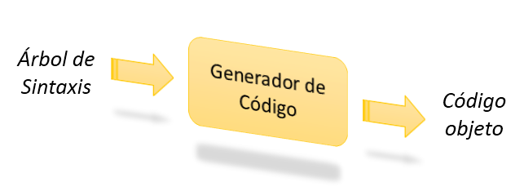
Our compiler, Titan, will implement code generation in a simpler way. It will be integrated in the same "parser", so that while we identify the corresponding syntactic elements, we will write assembly code in the output file.

Assembler Variables
In these articles, as we indicated at the beginning, we will not teach to program in assembler, but we will assume that the reader already has knowledge in this regard. Otherwise, there is enough information available on the network, to soak up the subject. Here we will only do a brief review:
We will begin by reviewing first, how the declaration of variables in 32-bit Intel x86 language is made.
The syntax in the declaration of variables in assembler (and in general all the assembly language) depends not only on the brand (Intel) and the destination architecture (32-bit x86), but will also depend on the assembler we are using.
In the world of Intel there are two currents of assemblers, already quite established:
- AT&T syntax: Use prefixes for registers and memory addresses, besides the destination operand always goes to the end: movl $ 1,% eax
- Intel syntax: Does not use prefixes for registers or memory and the destination operand always goes to the beginning: mov eax, 1
As for the declarations of variables, there are also differences between both syntaxes, but here we will focus on that of Intel, because we will be using the MASM32 assembler, which works precisely on the Intel syntax.
Continuing with our assembly review, the declaration of variables is done in the DATA section:
.DATA
num1 DB 5
num2 DW 5000
num3 DD 500000
arre1 DB 10 DUP (?)
This block of code defines variables of different sizes, such as memory locations in the data section of our assembly program. There are several instructions for declaring memory space:
DB Reserve 1 byte
DW Reserve 2 bytes
DD Reserve 4 bytes
DQ Reserve 8 bytes
DT Reserve 10 bytes
Thus, the instruction:
num1 DW 5000
Indicates that 2 bytes of data memory should be reserved, and that data should be initialized with the value 5000.
The DUP instruction indicates that multiple memory items must be reserved. For example, the instruction:
arre1 DB 10 DUP (?)
Indicates that 10 bytes of memory must be reserved and these bytes are not required to be initialized to any particular value. This notation will not be useful when we implement arrangements.

Generating assembler
Now that we know what the instructions we need to generate are, we will focus on giving our compiler the possibility of generating real assembly code.
This is simple because an assembly program is just a text file with the appropriate instructions.
We need to include instructions to the main program, to create a text file as a template to which we can add the instructions that we generate.
The template or general scheme of an assembly program that we will implement will be quite simple:
include \ masm32 \ include \ masm32rt.inc
.data

.code

end
The ".code" section is the one that will include executable code as opposed to the ".data" section that will only contain declarations. This fairly simple program can be assembled without errors, but the link will fail, because an entry point for the main program is expected. That is why our final template will be a bit different:
include \ masm32 \ include \ masm32rt.inc
.data
.code
start:

end start
That maintains the same idea of ​​simplicity. Of course the programs will be more complex than this simple template, which does nothing, but we must take a base from which to start.
To generate this template we must modify the main block of our compiler. A simple solution could be something like this:
begin
// Open input file
AssignFile (inFile, 'input.tit');
Reset (inFile);
// Open output file
AssignFile (outFile, 'input.asm');
Rewrite (outFile);
// Start flags
nVars: = 0; // Initial number of variables
srcRow: = 0;
// Write file header
WriteLn (outFile, 'include \ masm32 \ include \ masm32rt.inc');
WriteLn (outFile, '.data');
// Here we will process the variables
WriteLn (outFile, '.code');
WriteLn (outFile, 'start:');
MsjError: = '';
NextLine; // To do the first reading.
while EndOfFile <> 1 do begin
NextToken;
writeln (srcToken);
end;
WriteLn (outFile, 'exit');
WriteLn (outFile, 'end start');
CloseFile (outFile);
CloseFile (inFile);
ReadLn;
end.
This code will generate the template we are looking for (Review the file 'input.asm'). And although it is an empty code, it is actually the first code, in assembler, that our compiler generates.
But we must consider that our definition of language allows us to declare variables at any point, and not only at the beginning (The experienced reader will have quickly noticed the problem). So this poses an additional problem. Fortunately, the MASM32 allows many “.data” and “.code” sections. But we also don't want to create a “.data” block for each variable that we declare, but as far as possible they can be grouped into a single “.data” block.
To correct this detail, we must use a couple of additional flags:
InVarSec: integer;
FirstCode: integer;
The first will help us to know if in the token exploration process, we are in a “.data” section. This way we will know that we must open a “.code” section if we are going to generate executable ASM instructions.
The other flag will help us to know if it is the first time we are generating code. We need this to know where to include the “start:” entry of the main procedure of our generated ASM code.
Our main program code will then look like this:
begin
// Open input file
AssignFile (inFile, 'input.tit');
Reset (inFile);
// Open output file
AssignFile (outFile, 'input.asm');
Rewrite (outFile);
// Start flags
nVars: = 0; // Initial number of variables
srcRow: = 0; //Line number
FirstCode: = 1; // Start flag
// Write file header
WriteLn (outFile, 'include \ masm32 \ include \ masm32rt.inc');
WriteLn (outFile, '.data');
WriteLn (outFile, '_regstr DB 256 dup (0)');
InVarSec: = 1; // We are in the variables section
MsjError: = '';
NextLine; // To do the first reading.
while EndOfFile <> 1 do begin
NextToken;
writeln (srcToken);
if srcToktyp = 0 then begin
// Line break, nothing is done
end else if srcToktyp = 1 then begin
// Space, nothing is done
end else if srcToktyp = 5 then begin
ExtractComment; //Commentary
end else if srcToken = 'var' then begin
// It's a statement
if InVarSec = 0 then begin
// We are out of a block of variables
WriteLn (outFile, '.data');
InVarSec: = 1; // set flag
end;
// *** Here we process variables

end else begin
// It must be an instruction. Here you must start the code section
if InVarSec = 1 then begin
// We are inside a blqoue of variables
WriteLn (outFile, '.code');
InVarSec: = 0; // set flag
end;
if FirstCode = 1 then begin
// First instruction
WriteLn (outFile, '.code');
WriteLn (outFile, 'start:');
FirstCode: = 0; // Activate flag
end;
// **** Here we process instructions.

end;
end;
if MsjError <> '' then begin
WriteLn ('Line:', srcRow, ',', idxLine, ':', MsjError);
end;
// Finished token scanning
if FirstCode = 1 then begin
// No instructions found. We include code header in ASM.
WriteLn (outFile, '.code');
WriteLn (outFile, 'start:');
end;
WriteLn (outFile, 'exit');
WriteLn (outFile, 'end start');
CloseFile (outFile);
CloseFile (inFile);
WriteLn ('<<< Press <Enter> to continue >>>');
ReadLn;
end.
We see several new details in this new code. First is the mandatory declaration of a variable called "_regstr" in the data section. This variable will be used as a work record for strings. The concept of work registration will be seen later, but in broad strokes, it is the place where a value is stored to perform an operation on it.
Another new detail we see in this code is that an identification routine has been added, for the type of token, in the main loop. This routine uses the value stored in “srcToken” to determine the type of token.
Our token identification routine considers the following.
- If “srcToken” is 0, it is a line break.
- If “srcToken” is 1, it is a blank space.
- If “srcToken” is 5, it is a comment.
- If the token is "var", it is the declaration of a variable.
- If it is not one of the above, it is assumed that it is a common instruction.
This identification method is quite simple, but it will serve us well in this first stage of our software. Remember that the values ​​of "srcToken" were defined in a previous article .
Note that we have not yet implemented the routines for the treatment of declaration of variables or instructions, but we could write any program in “input.tit” and we will see that it generates an ASM code, empty but functional in “input.asm” .
The FirstCode flag is necessary to be able to know when the compiler is generating the first code, to include the “start:” block. It also serves at the end of the main loop to know when no instruction has been generated and to be able to give the ASM file the appropriate format.
If the way this code works is confusing, you might want to try to implement your own solution yourself, and you will probably come up with a scheme similar to this. However, raising alternative solutions is always a good way to learn.
As always, the full source code of this article is in my GitHub .
In the following article we will finally see how to implement variable processing.

PART 8 - VARIABLE DECLARATION
April 19, 2019 Tito Hinostroza Leave a comment
In the previous article we implemented a true assembler code generator, which although empty, will serve as the basis for implementing the following functions.
In this article we will implement the routines that will allow the basic declaration of variables, in our Titan language. These routines will work by detecting the variable declaration blocks in order to directly generate the corresponding assembly instructions.
Seeing it like this, implementing the declaration of variables in our compiler will consist in translating the declaration of variables in the Titan language into the ASM language.
This form of code generation is somewhat different from how most compilers work, but it will work quite well for our compiler.
In a common compiler, the recognition of variables is also a complex process, since the variables can be of types and be at the same time, composition of other variables, such as arrays and registers. In addition, it should be considered that the variables can have different scopes (local, global or restricted) and also different storage (static, dynamic, stack, ...).
In our implementation, however, we will only work with two simple types and their corresponding arrangements. Despite this, the necessary code is considerable.

A simple code
We will start by adding a routine that processes the declaration of variables in our compiler. A simple version of this routine could be:
procedure ParserVar;
{Does the parsing for the declaration of variables.}
var
varName, typName: String;
begin
NextToken; // Take the "var"
TrimSpaces; // Remove spaces
if srcToktyp <> 2 then begin
MsjError: = 'An identifier was expected.';
exit;
end;
varName: = srcToken;
NextToken; // Take variable name
TrimSpaces;
//Expected ":"
CaptureChar (ord (':'));
if MsjError <> '' then exit;
// Read type
TrimSpaces;
typName: = srcToken;
if typName = 'integer' then begin
GetLastToken; // You must finish the line
if MsjError <> '' then exit;
WriteLn (outFile, '' + varName + 'DD 0');
// Register variable
varNames [nVars]: = varName;
varType [nVars]: = 1; // Integer
varArrSiz [nVars]: = 0; // It is not fix
inc (nVars);
end else if typName = 'string' then begin
// You must finish the line
GetLastToken; // You must finish the line
if MsjError <> '' then exit;
WriteLn (outFile, '' + varName + 'DB 256 dup (0)');
// Register variable
varNames [nVars]: = varName;
varType [nVars]: = 2; // String
varArrSiz [nVars]: = 0; // It is not fix
inc (nVars);
end else begin
MsjError: = 'Unknown type:' + typName;
exit;
end;
end;
This routine should be called when it has been detected that the current token is "var". The work, which comes later, is to extract the tokens according to the syntax we have defined for our Titan language:
var <variable name>: <type>
This routine is a simplified version that does not consider the case of fixes and has little error protection.
To activate, in our compiler, the recognition of declarations, we need to modify our main program, so that it passes the processing of variables, to our newly created routine:
end else if srcToken = 'var' then begin
// It's a statement
if InVarSec = 0 then begin
// We are out of a block of variables
WriteLn (outFile, '.data');
InVarSec: = 1; // set flag
end;
// *** Here we process variables
ParserVar;
end else begin
This construction is logical, because we know that in our language, the declaration of variables is made with the reserved word "var". The explanation of this structure was made in the previous article.
Note that in the ParserVar () code used to analyze the source code lexicon, the sequence of instructions has the form:
cad: = srcToken // Do something with "srcToken"
NextToken; // Take variable name
TrimSpaces; // Skip the spaces that could have
Recurring calls to "TrimSpaces" are necessary because our language has been defined so that it is indifferent to spaces. If it were not included, we would have to put all the tokens together in the source code.
It is highly recommended, and instructive, to experiment with the code to see the errors that are generated or try to implement different syntaxes than the one defined for our language.
The ParserVar () procedure is reduced because it only analyzes the declaration of simple variables and because there are only two types of data in our language.
At this level we can experiment by compiling a simple declaration of variables such as:
var a: integer
When compiling this code, we will obtain in our ASM output file, the declaration of variables in the MASM32 syntax. We use Notepad ++ to display the content of the source and output file:
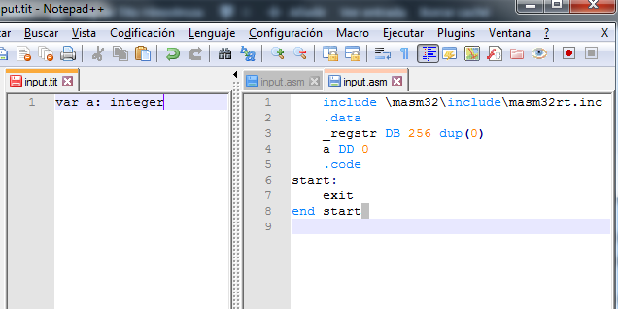
The assembly instruction that corresponds to the declaration of the variable a is “a DD 0”. 4 bytes are reserved because we have defined that the whole variables are 4 bytes in length. If a declaration of a string is used, we will see that it reserves 256 bytes of memory.
If you get errors in the source code, review the implementation of ParserVar ().
The generated assembly code is syntactically valid but will not execute anything and will only reserve memory space for our variable. In the following articles, when we generate true assembler instructions, we will use these statements

Improving the code
So far, the declaration of variables works quite well, but only refers to variables of simple type. To support the declaration of arrangements we need to extend this code with the processing of the characters "[" and "]". The definition of RAM space is simple, because it is only enough to multiply the size of the data type by the size of the array.
The following code is already more complete and also supports the declaration of arrangements of the two basic types of data that we handle in Titan:
procedure ParserVar;
{Does the parsing for the declaration of variables.}
var
varName, typName: String;
arrSize: integer;
begin
NextToken; // Take the "var"
TrimSpaces; // Remove spaces
if srcToktyp <> 2 then begin
MsjError: = 'An identifier was expected.';
exit;
end;
varName: = srcToken;
NextToken; // Take variable name
TrimSpaces;
// Read type
if srcToken = '[' then begin
// It is an arrangement of some kind
NextToken; // Take the token
TrimSpaces;
if srcToktyp <> 3 then begin
MsjError: = 'Expected number.';
end;
arrSize: = StrToInt (srcToken); // Fix size
NextToken;
CaptureChar (ord (']'));
if MsjError <> '' then exit;
//Expected ":"
CaptureChar (ord (':'));
if MsjError <> '' then exit;
// Must follow common type
NextToken;
typName: = srcToken;
if typName = 'integer' then begin
GetLastToken; // You must finish the line
if MsjError <> '' then exit;
WriteLn (outFile, '' + varName + 'DD', arrSize, 'dup (0)');
// Register variable
varNames [nVars]: = varName;
varType [nVars]: = 1; // Integer
varArrSiz [nVars]: = arrSize; // It's fix
inc (nVars);
end else if typName = 'string' then begin
// You must finish the line
GetLastToken; // You must finish the line
if MsjError <> '' then exit;
WriteLn (outFile, '' + varName + 'DB', 256 * arrSize, 'dup (0)');
// Register variable
varNames [nVars]: = varName;
varType [nVars]: = 2; // String
varArrSiz [nVars]: = arrSize; // It's fix
inc (nVars);
end else begin
MsjError: = 'Unknown type:' + typName;
exit;
end;
end else if srcToken = ':' then begin // It's common type declaration
NextToken; //Taking ":"
TrimSpaces;
typName: = srcToken;
if typName = 'integer' then begin
GetLastToken; // You must finish the line
if MsjError <> '' then exit;
WriteLn (outFile, '' + varName + 'DD 0');
// Register variable
varNames [nVars]: = varName;
varType [nVars]: = 1; // Integer
varArrSiz [nVars]: = 0; // It is not fix
inc (nVars);
end else if typName = 'string' then begin
// You must finish the line
GetLastToken; // You must finish the line
if MsjError <> '' then exit;
WriteLn (outFile, '' + varName + 'DB 256 dup (0)');
// Register variable
varNames [nVars]: = varName;
varType [nVars]: = 2; // String
varArrSiz [nVars]: = 0; // It is not fix
inc (nVars);
end else begin
MsjError: = 'Unknown type:' + typName;
exit;
end;
end else begin
MsjError: = 'Expected ":" or "[".';
exit;
end;
end;
This routine is a bit extensive, but the code is not very complex, just consider an extension to consider the declarations of variables in array mode like: var x [10]: integer
If we compile this statement, we will get the assembly code shown in the following figure:
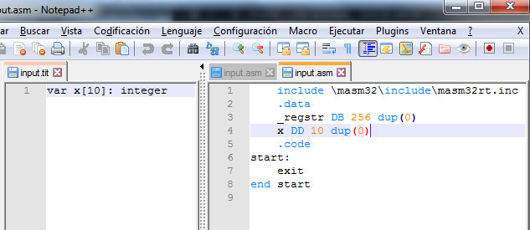
The generated assembly instruction, in this case, is “x DD 10 dup (0)” that corresponds to a 4-byte data array, initialized to zero.
Additional declarations of variables can be included and these will be recognized correctly.
A detail, which should be analyzed in ParserVar (), is the method used to detect and process errors. The method is basic but effective. In short, it consists in analyzing the possible options and if an unexpected condition is obtained, the compilation is stopped and an error message is created.
In this article, we have managed to recognize the declarations of variables in our language, but true executable instructions have not yet been generated.
In the next part we will begin to recognize expressions and generate true executable code, in assembler.

PART 9 - ANALYZING EXPRESSIONS
May 27, 2019 Tito Hinostroza Leave a comment
In the previous chapter we saw how to implement the recognition of the variables of our compiler, using the syntax of our Titan language.
In this article, we will see how we can implement a simple expression analyzer and thus be able to move forward with the implementation. But for that, we need to first handle some important concepts.

The expressions
We understand as expressions the set of operands and operators, as in the following example:
1 + 2
In this example, the numbers 1 and 2 constitute the operands, while the “+” symbol is the operator.
Expressions can be more complex than a simple sum:
x + y * (1 + abs (j))
Expressions are probably the most abundant elements in most programming languages.
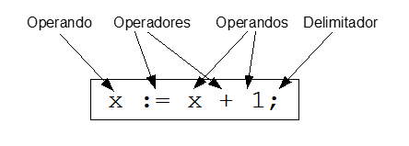

Notation of expressions
Expressions, and two notations are used to express them:
- Notation Infix: 1 + 2 * 3
- Notation Prefix: * 2 3 + 1
- Postfix notation: 2 3 * 1 +
The most common expressions are those of the Infix type, because they resemble the way in which the expressions taught to us in school are expressed.
The other forms are rare and are used in some types of calculators (such as some HP models) or languages ​​(such as Forth).
In our compiler we will treat the expressions in Infix notation.

Operators
The operators, together with the operands, make up the expressions. Operators determine the operations that must be performed within an expression.
If we analyze the operators in the expressions in Infix, as in the following example:
a + b + c * d
And we try to solve it, we would start by evaluating a + b first, then we will evaluate that result with c, and finally that result with d.
In this process, we can note that operators always apply to two operands.
We will call this type of operators binary operators. Most operators fall into this category, such as addition (+), subtraction (-) or multiplication (*).
But there are also operators that apply to a single operand, such as the C increase operator (++) or the decrease operator (-). These types of operators are called Unary Operators.

Operator Precedence
Expressions are always evaluated by applying the operation, which defines the operator, on the operands, and then using the result as a new operator to apply the next operator, if it exists.
In a simple expression that only uses only one type of operator, the evaluation is usually done in the way the expression is read, from left to right. So if the expression is:
a + b + c + d
The order of evaluation will be:
((a + b) + c) + d
However, some operators may be given higher priority over others to force them to be evaluated earlier. This priority is called "Precedence" and determines the order of evaluation of the expressions. As an example, consider the case in which we assign greater precedence to the multiplication operator (*) than to the sum (+) operator, then the expression:
a + b * c
It should be evaluated as:
a + (b * c)
Operator precedence is well defined in programming languages, although each language can define a different precedence scheme.

Evaluation of expressions in Titan
Expressions will be evaluated, within our compiler by a recursive routines that consider the precedence of operators. But these routines have a somewhat high level of complexity, so we will start with a simple routine that allows you to evaluate simple expressions of one or two operands and a single operator, which can only be + or -.
The process, in short, can be described more or less like this:
- Read Operating1
- If it is an end of expression, exit.
- Read operator
- Read Operating 2
We will call this routine EvaluateExpression () and later we will complete it with new features:
procedure EvaluateExpression;
{Evaluate the current expression and update resStorag, resVarNam, resCteInt, resCteStr.
You can generate code if necessary.}
begin
// Take first operand
GetOperand1;
if MsjError <> '' then exit;
// Save operand data
// Check if there are operands, or the expression ends here
TrimSpaces;
// Capture first operand, assuming it is the only one
if srcToktyp = 0 then exit; // Finished the line and the expression
if srcToken = ')' then exit; // Finished the expression
if srcToken = ']' then exit; // Finished the expression
// There are more tokens
// Extract operator
if srcToken = '+' then begin
NextToken; // take token
GetOperand2;
if MsjError <> '' then exit;
OperAdd; // You can exit with error
end else if srcToken = '-' then begin
NextToken; // take token
GetOperand2;
if MsjError <> '' then exit;
OperSub; // You can exit with error
end else begin
MsjError: = 'Syntax error:' + srcToken;
exit;
end;
end;
The operands are read using the GetOperand1 () and GetOperand2 () routines, which leave the attributes of the operands in the corresponding variables:
procedure GetOperand1;
begin
GetOperand;
op1Type: = resType;
op1Storag: = resStorag;
op1VarNam: = resVarNam;
op1CteInt: = resCteInt;
op1CteStr: = resCteStr;
end;
procedure GetOperand2;
begin
GetOperand;
op2Type: = resType;
op2Storag: = resStorag;
op2VarNam: = resVarNam;
op2CteInt: = resCteInt;
op2CteStr: = resCteStr;
end;
These routines are actually, wrappers of the true routine (GetOperand) that reads the operands and does the hard work of identification and categorization:
procedure GetOperand;
{Extract an operand. Update "resXXX" variables.}
var
n: integer;
begin
TrimSpaces;
// Capture first operand, assuming it is the only one
if srcToktyp = 3 then begin // Literal Number
n: = StrToInt (srcToken); // Error verification is missing
resStorag: = 0; //Constant
resType: = 1; // Integer
resCteInt: = n; //Value
NextToken;
end else if srcToktyp = 4 then begin // Literal String
resStorag: = 0; //Constant
resType: = 2; // Integer
resCteStr: = copy (srcToken, 2, length (srcToken) -2); //Value
NextToken;
end else if srcToktyp = 2 then begin // Identifier
// Is identifier

end else begin
MsjError: = 'Syntax error:' + srcToken;
exit;
end;
end;
This routine is incomplete because it does not consider the case of identifiers, but only evaluates constant or literal operands, but its simplicity helps us to better understand its operation.
The identification of the operand is by means of the variable “srcToktyp”, by means of a routine comparison.
In the following article we will expand the GetOperand () code to consider the case of the variables.
There are a couple more routines we need for EvaluateExpression () and they are probably the biggest we have written for now. These routines are OperAdd () and OperSub () and are the routines that will generate the code that finally implements the operations that are performed when evaluating the expressions:
procedure OperAdd;
{Perform the "+" operation on the "op1XXX" and "op2XXX" operands. Returns result in
resXXX "}
begin
if op1Type <> op2Type then begin
MsjError: = 'You cannot add these types';
exit;
end;
// They are the same type
if op1Type = 1 then begin
// ********* Sum of integers **************
resType: = 1; //
if op1Storag = 0 then begin
if op2Storag = 0 then begin
// --- Constant + Constant ---
resStorag: = op1Storag;
resCteInt: = op1CteInt + op2CteInt;
end else if op2Storag = 1 then begin
// --- Constant + Variable
resStorag: = 2; //Expression
writeln (outFile, 'mov eax,' + op2VarNam);
writeln (outFile, 'add eax,', op1CteInt);
end else if op2Storag = 2 then begin
// --- Constant + Expression
resStorag: = 2; //Expression
writeln (outFile, 'add eax,', op1CteInt);
end else begin
MsjError: = 'Operation not implemented';
exit;
end;
end else if op1Storag = 1 then begin
if op2Storag = 0 then begin
// --- Variable + Constant ---
resStorag: = 2; //Expression
writeln (outFile, 'mov eax,' + op1VarNam);
writeln (outFile, 'add eax,', op2CteInt);
end else if op2Storag = 1 then begin
// --- Variable + Variable
resStorag: = 2; //Expression
writeln (outFile, 'mov eax,' + op1VarNam);
writeln (outFile, 'add eax,', op2VarNam);
end else if op2Storag = 2 then begin
// --- Variable + Expression
resStorag: = 2; //Expression
writeln (outFile, 'mov ebx,' + op1VarNam);
writeln (outFile, 'add eax, ebx');
end else begin
MsjError: = 'Operation not implemented';
exit;
end;
end else if op1Storag = 2 then begin
if op2Storag = 0 then begin
// --- Expression + Constant ---
resStorag: = 2; //Expression
writeln (outFile, 'add eax,', op2CteInt);
end else if op2Storag = 1 then begin
// --- Expression + Variable
resStorag: = 2; //Expression
writeln (outFile, 'add eax,', op2VarNam);
end else if op2Storag = 2 then begin
// --- Expression + Expression
resStorag: = 2; //Expression
writeln (outFile, 'pop ebx');
writeln (outFile, 'add eax, ebx');
end else begin
MsjError: = 'Operation not implemented';
exit;
end;
end else begin
MsjError: = 'Operation not implemented';
exit;
end;
end else if op1Type = 2 then begin
// ********* Sum of chains **************
resType: = 2; //
if op1Storag = 0 then begin
if op2Storag = 0 then begin
// --- Constant + Constant ---
resStorag: = op1Storag;
resCteStr: = op1CteStr + op2CteStr;
end else if op2Storag = 1 then begin
// --- Constant + Variable
resStorag: = 2; //Expression
DeclareConstantString (op1CteStr);
WriteLn (outFile, 'invoke szCopy, addr' + constr + ', addr _regstr');
writeln (outFile, 'invoke szCopy, addr' + op2VarNam + ', addr _regstr +', length (resCteStr));
// end else if op2Storag = 2 then begin
// // --- Constant + Expression
// resStorag: = 2; //Expression
// writeln (outFile, 'add eax,', op1CteInt);
end else begin
MsjError: = 'Operation not implemented';
exit;
end;
end else if op1Storag = 1 then begin
if op2Storag = 0 then begin
// --- Variable + Constant ---
resStorag: = 2; //Expression
WriteLn (outFile, 'invoke szCopy, addr' + op1VarNam + ', addr _regstr');
DeclareConstantString (op2CteStr);
writeln (outFile, 'invoke szCatStr, addr _regstr, addr' + constr);
end else if op2Storag = 1 then begin
// --- Variable + Variable
resStorag: = 2; //Expression
WriteLn (outFile, 'invoke szCopy, addr' + op1VarNam + ', addr _regstr');
writeln (outFile, 'invoke szCatStr, addr _regstr, addr' + op2VarNam);
end else if op2Storag = 2 then begin
// --- Variable + Expression
resStorag: = 2; //Expression
WriteLn (outFile, 'invoke szCopy, addr' + op1VarNam + ', addr _regstr');
writeln (outFile, 'invoke szCatStr, addr _regstr, addr' + op2VarNam);
end else begin
MsjError: = 'Operation not implemented';
exit;
end;
// end else if op1Storag = 2 then begin
// if op2Storag = 0 then begin
// // --- Expression + Constant ---
// resStorag: = 2; //Expression
// writeln (outFile, 'add eax,', op2CteInt);
// end else if op2Storag = 1 then begin
// // --- Expression + Variable
// resStorag: = 2; //Expression
// writeln (outFile, 'add eax,', op2VarNam);
// end else if op2Storag = 2 then begin
// // --- Expression + Expression
// resStorag: = 2; //Expression
// writeln (outFile, 'pop ebx');
// writeln (outFile, 'add eax, ebx');
// end else begin
// MsjError: = 'Operation not implemented';
// exit;
// end;
end else begin
MsjError: = 'Operation not implemented';
exit;
end;
end;
end;
procedure OperSub;
{Perform the "-" operation on the "op1XXX" and "op2XXX" operands. Returns result in
"resXXX"}
begin
if op1Type <> op2Type then begin
MsjError: = 'You cannot subtract these types';
exit;
end;
// They are the same type
if op1Type = 1 then begin
// ********* Subtraction of integers **************
resType: = 1; //
if op1Storag = 0 then begin
// Constant + something
if op2Storag = 0 then begin
// --- Constant - Constant ---
resStorag: = op1Storag;
resCteInt: = op1CteInt - op2CteInt;
end else if op2Storag = 1 then begin
// --- Constant - Variable
resStorag: = 2; //Expression
writeln (outFile, 'mov eax,', op1CteInt);
writeln (outFile, 'sub eax,', op2VarNam);
end else if op2Storag = 2 then begin
// --- Constant - Expression
resStorag: = 2; //Expression
writeln (outFile, 'mov ebx,', op1CteInt);
writeln (outFile, 'sub eax, ebx');
end else begin
MsjError: = 'Operation not implemented';
exit;
end;
end else if op1Storag = 1 then begin
// Variable + something
if op2Storag = 0 then begin
// --- Variable - Constant ---
resStorag: = 2; //Expression
writeln (outFile, 'mov eax,' + op1VarNam);
writeln (outFile, 'sub eax,', op2CteInt);
end else if op2Storag = 1 then begin
// --- Variable - Variable
resStorag: = 2; //Expression
writeln (outFile, 'mov eax,' + op1VarNam);
writeln (outFile, 'sub eax,', op2VarNam);
end else if op2Storag = 2 then begin
// --- Variable - Expression
resStorag: = 2; //Expression
writeln (outFile, 'mov ebx,' + op1VarNam);
writeln (outFile, 'sub ebx, eax');
writeln (outFile, 'mov eax, ebx');
end else begin
MsjError: = 'Operation not implemented';
exit;
end;
end else if op1Storag = 2 then begin
// Expression less something
if op2Storag = 0 then begin
// --- Expression - Constant ---
resStorag: = 2; //Expression
writeln (outFile, 'sub eax,', op2CteInt);
end else if op2Storag = 1 then begin
// --- Expression - Variable
resStorag: = 2; //Expression
writeln (outFile, 'sub eax,', op2VarNam);
end else if op2Storag = 2 then begin
// --- Expression - Expression
resStorag: = 2; //Expression
writeln (outFile, 'pop ebx');
writeln (outFile, 'sub ebx, eax');
writeln (outFile, 'mov eax, ebx');
end else begin
MsjError: = 'Operation not implemented';
exit;
end;
end else begin
MsjError: = 'Operation not implemented';
exit;
end;
end;
end;
These routines still need to be completed but the work scheme can be understood. The idea is to generate the code for each expression consisting of an operator and two operands and with a different combination of "op1Storag" and "op2Storag" (the storage).
The teaching here is how to generate assembly code to process the operations (parts of the expressions) that are requested.
Although the expressions are complex sets of operands and operators, the idea is that they can always be simplified as simple sub-expressions of two operands and a binary operator. In the case of expressions with unary operators, we will not see it in this project because it is not necessary to build the compiler.
In the end we will see that the generation of code, almost completely, consists in implementing all the possible elementary operations of the expressions. For now our operations are the most elementary, but later we will complete them with additional ones.
A routine that is used in previous operations is: DeclareConstantString ():
procedure DeclareConstantString (constStr: string);
{Insert the declaration of a string constant, in the data section, to
to be able to work it.}
var
tmp: String;
begin
tmp: = IntToStr (nconstr);
constr: = '_ctestr' + tmp; // constant name
WriteLn (outFile, '.data');
WriteLn (outFile, '' + constr + 'db "' + constStr + '", 0');
WriteLn (outFile, '.code');
inc (nconstr);
end;
His work is simple and is described in the commentary of the code.
New global variables have had to be added in the code, to support the various routines analyzed here.

Summary
Although we still cannot compile executable code, in this article, we have taken a considerable step in implementing what corresponds to the expression analyzer of our compiler. Expression analyzers, in compilers, are quite extensive programs of considerable complexity. However, in our compiler, we have been able to write simple code, due to the restrictions we have imposed on our language and the design of the compiler.
As always, the complete project of this article can be seen at https://github.com/t-edson/CreaTuCompilator , as well as that of previous articles.
In the next installment we will use our prototype expression analyzer to implement the assignments and we will see true executable code generated.

PART 10 - THE FIRST INSTRUCTIONS
September 23, 2019 Tito Hinostroza Leave a comment
In the previous chapter we saw how to implement a simple expression analyzer for our compiler. But we didn't get to use it, because we can't still process instructions. And although some elementary expressions, such as 1 + 1, can be compiled, these expressions themselves do not constitute valid instructions in our programming language.
In this delivery we will see how to implement the processing of one of the most basic instructions such as the assignment of values ​​to variables. An example of this instruction would be:
x = 1
Before we begin with the implementation of the assignments, let's review the definition of storage.

Operator Storage
This is another of the concepts that we will handle in our compiler.
Storage determines the way an operand is saved and can have many types. For example, it may be that the operand is a constant and does not use RAM space, or it may be that the operand is in RAM in a static area or in the stack, etc.
Storage (as well as the type of an operand) is important because it provides the information the compiler needs in order to generate the appropriate instructions for the requested operations.
Although the storage can be very diverse, in our compiler, we will only consider 4 cases:
// 0 -> Constant
// 1 -> Variable
// 2 -> Expression
// 1000 -> Without storage
A type 0 storage refers to a numeric or string literal, such as:
123
"Cheers".
This storage is one of the most basic and also the most desirable, because they do not take up memory space in the program, and are only loaded into the program when required.
Type 1 storage indicates that the operand is in some area of ​​memory and will be located by its address. It is the preferred storage to handle simple variables. This storage is also easy to use because to access the value of the operand, just refer to an area of ​​memory where the variable resides.
The following operands belong to this type of storage:
numeric_variable
string variable
x
Type 2 storage indicates that the value of the operand must be stored somewhere else, since it is not a constant or a variable. Compilers implement various methods to work with expressions, but in our case, we will store the expressions in work records.
For numerical expressions, we will use the EAX register.
For string expressions we will use a RAM zone, reserved by the compiler, called "_regstr" which is a 256-byte zone.
In summary, according to their storage, operands have their value in
Type of operand Location of its value
------------------ --------------------
Constant Does not exist until compiled
Variable Fixed RAM address
Expression Registration of the CPU or RAM.

Compiling an expression
The compilation of an expression consists of converting the expression into a sequence of assembly instructions.
Consider that we want to compile the following expression:
10 + x
Of these two operands, only the second one exists previously stored (it is assumed that somewhere in the RAM). The first operand is a constant (storage 0) and did not exist until the moment this routine is compiled. In other words, operand "10" has not been occupying in memory.
If we generate assembly code for this simple operation, we would have something like:
mov eax, x; Load operating with “Variable” storage.
add eax, 10; Add to operating with “Constant” storage.
Which consists of loading the value of the variable "x" into the EAX register, and then adding the value 10 to the EAX register.
The result (from Expression storage) is in the EAX register, which is like the record for returning results. It is common, in compilers, to use multiple records to return expression results. These results can then be saved in another variable or used to calculate new expressions.
For the compilation of expressions, we will use simple routines of two operands and one operator. The more complex expressions will break down into simple expressions.

Titan assignments
Assignments are probably the most used instructions within a programming language. They serve primarily to initialize variables, to modify the content of a variable or to save the result of expressions.
Many languages, such as C or C ++, consider assignments as simple expressions that make use of the assignment operator (=) and can also return values. Hence, codes such as:
x = (y = 1);
However, other languages, such as Pascal, consider assignments as special instructions, which do not return values. In other words, they are not handled as expressions.
In our Titan language, we will consider expressions as special instructions so they will not be part of an expression as such. This will help simplify the analysis of expressions.
The assignments are of the form:
a = b
For the recognition of this type of "expressions", we first need a routine to recognize the variables. This routine will only explore the varNames [] array for the name of the searched variable:
procedure FindVariable;
{Find the variable with the name that is in "srcToken", and update the variables:
"curVarName", "curVarType", and "curVarArSiz".
If it is not found, it returns empty string in "curVarName".}
var
tmp: string;
continue: integer;
curVar: integer;
begin
curVar: = 0;
tmp: = varNames [curVar];
contin: = ord (tmp <> srcToken);
while contin = 1 do begin
inc (curVar);
if curVar = 256 then break;
tmp: = varNames [curVar];
contin: = ord (tmp <> srcToken);
end;
// Check if you found
if contin = 0 then begin
curVarName: = varNames [curVar];
curVarType: = varType [curVar];
curVarArSiz: = varArrSiz [curVar];
exit; // "curVar" contains the index
end;
// Did not find
curVarName: = '';
end;
FindVariable () returns a null string in "curVarName" when it does not find the searched variable.
Now that we have how to identify a variable, we have to implement the procedure to perform the assignment itself. This procedure, somewhat extensive, consists in extracting the tokens of an expression, which must have the form:
<variable> = <variable or constant>
Considering also that the variable to be assigned can also be an arrangement:
<variable> [index] = <variable or constant>
On the other hand, we will only consider for now the case of constants or variables, as elements that can be assigned.
The code in question is:
procedure ProcessAssigment;
begin
NextToken;
TrimSpaces;
if srcToken = '[' then begin
ReadArrayIndex; // Update idxStorag, idxCteInt, and idxVarNam.
// Valid if the variable is array
if curVarArSiz = 0 then begin
MsjError: = 'This variable is not an array.';
exit;
end;
end else begin
idxStorag: = 1000; // No storage
end;
TrimSpaces;
if srcToken <> '=' then begin
MsjError: = 'Expected "=".';
exit;
end;
NextToken; // Take "="
// Evaluate expression
EvaluateExpression;
if MsjError <> '' then begin
exit;
end;
// Encode the assignment
if resType = 1 then begin
// Integer
if asgVarType <> 1 then begin
MsjError: = 'An integer cannot be assigned to this variable.';
exit;
end;
if resStorag = 0 then begin
//Constant
if idxStorag = 1000 then begin // No fix
WriteLn (outFile, 'mov DWORD PTR', asgVarName, ',', resCteInt); //
end else if idxStorag = 0 then begin // Indexed by constant
WriteLn (outFile, 'mov DWORD PTR [', asgVarName, '+', idxCteInt * 4, '],', resCteInt);
end else begin
MsjError: = 'This type of expression is not supported.';
exit;
end;
end else if resStorag = 1 then begin
//Variable
if idxStorag = 1000 then begin // No fix
WriteLn (outFile, 'mov eax,', resVarNam);
WriteLn (outFile, 'mov' + asgVarName + ', eax');
end else begin
MsjError: = 'This type of expression is not supported.';
exit;
end;
end else begin
//Expression. Is already in EAX
if idxStorag = 1000 then begin // No fix
WriteLn (outFile, 'mov' + asgVarName + ', eax');
end else begin
MsjError: = 'This type of expression is not supported.';
exit;
end;
end;
end else begin
// String
if asgVarType <> 2 then begin
MsjError: = 'You cannot assign a string to this variable.';
end;
if resStorag = 0 then begin
// <variable> <- Constant
if idxStorag = 1000 then begin // No fix
DeclareConstantString (resCteStr);
WriteLn (outFile, 'invoke szCopy, addr' + constr + ', addr' + asgVarName);
end else if idxStorag = 0 then begin // Indexed by constant
DeclareConstantString (resCteStr);
WriteLn (outFile, 'invoke szCopy, addr' + constr + ', addr', asgVarName, '+',
idxCteInt * 256);
end else begin
MsjError: = 'This type of expression is not supported.';
exit;
end;
end else if resStorag = 1 then begin
// <variable> <- Variable
WriteLn (outFile, 'invoke szCopy, addr' + resVarNam + ', addr' + asgVarName);
end else begin
//Expression. It's already in "_regstr"
WriteLn (outFile, 'invoke szCopy, addr _regstr' + ', addr' + asgVarName);
end;
end;
end;
This routine includes assembly code generation to perform the assignment. The assignment of numbers is easy because it is done with simple MOV transfer instructions, but the assignment of strings is implemented by calling the macro szCopy, which provides us with MASM32, and that allows moving bytes from one address to another.
As the assignment considers the case of the assignment of fixes, the idxStorag flag is used, which is updated with the ReadArrayIndex () procedure:
procedure ReadArrayIndex;
{Read the index of an arrangement. That is, what goes in square brackets: [].
Returns information in the variables: idxStorag, idxCteInt, and idxVarNam.
It does not generate code and does not use any additional records, because it restricts that the
Index is a constant or a simple variable.
It is assumed that the current token is '['.
If you find an error, return the message in "MsjError"}
begin
// It's access to fix
NextToken; //Taking '['
EvaluateExpression;
if MsjError <> '' then exit;
if resStorag = 2 then begin
{The use of expressions here is restricted, for simplicity, so as not to complicate the
code generation So we will only have constants or variables as an index.}
MsjError: = 'Expressions are not allowed here.';
exit;
end;
if resStorag = 1 then begin
//It is variable. It can only be whole.
if resType <> 1 then begin
MsjError: = 'Expected whole varaible.';
exit;
end;
end;
CaptureChar (ord (']'));
if MsjError <> '' then exit;
// Yes, it is an arrangement. Save information about the index.
// It can only be integer or integer variable.
idxStorag: = resStorag; // Save index storage.
idxCteInt: = resCteInt; // Integer value
idxVarNam: = resVarNam; // Name of varaible
end;
This routine will allow us to read the index of an array, that is, what goes between the square brackets []. And it returns additional information in some global variables. One of them, idxStorag, tells us if the index is a constant or a variable.
Now that we have a routine to find FindVariable () variables, we can now complete our GetOperand () routine, which was incomplete in the previous article:
procedure GetOperand;
{Extract an operand. Update "resXXX" variables.}
var
n: integer;
begin
TrimSpaces;
// Capture first operand, assuming it is the only one
if srcToktyp = 3 then begin // Literal Number
n: = StrToInt (srcToken); // Error verification is missing
resStorag: = 0; //Constant
resType: = 1; // Integer
resCteInt: = n; //Value
NextToken;
end else if srcToktyp = 4 then begin // Literal String
resStorag: = 0; //Constant
resType: = 2; // Integer
resCteStr: = copy (srcToken, 2, length (srcToken) -2); //Value
NextToken;
end else if srcToktyp = 2 then begin // Identifier
// Verify system function
if srcToken = 'length' then begin
NextToken;
CaptureChar (ord ('('));
if MsjError <> '' then exit;
EvaluateExpression; // recursive call
if MsjError <> '' then exit;
CaptureChar (ord (')'));
if MsjError <> '' then exit;
if resType <> 2 then begin
MsjError: = 'A string was expected.';
exit;
end;
if resStorag = 0 then begin
// Constant string
resType: = 1; // Returns numerical constant
resCteInt: = length (resCteStr);
end else if resStorag = 1 then begin
// string variable
WriteLn (outFile, 'invoke szLen, addr' + resVarNam);
resType: = 1; // Return number in EAX
resStorag: = 2; //Expression
end else if resStorag = 2 then begin
// string expression
WriteLn (outFile, 'invoke szLen, addr _regstr');
resType: = 1; // Return number in EAX
resStorag: = 2; //Expression
end else begin
MsjError: = 'Storage not supported';
exit;
end;
end else begin
// Search variable
FindVariable;
if curVarName = '' then begin
MsjError: = 'Unknown identifier:' + srcToken;
exit;
end;
// It is a variable. It could be an arrangement.
NextToken;
TrimSpaces;
if srcToken = '[' then begin
// It's access to fix
ReadArrayIndex; // Update idxStorag, idxCteInt, and idxVarNam.
// Valid if the variable is array
if curVarArSiz = 0 then begin
MsjError: = 'This variable is not an array.';
exit;
end;
// We extract value and return as expression
resStorag: = 2; //Expression
resType: = curVarType; // Returns the same type as the variable.
if resType = 1 then begin
// Arrangement of integers
WriteLn (outFile, 'mov eax, DWORD PTR [', curVarName, '+', idxCteInt * 4, ']');
end else begin
// Chain arrangement
WriteLn (outFile, 'invoke szCopy, addr' + curVarName + '+', idxCteInt * 256, ', addr _regstr');

end;
end else begin
// It is a common variable
resStorag: = 1; //Variable
resType: = curVarType; //Type
resVarNam: = curVarName;
end;
end;
end else begin
MsjError: = 'Syntax error:' + srcToken;
exit;
end;
end;
This implementation also includes the processing of the length () function that our compiler will recognize and return (with Expression storage) the length of a string.
Now that we have GetOperand () more complete, we will give more power to EvaluateExpression () so that it also considers expressions with variables.
It should be noted that EvaluateExpression () and GetOperand () call each other mutually, so they implement what is called "Mutual Recursivity."
Finally, we can modify our main program so that it finally processes the assignment operations and the evaluation of simple expressions.
...
// **** Here we process instructions.
// and no further declarations should be allowed.
if srcToktyp = 2 then begin
// It is an identifier, it can be an assignment
FindVariable;
if curVarName = '' then begin
MsjError: = 'Expected variable:' + srcToken;
break;
end;
// Must be an assignment
ProcessAssigment;
if MsjError <> '' then break;
end else begin
MsjError: = 'Unknown instruction:' + srcToken;
break;
end;
...

In the following article, we will test the code and implement a simple routine to display values ​​on the screen.

PART 11 - TESTING THE EXPRESSION EVALUATOR
September 25, 2019 Tito Hinostroza Leave a comment
In the previous chapter we explained the concept of storage for operands, while improving our expression analyzer and recognition of operands.
We also added various routines for the generation of code for assignment operations and simple operations, but we did not try them.
In this installment, we will test the assignments and some simple expressions to verify that the code generation process is correct. This will be the first time, in this article, that we will generate code, truly executable.

Expression Processing
According to our implementation, the expressions are processed in the main program body:
begin
...
while EndOfFile <> 1 do begin
NextToken;
writeln (srcToken);
if srcToktyp = 0 then begin
// Line break, nothing is done
end else if srcToktyp = 1 then begin
// Space, nothing is done
end else if srcToktyp = 5 then begin
ExtractComment; //Commentary
end else if srcToken = 'var' then begin
// It's a statement
if InVarSec = 0 then begin
// We are out of a block of variables
WriteLn (outFile, '.data');
InVarSec: = 1; // set flag
end;
// *** Here we process variables
ParserVar;
end else begin
// It must be an instruction. Here you must start the code section
if InVarSec = 1 then begin
// We are inside a block of variables
WriteLn (outFile, '.code');
InVarSec: = 0; // set flag
end;
if FirstCode = 1 then begin
// First instruction
WriteLn (outFile, '.code');
WriteLn (outFile, 'start:');
FirstCode: = 0; // Activate flag
end;
// **** Here we process instructions.
// and no further declarations should be allowed.
if srcToktyp = 2 then begin
// It is an identifier, it can be an assignment
FindVariable;
if curVarName = '' then begin
MsjError: = 'Expected variable:' + srcToken;
break;
end;
// Must be an assignment
ProcessAssigment;
if MsjError <> '' then break;
end else begin
MsjError: = 'Unknown instruction:' + srcToken;
break;
end;
end;
end;
...
end.
Expressions are processed after discarding cases of blank lines, spaces, comments or statements.
Also note that expressions must start with an identifier. In addition, they assume that they will always be of the allocation type, that is, in the form:
If for example we write our program (input.tit) with the following expression:
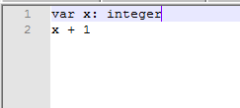
When executing Our compiler, from Lazarus, we will see that he complains with an error message:
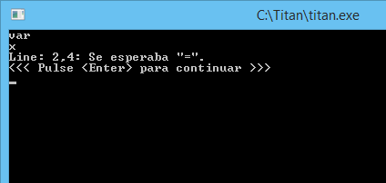
Note that the error message is accurate and also correctly indicates the position of the error.
What indicates the error is that the operator is expected, after the “x”, to be the assignment operator, that is, that he expected an expression of type “x =…”, because it has been defined in ProcessAssigment () that Only expressions of this form are accepted.
An assignment expression, however, will be processed correctly:
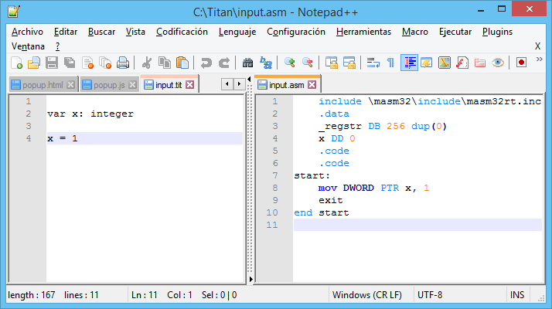
Eureka! This is our first code generated by the compiler.
The part on the right corresponds to the assembly file generated from our source code on the left. The first time this code is observed it may seem magic, as it is generating code from code, and it is one of the most rewarding parts of creating compilers.
This generated code (input.asm file) can be assembled correctly in an executable, using our “test.bat” script, as we explained in previous deliveries of this article. The executable, however, will not show anything but will execute the requested instruction.
The instruction generated “mov DWORD PTR x, 1” comes from the ProcessAssigment () procedure of our compiler:
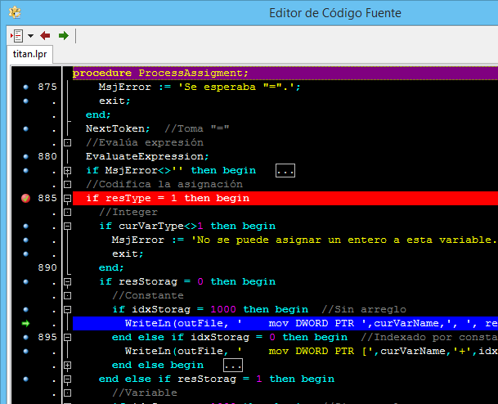
That is executed when it is detected that an integer constant is assigned to an integer variable. The variables "curVarType" and "curVarName" maintain information on the variable to which some value is being assigned.
The assembly instructions, we write them in the output file, using writeln (), and directing the output to the * .asm file.
If we change, the source program using only variables, we will see that similar assembly code is generated:
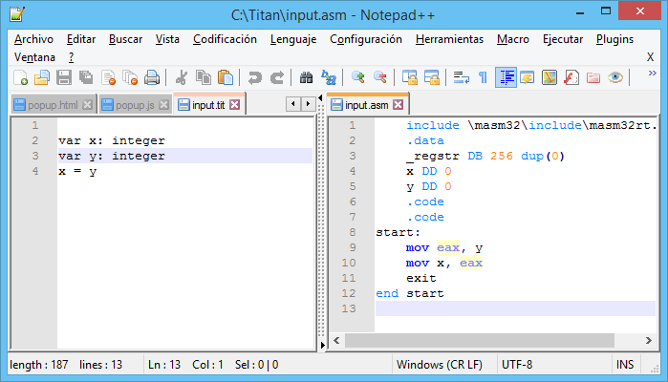
In this case, two assembly instructions are generated to perform the assignment.
If we analyze the behavior of the compiler, we will see that there is nothing magical about his work. It only consists in generating correctly, the appropriate instructions, for the appropriate situation.
Maybe someone wonders And how did the compiler know what code to generate?
Broadly speaking, the main program determines, by discard (not declaration, space, blank line), that the current line must be an assignment instruction. Then it captures information about the variable to be assigned (in asgVarName and asgVarType) and calls the ProcessAssigment () routine, who reads the assignment operator “=” and reads the right part of the assignment with the help of EvaluateExpression ( ) who determines the type of operand to be assigned. Then after some type validations, what type of data is to be assigned is detected, and the corresponding instructions are generated.
But that's not all our compiler can do. The EvaluateExpression () routine is also capable of generating code for addition and subtraction operations using the OperAdd and OperSub procedures. These procedures work similar to ProcessAssigment (), identifying the two operands of the expression and generating the code necessary to evaluate the expression:
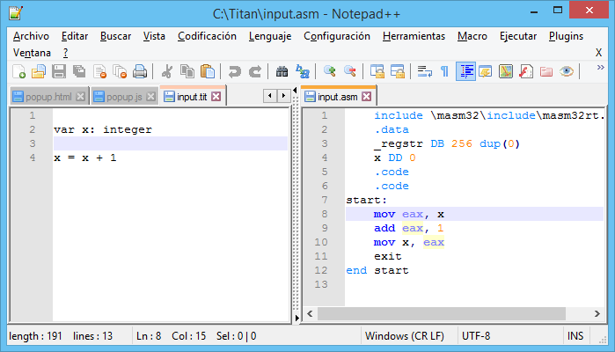
In this case the code is being generated in two parts. The first evaluates “x + 1” with two assembly instructions:
mov eax, x
add eax, 1
The other part assigns the result, which is of the "Expression" type and it is all done in a single assembly instruction:
mov x, eax
Putting all the instructions together, it will give us the idea that the compiler did something smart to evaluate a more elaborate expression.
Unfortunately, our EvaluateExpression () expression evaluator will only process simple expressions of one or two operands.
Additionally, we can also assign strings, because our ProcessAssigment () routine also recognizes the type string:
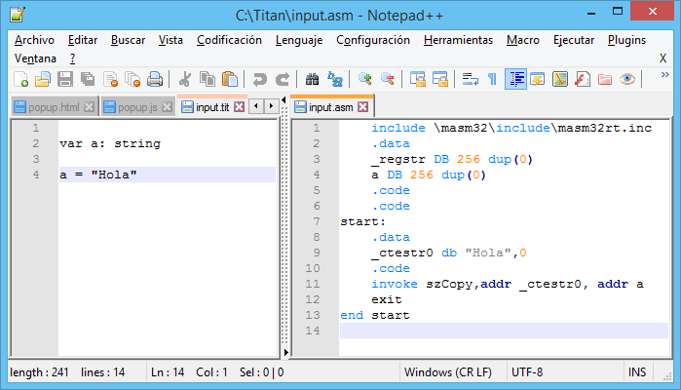
Note that our routine first creates a segment of data to write the bytes that correspond to the string. This segment is delimited by the lines ".data" and ".code" and serves to make additional data declarations. In our case, since it is a “string” operand of constant storage (literal), it is written first in RAM, as if it were a variable (see routine DeclareConstantString ()), and then copy it to the variable using the macro "szCopy".
This macro generates the code necessary to copy, byte by byte, all the characters of the variables, until finding the null character, so it works very similar to the routines of the C language. During the development of the compiler, we will prefer to use macros already existing to simplify our assembly code. If the reader has trouble understanding how these macros work, we recommend that you first review the documentation referring to macros in MASM32.
If the assignment of strings is made with variables, it can be deduced that the generated code is simpler because it will not be necessary to generate an additional declaration.
An additional detail The OperAdd () routine includes string processing, so you can also perform string concatenation, returning a string expression.
Let's first try to concatenate two string literals:
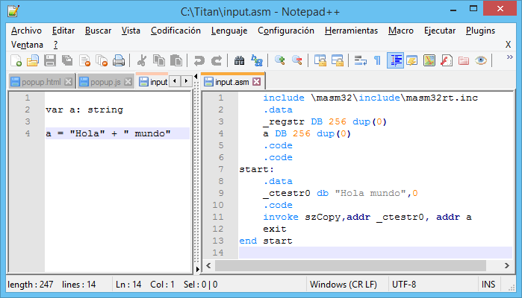
We can see that the expression evaluator is clever enough to be able to perform concatenation at compile time, instead of generating code for it. This is an example of code optimization and is a common feature in modern compilers.
To force the compiler to generate concatenation code, we need to create one more variable:
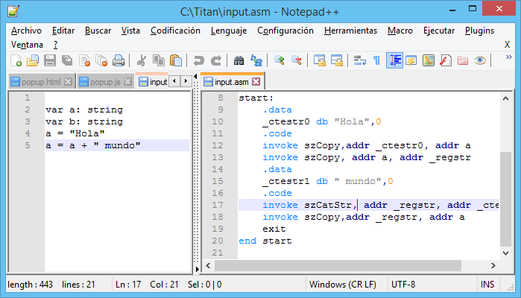
Now if we see that concatenation is done by calling the macro szCatStr, which is the one who does the heavy work of gathering the bytes of the string variables.
And with this demonstration, we conclude this delivery. For now we can not see the output on the screen of the actions taken, but in the next installment, we will write a routine that will allow us to show the results of our operations, so that we can write our first “Hello world”.

Part 12 - System functions
October 27, 2021
In the previous chapter we used our expression evaluator, which although quite simple, allowed us to generate code for different numeric and string expressions, which are the only two types of data that our compiler handles.
In this chapter, and for the first time, we will allow our compiler to be able to write messages on the screen. This will allow us, finally, to be able to write a true "Hello world", which is as important as when we hear a baby say its first words.

A stop along the way
So far, the source code of our compiler has been growing and acquiring more capabilities. At this point it should be remembered that our compiler design is quite simplistic compared to what a true compiler would be, and that we only created it for educational purposes, but it still maintains a design, the same one that we will describe in the following lines.
To begin with, we have the section for declaring global variables, which are the majority of variables, because using local variables is avoided in order to have a fairly simplified code.
Then we have the lexical analyzer functions section:
- function EndOfLine: integer;
- function EndOfFile: integer;
- procedure NextLine;
- procedure ReadChar;
- procedure NextChar;
- function NextCharIsSlash: integer;
- function IsAlphaUp: integer;
- function IsAlphaDown: integer;
- function IsNumeric: integer;
- procedure ExtractIdentifier;
- procedure ExtractSpace;
- procedure ExtractNumber;
- procedure ExtractString;
- procedure ExtractComment;
- procedure NextToken;
These functions are what recognize and extract the tokens from the input source file. The current token is stored in the variable "srcToken" and the token type is stored in "srcToktyp".
Then we include a set of functions that include parsing and semantic analysis:
- procedure TrimSpaces;
- procedure GetLastToken;
- procedure CaptureChar (c: integer);
- procedure ParserVar;
- procedure FindVariable;
- procedure ReadArrayIndex;
- procedure ProcessAssigment;
Let's remember that, for simplicity, we are not including an independent parsing module, because it would make our compiler too complex, which is what we want to avoid. In our implementation, it could be said that we perform syntactic and semantic analysis at the same time. And even, the generation of code, or synthesis, we carry out while we do the syntactic-semantic analysis.
The code generation is mainly done in the expression evaluation function, which is implemented with various functions:
- GetOperand;
- procedure GetOperand1;
- procedure GetOperand2;
- procedure DeclareConstantString (constStr: string);
- procedure OperAdd;
- procedure OperSub;
- procedure EvaluateExpression;

Creating our "print" function
So far our compiler has only been able to process statements and expressions. But now we need you to recognize our first function of the system. This first function will be the «print» function, which will allow us to write messages on the screen.
To implement this function, we can use different methods within MASM32, but in this case I have chosen to use a macro that allows writing messages on the screen. This will help us, because otherwise we would have to deal with obscure calls to the BIOS or their equivalents.
The MASM32 "print" macro is easy to use, as shown in the following assembler code:
.code
start:
print "Hola"
exit
end start
So to print a message on the screen we only have to detect when the "print" function is called and write the assembler "print" instruction with the corresponding parameter. The difficult part will be to consider all the cases that the parameter can have, which for our case can be:
- Constants (literals) of type numeric or string, such as: 123 or "Hello"
- Numeric or text variables such as: my_variable
- Result of expressions, such as: 1 + x
If we only had to print constants, the implementation of our "print" function would be something like this:
procedure processPrint (ln: integer);
begin
NextToken; // Pass the "print"
EvaluateExpression;
if MsjError <> '' then exit;
if resType = 1 then begin
// Print constant
Integer write (outFile, 'print "');
write (outFile, resCteInt, '"');
end else if resType = 2 then begin
// Print constant string
write (outFile, 'print "' + resCteStr + '"');
end;
end;
Which writes the assembly instruction «print» with the appropriate parameter (Actually «print» is a macro from MASM32).
Then we should only call this function for when we find a call to the "print" function in our program on Titan. That is, our "print" instruction in Titan will become the MASM32 macro "print". The similarity of names is just a coincidence. We could well have called our print-to-screen instruction by any other name. We put "print" when we defined the language, but we could have used "write", "print" or something similar.
But since we must consider that we can print not only constants, we must use the facilities of the «print» macro to receive the address of the string that we want to print.
Printing a variable, numeric, implies that we have to first convert the numeric value to its representation in a string. This is necessary because, for example, the numeric value 123, stored in a variable, is just a set of bits, which has nothing to do with the ASCII characters "1", "2", and "3" that we want to display in the console.
To carry out the conversion, we will use another of the functions that MASM32 offers us and it is called "dwtoa". So in our compiler, instructions of type "print variable_numerica" ​​must first be converted into a call to "dwtoa" and then a call to the macro "print", something like this:
invoke dwtoa, variable_numerica , addr _regstr';
print addr _regstr;
Note that the text result of the conversion of our numeric variable will be stored in our temporary memory zone "_regstr", which we like very well in this case.
The case of printing expressions is also somewhat similar to the case of variables.
Finally, our function that implements the code generation for the «print» instruction, would be this:
procedure processPrint (ln: integer);
{Implements the "print" and "println" statements. If "ln" = 0 "print" is compiled,
otherwise "println" is compiled.}
Begin
NextToken; // Pass the "print"
EvaluateExpression;
if MsjError <> '' then exit;
if resStorag = 0 then begin
// Constant Storage
if resType = 1 then begin
// Print
Integer constant write (outFile, 'print "');
write (outFile, resCteInt, '"');
end else if resType = 2 then begin
// Print constant string
write (outFile, 'print "'
if resType = 1 then begin
// Print integer variable
writeln (outFile, 'invoke dwtoa,' + resVarNam + ', addr _regstr');
write (outFile, 'print addr _regstr');
end else if resType = 2 then begin
// Print constant string
write (outFile, 'print addr' + resVarNam);
end;
end else if resStorag = 2 then begin
// Storage in expression
if resType = 1 then begin
// Print integer variable
writeln (outFile, 'invoke dwtoa, eax, addr _regstr');
write (outFile, 'print addr _regstr');
// Print constant string
write (outFile, '
end;
end else begin
MsjError: = 'Storage not supported';
exit;
end;
if ln = 0 then writeln (outFile, '') else writeln (outFile, ', 13,10');
end;
Observe that all possible cases are separated, as we have commented.
Furthermore, it is being used to implement another instruction in our Titan language, which is "println" which does the same as "print" but adds a line break at the end. To do this, set the «ln» parameter to 1.
Once this function is added we already have support for printing on the screen with "print" and "println", but we still have to intercept the calls to these instructions from within our source code. We do that in the main body of the compiler code, adding the following instructions:
...
//**** Aquí procesamos instrucciones.
//y ya no se deben permitir más declaraciones.
if srcToken = 'print' then begin
processPrint(0);
if MsjError<>'' then break;
end else if srcToken = 'println' then begin
processPrint(1);
if MsjError<>'' then break;
end else if srcToktyp = 2 then begin
//Es un identificador, puede ser una asignación
...
And with this we now have support for "print" and "println" and we will finally be able to send messages on the screen.
Let's try our first "Hello world." Let's create the following program on Titan, in the input.tit file:
print "Hello"
And let's run our compiler, from Lazarus.
If everything went well, we must obtain the following code in the output (file "input.asm"):
include \ masm32 \ include \ masm32rt.inc
.data
_regstr DB 256 dup (0)
.code
.code
start:
print "Hello"
exit
end start
And now yes, we can assemble and run the program, with our "test.bat" file, and we will see a beautiful "Hello" in our console:
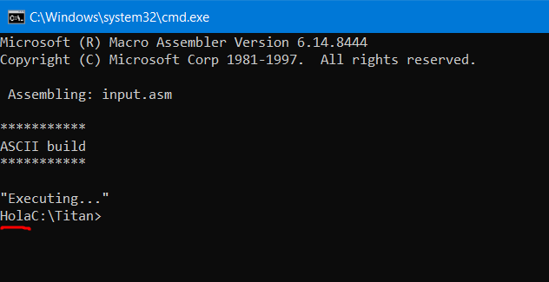
This is our first program to print a message on the screen. Note that the message does not print the line break so the prompt appears on the same line.
Let's now try the famous "Hello World":
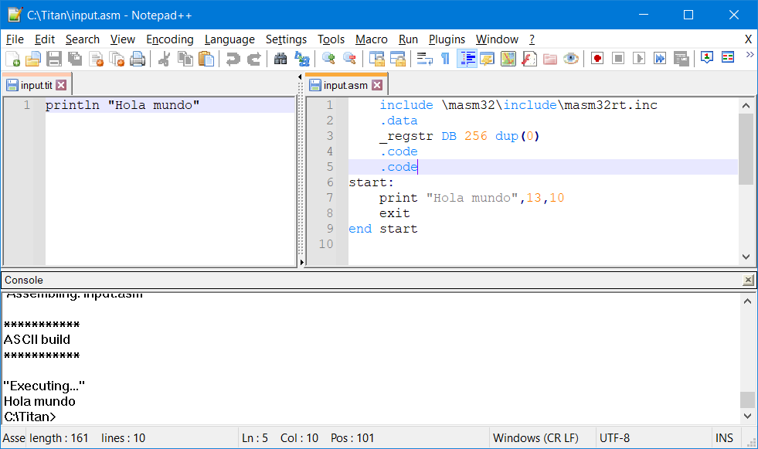
Observe how the line break is now included at the end of the chain.
But our routine doesn't just print string literals. It is able to print numeric expressions as well:
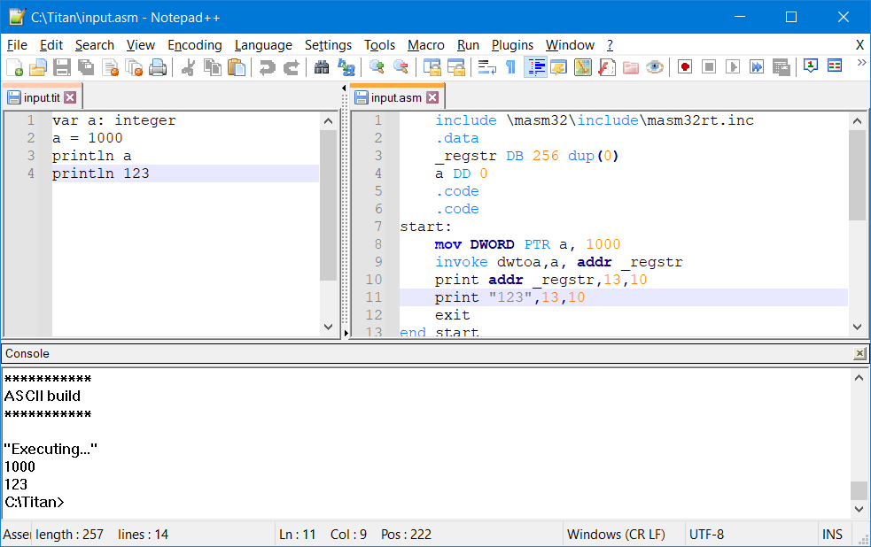
Observe the previous call to «dwtoa» and the use of «_regstr» when printing numeric variables.
Furthermore, we can let our expression evaluator work together to print simple expressions:
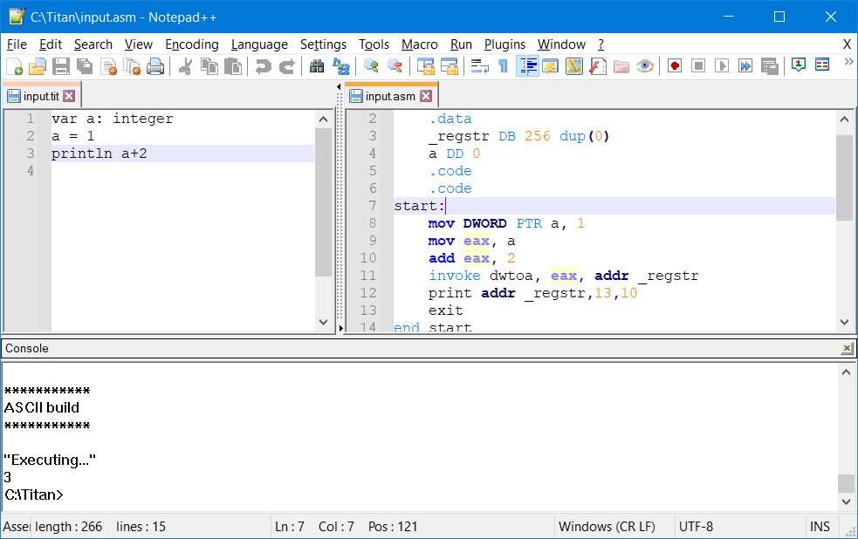
A review of the generated ASM code helps us understand how the magic of being able to print expressions is achieved. The trick is that the expression evaluator is called first and then the processPrint () routine.
So far we have made a breakthrough with our compiler. In the next article we will be reviewing and completing some pending functions.

