Tatiana Frolova

Rhode Island Police Report
Abstract
Rhode Island Police report provides a better understanding of the Rhode Island traffic violation problem, such as what type of violations were committed by gender, what gender speeding the most and comparing speeding tickets outcome by gender, whose vehicle get commonly searched by gender, and stops related to drugs trafficking. The report represented statistical techniques, such as statistical analysis and graphs, therefore the report developed several useful descriptive statistics outcomes that helped to better summarize those findings; that can be provided to each department of the state police that would help to improve transportation and traffic safety and quality.

Section 1. Introduction
The purpose of our statistical research is to improve road safety and traffic control by the Rhoad Island Police department. The report provides the findings in order to better understand the problem, such as different violations were committed by different gender.
Does gender affect who gets a ticket for speeding? In other words, who does get more speeding tickets female or male. Does gender affect whose vehicle is searched, in other words whose vehicle gets more commonly get searched, male or female? Does gender affect whose vehicle was being stopped related to drugs? What is the Probability whose vehicle was being stopped related to drugs? In addition, were included results of: Distribution of stop outcomes by month of the year by summarizing total outcome by each month of each year; How the time of the day affects stop outcomes; How the day of the week affects stop outcomes, in other words in which day of the week drives commit to more traffic violation; Distributions of overall stop outcomes by each year in order to see if traffic violation is increasing over the years of study.
The original data set was collected and compiled by the police of Rhode Island during a period of time April 1st, 2005, and December 31st, 2015. During the 10 years, 91741 violation records were collected, which provides a full understanding of the road traffic situation in Rhode Island. It is important to analyze the past 10 years of data collection which will help provide a safety strategy for the future of Rhode Island residents.
The outline of the remainder of this report is as follows. In Section 2, I represent the most important characteristics of the data. Section 3 represents a summary of characteristics from Section 2. Also, in Section 3 you can find a discussion of a model to represent the data and Interpretation. Section 4 contains summary and conclusion remarks.

Section2. Data Characteristics
These experimental data were compiled by Rhode Island Police department in period 2005 – 2015. The data are crossed-sectional and containing qualitative and quantitative paraments.
Data outcome contains 91741 row record and 15 columns which describe state, stop date, stop time, county name, driver gender, driver race, violation raw, violation, search conducted, search type, stop outcome, is arrested, stop duration, drugs related stop, and district.
Police stopped 62762 males and 23774 females (Figure 1.0), which were categorized by race, such as were stopped 61872 White drivers, 12285 Black, 9727 Hispanic, 2390 Asian, and 265 of the Others (Figure 1.1).
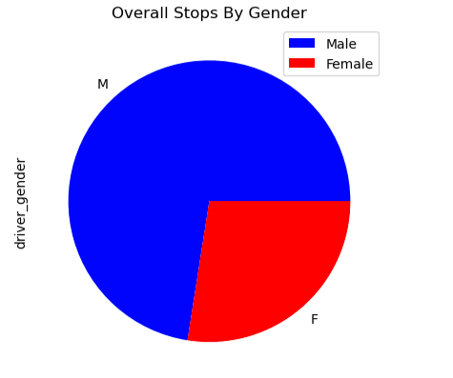
Fig 1.0 Pie Plot Chart Overall Stops by Gender

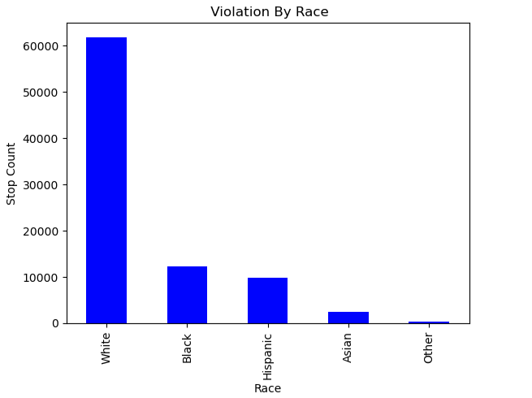
Fig 1.1 Bar Plot Stops outcome by Race
Stopped outcomes were given 77092 citations, 5137 warnings, 2735 drivers were arrested, 625 times no actions were taken, 607 were not displayed, and arrest passengers 343 times (Figure 1.2). Reported stop duration times were 0-15 Min 69579 times, 16-30 Min 13740 times, and over 30 Min 3220 times (Figure 1.3).
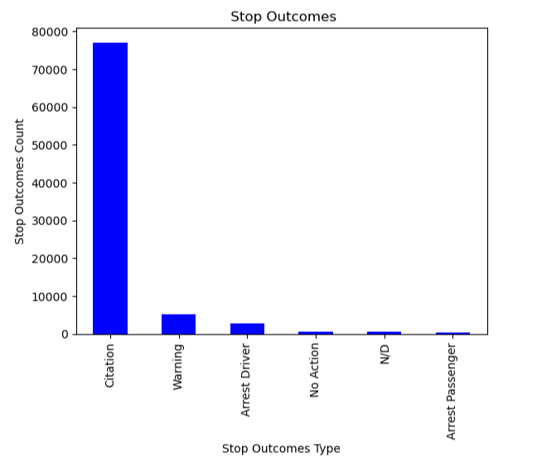
Fig. 1.2 Bar Plot Stopped outcomes

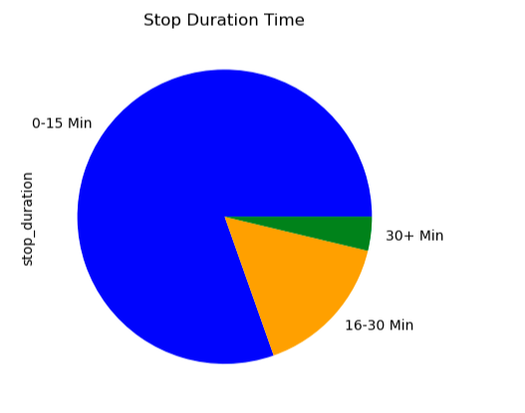
Fig. 1.3 Pie Plot Chart Stop Duration Time

Section 3. Model Selection and Interpretation:
The 2023 Rhode Island Police Analysis report indicated that for the April 1, 2005 – December 31, 2015 study period, the Rhode Island Police Department made 91741 traffic stops violations.
Table 1.0 provides more details on the outcomes. In this table is organized by 8420 equipment violations were committed by male and 2501 equipment violations were committed by female. 12938 moving violations were committed by male and 3286 violations were committed by female. 3702 the other violations were committed by male and 707 violations were committed by female. 2647 registration/plates violations were committed by male and 1056 violations were committed by female. 2278 seat belt violations were committed by male and 578 violations were committed by female. 32777 Speeding violations were committed by male and 15646 violations were committed by female.
Table 1.0. Categories of violations by gender
Violations | Equipment | Moving violation | Registration/plates | Seat belt | Speeding | Other
Male | 8420 | 12938 | 2647 | 2278 | 32777 | 3702
Female | 2501 | 3286 | 1056 | 578 | 15646 | 707

The gender disparities in the Rhode Island Police Department data were studied using a more detailed/probability review of traffic violations during the study period. Part of the analysis involved mapping speeding stops, vehicle searches, and stops related to drugs.

The analysis indicated a statistically significant disparity in the probability rate of speeding violation tickets by driver gender. Outcomes were summarized in Table 2.0. The probability that a person who is female got a speeding ticket is 32.31 % and a male gets a speeding ticket is 67.69%. That outcome was calculated based on an analysis of 48423 total speeding violations, 15646 tickets were given to female drivers, and 32777 tickets were given to male drivers.

Table 2.0 Speeding violation tickets by driver gender
 | Speeding Tickets Count | Probability (%)
Male | 32777 | 67.69
Female | 15646 | 32.31
Total Speeding Tickets | 48423 | 100

In Table 3.0 summary of analysis and report, which also include results of the calculation that represent evidence that out of total 91741 violations, 3307 vehicles have been searched, and 83229 have not been searched. Therefore 2851 male drivers' vehicles have been searched, and 456 female drivers' vehicles have been searched. 59911 male drivers' vehicles have not been searched, and 23318 female drivers' vehicles have not been searched. The probability male vehicles get searched is 86.21% compared to female vehicles getting searched is 13.79%.

Table 3.0 Vehicles searched conducted
 | Count of vehicles have been searched | Probability (%)
Male | 2851 | 86.21
Female | 456 | 13.79
Total | 3307 | 100
In addition to reviewing traffic violations by gender, we also conducted stops on the roadways with the greatest number of drug-related stops, which were displayed in Table 4.0. During the study period, 862 vehicles have been stopped drug-related, 755 vehicles were driven by male drivers, and 107 vehicles were driven by female drivers. Which was an 87.59% of probability that vehicles have been stopped drug-related if a driver is male, and there was a 12.41% of probability that vehicles have been stopped drug-related if a driver is female.
Table 4.0 Vehicles drug-related stops
 | Count of vehicles drug-related stops | Probability (%)
Male | 755 | 87.59
Female | 107 | 12.41
Total | 862 | 100

In addition to the main report, researchers included in The Rhode Island police report of statistical analysis of dates and times during the period of study 2005 -2015, which included:
Distributions of overall stop outcomes by each year; How the time of the day affects stop outcomes; How the day of the week affects stop outcomes, in other words, which day of the week drivers commit to more traffic violations; Distribution of stop outcomes by month of the year by summarizing total stops outcome by each month of each year.

The Rhode Island traffic stops outcome by each year of study. Stop outcomes included counting calculation of vehicles that were stopped by police each year, the statistical analysis indicated that in 2012 police stopped 10972 vehicles, in 2006 stopped 10560 vehicles, in 2007 stopped 9575 vehicles, in 2014 stopped 9036 vehicles, in 2008 stopped 8860 vehicles, in 2015 stopped 8399 vehicles, in 2011 stopped 8301, in 2013 stopped 8060 vehicles, in 2009 stopped 7820 vehicles, in 2010 stopped 7654 vehicles, and in 2005 2504 vehicles were stopped. Those results were summarized and presented in Table 5.0.

Table 5.0 Count Traffic Stop Outcomes by Year
Year | Count Traffic Stop Outcomes
2012 | 10972
2006 | 10560
2007 | 9575
2014 | 9036
2008 | 8860
2015 | 8399
2011 | 8301
2013 | 8060
2009 | 7820
2010 | 7654
2005 | 2504

How the time of the day affects stop outcomes; Results of stop time outcomes were summarized in Table 6.0.
Table 6.0 Stop Outcomes by Time of The Day
Time of Stops by Hour (Military Time) | Count Traffic Stop Outcomes
10:00 – 10:59 | 7402
9:00 – 9:59 | 6738
11:00 – 11:59 | 5996
14:00 – 14:59 | 5613
23:00 – 23:59 | 5544
8:00 – 8:59 | 5218
00:00 – 00:59 | 5206
15:00 – 15:59 | 5017
13:00 – 13:59 | 4787
7:00 – 7:59 | 4561
1:00 – 1:59 | 4409
16:00 – 16:59 | 3754
12:00 – 12:59 | 3665
22:00 – 22:59 | 3649
20:00 – 20:59 | 3334
6:00 – 6:59 | 3210
2:00 – 2:59 | 2942
17:00 – 17:59 | 2780
19:00 – 19:59 | 2573
18:00 – 18:59 | 2214
21:00 – 21:59 | 1455
3:00 – 3:59 | 1166
4:00 – 4:59 | 290
5:00 – 5:59 | 218

How the day of the week affects stop outcomes, in other words, which day of the week drivers commit to more traffic violations; Results of stop time outcomes were summarized in Table 7.0.
On Saturday Rhode Island police stopped on Saturday 14189 vehicles, on Sunday 13357 vehicles, on Monday 13193 vehicles, on Friday 12998, on Tuesday 12835, on Wednesday 12624, and on Thursday 12545 vehicles.
Table 7.0 Stop Outcomes by Day of The Week
Day Of the Week | Count Traffic Stop Outcomes
Saturday = 5 | 14189
Sunday = 6 | 13357
Monday = 0 | 13193
Friday = 4 | 12998
Tuesday = 1 | 12835
Wednesday = 2 | 12624
Thursday = 3 | 12545

Distribution of stop outcomes by month of the year. The calculation was produced by summarizing total stops outcome by each month of each year. Table 8.0 shows summary of the stop outcomes count by each month; The number of vehicles stopped by police, in order to indicate which month demonstrates the most traffic violations. Table 8.0 demonstrates summary of stop outcomes distributed by month. In January were 8387 stop outcomes, in November were 8008 stop outcomes, in May were 7881 stop outcomes, in March were 7755 stop outcomes, in October were 7751 stop outcomes, in July 7658 stop outcomes, in August were 7614 stop outcomes, in September were 7611 stop outcomes, in June were 7570 stop outcomes, in April were 7405 stop outcomes, in December were 7109 stop outcomes, and in February were 6992 stop outcomes.
Table 8.0 Stop Outcomes by Day of The Week
Month Of the Year | Count Traffic Stop Outcomes
January | 8387
November | 8008
May | 7881
March | 7755
October | 7751
July | 7658
August | 7614
September | 7611
June | 7570
April | 7405
December | 7109
February | 6992

Section 4. Summary and conclusion Remarks:
Based on the statistical analysis of the Rhode Island Police Analysis report during the period of study the April 1, 2005 – December 31, 2015; We calculated and summarized outcomes of traffic stop violations, and a more detailed review of traffic violations such as speeding stops, vehicle searches, and stops related to drugs by gender. in order to detect which gender male or female committed to more violation and traffic vehicle stops which are related to different violations. The summary of the final report is displayed in Table 9.0
Table 9.0 Outcomes Stops Summary By Gender
 | Speeding Tickets Count | Probability (%) of Speeding Tickets | Count of vehicles have been searched | Probability (%) of vehicles have been searched | Count of vehicles drug-related stops | Probability (%) of vehicles drug-related stops
Male | 32777 | 67.69 | 2851 | 86.21 | 755 | 87.59
Female | 15646 | 32.31 | 456 | 13.79 | 107 | 12.41
Difference by gender stops outcome | 17131 |  | 2395 |  | 648

These results were statistically significant (Based on my examination of Figure 2.0) The Bar plot visualization of genders' commitment to different violations. Most of the violations were related to speeding. 32777 Speeding violations were committed by males and 15646 violations were committed by females. The second greatest violation was a moving violation. 12938 moving violations were committed by males and 3286 violations were committed by females. Therefore, males commit to more different types of violations than females.
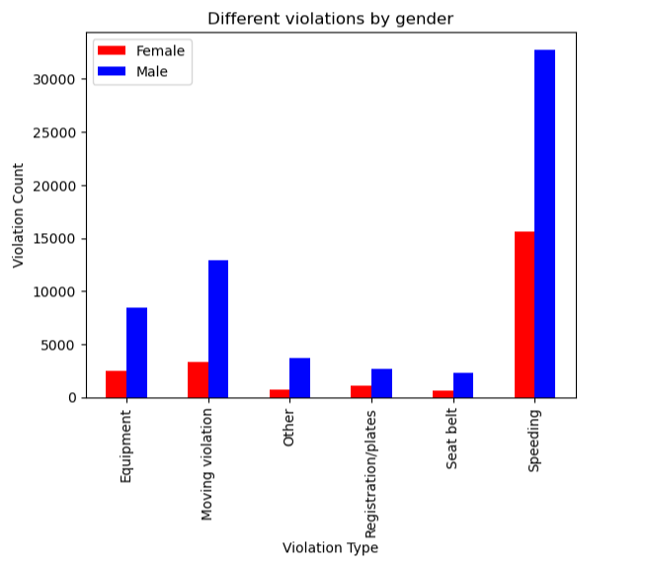
Fig. 2.0. Bar Plot of visualization genders commitment to different violations
Based on the statistical analysis and observation research in order to calculate and summarize outcomes and probability outcomes of traffic stop violations, and a more detailed review of traffic violations such as speeding stops, vehicle searches, and stops related to drugs by gender, we received results, such as:
Probability that females got speeding tickets 32.31 % and males get speeding tickets 67.69%. 15646 tickets were given to female drivers, and 32777 tickets were given to male drivers; That appears that male gets 17131 tickets more speeding tickets than female. Figure 2.1 represents results.
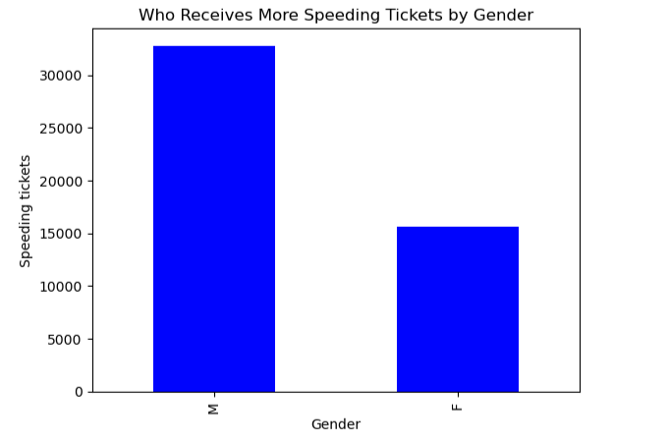
Fig. 2.1. Bar Plot of Who Receives More Speeding Tickets by Gender
Probability that male vehicles get searched is 86.21% compared female vehicles get searched is 13.79%. These results based on study data of 2851 male drivers' vehicles have been searched, and 456 female drivers' vehicles have been searched. There were 2395 males’ vehicles get commonly searched than females’. However, 59911 male drivers' vehicles have not been searched, and 23318 female drivers' vehicles have not been searched. Figure 2.2 displays the outcome.
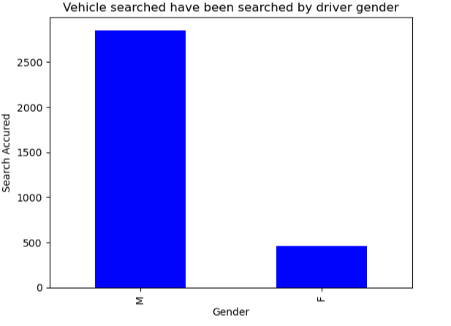
Fig. 2.2. Bar Plot of Vehicle have been searched by driver gender
The calculation whose vehicle gets more commonly stopped drug related male or female; There is strong evidence that vehicles have been stopped drug related 87.59% for male drivers and 12.41% for female drivers. Based on research data outcomes that out of 91741 total drives, 862 vehicles have been stopped drug-related. 755 vehicles were driven by male drives and 107 vehicles were driven by female drivers. Therefore, we conclude that there is significant evidence that male vehicle gets more commonly drug related stopped than females. Figure 2.3 illustrates a summary of results.
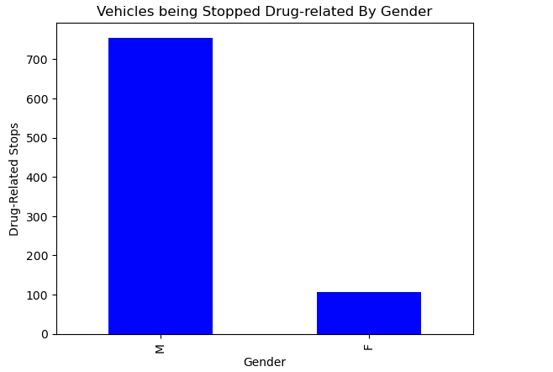
Fig. 2.3. Bar Plot of Vehicles being Stopped Drug-related By Gender

Summary of the top 3 common date/time outcomes with count of stops outcomes demonstrates Table 10.0.
Table 10.0. Summary of the top 3 common date/time outcomes with count of stops outcomes
Year with most stop outcomes | Count Traffic Stop Outcomes by Years | Most common Time of Stops by Hour (Military Time) | Count Traffic Stop Outcomes by Time of the Day | Most common Day of the Week | Count Traffic Stop Outcomes by Day of the Week | Most Common Month of the Year | Count Traffic Stop Outcomes by Month of the Year
2012 | 10972 | 10:00 – 10:59 | 7402 | Saturday | 14189 | January | 8387
2006 | 10560 | 9:00 – 9:59 | 6738 | Sunday | 13357 | November | 8008
2007 | 9575 | 11:00 – 11:59 | 5996 | Monday | 13193 | May | 7881

Based on the statistical analysis and observation of the Rhode Island Police Analysis report during the period of study the April 1, 2005 – December 31, 2015; Additional report summarized outcomes of overall stop outcomes by each year, in other words, what year had the most stop outcomes and what year had the least stop outcomes. There is strong evidence that in 2012 10972 drivers were stopped which makes the year with the most stop outcomes, and in 2005 police stopped and recorded 2504 stops which makes the year 2005 the year with the least stop outcomes.

Based on analysis there is significant evidence to conclude that there were no gradual decreases or increases in traffic violations during the 2005 – 2015 years of study because the highest number stops were in 2012, 2006, and 2007; Lowest numbers of stops were in 2009, 2010, and 2005, which demonstrates Figure 2.4.
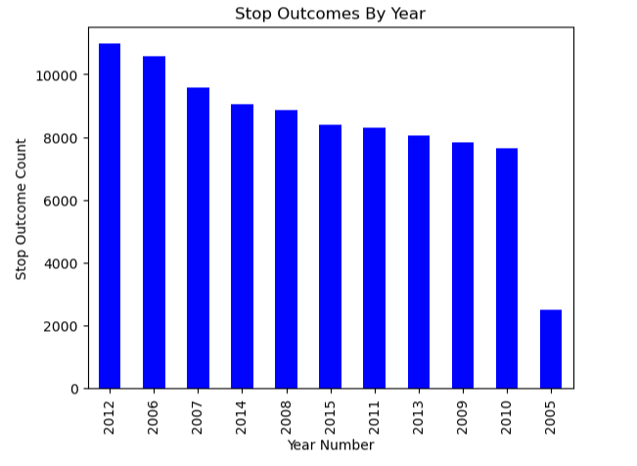
Fig. 2.4. Bar Plot Count Traffic Stop Outcomes by Year

Based on the statistical analysis and observation research in order to calculate and summarize stop outcomes by the time, and how the time of the day affects stop outcomes, we received results that most stops were between 10:00 – 10:59 (7402 stops), between 9:00 – 9:59 (6738 stops), and between 11:00 – 11:59 (5996 stops). Least stops were indicated between 3:00 – 3:59 (1166 stops), between 4:00 – 4:59 (290 stops), and between 5:00 – 5:59 (218 stops). Figure 2.5 shows overall summary stop time outcome (represents in military time).
Based on the received numbers, there is significant evidence to conclude that the highest number of all drives were stopped between 9:00 – 11:59 am and the lowest number of drives were stopped between 3:00 – 5:59 am. We also can conclude that drivers commit more traffic violations in the morning time and fewer violations in the nighttime.
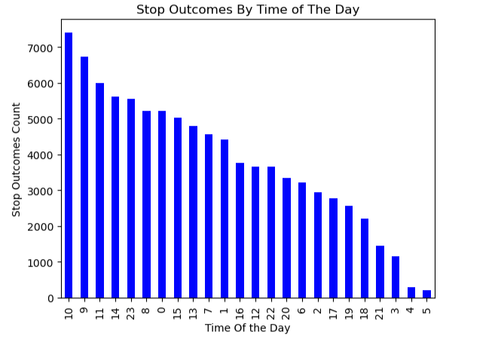
Fig. 2.5. Bar Plot Count Traffic Stop Outcomes by Time of The Day

Based on the statistical analysis and observation research in order to calculate and summarize stop outcomes by day of the week. How the day of the week affects stop outcomes, in other words, which day of the week drivers commit to more traffic violations.
There is strong evidence that on Saturday police stopped 14189 vehicles, on Sunday 13357 vehicles, on Monday 13193 vehicles, on Friday 12998, on Tuesday 12835, on Wednesday 12624, and on Thursday 12545 vehicles.
Therefore, based on the received numbers we conclude that day of the week affect stop outcomes because the highest number of all drives were stopped on Saturday and Sunday and least stopped occurred on Wednesday and Thursday.
Figure 2.6. demonstrates visualization of stop outcomes by day of the week where Monday = 0, Tuesday = 1, Wednesday = 2, Thursday = 3, Friday = 4, Saturday = 5, Sunday = 6.
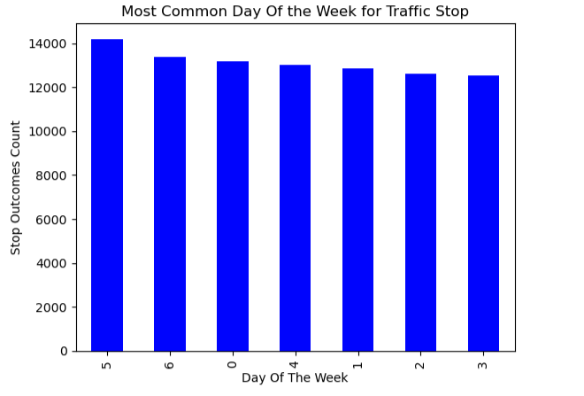
Fig. 2.6. Bar Plot Count Traffic Stop Outcomes by Day of The Week
Based on the statistical analysis and observation research in order to calculate and summarize distribution of stop outcomes by month of the year by summarizing total stops outcome by each month of each year, the results were visualized in Figure 2.7, which illustrates the number of traffic stops that occurred each month. Where 1 = January 2 = February 3 = March, 4 = April, 5 = May, 6 = June, 7 = July, 8 = August, 9 = September, 10 = October, 11 = November, 12 = December.
There is significant evidence to conclude that there is not seasonal traffic stops escalation, because the highest volume of traffic stops occurred in January (8387 stops), November (8008 stops) and May (7881 stops) and the lowest volume occurred in April (7405 stops), December (7109), and February (6992).
Figure 2.7 visualizes the summary of the stop outcomes count by each month where 1 = January, 2 = February 3 = March, 4 = April, 5 = May, 6 = June, 7 = July, 8 = August, 9 = September, 10 = October, 11 = November, 12 = December.
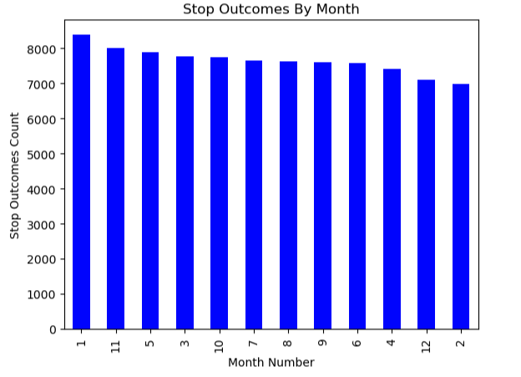
Fig. 2.7. Bar Plot Stop Outcomes by Month

A total of 91741 traffic stops were made along Rhode Island by the Police department during the study years 2005 -2015; Although certain assumptions and conclusions have been made earlier that male drivers were more likely committed to different types of violations than females. It is reasonable to conclude that of numbers for male drivers are significantly higher than female drivers committing traffic violence because male drivers received more speeding tickets, male drivers' cars get more commonly searched, and more often get stopped drug related based on our research report and calculations. Additional date/time analysis report provided significant evidence that traffic stops outcome is not increased during the years of study, there is no indication of seasonal escalation of violation reports, however, most traffic violations were committed in the morning hours between 9:00 – 11:59 am, and during the weekend days. It is likely that this report helps with the demand for police departmental resources during the busier months and times and does allow for the same level of traffic enforcement that might occur during other times.

