## Mandatory Exercise 2

Procedure:

For solving the exercise, we first tried to get the system working and then worried about optimization the system. A function for generation a LUA script was written which made all the default setups and also outputted the path given in the assignment into the LUA script in order to run the simulation in RobWorks.

Another function was implemented which ran the simulated route 100 times with a certain epsilon and saved the resulting path length and time used into a text file. The text file was imported into matlab and processed. The results are given below.

Results:

The tables give a quick overview of the data we got from which epsilon. The data from the tables is plotted to give a better visualisation of the data. Figure 1 is a screen shot of the table with data from the starting position to the bottle. Figure 2 is the data from the bottle to the table. A quick look of the table and it is apparent that Figure 1 is both faster and has less steps.

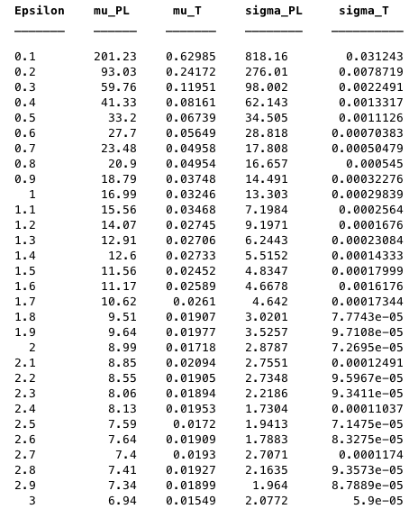

Figure 1 - Table containing the mean and variance of both path length and time with different epsilons values. Each sample consists of 100 trials with the RRT planner. These are from the robot going from starting position to the bottle.

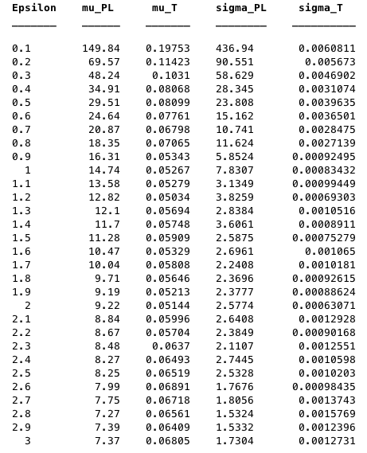

Figure 2 - The table contains the mean and variance of both path length and time with different epsilon values. Each sample consists of 100 trials with the RRT planner. This table is made from the path planned from the bottle to the table.

To better visualize the data the mean of that path lengths and the time has been plotted against epsilon. The plots for the path and time from starting position to the bottle can be seen in Figure 2 and 3, and a plot of the path from the bottle to the table can be seen in Figure 4 and 5.

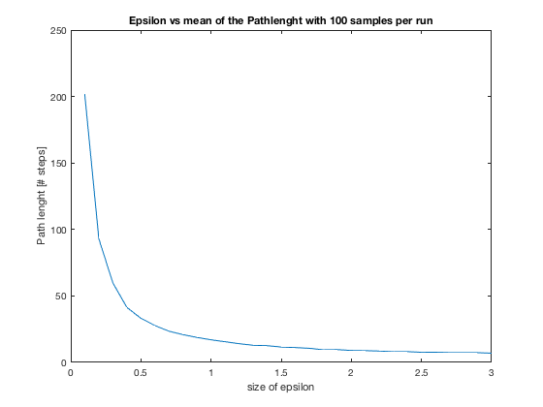

Figure 3 - This plot shows how the amount of steps decrease the higher epsilon is set.

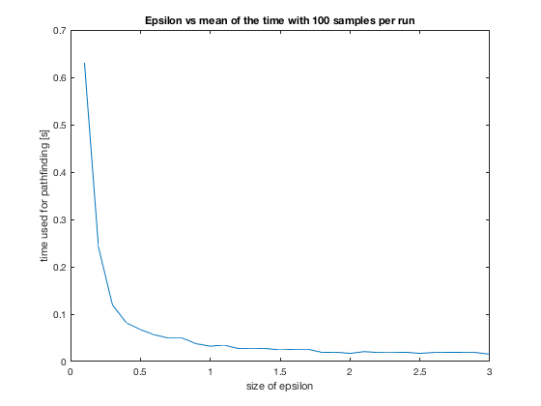

Figure 4 - The plot shows how the time decreases while the epsilon increases

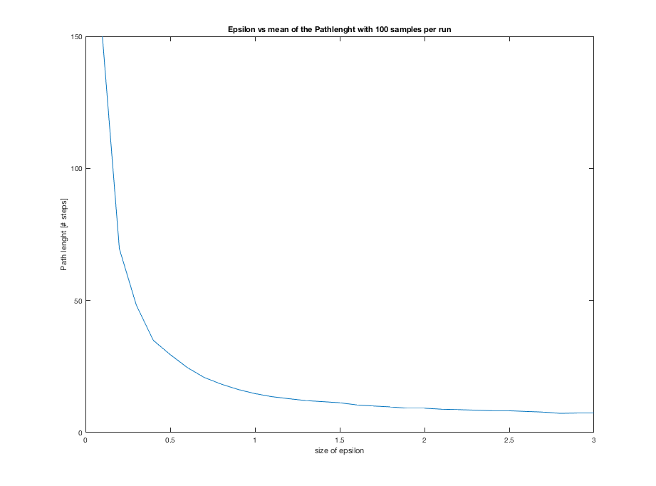

Figure 5 - Plot show the relationship between the amount of steps in the path and the epsilon

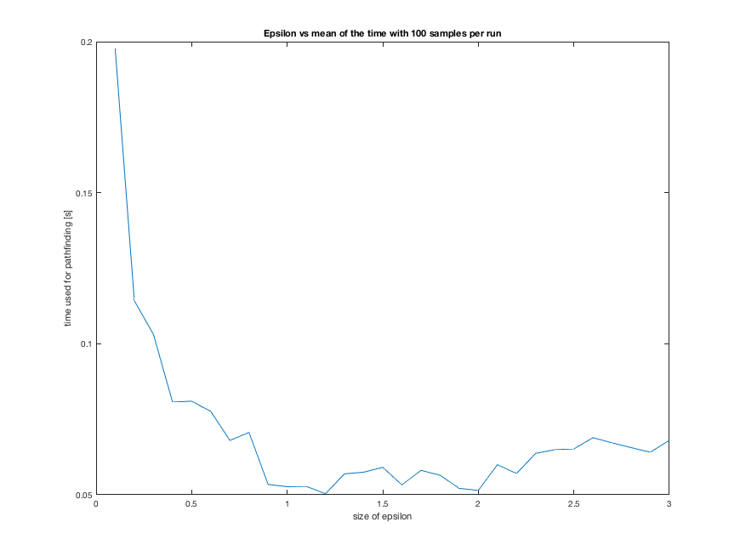

Figure 6 - Show the relationship between time and epsilon.

From the plots, it seems the plots from the starting position to the bottle are both less jagged than the plots showing the time and steps from the bottle to the table. This could be because of the bottle is now attached to the robot so planner has to account for another frame.

From these result, it is hard to decide which epsilon would be most desirable to use, but if we let the best of the worst dictate we can estimate an epsilon for this configuration. Taking the worst of the best, means we use the table from when the bottle has to go from the pallet to the table since this generally takes more time to calculate, and then using the epsilon that yields the lowest time. Using this tactic lets us to believe that epsilon at **1.2** is the best choice for this exercise.

Reflections:

The RRT path planner used in the exercise is a proballistic path planner and is from a build-in library of RobWorks and has been treated as and black box. This makes it a little problematic because the general documentation of RobWorks is hard to come by.

When running the simulation, it seems there is a small collision with the pallet and bottle in the moment the bottle is grabbed. We were not able to explain the nature of this, but we suspect it could be if the bottle is angle straight after it has been picked up, or I could be round off error from the path-planner. The issue was not further investigated.