

Project 2 – Final Team Project

By

The Best Team

Miguel Mawyin & Trevor Hebert

Table of Contents

3. Description

4. Wireframes

6. Images

9. Future functionality

Description

The Best Team has created the best forum ever, it is a programming forum. The forum is divided into sections, each which can contain an unlimited amount of topics. An unlimited number of sections can be created by administrator users. Inside topics, threads can be created by users; these are used to discuss issues, ideas, programming, etc. Users can comment on any thread created.

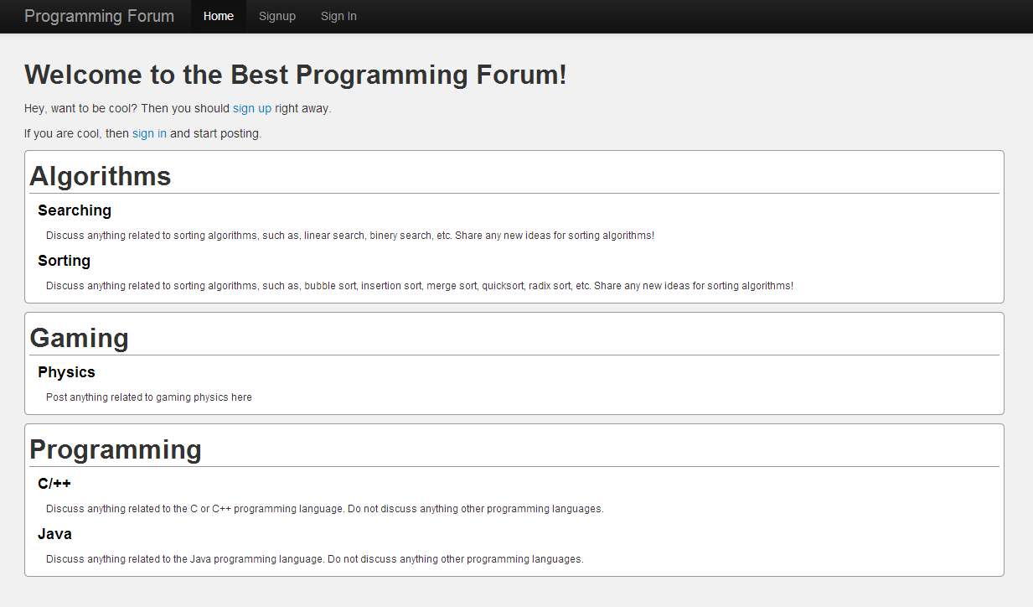

*Programming Forum index page*

In the above image you can see 3 different sections (Algorithms, Gaming, and Programming), each containing different topics within them. The forum is extremely secure; you would have easier time hacking into a government computers during a lock down foreign attack. The site is broken down into two kinds of users, administrators and users. Administrators can create and delete sections and topics. Users are only allowed to post if they have authenticated themselves.

Wireframes

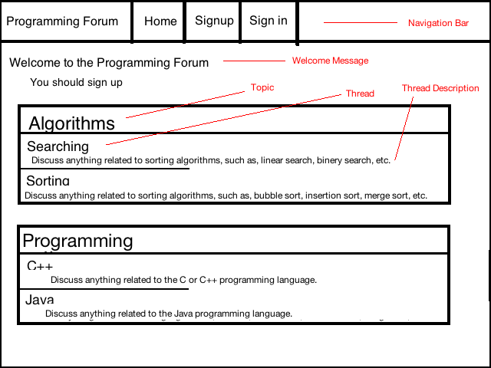

*Homepage Wireframe*

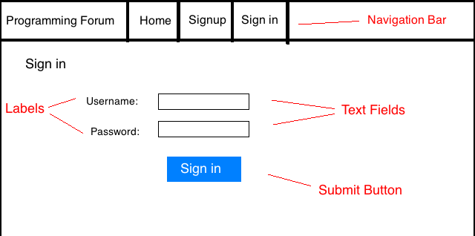

Sign in Wireframe

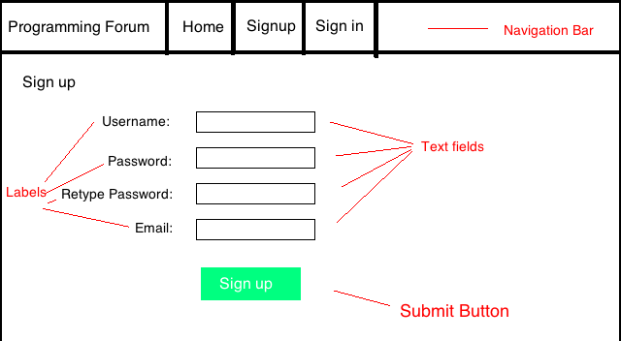

*Sign up Wireframe*

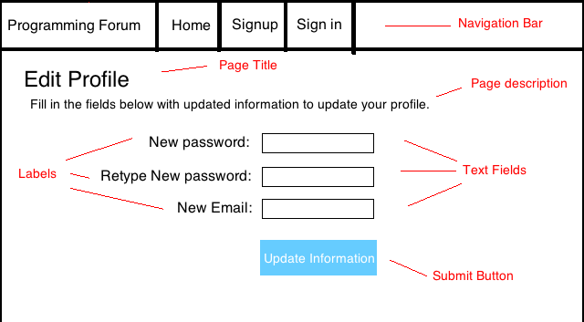

Edit Profile Wireframe

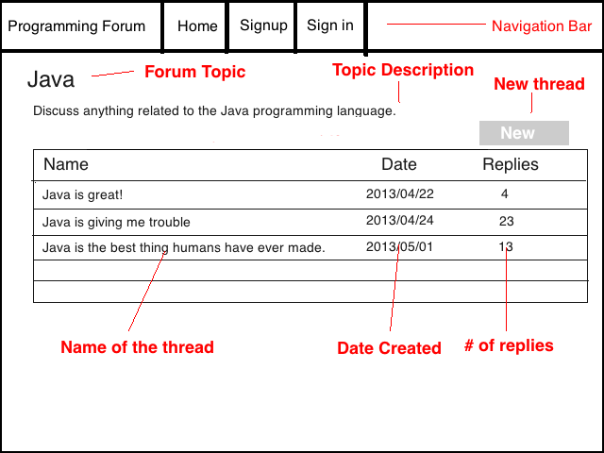

*Topic Wireframe*

Images



*Home Page*

*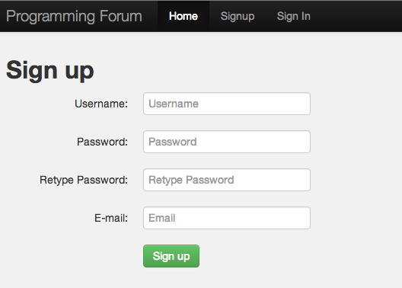*

*Sign up*

*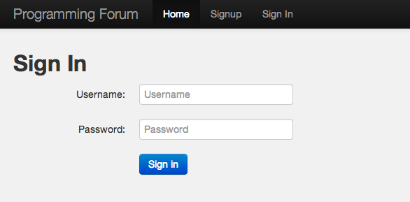*

*Sign In*

*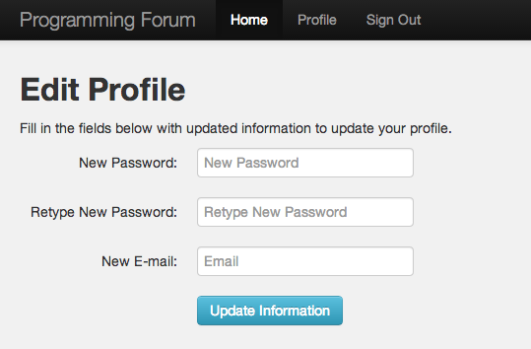*

*Edit Profile*

*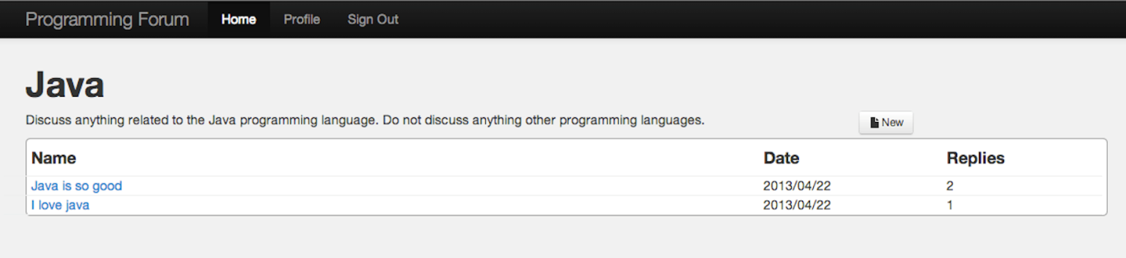*

*Topic selection*

*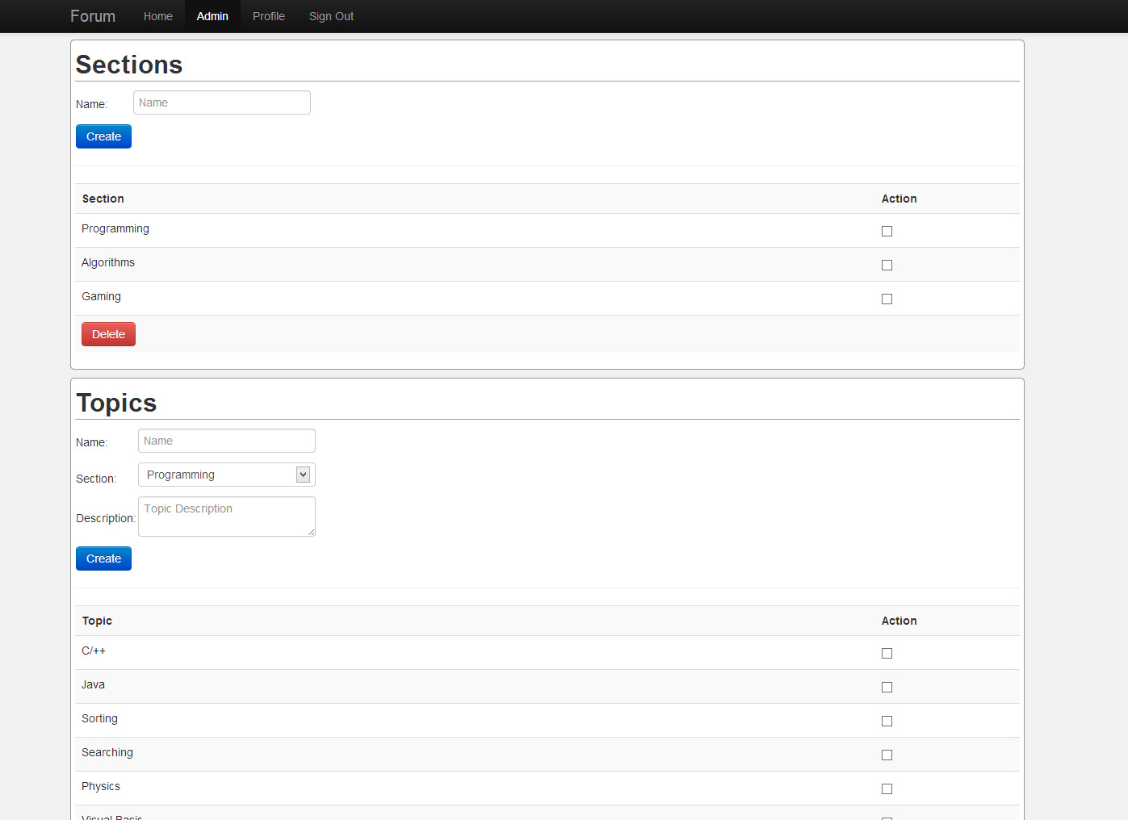*

*Admins Page*

Future Functionality

Being the best forum in the world, there isn’t much future functionality required. Possible functionality that could be implemented later would include:

* Delete threads/comments
* Comment on particular user
* Admin ban user
* Searching feature
* Avatars for users
* Private messaging
* Comments with images