

**Table of Contents**

**2 & 3 -** Description, Navigation bar, Colors, Typography

**4 -** Wireframes, Branding

**Trevor's Personal Portfolio Website**

**Description**

**This website is designed to help me to look more professional as well as to showcase my past work that I have done.**

**Navigation Bar**

**Navbar.png**

**This is the primary method of navigating the website. Clicking on the text or the box surrounding it will bring you to the corresponding webpage. The box that is highlighted shows the current page you're on.**

**Colors & Typography**

|  |
| --- |
| **black.png#000000 - Used for header, footer, and aside background.** |
| **blue.png#3E94D1 - Used for the navigation bar** |
| **darkblue.png#03406A -** **Used on the navigation bar to show the current page** |
| **darkgreen.png#014D57 - Used as the background color of the website** |
| **green.png#599100- Used for hovering effects** |

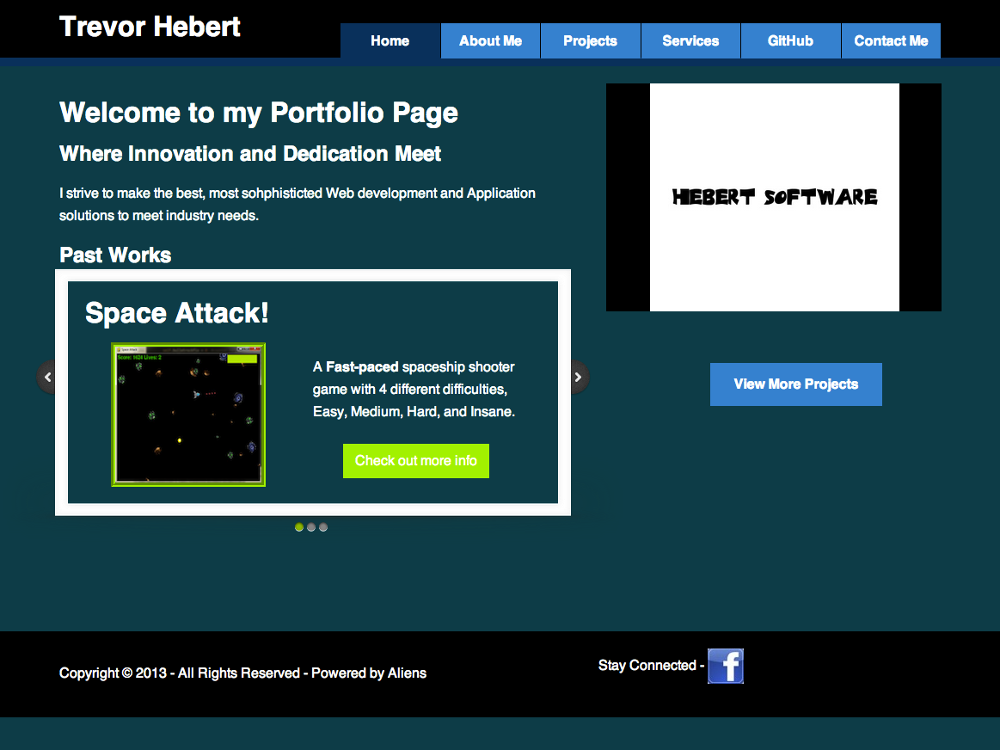

**All fonts are Helvetica and are differently sized. All text is white.**

**Wireframes & Branding**



