 | <Project Name>  Technical Design Document
 | Prepared By / Last Updated By | Reviewed By | Approved By
Name
Role
Signature
Date

Table of Contents

1.0 Introduction 3
1.1 Purpose of this document 3
1.2 Project overview 3
2.0 Solution Summary 3
2.1 Scope 3
2.2 Assumptions 3
2.3 Dependencies 3
2.4 Risks 3
3.0 Schematic Diagram 3
4.0 System Design 4
4.1 Proposed design 4
4.2 Component inventory 4
5.0 Database Design 4
5.1 Data Model 4
5.2 Tables Structure 4
6.0 Appendices 4
6.1 Glossary 4
6.2 Other 5
7.0 Terms & Conditions 5
8.0 Change Log 5

Introduction

Purpose of this document
The purpose of this document is to document the technical design, component details and Database design. This will also capture the scope, assumptions, risk, dependencies of Outreach project.

Project overview
There are two actors volunteer and the admin .The admin has the control over the events such as creating the event ,taking the attendance of the volunteers .The volunteer can participate in the event .Both the actors can donate in outreach .

Solution Summary

Scope
The Scope of project is to register the volunteer or the admin as per the requirements .The actors are provided with different functionalities such as create event ,taking attendance ,participating in the event for the volunteer and the inviting the colleagues.

Assumptions
While the volunteer is inviting to the colleague it is provided with the email ID and it is supposed to be send to particular colleague.

Dependencies
- Eclipse IDE.
- MySQL Workbench.
- Maven.
- GitLab .

Risks
The non-functional risks such as system crash.

Schematic Diagram
A schematic, or schematic diagram, is a representation of the elements of a system using abstract, graphic symbols rather than realistic pictures. It gives an overview of overall system

System Design

Proposed design
There are two options to the user for the application volunteer and the admin .Both the users has to register .And then use the application .The Validation is also carried out .When the user is the admin then he has to create the events and has the facilities to take the attendance of the volunteers .The volunteer has the facilities to participate in the event and can invite the colleagues through email Id.The volunteers are provided the Wah-points based on the attendance .There is a provision of donation at the outreach program .Both the actors can donate for the outreach program.

Component inventory
<This sub-section shall list the components for this project>

Database Design

Data Model
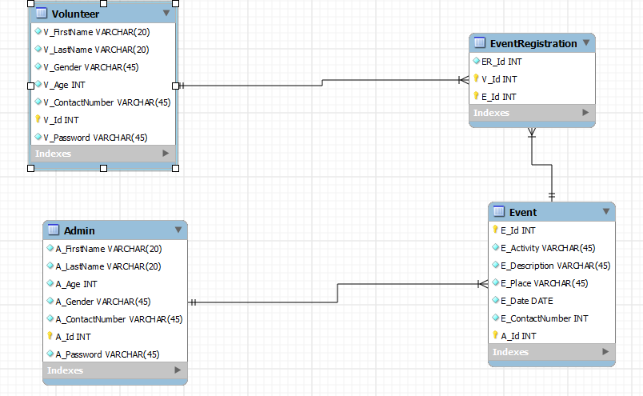

Tables Structure

Volunteer Table
Column Name | Data Type | Length | Nulls
V_FirstName | varchar | 20 | NA
V_LastName | varchar | 20 | NA
V_Gender | varchar | 20 | NA
V_Age | integer | 5 | NA
V_ContactNumber | varchar | 45 | NA
V_Id | integer | 10 | NA
V_Password | varchar | 45 | NA

Admin Table
Column Name | Data Type | Length | Nulls
A_FirstName | varchar | 20 | NA
A_LastName | varchar | 20 | NA
A_Gender | varchar | 20 | NA
A_Age | integer | 5 | NA
A_ContactNumber | varchar | 45 | NA
A_Id | integer | 10 | NA
A_Password | varchar | 45 | NA

Event Table
Column Name | Data Type | Length | Nulls
E_Id | integer | 10 | NA
E_Activity | varchar | 45 | NA
E_Description | varchar | 45 | NA
E_Place | varchar | 45 | NA
E_Date | Date |  | NA
E_ContactNumber | int | 10 | NA
A_Id | integer | 10 | NA

EventRegistration
Column Name | Data Type | Length | Nulls
R_Id | integer | 10 | NA
E_Id | integer | 10 | NA
V_Id | integer | 10 | NA

Appendices

Glossary
Acronyms | Definitions

Other

Terms & Conditions
Disclaimer: Please do not circulate or distribute this document outside of Cognizant Network, We have a Zero Tolerance Policy. Kindly adhere to 100% Compliance at all times.

Change Log
Please note that this table needs to be maintained even if a Configuration Management tool is used.
Version Number | Changes made
V<n.n> | <If the change details are not explicitly documented in the table below, reference should be provided here>
V<n.n> | Page no | Changed by | Effective date | Changes effected

