**Introduction:** The hydrological cycle is a natural process where water is transferred from one place to another through some methods and presence of some factors. It involves the continuous recycling of water between the atmosphere, land and oceans. Solar radiation is the driven factor of this cycle. If we take a look into the diagram (Ruit et al., n.d.), it can be seen that water is evaporating due to the solar radiation from the water bodies from all over the earth surface like oceans, rivers, lakes and cause vegetative transpiration. Later on this excess amount of water vapor particles go above the atmosphere and there it condensed down and forms clouds. It falls in forms of rain, snow or hail known as precipitation. The water gets stored in the ground by an infiltration process.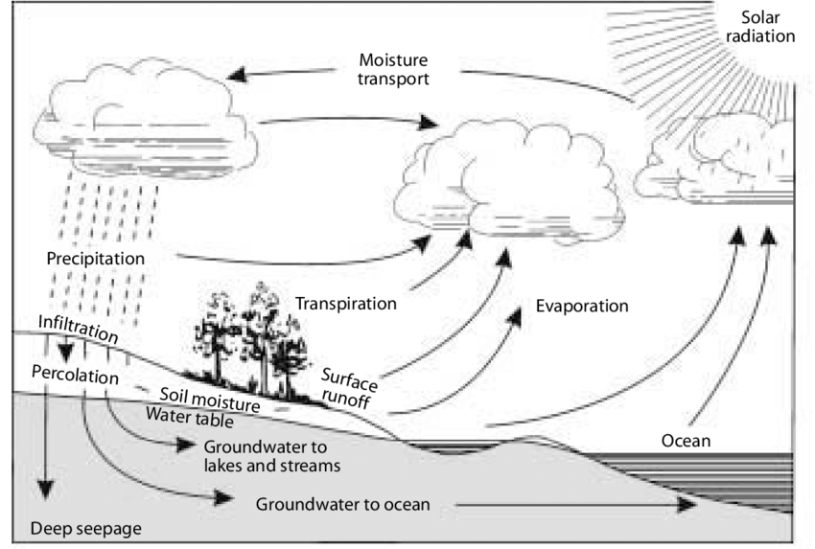

**Increasing Demands of Water:** Every year 85 Million people are added causing stress on resources and services. The demand for water is surging due to this population growth, industrial development, agriculture expansions and so on. Water is a vital source for human survival. According to UN Water (2023), agriculture accounts for approximately 70% of global freshwater usage for irrigation purposes. For cooling and operating machinery industries use 20% water. Households account for 10% of freshwater consumption. According to the Office of the Director of National Intelligence (March 2021), over the next 20 years, there will be a greater demand for water due to factors like population expansion, changes in lifestyle, development, and agricultural techniques. By 2050, the world's water consumption is expected to rise by 20–50% above current levels, with the biggest growth occurring in the household and industrial sectors. As industrial and agricultural activities increase, water resources become further stressed. This intense demand is changing the natural water cycles and its continuation of natural flow.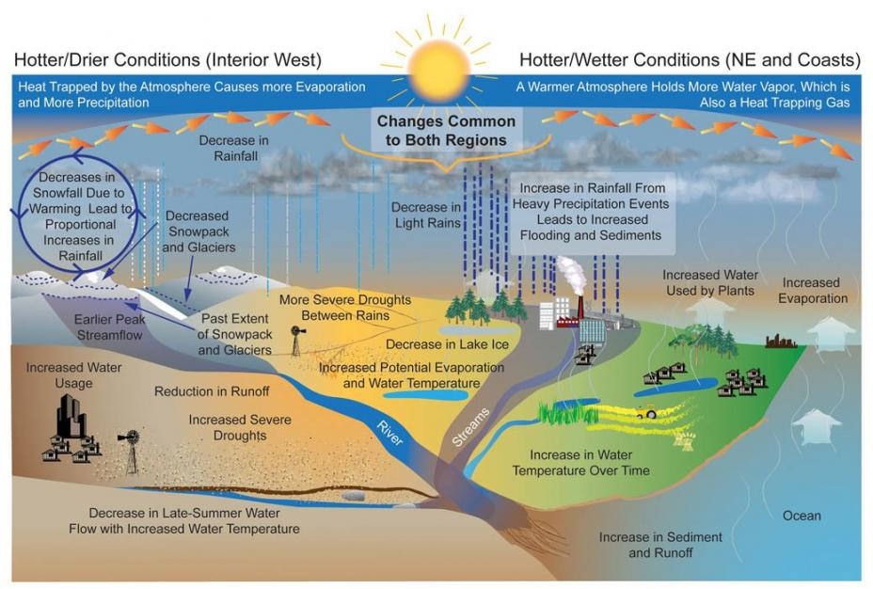

**Importance of Water:** The increased demand for water directly impacts the hydrological cycle in ways that are both immediate. There goes a proverb that 'water water everywhere not a drop to drink.' So it is clear that there is not a huge amount of freshwater. Due to the effects on the cycle the increasing water withdrawal disrupts natural water flows. Some of the notable impacts are:

1. Lowering of Groundwater Levels: One of the most significant impacts is the over extraction of surface and groundwater resources. Over pumping lowers the groundwater levels causing drying up wells and destruction of water supplies.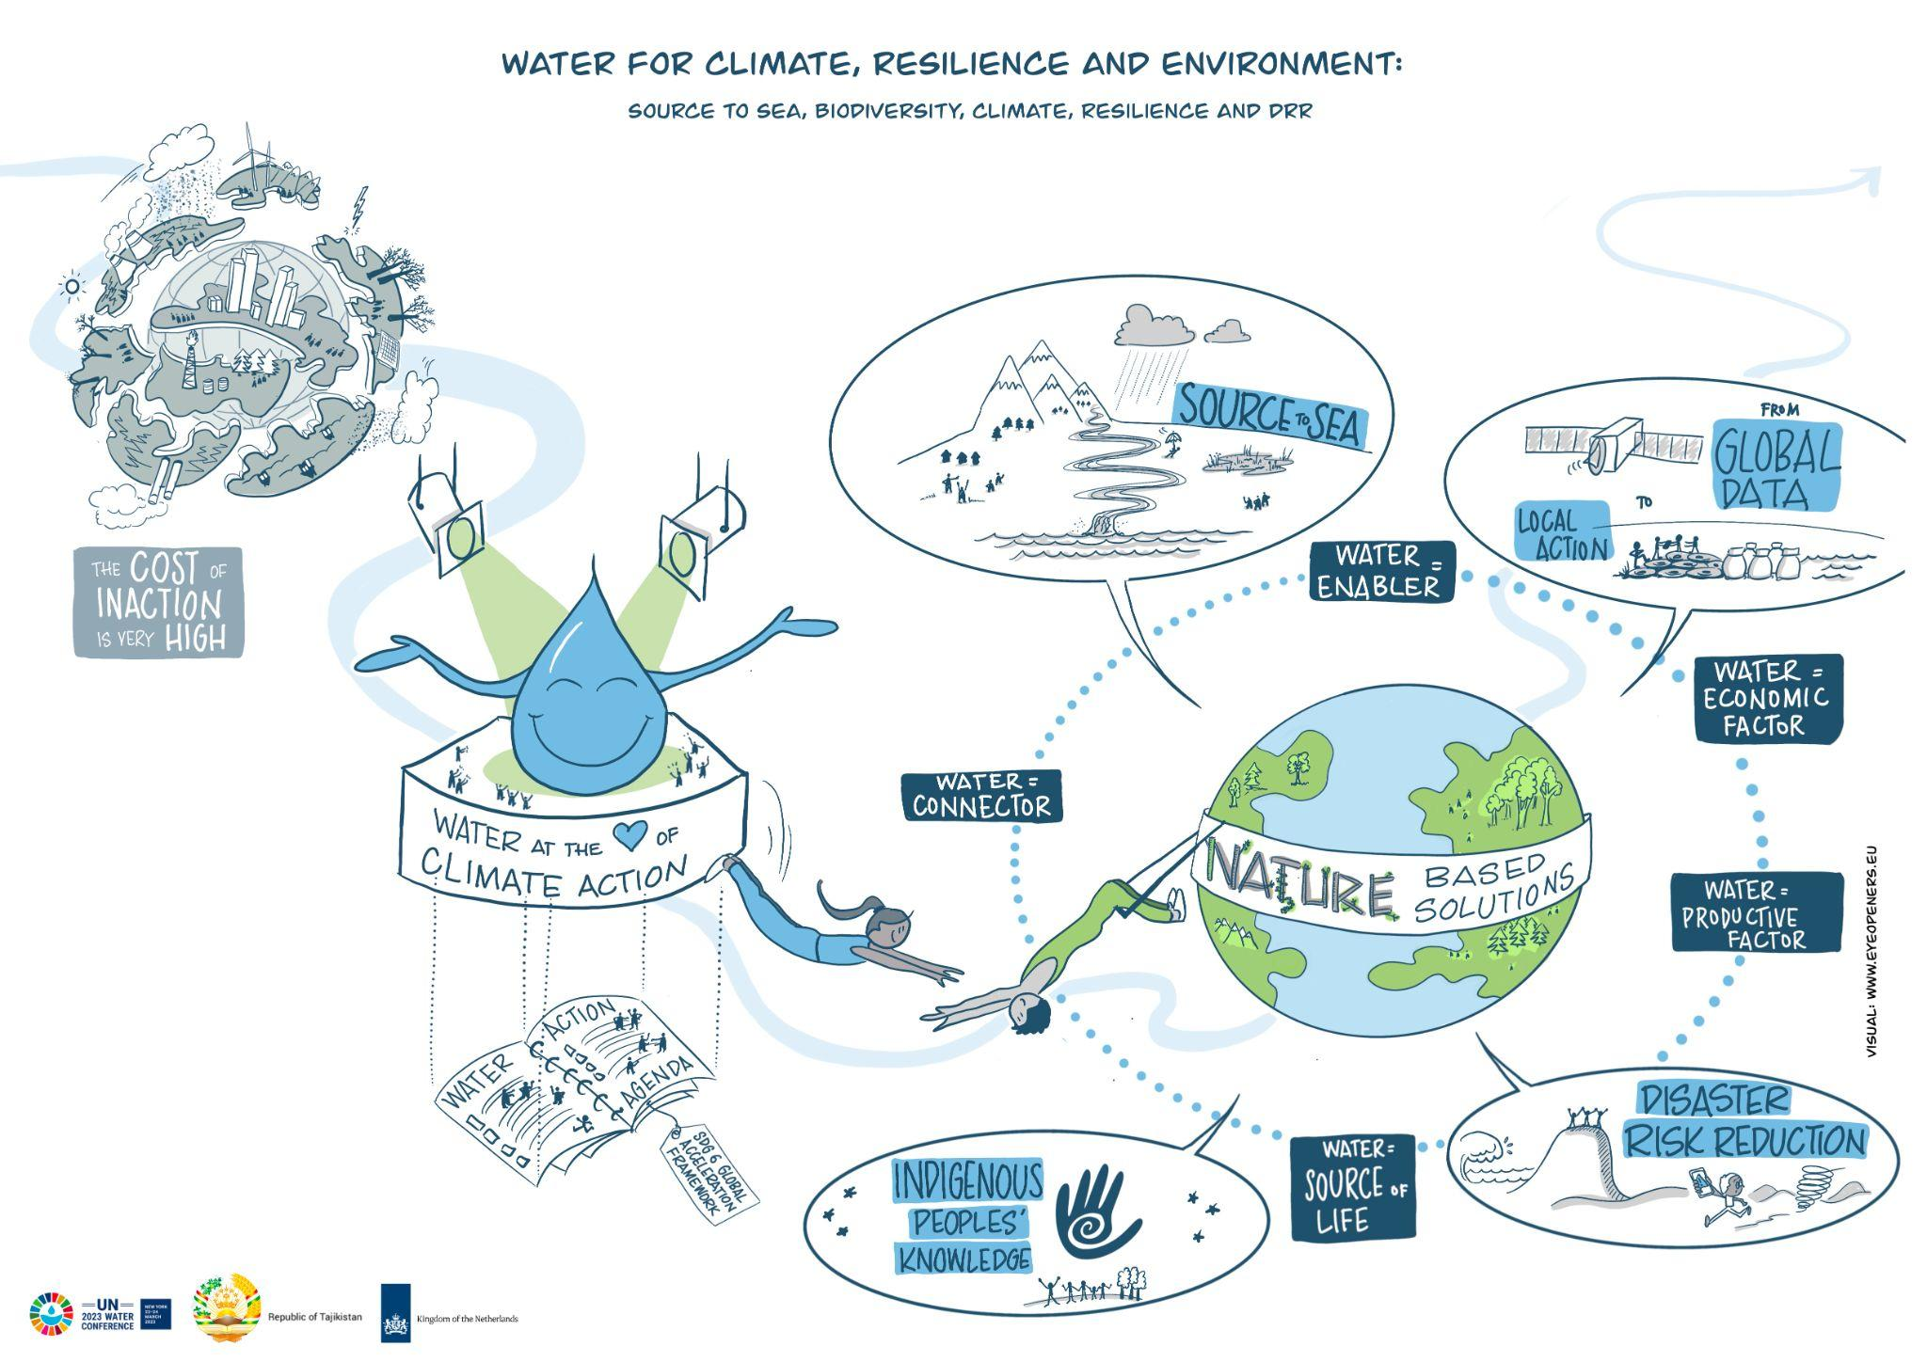
2. Alternation of River Flows: Excessive extraction for agriculture or industry reduces river flows and harms the ecosystem. It is also reducing water availability. The direction of the river and other water bodies are changing due to the mismanagement and impact on the cycle.
3. Climate Change Exacerbate: Due to increased use of water and deforestation, affects the cycle by alternating precipitation patterns and causing draughts, floods.

According to the United States Environmental Protection Agency (2016, December 21), the increased demand of water causing the lack of groundwater and water bodies are affected due to industries, habitation and others. 

**Sustainable Use of Water:** Some key methods for sustainable water use are: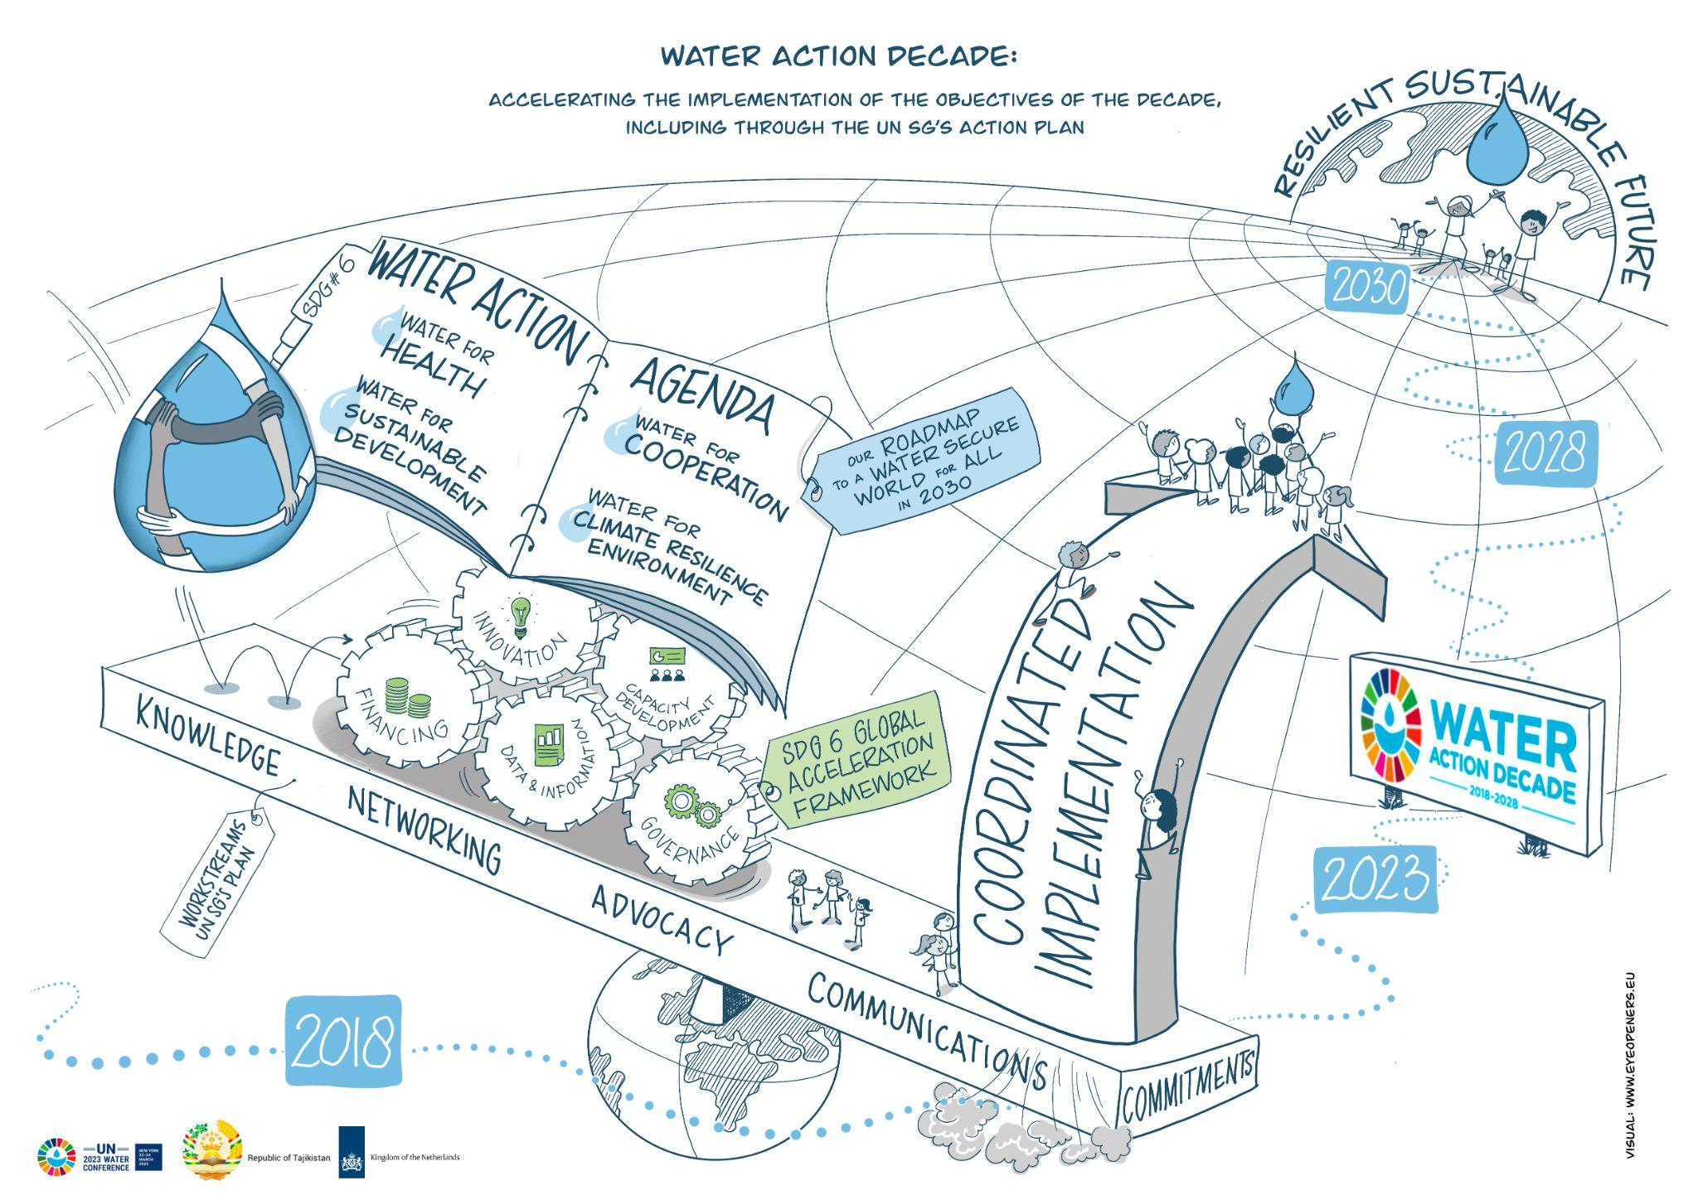

1. Efficient Irrigation Practice: According to UNDP, rainwater harvesting methods need to be started by 2025 to collect and store rainwater for irrigation. This would cause less pressure to the ground water sources. 
2. Reducing Water Loss in Urban Areas: We need to maintain and monitor to minimize water loss. We can introduce smart technologies to help in this matter. For example, smart water meters help detect leaks early and allow for repairs, preventing unnecessary wastage.
3. Water Recycling and Reuse: The industries should establish water treatment plants so that they can reuse their water again. This would minimize the pressure on the water bodies and treated waste water can be safely reused in various applications.
4. Public Awareness and Education: We need to raise awareness among communities about the importance of water and sustainability.

**Conclusion:** More sustainable management techniques are being adopted as a result of the rising demand for water. A multifaceted approach is necessary for effective water conservation. This covers policy modifications, technology advancements, and public collaboration. In order to guarantee equitable water distribution and resolve current disputes over water scarcity, cooperation between nations that share water sources is also essential. In my opinion, cultivating a culture will be necessary to achieve sustainable water management. Water would be regarded as a shared and limited resource in this culture. We can strive for a day when the hydrological cycle is stable and there will be water for future generations.

**References:**

Office of the Director of National Intelligence. (2021, March1). *Office of the Director of National Intelligence - Global Trends*. Office of the Director of National Intelligence - Global Trends. <https://www.dni.gov/index.php/gt2040-home/gt2040-deeper-looks/future-of-water>

United States Environmental Protection Agency. (2016, December 21). *Climate Impacts on Water Resources | Climate Change Impacts | US EPA*. US EPA. <https://19january2017snapshot.epa.gov/climate-impacts/climate-impacts-water-resources_.html>