Machine Learning Engineer Nanodegree
Capstone Proposal
Tyler Lanigan
November 7th, 2016

Domain Background
The quality of the comments made on internet forums has always suffered due to anonymity of it’s users. When users comments on, for instance, a YouTube video, there is no repercussion for what they say, and the dialogue generated is often not helpful. Different websites have tried different methods for extracting more useful comments. Reddit uses an upvote system, Quora fosters a community that values high quality responses over low quality ones, and Amazon allows for it’s users to to rate the “helpfulness” of reviews left on their products. Amazon’s system, in particular, then allows for the higher rated comments to be displayed at the top of the review forum so that new users can see the top rated comments in order to help them make their own purchasing decisions.

Even though Amazon’s helpfulness rating system seems to work on the surface level, poor quality comments still seem to be at the top of their review forms. Having poor quality reviews hurts Amazon’s business, as a major reason that people are willing to buy consumer goods online without seeing the items themselves, is that they have access to others peoples opinions of the item. For example, a review at the top of an app called “Friday Night at Freddies 4” is as follows:

“I love this game so much but at first I though it was lame but when I go in the game I can't beat the first night because cause I put it to full volume and I can't here the breathing bonnie strike at 4 am Chica at 5 and plus it not lame it's better than fnaf and fnaf 2 plus get this game when u buy fnaf”
This comment, despite being at the top of the forum, is difficult to understand, a run on sentence, and full of spelling errors. The reason for the failure is part of the algorithm for determining the order of the reviews relies on how recently the review has been made. The offending review was the most recent, but it’s helpfulness score was far less than previous reviews. This illustrates the difficult balance that must be struck between showing the highest rated reviews, and showing the newest reviews, to be rated by the community. An ideal system would predict the “helpfulness” of new reviews made, so that poor quality reviews would not need to be displayed the top in order for the community to rate them.

Problem Statement
The problem being addressed in this project is the poor quality of Amazon reviews at the top of the forum despite the “helpfulness” rating system. The problem arises from the “free pass” given to new reviews to be placed at the top of the forum, for a chance to be rated by the community. The proposed solution to this problem is to use machine learning techniques to design a system that “pre-rates” new reviews on their “helpfulness” before they are given a position at the top of the forum. This way, poor quality reviews will be more unlikely to be shown at the top of the forum, as they do not get the “free pass” because they are new. The proposed system will use a set of Amazon review data to train itself to predict a helpfulness score for new input data.

Datasets and Inputs
The dataset used for this project is provided by the University of California, San Diego
at a download link on their website (also referenced below). As the original dataset is massive, the problem will be formulated in the context of the Apps for Android subset of data. The data is provided in “json” format and will be converted to a pandas data frame for use in this project. Each review in the data frame has the following information:

- reviewerID - ID of the reviewer, e.g. A2SUAM1J3GNN3B
- asin - ID of the product, e.g. 0000013714
- reviewerName - name of the reviewer
- helpful - helpfulness rating of the review, e.g. 2/3
- reviewText - text of the review
- overall - rating of the product
- summary - summary of the review
- unixReviewTime - time of the review (unix time)
- reviewTime - time of the review (raw)

For our problem we will use the reviewText to generate features using natural language processing. The helpful rating will then be the target. The ‘helpful’ score can be explained as follows: a user can either rate the review as “helpful’ or ‘not helpful’. The helpful score results from taking the total ‘helpful’ ratings and dividing them by the total amount of ratings.

Solution Statement
The proposed machine learning system will use the Android App Amazon reviewText data and natural language processing to train itself to predict a helpfulness score for new input data. The system will be tested by comparing it’s prediction to a held-out testing set of data from the same dataset. The metric for determining the success of the system is discussed in more detail below.

Benchmark Model
The benchmark model used for our solution will be the quantitative ‘helpful’ score of the existing data. As this data has been rated by human users, it can be considered relatively reliable, and thus our solution should try to emulate this as much as possible.

Evaluation Metrics
In order to compare the results of our system with the benchmark model, a regression error score must be used. The follow 3 methods are examined:

Mean Absolute Error: In statistics, the mean absolute error (MAE) is a quantity used to measure how close forecasts or predictions are to the eventual outcomes. The MAE linearly penalizes an error for how far it is away from the benchmark. The mean absolute error is given by:
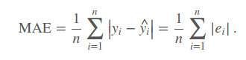
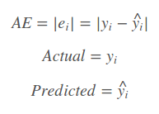
where:

Root Mean Squared error: The use of RMSE is very common and it makes an excellent general purpose error metric for numerical predictions. Compared to the similar Mean Absolute Error, RMSE amplifies and severely punishes large errors. The RMSE is given by:

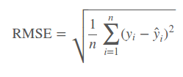

Root Mean Squared Log Error: RMSLE is also very common in certain problem formulations. It is used to more heavily penalize predictions that under-predict, rather than over-predict. The RMSLE is given by:
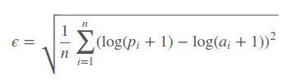
where: ϵ is the RMSLE value (score), n is the total number of observations in the data set, pi is your prediction, and ai is the actual response.
The goal of the project will be to minimize the RMSE of the system. As the MAE linearly penalizes the predictions, we could have a bunch of predictions that are significantly incorrect, offset by solutions that are only a little incorrect. The RMSLE will not be used because we don’t care if our system over predicts or under predicts. The RMSE will ensure that all of our predictions stay close to the benchmark, as predictions that are far away will be heavily penalized.

Project Design

A basic workflow is presented as follows:

- The data must be obtained and parsed into the correct format. In our case, the data will be placed in a pandas data frame as this is a commonly used data type in machine learning.
- The data will be cleaned by removing any null entries, punctuation and weird charaters/html tags. Additionally, all useless information will be removed leaving only the input text and the ‘helpful’ rating.
- Features will be generated using natural language processing techniques. Features could include ‘# spelling mistakes’, length of review, or amount of capitals in a row. Additional features could be generated using Term frequency and inverse document frequency (TFIDF).
- As this system will be a real time system, editing the reviews as they come in, performance must be taken into consideration. Therefore a feature reduction stage will take place. Methods used could be PCA or select K-best.
- The training data will be shuffled, and split into training and test data.
- A regresser will be trained on the data, and tuned using a parameter grid and cross fold validation. Different algorithms will be looked at in order to determine which works the best including: logistic regression, boosting algorithms and neural networks.
- The final result will be compared to the test set using the RMSE metric.

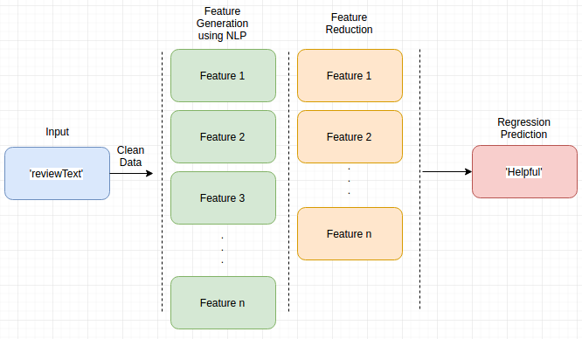

References

- Inferring networks of substitutable and complementary products. J. McAuley, R. Pandey, J. Leskovec Knowledge Discovery and Data Mining, 2015.
- Image-based recommendations on styles and substitutes J. McAuley, C. Targett, J. Shi, A. van den Hengel SIGIR, 2015.

