1.Table products

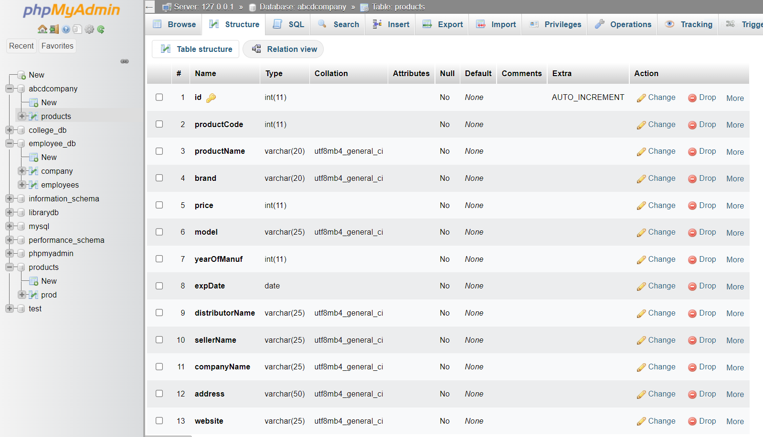

2.Inserted values

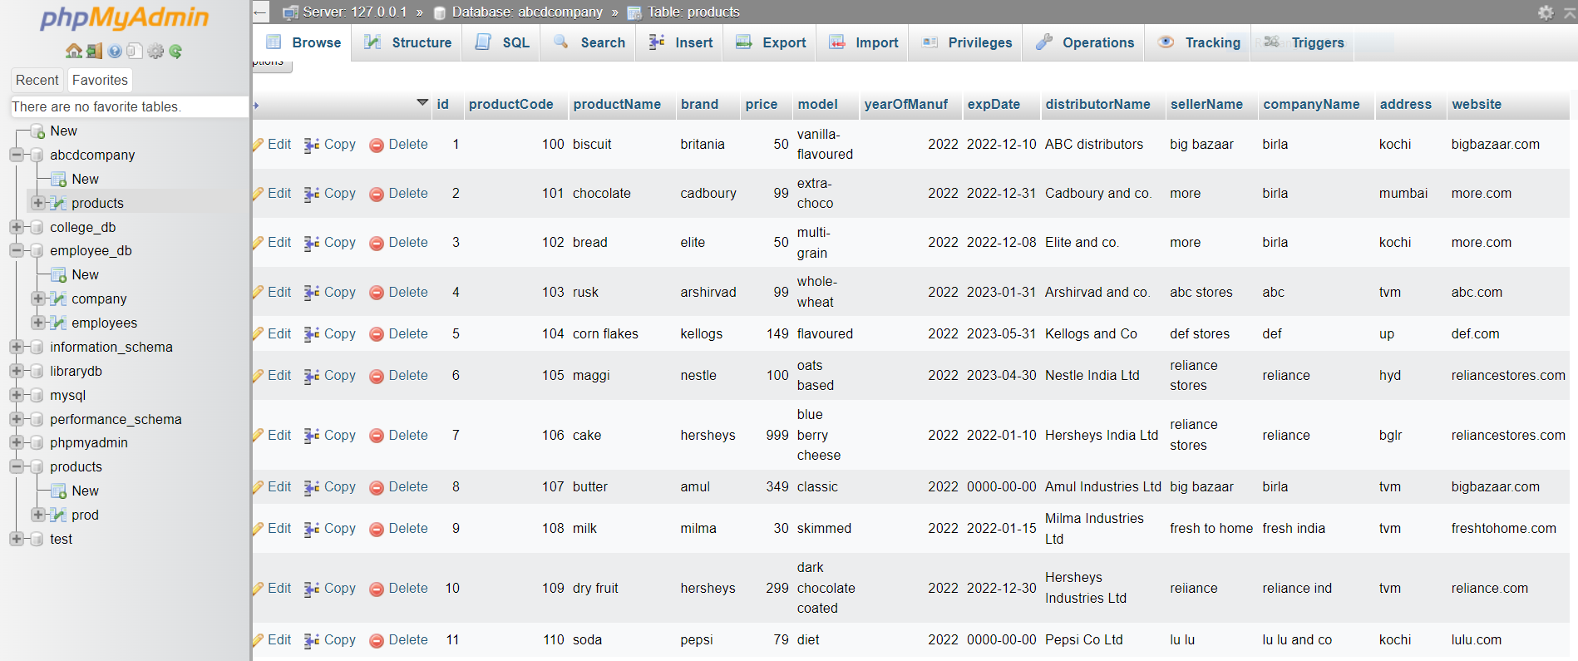

3. view all products

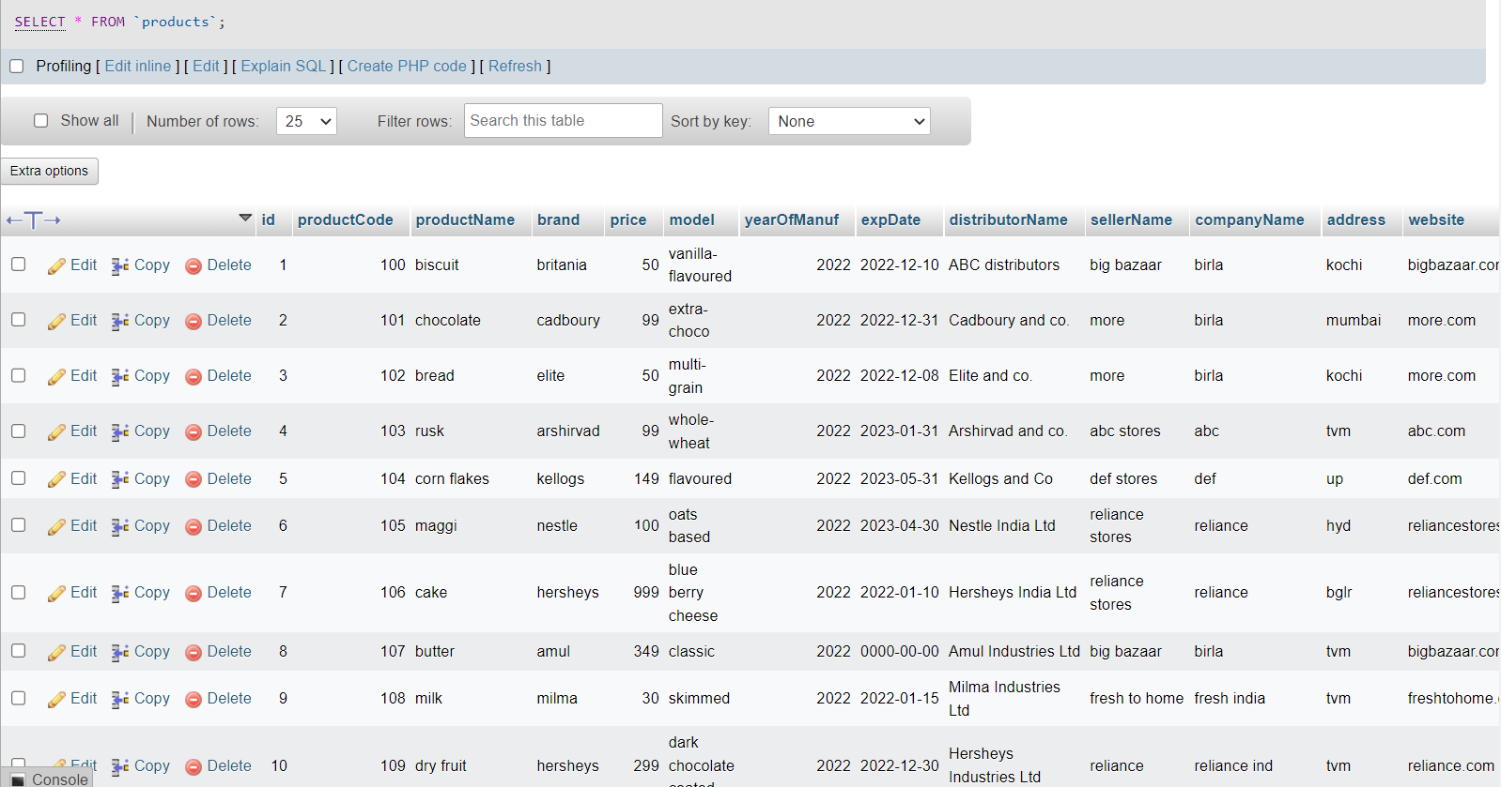
4.Search a product using product code

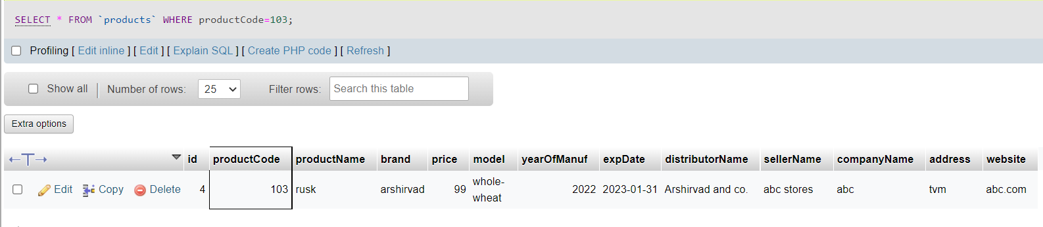

5. Update product details using product code

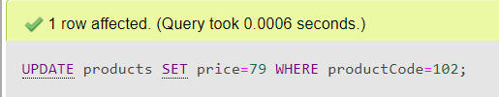

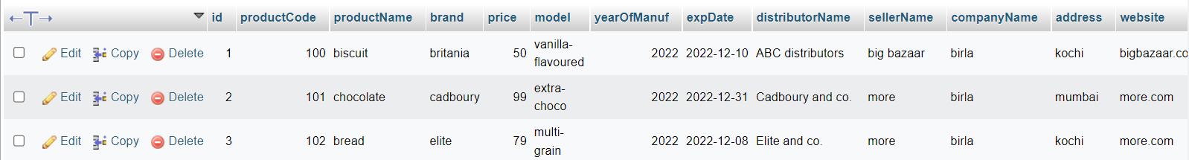

6. Delete product using product code

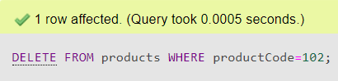

7.Display details of products whose price is greater than 50

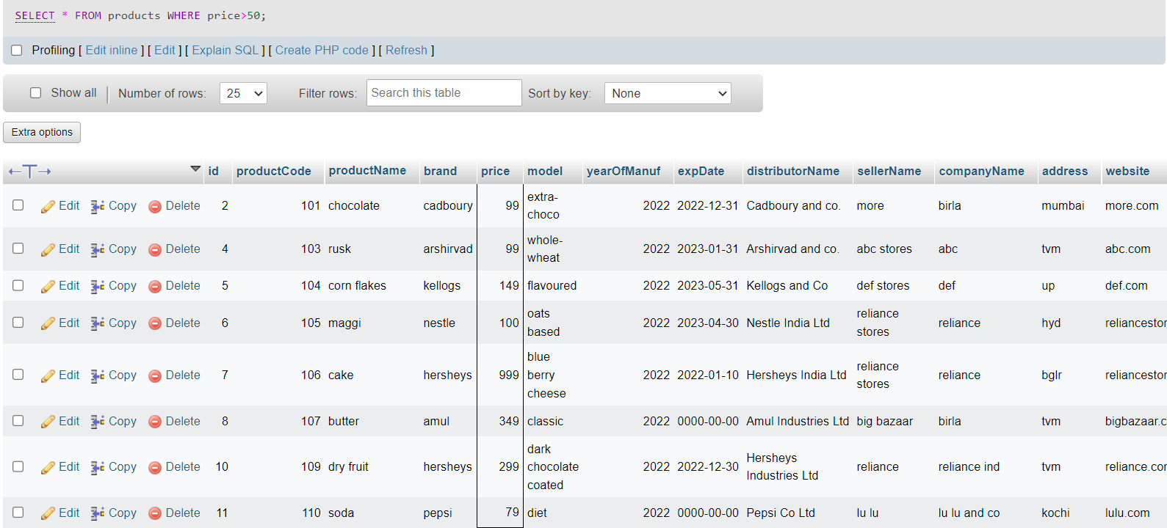

8.Display count of total no of products in company

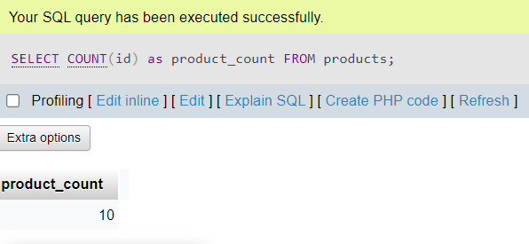

9.Display all product details in alphabetical order

