GAME DESIGN DOCUMENT

DODGE LINE
2D Tactical Tower Defense | Unity | Windows PC

1. Concept and Vision

1.1 High Concept
Dodge Line is a top-down 2D tower defense game in which some enemies predict incoming projectile threats and retreat along their route. Enemies that reach a base do not disappear: they stop and keep attacking until destroyed. In two-player cooperative play, each player protects a separate base, shares the same energy pool, and loses with the team if either base falls. Players must manage forward interception, last-line defense, and cross-lane support.

1.2 Design Pillars
- Readable counterplay: warning cues precede retreat; enemy decisions have finite reaction time, retreat distance, cooldown, and charges.
- Dual-layer defense: the path is an interception opportunity, while base-adjacent firepower remains essential because leaked enemies continue attacking.
- Shared-failure co-op: two bases, one economy, and legal shared building areas generate real coordination rather than two independent solo games.

1.3 Audience and Session
Primary audience: players comfortable with short strategy games and tower defense systems; secondary audience: two friends playing cooperative LAN sessions. Intended session length is approximately 10–15 minutes per level after tuning. The game uses mouse and keyboard and targets a fixed camera for Windows PC.

1.4 Reference Games and Design Interpretation
Reference | Relevant design lesson | Dodge Line distinction
Bloons TD 6 | Clear paths, positional tower coverage, readable escalating wave pressure | Enemy reactions to physical projectiles are part of player counterplay
Kingdom Rush | Wave preparation cues and discrete upgrade choices support planning | Enemies can survive reaching the objective and persist as attackers
Plants vs. Zombies | Teach mechanics in stages with simple visible enemies and resources | Two-base shared-failure co-op and motion-based dodging rather than fixed lanes alone

2. Core Gameplay and Player Rules

2.1 Core Loop
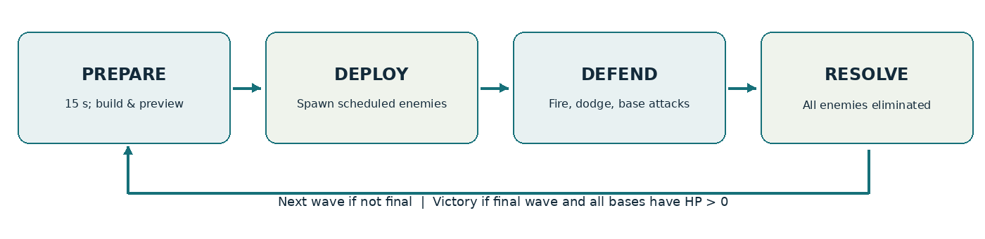
Figure 1. Wave loop; the loop repeats until the last wave or an immediate defeat.
- Preparation (15 seconds): preview enemy types and approximate pressure by lane; place, upgrade, or sell defenses. Press Space to ready; if all required players are ready, start immediately.
- Combat: the host spawns enemies at the authored interval; defenses target and fire automatically; enemies move, evade if eligible, or attack their assigned bases. Players may build and modify defenses during combat.
- Resolution: a wave ends only when all scheduled enemies have spawned and all are dead. Award the wave-completion bonus and enter the next preparation phase.
- Victory or defeat: win after all enemies from the final wave are destroyed and every required base retains positive HP. Lose immediately if any required base reaches zero HP.

2.2 Controls and Player Actions
Input | Action | Validation / response
Left mouse | Select a defense or place the chosen defense | Show ghost position and range; legal placement only if enough energy and no forbidden overlap
Right mouse / Esc | Cancel selection or placement | Never spends energy
1 / 2 / 3 | Select Thorn Bow / Dust Cannon / Wire Trap | Buttons disabled until unlocked and affordable
U / X | Upgrade / sell selected defense | Upgrade to level 3 maximum where applicable; host validates shared energy
Space | Ready/start next wave | Solo starts early; in co-op, all players ready or 15-second countdown expires
P | Pause in solo mode | Co-op does not pause the authoritative simulation

Weapon and Trap Placement Rules
The game distinguishes between defensive towers and ground traps, each following different placement rules.
Defensive Towers (Thorn Bow and Dust Cannon):
- Can only be placed on valid buildable terrain.
- Cannot be placed on enemy paths, bases, obstacles, or occupied tower positions.
- Automatically attack enemies within their effective range.
Wire Traps:
- Can only be placed directly on valid enemy path tiles.
- Cannot overlap other traps, spawn points, bases, or enemies currently occupying the placement position.
- Do not physically block enemy movement or alter their predetermined paths.
- Activate when an enemy enters their trigger area, reducing movement speed by 50% for 2 seconds.
- Each trap can affect up to six distinct enemies before being removed.
- An enemy can activate the same trap only once, even if it passes through the trigger area multiple times while advancing or evading.
- A trap only activates for enemies traversing its assigned path segment. Enemies on separate nearby paths cannot trigger it merely by entering the physical detection radius.
- Slow effects from multiple Wire Traps do not stack multiplicatively.
Placement Feedback:
When selecting a defensive tower or Wire Trap, the player sees a placement preview. The preview indicates valid and invalid placement positions. Wire Traps snap to valid path tiles, while defensive towers can be positioned freely within valid buildable areas.
All placement requests are validated by the host in cooperative mode.

2.3 Base Attack and Final Defense
On reaching the end of its assigned path, an enemy enters AttackBase and stops at a predefined attack slot near that base. It remains alive and targetable. The first attack occurs after the enemy-specific wind-up delay; subsequent attacks occur at the specified attack interval. Damage is applied on discrete attack events, never every frame. Attackers in AttackBase no longer dodge. The base does not automatically retaliate. Defenses may target attacking enemies, and targeting prioritizes AttackBase units ahead of moving enemies.
Each base must have legal building terrain from which at least one committed defense can hit every valid attack slot. If several enemies reach a base, they occupy preassigned slots or non-overlapping points within a targetable defense zone. The path endpoint is not a safe zone outside tower range.

2.4 Victory, Loss and Scoring
Solo victory: final-wave spawn queue empty, no active enemies, and Base A HP > 0. Cooperative victory: the same enemy-clear condition, and both Base A and Base B HP > 0. Either base at 0 HP triggers immediate shared defeat. Score = 100 × total remaining base HP + remaining shared energy + kill points. Kill points are distinct from the energy bounties; initially kill points equal 10 per ordinary enemy and 100 for a miniboss.

3. Weapons, Projectiles and Physics

3.1 Weapon Specifications (Initial Tuning Values)
Defense | Base cost | Damage L1/L2/L3 | Fire interval | Range L1/L2/L3 | Special behavior
Thorn Bow | 50 | 12 / 17 / 23 | 0.80 s | 4.0 / 4.3 / 4.6 | Single-target physical projectile; travel speed 6 units/s; upgrades cost 35 and 45
Dust Cannon | 90 | 22 / 30 / 40 | 1.60 s | 5.0 / 5.2 / 5.5 | Physical shell, 5 units/s; explosion radius 1.2; upgrades cost 65 and 85
Wire Trap | 35 | No damage | Triggered by eligible enemy entry | Activation radius 0.8 | Placed directly on valid path tiles; non-blocking trigger; 50% slow for 2 seconds; up to 6 distinct enemy activations; no upgrades.

The damage and upgrade tables are the authoritative numeric source. Earlier continuous damage formulas and older upgrade cost percentages are removed because they do not match the new rounded values. Damage after armor = max(1, base damage − target armor). No upgrade branches are planned.

3.2 Targeting and Lead Aim
Defenses first prioritize enemies in AttackBase within range. Otherwise they target the in-range enemy with the shortest remaining path distance to its assigned base. The target is acquired when a firing cycle completes. A moving enemy is aimed at using a two-step iterative travel-time estimate: t ≈ distance(weapon, enemy) / projectile speed, then aimPoint ≈ enemyPosition + enemyVelocity × t. The projectile travels in a fixed direction/trajectory after release and does not home. Predictions around turns are intentionally approximate for MVP; physics collision determines hits.

3.3 Projectile and Explosion Rules
- Thorn projectile: kinematic Rigidbody2D with a trigger hitbox; fixed heading and speed, despawns on first valid enemy hit, blocker hit or lifetime expiry.
- Dust shell: travels to a locked aim point; explodes on first enemy impact or arrival at that aim point, whichever occurs first; a timed failsafe prevents lingering shells.
- Dust explosion: overlaps enemies within a fixed radius of 1.2 units; applies damage at most once per enemy per explosion. No blast falloff in MVP.
- Projectile-owner and team colliders are ignored; enemy hitboxes are consistent with sensor and damage rules. Reused object pools are desirable after profiling, not a prerequisite for the first prototype.
- Slow effect: An activated Wire Trap reduces enemy movement speed by 50% for 2 seconds. Each enemy can activate the same trap only once, including when it retreats and passes through the trap again. Activation by another trap refreshes the slow duration but does not stack the speed reduction multiplicatively.

3.4 Physics and Collision Responsibilities
Physics2D handles projectile collision detection, radial damage queries, enemy hitboxes, and non-blocking Wire Trap triggers.

Each Wire Trap uses a Collider2D configured as a trigger rather than a solid obstacle. Traps are placed directly on valid enemy path tiles and do not block movement, redirect enemies, or modify their predetermined routes.

When an enemy enters a trap's trigger area, the system verifies that the enemy is traversing the trap's assigned path segment and has not previously activated that specific trap. If the activation is valid, the slow effect is applied and the trap's remaining activation count decreases by one. The trap is removed after affecting six distinct enemies.

Enemy navigation remains controlled by authored paths and path progress rather than physical separation forces. In cooperative mode, the host authoritatively validates trap placement, activation, status effects, and removal..

4. Enemy AI and Navigation

4.1 Enemy States
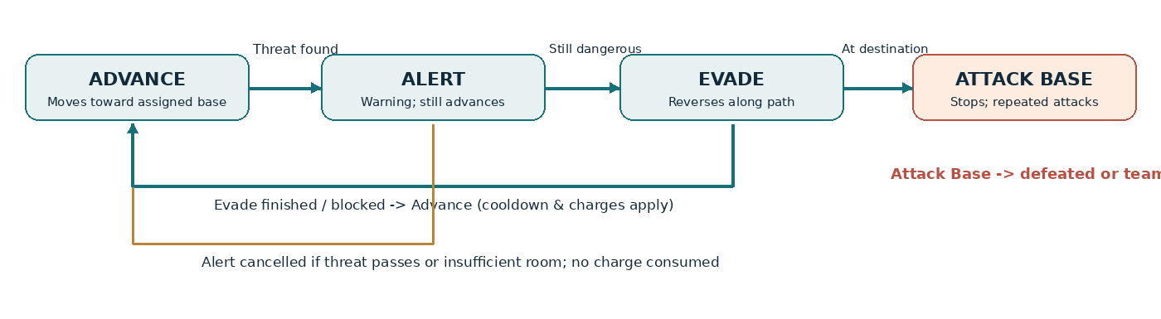
Figure 2. Behavior flow. Death is a terminal event from every active state.
Advance means moving toward the target base. Alert signals a predicted projectile threat while the enemy continues advancing during reaction time. Evade reverses a bounded distance along the already traveled route. AttackBase begins on reaching the target base and lasts until defeat or team loss. Death is a terminal event rather than a fifth walking state.

4.2 Threat Detection (Closest Point of Approach)
Every 0.1 s, an eligible dodging enemy considers nearby active physical projectiles. Let d = projectilePosition − enemyPosition and u = projectileVelocity − enemyVelocity. For ||u||² > ε, the nearest-approach time is tCPA = clamp(−dot(d,u) / ||u||², 0, min(1.2 s, projectileRemainingLifetime)). The predicted separation is δ = ||d + u × tCPA||. A threat exists if δ <= enemyHitRadius + projectileHitRadius + safetyMargin. If ||u||² <= ε, use current separation and avoid division by zero.
The decision to react is deterministic in the committed MVP: if the enemy has charges, its cooldown has expired, and a new projectile qualifies as dangerous, it enters Alert. Each enemy-projectile pair is evaluated for an alert decision only once while that projectile exists; repeated 10 Hz ticks must not reroll a probability. This is an attempted dodge, not a guaranteed successful dodge.

4.3 Evasion and Counterplay
After the reaction delay, the enemy rechecks whether the threat remains. If it remains and the available retreat distance is at least 0.3 units, the enemy reverses up to its maximum backstep, constrained by the origin and occupied path space. A charge is consumed and cooldown begins only when the reverse motion actually starts. If a threat passes or retreat is impossible, Alert ends without consuming a charge. The physical hit or miss is resolved by projectile collision. Enemies in AttackBase never evade.
Counterplay: The Thorn Bow relies on timing and positioning, while the Dust Cannon retains area damage even when its projectile misses the intended enemy directly. Wire Traps are placed directly on valid enemy path tiles and slow enemies that cross them while advancing or retreating. Because traps do not produce incoming projectiles, dodging enemies cannot detect or evade them through the projectile threat-sensing system. A retreating enemy may trigger a previously unused trap, but the same enemy cannot consume multiple activations from that trap. High-density enemy groups may also restrict retreat space. Warning symbols and retreat animations make these interactions observable to players.

4.4 Enemy Statistics (Initial Tuning Values)
Enemy | HP | Move speed | Armor | Base attack dmg / interval / first hit | Reward | Dodge
Runner | 40 | 1.6 | 0 | 1 / 2.0 s / 1.0 s | 6 | No
Retreat Wisp | 55 | 1.3 | 0 | 1 / 2.0 s / 1.0 s | 10 | 2 charges; 0.20 s alert; backstep 1.5; reverse speed 1.2×; 4 s cooldown
Iron Guard | 160 | 0.8 | 4 | 2 / 3.0 s / 1.5 s | 20 | No
Shadow Matriarch | 450 | 0.7 | 3 | 3 / 4.0 s / 2.0 s | 100 | 3 charges; 0.15 s alert; backstep 1.0; reverse speed 1.2×; 6 s cooldown

The miniboss uses the same AI code as Retreat Wisp with different EnemyData, not a separate behavior tree. Values are baseline parameters and must be balanced with actual survival and base-attack pressure.

4.5 Path Following and Enemy Spacing
Each map contains authored paths represented by ordered waypoint segments. An enemy stores pathId, segmentId, pathProgress, targetBaseId and local speed modifier. Movement advances or decreases pathProgress. When enemies share a segment, minimum separation is enforced along the path; at merges, both incoming streams enter one common segment under a deterministic occupancy rule. Retreat cannot pass another enemy or the spawn boundary. A* search and dynamic weighted re-routing are not part of the committed MVP.
Enemy navigation paths and trap placement areas are represented separately. Waypoints define how enemies move, while valid path tiles define where Wire Traps may be placed. Each trap is associated with the path segment it occupies. This prevents traps from affecting enemies on nearby but separate routes. Wire Traps only modify movement speed when activated; they never block or change the assigned navigation path.

4.6 AI Acceptance Tests
Test case | Acceptance evidence
Repeated projectile sensing | One projectile does not trigger multiple separate alert decisions for the same enemy
Threat no longer exists | Alert cancels; no charge or cooldown spent
Blocked retreat | Enemy does not clip through another enemy; no charge spent if movement never begins
Finite dodges | After 2 Wisp or 3 Matriarch successful evade starts, no further retreats occur
Damage still physics-driven | A retreating enemy can still be hit; a missed projectile is not recorded as a hit
Detection / attempt / success logs | Separately count eligible threats, starts of Evade, and actual projectile misses; no pre-claimed success percentage

5. Resource Economy and Difficulty

5.1 Energy and Defense Economy
Setting | Solo | Co-op
Starting energy | 150 | 250 shared
Passive income | 2 energy/s during active combat only | 3 energy/s shared during active combat only
Kill rewards | Table in Section 4.4 | Same bounty per kill; rewards go to shared pool
Wave-clear reward | 20 + 5 × wave number | Same formula once per wave
Ready early bonus | +5 energy when player starts before timer expires | +5 once when both players ready before expiry
Sell refund | 70% of total paid for base + upgrades, rounded down | Identical shared refund

The economy values are starting assumptions, not guaranteed totals. Enemy leaks are impossible in this design because enemies persist in AttackBase; the team earns bounty only on kills. The old estimate of 3,300 energy per level is removed until simulated wave durations and playtests are available.

5.2 Scaling and Balance Rule
Effective enemy HP = base HP × (1 + 0.08 × (waveIndex − 1)) × levelMultiplier. Level 1 multiplier is 1.00 and Level 2 is 1.10. In cooperative mode, the same per-enemy HP applies; do not add an automatic co-op HP multiplier until playtests justify one. Co-op wave size is initially 1.5 times solo count (rounded by type), distributed across two bases by prevalidated patterns. Boss counts are explicitly authored, not multiplied. Armor and attack damage do not scale with wave index in MVP.
Balance is evaluated through base HP remaining, average wave duration, tower diversity, pressure at AttackBase, and both players’ contribution to co-op defense. Theoretical DPS (damage/attack interval) is a reference metric, not sufficient proof of balance because aim, armor, AoE, time in range, and dodges alter effective damage.

6. Level and Content Design

6.1 Content Progression
Level | Waves | Unlocked defenses | New challenge | Committed outcome
1 — Forest Road | 6 | Thorn Bow and Wire Trap | Introduce placement, upgrade/sell, Wisp warnings, armored enemies and miniboss | One-base clear and two-base co-op variant
2 — Forked Crossing | 8 | Adds Dust Cannon | Two paths/branch pressure, area damage, shared coverage positions | One-base clear and two-base co-op variant

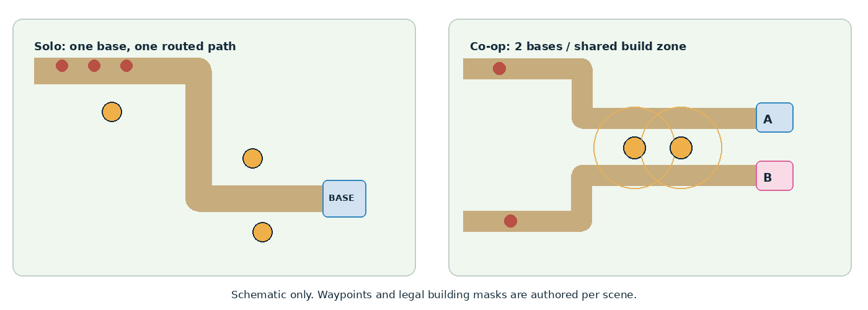
Figure 3. Navigation schematic. The co-op variant provides two destinations, but a shared central build area allows meaningful support.
Map dimensions, exact route lengths, and build masks are authored in Unity scenes. In both variants, the end-of-route attack slots must be covered by at least one legal defense placement. Obstacles block placement but do not change the authored enemy route.
Each level defines separate placement areas for defensive towers and Wire Traps. Thorn Bows and Dust Cannons can only be placed on valid buildable terrain outside enemy paths. Wire Traps can only be placed directly on designated path tiles, excluding spawn points, bases, base attack slots, occupied trap positions, and positions currently occupied by enemies.

Trap placement areas are aligned with the authored enemy routes. Traps remain non-blocking and do not change enemy navigation. The placement preview visually distinguishes valid tower terrain from valid trap locations.

6.2 Level 1 WaveData — Forest Road
Wave | Runner | Retreat Wisp | Iron Guard | Matriarch | Teaching / pressure
1 | 6 | 0 | 0 | 0 | Place Thorn Bow; core feedback
2 | 8 | 0 | 0 | 0 | Upgrade/sell; first line defense
3 | 8 | 2 | 0 | 0 | Show threat warning and retreat
4 | 8 | 4 | 1 | 0 | Mix evasion and armor
5 | 10 | 4 | 2 | 0 | Introduce last-line defense
6 | 8 | 5 | 2 | 1 | Mini-boss and full loop

6.3 Level 2 WaveData — Forked Crossing
Wave | Runner | Retreat Wisp | Iron Guard | Matriarch | Primary focus
1 | 8 | 3 | 1 | 0 | Introduce second route and Dust Cannon
2 | 10 | 4 | 2 | 0 | AoE placement and shared range
3 | 10 | 6 | 2 | 0 | Mixed timing
4 | 12 | 6 | 3 | 0 | Increased merge pressure
5 | 10 | 8 | 4 | 0 | Retreating groups
6 | 12 | 8 | 4 | 0 | Two-lane resource competition
7 | 14 | 8 | 5 | 0 | Late-wave hold
8 | 12 | 9 | 5 | 1 | Final cooperative coordination

6.4 Cooperative Wave Allocation
Solo uses authored spawn schedules. Co-op uses the same enemy compositions scaled to the two-base mode and prevalidated spawn allocation patterns, rather than arbitrary independent random spawns. For each wave the host selects a seeded pattern that usually keeps estimated threat on each lane around 40–60% of the total; boss allocation is explicitly constrained and displayed during preparation. The preview identifies pressure for both bases, so random variety never removes planning time.
Each enemy receives targetBaseId and pathId when spawned and never switches bases while moving. Both players can place defenses on any legal terrain, including their partner’s lane. Co-op enemies may be targeted by towers covering either lane.

6.5 Tutorial and Pacing
- Level 1, Wave 1: contextual prompt for selecting and placing a Thorn Bow; legal preview highlights eligible terrain.
- Level 1, Wave 2: prompt for upgrade and sell and a warning that reaching the base starts repeated attacks rather than despawning.
- Level 1, Wave 3: Introduce the Retreat Wisp and its warning behavior. Teach players to place a Wire Trap directly on a valid path tile to slow advancing or retreating enemies. The placement preview highlights valid path tiles and rejects placement on ordinary buildable terrain. The first warning briefly pauses the local single-player tutorial presentation, while cooperative mode uses a non-blocking callout.
- Level 1, Wave 5: show why a backup tower near the base matters.
- Level 2, Wave 1: show Dust Cannon, AoE target marker and the two-lane co-op HUD.

7. Network and Two-Base Cooperative Play

7.1 Mode and Authority
The committed network mode is 2-player host–client over the same LAN, using Netcode for GameObjects and Unity Transport compatible with the team’s selected Unity version. The host runs the authoritative GameManager, enemy AI, damage, energy, bases and wave state. Clients send validated commands and display state. Internet relay, server hosting and mid-session rejoin are out of scope.
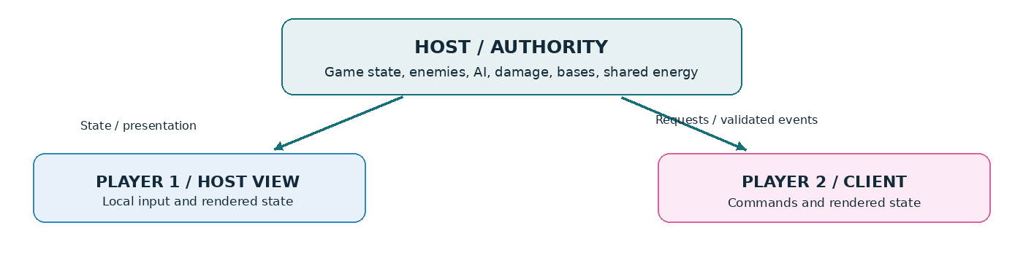
Figure 4. Host-authoritative data flow for a two-base game with a shared economy.

7.2 Replicated State and Commands
Category | Owner / synchronization | Validation
Global game phase, wave, shared energy | Host; synchronized authoritative values | All changes only on host
Base A HP and Base B HP | Host; separate per-base state | Either <= 0 triggers shared defeat
Enemy: pathId, targetBaseId, state, health, position | Host-created authoritative enemy objects; client interpolation | No client-side authoritative damage or AI
Tower and trap placement, upgrades, sales, and trap activation | Client sends placement or modification requests to the host. The host creates and updates defensive objects and synchronizes trap activation counts and effects. | Host validates shared energy, unlocked defense types, tower buildable terrain, trap path tiles, forbidden overlaps, and eligible trap activations.
Ready for next wave | Each participant signals ready; host starts on both ready or timer expiry | One bonus maximum per wave
Projectile fire / hit / death cues | Host authoritative results; clients render cosmetics | No second hit computation on client

Concurrent spending is serialized by the host. If both players attempt to buy with insufficient combined energy, at most one transaction is accepted. Requests denied by the host remove their provisional placement ghost and show short visual/audio feedback. Color and icon shape indicate which player placed each tower; neither player has exclusive building zones.

7.3 Disconnect and Latency
If a client leaves, the host may continue the same wave alone with both bases still active; the rules and enemy counts are not automatically rescaled mid-wave. If the host leaves, the client returns to the main menu with an explanation. Latency handling emphasizes interpolation and confirmation of build commands; responsiveness is validated on a LAN and with artificial delays, but no fixed RTT or packet-loss tolerance is claimed before testing.

7.4 Network Acceptance
- Two Windows builds join one LAN session and display the same wave and both base HP values.
- Two simultaneous purchase requests cannot drive the shared energy below zero.
- Enemies remain assigned to the same base on both machines, including during retreat and base attack.
- One base reaching zero ends the session for both players.
- Host and client resolve win/loss identically after the final enemy dies.

8. World, Visuals, UI and Audio

8.1 Setting and Characters
The Mist Valley is defended by isolated forest outposts against shadow creatures that learned to recognize projectile trajectories. A Wisp retreats when it predicts a collision; armored enemies absorb fire; the Shadow Matriarch commands the final assault. In co-op two wardens protect separate outposts, and the fall of either endangers the whole valley. Story is conveyed through short level-intro text, contextual wave prompts and visible enemy feedback; no cutscenes are required.

8.2 Style Guide and Mood Board
Art direction: readable flat hand-painted fantasy from a fixed top-down camera. Forest ground #4A6B4F; path #B89B72; cool mist/UI #C9D6DF; weapons #F2A93B; enemies/warnings #C8483B; Player 1 #3FA7D6; Player 2 #E85D9C. Distinguish enemies by shape, not color alone. Use patterned legal/forbidden placement previews.
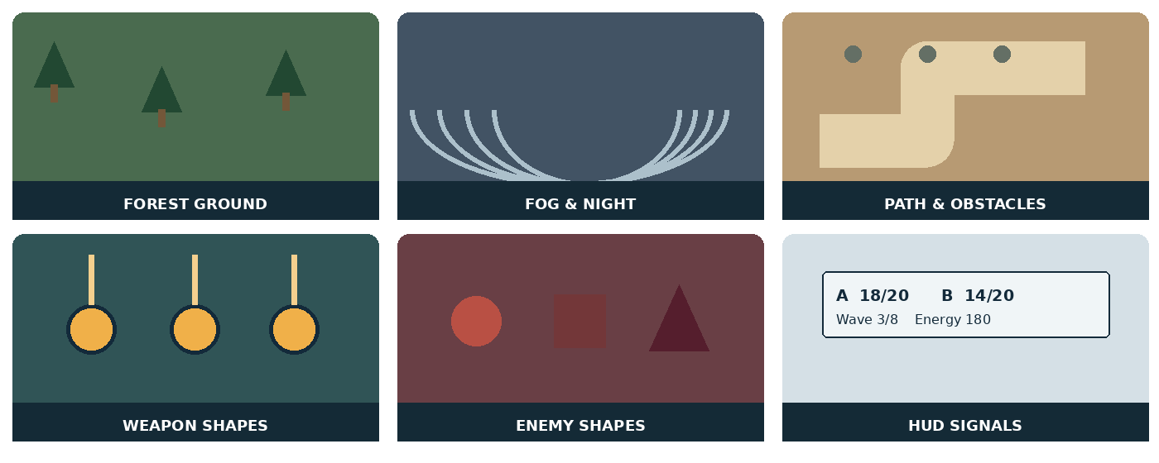
Figure 5. Six original visual studies showing terrain, fog, path geometry, towers, enemy silhouettes and HUD language.

8.3 HUD Wireframe
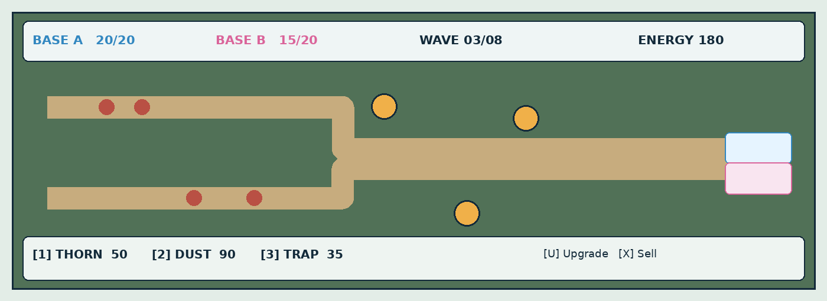
Figure 6. Cooperative HUD wireframe. Solo hides Base B. Layout is a functional mockup, not final artwork.
HUD must show Base A HP, Base B HP (in co-op), current wave, shared energy, selected defense, build costs, remaining preparation time, and warning indicators for enemies attacking either base. Tower range and AoE preview appear on selection. A secondary signal identifies the owning player without relying exclusively on color.
When a Wire Trap is selected, the placement preview highlights valid enemy path tiles rather than ordinary buildable terrain. The preview also indicates the trap's trigger radius. Once placed, selecting a trap displays its remaining activation count out of six. Invalid placement attempts provide immediate visual feedback without spending energy.

8.4 Screen Flow
Main Menu -> Solo / Co-op -> (Solo level select / Host or Join LAN) -> Preparation -> Combat -> Next Wave -> Win or Loss -> Retry / Menu. Settings include master/music/SFX volume. The pause panel is solo-only. Host selects the map and informs the client; no matchmaking or account system is planned.

8.5 Audio List and Asset Plan
Asset class | Minimum planned set | Production approach
Sprites | 3 defenses (with subtle upgrade indicators); 4 enemies with move/death frames; base and tile variants | Original or correctly licensed third-party assets; document provenance
UI | Defense icons, status icons, 2 base HP displays, warning marker, menu/pause/win/lose | Consistent scale and accessible labels
SFX | Place/reject, upgrade/sell, three defense activations, hit/explosion, Wisp alert/retreat, base hit, win/lose, UI select | Small curated library; no need for separate sound for every enemy type
Music | Menu loop, combat loop, short win/lose cues | Licensed or original; sources recorded in Credits

Every third-party asset is recorded in an asset-credit register with name, creator, source URL, license type and modifications. Assets generated using AI are separately declared. Do not present acquired art as student-created art.

9. Technical and Production Plan

9.1 Unity Architecture
Component | Responsibility
GameManager | Preparation / combat / win / loss state transitions and rules
WaveSpawner + WaveData | Author and spawn waves; in co-op allocate targetBaseId/pathId from approved patterns
PathData + PathFollower | Waypoint paths, progress, lane merge and retreat spacing
EnemyController + EnemyAI | FSM, CPA, combat state and damage receipt
BaseController | Assigned attack slots, HP, repeated damage and team defeat
TowerWeapon + Projectile | Tower targeting, firing, upgrades, projectile movement, hit detection, and area damage.
WireTrap | Non-blocking path trigger, enemy activation tracking, movement slow effects, remaining activation count, and removal after six distinct activations.
PlacementSystem | Validates tower buildable areas and Wire Trap path tiles separately; manages placement previews, path-tile snapping, overlap checks, affordability, and host-validated placement requests.
ResourceManager | Shared or solo energy, rewards, upgrade/sell and score
NetworkSession / authoritative commands | Host/join, validated placement and synchronized gameplay state
UIManager + AudioManager | HUD, prompts, feedback, menus and playback

Static balance data lives in ScriptableObjects: EnemyData, WeaponData, WaveData and LevelData. Runtime objects track health, charges, cooldown, path progress, projectile IDs, ownership and base references. Maintain a logical separation between simulation and presentation. Git branches should be feature-based, reviewed through pull requests, with Unity .gitignore and only necessary source/assets committed.

9.2 Eight-Week Milestones
Week | Exit criterion
1–2 | Repo/scenes established; one path, Runner, Thorn Bow, core spawn/damage/base attack, functional solo win/lose
3 | Wisp FSM and CPA prototype; first host–client connectivity and one validated placement request
4 | Vertical slice: one short playable wave on two bases with shared energy and synchronized HP
5 | Dust Cannon and Wire Trap; Iron Guard and Matriarch data; attack slots and co-op allocation
6 | Level 2 content, full HUD/menu/tutorial prompts; all MVP states integrated
7 | External playtests, economy tuning, performance profiling, network fault scenarios, licensed art/audio
8 | Bug fixes, release build on clean PC, README, asset credits, A2 change log and team oral demo

9.3 Workstream Roles
Workstream | Responsibilities / evidence
Gameplay integration | GameManager, placement, resources, weapons; a complete solo playthrough
AI and movement | PathData, CPA, FSM, base attack logic and reproducible tests
Network | NGO session, requests, replicated state and two-build test evidence
UI/UX and level design | HUD, menu, map build masks, onboarding and playtest observations
Art/audio/quality & documentation | Asset rights/credits, polish, regression tests, README and demo preparation

A named owner and backup must be assigned to each workstream before A1 submission. Every member must understand and be able to explain their actual code contributions; role names do not imply fabricated student assignments.

9.4 Main Risks and Mitigations
Risk | Mitigation
Two-base co-op scope exceeds schedule | Prototype dual-base synchronized wave by Week 4, before content expansion
Indefinite base attacks cause unwinnable stall | Every attack slot must be in legal range of at least one build position; test reachability/coverage
AI sensing misinterprets chance as success | Deterministic one-shot threat decision; log attempts and actual physical misses separately
Two incoming lanes cause enemy overlap | Authored path merge segments and distance-based occupancy tests
Upgrade spam or resource exploitation | Host-only transactions, bounded upgrades, sell floor and economy test matrix
Audio/visual polish crowds out core game | Use licensed placeholders early; final polish only after complete build
A2 mismatch with A1 | Use the committed scope matrix and log deviations with rationale after submission

9.5 Testing and Delivery
Rubric / acceptance area | Evidence artifact
GDD completeness and coherence (A1) | This document, source/original design boards, level sketches, scope, data tables and ownership
GDD fidelity & complete play loop (A2) | Solo and LAN co-op full-level playthrough, 2 bases in co-op, AttackBase and final-wave win
Gameplay and feel | External playtest observations, readable dodge warnings, build confirmation and hit feedback
Levels and balance | Complete Level 1 (6 waves) and Level 2 (8 waves), logs and recorded tuning decisions
Tower and trap placement validation | Towers cannot be placed on enemy paths, while Wire Traps can only be placed on valid path tiles. Traps do not block movement, activate at most once per distinct enemy, expire after six valid activations, and remain synchronized between host and client.
Code quality / technical content | Structured components, physics demonstration, AI decision logs, network authority and Git history
Stability and performance | No blocking errors on target PC; measured FPS in stress scene, not an unsupported guarantee
Build and documentation | Standalone Windows build, README, known controls, credits and licenses
Demo and oral defense | Recorded playtest and team members’ explanation of implemented systems

9.6 AI Tools and Change Logging
AI-assisted drafting, coding, or asset creation must be declared by the team with a truthful description of which tool was used and for what work. No tool usage is asserted in this baseline without the team’s confirmation.
Pre-submission changes to the draft GDD are recorded in a separate internal design revision log. The official A2 change log starts from the final submitted A1 GDD and records each implementation deviation, its cause, effect, playtest evidence and whether the committed acceptance scope changed. A sample official entry format is: Date | A1 section | Proposed A2 deviation | Reason/evidence | Impact | Approved by.

Appendix A. Definitions and Reproducibility
Term | Operational meaning
Threat detected | CPA predicts projectile overlap within the sensing horizon and allowed projectile lifetime
Dodge attempt | Enemy begins backward motion from Evade; warning alone is not a dodge
Successful dodge | Threatening shot does not deal damage because of enemy displacement; measured against a stated counterfactual or controlled test
Enemy defeated | HP reaches zero; a death event is emitted once
Wave complete | Spawn queue is exhausted AND activeEnemyCount = 0
AttackBase | End-of-route enemy attacks assigned base on a timer until defeated
Shared failure | In co-op, either Base A HP <=0 or Base B HP <=0 ends the entire match
MVP / committed scope | Mandatory behaviors the team is accountable for implementing at A2

