*LAB-1*

Introduction to R

R is an open-source programming language that is widely used as a statistical software and data analysis tool. R generally comes with the Command-line interface. R is available across widely used platforms like Windows, Linux, and macOS. Also, the R programming language is the latest cutting-edge tool.

It was designed by **Ross Ihaka and Robert Gentleman** at the University of Auckland, New Zealand, and is currently developed by the R Development Core Team. R programing language is an implementation of the S programming language. It also combines with lexical scoping semantics inspired by Scheme. Moreover, the project conceives in 1992, with an initial version released in 1995 and a stable beta version in 2000.

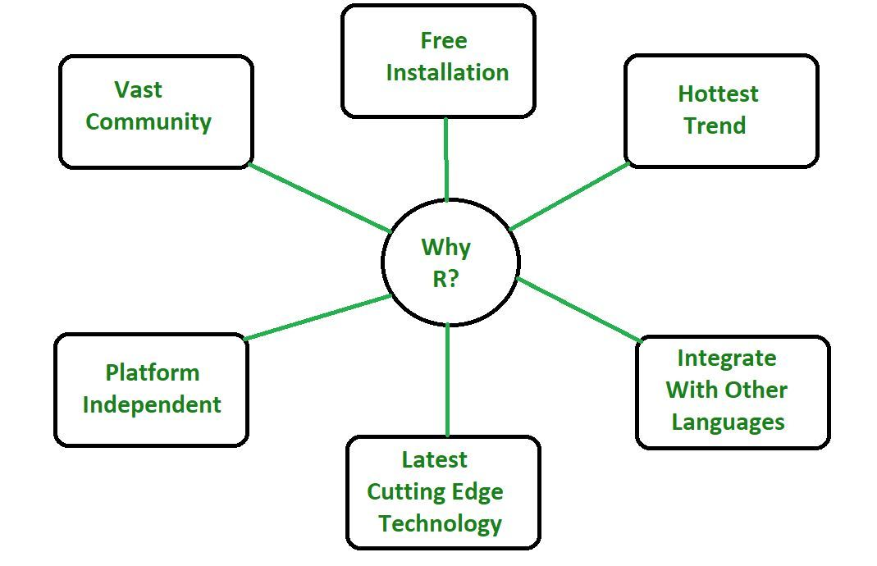

#### Why R Programming Language?

* R programming is used as a leading tool for machine learning, statistics, and data analysis. Objects, functions, and packages can easily be created by R.
* It’s a platform-independent language. This means it can be applied to all operating system.
* It’s an open-source free language. That means anyone can install it in any organization without purchasing a license.
* R programming language is not only a statistic package but also allows us to integrate with other languages (C, C++). Thus, you can easily interact with many data sources and statistical packages.
* The R programming language has a vast community of users and it’s growing day by day.
* R is currently one of the most requested programming language in the Data Science job market that makes it the hottest trend nowadays.

***Features of R Programming Language***

**Statistical Features of R:**

* **Basic Statistics:** The most common basic statistics terms are the mean, mode, and median. These are all known as “Measures of Central Tendency.” So using the R language we can measure central tendency very easily.
* **Static graphics:** R is rich with facilities for creating and developing interesting static graphics. R contains functionality for many plot types including graphic maps, mosaic plots, biplots, and the list goes on.
* **Probability distributions:** Probability distributions play a vital role in statistics and by using R we can easily handle various types of probability distribution such as Binomial Distribution, Normal Distribution, Chi-squared Distribution and many more.

**Programming Features of R:**

* **R Packages:** One of the major features of R is it has a wide availability of libraries. R has CRAN(Comprehensive R Archive Network), which is a repository holding more than 10, 0000 packages.
* **Distributed Computing:** Distributed computing is a model in which components of a software system are shared among multiple computers to improve efficiency and performance. Two new packages **ddR and multidplyr** used for distributed programming in R were released in November 2015.

**Advantages of R:**

* R is the most comprehensive statistical analysis package. As new technology and concepts often appear first in R.
* As R programming language is an open source. Thus, you can run R anywhere and at any time.
* R programming language is suitable for GNU/Linux and Windows operating system.
* R programming is cross-platform which runs on any operating systems.
* In R, everyone is welcome to provide new packages, bug fixes, and code enhancements.

**Disadvantages of R:**

* In the R programming language, the standard of some packages is less than perfect.
* Although, R commands give little pressure to memory management. So R programming language may consume all available memory.
* In R basically, nobody to complain if something doesn’t work.

**Applications of R:**

* We use R for Data Science. It gives us a broad variety of libraries related to statistics. It also provides the environment for statistical computing and design.
* R is used by many quantitative analysts as its programming tool. Thus, it helps in data importing and cleaning.
* R is the most prevalent language. So many data analysts and research programmers use it. Hence, it is used as a fundamental tool for finance.
* Tech giants like Google, Facebook, bing, Accenture, Wipro and many more using R nowadays.

# Windows Users

### To Install R:

* 1. Open an internet browser and go to [www.r-project.org](http://www.r-project.org/).
  2. Click the "download R" link in the middle of the page under "Getting Started."
  3. Select a CRAN location (a mirror site) and click the corresponding link.
  4. Click on the "Download R for Windows" link at the top of the page.
  5. Click on the "install R for the first time" link at the top of the page.
  6. Click "Download R for Windows" and save the executable file somewhere on your computer.  Run the .exe file and follow the installation instructions.
  7. Now that R is installed, you need to download and install RStudio.

### To Install RStudio

* 1. Go to [www.rstudio.com](http://www.rstudio.com/) and click on the "Download RStudio" button.
  2. Click on "Download RStudio Desktop."
  3. Click on the version recommended for your system, or the latest Windows version, and save the executable file.  Run the .exe file and follow the installation instructions.

# Mac Users

### To Install R

* 1. Open an internet browser and go to [www.r-project.org](http://www.r-project.org/).
  2. Click the "download R" link in the middle of the page under "Getting Started."
  3. Select a CRAN location (a mirror site) and click the corresponding link.
  4. Click on the "Download R for (Mac) OS X" link at the top of the page.
  5. Click on the file containing the latest version of R under "Files."
  6. Save the .pkg file, double-click it to open, and follow the installation instructions.
  7. Now that R is installed, you need to download and install RStudio.

### To Install RStudio

* 1. Go to [www.rstudio.com](http://www.rstudio.com/) and click on the "Download RStudio" button.
  2. Click on "Download RStudio Desktop."
  3. Click on the version recommended for your system, or the latest Mac version, save the .dmg file on your computer, double-click it to open, and then drag and drop it to your applications folder.

*Some Basic commands and Output in R*

**1.write a command to get absolute value of -10**

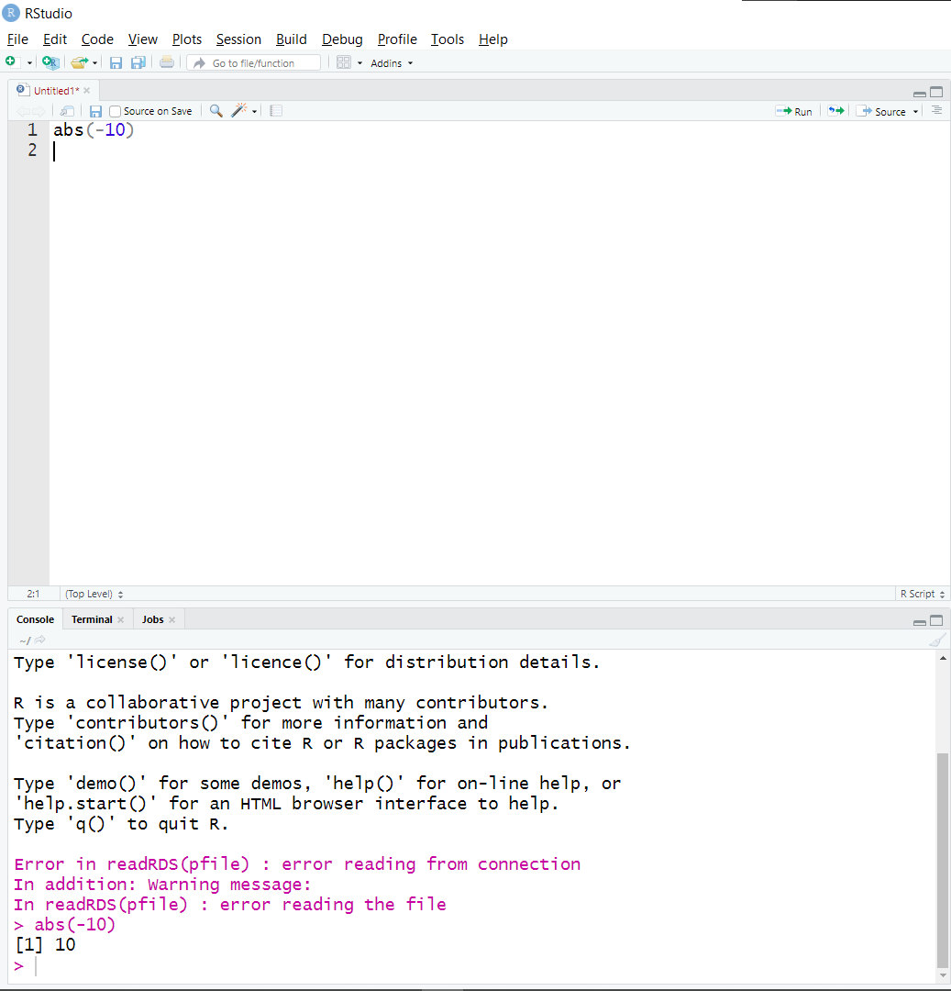

2.write a command to get ceil and floor value of 4.5.

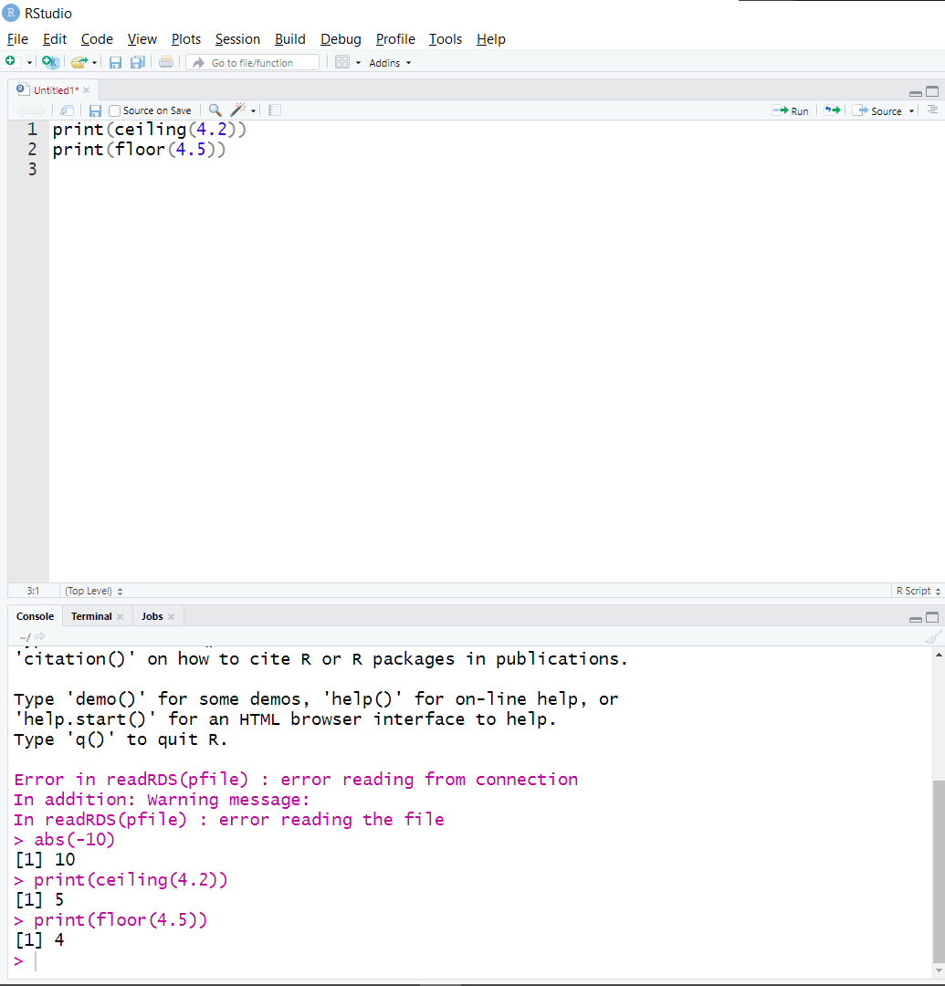

3.Write a command to get square root value of 100

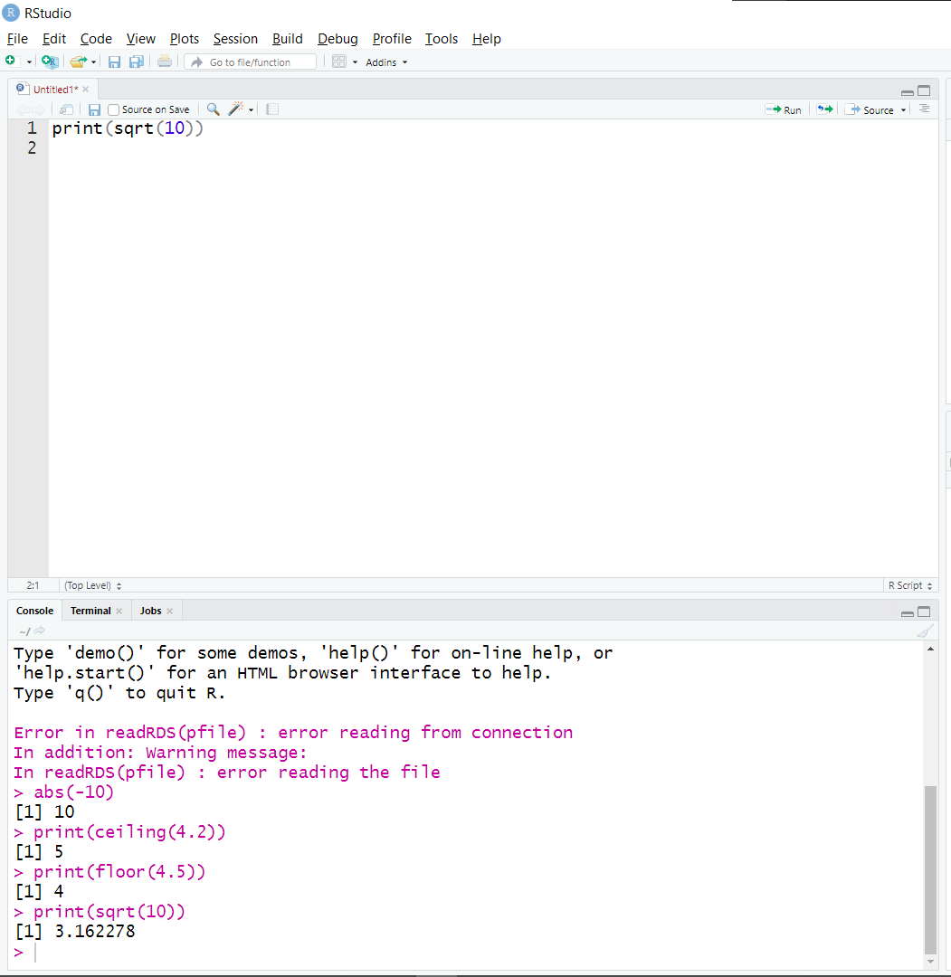

4.Write a command to get the exponential value of 4.

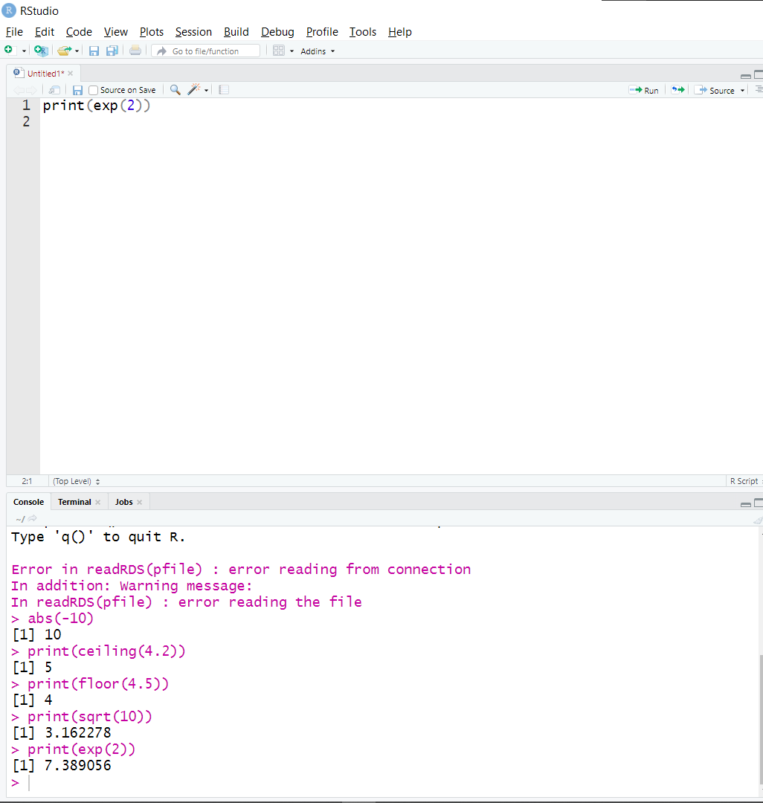

5.Write a command to get the pi value.

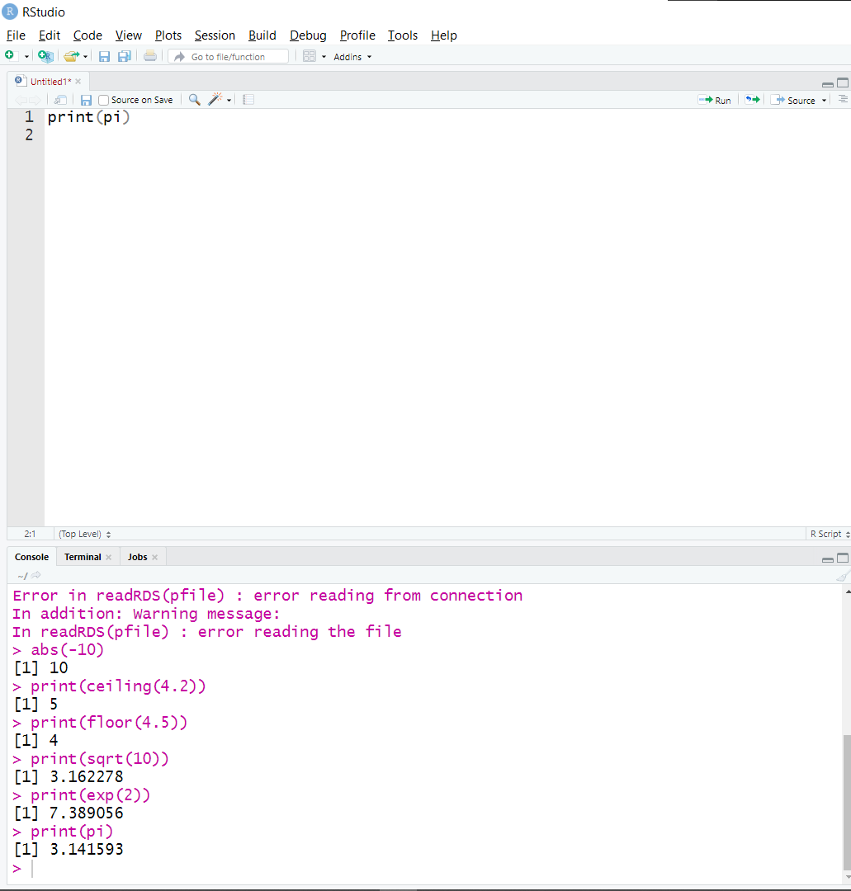

6.write a command to get the logarithmic value of 100

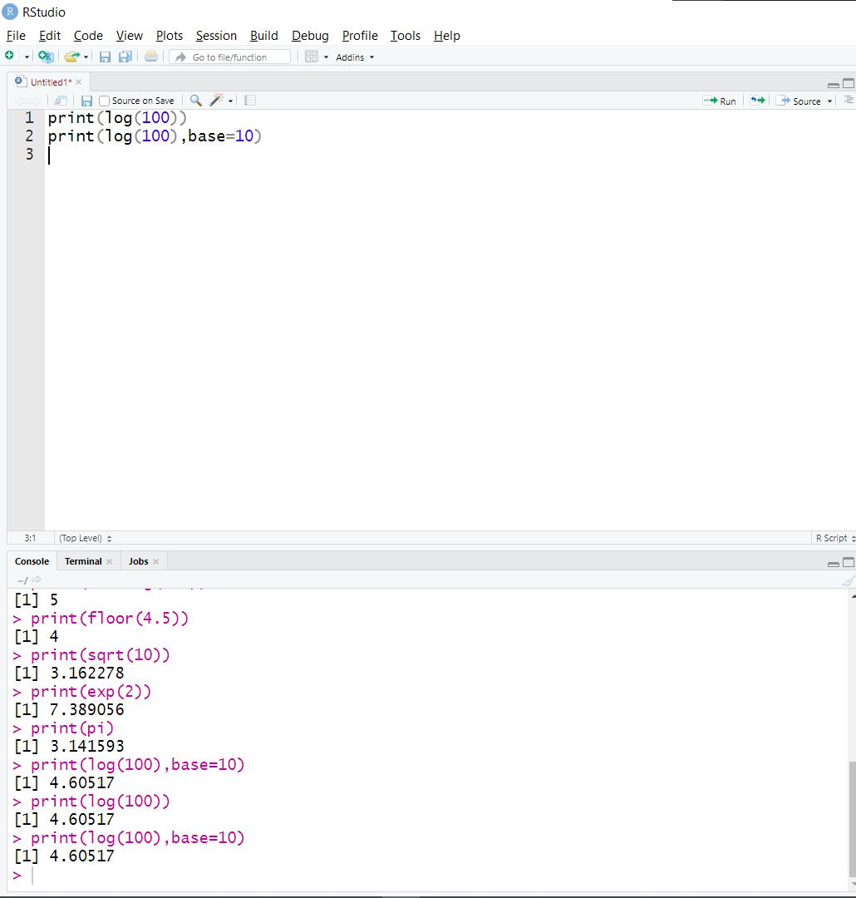

7.write a command to print (2+2)*2.

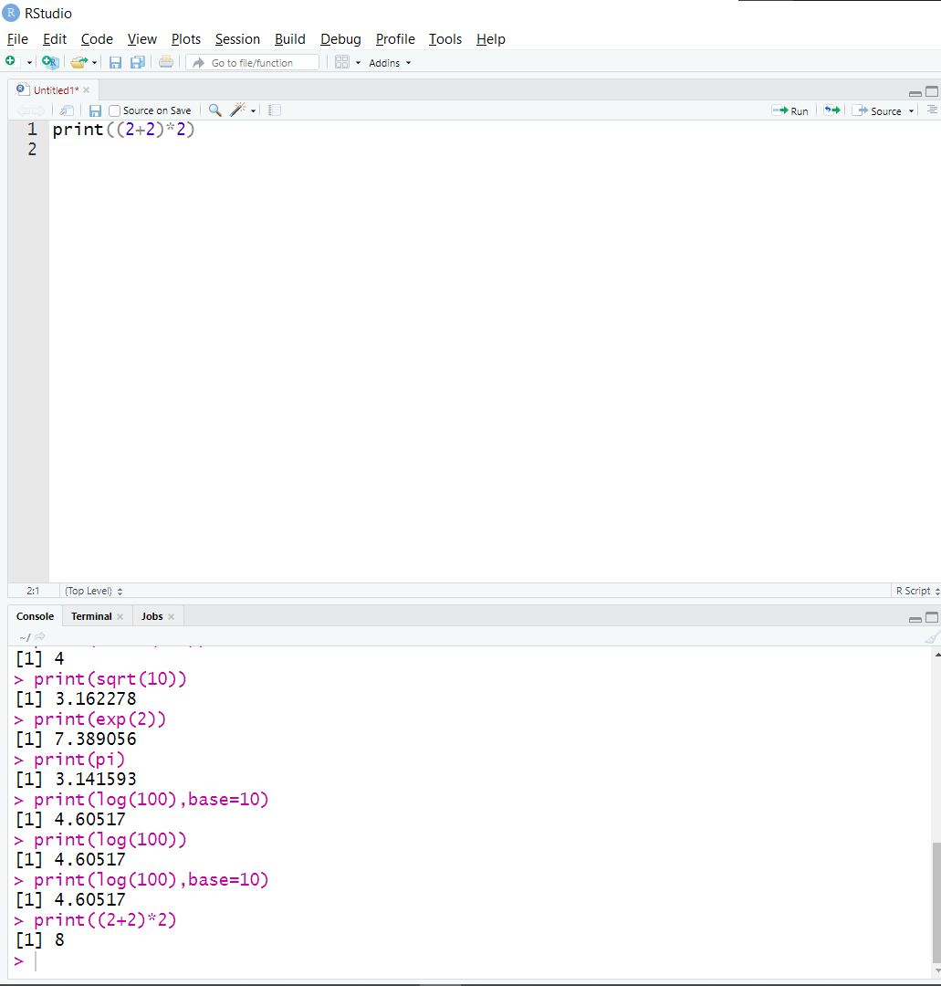

8.write a command to print 1+(2*2).

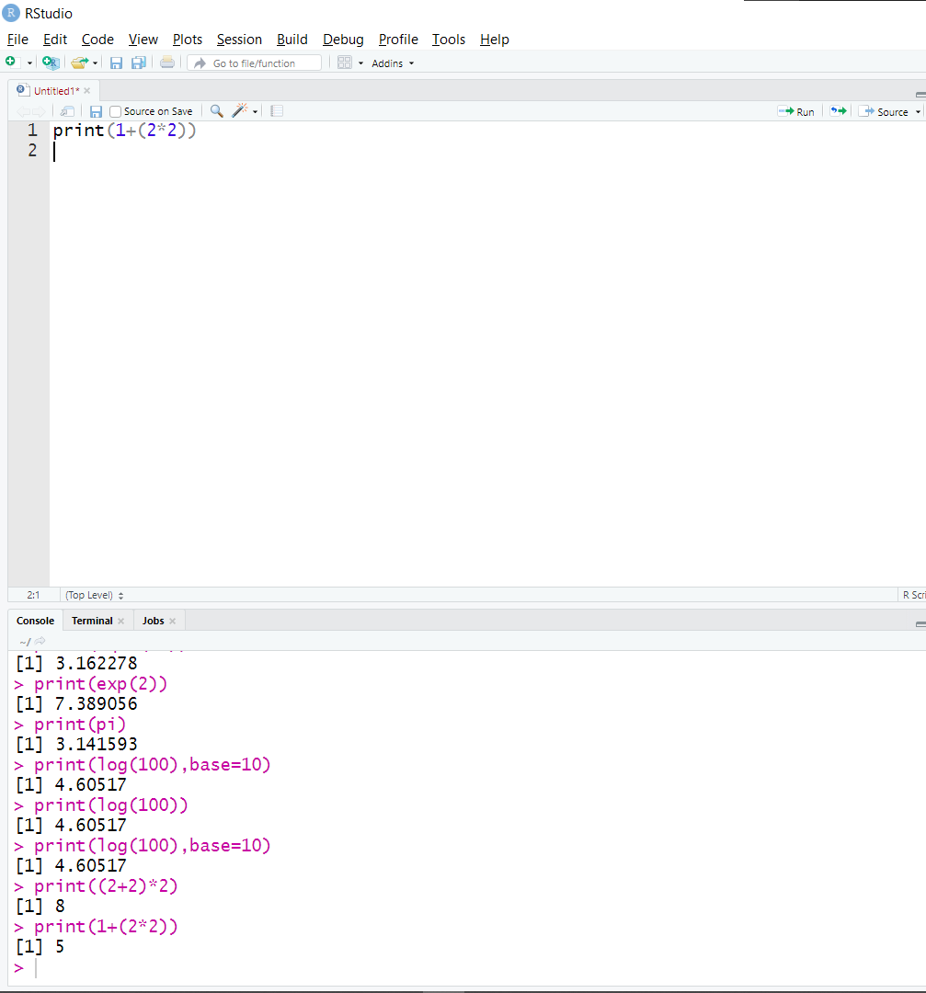

9.Command to check 2==2

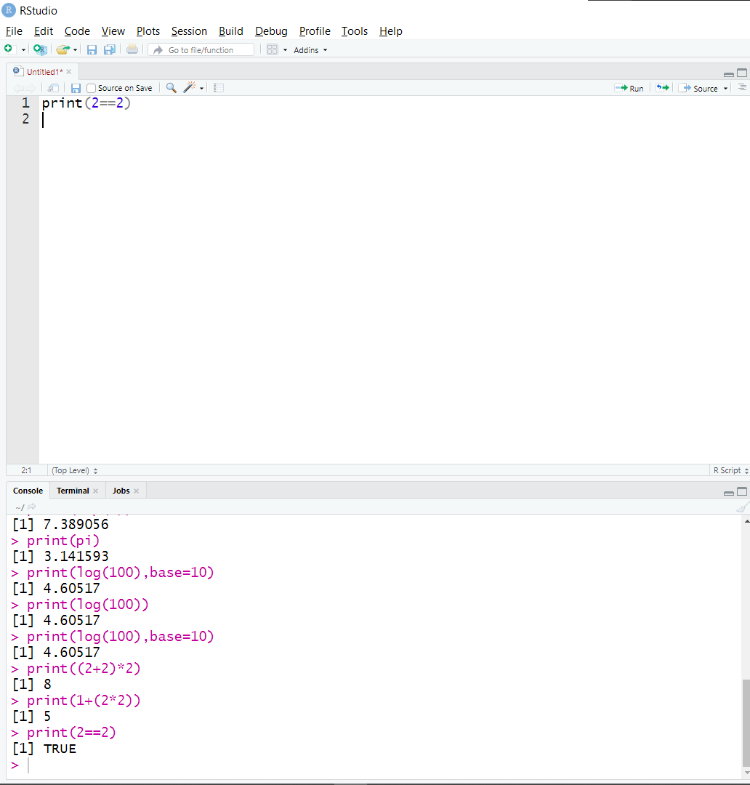

10.Command to check 5<=6 and 5>=6

