BUSINESS INSIGHTS REPORT
Task 04 | Marketing Campaign Exploratory Data Analysis
SkillCraft Technology | Illustrative synthetic dataset | Prepared: 31 October 2026

1. Executive Summary
The five-channel campaign dataset records total spend of 100,000 and attributed revenue of 724,692, producing an overall ROAS of 7.25x and a revenue-to-spend ROI of 624.7%. Search Ads is the strongest channel by ROAS (10.31x), while Display Ads is the weakest (2.12x). These results are illustrative and depend on the synthetic assumptions used to construct the dataset.

2. Channel Performance
Channel | Spend | Revenue | Conversions | ROAS | CPA
Email | 18,000 | 136,080 | 1,890 | 7.56x | 9.52
Social Media | 26,000 | 126,720 | 1,440 | 4.87x | 18.06
Search Ads | 32,000 | 329,840 | 3,472 | 10.31x | 9.22
Display Ads | 14,000 | 29,716 | 437 | 2.12x | 32.04
Affiliate | 10,000 | 102,336 | 1,248 | 10.23x | 8.01
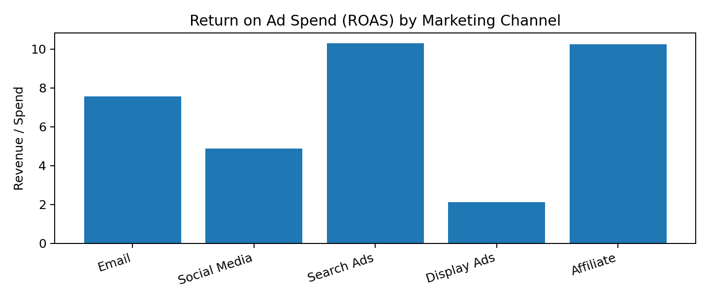

3. Key Findings
- Search Ads delivers the highest ROAS at 10.31x and should be tested for carefully controlled budget expansion.
- Display Ads has the lowest ROAS at 2.12x; review audience targeting, creative quality, landing-page experience and attribution before reducing spend.
- Compare CPA and conversion rate alongside ROAS. A high ROAS channel may have limited scale, while a lower-ROAS channel may support reach or assisted conversions.
- Use consistent attribution windows and include margin, refunds and customer lifetime value before making final budget decisions.

4. Budget Recommendation
Prioritize incremental testing in Search Ads, subject to capacity and marginal-return checks. Keep a controlled test budget for Display Ads while diagnosing its funnel performance. Reallocate budget gradually rather than making a large one-time shift. Validate these recommendations against actual campaign data and contribution margin.

5. Method and Limitations
ROAS = Revenue ÷ Spend. ROI = (Revenue − Spend) ÷ Spend. CPA = Spend ÷ Conversions. CTR = Clicks ÷ Impressions. Conversion rate = Conversions ÷ Clicks. This is a small, constructed example with five channel-level observations; it cannot establish statistical significance or causal effects. Revenue is treated as attributed revenue and is not adjusted for product cost, agency fees, refunds or lifetime value.

