OmniCharge
Project Report
Mobile Recharge Platform built with Angular, Spring Boot microservices and cloud-native support services
Project | OmniCharge Mobile Recharge Platform | Document Type | Industry-Level Project Report
Repository | D:\Capgemini\sprint | Prepared On | May 3, 2026
Architecture | Spring Boot Microservices | Frontend | Angular 21
Deployment | Docker Compose | Quality Tooling | JaCoCo, SonarQube, Swagger, Zipkin
This report packages the project in a professional delivery format: business scope, architecture, service design, API surface, data model, security posture, deployment approach, test strategy and improvement roadmap.
Prepared from repository evidence: README, docs, Docker Compose, application properties and source files.

Table of Contents
- 1. Executive Summary
- 2. Business Context and Scope
- 3. Technology Stack
- 4. Architecture Overview
- 5. Service and Module Breakdown
- 6. Functional Design
- 7. Data and Integration Design
- 8. Security, Observability and Quality
- 9. Deployment and Operations
- 10. Testing Strategy
- 11. Delivery Assessment and Roadmap
- 12. Conclusion

1. Executive Summary
OmniCharge is a full-stack mobile recharge platform that supports user registration, secure login, operator and plan discovery, recharge initiation, payment processing, wallet top-up, transaction history, administrative management and notification delivery. The project is structured as a modern microservices system with an Angular frontend and multiple Spring Boot services behind a single API Gateway.
- Business value: provides a guided digital recharge journey for users and operational control for administrators.
- Architecture value: separates domain responsibilities into services for user management, operator catalog, recharge, payment and notification.
- Reliability value: uses RabbitMQ for asynchronous payment and notification processing, Redis caching for frequently read catalog data and service health endpoints for operations.
- Delivery value: includes Dockerfiles, Docker Compose, Swagger API documentation, JaCoCo coverage support, SonarQube scanning and a dedicated documentation folder.

2. Business Context and Scope
The platform addresses the recharge lifecycle from account access to transaction confirmation. The scope is intentionally broad enough to demonstrate real industry concerns such as authentication, role-based access, service discovery, configuration, caching, messaging, observability and quality gates.
Actor | Primary Responsibilities | Implemented Surface
End User | Register, log in, browse operators, select plans, initiate recharge, pay, manage wallet and view history. | Angular user pages, Auth Service, Recharge Service, Payment Service and User Service wallet APIs.
Administrator | Manage users, operators, plans, recharges and transactions. | Admin registration/login, admin dashboard, role-protected APIs and catalog management endpoints.
Platform Services | Route requests, discover services, load shared configuration, process async events and expose health/trace data. | API Gateway, Eureka Server, Config Server, RabbitMQ, Redis, Zipkin and Actuator.

In-Scope Capabilities
- User and admin registration/login with JWT-based stateless authentication.
- Operator and recharge plan CRUD for administrators and browsing for authenticated users.
- Recharge request creation with mobile number, operator and plan validation.
- Payment flow with card, UPI, netbanking and wallet support through a dummy payment gateway abstraction.
- Wallet top-up and balance update through service-to-service calls.
- Notification handoff through RabbitMQ and email service integration hooks.
- Centralized API routing, Swagger documentation and Docker-based local deployment.

Assumptions and External Boundaries
- The payment gateway is represented by an internal dummy gateway service; production integration would require a certified payment provider.
- Operator fulfillment is modeled through internal recharge status management rather than a live telecom provider API.
- SMTP, secrets and external configuration values are environment-driven and must be replaced with production-grade secret handling before release.

3. Technology Stack
Layer | Technology | Purpose
Frontend | Angular 21, TypeScript, RxJS | Single-page application, lazy-loaded routes, guards, HTTP services and user/admin workflows.
Backend | Java 21, Spring Boot 3.5.12 | REST services, security, domain logic, persistence and API documentation.
Microservices | Spring Cloud 2025.0.1 | Gateway routing, Eureka discovery, Config Server and OpenFeign service-to-service calls.
Persistence | PostgreSQL | Dedicated databases for users, operators, recharges and payments.
Cache | Redis | 10-minute cache for frequently read operator and recharge plan data.
Messaging | RabbitMQ | Durable payment and notification queues with JSON message conversion.
Security | Spring Security, JWT, BCrypt | Stateless authentication, role checks, token validation and password hashing.
Observability | Actuator, Micrometer, Zipkin | Health endpoints, runtime telemetry and distributed tracing.
Quality | JUnit, Mockito, JaCoCo, SonarQube | Unit/integration testing, coverage and static quality analysis.
Deployment | Docker, Docker Compose | Containerized local/runtime setup for infrastructure and services.

4. Architecture Overview
The architecture follows a gateway-first microservices pattern. The frontend sends API calls to the gateway, the gateway validates protected requests and routes them to domain services registered in Eureka. Each data-owning service persists to its own PostgreSQL database. The operator catalog is cached in Redis, while recharge/payment handoffs use RabbitMQ for asynchronous processing.
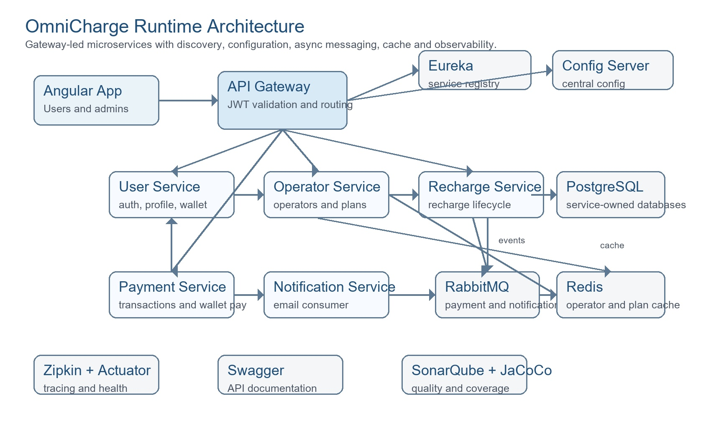
Figure 1. High-level OmniCharge runtime architecture.

Architectural Quality Drivers
Quality Driver | How the Project Supports It | Industry Interpretation
Scalability | Services can be scaled independently; RabbitMQ decouples payment and notification work. | Good foundation for horizontal scaling by domain load.
Maintainability | Each service has controller, service, repository, entity and DTO boundaries. | Clear ownership improves feature isolation and testing.
Resilience | Payment status updates use retry-oriented logic and event publishing. | Compensation and failure handling are considered in the payment path.
Operability | Actuator, Zipkin and Docker health checks are configured. | Supports local diagnostics and production-style observability practices.
Security | JWT validation, role protection, BCrypt password encoding and secretized configuration are present. | Strong baseline, with production hardening opportunities listed later.

5. Service and Module Breakdown
Service | Port | Primary Responsibility | Storage / Integration
api-gateway | 8080 | Single backend entry point, path routing, JWT validation, Swagger aggregation. | Eureka client, Config Server, Zipkin.
user-service | 8081 | Users, admins, login, JWT issue, profile, password change and wallet balance. | PostgreSQL user_db, BCrypt, JWT, Feign wallet access.
operator-service | 8082 | Mobile operators and recharge plans. | PostgreSQL operator_db, Redis cache.
recharge-service | 8083 | Recharge initiation, validation, status, cancellation and history. | PostgreSQL recharge_db, OpenFeign to Operator Service, RabbitMQ payment.queue.
payment-service | 8084 | Transactions, payment processing, wallet top-up, status update retry and notification publishing. | PostgreSQL payment_db, OpenFeign to User/Recharge, RabbitMQ notification.queue.
notification-service | 8085 | Consumes notification messages and sends email notifications. | RabbitMQ notification.queue, SMTP configuration.
eureka-server | 8761 | Service registry for runtime discovery. | Netflix Eureka dashboard and service registry.
config-server | 8888 | Centralized configuration endpoint for services. | Spring Cloud Config.

Repository Size Indicators
Service | Main Java Files | Test Java Files | Controller Classes | Test Classes
api-gateway | 5 | 4 | 0 | 3
config-server | 1 | 1 | 0 | 0
eureka-server | 1 | 1 | 0 | 0
notification-service | 11 | 8 | 0 | 7
operator-service | 21 | 10 | 2 | 9
payment-service | 26 | 10 | 1 | 9
recharge-service | 21 | 11 | 1 | 10
user-service | 24 | 8 | 2 | 7

6. Functional Design

User and Admin Authentication
The authentication module supports separate user and admin login flows. Passwords are encoded with BCrypt, JWT tokens are issued after successful authentication and protected APIs are guarded by Spring Security filters. The Angular frontend stores session cookies, applies an HTTP interceptor for the Authorization header and includes route guards for user/admin screens.

Catalog Management
Operator Service manages mobile operators and recharge plans. Admins can create, update, patch and delete catalog records. Users consume read APIs to select active operators and plans. Redis caching is configured for operators, plans, individual lookup and plans by operator.

Recharge and Payment Journey
Recharge Service validates the mobile number, operator and plan, saves the recharge as PENDING and publishes an event to RabbitMQ. Payment Service creates a PENDING transaction, completes payment when the user submits a payment request, updates recharge status through Feign and publishes a notification event. Wallet payment and wallet top-up are supported through User Service wallet APIs.
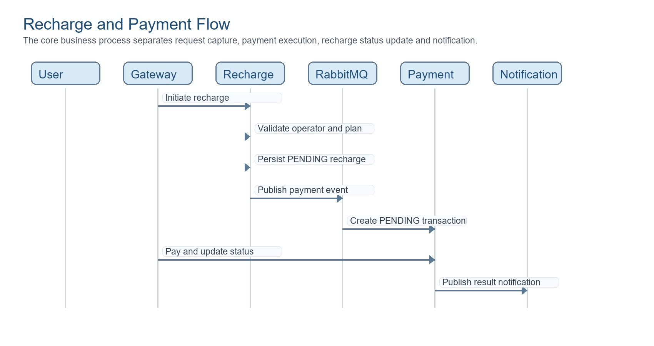
Figure 2. Core recharge and payment sequence.
Functional Area | Representative APIs | Primary Files
Authentication | POST /api/auth/register, /register-admin, /user/login, /admin/login | AuthController.java, UserServiceImpl.java, JwtUtil.java, Angular auth.service.ts.
Users and Wallet | GET /api/users/profile, /all, /profile/wallet; POST /profile/wallet/update | UserController.java, UserServiceImpl.java, UserRepository.java.
Operators | GET/POST/PUT/PATCH/DELETE /api/operators | OperatorController.java, OperatorServiceImpl.java, Operator.java.
Plans | GET/POST/PUT/PATCH/DELETE /api/plans, /operator/{id}, /category/{category} | RechargePlanController.java, RechargePlanServiceImpl.java, RechargePlan.java.
Recharge | POST /api/recharge/initiate, GET /my-history, PUT /{id}/cancel, PUT /update-status/{id} | RechargeController.java, RechargeServiceImpl.java, RechargeEventPublisher.java.
Payments | POST /api/transactions/pay, /wallet/topup; GET /my-transactions, /all, /status/{status} | TransactionController.java, PaymentServiceImpl.java, RechargeEventConsumer.java.
Notifications | RabbitMQ notification.queue | NotificationConsumer.java, EmailService.java, RabbitMQConfig.java.

7. Data and Integration Design
Domain Entity | Service Owner | Key Fields | Notes
User | user-service | username, email, password, fullName, phone, role, active, walletBalance | Username and email are unique; wallet balance uses decimal precision.
Operator | operator-service | name, type, status, logoUrl, description | One operator owns many recharge plans.
RechargePlan | operator-service | planName, price, validity, data, calls, sms, category, status, operator | Plan validation ensures selected plan belongs to selected operator.
RechargeRequest | recharge-service | username, mobileNumber, operatorId, planId, amount, validity, dataInfo, status, timestamps | Lifecycle statuses include PENDING, SUCCESS, FAILED and CANCELLED.
Transaction | payment-service | transactionId, rechargeId, username, amount, status, method, reference, failureReason, timestamps | Transaction ID is unique; top-up uses a dedicated transaction pattern.

Integration Patterns
- Synchronous calls: Recharge Service validates operator/plan through OpenFeign; Payment Service updates recharge status and wallet balance through OpenFeign.
- Asynchronous calls: Recharge Service publishes payment events to payment.queue; Payment Service publishes notification events to notification.queue.
- Caching: Operator Service uses Redis with 10-minute TTL for catalog reads.
- Database ownership: user_db, operator_db, recharge_db and payment_db isolate domain data by service.

8. Security, Observability and Quality

Security Posture
Area | Current Implementation | Production Recommendation
Authentication | Spring Security authentication manager and JWT token generation. | Add refresh-token rotation, token revocation strategy and shorter access-token lifetime.
Password Storage | BCryptPasswordEncoder is configured in User Service. | Add password policy enforcement and breached-password checks.
Authorization | Role checks protect admin APIs and Angular admin routes. | Add method-level authorization review for all internal and admin-only endpoints.
Secrets | .env.example documents secret inputs and Compose injects environment values. | Use a secret manager or vault, never commit live .env files and rotate secrets per environment.
Frontend Session | Session cookies store current user and token; idle timeout clears inactive sessions. | Use HttpOnly, Secure cookies through the backend for production token storage.
Network | Local Compose uses service networking and exposed ports. | Terminate TLS at ingress/gateway and restrict direct service exposure outside the cluster/network.

Observability and Quality Tooling
- Actuator health endpoints are exposed and Docker Compose uses health checks for service readiness.
- Zipkin and Micrometer tracing endpoints are configured for distributed request visibility.
- Swagger/SpringDoc is configured per service with gateway-level API documentation aggregation.
- JaCoCo and SonarQube are included for coverage and maintainability checks.
- Logback configuration files are present in multiple services, supporting structured service logging practices.

9. Deployment and Operations
Docker Compose provisions the platform infrastructure and application containers on a shared omnicharge-net network. The stack includes PostgreSQL, RabbitMQ, Redis, SonarQube, Zipkin, Eureka, Config Server and the backend services. Each backend service has a Dockerfile and is configured with environment variables for database, JWT, tracing and service discovery settings.
Operational Component | Role | Important Ports
Angular frontend | Browser UI for users and administrators. | 4200
API Gateway | External backend entry point. | 8080
User, Operator, Recharge, Payment, Notification services | Domain microservices. | 8081-8085
Eureka Server | Service registry and discovery dashboard. | 8761
Config Server | Centralized configuration service. | 8888
PostgreSQL | Relational persistence and SonarQube database. | 5432
RabbitMQ | Async queue broker and management dashboard. | 5672, 15672
Redis | Low-latency cache for catalog reads. | 6379
Zipkin | Distributed tracing UI. | 9411
SonarQube | Static quality and coverage dashboard. | 9000

Recommended Runbook
- Create a local .env file from .env.example and replace all placeholders.
- Start infrastructure and services with Docker Compose.
- Verify Eureka registration, service health endpoints and gateway Swagger.
- Run backend tests with mvn test per service and frontend tests with npm test.
- Run JaCoCo verification and SonarQube scan before release packaging.
- Review logs and Zipkin traces for the recharge/payment journey.

10. Testing Strategy
The repository includes service-level test classes across the main backend services and Angular test support on the frontend. Testing should be treated as a release gate: unit tests validate domain logic, controller tests validate API behavior and integration tests validate the end-to-end recharge/payment flow across services and queues.
Test Layer | Purpose | Examples / Commands
Unit Tests | Validate service methods, DTO mapping, utility classes and error handling. | mvn test inside user-service, operator-service, recharge-service, payment-service and notification-service.
Controller Tests | Validate REST request/response behavior and role restrictions. | Controller test classes under src/test/java in user, operator, recharge and payment services.
Integration Tests | Validate service-to-service and queue-driven flows. | Recommended: Testcontainers for PostgreSQL, RabbitMQ and Redis.
Frontend Tests | Validate Angular components, guards, services and routing. | npm test inside omnicharge-frontend.
Quality Gates | Measure coverage, bugs, vulnerabilities and maintainability. | mvn clean verify for JaCoCo; powershell -ExecutionPolicy Bypass .\sonar-scan.ps1 for SonarQube.

11. Delivery Assessment and Roadmap
Area | Current Maturity | Next Industry-Level Improvement
Architecture | Strong microservices foundation with gateway, discovery, config, queues and separate databases. | Add API versioning, formal ADRs and deployment diagrams for cloud environments.
Security | Good baseline with BCrypt, JWT, role checks and environment-driven secrets. | Adopt secret manager, HttpOnly token cookies, TLS, rate limiting and audit logging.
Resilience | Async messaging and retry-oriented payment update logic exist. | Add circuit breaker policies, dead-letter queues, idempotency keys and compensation workflows.
Data | Service-owned PostgreSQL databases are initialized through Docker. | Add migration tooling such as Flyway/Liquibase and seed data profiles.
Observability | Actuator, Zipkin and logback support runtime visibility. | Add structured JSON logs, metrics dashboards, alert thresholds and trace sampling policy.
Testing | Unit/controller tests and quality tools are present. | Add contract tests, integration tests and CI pipeline gates.
Frontend | Angular route guards, interceptor and domain pages are present. | Add form-level validation polish, E2E tests and accessibility checks.

12. Conclusion
OmniCharge demonstrates a complete industry-style full-stack application with a clean separation of frontend, gateway, domain services, databases, queueing, caching, documentation and quality tooling. The project is suitable as a portfolio-grade microservices implementation and can be advanced toward production readiness by strengthening secrets management, deployment automation, integration testing, resilience patterns and operational monitoring.
Overall, the project shows strong engineering breadth: it covers the customer journey, administrative controls, service-to-service coordination, asynchronous processing, security foundations and operational support in one coherent platform.

