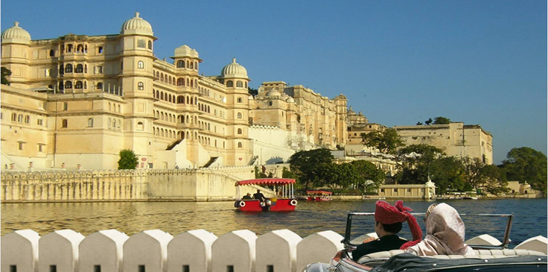

**Tour Name : Rajasthan’s Grandiosity**

**Tour Code : II#04**

**Duration : 10 Nights / 11 Days**

**Places covered : Delhi, Agra, Ranthambhore, Jaipur, Udaipur, Mumbai**

**Interests : Culture, Heritage, Wildlife, Photography**

**ITINERARY**

**Day 01: Arrive Delhi**

Arrive Delhi, meet and greet on arrival and transfer to your hotel. Overnight stay at the hotel.

**Day 02: Delhi**

City tour of Delhi starts with a drive past the government buildings, art-deco residential quarters, broad avenues with a green cover and a visit to the famous monuments such as the Humayun's Tomb and Qutub Minar. An exhilarating Rickshaw Ride (Pedi-cab) through the narrow, meandering streets of the medieval market of Chandni Chowk is worth experiencing. Overnight stay at the hotel.

**Day 03: Delhi to Agra**

After breakfast, drive to Agra. Arrive and check-in at the hotel. Visit Taj Mahal, one of the Seven Wonders of the World (closed  on  Friday) also visit Agra  Fort,  an  outstanding example  of  Mughal  architecture  and  the seat and stronghold of the Mughal Empire. Overnight stay at **hotel.**

**Day 04: Agra to Ranthambhore**

After a leisurely breakfast at hotel, transfer to railway station to board train to Sawai Madhopur – Ranthambhore National Park. The two hours journey will take you through the delightful scenery of Ranthambhore National Park – the former hunting ground of Maharaja of Jaipur. Arrive and check-in at the hotel. Overnight stay at the hotel.

**Day 05: Ranthambhore**

Morning and afternoon game drives in Ranthambhore National Park. Overnight stay at the hotel.

**Day 06: Ranthambhore to Jaipur**

Morning at leisure and later drive to Pink City – Jaipur. Arrive and check-in at the hotel. Rest of the day is at leisure. Overnight stay at hotel.

**Day 07: Jaipur**

Explore the magnificent Amber Fort, offering views of Maota Lake and the historic old town (ascend on elephant back). Drive past Hawa Mahal, a pyramidal facade with overhanging lattice screened windows, domes and spires. Visit the City Palace Museum and Astronomical observatory. Overnight stay at the hotel.

**Day 08: Jaipur to Udaipur**

After breakfast, in-time transfer to airport to board flight to Udaipur – City of Lakes. Arrive and check-in at the hotel. Evening enjoy the boat cruise on the serene and beautiful Lake Pichola. Overnight stay at the hotel.

**Day 09: Udaipur**

Morning guided sightseeing tour of Udaipur - visit the City Palace Museum. Later visit Jagdish Temple – built in 1651 AD. Also visit Sahelion Ki Bari – the spectacular garden displaying the unique life style of the royal ladies who once lived in the palaces. Overnight stay at the hotel.

**Day 10: Udaipur – Mumbai**

Morning transfer to airport to board flight to Mumbai. On arrival, transfer to hotel. Afternoon guided sightseeing tour of Mumbai. Overnight stay at hotel.

**Day 11: Leave Mumbai**

In time transfer to airport to board your onward flight to next destination.

**END OF TOUR**

**Incoming India** offers you flexibility of choosing your Holidays –

We mix it; match it to suit your interest, preferences & budgets…