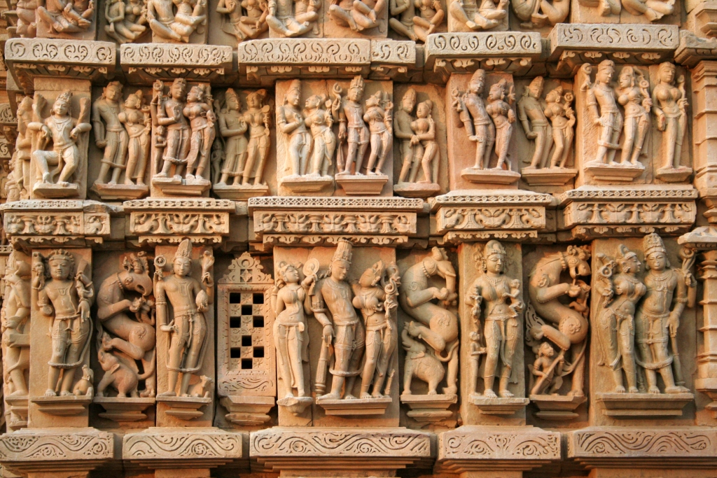

**Tour Name : Highlights of North India**

**Tour Code : II#05**

**Duration : 09 Nights / 10 Days**

**Places covered : Delhi, Jaipur, Agra, Khajuraho, Varanasi and Delhi**

**Interests : Culture, Heritage, Local Experience, Photography**

**Day 01: Arrive Delhi**

Arrive Delhi, meet and greet on arrival and transfer to your hotel. Overnight stay at hotel.

**Day 02: In Delhi**

After breakfast, proceed for the sightseeing tour of Old Delhi; walk through the busy lanes of Chandni Chowk, spice market, Red Fort (Closed on Monday) & Jama Masjid (Friday Mosque). Afternoon visit New Delhi – Humayun Tomb, Lotus Temple and Drive Past India Gate, Government buildings, Rastrapathi Bhawan (Presidents house). Overnight stay at the hotel.

**Day 03: Delhi to Jaipur**

After breakfast, drive to Jaipur. Arrive and check-in at the hotel. Overnight stay at the hotel.

**Day 04: In Jaipur**

Breakfast at hotel. Morning excursion to Amber Fort with photo stop at Hawa Mahal (Palace of Winds), climb up Amber fort on Elephant back. Afternoon visit Jaipur city - City Palace, Royal Observatory. Enjoy rickshaw ride in Jaipur. Overnight stay at hotel.

**Day 05: Jaipur to Agra**

Breakfast at hotel. Morning drive to Agra en-route visit Fatehpur Sikri. Upon arrival in Agra, check in at hotel. Overnight stay at hotel.

**Day 06: Agra**

After breakfast, proceed for the visit to Taj Mahal (closed on Friday’s), built by the Mughal Emperor Shah Jahan as an expression of his love for his wife Mumtaz Mahal. Later visit the Agra Fort - the seat and the stronghold of the Mughal Empire under successive generations. Afternoon at leisure. Overnight stay at hotel

**Day 07: Agra to Khajuraho**

After breakfast, transfer to railway station to board morning Shatabadi Express train to Jhansi. Upon arrival at Jhansi, proceed for sightseeing tour of Orchha. Visit Jehangir Mahal & Ram Raja Temple, Laxminarayan Temple. Post visit, drive to Khajuraho. Arrive and check-in at the hotel. Overnight stay at hotel.

**Day 08: Khajuraho to Varanasi**

Breakfast at hotel. Morning visit the famous 10th century Western, Eastern and Southern group of temples. Afternoon transfer to airport to board flight for Varanasi. Arrive and check-in at the hotel. Evening witness Aarti ceremony on The Ganges. Overnight at hotel.

**Day 09: Varanasi**

Early morning, boat ride on holy river Ganges. On your way back visit Viswanath Temple (Golden temple) from outside (Non Hindus not allowed inside). Return for breakfast at hotel. Later proceed for city tour visiting important sites including Bharat Kala Bhavan, Banras Hindu University and Mother India Temple. Afternoon visit Sarnath -the place that symbolizes the birth of Buddhism. Evening return to hotel. Overnight stay at hotel.

**Day 10: Varanasi – Delhi**

Breakfast at hotel. Morning at leisure. Afternoon transfer to airport to board flight for Delhi. Upon arrival, transfer to the international airport to board flight for your onward destination.

**Tour Ends**

**Incoming India** offers you flexibility of choosing your Holidays –

We mix it; match it to suit your interest, preferences & budgets…