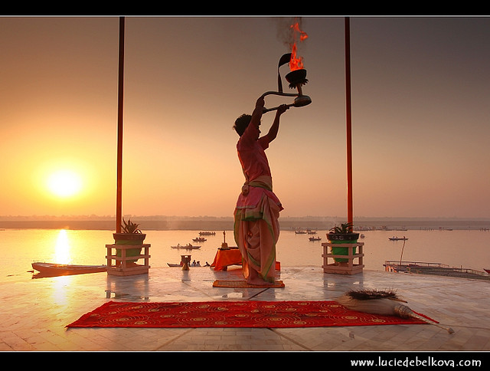

**Tour Name : The Classical Indian Route**

**Tour Code : II#02**

**Duration : 11 Nights / 12 Days**

**Places covered : Del – Varanasi – Khajuraho – Orchha – Agra – Fathepur Sikri – Jaipur –Del**

**Interests : Culture, Heritage, Spiritual, Local Experience, Photography**

**Day 01: Arrive Delhi**

Upon arrival at Delhi International airport, you will be welcomed by our representative after which proceed to Hotel for check-in. overnight at the hotel.

**Day 02: Delhi**

After breakfast at the hotel, enjoy the sightseeing tour of Old and New Delhi. Tour of Old Delhi includes a drive past the Red Fort, visit to the Jama Masjid, the largest mosque in Asia and the Raj Ghat memorial to Mahatma Gandhi. Afternoon tour of New Delhi includes visit to the Qutab Minar, the astonishing victory tower built in the early 13th century, an architecture masterpiece, also visit the tomb of the Mughal Emperor Humayun; drive past the imposing India Gate, the Parliament buildings and the Rashtrapathi Bhawan. Return to your hotel after the sightseeing tour. Overnight at the hotel.

**Day 03: Delhi – Varanasi (By Flight)**

After breakfast, you will be transferred to Airport to connect flight to Varanasi. Upon arrival at Varanasi airport, meet and greet by our representative and transfer you to hotel. Afternoon will be at leisure for independent activities. Overnight at the hotel.

**Day 04: Varanasi**

Early morning proceed for a boat cruise on the river Ganges around the ghats. At dawn, the Ghats (banks of river Ganges) are abuzz with activity of the devotees performing their ablutions in the river or offering prayers to the rising sun and performing other religious rituals. Also visit Kashi – Vishwanath Temple, the most sacred of shrines dedicated to Lord Shiva, the patron deity of Varanasi. Return to hotel for breakfast after the tour. After breakfast, proceed for an excursion to Sarnath, a major Buddhist centre in the world. Overnight at the Hotel.

**Day 05: Varanasi – Khajuraho (By Flight)**

Breakfast at the Hotel. In time transfer to airport to board flight to Khajuraho. Upon arrival at Khajuraho airport, meet and greet by our representative and transfer to hotel. Rest of the day is at leisure for independent activities. Overnight at the Hotel.

**Day 06: Khajuraho**

After breakfast at the hotel, visit the Eastern Group & Western Group of Chandela Temple Complex. Among the Western Group of temples, the most important temple being the Kandariya Mahadeo Temple, dedicated to Lord Shiva. It is one of the largest and most typical of the Khajuraho temples. The Eastern Group of temples include the Ghantai Temple, Vamana Temple dedicated to the "Vamana" or dwarf incarnation of Lord Vishnu and the Javari Temple.

Overnight at the Hotel.

**Day 07: Khajuraho – Orchha – Jhansi – Agra**

After breakfast at the Hotel, transfer to Jhansi railway station (195 KMS / 5Hrs.) to connect train Shatabdi Express to Agra. En-route visit Orchha, whose grandeur has been captured in stone, frozen in time having a rich legacy of the ages. This medieval city has palaces and the temples built by its Bundela rulers in the 16th century and till date retain much of their perfection.

Upon arrival at Agra railway station, transfer to hotel. Overnight at the Hotel.

**Day 08: Agra**

After breakfast visit Taj Mahal; the monument of eternal love made by the Mughal Emperor Shah Jahan for his beloved wife Mumtaz Mahal. Also visit Agra Fort, an outstanding example of Mughal architecture. Overnight at the Hotel.

**Day 09: Agra – Fatehpur Sikri – Jaipur**

After breakfast at the hotel, you will be driven from Agra to Jaipur (220 KMS / 6Hrs.) en-route visiting Fatehpur Sikri, the deserted red sandstone city, built by the Great Mughal Emperor Akbar. After visit, continue your drive to Jaipur, upon arrival, check-in at your hotel. Overnight at Hotel.

**Day 10: Jaipur**

After breakfast, you will proceed for city tour of Jaipur. Morning you will be driven just outside Jaipur to the ancient capital Amer to see the fabulous Amer Fort. Afternoon proceed to visit the City Palace, which is an overwhelming complex of exquisite palaces, gardens and courtyards, decorative art and carved doorways. The palace museum houses collections of rare manuscripts, armoury, costumes, carpets and miniature paintings. Overnight at the Hotel.

**Day 11: Jaipur – Delhi – Onward Destination**

After Breakfast at the Hotel, free time for individual activities. Afternoon; drive back to Delhi (260 KMS / 6Hrs.). Upon arrival, you’ll be transferred to the international airport on-time to board flight for your onward destination.

**Tour Ends**

**Incoming India** offers you flexibility of choosing your Holidays –

We mix it; match it to suit your interest, preferences & budgets…