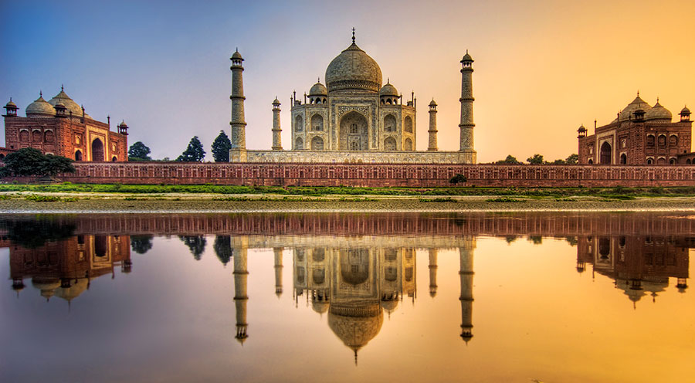

**Tour Name : Golden Triangle Tour**

**Tour Code : II#01**

**Duration : 06 Nights / 07 Days**

**Places covered : Delhi, Agra, Fatehpur Sikri, Jaipur and Delhi**

**Interests : Culture, Heritage, Local Experience, Photography**

Golden Triangle Tour is the most popular among the tourists in India. This incredible Golden Triangle Tour comprises of the three famous cities of India – Delhi, Agra and Jaipur, telling the tales of greatness, glory and history of India.

**Day 01: Arrive Delhi**

Upon arrival at Delhi International airport, you will be greeted by our representative. Thereafter you will be preceded to your Hotel accommodation for check in. Overnight at the hotel.

**Day 02: Delhi**

This morning, after breakfast firstly, the sightseeing tour starts with the visit to old Delhi, walk through the busy lanes of Chandni Chowk, spice market, Red Fort (Closed on Monday) & Jama Masjid (Friday Mosque). Later visit the New Delhi - drive past imposing India Gate and the Rastrapathi Bhawan (Presidents house), visit Laxmi Narayan Temple, the Qutub Minar, tallest stone tower in India. Overnight at the hotel.

**Day 03: Delhi – Agra**

After breakfast at the hotel, you will be driven to Agra (204 KMS/ 4½ Hrs.). Upon arrival proceed to check in to your hotel. Overnight at the hotel.

**Day 04: Agra**

Early morning, you will be proceeding for a sunrise tour of the Taj Mahal (closed on Fridays). Midway Tonga’s “horse carriages” would be waiting for you and will drop you at the gates of the Taj Mahal. Built by the Mughal Emperor Shah Jahan as an expression of his love for his wife Mumtaz Mahal, in mid 17th Century, the Taj Mahal is truly one of the Seven Wonders of the World. Return to your hotel after the sunrise tour for breakfast. After breakfast, visit the Agra Fort, an outstanding example of Mughal architecture. In the afternoon, visit Itimad-ud-Daulah, the beautiful tomb of Mirza Ghiyath Beg. Return to your hotel after the sightseeing tour. Overnight at the hotel.

**Day 05: Agra – Fatehpur Sikri Jaipur**

After breakfast at the hotel, you will be driven from Agra to Jaipur (220 KMS / 6 hours) en-route visitng Fatehpur Sikri, the deserted red sandstone city, built by the Great Mughal Emperor Akbar as his capital and palace in the late 16th century. It was abandoned soon after it was built when the local wells went dry. Continue driving to Jaipur, upon arrival check-in at hotel. Overnight at the hotel.

**Day 06: Jaipur**

After breakfast at the hotel, you will be driven just outside Jaipur to the ancient capital of Amber to see the fabulous Amber Fort. En-route to Amber you will stop and see the ‘Palace of Winds’, also known as Hawa Mahal.

Afternoon, visit the city of Jaipur. The most prominent highlights to be seen while touring Jaipur include the City Palace, which is an overwhelming complex of exquisite palaces, gardens and courtyards, decorative art and carved doorways. Walk to the adjacent Jantar Mantar or Astronomical Observatory made by the Maharaja of Jaipur, built in 1726 and is one of the five such astronomical wonders built by Sawai Jai Singh. You will also have the opportunity to wander the local markets. Return to your hotel after the sightseeing tour. Overnight at the hotel.

**Day 07: Jaipur – Delhi – Onward Destination**

Breakfast in the Hotel. Afternoon you will be driven back to Delhi (260 KMS / 6 Hrs.). Upon arrival, you’ll be transferred to the international airport on-time to board flight for your onward destination.

**Tour Ends**

**Incoming India** offers you flexibility of choosing your Holidays –

We mix it; match it to suit your interest, preferences & budgets…